Valuation Report of the Immovable Property

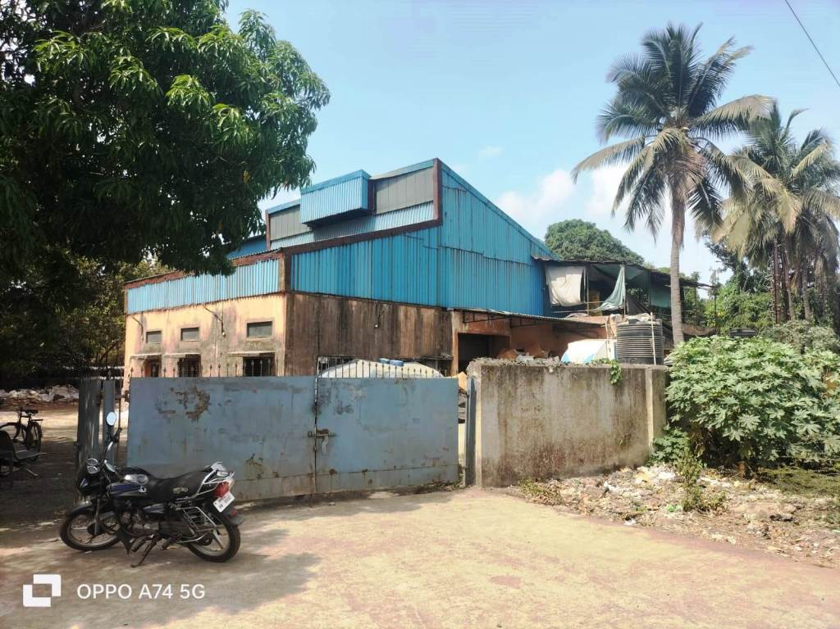

**Details of the property under consideration:**

Name of Owner: **M/s.** **Concept Home Textiles Private Limited**

Industrial Land & Building on Plot No. F-8/2, **"Tarapur Industrial Area"**, M.I.D.C., Village - Kolwade, Boisar (West), Taluka & District - Palghar, PIN - 401 507, State - Maharashtra, Country - India

# Latitude Longitude - 19°47'39.7"N 72°43'48.6"E

# 

**Valuation Done for:**

**Cosmos Bank**

# Borivali West (MRO A-2) Branch

# Shop No. 12 & 14, Mayfair, Ramdas Sutrale Marg, Opp. Chandawarkar Road, Borivali (West)

# Mumbai - 400 092, State - Maharashtra, Country - India

Vastu/Mumbai/06/2024/8983/2300085

13/12-83-JABS Date: 10.06.2024

# VALUATION OPINION REPORT

The property bearing Industrial Land & Building on Plot No. F-8/2, **"Tarapur Industrial Area"**, M.I.D.C., Village - Kolwade, Boisar (West), Taluka & District - Palghar, PIN - 401 507, State - Maharashtra, Country – India belongs to **M/s. Concept Home Textiles Private Limited.**

**Boundaries of the property.**

|  |  |  |  |
| --- | --- | --- | --- |
| **Building** | : | **As per actual site** | **As per document** |
| **North** | : | Navapur Road | Road (R/W. 30.50 mtrs) |
| **South** | : | Tata Steel Wire Rod Mill | Plot No. F-8/1 |
| **East** | : | Open Land | Plot No. F-8/1 |
| **West** | : | Tata Steel Global Wires Ltd. | Plot No. F-8/1 |

Considering various parameters recorded, existing economic scenario, and the information that is available with reference to the development of neighborhood and method selected for valuation, we are of the opinion that, the property premises can be assessed and valued for banking purpose as below –

|  |  |  |  |  |
| --- | --- | --- | --- | --- |
| **Particulars** | **Fair Market Value In (₹)** | **Realizable Value In (₹)** | **Distress Sale Value In (₹)** | **Insurable Value In**  **(₹)** |
| Industrial Land & Building | 6,45,92,584.00 | 5,81,33,326.00 | 5,16,74,067.00 | 2,14,19,320.00 |

The valuation of the property is based on the documents produced by the concern. Legal aspects have not been taken into considerations while preparing this valuation report.

Hence certified

## Manoj B. Chalikwar

## Registered Valuer

## Chartered Engineer (India)

## Reg. No. CAT-I-F-1763

Cosmos Emp. No. H.O./Credit/67/2019-20

Encl: Valuation report in Form – 01

Industrial Land & Building on Plot No. F-8/2, **"Tarapur Industrial Area"**, M.I.D.C., Village - Kolwade, Boisar (West), Taluka & District - Palghar, PIN - 401 507, State - Maharashtra, Country – India

*Form 0-1*

*(See Rule 8 D)*

REPORT OF VALUATION OF IMMOVABLE PROPERTY (OTHER THAN AGRICULTURAL LANDS, PLANTATIONS, FORESTS, MINES AND QUARRIES)

GENERAL:

|  |  |  |  |
| --- | --- | --- | --- |
| 1 | Purpose for which the valuation is made | | To assess the Fair Market Value as on 10.06.2024 for Banking Purpose |
| 2 | Date of inspection | | 01.06.2024 |
|  | Name of the owner/ owners | | **M/s. Concept Home Textiles Private Limited** |
| 4 | If the property is under joint ownership / co-ownership, share of each such owner. Are the shares undivided? | | Pvt. Ltd. Company Ownership |
| 5 | Brief description of the property | | **Address:** Industrial Land & Building on Plot No. F-8/2, **"Tarapur Industrial Area"**, M.I.D.C., Village - Kolwade, Boisar (West), Taluka & District - Palghar, PIN - 401 507, State - Maharashtra, Country – India  **Contact Person:**  Mr. Rajan (Company Manager)  Contact No. 8369127710 |
| 6 | Location, street, ward no | | M.I.D.C., Village - Kolwade, Boisar (West), Taluka & District - Palghar |
| 7 | Survey/ Plot no. of land | | Plot No. F-8/2 |
| 8 | Is the property situated in residential/ commercial/ mixed area/ industrial area? | | Industrial area |
| 9 | Classification of locality-high class/ middle class/poor class | | Middle Class |
| 10 | Proximity to civic amenities like schools, Hospitals, Offices, market, cinemas etc. | | All the amenities are available in the vicinity |
| 11 | Means and proximity to surface communication by which the locality is served | | Served by Buses, Auto, and Private cars |
|  | *LAND* | |  |
| 12 | Area of land supported by documentary proof. Shape, dimension and physical features | | Plot Area is 3,000 Sq. M.  (Area as per Deed of Assignment) |
| 13 | Roads, Streets or lanes on which the land is abutting | | Navapur Road |
| 14 | If freehold or leasehold land | | Leasehold land of M.I.D.C |
| 15 | If leasehold, the name of Lessor/lessee, nature of lease, date of commencement and termination of lease and terms of renewal of lease. | | Lease period – 95 years computed form the 1st day of April 1985  Lease Rent – Information not available |
| (i) Initial premium | |
| (ii) Ground rent payable per annum | |
| (iii) Unearned increase payable to the Lessor in the event of sale or transfer | |
| 16 | Is there any restriction covenant in regard to use of land? If so attach a copy of the covenant. | | Industrial |
| 17 | Are there any agreements of easements? If so, attach a copy of the covenant | | Information not available |
| 18 | Does the land fall in an area included in any Town Planning Scheme or any Development Plan of Government or any statutory body? If so, give Particulars. | | Coming under M.I.D.C. layout |
| 19 | Has any contribution been made towards development or is any demand for such contribution still outstanding? | | Information not available |
| 20 | Has the whole or part of the land been notified for acquisition by government or any statutory body? Give date of the notification. | | No |
| 21 | Attach a dimensioned site plan | | Copy of Approved Site Plan not available for our verification. |
|  | *IMPROVEMENT* | |  |
| 22 | Attach plans and elevations of all structures standing on the land and a lay-out plan. | | Copy of Part Occupancy Certificate No. MIDC / SPA / IFMS / E45981 dated 18.11.2021 for Building NO. 1 on Plot No. F-8/2, Tarapur Industrial Area issued by M.I.D.C. |
| 23 | Furnish technical details of the building on a separate sheet (The Annexure to this form may be used) | | Attached |
| 24 | Is the building owner occupied/tenanted/both? | | Owner Occupied in the name of Concept Home Textiles Private Limited |
|  | If the property owner occupied, specify portion and extent of area under owner-occupation | | N.A. |
| 25 | What is the Floor Space Index permissible and Percentage actually utilized? | | Floor Space Index permissible - As per M.I.D.C. norms  Percentage actually utilized – Information not available |
| 26 | *RENTS* | |  |
|  | (i) | Names of tenants/ lessees/ licensees, etc. | N.A. |
|  | (ii) | Portions in their occupation | N.A. |
|  | (iii) | Monthly or annual rent/ compensation / license fee, etc. paid by each | N.A. |
|  | (iv) | Information not available | N.A. |
| 27 | Are any of the occupants related to, or close to business associates of the owner? | | N.A. |
| 28 | Is separate amount being recovered for the use of fixtures, like fans, geysers, refrigerators, cooking ranges, built-in wardrobes, etc. or for services charges? If so, give details | | N.A. |
| 29 | Give details of the water and electricity charges, if any, to be borne by the owner | | N.A. |
| 30 | Has the tenant to bear the whole or part of the cost repairs and maintenance? Give particulars | | N.A. |
| 31 | If a lift is installed, who is to bear the cost of maintenance and operation- owner or tenant? | | N.A. |
| 32 | If a pump is installed, who is to bear the cost of maintenance and operation- owner or tenant? | | N.A. |
| 33 | Who has to bear the cost of electricity charges for lighting of common space like entrance hall, stairs, passage, compound, etc. owner or tenant? | | N.A. |
| 34 | What is the amount of property tax? Who is to bear it? Give details with documentary proof | | N.A. |
| 35 | Is the building insured? If so, give the policy no., amount for which it is insured and the annual premium | | N.A. |
| 36 | Is any dispute between landlord and tenant regarding rent pending in a court of rent? | | N.A. |
| 37 | Has any standard rent been fixed for the premises under any law relating to the control of rent? | | N.A. |
|  | *SALES* | |  |
| 38 | Give instances of sales of immovable property in the locality on a separate sheet, indicating the Name and address of the property, registration No., sale price and area of land sold. | | As per sub registrar of assurance records |
| 39 | Land rate adopted in this valuation | | As the property under consideration is an Industrial Land. The rate is considered as composite rate.  ` 15,000.00 per Sq. M. |
| 40 | If sale instances are not available or not relied up on, the basis of arriving at the land rate | | Online Price Indicators, Location, development of surrounding area, type of land and construction, construction specifications, age of building, condition of the premises & building, facilities provided and its prevailing market rate. |
|  | *COST OF CONSTRUCTION* | |  |
| 41 | Year of commencement of construction and year of completion | | Year of Construction:  Ground Floor (Old Structure) - 1986 (As mentioned in the Part Occupancy Certificate of New Building)  Ground + 1 Upper Floor – 2021 (As per Part Occupancy Certificate of New Building) |
| 42 | What was the method of construction, by contract / By employing Labour directly / both? | | Information not available |
| 43 | For items of work done on contract, produce copies of agreements | | Information not available |
| 44 | For items of work done by engaging Labour directly, give basic rates of materials and Labour supported by documentary proof. | | Information not available |
|  | Remark: | |  |

*PART II- VALUATION*

GENERAL:

Under the instruction of Cosmos Bank, Borivali West (MRO A-2) Branch to assess fair market value as on **10th June 2024** for Industrial Land & Building on Plot No. F-8/2, **"Tarapur Industrial Area"**, M.I.D.C., Village - Kolwade, Boisar (West), Taluka & District - Palghar, PIN - 401 507, State - Maharashtra, Country – India belongs to **M/s. Concept Home Textiles Private Limited**

**We are in receipt of the following documents:**

|  |  |
| --- | --- |
|  | Copy of Deed of Assignment dated 15.03.2018 between Bombay Oxygen Corporation Limited (the Assignor) AND Concept Home Textiles Private Limited (the Assignee) |
|  | Copy of Part Occupancy Certificate No. MIDC / SPA / IFMS / E45981 dated 18.11.2021 for Building NO. 1 on Plot No. F-8/2, Tarapur Industrial Area issued by M.I.D.C. |
|  | Copy Agreement dated 02.05.2019 between Maharashtra Industrial Development Corporation (the Lessor) AND M/s. Concept Home Textile Pvt. Ltd. (the Lessee) |

**LOCATION:**

The said property is Industrial Land & Building on Plot No. F-8/2, **"Tarapur Industrial Area"**, M.I.D.C., Village - Kolwade, Boisar (West), Taluka & District - Palghar, PIN - 401 507, State - Maharashtra, Country – India. It is falls in Industrial Zone. It is at 3.6 km. travel distance from Boisar railway station.

**BUILDING:**

The property under reference is an industrial land building is Ground + 1 upper floor structure with AC sheet roofing (on Plot No. F-8/2). It is a RCC framed structure with 9" thick external walls and 6" thick internal brick walls. The walls are having sand faced plaster from outside. The building external condition is normal. The structure is used for Industrial purpose.

As per actual site measurement, the total Carpet area of Ground Floor is 7,950.00 Sq. Ft. & First Floor is 3,626.00

**As per Part Occupancy Certificate, total Built-up Area is 1,372.91 Sq. M., which is considered for valuation.**

**Valuation as on 10th June 2024:**

1. **Land Valuation:**

|  |  |  |  |
| --- | --- | --- | --- |
| **Fair Market Value** |  | | |
| A) Land | **Area in Sq. M.** | **Rate in `** | **Fair Market Value in `** |
| Plot No. F-8/2 | 3,000.00 | 15,000/- | 4,50,00,000/- |
| Total | | | **4,50,00,000/-** |

1. **Valuation of Structures.**

The Built-up area of the building : As per valuation table below

**Deduct Depreciation:**

Year of Construction of the building : Ground Floor (Old Structure) – 1986 (As mentioned in the

Part Occupancy Certificate of New Building)

Ground + 1 Upper Floor = 2021 (New Structure)

(As per part Occupancy Certificate of new building)

Expected total life of building : 60 Years

Age of the building as on 2024 : 38 Years (Old Structure) &

03 Years (New Structure)

Cost of Construction : As per valuation table below

Depreciation : As per valuation table below

Amount of depreciation : As per valuation table below

**Depreciated cost of construction** : As per valuation table below

**Government Value:**

|  |  |  |  |
| --- | --- | --- | --- |
| **Particulars** | **Area in Sq. M.** | **Rate in `** | **Value in `** |
| Land | 3,000.00 | 3,895/- | 1,16,85,000/- |
| Structure | As per valuation table | | 1,87,79,039/- |
| **Total** |  |  | **3,04,64,039/-** |

**B) Structure:**

|  |  |  |  |  |  |  |  |  |
| --- | --- | --- | --- | --- | --- | --- | --- | --- |
| **Floor** | **Built up Area in**  **Sq. M.** | **Year of Const.** | **Total Life of Structure** | **Replacement Rate** (`) | **Age Of Build. (Years)** | **Depreciated Rate** (`) | **Depreciated Value** (`) | **Full Value** (`) |
| Ground (RCC – Old Structure) | 469.31 | 1986 | 50 | 20,000/- | 38 | 13,680/- | 29,66,039**/-** | 93,86,200**/-** |
| Ground Floor (RCC New Structure) | 451.80 | 2021 | 50 | 20,000/- | 3 | 20,000/- | 90,36,000**/-** | 90,36,000**/-** |
| First | 451.80 | 2021 | 50 | 15,000/- | 3 | 20,000/- | 67,77,000**/-** | 67,77,000**/-** |
| **Total** | | | | | | | **1,87,79,039/-** | **2,51,99,200/-** |

**C) Land Development:**

|  |  |  |  |
| --- | --- | --- | --- |
| Land | **Area in Sq. M.** | **Rate in `** | **Fair Market Value in `** |
| 1,627.09 | 500/- | **8,13,545/-** |

**TOTAL VALUE OF THE PROPERTY:**

|  |  |
| --- | --- |
| **Particulars** | **Value (`)** |
| **Land** | 4,50,00,000.00 |
| **Land Development** | 8,13,545.00 |
| **Buildings** | 1,87,79,039.00 |
| **Fair Market Value** | **6,45,92,584.00** |
| **Realizable Value** | **5,81,33,326.00** |
| **Distress Sale Value** | **5,16,74,067.00** |
| **Insurable value**  **(Depreciated Cost of Construction (2,51,99,200/-) – Subsoil structure cost (15%)** | **2,14,19,320.00** |

Taking into consideration above said facts, we can evaluate the value of Industrial Land & Building on Plot No. 103, **"Ambernath Industrial Area"**, MIDC, Village Chikhloli, Taluka Ambernath, District Thane, PIN – 421 501, State - Maharashtra, Country – India for this particular purpose at **` 6,45,92,584.00 (Rupees Six Crore Forty Five Lakhs Ninety Two Thousand Five Hundred Eighty Four Only)** as on **10th June 2024.**

**NOTES**

1. I, Manoj B. Chalikwar with my experience and ability to judgment I am of the considered opinion that the fair market value of the property as on 10th June 2024 is ` 6,45,92,584.00 (Rupees Six Crore Forty Five Lakhs Ninety Two Thousand Five Hundred Eighty Four Only). Value varies with time and purpose and hence this value should not be referred for any purpose other than mentioned in this report.
2. This valuation is done on the basis of information, which the valuer has obtained by information provided by the client about the premises and location of the surrounding area and also prevailing rates in the surrounding area, and further subject to document as mentioned in valuation report.
3. This valuer should not be held responsible for authentication of documents, clear title and other such related matters. For that purpose, Latest Legal Opinion should be sought.

*PART III- DECLARATION*

I hereby declare that

* + 1. The information furnished in part I is true and correct to the best of my knowledge and belief;
    2. I have no direct or indirect interest in the property valued:

ANNEXURE TO FORM 0-1

Technical details Main Building

|  |  |  |
| --- | --- | --- |
| 1. | No. of floors and height of each floor | Old Structure - Ground Floor only  New Structure - Ground + 1 Upper Floor with AC sheet roofing |
| 2. | Plinth area floor wise as per IS- 1225 | As per valuation table |
| 3 | Year of construction | Ground Floor (Old Structure) - 1986 (As mentioned in the Part Occupancy Certificate of New Building)  Ground + 1 Upper Floor – 2021 (As per Part Occupancy Certificate of New Building) |
| 4 | Estimated future life | Old Structure - 12 Years  New Structure – 47 Years (Subject to proper, preventive periodic maintenance and structural repairs.) |
| 5 | Type of construction- load bearing walls/RCC frame/ steel frame | RCC framed structure |
| 6 | Type of foundations | RCC. |
| 7 | Walls | All external walls are 9” thick and partition walls are 6” thick. |
| 8 | Partitions | 6” thick brick wall |
| 9 | Doors and Windows | MS rolling shutters, Allumnium framed sliding windows & Steel framed fixed windows |
| 10 | Flooring | Kota finished flooring |
| 11 | Finishing | Cement plastering |
| 12 | Roofing and terracing | RCC & G. I. sheet roofing |
| 13 | Special architectural or decorative features, if any | Normal |
| 14 | |  |  | | --- | --- | | (i) | Internal wiring – surface or conduit | | (ii) | Class of fittings: Superior/ Ordinary/ Poor. | | Industrial type wiring |
| 15 | Sanitary installations   |  |  | | --- | --- | | (i) | No. of water closets | | (ii) | No. of lavatory basins | | (iii) | No. of urinals | | (iv) | No. of sinks |   Class of fittings: Superior colored / superior white/ordinary. | As per requirements |
| 16 | Compound wall  Height and length  Type of construction | Compound wall of R.C.C. columns with Brick Masonry wall |
| 17 | No. of lifts and capacity | No lift |
| 18 | Underground sump – capacity and type of construction | As per requirements |
| 19 | Over-head tank Location, capacity Type of construction | As per requirements |
| 20 | Pumps- no. and their horse power | As per requirements |
| 21 | Roads and paving within the compound approximate area and type of paving | Tar Road |
| 22 | Sewage disposal – whereas connected to public sewers, if septic tanks provided, no. and capacity | Connected to M.I.D.C. sewer line |
| 23 | General Remarks |  |

**Actual site photographs**

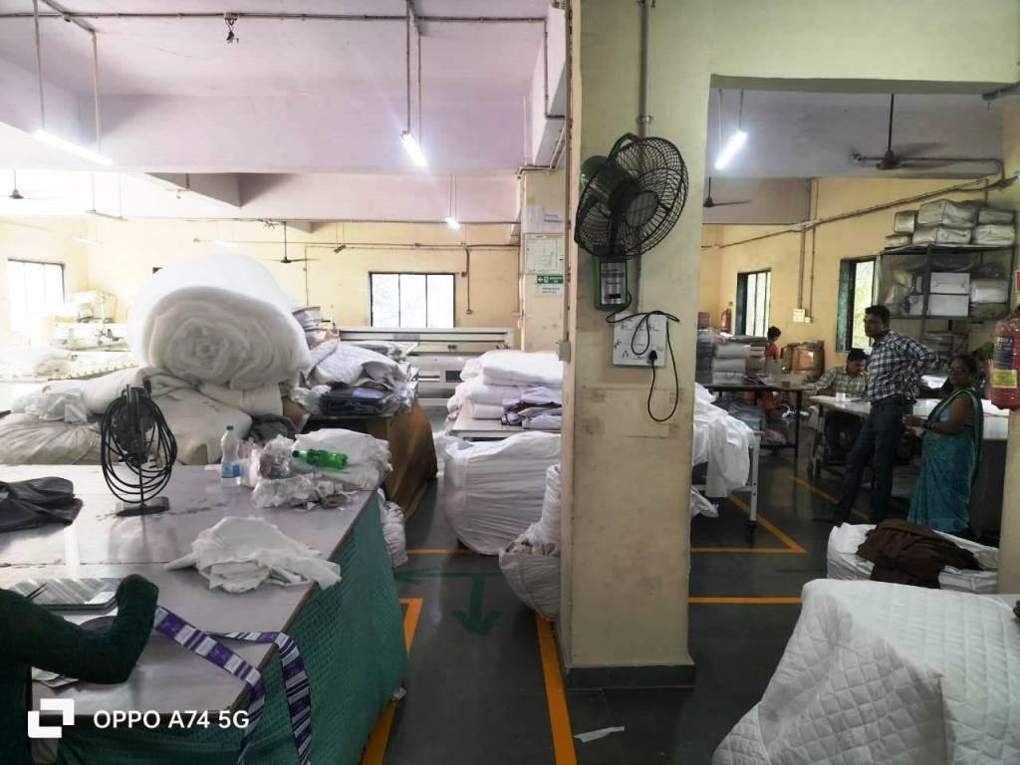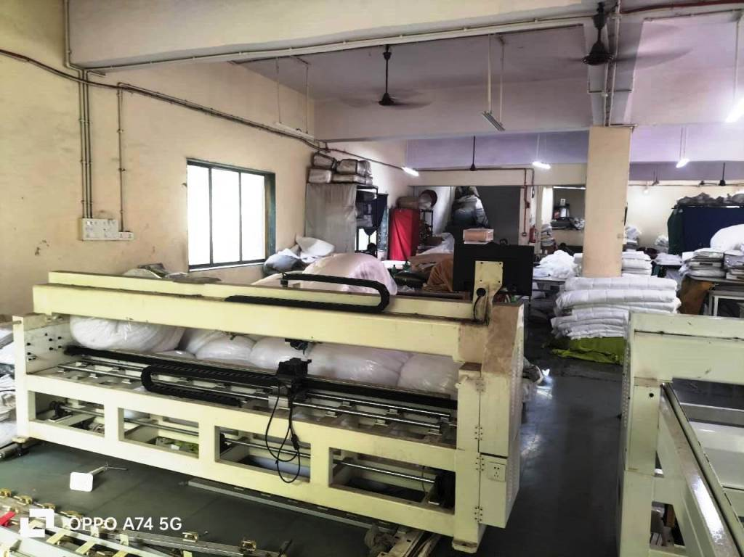

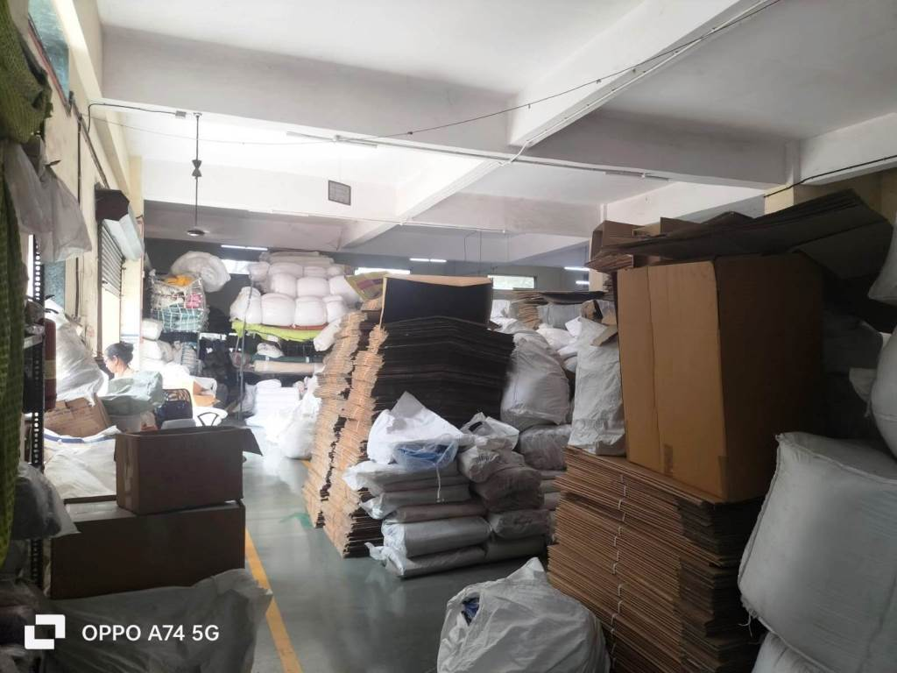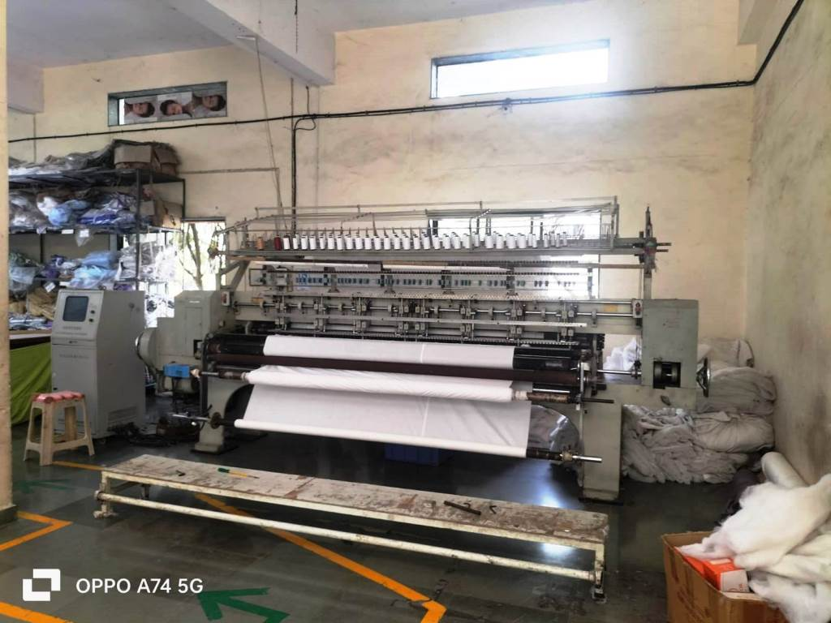

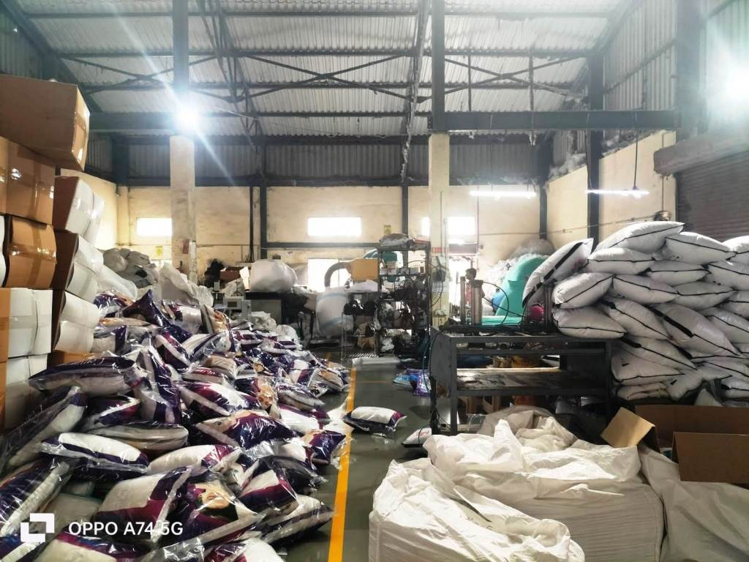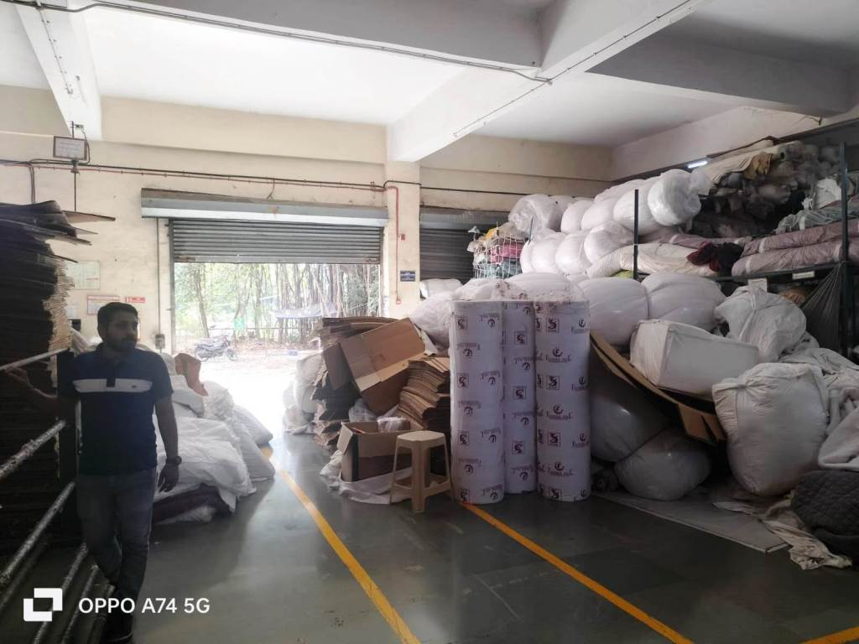

**Actual site photographs**

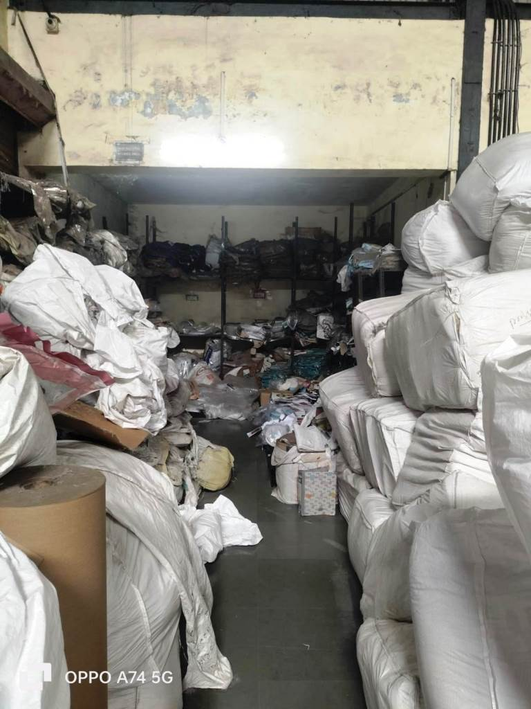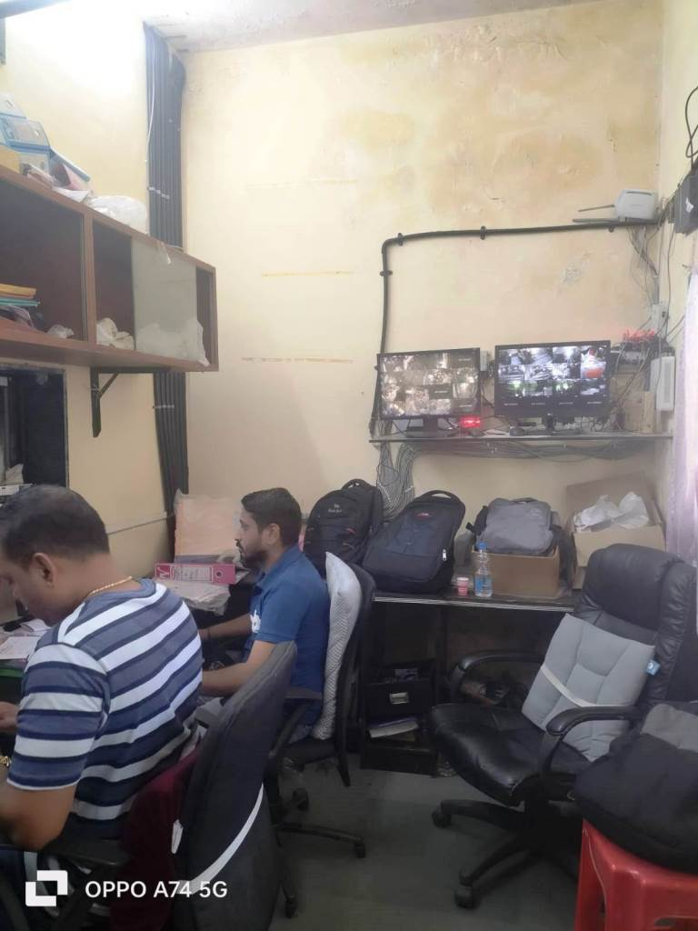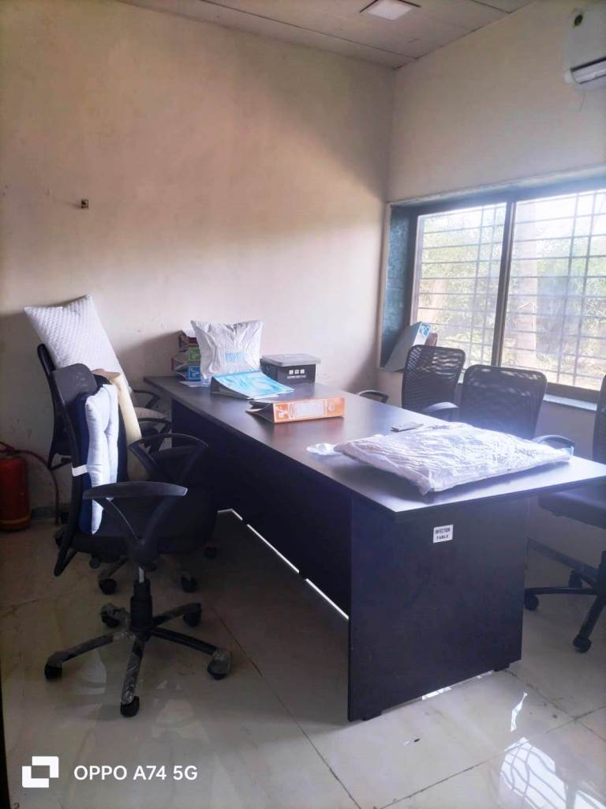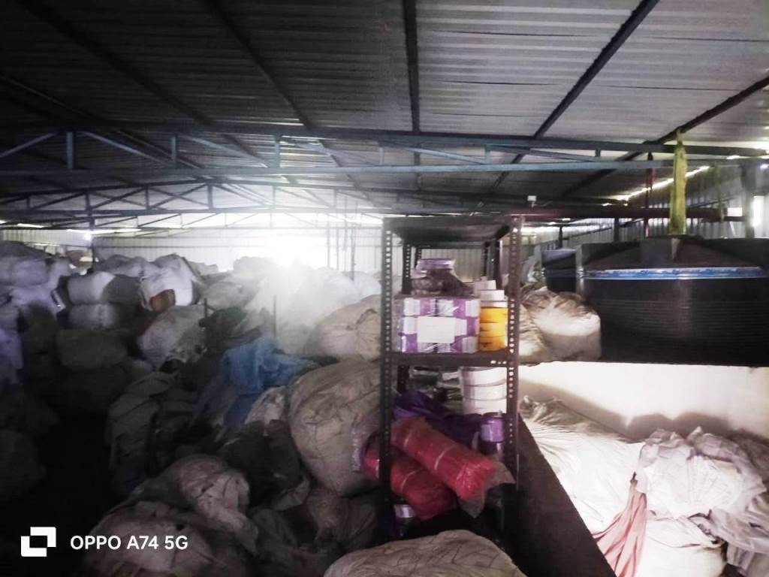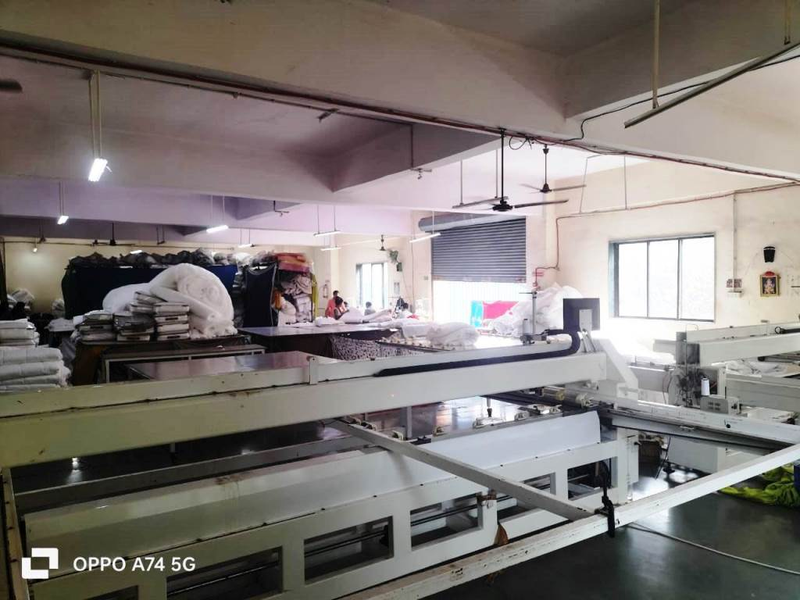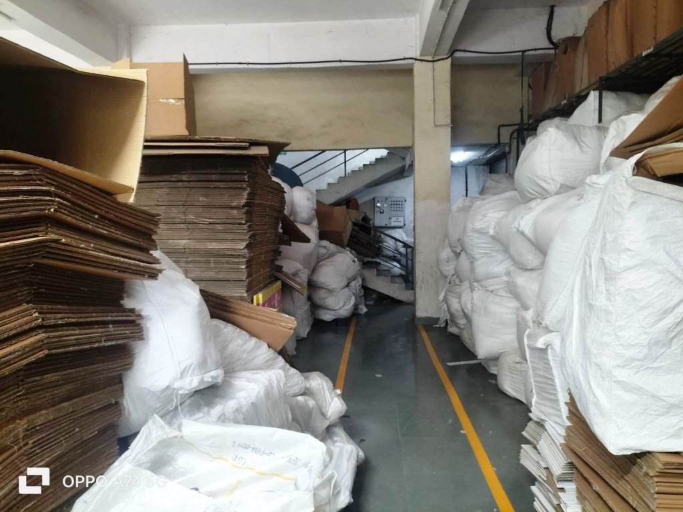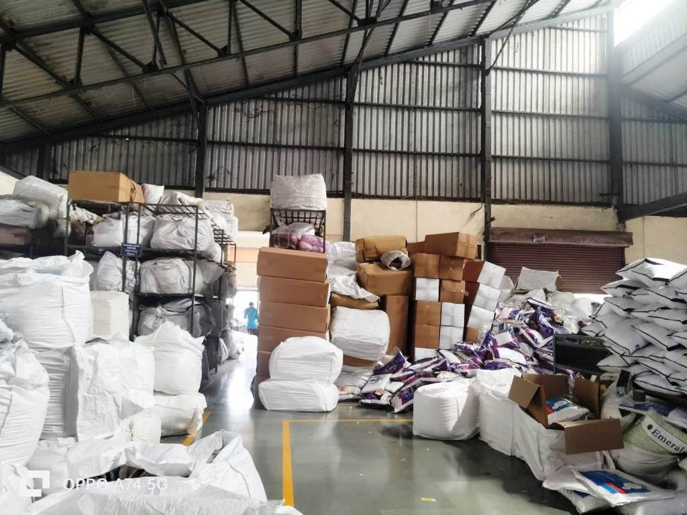

**Actual site photographs**

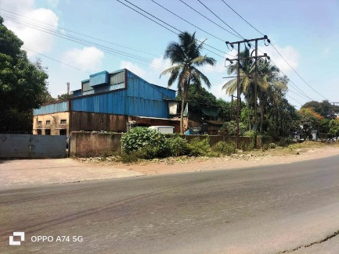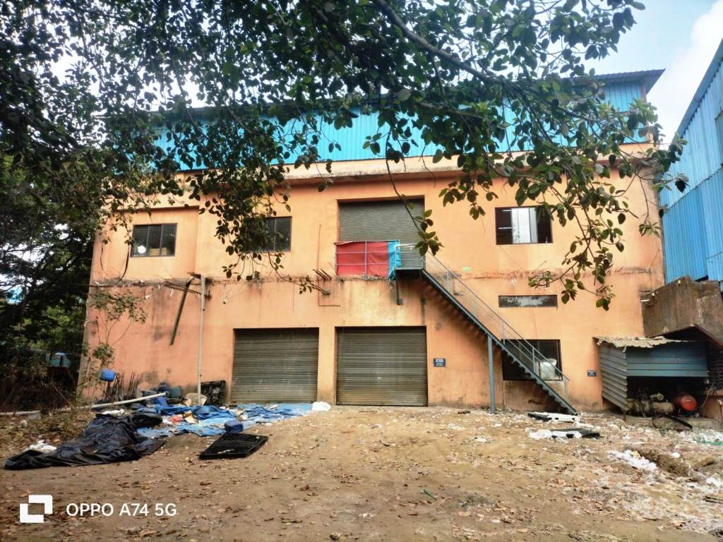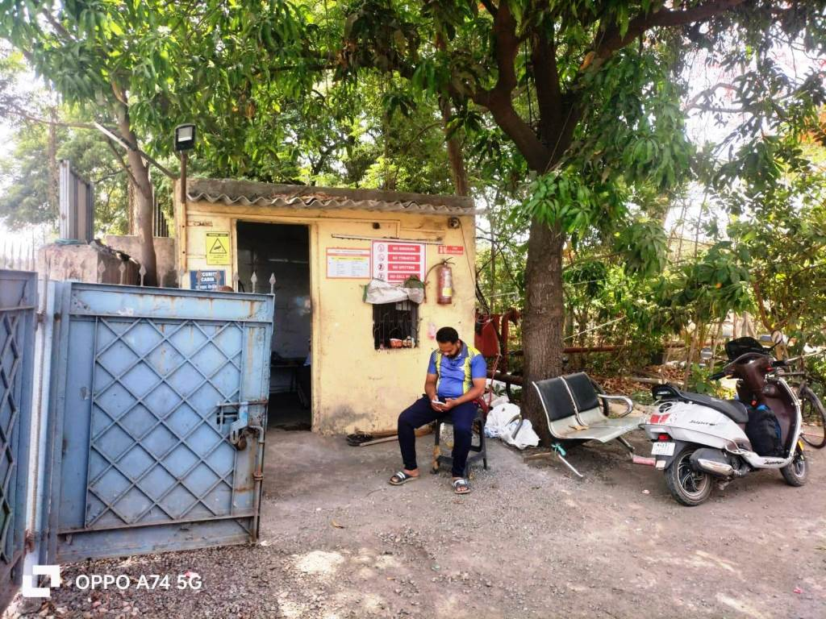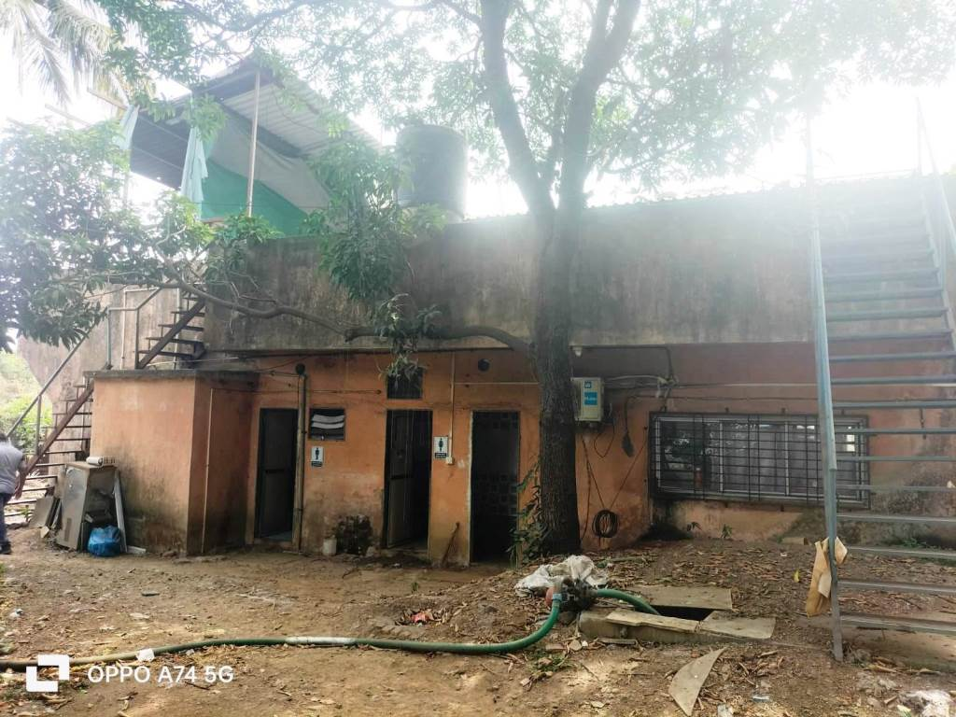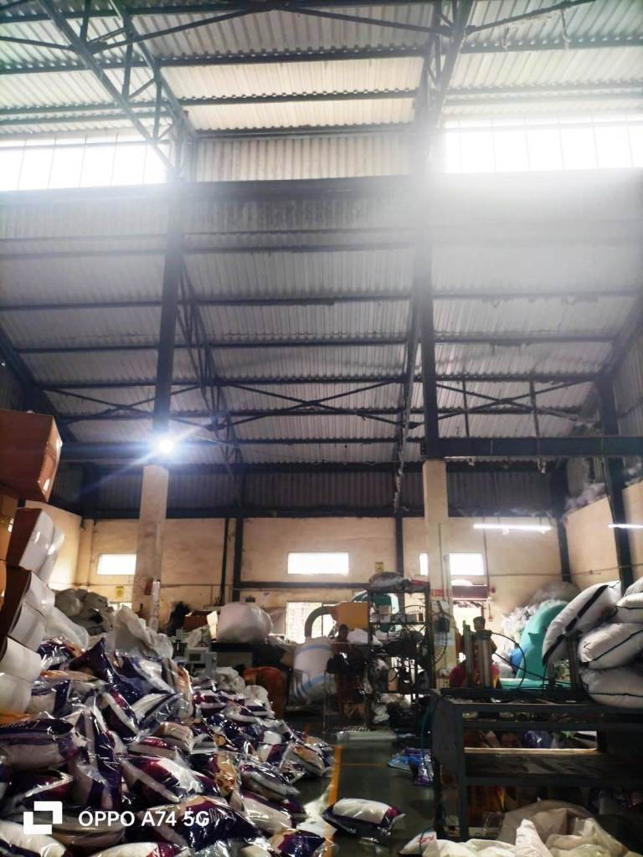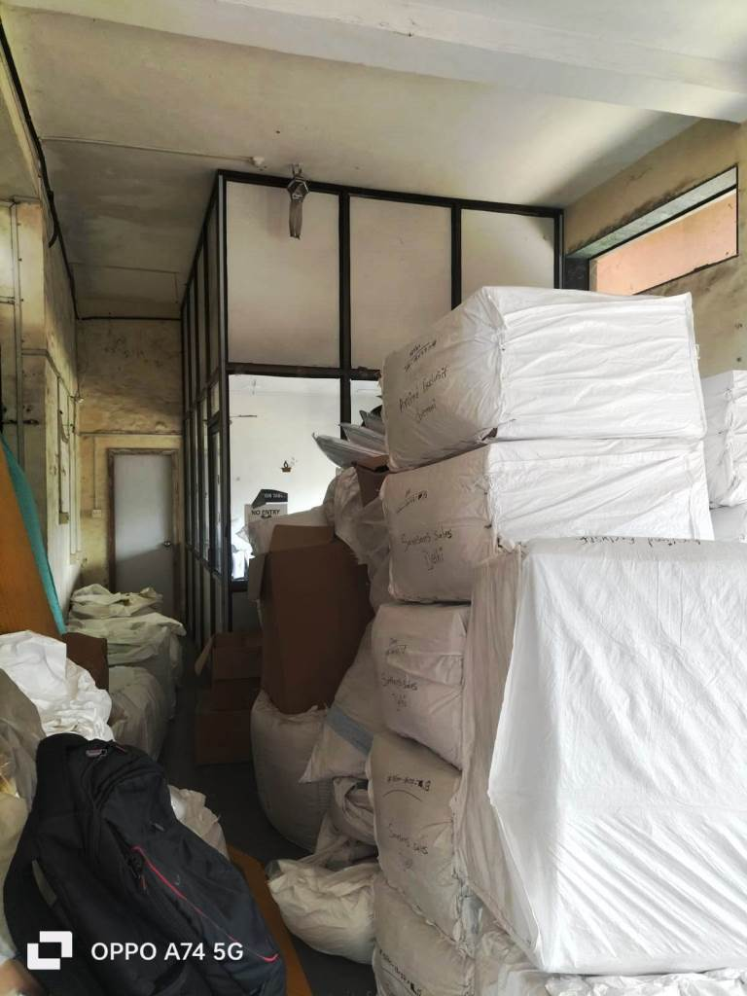

Route Map of the property

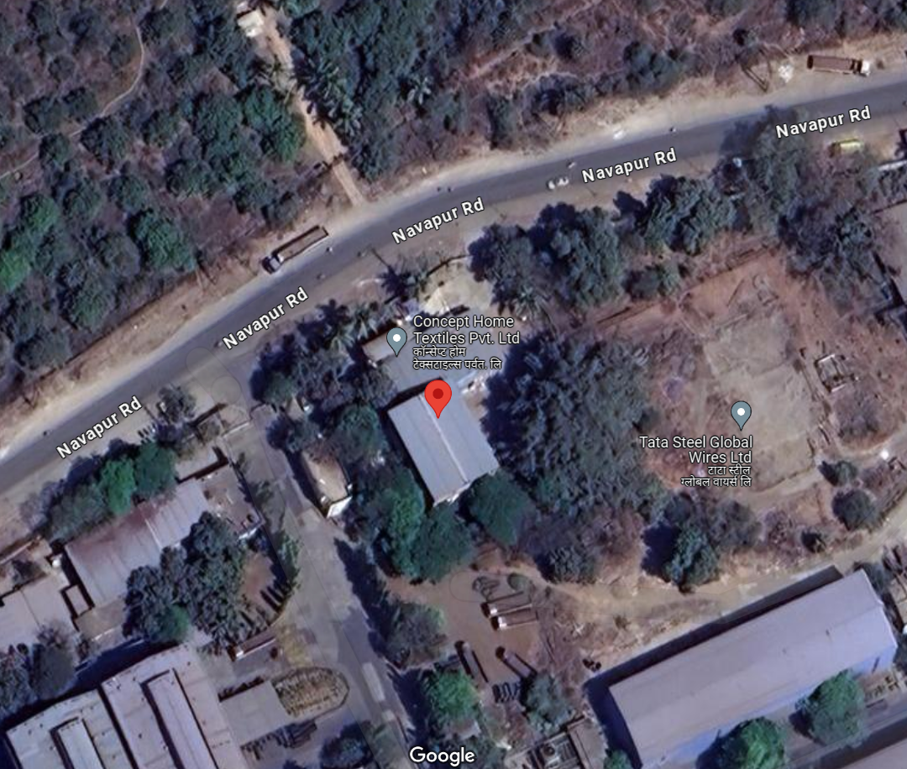**Site u/r**

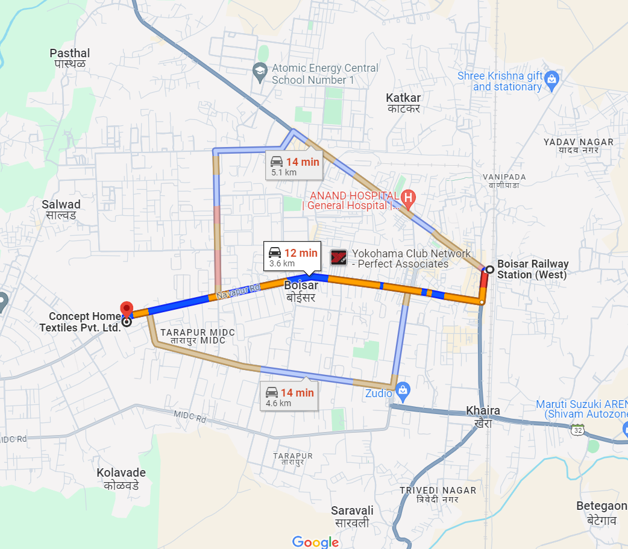

# Latitude Longitude - 19°47'39.7"N 72°43'48.6"E

**Note:** The Blue line shows the route to site from nearest Railway Station (Boisar - 3.6 KM.)

**M.I.D.C. MAP**

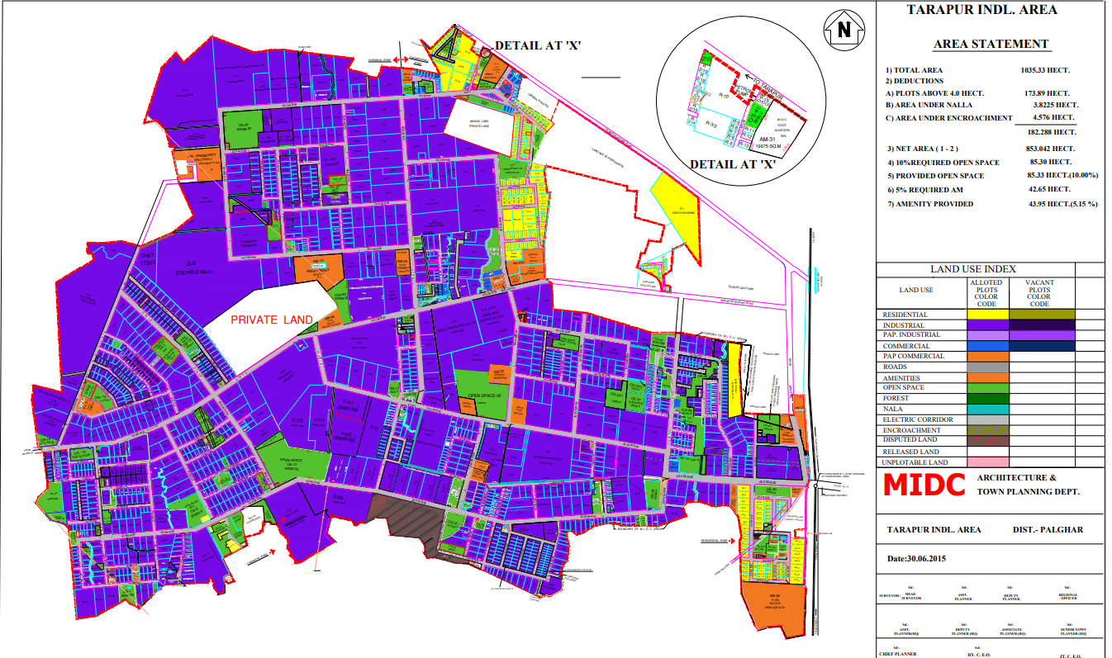**15.8**

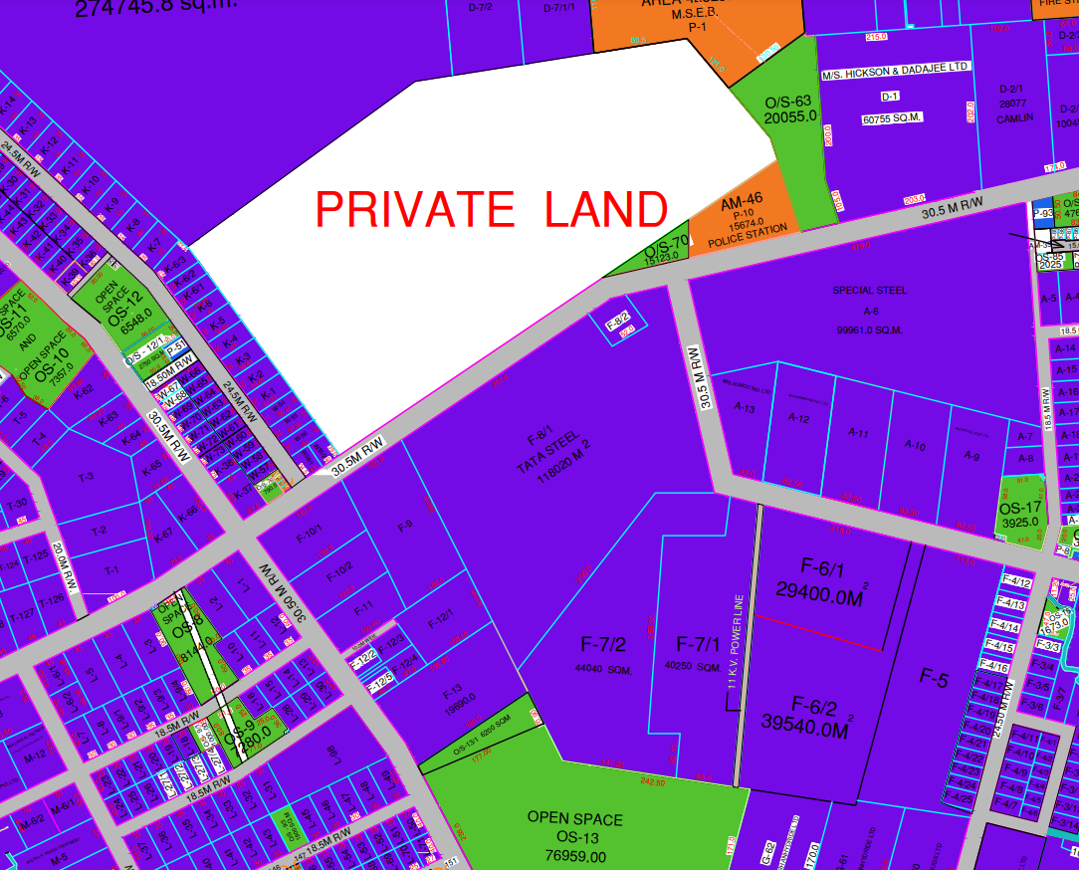

**READY RECKONER RATE**

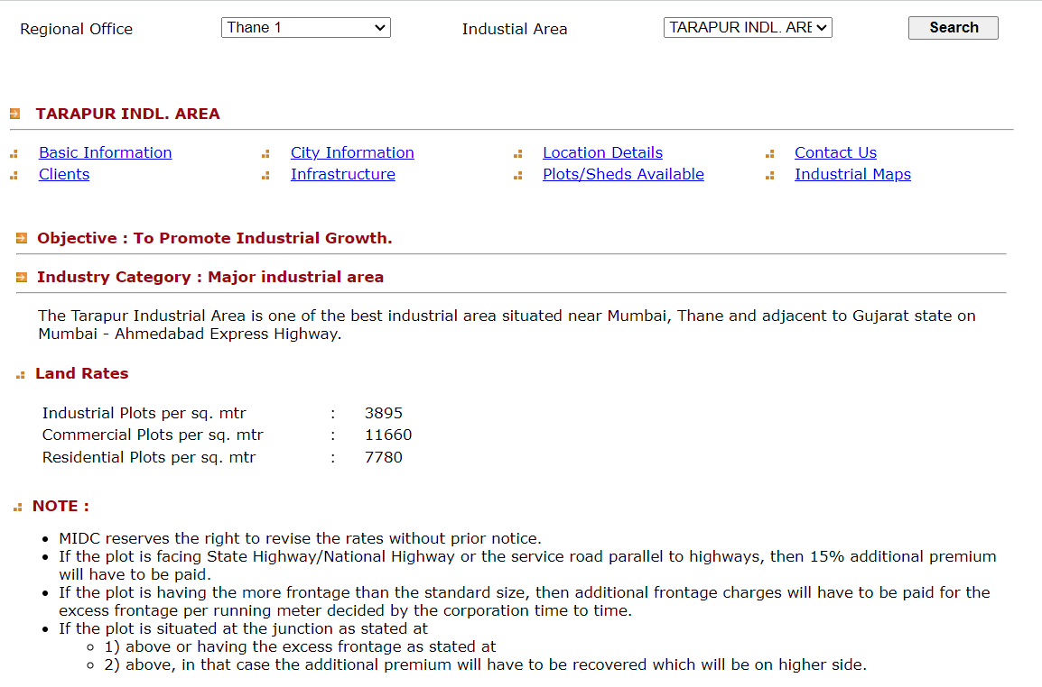

**Price Indicators**

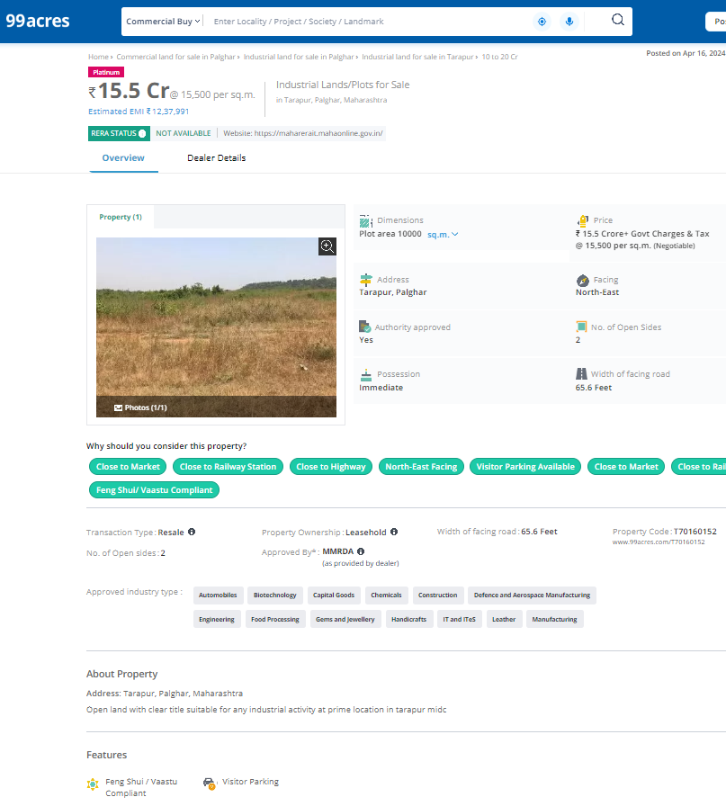

**DEFINITION OF VALUE FOR THIS SPECIFIC PURPOSE**

This exercise is to assess **Fair Market Value** of the property under reference as on **10th June 2024.**

The term **Fair Market Value** is defined as

*“The most probable price, as of a specified date, in cash, terms equivalent to cash, or in other precisely revealed terms for which the specified property rights would sell after reasonable exposure in a competitive market under all conditions requisite to a fair sale, with the buyer and seller each acting prudently knowledgeably and for self-interest assuming that neither is under undue duress”.*

Fundamental assumptions and conditions presumed in this definition are:

1. Buyer and seller are motivated by self-interest.

2. Buyer and seller are well informed and are acting prudently.

3. The property is exposed for a reasonable time on the open market.

4. Payment is made in cash or equivalent or in specified financing terms.

#### UNDER LYING ASSUMPTIONS

1. We assume no responsibility for matters of legal nature affecting the property appraised or the title thereto, nor do we render our opinion as to the title, which is assumed to be good and marketable.

2. The property is valued as though under responsible ownership.

3. It is assumed that the property is free of liens and encumbrances.

4. It is assumed that there are no hidden or unapparent conditions of the subsoil or structure that would render it more or less valuable. No responsibility is assumed for such conditions or for engineering that might be required to discover such factors.

5. There is no direct/ indirect interest in the property valued

6. The rates for valuation of the property are in accordance with the Govt. approved rates and prevailing market rates.

## Manoj B. Chalikwar

## Registered Valuer

## Chartered Engineer (India)

## Reg. No. CAT-I-F-1763

Cosmos Emp. No. H.O./Credit/67/2019-20