Valuation Report of the Immovable Property

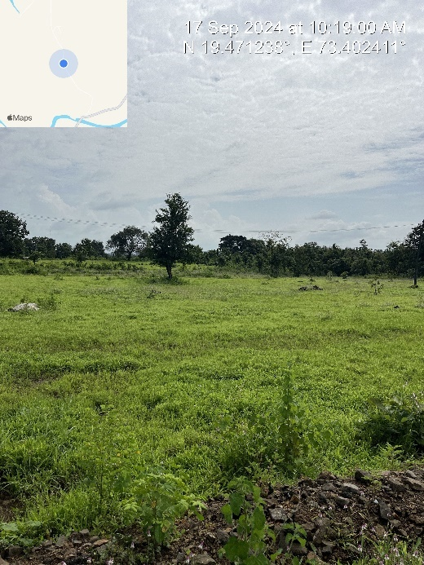

**Details of the property under consideration:**

Name of Owner: **Mrs. Sucheta V. Tamrakar & Mr. Vinod R. Tamrakar**

Residential Plot No. 111, Survey No. 284 (Old Gut No. 226, 227, 47/1) , Village – Sarangpuri, Taluka – Shahapur, District -Thane, State - Maharashtra, Country - India

# Latitude Longitude - 19°28'16.0"N 73°24'06.9"E

# 

**Valuation Done for:**

**Cosmos Bank**

# Mulund (East) Branch

# Ground + 1st Floor of Shop No. 2, 1st Floor of Shop No. 1, "Romell Vasanti", Vasanti Vihar Co-op. Hsg. Soc. Ltd., Navghar Road, Mulund (East), Mumbai – 400 081, State – Maharashtra, Country – India

Vastu/Mumbai/09/2024/008963/2308315

23/20-321-AU Date: 23.09.2024

# VALUATION OPINION REPORT

The property Residential Plot No. 111, Survey No. 284 (Old Gut No. 226, 227, 47/1), Village – Sarangpuri, Taluka – Shahapur, District -Thane, State - Maharashtra, Country - India belongs to **Mrs. Sucheta V. Tamrakar & Mr. Vinod R. Tamrakar.**

**Boundaries of the property.**

|  |  |  |  |
| --- | --- | --- | --- |
| **Open Plot** | : | **As per actual site** | **As per Documents** |
| North | : | Proposed Tar Road | Tar Road |
| South | : | Open Plot | Plot No. 110 |
| East | : | Open Plot | Plot No. 112 |
| West | : | Proposed Tar Road | Tar Road |

Considering various parameters recorded, existing economic scenario, and the information that is available with reference to the development of neighborhood and method selected for valuation, we are of the opinion that, the property premises can be assessed and valued for banking purpose for –

|  |  |  |  |
| --- | --- | --- | --- |
| **Particulars** | **Fair Market Value In (₹)** | **Realizable Value In (₹)** | **Distress Sale Value In (₹)** |
| Residential Plot | 8,64,000.00 | 7,77,600.00 | 6,91,200.00 |

The valuation of the property is based on the documents produced by the concern. Legal aspects have not been taken into considerations while preparing this valuation report.

Hence certified

## Manoj B. Chalikwar

## Registered Valuer

## Chartered Engineer (India)

## Reg. No. CAT-I-F-1763

## Cosmos Emp. No. H.O./Credit/67/2019-20

Encl. Valuation Report

Valuation Report of Residential Plot No. 111, Survey No. 284 (Old Gut No. 226, 227, 47/1), Village – Sarangpuri, Taluka – Shahapur, District -Thane, State - Maharashtra, Country - India.

*Form 0-1*

*(See Rule 8 D)*

REPORT OF VALUATION OF IMMOVABLE PROPERTY (OTHER THAN AGRICULTURAL LANDS, PLANTATIONS, FORESTS, MINES AND QUARRIES)

GENERAL:

|  |  |  |  |
| --- | --- | --- | --- |
| 1 | Purpose for which the valuation is made | | To assess the Fair Market Value as on 23.09.2024 for Bank Loan Purpose |
| 2 | Date of inspection | | 17.09.2024 |
|  | Name of the owner/ owners | | **Mrs. Sucheta V. Tamrakar & Mr. Vinod R. Tamrakar** |
| 4 | If the property is under joint ownership / co-ownership, share of each such owner. Are the shares undivided? | | Joint Ownership |
| 5 | Brief description of the property | | **Address:** Residential Plot No. 111, Survey No. 284 (Old Gut No. 226, 227, 47/1), Village – Sarangpuri, Taluka – Shahapur, District -Thane, State - Maharashtra, Country - India.  **Contact Person:**  Mr. Manish (Developer’s Brother)  Contact No. +91 81080 61096 |
| 6 | Location, street, ward no | | Village – Sarangpuri, Taluka – Shahapur, District -Thane |
| 7 | Survey/ Plot no. of land | | Residential Plot No. 111, Survey No. 284 |
| 8 | Is the property situated in residential/ commercial/ mixed area/ industrial area? | | Residential undeveloped Area |
| 9 | Classification of locality-high class/ middle class/poor class | | Middle Class |
| 10 | Proximity to civic amenities like schools, Hospitals, Offices, market, cinemas etc. | | All the amenities are available within 5 Km. range |
| 11 | Means and proximity to surface communication by which the locality is served | | Served by Auto and Private cars |
|  | *LAND* | |  |
| 12 | Area of land supported by documentary proof. Shape, dimension and physical features | | Land Area – 216.00 Sq. M.  (Area as per Sale Deed) |
| 13 | Roads, Streets or lanes on which the land is abutting | | Off. Patole Road |
| 14 | If freehold or leasehold land | | Freehold |
| 15 | If leasehold, the name of Lessor/lessee, nature of lease, date of commencement and termination of lease and terms of renewal of lease. | | N.A. |
| (i) Initial premium | |
| (ii) Ground rent payable per annum | |
| (iii) Unearned increase payable to the Lessor in the event of sale or transfer | |
| 16 | Is there any restriction covenant in regard to use of land? If so attach a copy of the covenant. | | Residential |
| 17 | Are there any agreements of easements? If so, attach a copy of the covenant | | Information not available |
| 18 | Does the land fall in an area included in any Town Planning Scheme or any Development Plan of Government or any statutory body? If so, give Particulars. | | Yes |
| 19 | Has any contribution been made towards development or is any demand for such contribution still outstanding? | | Information not available |
| 20 | Has the whole or part of the land been notified for acquisition by government or any statutory body? Give date of the notification. | | No |
| 21 | Attach a dimensioned site plan | | N.A., the property under consideration is open land only for valuation |
|  | *IMPROVEMENT* | |  |
| 22 | Attach plans and elevations of all structures standing on the land and a lay-out plan. | | N.A., the property under consideration is open land only for valuation |
| 23 | Furnish technical details of the building on a separate sheet (The Annexure to this form may be used) | | N.A., the property under consideration is open land only for valuation |
| 24 | Is the building owner occupied/tenanted/both? | | Vacant and under Owner’s possession. |
|  | If the property owner occupied, specify portion and extent of area under owner-occupation | | N.A. |
| 25 | What is the Floor Space Index permissible and Percentage actually utilized? | | N.A. |
| 26 | *RENTS* | |  |
|  | (i) | Names of tenants/ lessees/ licensees, etc. | N.A. |
|  | (ii) | Portions in their occupation | N.A. |
|  | (iii) | Monthly or annual rent/ compensation / license fee, etc. paid by each | N.A. |
|  | (iv) | Gross amount received for the whole property | N.A. |
| 27 | Are any of the occupants related to, or close to business associates of the owner? | | N. A. |
| 28 | Is separate amount being recovered for the use of fixtures, like fans, geysers, refrigerators, cooking ranges, built-in wardrobes, etc. or for services charges? If so, give details | | N. A. |
| 29 | Give details of the water and electricity charges, if any, to be borne by the owner | | N. A. |
| 30 | Has the tenant to bear the whole or part of the cost repairs and maintenance? Give particulars | | N. A. |
| 31 | If a lift is installed, who is to bear the cost of maintenance and operation- owner or tenant? | | N. A. |
| 32 | If a pump is installed, who is to bear the cost of maintenance and operation- owner or tenant? | | N. A. |
| 33 | Who has to bear the cost of electricity charges for lighting of common space like entrance hall, stairs, passage, compound, etc. owner or tenant? | | N. A. |
| 34 | What is the amount of property tax? Who is to bear it? Give details with documentary proof | | N. A. |
| 35 | Is the building insured? If so, give the policy no., amount for which it is insured and the annual premium | | N. A. |
| 36 | Is any dispute between landlord and tenant regarding rent pending in a court of rent? | | N. A. |
| 37 | Has any standard rent been fixed for the premises under any law relating to the control of rent? | | N. A. |
|  | *SALES* | |  |
| 38 | Give instances of sales of immovable property in the locality on a separate sheet, indicating the Name and address of the property, registration No., sale price and area of land sold. | | As per sub registrar of assurance records |
| 39 | Land rate adopted in this valuation | | ` 4,000.00 per Sq. M. |
| 40 | If sale instances are not available or not relied up on, the basis of arriving at the land rate | | Online Price Indicators, Location, development of surrounding area, type of land, condition of the plot, facilities provided and its prevailing market rate. |
|  | *COST OF CONSTRUCTION* | |  |
| 41 | Year of commencement of construction and year of completion | | N.A. |
| 42 | What was the method of construction, by contract / By employing Labour directly / both? | | N.A. |
| 43 | For items of work done on contract, produce copies of agreements | | N.A. |
| 44 | For items of work done by engaging Labour directly, give basic rates of materials and Labour supported by documentary proof. | | N.A. |

*PART II- VALUATION*

GENERAL:

Under the instruction of Cosmos Bank, Mulund (East) Branch to assess fair market value as on 23.09.2024 for Residential Plot No. 111, Survey No. 284 (Old Gut No. 226, 227, 47/1), Village – Sarangpuri, Taluka – Shahapur, District -Thane, State - Maharashtra, Country - India belongs to **Mrs. Sucheta V. Tamrakar & Mr. Vinod R. Tamrakar.**

**We are in receipt of the following documents:**

|  |  |
| --- | --- |
| 1 | Copy of Sale Deed dated 26.10.2017 between Mr. Madhukar Bhaghwan Padwal & Mr. Santosh Sawalaram Parab (Vendors / Developer) AND Mrs. Sucheta V. Tamrakar & Mr. Vinod R. Tamrakar (the Purchaser) |
| 2 | Copy of 7/12 & 6 Extract |
| 3 | Copy of Construction Permission No. Mahsul/K - 1/ Amended N.A. / Construction / Permission N.A. P. S.R. 07/2008 issued by Office of Tahsildar, Shahapur dated 22.10.2008 (For Gut No. 226, 227, 47/1) |
| 4 | Copy of Layout Plan Revenue Department / N.A. Plot / S.R. – K.A.1/ 68 approved by Tahsildar, Shahapur dated 22.10.2008 (For Gut No. 226, 227, 47/1) |

**LOCATION:**

The said property is located at Village – Sarangpuri, Taluka – Shahapur, District -Thane, State - Maharashtra, Country - India.

As per Approved Layout plan, the property falls in Residential Zone. It is at a travelling distance of 14.3 km. travelling distance from Asangaon railway station.

**PROPERTY:**

The property is Residential Plot. At the time of visit, the layout/project boundary was not defined / available. There was no project sign board or any land development like internal roads, plot demarcation, amenities development. In spite the project being 15 to 16 years old and there is no other development in the nearby vicinity of 3 KM. The developed plots at a distance of 5 to 10 km. are sold in the range of Rs. 6,000/- to Rs. 8,000/- per sq. m. depending upon the size, location, amenities provided and present development at the nearby area.

**Valuation as on 23rd September 2024:**

1. **Land Valuation:**

|  |  |  |  |
| --- | --- | --- | --- |
| **Particulars** | **Area in Sq. M.** | **Rate in `** | **Value in `** |
| Plot | 216.00 | 4,000/- | 8,64,000/- |
| **Total** |  |  | **8,64,000/-** |

1. **Valuation of Structures.**

The Built-up area of the building : **Not applicable, being valuation of land only**

**Deduct Depreciation:**

Year of Construction of the building : N.A.

Expected total life of building : N.A.

Age of the building as on 2024 : N.A.

Cost of Construction : N.A.

Depreciation : N.A.

Amount of depreciation : N.A.

**Depreciated cost of construction** : N.A.

**Government Value:**

|  |  |  |  |
| --- | --- | --- | --- |
| **Fair Market Value** |  | | |
| A) Land | **Area in Sq. M.** | **Rate in `** | **Fair Market Value in `** |
| 216.00 | 2,290/- | **4,94,640/-** |

**TOTAL VALUE OF THE PROPERTY:**

|  |  |
| --- | --- |
| **Particulars** | **Value (`)** |
| **Land** | 8,64,000/- |
| **Fair Market Value** | **8,64,000/-** |
| **Realizable Value** | **7,77,600/-** |
| **Distress Sale Value** | **6,91,200/-** |
| **Insurable value** | **-** |

Taking into consideration above said facts, we can evaluate the value of Residential Plot No. 111, Survey No. 284, Village – Sarangpuri, Taluka – Shahapur, District -Thane, State - Maharashtra, Country - India for this particular purpose at **` 8,64,000/- (Rupees Eight Lakh Sixty Four Thousand Only)** as on **23rd September 2024.**

**NOTES**

1. I, Manoj B. Chalikwar with my experience and ability to judgment I am of the considered opinion that the fair market value of the property as on 23rd September 2024. is ` 8,64,000/- (Rupees Eight Lakh Sixty Four Thousand Only). Value varies with time and purpose and hence this value should not be referred for any purpose other than mentioned in this report.
2. This valuation is done on the basis of information, which the valuer has obtained by information provided by the client about the premises and location of the surrounding area and also prevailing rates in the surrounding area, and further subject to document as mentioned in valuation report.
3. This valuer should not be held responsible for authentication of documents, clear title and other such related matters. For that purpose, Latest Legal Opinion should be sought.

*PART III- DECLARATION*

I hereby declare that

* + 1. The information furnished in part I is true and correct to the best of my knowledge and belief;
    2. I have no direct or indirect interest in the property valued:

ANNEXURE TO FORM 0-1

Technical details Building

|  |  |  |
| --- | --- | --- |
| 1. | No. of floors and height of each floor | N.A., the property under consideration is open land only for valuation. |
| 2. | Plinth area floor wise as per IS- 1225 | - |
| 3 | Year of construction | - |
| 4 | Estimated future life | - |
| 5 | Type of construction- load bearing walls/RCC frame/ steel frame | - |
| 6 | Type of foundations | - |
| 7 | Walls | - |
| 8 | Partitions | - |
| 9 | Doors and Windows | - |
| 10 | Flooring | - |
| 11 | Finishing | - |
| 12 | Roofing and terracing | - |
| 13 | Special architectural or decorative features, if any | - |
| 14 | |  |  | | --- | --- | | (i) | Internal wiring – surface or conduit | | (ii) | Class of fittings: Superior/ Ordinary/ Poor. | | - |
| 15 | Sanitary installations   |  |  | | --- | --- | | (i) | No. of water closets | | (ii) | No. of lavatory basins | | (iii) | No. of urinals | | (iv) | No. of sinks |   Class of fittings: Superior colored / superior white/ordinary. | - |
| 16 | Compound wall  Height and length  Type of construction | - |
| 17 | No. of lifts and capacity | - |
| 18 | Underground sump – capacity and type of construction | - |
| 19 | Over-head tank Location, capacity Type of construction | - |
| 20 | Pumps- no. and their horse power | - |
| 21 | Roads and paving within the compound approximate area and type of paving | BT Road |
| 22 | Sewage disposal – whereas connected to public sewers, if septic tanks provided, no. and capacity | - |
| 23 | General Remarks |  |
|  | 1. ***As per agreement, the property is N.A. Land having Survey No. 284 and plot no. 111. But as per agreement sanctioned layout plan provided is for Gut No. 226, 227 and 47/1. (Annexure – C of agreement)*** 2. ***The layout was approved in the year 2008 whereas the agreement is registered in the year 2017.*** 3. ***The agreement has N.A. Order which is not provided to us. For the purpose of valuation, we have considered the land area as per Sale Deed.*** 4. ***At the time of visit, the Plot was not properly demarcated and without identification name board. We have done the site inspection as guided by the Mr. Manish (Developer’s Brother) - Contact No. +91 81080 61096.*** 5. ***There is no sign board for the entire project.*** | |

**Actual site photographs**

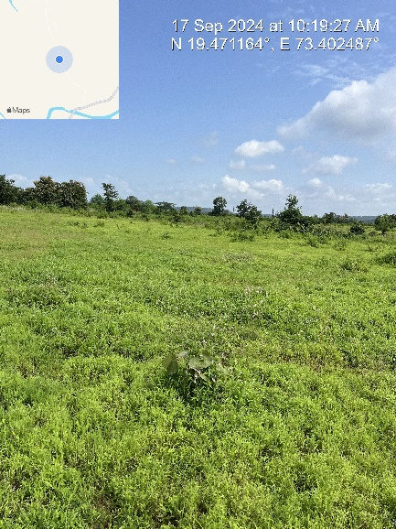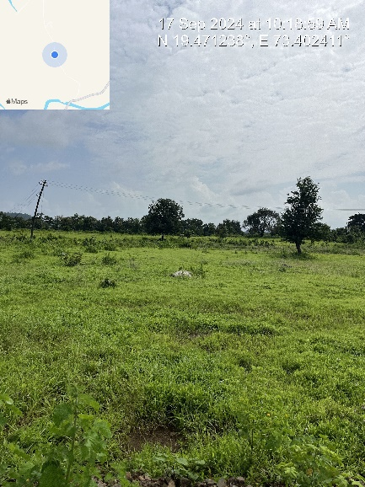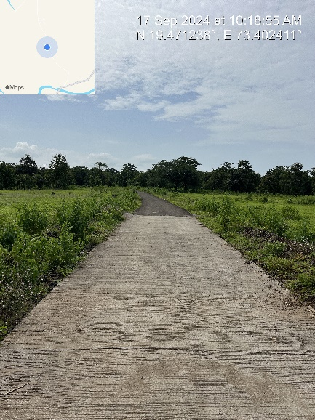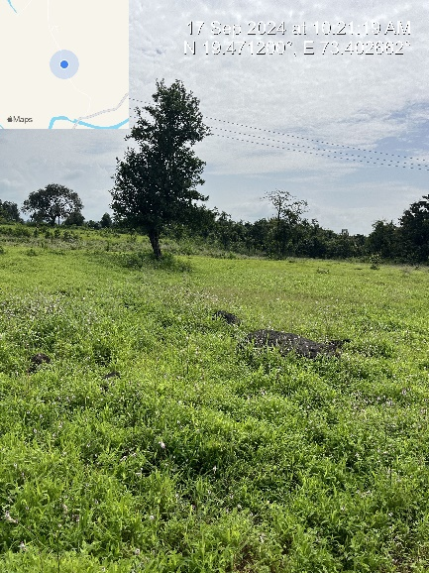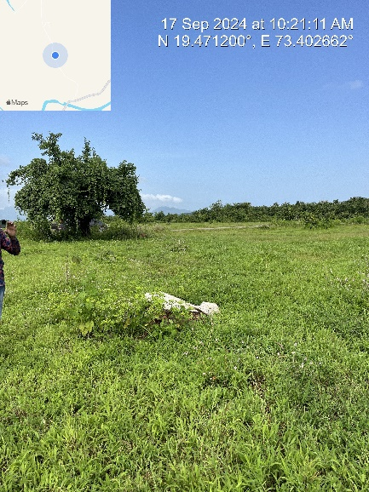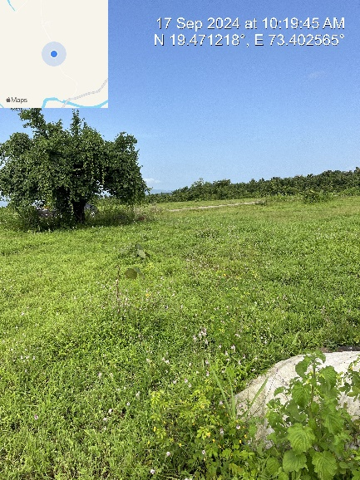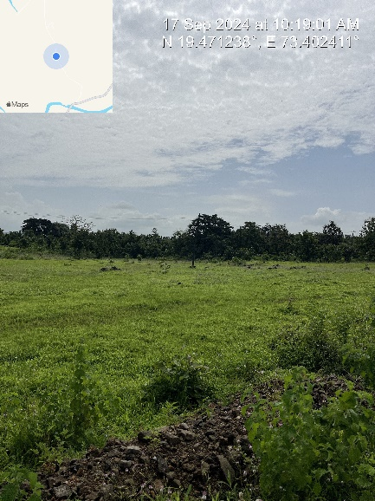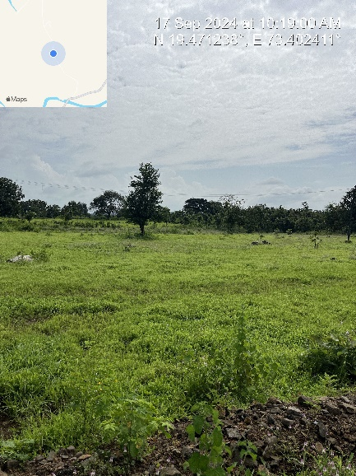

**Route Map of the property**

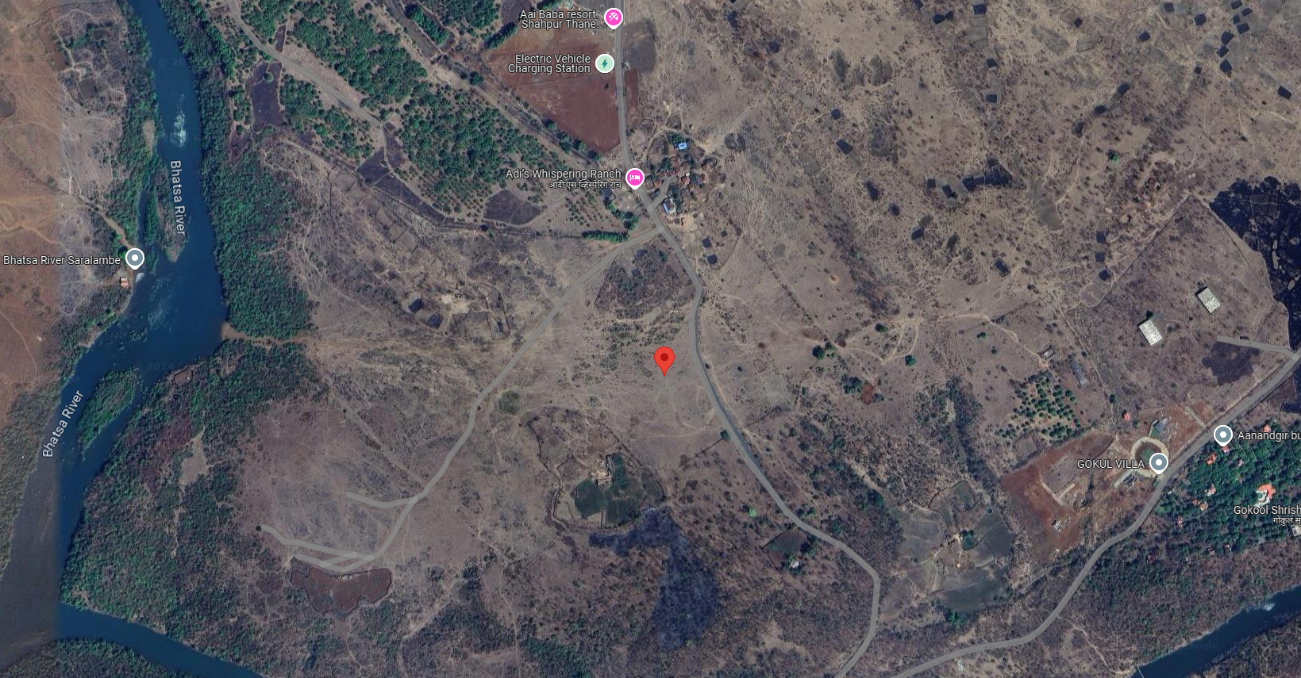

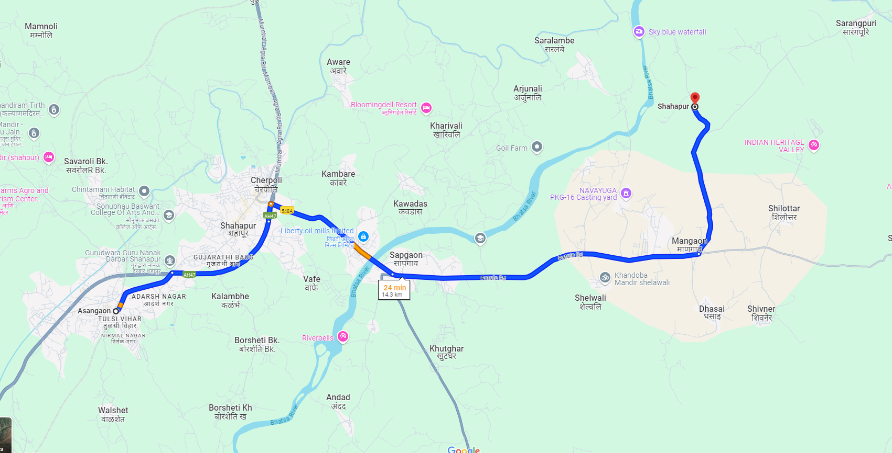

# Latitude Longitude - 19°28'16.0"N 73°24'06.9"E

**Note:** The Blue line shows the route to site from nearest railway station (Asangaon – 14.3 KM.)

**READY RECKONER RATE**

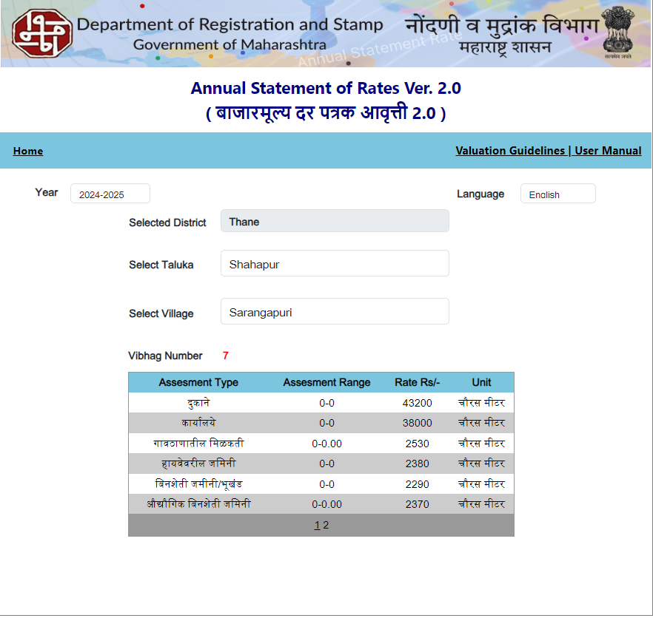

**Price Indicators**

|  |  |  |  |
| --- | --- | --- | --- |
| **Property** | Residential Land at Banjara Hills | | |
| **Source** | https://www.99acres.com/ | | |
| **Particulars** | **Area in Sq. Ft.** | **Area in Sq. M.** | **Rate per Sq. M.** |
| Residential Land | 3,606.00 | 335.01 | 5,970.00 |

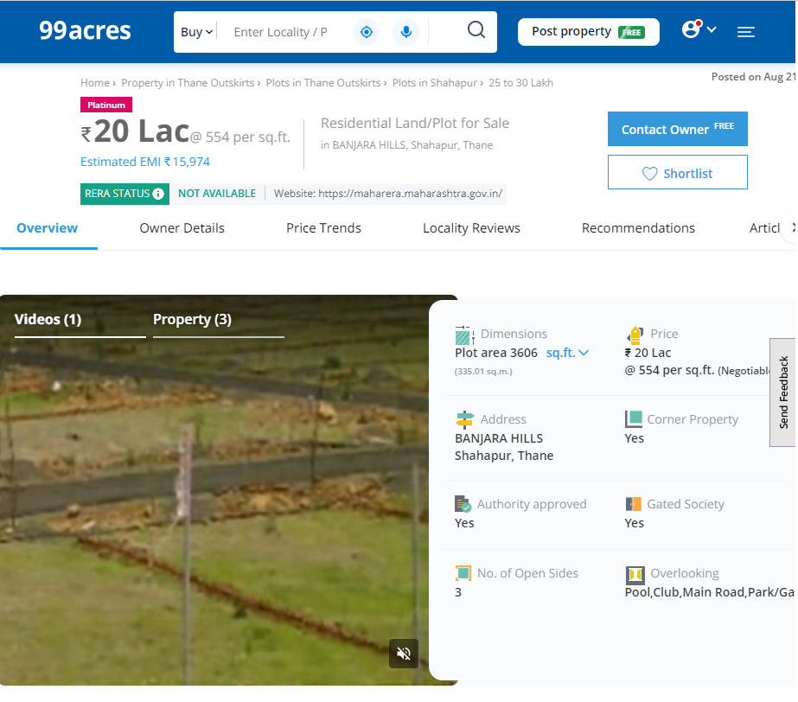

**Price Indicators**

|  |  |  |  |
| --- | --- | --- | --- |
| **Property** | Residential Land at Seema Banjara Hills | | |
| **Source** | https://www.99acres.com/ | | |
| **Particulars** | **Area in Sq. Ft.** | **Area in Sq. M.** | **Rate per Sq. M.** |
| Residential Land | 1,627.00 | 151.15 | 7,939.00 |

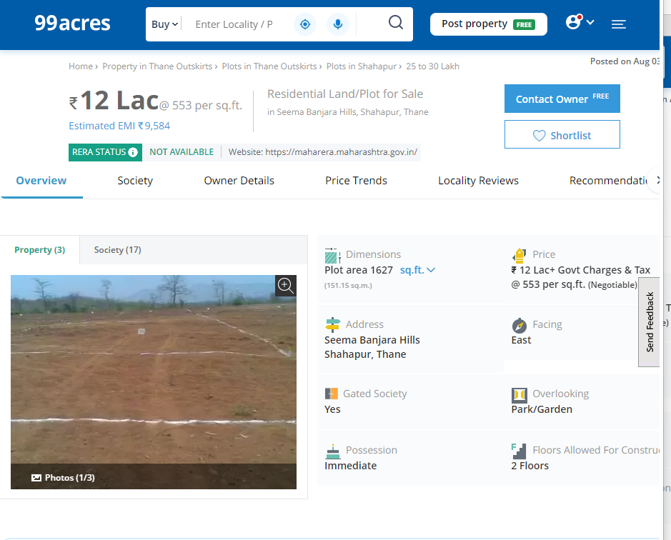

**DEFINITION OF VALUE FOR THIS SPECIFIC PURPOSE**

This exercise is to assess **Fair Market Value** of the property under reference as on **23rd September 2024.**

The term **Fair Market Value** is defined as

*“The most probable price, as of a specified date, in cash, terms equivalent to cash, or in other precisely revealed terms for which the specified property rights would sell after reasonable exposure in a competitive market under all conditions requisite to a fair sale, with the buyer and seller each acting prudently knowledgeably and for self-interest assuming that neither is under undue duress”.*

Fundamental assumptions and conditions presumed in this definition are:

1. Buyer and seller are motivated by self-interest.

2. Buyer and seller are well informed and are acting prudently.

3. The property is exposed for a reasonable time on the open market.

4. Payment is made in cash or equivalent or in specified financing terms.

#### UNDER LYING ASSUMPTIONS

1. We assume no responsibility for matters of legal nature affecting the property appraised or the title thereto, nor do we render our opinion as to the title, which is assumed to be good and marketable.

2. The property is valued as though under responsible ownership.

3. It is assumed that the property is free of liens and encumbrances.

4. It is assumed that there are no hidden or unapparent conditions of the subsoil or structure that would render it more or less valuable. No responsibility is assumed for such conditions or for engineering that might be required to discover such factors.

5. There is no direct/ indirect interest in the property valued

6. The rates for valuation of the property are in accordance with the Govt. approved rates and prevailing market rates.

##### DECLARATION OF PROFESSIONAL FEES CHARGED

We hereby declare that, our professional fees are not contingent upon the valuation findings. However, if the statute AND/OR clients demands that, the fees should be charged on the percentage of assessed value then, with the full knowledge of the AND/OR end user, it is being charged accordingly.

# VALUATION OF THE PROPERTY PREMISES

Considering various parameters recorded herein above, existing economic scenario, and the information that is available with reference to the development of neighborhood and method selected for valuation, we are of the opinion that, the property premises can be assessed and valued for banking purpose as on day for ` 8,64,000.00 (Rupees Eight Lakh Sixty Four Thousand Only).

## Manoj B. Chalikwar

## Registered Valuer

## Chartered Engineer (India)

## Reg. No. CAT-I-F-1763

## Cosmos Emp. No. H.O./Credit/67/2019-20