Vastu/Nashik/05/2024/008947/2306491
28/7-351-RYBS
Date: 28.05.2024

Intended User:
Punjab National Bank
Canada Corner Branch
Shop No.2,3,4 Prestige Point, Opp. Vasant Market, Canada Corner
Nashik – 422 005, State – Maharashtra, Country – India.

Sub: Vetting of Extra Amenities

Sir,

With reference to above subject, we have evaluated the Extra Amenities for Residential Flat No. 44, 6th Floor, "Vitthal Darshan Apartment", Survey No. 194/ A/ Plot/ 70/ 195/ A/ Plot/ 89, Plot No. 70 + 79, Opp. Shri Vitthal Rukmini And Sant Savta Maharaj Mandir, Sant Narahari Maharaj Road, Village – Pimpalgaon Bahula, Taluka & District - Nashik, PIN Code – 422 006, State – Maharashtra, Country – India belongs to M/s. Niwas Developers Name of Proposed Purchaser: Miss. Jayashri Vasant Gawali.

We have verified the rates quoted as per current market rates. Details of Extra Amenities considered as per copy of Extra Amenities Agreement between Miss. Jayashri Vasant Gawali. (First Party). Mr. Sanjay Babulal Mahjan (Second Party) received on dated 27.04.2024. The Extra Amenities amount is Rs. 2,70,000/- (Rupees Two Lakh Seventy Thousand Only)

The said Cost Vetting Certificate is valid upto next 6 months Only.

Thanking you

Sincerely yours

Manoj B. Chalikwar
Registered Valuer
Chartered Engineer (India)
Reg. No. CAT-I-F-1763
SBI Empanelment No.: SME/TCC/2021-22/86/3
Encl. Valuation Report

Agreement for Extra Amenities
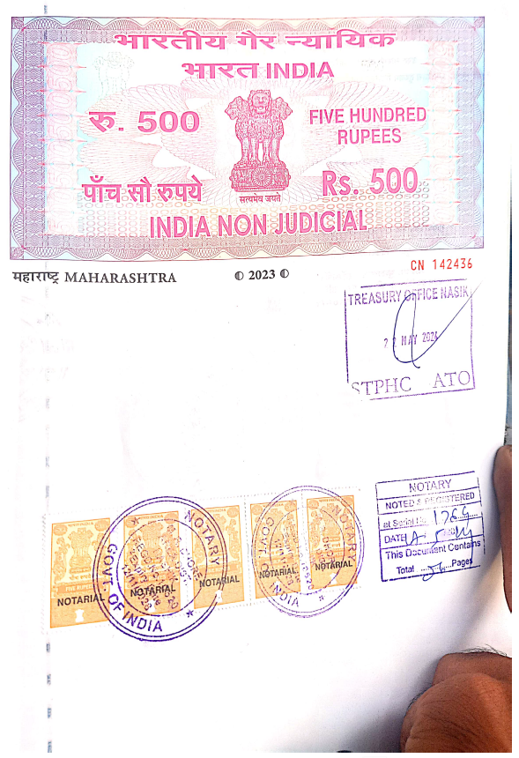
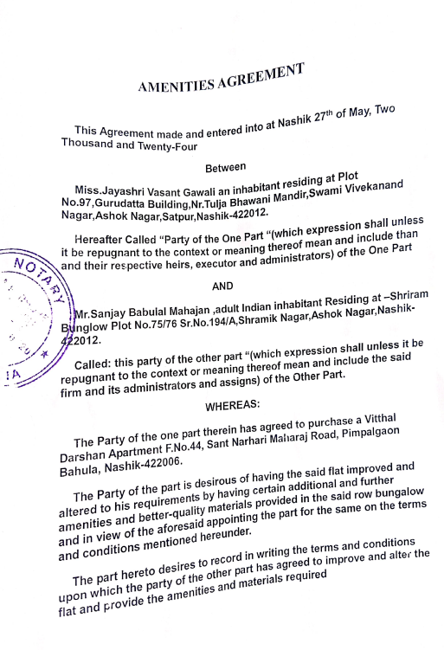

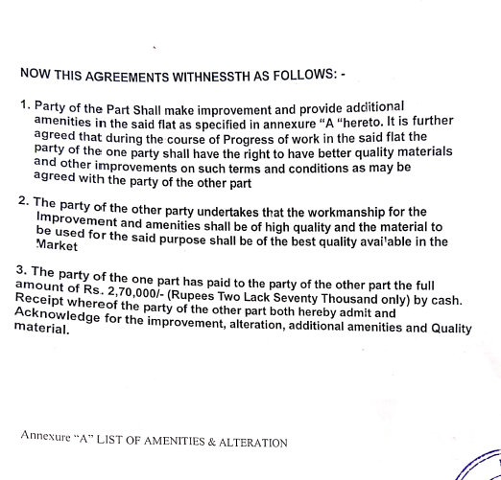
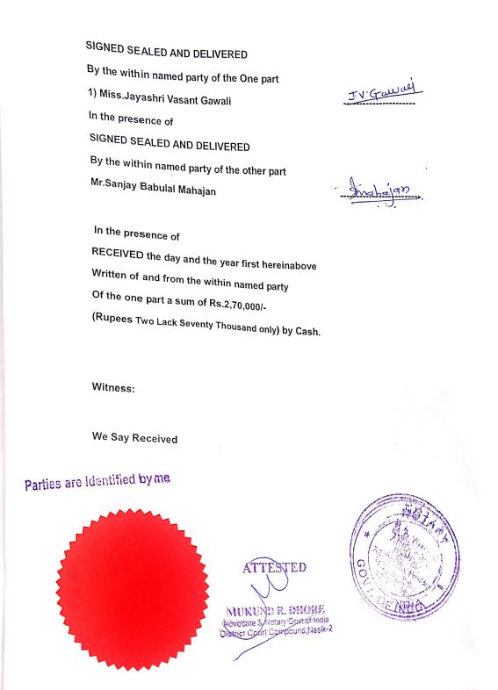

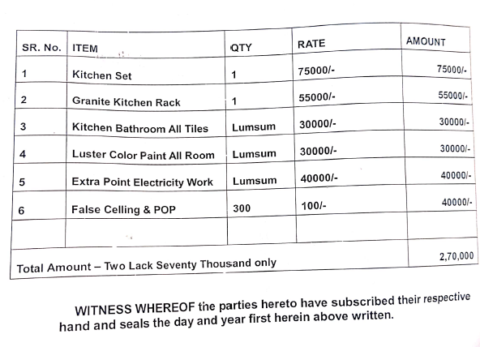

The Extra Amenities amount is Rs. 2,70,000/- (Rupees Two Lakh Seventy Thousand Only)

