Vastu/Nashik/05/2024/008918/2306469
27/2-329-CHBS
Date: 27.05.2024

To,
The Branch Manager
State Bank of India
RACPC Nashik Branch
1st Floor, Patel Plaza, N.D. Patel Road,
Opp. BSNL, Landmark Seawoods Navratna Hotel,
Nashik - 422001, State – Maharashtra, Country – India.

Sub: Vetting of Estimate

Sir,

With reference to above subject, we have evaluated the Estimate for Residential Land and Proposed Bungalow on Plot No.27, Survey No.675+676, Opposite Lakshmi Kamal Row House, Mouje - Adgoan , Taluka – Nashik, District – Nashik, Pin Code – 422 003, State – Maharashtra, Country – India belongs to Shri.Bhushan Bapurao Ahire

We have verified the rates quoted as per current market rates. Details of Estimate considered as per copy of Estimate Provided by Ideal Designers received on dated 25.05.2024. The Estimate amount is Rs.41,00,000/- (Rupees Forty-One Lakh Only.)

Note:1) The said Cost Vetting Certificate is valid upto next 6 months Only.

Thanking you

Sincerely yours

Manoj B. Chalikwar
Registered Valuer
Chartered Engineer (India)
Reg. No. CAT-I-F-1763
SBI Empanelment No.: SME/TCC/2021-22/86/3

Estimate
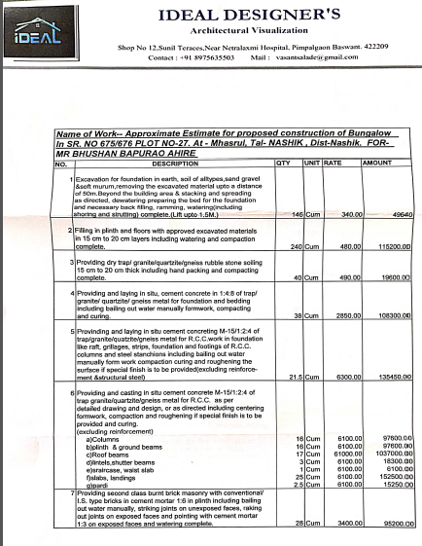
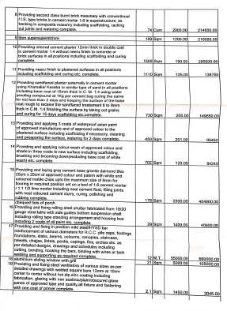

Estimate
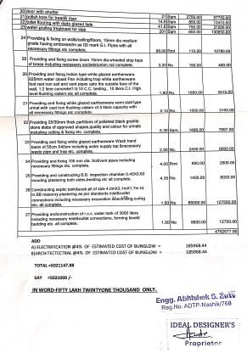

The Estimate amount is Rs.41,00,000/- (Rupees Forty-One Lakh Only.)

