COST VETTING REPORT

Details of the property under consideration:

Name of Project: "Aneesh Apartment Co. Op. Housing Soc. Ltd.

"Aneesh Apartment Co. Op. Housing Soc. Ltd., Proposed Redevelopment Building on Plot Bearing
C.T.S. No. 503C, S. No. 212A, Hissa No. 3, S. No. 214 Part, Plot No. 1, (Azad Lane, Off S. V. Road,
K / W Ward, Village – Vile Parle, Andheri (West), Mumbai – 400 058, State – Maharashtra, Country – India

Latitude Longitude: 19°06'49.2"N 72°50'29.4"E

Valuation Done for:
State Bank of India
SME Chembur Branch
Unit No. 11, Building No. 11, Ground Floor, Corporate Park, Sion Trombay Road,
Chembur, Mumbai, Pin Code – 400 071, State - Maharashtra, Country – India.

Vastu/SBI/Mumbai/06/2024/8911/2306061
24/02-200-PY
Date: 03.06.2024

To,
The Branch Manager,
State Bank of India
SME Chembur Branch
Unit No. 11, Building No. 11,
Ground Floor, Corporate Park,
Sion Trombay Road, Chembur,
Mumbai, Pin Code – 400 071,
State - Maharashtra, Country – India.

Sub: Cost Vetting Report for "Aneesh Apartment Co. op. Housing Soc. Ltd., Andheri (West), Mumbai – 400 058.

Dear Sir,
In accordance with your letter of engagement as stated above, we enclose our Report on Cost Vetting for "Aneesh Apartment Co. Op. Housing Soc. Ltd., Proposed Redevelopment Building on Plot Bearing C.T.S. No. 503C, S. No. 212A, Hissa No. 3, S. No. 214 Part, Plot No. 1, (Azad Lane, Off S. V. Road, K / W Ward, Village – Vile Parle, Andheri (West), Mumbai – 400 058, State – Maharashtra, Country – India.
M/s. Banaji Silverline Developers LLP is proposing Redevelopment Building on Plot Bearing C.T.S. No. 503C, S. No. 212A, Hissa No. 3, S. No. 214 Part, Plot No. 1, (Azad Lane, Off S. V. Road, K / W Ward, Village – Vile Parle, Andheri (West), Mumbai – 400 058, State – Maharashtra, Country – India. Project is comprising Rehab cum Sale Building.
Residential of Rehab cum Sale Building is proposed of Basement (Part) + Ground Floor + 1st to 9th Upper Floors with total RERA carpet area of 23,490.67 Sq. Ft. which consists 2 BHK, 2.5 BHK & 3 BHK with 14 nos. of Sell flats & 13 nos. of tenant’s flats providing with Fitness Centre, Society Office, & Other Amenities.
Our analysis of the cost vetting is enclosed in this report. This Report forms an integral whole and cannot be split in parts. The outcome of the report/ study can only lead to proper conclusions if the Report as a whole is taken into account.

The information used by Vastukala Consultants (I) Pvt. Ltd. (VCIPL) in preparing this report has been obtained from a variety of sources and other relevant documents provided by the client & bank. As agreed, we have performed our cost vetting exercise with the data available related to the business, considering the market prospects and projections. Our results are dependent on documents provided by client & bank, the underlying assumptions, which has been analyzed at a broader level by VCIPL while assessing their reasonableness.
Total Project Cost for the completion of Project will be ` 44.53 Cr.

For Vastukala Consultants (I) Pvt. Ltd.

Manoj B. Chalikwar
Registered Valuer
Chartered Engineer (India)
Reg. No. IBBI / RV / 07/2018/10366
Reg. No. CAT-I-F-1763
SBI Empanelment No.: SME/TCC/2021-22/86/3
About the Project:
Proposed Redevelopment Building on Plot Bearing C.T.S. No. 503C, S. No. 212A, Hissa No. 3, S. No. 214 Part, Plot No. 1, (Azad Lane, Off S. V. Road, K / W Ward, Village – Vile Parle, Andheri (West), Mumbai – 400 058. It is about 950 M. travelling distance from Andheri (West) Railway station

Area Statement as per Approved Plan
AREA STATEMENT
1 | Area of Plot (As Per P. R. Card of C.T.S. No. 503c) |  | 695.40
 | a. | Area of reservation plot
 | b. | Area of road set back
 | C. | Area of DP road
2 | Deduction For
A | For Reservation / Road Plot
 | a. | Road set back area
 | b. | Proposed DP. road to be handed over (100%) (reg. No. 16)
 | c. | i) RESERVATION AREA TO BE HANDED OVER (100%) (REG. NO. 17)
 |  | ii) RESERVATION AREA TO BE HANDED OVER AS PER AR (REG. NO. 17)
B | For Amenity Area
 | a. | Area of amenity plot/plots to be handed over as per dcr 14 (a)
 | b. | Area of amenity plot/plots to be handed over as per dcr 14 (b)
 | c. | Area of amenity plot/plots to be handed over as per dcr 35 (abeyance)
3 | Total deduction [(2a) + (2b) + (2c)]
4 | Balance area of plot (1 minus 3) |  | 695.40
5 | Plot area under development after areas to be handed over to MCGM/appropriate authority as per sr.no. 4 above |  | 695.40
6 | FSI |  | 2.20
7 | Permissible built-up area as per FSI (5 x 6) |  | 1,529.88
8 | Built up equal to area of land handed over as per regulation 30(a)
 | i | As per 2(a) and 2(b) except 2(a) (c) (ii) above with in cap of "admissible TDR" as column 6 of table-12 on remaining/balance plot.
 | ii | In case of 2(a) (c) (ii) permissible over and above permissible BUA on remaining/balance plot.
9 | Built up area in lieu of cost of construction of built-up amenity to be handed over (within the limit of permissible BUA on remaining plot)
10a | Permissible zonal BUA (plot area x 1.00) |  | 695.40
10b | Built up area due to " additional FSI by charging premium" as per table no. 12 of regulation no. 30(a) on remaining/balance plot. (Plot area x 0.50) |  | 347.70
11 | Built up area due to admissible "TDR" as per table no. 12 of regulation no. 30(a) and 32 on remaining/balance plot (plot area x 0.70) (120 Sq. M. as 33 (7) (b) incentive area + 366.78 Sq. M. as TDR = 486.78 Sq. M. |  | 486.78
12 | PERMISSIBLE BUA (10a + 10b + 11) |  | 1,529.88
13 | Proposed built up area [ as the case may be with/without BUA as per 2 (c)] |  | 1,529.88
14 | TDR generated if any as per regulation 30(a) and 32
15 | Fungible compensatory area as per reg. 31 (3)
 | a. | i) Permissible fungible compensatory area for rehab component without charging premium. | 272.58
 |  | ii) Fungible compensatory area availed for rehab component without charging premium. | 235.30
 |  | iii) Permissible fungible compensatory area for rehab non-residential component without charging premium
 |  | iv) Fungible compensatory area availed for rehab non-residential component without charging premium
 | b. | i) Permissible fungible compensatory area by charging premium (perm. Sale BUA = 751.08 Sq. M. x 35% = 262.88 Sq. M.) | 262.88
 |  | ii) Fungible compensatory area availed on payment of premium | 261.35
16 | Total built up area proposed including fungible compensatory area [3 + 15(a) (ii) + 15 (a) (iv) + 15 (b) (ii)] |  | 2,026.53
17 | FSI consumed on net plot [13/4] |  | 2.20
 | OTHER REQUIREMENTS:
A | Reservation/designation
 | a. | Name of reservation
 | b. | Area of reservation affecting the plot
 | c. | Area of reservation land to be handed over as per regulation no. 17
 | d. | Built up area of amenity to be handed over as per regulation no. 17
 | e. | Area/built up area of designation
B | Plot area/built up amenity to be handed over as per regulation no
 | i | 14 (A)
 | ii | 14 (B)
 | iii | 15
C | Requirement of recreational open space in layout/plot as per regulation no. 27
D | TENEMENT STATEMENT
 | i | Proposed built up area (16 above) | 2,026.53
 | ii | Less deduction of non-residential area (shop etc.) | -
 | iii | AREA AVAILABLE FOR TENMENTS (i) MINUS (ii) | 2,026.53
 | iv | Tenement permissible (density of tenements/hectare) | 31.00
 | v | Total number of tenements proposed on the plot | 23.00
E | PARKING STATEMENT
 | i | Parking required by regulation for: (as per concession approved under file no. P-17042/2023/(503c)/k/w ward/vile parle-k/w/337/1/new dated 23.10.2023) | 44.00
 |  | Car | 27.00
 |  | Scooter/ motor cycle
 |  | Outsiders (visitors) | 17.00
 | ii | Covered garage permissible
 | iii | Covered garage proposed
 |  | Car | 27.00
 |  | Scooter/ motor cycle
 |  | Outsiders (visitors) | 15.00
 | iv | Total parking provided | 42.00
D | TRANSPORT VEHICLES PARKING
 | i | Spaces for transport vehicles parking required by reg.
 | ii | Total no. Of transport vehicle parking provided.

Area Statement as per Concession Drawing Plan
Area Statement
1 | Area Of Plot (As Per P. R. Card of C.T.S. No. 503c) |  | 695.40
 | A. | Area Of Reservation Plot | -
 | B. | Area Of Road Set Back | -
 | C. | Area Of DP Road | -
2 | Deduction For |  | -
2a | For Reservation / Road Plot |  | -
 | A. | Road Set Back Area | -
 | B. | Proposed D.P. Road to Be Handed Over (100%) (Reg. No. 16) | -
 | C. | I) Reservation Area to Be Handed Over (100%) (Reg. No. 17) | -
 |  | II) Reservation Area to Be Handed Over as Per (Reg. No. 17) | -
2b | For Amenity Area |  | -
 | A. | Area Of Amenity Plot/Plots to Be Handed Over as Per Dcr 14 (A) | -
 | B. | Area Of Amenity Plot/Plots to Be Handed Over as Per Dcr 14 (B) | -
 | C. | Area Of Amenity Plot/Plots to Be Handed Over as Per Dcr 35 (Abeyance) | -
2c | Deduction For Existing B.U.A. To Be Retained If Any/Land Component of Existing B.U.A. Existing as Per Regulation Under Which the Development Was Allowed |  | -
3 | Total Deduction [(2a) + (2b) + (2c)] |  | .
4 | Balance Area Of Plot (1 Minus 3) |  | 695.40
5 | Plot Area Under Development After Areas to Be Handed Over to MCGM/Appropriate Authority as Per Sr. No. 4 Above |  | 695.40
6 | FSI |  | 4.00
7 | Permissible Built-Up Area as Per FSI (5 x 6) |  | 2,781.60
8 | Built Up Equal to Area of Land Handed Over as Per Regulation 30(A) |  | -
 | I | As Per 2(A) And 2(B) Except 2(A) (C) (ii) Above with In Cap Of "Admissible TDR" As Column 6 Of Table-12 On Remaining/Balance Plot. | -
 | ii | In Case Of 2(A) (C) (ii) Permissible Over and Above Permissible BUA on Remaining/Balance Plot. | -
9 | Built Up Area In Lieu Of Cost of Construction of Built-Up Amenity to Be Handed Over (Within the Limit of Permissible Bua on Remaining Plot) |  | -
10 | Built Up Area Due To " Additional FSI By Charging Premium" As Per Table No. 12 Of Regulation No. 30(A) On Remaining/Balance Plot. (Plot Area X 0.50) |  | 347.70
11 | Built Up Area Due to Admissible "TDR" As Per Table No. 12 Of Regulation No. 30(A) And 32 On Remaining/Balance Plot (Plot Area X 0.70) (120 Sq. M. As 33 (7) (B) Incentive Area + 366.78 Sq. M. As TDR = 486.78 Sq. M. |  | 486.78
12 | 12a | I) Permissible Zonal Bua | 695.40
 |  | ii) Built Up Area Can Be Consumed on Plot Due to Admissible TDR/Additional FSI As Per Table No. 12 Of Regulation No 30 (A) And 32 On Remaining/Balance Plot. | 834.48
 |  | iii) Permissible Bua Can Be Consumed on Plot For 33 (12) (B) | 451.66
 | 12b | Permissible Built-Up Area [ As the Case May Be With/Without Bua as Per 2 (C)] {[12a (I) + (ii) + (iii)]} | 1,981.54
13 | Proposed Built Up Area [ As the Case May Be With/Without Bua As Per 2 (C)] |  | 1,981.54
14 | TDR Generated If Any as Per Regulation 30(A) And 32 |  | -
15 | Fungible Compensatory Area as Per Reg. 31 (3) |  | -
 | A. | I) Permissible Fungible Compensatory Area for Rehab Component Without Charging Premium. | 377.85
 |  | ii) Fungible Compensatory Area Availed for Rehab Component Without Charging Premium. | 286.84
 |  | iii) Permissible Fungible Compensatory Area for Rehab Non-Residential Component Without Charging Premium | -
 |  | iv) Fungible Compensatory Area Availed for Rehab Non-Residential Component Without Charging Premium | -
 | B. | i) Permissible Fungible Compensatory Area by Charging Premium (Perm. Sale Bua = 751.08 Sq. M. X 35% = 262.88 Sq. M.) | 288.44
 |  | ii) Fungible Compensatory Area Availed on Payment Of Premium | 251.21
16 | Total Built Up Area Proposed Including Fungible Compensatory Area [ 13 + 15(A) (ii) + 15 (A) (Iv) + 15 (B) (ii)] |  | 2,519.59
17 | FSI Consumed on Net Plot [13/5] |  | 2.85
 | Other Requirements: |  | -
A | Reservation/Designation |  | -
 | A. | Name Of Reservation | -
 | B. | Area Of Reservation Affecting the Plot | -
 | C. | Area Of Reservation Land to Be Handed Over as Per Regulation No. 17 | -
 | D. | Built Up Area of Amenity to Be Handed Over as Per Regulation No. 17 | -
 | E. | Area/Built Up Area of Designation | -
B | Plot Area/Built Up Amenity to Be Handed Over as Per Regulation No |  | -
 | I | 14 (A) | -
 | ii | 14 (B) | -
 | iii | 15 | -
C | Requirement Of Recreational Open Space in Layout/Plot as Per Regulation No. 27 |  | -
D | Tenement Statement
 | i | Proposed Built Up Area (16 Above) | 2,519.59
 | ii | Less Deduction of Non-Residential Area (Shop Etc.) | -
 | iii | Area Available for Tenements (I) Minus (ii) | 2,519.59
 | iv | Tenement Permissible (Density of Tenements/Hectare) | 31.00
 | v | Total Number of Tenements Proposed on The Plot | 33.00
E | Parking Statement
 | i | Parking Required by Regulation For: (As Per Concession Approved Under File No. P-17042/2023/(503c)/K/W Ward/Vile Parle-K/W/337/1/New Dated 23.10.2023) | 44.00
 |  | Car | 29.00
 |  | Scooter/ Motor Cycle | -
 |  | Outsiders (Visitors) | 15.00
 | ii | Covered Garage Permissible | -
 | iii | Covered Garage Proposed | -
 |  | Car | 29.00
 |  | Scooter/ Motor Cycle | -
 |  | Outsiders (Visitors) | 13.00
 | iv | Total Parking Provided | 42.00
D | Transport Vehicles Parking
 | i | Spaces For Transport Vehicles Parking Required by Reg. | -
 | ii | Total No. Of Transport Vehicle Parking Provided. | -

Construction Area as per Concession Drawing Plan for Rehab cum Sale Building

Sr. No. | Floor | Built Up Area in Sq. M. | Staircase Area in Sq. M. | Other Area in Sq. M. | Total Construction Area in Sq. M.
1 | Part Basement | - | 9.39 | 239.70 | 249.09
2 | Ground Floor | - | 33.96 | 263.66 | 297.62
3 | 1st Floor | 266.69 | 30.93 | - | 297.62
4 | 2nd Floor | 250.69 | 30.93 | 19.30 | 300.92
5 | 3rd Floor | 260.51 | 30.93 | 19.30 | 310.74
6 | 4th Floor | 260.51 | 30.93 | 19.30 | 310.74
7 | 5th Floor | 296.99 | 30.93 | - | 327.92
8 | 6th Floor | 296.99 | 30.93 | - | 327.92
9 | 7th Floor | 296.99 | 30.93 | - | 327.92
10 | 8th Floor | 296.99 | 30.93 | - | 327.92
11 | 9th Floor | 296.99 | 30.93 | - | 327.92
12 | Terrace / OHT | - | 59.27 | - | 59.27
TOTAL |  | 2,523.35 | 380.99 | 561.26 | 3,465.60
No. of Stack Parking Car |  |  |  |  | 42 Nos.

Project Cost
Sr. No. | Particulars | Total Estimated Amount in ` | Total Estimated Amount  in ` Cr.
1 | Land Cost
 | Acquisition Cost of Land or Development Rights, and Legal Cost. | 81,47,800.00 | 0.81
 | Rent to Tenants, Lease premium, Lease Rent, interest cost incurred or payable on Land Cost | 3,95,14,948.00 | 3.95
 | Amount of Premium payable to obtain development rights, FSI, additional FSI, fungible area, and any other incentive under DCR from Local Authority or State Government or any Statutory Authority. | 13,63,00,000.00 | 13.63
 | Acquisition cost of TDR (if any) | 3,41,54,022.00 | 3.42
2 | Cost of Construction
 | Estimated construction cost of rehab cum sale building including site development and infrastructure for the same. | 15,44,25,600.00 | 15.44
 | On site expenditure for development of entire project excluding cost of construction as per(i) above,
a. | Architect Fees & Consultant fees | 77,21,280.00 | 0.77
b. | Admin Cost includes salaries, site overheads, development works, cost of services (including water, electricity, sewerage, drainage, layout roads etc.), cost of machineries and equipment including its hire and maintenance cost, consumables etc. All costs directly incurred to complete the construction of the entire phase of the project registered. | 92,65,536.00 | 0.93
c. | Marketing Cost | 1,18,65,562.00 | 1.19
3 | Interest during the Project | 4,00,00,000.00 | 4.00
4. | Contingency Charges | 46,32,768.00 | 0.46
 | GRAND TOTAL: | 44,60,27,516.00 | 44.60

Manoj B. Chalikwar
Registered Valuer
Chartered Engineer (India)
Reg. No. IBBI / RV / 07/2018/10366
Reg. No. CAT-I-F-1763
SBI Empanelment No.: SME/TCC/2021-22/86/3

Comments on each element of Cost of Project: -
- Land Cost:
As per Present Ready Reckoner rate the Project Land Value is ` 10.39 Cr. considering Land Rate @ ` 1,49,370.00 per Sq. M. & Net Plot Area of 695.40 Sq. M.
As per document purchase cost of land & stamp duty cost is ` 81,47,800.00 i.e., ` 0.81 Cr. which is 1.83% of Total Project Cost.
Sr. No. | Agreement Name | Date | Particulars | Total Amount in ` | Incurred Amount in `
1 | Development Agreement | 19-04-2023 | Stamp Duty | 81,16,000.00 | 81,16,000.00
2 | Development Agreement | 19-04-2023 | Reg. Fees | 30,000.00 | 30,000.00
3 | Development Agreement | 19-04-2023 | Reg. Fees | 1,800.00 | 1,800.00
 | TOTAL |  |  | 81,47,800.00 | 81,47,800.00

- Payment Payable to Rehab Tenants:
Since it is a Redevelopment project under Sec (33)7 from the date of shifting of 13 Tenants till handing over their respective new flats as per the Tenant Agreement. Further the rent keeps on increasing 10% each year. The existing Tenants has to be given total rental of ` 3,95,14,948.00 i.e., ` 3.95 Cr. Builder has paid ` 0.97 Cr. which is 8.86 % of Total Project Cost.
Existing Tenants Carpet Area & Rent per month for Flat are as follows:
Sr. No. | Particulars |  | Units
1 | No. of Tenants | 13.00 | Nos.
2 | Total Existing Carpet Area | 8,551.00 | Sq. Ft.
3 | Rate per Sq. Ft. on Existing Carpet Area for March 24 to Feb 26 | 90.00 | Rupees
4 | Rent per tenant per month for March 24 to Feb 26 | 7,69,590.00 | Rupees
5 | Rent per year for March 24 to Feb 26 | 1,84,70,160.00 | Rupees
6 | Rate per Sq. Ft. on Existing Carpet Area for March 26 to Feb 27 | 99.00 | Rupees
7 | Rent per tenant per month for March 26 to Feb 27 | 8,46,549.00 | Rupees
8 | Rent per year for March 26 to Feb 27 | 1,01,58,588.00 | Rupees
9 | Rate per Sq. Ft. on Existing Carpet Area for Hardship Compensation | 1,200.00 | Rupees
10 | Total Hardship Compensation Cost | 1,02,61,200.00 | Rupees
11 | Shifting Charges per Tenant | 25,000.00 | Rupees
12 | Total Shifting Charges | 3,25,000.00 | Rupees
13 | Corpus Fund | 3,00,000.00 | Rupees
Total Rent Cost (5 + 8 + 10 + 12 + 13) |  | 3,95,14,948.00 | Rupees

- TDR Charges:
The TDR charges is ` 3,41,54,022.00 i.e., ` 3.42 Cr. which is 7.66% of Total Project Cost.
Sr.  No. | Agreement Name | Date | Particulars | Area in Sq. M. | Estimate  Amount in ` | Incurred  Amount in `
1 | Agreement for Transfer / Utilisation of TDR | 04-12-2023 | Purchase Cost | 143.60 | 1,16,68,564.00 | 1,16,68,564.00
2 | Agreement for Transfer / Utilisation of TDR | 04-12-2023 | Stamp Duty | 143.60 | 3,50,057.00 | 3,50,057.00
3 | Agreement for Sale of TDR (FSI) | 11-12-2023 | Purchase Cost | 243.50 | 1,55,35,000.00 | 1,55,35,000.00
4 | Agreement for Sale of TDR (FSI) | 11-12-2023 | Stamp Duty | 243.50 | 4,66,050.00 | 4,66,050.00
 | SUB - TOTAL |  |  | 387.10 | 2,80,19,671.00 | 2,80,19,671.00
5 | Pending TDR Purchase Agreement |  | Purchase Cost | 99.68 | 59,55,681.00 | -
6 |  |  | Stamp Duty | 99.68 | 1,78,670.00
TOTAL |  |  |  | 486.78 | 3,41,54,022.00 | 2,80,19,671.00

- Building Cost of Construction for Sale Building:
Construction Area of Sale Building = 3,465.60 Sq. M. i.e., 37,303.72 Sq. Ft.
No. of Stack Car Parking = 42 Nos.
Total estimated cost for construction of Building (includes cost of RCC work, manpower, lift, material, painting, finishing work, site development, etc.) is ` 12,12,96,000.00 i.e., ` 12.13 Cr. which comes ` 35,000.00 per Sq. M. on construction area for building, deep excavation & piling cost is ` 1,21,29,600.00 i.e., ` 1.21 Cr. which comes 10% of cost of construction and cost for stack parking is ` 2,10,00,000.00 i.e., ` 2.10 Cr. which comes ` 5,00,00,000.00 per stack parking.
Hence, total construction cost (Cost of construction of building + Cost of Deep Excavation & Piling Cost + Cost of stack parking) (` 12,12,96,000.00 + ` 1,21,29,600.00 + ` 2,10,00,000.00) = ` 15,44,25,600.00 i.e., ` 15.44 Cr.
The total construction area is 3,465.60 Sq. M. i.e., 37,303.72 Sq. Ft., projected cost of ` 15.44 Cr is 34.62% of total project cost
VCIPL opinion the construction cost of 35,000/- Per Sq. M. which is in line with Market-Trend.
Particulars | Rate per Sq. M.
Excavation Work | 2,500.00
Total RCC Work | 15,000.00
Final Finishing Work | 10,500.00
Other Work | 7,000.00
Cost of Construction | 35,000.00
Deep Excavation & Piling Cost | 10% of Cost of Construction
Stack Car Parking Cost | 5,00,000.00 per parking

- Approval Charges:
The Total Approval Cost (Fungible Cost & Development Cess Premium Cost) as per architect letter will be ` 13,63,00,000.00 i.e., ` 13.63 Cr. which is 30.56% of Total Project Cost.
As per information & data provided by developer.
Sr. No. | Particulars | Estimated Cost in `
1 | Development Charges for land | 10,38,720.00
2 | Development Charges for building | 1,59,81,850.00
3 | Development Cess | 1,59,81,850.00
4 | Development charges for fitness center | 3,45,860.00
5 | Additional FSI | 1,70,05,780.00
6 | Fungible Value @ 50% on RR | 2,35,75,720.00
7 | Infrastructure development | 28,68,310.00
8 | LUC Tax | 84,97,980.00
9 | Labour Welfare Cess | 10,89,000.00
10 | Scrutiny Fees | 6,26,400.00
11 | TDR Scrutiny Fees | 38,950.00
12 | IOD Deposit | 38,750.00
13 | CFO capitation fees | 3,40,000.00
14 | Fire Station Charges | 54,000.00
15 | SWD, Sewerage, Extra water sewerage, PCO, HE Charges | 23,25,000.00
16 | Debris Removal Deposit | 45,000.00
17 | Staircase Premium | 1,16,63,190.00
18 | Open Space Deficiency | 2,98,14,740.00
19 | Occupancy Charges | 49,68,900.00
Total Estimated Approval Cost |  | 13,63,00,000.00

- Architect Cost, RCC & Other Professional Charges:
The total Architect charges of ` 77,21,280.00 i.e., ` 0.77 Cr. is 5.0% of total construction cost building & it is line up with Market trend.
The professional charge consists of Architect & Legal which in market is in the range of 2% - 5% of Total Construction cost of the project.

- Administrative Expenses:
Salaries, site overheads, development works, cost of services (including water, electricity, sewerage, drainage, layout roads etc.), cost of machineries and equipment including its hire and maintenance cost, consumables etc. All costs directly incurred to complete the construction of the entire phase of the project registered is estimated 6% of total construction cost Building which comes to ` 92,65,536.00 i.e., ` 0.93 Cr.
The admin charges which in market is in the range of 4% - 6% of Total Construction cost of the project.

- Marketing Expenses:
Marketing costs directly incurred to complete the construction of the entire phase of the project registered is estimated at 2% of total Sale income from the project which comes to ` 1,11,28,762.00 i.e., ` 1.11 Cr.
The marketing charge consists of brokerage & commission which in market is in the range of 1% - 3% of Total Sale income of the property.

- Interest Costs:
The Interest cost for the term loan is ` 4,00,00,000.00 i.e., ` 4.00 Cr., which is 8.97% of total project cost.
As per information provided by the client.

- Contingency Costs:
The contingency charges estimated at 3% of total cost of construction which comes to ` 46,32,768.00 i.e., ` 0.46 Cr.
Observation and Construction: -
Total estimated cost of project i.e., ` 44,60,27,516.00 (Rupees Forty – Four Crore Sixty Lakh Twenty – Seven Thousand Five Hundred Sixteen Only) i.e., ` 44.60 Cr. is fair & reasonable.
The project cost is including land premium payable to concern authorities, Rent Cost, TDR Cost, Fungible FSI Premium, Cost of Construction of Rehab cum Sale Building, professional charges on site expenses including admin & marketing expenses, premiums / charges to be paid to competent authority and Bank interest, etc. we have not independently verified interest cost hence not consider in cost vetting.
As per present sanctioned building plan, permissible built-up area on the said plot is 5,623.08 Sq. M. The rehab cum sale building is presently approved for Basement (Part) + Ground Floor + 1st to 7th Upper Floors only. The Developer has submitted the concession drawing plan to the competent authority for utilization of total permissible Built-up area and fungible FSI. The rehab cum sale building is presently under sanction for Basement (Part)+ Ground Floor + 1st to 9th Upper Floors only. Estimated cost of entire project of 9th upper floors are considered.
Total estimated cost of construction of Rehab cum Sales building is ` 12,12,96,000.00 i.e., ` 12.13 Cr. which comes ` 35,000.00 per Sq. M. on construction area for building, deep excavation & piling cost is ` 1,21,29,600.00 i.e., ` 1.21 Cr. which comes 10% of cost of construction and cost for stack parking is ` 2,10,00,000.00 i.e., ` 2.10 Cr. which comes ` 5,00,00,000.00 per stack parking. Hence, total construction cost (Cost of construction of building + Cost of Deep Excavation & Piling Cost + Cost of stack parking) (` 12,12,96,000.00 + ` 1,21,29,600.00 + ` 2,10,00,000.00) = ` 15,44,25,600.00 i.e., ` 15.44 Cr.., which is fair & reasonable considering the present status of project, type & quality of construction & specification of the building materials to be used, height of the structure, amenities to be provided in proposed building.

Assumptions & Remarks-
- The adequacy of Engineering / Structural design is beyond the scope of our assignment.
- Estimated project completion date is 31/03/2026. The cost is certified based on the assumptions that the project will be completed within time frame. Few assumptions are made regarding inflation & cost rise etc. during construction period.

Photo copy of following document is provided to us & this report should be read along with it:
- Copy of Developer Agreement dated 19.04.2023 between M/s. Aneesh Apartments Co-operative Housing Society Ltd. (The Society) and M/s. Banaji Silverline Developers LLP (The Developers) through registered agreement Doc. No. BDR-18/6851/2023 dated 20.04.2023.
- Copy of Sale of TDR (FSI) Agreement dated 11.12.2023 between M/s. Gurukrupa Developers (Transferor) and M/s. Banaji Silverline Developers LLP (Transferee) of 243.50 Sq. M. (TDR FSI Area) through DRC No. SRA/1504/Spillover/Final bearing Folio No. TDR/SRP/HE-16 ward Phase -I/Spillover/Final dated 23.11.2023.
- Copy of Transfer / Utilisation of TDR (FSI) Agreement dated 04.12.2023 between M/s. National Textile Corporation Ltd. (Transferor) and M/s. Banaji Silverline Developers LLP (Transferee) of 143.60 Sq. M. (TDR FSI Area) through DRC No. 000933 bearing Folio No. TDR/City/Ward/G/N-12/I(DRC) dated 20.03.2017.
- Copy of Intimation of Disapproval (IOD) Letter No. P-17042/2023/(503C)/K/W Ward/Vile Parle-K/W/IOD/1/New dated 06.02.2024 issued by Municipal Corporation of Greater Mumbai (MCGM).
- Copy of Approved Plan P-17042/2023/(503C)/K/W Ward/Vile Parle-K/W/IOD/1/New dated 06.02.2024 issued by Municipal Corporation of Greater Mumbai (MCGM).
Approved upto: Basement (Part) + Ground Floor + 1st to 7th Upper Floors
- Copy of Commencement Certificate No. P-17042/2023/(503C)/K/W Ward/Vile Parle-K/W/CC/1/New dated 19.03.2024 valid upto 18.03.2025 issued by Municipal Corporation of Greater Mumbai (MCGM).
(This CC is endorsed for the work for up to plinth level as per approved plan dated 06.02.2024)
- Copy of Concession Drawing Plan Dated 16.05.2023 submitted to Municipal Corporation of Greater Mumbai (MCGM).
Approval upto: Basement (Part) + Ground Floor + 1st to 9th Upper Floors
- Copy of No Objection Certificate for Height Clearance Noc ID No. JUHU/WEST/B/042123/753707 dated 09.05.2023 valid upto 08.05.2031 issued Airports Authority of India.
- Copy of CA Certificate dated 14.05.2024 issued by M/s. Shyam Prajapati & Associates.
- Copy of CA (Form 3) Certificate dated 30.04.2024 issued by M/s. Priyesh Jain & Associates.
- Copy of Architect’s Certificate dated 14.05.2024 issued by Kaushal Chouhan.
- Copy of Engineer’s Certificate dated 30.04.2024 issued by Fahad Bhati.
- Copy of Application for RERA Certificate Application No. REA51800160151 dated 15.05.2024 submitted to Maharashtra Real Estate Regulatory Authority (MAHRERA)

Actual Site Photographs
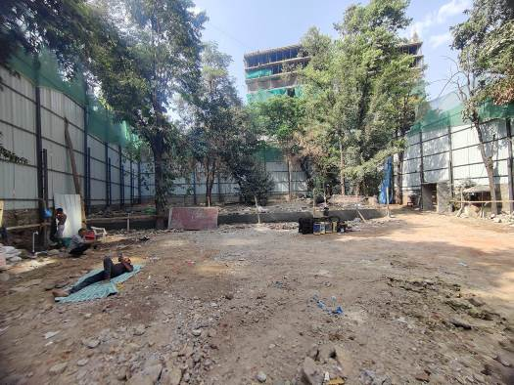
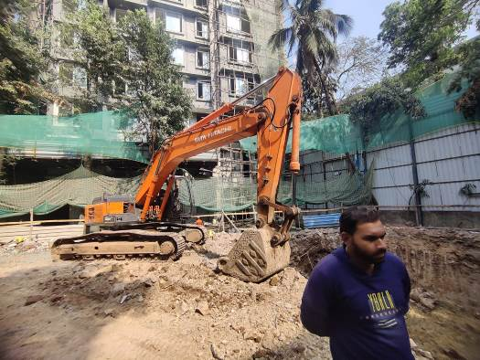
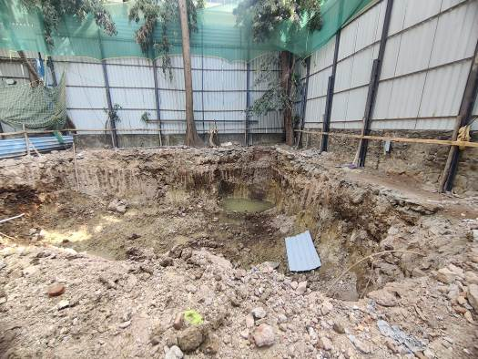
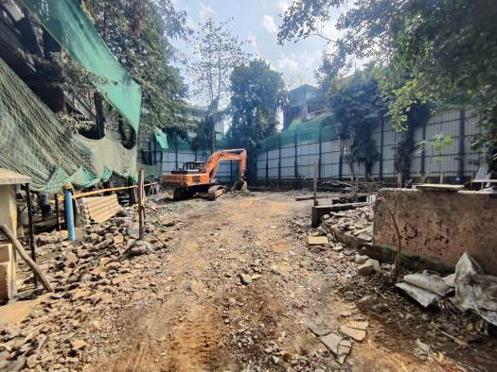
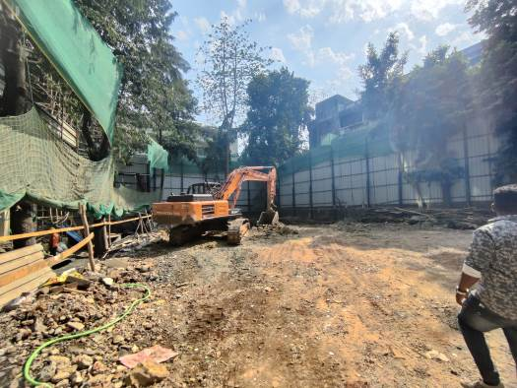
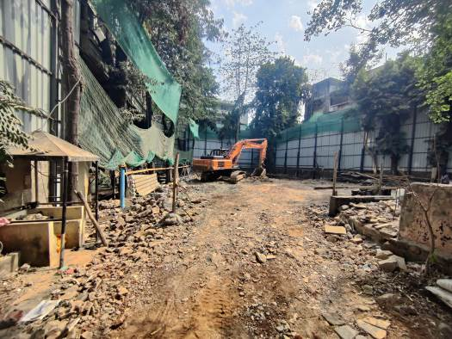

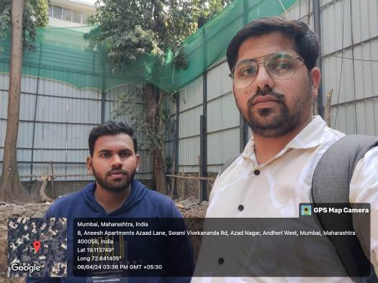
Route Map of the property
Site u/r
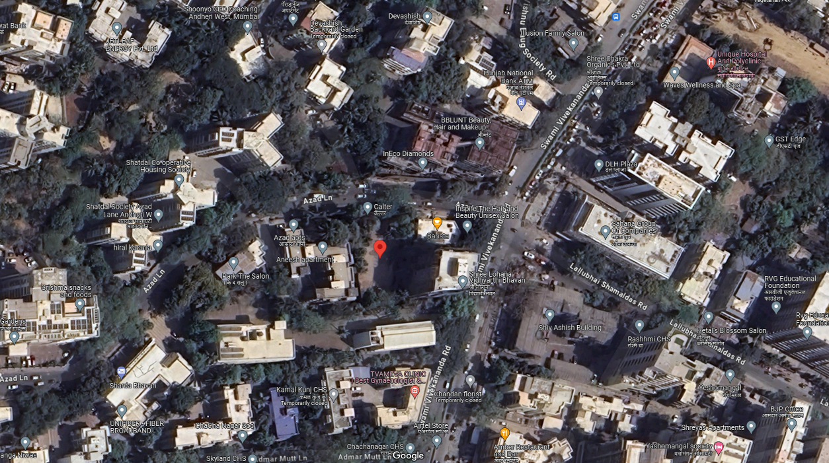

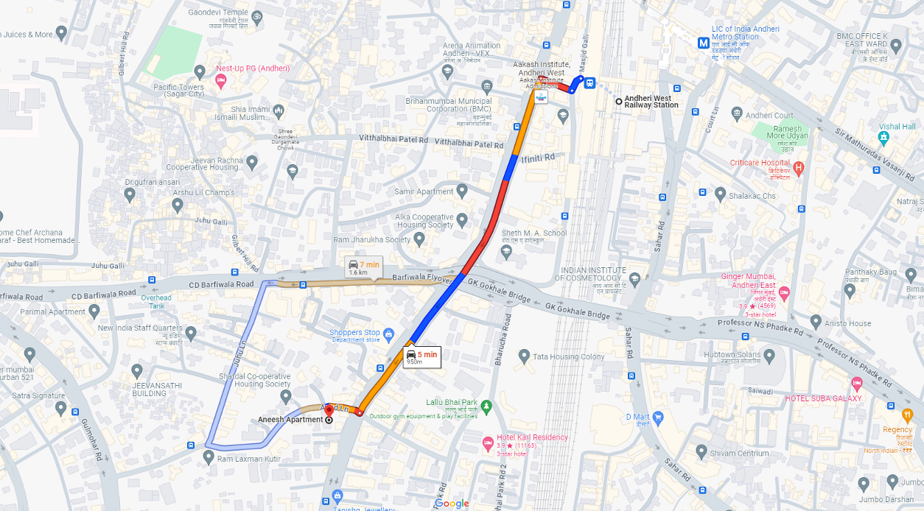

Latitude Longitude: 19°03'44.3"N 72°55'20.7"E
Note: The Blue line shows the route to site from nearest railway station (Andheri – 950 M.)

