COST VETTING REPORT

Details of the property under consideration:

Name of Project: "Sundarvan Nines"

"Sundarvan Nines", Proposed Residential cum Commercial building on Plot bearing Final Plot No. 118A & 118B, Chinchpada Road, Village - Pen, Taluka - Pen, District – Panvel, Pin Code – 402 107,
State – Maharashtra, Country – India

Latitude Longitude: 18°43’59.2”N 73°05’37.5”E

Valuation Done for:
State Bank of India
Panvel Branch
278/1, Safiya Terrace, Mulla Park, M. G. Road, Panvel, Navi Mumbai,
Pin Code – 410 206, State - Maharashtra, Country – India

Vastu/SBI/Mumbai/06/2024/8909/2304243
28/10-472-PY
Date: 11.06.2024

To,
The Branch Manager,
State Bank of India
Panvel Branch
278/1, Safiya Terrace,
Mulla Park, M. G. Road,
Panvel, Navi Mumbai, Pin Code – 410 206,
State - Maharashtra, Country – India.

Sub: Cost Vetting Report for "Sundarvan Nines" at Pen, Pin Code – 402 107.

Dear Sir,
In accordance with your letter of engagement as stated above, we enclose our Report on Cost Vetting for "Sundarvan Nines", Proposed Residential cum Commercial building on Plot bearing Final Plot No. 118A & 118B, Chinchpada Road, Village - Pen, Taluka - Pen, District – Panvel, Pin Code – 402 107, State – Maharashtra, Country – India.
M/s. F ND H Constructions LLP, is a Limited Liability Partnership Firm established on 26th April, 2022. The firm is in operation for over the last 2 years, M/s F ND H Constructions LLP, a Builders & Developers has created a history of success by building a robust portfolio for itself by delivering dream homes to affordable homes in and around Pen area. The firm has established ourselves as one of the most preferred real estate developers.
M/s. F ND H Constructions LLP is developing a Residential cum Commercial building on Plot bearing Final Plot No. 118A & 118B, Chinchpada Road, Village - Pen, Taluka - Pen, District – Panvel, Pin Code – 402 107, State – Maharashtra, Country – India. Project is comprising Commercial cum Residential Building.
Commercial cum Residential Building is proposed of Wing A & B of Ground Floor + Raised Ground Floor + 1st & 2nd Commercial Floor + 3rd Podium Floors + 4th to 14th Upper Residential Floors with total RERA carpet area of 1,06,092.78 Sq. Ft. which consists 2 BHK, 3 BHK, Offices and Departmental Stores units with 122 nos. of Sell flats, 12 nos. of Sell Offices and Departmental Stores providing with Fitness Centre, Jogging Track, Society Office, & Other Amenities.

In this regard, SBI, Panvel Branch, 278/1, Safiya Terrace, Mulla Park, M. G. Road, Panvel, Navi Mumbai, Pin Code – 410 206, has approached Vastukala Consultants (I) Pvt. Ltd. (VCIPL) to conduct a Cost Vetting of the said project.
Our analysis of the cost vetting is enclosed in this report. This Report forms an integral whole and cannot be split in parts. The outcome of the report/ study can only lead to proper conclusions if the Report as a whole is taken into account.
The information used by Vastukala Consultants (I) Pvt. Ltd. (VCIPL) in preparing this report has been obtained from a variety of sources and other relevant documents provided by the client & bank. As agreed, we have performed our cost vetting exercise with the data available related to the business, considering the market prospects and projections. Our results are dependent on documents provided by client & bank, the underlying assumptions, which has been analyzed at a broader level by VCIPL while assessing their reasonableness.
Total Project Cost for the completion of Project will be ` 70.77 Cr.

For Vastukala Consultants (I) Pvt. Ltd.

Manoj B. Chalikwar
Registered Valuer
Chartered Engineer (India)
Reg. No. IBBI / RV / 07/2018/10366
Reg. No. CAT-I-F-1763
SBI Empanelment No.: SME/TCC/2021-22/86/3
About the Project:
Proposed Residential cum Commercial building on Plot bearing Final Plot No. 118A & 118B, Village - Pen, Taluka - Pen, District – Panvel, Pin Code – 402 107. It is about 450 M. walking distance from Pen Bus station & 1.20 Km. travelling distance from Pen Railway Station.

Area Statement as per Approved Plan
AREA STATEMENT
1 | Area of Plot (Minimum area of a, b, c, to be considered) |  | 4,046.70 | Sq. M.
 | a. | As per Ownership document (7/12, CTS extract) | 4,046.70 | Sq. M.
 | b. | As per measurement sheet | 4,046.70 | Sq. M.
 | c. | As per site | 4,046.70 | Sq. M.
2 | Deduction For
 | a. | Proposed 18.0 M. D.P. Road widening Area | 124.00 | Sq. M.
 | b. | Town Plaza Reservation Area | - | Sq. M.
 | c. | Area not in possession | - | Sq. M.
 |  | Total (a + b + c) = | 124.00 | Sq. M.
3 | Balance Area of plot (1-2) = 4046.70 - 124.00 = |  | 3,922.70 | Sq. M.
4 | Amenity Space (If Applicable)
 | a. | Required | - | Sq. M.
 | b. | Proposed | - | Sq. M.
5 | Net Plot Area (3-4 (c )) |  | 3,922.70 | Sq. M.
6 | Recreational open space (if applicable)
 | a. | Required | - | Sq. M.
 | b. | Proposed | - | Sq. M.
7 | Internal Road Area |  | - | Sq. M.
8 | Pro Data Plotable area |  | - | Sq. M.
9 | B.U.A. with reference of basic F.S.I. as per front road width (Sr. No. 8 x basic FSI) = 3922.70 x 1.1 = |  | 4,314.97 | Sq. M.
10 | Additional of FSI on payment of Premium
 | a. | Maximum permissible premium FSI based on road width / TOD zone = | 0.30
 | b. | Proposed FSI on payment of premium = 4046.70 x 0.3 = | 1,214.01 | Sq. M.
11 | In-Situ FSI/TDR Loading
 | a. | In-Situ area against D. P. Road (2.0 x 124.00), Balanced area = 248.00 Sq. M. | - | Sq. M.
 | b. | In-situ area against Amenity Space if handed over (2.00 or 1.85 x Sr. No. 4 (b) and/or (c)) | - | Sq. M.
 | c. | TDR area To Be Utilized in this proposal. [ (Max. Permissible = 0.7 x 4046.70) = 2832.69] TDR utilised in this proposal = | 2,832.69 | Sq. M.
 | d. | Total In-Situ/TDR loading proposal [11 (a) + (b) + (c)] | 2,832.69 | Sq. M.
12 | Additional FSI area under chapter No. 7 |  | - | Sq. M.
13 | Total Entitlement of permissible FSI in the proposal
 | a. | [9+10(b) + 11(d) = 4314.97 + 1214.010 + 2832.690 = | 8,361.69 | Sq. M.
 | b. | Residential Ancillary area FSI upto 60% with payment charges = 60% of 6789.92 = (Refer Table Z) | 4,073.95 | Sq. M.
 | c. | Commercial Ancillary area FSI upto 80% with payment of charges = 80% of 1571.7494 = (Refer Table - Z) | 1,257.40 | Sq. M.
 | d. | Total Entitlement (a + b + c) | 13,693.02 | Sq. M.
14 | Proposed Utilization of FSI, Permissible as per road width (refer table - Z) |  | 3.46
15 | Total Built up Area in Proposal
 | a. | Existing Built up Area | - | Sq. M.
 | b. | Proposed Built up area (As per P-Line) | 13,686.36 | Sq. M.
 | c. | Total (a + b) | 13,686.36 | Sq. M.
16 | FSI Consumed (15/13) (Should not be more than serial no. 14 above) |  | 1.00 | Sq. M.
17 | Area For Inclusive Housing, if any
 | a. | Required (20% of Sr. No. 5) | - | Sq. M.
 | b. | Proposed | - | Sq. M.

Construction Area as per Approved Plan for Building

Sr. No. | Floor | Built Up Area in Sq. M. | Other Area in Sq. M. | Stilt Area in Sq. M. | Total Construction Area in Sq. M.
1 | Ground Floor | 956.67 | 364.90 | 564.35 | 1,885.92
2 | Raised Ground Floor | - | 99.76 | 693.22 | 792.98
3 | 1st Floor | 937.41 | 141.97 | 682.47 | 1,761.85
4 | 2nd Floor | 935.07 | 141.77 | 684.92 | 1,761.76
5 | 3rd Floor | 55.87 | 1,036.29 | 589.60 | 1,681.76
6 | 4th Floor | 759.06 | 80.13 | - | 839.19
7 | 5th Floor | 985.16 | 123.50 | - | 1,108.66
8 | 6th Floor | 1,035.71 | 110.34 | - | 1,146.05
9 | 7th Floor | 961.22 | 111.91 | - | 1,073.13
10 | 8th Floor | 985.16 | 123.50 | - | 1,108.66
11 | 9th Floor | 1,058.79 | 84.75 | - | 1,143.54
12 | 10th Floor | 985.16 | 118.20 | - | 1,103.36
13 | 11th Floor | 985.16 | 123.50 | - | 1,108.66
14 | 12th Floor | 1,002.01 | 71.13 | - | 1,073.14
15 | 13th Floor | 1,058.79 | 84.75 | - | 1,143.54
16 | 14th Floor | 985.16 | 118.20 | - | 1,103.36
17 | OHT / LMR | - | 195.13 | - | 195.13
Total Area in Sq. M. |  | 13,686.36 | 3,129.73 | 3,214.56 | 20,030.65

Project Cost
Sr. No. | Particulars | Total Estimated Amount in ` | Total Estimated Amount  in ` Cr.
1 | Land Cost
 | Acquisition Cost of Land or Development Rights, and Legal Cost. | 6,58,87,920.00 | 6.59
 | Rent to Tenants, Lease premium, Lease Rent, interest cost incurred or payable on Land Cost | - | -
 | Amount of Premium payable to obtain development rights, FSI, additional FSI, fungible area, and any other incentive under DCR from Local Authority or State Government or any Statutory Authority. | 2,26,38,149.00 | 2.26
 | Acquisition cost of TDR (if any) | - | -
2 | Cost of Construction
 | Estimated construction cost of sale building including site development and infrastructure for the same. | 50,07,66,325.00 | 50.08
 | On site expenditure for development of entire project excluding cost of construction as per(i) above,
a. | Architect Fees & Consultant fees | 1,50,22,990.00 | 1.50
b. | Admin Cost includes salaries, site overheads, development works, cost of services (including water, electricity, sewerage, drainage, layout roads etc.), cost of machineries and equipment including its hire and maintenance cost, consumables etc. All costs directly incurred to complete the construction of the entire phase of the project registered. | 2,00,30,653.00 | 2.00
c. | Marketing Cost | 1,58,01,787.00 | 1.58
3 | Interest during the Project | 5,75,00,000.00 | 5.75
4. | Contingency Charges | 1,00,15,327.00 | 1.00
 | GRAND TOTAL: | 70,76,63,151.00 | 70.77

Manoj B. Chalikwar
Registered Valuer
Chartered Engineer (India)
Reg. No. IBBI / RV / 07/2018/10366
Reg. No. CAT-I-F-1763
SBI Empanelment No.: SME/TCC/2021-22/86/3

Comments on each element of Cost of Project: -
- Land Cost:
As per Present Ready Reckoner rate the Project Land Value is ` 4.82 Cr. considering Land Rate @ ` 12,300.00 per Sq. M. & Net Plot Area of 3,922.70 Sq. M.
As per document purchase cost of land & stamp duty cost is ` 6,58,87,920.00 i.e., ` 6.59 Cr. which is 9.31% of Total Project Cost.
Sr. No. | Agreement Name | Date | Survey No. | Area in Sq. M. | Particulars | Total Cost in ` | Incurred Amount in `
1 | Sale Deed | 03.10.2022 | 118 / A | 2,236.00 | Purchase Cost | 3,24,00,000.00 | 2,74,00,000.00
2 |  |  |  |  | Reg. Fees | 30,000.00 | 30,000.00
3 |  |  |  |  |  | 920.00 | 920.00
4 |  |  |  |  | Stamp Duty | 19,44,000.00 | 19,44,000.00
5 | Sale Deed | 29.08.2023 | 118 / B | 1,810.00 | Purchase Cost | 2,97,00,000.00 | 2,97,00,000.00
6 |  |  |  |  | Reg. Fees | 30,000.00 | 30,000.00
7 |  |  |  |  |  | 1,000.00 | 1,000.00
8 |  |  |  |  | Stamp Duty | 17,82,000.00 | 17,82,000.00
TOTAL |  |  |  | 4,046.00 |  | 6,58,87,920.00 | 6,08,87,920.00

- Building Cost of Construction for Building:
Construction Area of Building = 20,030.65 Sq. M. i.e., 2,15,609.95 Sq. Ft.
Total estimated cost for construction of Building (includes cost of RCC work, manpower, lift, material, painting, finishing work, site development, etc.) is ` 50,07,66,325.00 i.e., ` 50.08 Cr. which comes ` 25,000.00 per Sq. M. on construction area for building.
The total construction area is 20,030.65 Sq. M., projected cost of ` 50.08 Cr is 70.76% of total project cost
VCIPL opinion the construction cost of 25,000/- Per Sq. M. which is in line with Market-Trend.
Particulars | Rate per Sq. M.
Excavation Work | 1,500.00
RCC Work | 14,000.00
Final Finishing Work | 5,000.00
Other Work | 4,500.00
Cost of Construction | 25,000.00

- Approval Charges:
The Total Approval Cost (Fungible Cost & Development Cess Premium & TDR Cost) as per municipal council letter is ` 2,26,38,149.00 i.e., ` 2.26 Cr. which is 3.20% of Total Project Cost. Builder has paid ` 1.34 Cr.
Sr. No. | Particulars | Projected Cost in `
1 | Scrutiny Fees | 27,373.00
2 | Development Charges for Commercial | 13,91,941.00
3 | Development Charges for Residential | 26,70,875.00
4 | Premium Fees | 52,26,313.00
5 | Ancillary Charges | 65,54,486.00
6 | Cess Fees | 40,39,696.00
7 | Parking Fees | 9,68,625.00
8 | Fire Protection Fees | 17,58,840.00
TOTAL |  | 2,26,38,149.00
As per Municipal Council Letter submitted to developer.

- Architect Cost, RCC & Other Professional Charges:
The total Architect charges of ` 1,50,22,990.00 i.e., ` 1.50 Cr. is 3% of construction cost of building & it is line up with Market trend.
The professional charge consists of Architect & Legal which in market is in the range of 2% - 5% of Total Construction cost of the project.

- Administrative Expenses:
Salaries, site overheads, development works, cost of services (including water, electricity, sewerage, drainage, layout roads etc.), cost of machineries and equipment including its hire and maintenance cost, consumables etc. All costs directly incurred to complete the construction of the entire phase of the project registered is estimated 4% of construction cost of building which comes to ` 2,00,30,653.00 i.e., ` 2.00 Cr.
The admin charges which in market is in the range of 4% - 6% of Total Construction cost of the project.

- Marketing Expenses:
Marketing costs directly incurred to complete the construction of the entire phase of the project registered is estimated at 1.50% of total Sale income from the project which comes to ` 1,58,01,787.00 i.e., ` 1.58 Cr.
The marketing charge consists of brokerage & commission which in market is in the range of 1% - 3% of Total Sale income of the property.

- Interest Costs:
The Interest cost for the term loan is ` 5,75,00,000.00 i.e., ` 5.75 Cr., which is 8.13% of total project cost.
As per information provided by the client.

- Contingency Costs:
The contingency charges estimated at 2% construction cost of building which comes to ` 1,00,15,327.00 i.e., ` 1.00 Cr.

Observation and Construction: -
Total estimated cost of project i.e., ` 70,76,63,151.00 (Rupees Seventy Crore Seventy – Six Lakh Sixty – Three Thousand One Hundred Fifty – One Only) i.e., ` 70.77 Cr. is fair & reasonable.
The project cost is including land premium payable to concern authorities, Fungible FSI Premium, Cost of Construction of rehab & Sale Building, on site expenses including admin & marketing expenses, premiums / charges to be paid to competent authority and Bank interest, etc. we have not independently verified interest cost hence not consider in cost vetting.
As per present sanctioned building plan, permissible built-up area on the said plot is 7,835.15 Sq. M. The sale building is presently approved for Ground Floor + Raised Ground Floor + 1st & 2nd Commercial Floor + 3rd Podium Floors + 4th to 14th Upper Residential Floors only. Estimated cost of entire project of 14th upper floors is considered.
Total estimated cost of construction of Sales building is ` 50,07,66,325.00 i.e., ` 50.08 Cr. which comes ` 25,000.00 per Sq. M. on construction area for building, which is fair & reasonable considering the present status of project, type & quality of construction & specification of the building materials to be used, height of the structure, amenities to be provided in proposed building.

Assumptions & Remarks-
- The adequacy of Engineering / Structural design is beyond the scope of our assignment.
- Estimated project completion date is 30/12/2027. The cost is certified based on the assumptions that the project will be completed within time frame. Few assumptions are made regarding inflation & cost rise etc. during construction period.

Photo copy of following document is provided to us & this report should be read along with it:
- Copy of Sale Deed dated 03.10.2022 between Shree Deepak Popatlal Shah (The Seller) and M/s. F ND H Constructions LLP (The Purchaser) through registered agreement vide No. PVN/2357/2022 dated 03.10.2022. (For Plot No. 118A)
- Copy of Sale Deed dated 29.08.2023 between Shree Pradeep Popatlal Shah (The Seller) and M/s. F ND H Constructions LLP (The Purchaser) through registered agreement vide No. PVN/2044/2023 dated 29.08.2023. (For Plot No. 118B)
- Copy of Property Card dated 22.11.2022 for Plot No. 118A
- Copy of Property Card dated 03.10.2023 for Plot No. 118B
- Copy of Approved Plan No. PNP/K – 4/BV 3456/Building Permission/2023 – 2024/201/2024 dated 16.01.2024 issued by Pen Municipal Council.
Approved upto: Ground Floor + Raised Ground Floor + 1st & 2nd Commercial Floor + 3rd Podium Floors + 4th to 14th Upper Residential Floors
- Copy of Commencement Certificate No. PNP/K – 4/BV/Building Permission/3456/2023 – 2024/201/2024 dated 16.01.2024 issued by Pen Municipal Council.
(This CC is endorsed for the work for Ground Floor + Raised Ground Floor + 1st & 2nd Commercial Floor + 3rd Podium Floors + 4th to 14th Upper Residential Floors for Net Built – Up Area of 13,686.363 Sq. M.)
- Copy of CA Certificate (Form 3) dated 01.04.2024 issued by M/s. Dhandekar Methwani & Co.
- Copy of CA Certificate dated 15.12.2023 issued by M/s. Jatin Vora & Associates
- Copy of RERA Certificate No. P52000055988 dated 06.05.2024 issued by Maharashtra Real Estate Regulatory Authority (MAHRERA).
- Copy of Legal Title Report dated 04.04.2024 issued by Adv. N. N. Mhatre.
- Copy of Development Charges Letter Ref. No. PNP/K-4/BV/2023/2991 dated 29.12.2023 issued by Pen Municipal Council.

Actual Site Photographs
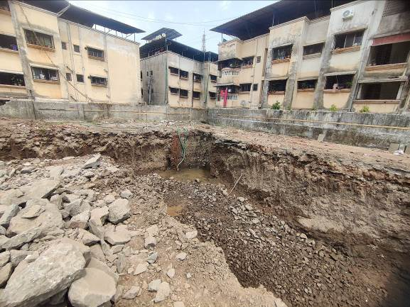
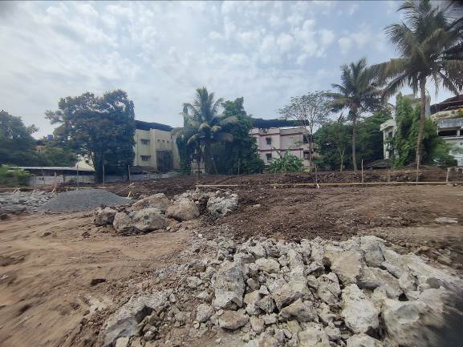
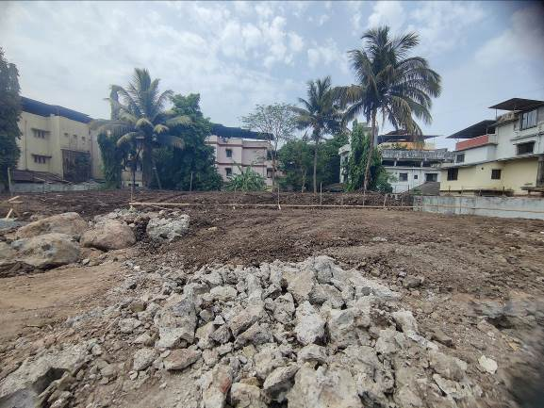
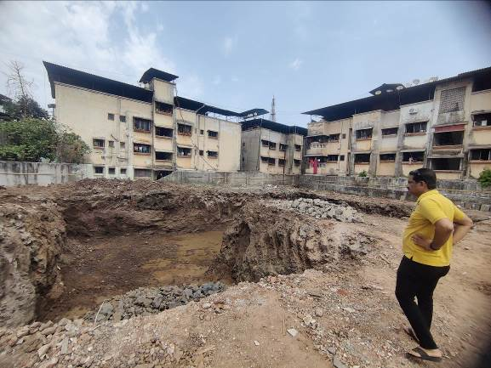
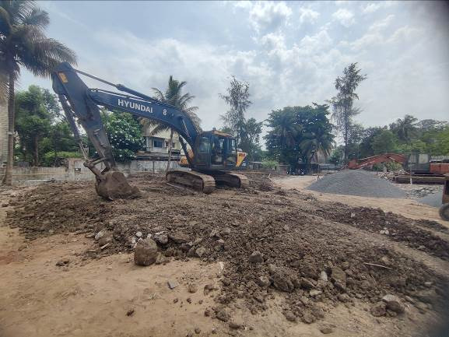
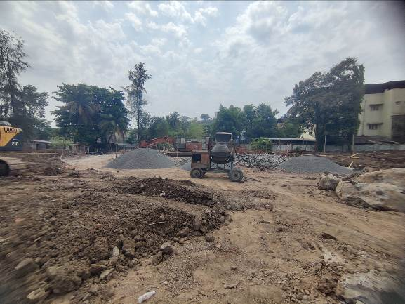
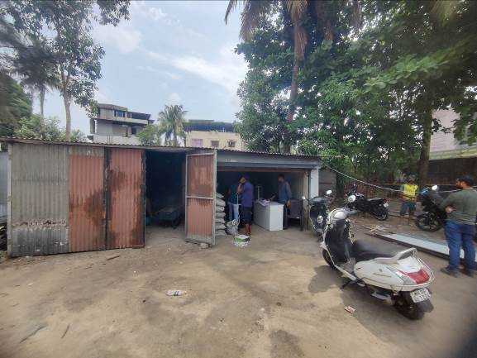
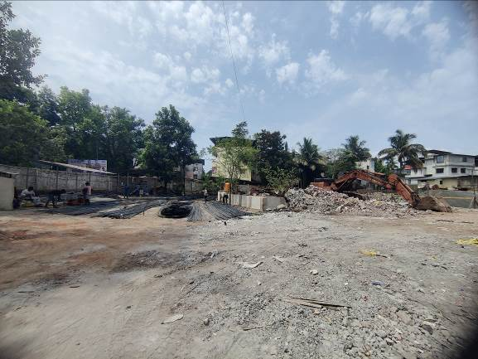
Actual Site Photographs
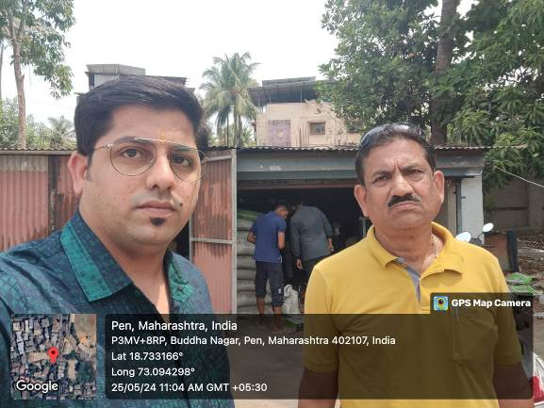
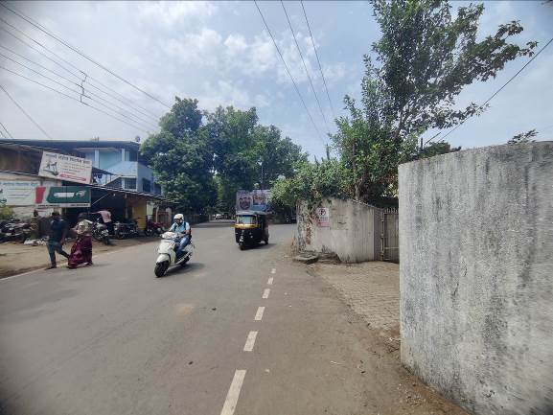
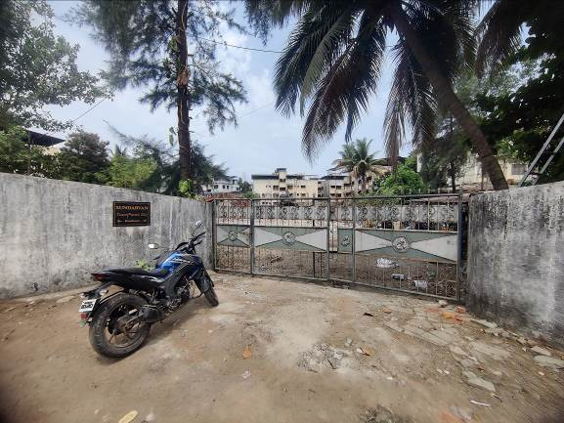
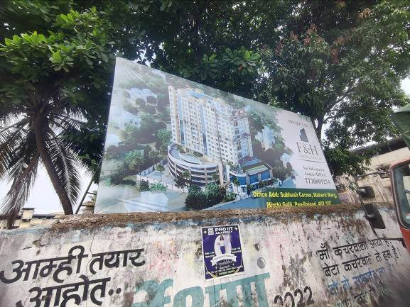
Route Map of the property
Site u/r
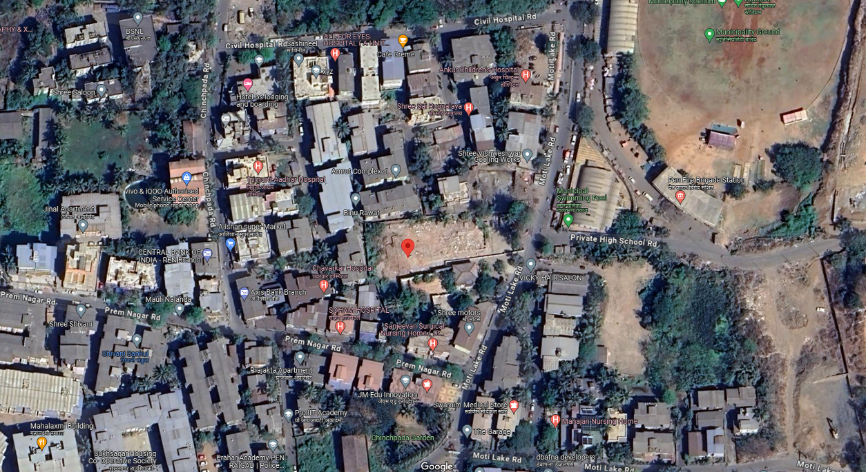

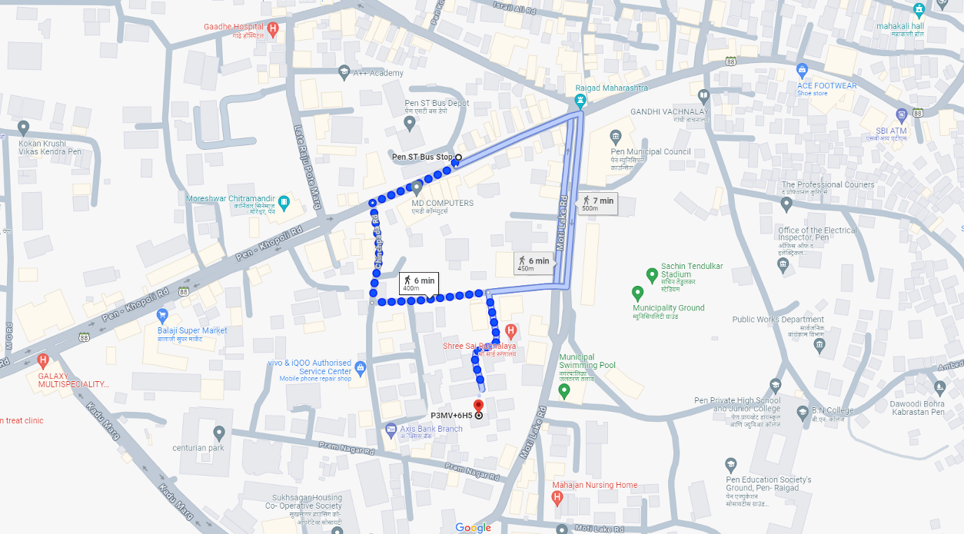

Latitude Longitude: 18°43’59.2”N 73°05’37.5”E
Note: The Blue line shows the route to site from nearest bus station (Pen – 450 M.)

