Vastu/Nashik/05/2024/008878/2306424
22/16-284-CHBS
Date: 22.05.2024

To,
The Branch Manager
State Bank of India
RACPC Nashik Branch
1st Floor, Patel Plaza, N.D. Patel Road,
Opp. BSNL, Landmark Seawoods Navratna Hotel,
Nashik - 422001, State – Maharashtra, Country – India.

Sub: Vetting of Estimate

Sir,

With reference to above subject, we have evaluated the Estimate for Residential Land and Proposed Bungalow on Plot No.18, Survey No.170/1/A/2, Opposite Water Tank, Third Cross Road, Mouje - Manmad , Taluka – Nandgaon, District – Nashik, Pin Code – 423 104, State – Maharashtra, Country – India belongs to Miss.Tarkeshwari Shashikant Chandanshiv & Mr.Dinesh Shashikant Chandanshiv

We have verified the rates quoted as per current market rates. Details of Estimate considered as per copy of Estimate Provided by S.B.Uphade & Associates received on dated 22.05.2024. The Estimate amount is Rs.34,00,000/- (Rupees Thirty-Four Lakh Only.)

Note:1) The said Cost Vetting Certificate is valid upto next 6 months Only.

Thanking you

Sincerely yours

Manoj B. Chalikwar
Registered Valuer
Chartered Engineer (India)
Reg. No. CAT-I-F-1763
SBI Empanelment No.: SME/TCC/2021-22/86/3

Estimate
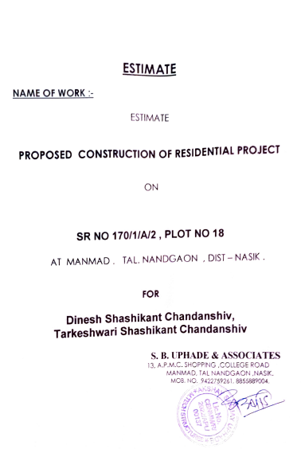
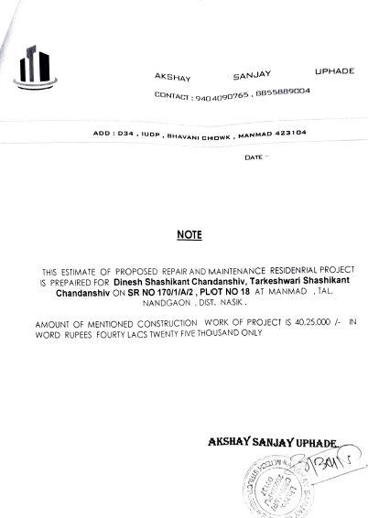

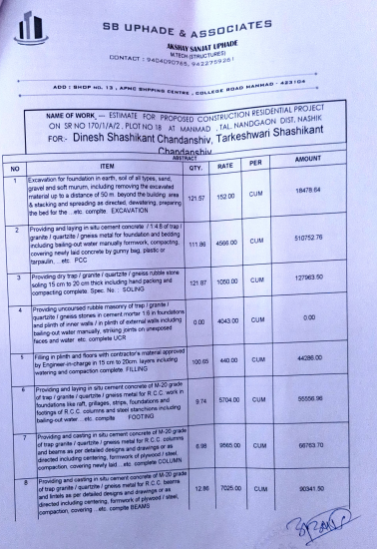
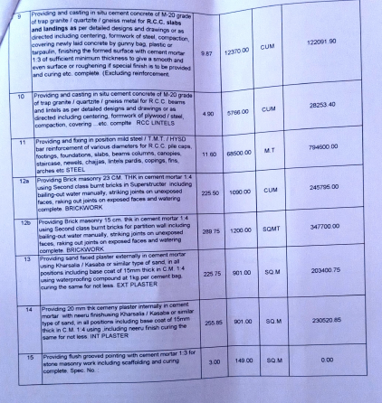

Estimate
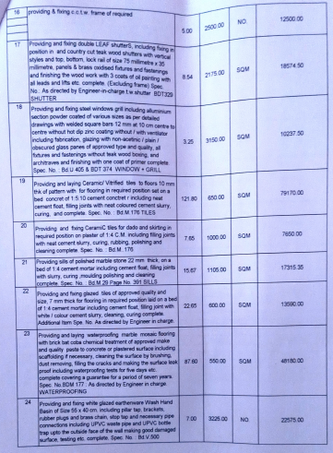
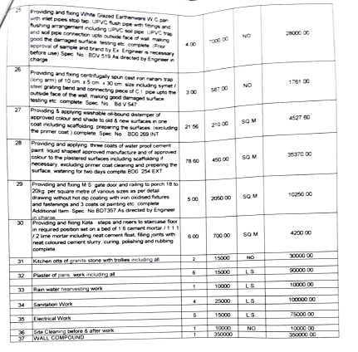

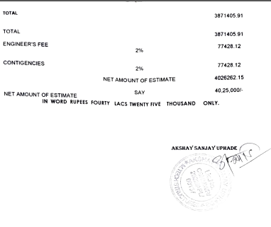

The Estimate amount is Rs.34,00,000/- (Rupees Thirty-Four Lakh Only.)

