
Name of Owner: M/s. APAR Industries Limited
Details of the property under consideration:
Movable Assets on Khat No. 254/334, Plot Nos. 1383, 1387, 1393, 1388, 1390 & 1385, Off. Pradhanmantri Sadak Yojana Road, Off. Kolabira Road, Mouza/ Village Raghunathpali, P.S. Kolabira, PIN Code- 768 213, District-Jharsuguda, State-Odisha, Country-India.
VALUATION REPORT OF MOVABLE ASSETS
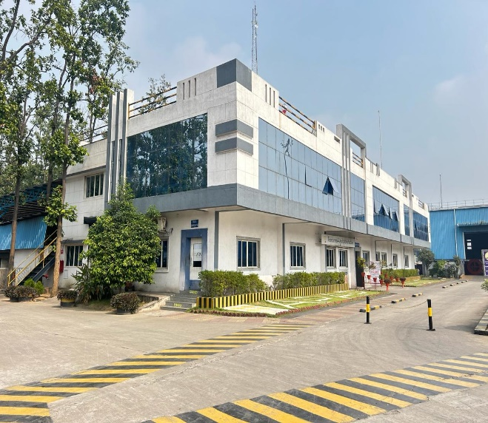




Report Prepared For
State Bank of India
GIFT City Gandhinagar Branch
14th Floor, Hiranandani Signature Tower, GIFT City, Gandhinagar – 382 355,
State - Gujarat, Country – India.
Vastukala Consultants (I) Pvt. Ltd.
B1-001, U/B Floor, Boomerang, Chandivali Farm Road, Powai, Andheri(East), Mumbai - 400 072.
: +91 98195 97579 | : www.vastukala.org
Mumbai • Delhi NCR • Indore • Aurangabad • Nanded • Pune
Raipur • Jaipur • Ahmedabad • Rajkot • Thane • Nashik

Index

Contents Page No.

1. VALUATION OPINION REPORT 3
2. VALUATION REPORT (IN RESPECT OF PLANT AND MACHINERY) 4
3 VALUATION RATIONALE 6
4. DOCUMENTS REFERRED 12
5. ABOUT COMPANY 12
6. OBSERVATION 13
7. DETAILS OF PLANT AND MACHINERY 14
8. DECLARATION CUM UNDERTAKING (Annexure-IV) 33
9. ACTUAL SITE PHOTOGRAPHS 37
10. ROUTE MAP OF THE PROPERTY 42
11. ASSUMPTIONS, CAVEATS, LIMITATION AND DISCLAIMERS 43
12. DEFINITION OF VALUE FOR THIS SPECIFIC PURPOSE 46
13. VALUATION OF MOVABLE ASSETS 47

Vastu/Thane/04/2024/8748/2302816
03/13-13-APU
Date: 19.04.2024

VALUATION OPINION REPORT
This is to certify that the Movable Assets on Khat No. 254/334, Plot Nos. 1383, 1387, 1393, 1388, 1390 & 1385, Off. Pradhanmantri Sadak Yojana Road, Off. Kolabira Road, Mouza/ Village Raghunathpali, P.S. Kolabira, PIN Code- 768 213, District-Jharsuguda, State-Odisha, Country-India belongs to M/s. APAR Industries Limited.
Boundaries of the property
North | : | Pradhanmantri Sadak Yojana Road
South | : | Internal Road
East | : | Fortis Chemical
West | : | Pradhanmantri Sadak Yojana Road
Considering various parameters recorded, existing economic scenario, and the information that is available with reference to the industrial development and method selected for valuation, we are of the opinion that, the assets can be assessed and valued for particular purpose at:
Particulars | Fair Market Value | Realizable Value | Distress Sale Value
Movable Assets | ₹ 43.28 Crores | ₹ 38.95 Crores | ₹ 34.62 Crores
Total | ₹ 43.28 Crores | ₹ 38.95 Crores | ₹ 34.62 Crores
Hence certified.
For Vastukala Consultants (I) Pvt. Ltd.

Umang Ashwin Patel
Govt. Reg. Valuer
Chartered Engineer (India)
Reg. No. CAT-VII-A-5062

2. VALUATION REPORT (IN RESPECT OF PLANT AND MACHINERY)
To,
The Chief Manager,
State Bank of India
GIFT City Gandhinagar Branch
14th Floor, Hiranandani Signature Tower,
GIFT City, Gandhinagar – 382 355, State - Gujarat, Country - India.
I | General (Form- O - 7)
1. | Location of factory/ works/ premises |  | : | Movable Assets located at Khat No. 254/334, Plot Nos. 1383, 1387, 1393, 1388, 1390 & 1385, Off. Pradhanmantri Sadak Yojana Road, Off. Kolabira Road, Mouza/ Village Raghunathpali, P.S. Kolabira, PIN Code- 768 213, District-Jharsuguda, State-Odisha, Country-India
2. | Purpose for which valuation is made |  | : | As per the request from State Bank of India, GIFT City Gandhinagar Branch to assess Fair Market value of the Movable Assets for Bank Loan purpose.
3. | a) | Date of inspection | : | 24.11.2023
 | b) | Date on which the valuation is made | : | 19.04.2024
 | c) | Report Date |  | 19.04.2024
4. | Basis of valuation / assumptions made of |  | : | As mentioned below.
 | - Indigenous Machines |  | : | The Movable Assets under valuation are Indigenous and Imported. For Valuation Cost Approach is used for calculation of Fair Market Value.  Basis of Valuation is as under: -  • Purchase Value/ Replacement Cost  • Visual Observation  • Specifications of Machinery  • Manufacturer of Machinery  • Condition of Machinery  • Present Maintenance  • Age of Machines  • Estimated Balance Economic Life  • Depreciation calculated by straight line method  We have assessed the Fair Market Value (FMV) by applying appropriate depreciation considering the above parameters.
 | - Imported Machines |  | :
5. | Details of the charges created on the assets |  | : | Information not available

3 VALUATION RATIONALE

3.1 METHODOLOGIES

3.1.1 MARKET APPROACH
As per Ind AS 113: Appendix A, it is defined as a valuation technique that uses prices and other relevant information generated by market transactions involving identical or comparable (i.e. similar) assets, liabilities or a group of assets and liabilities.
In order to compare the subject of the valuation with the price of the other tangible asset interests, Valuers adopt generally accepted and appropriate units of comparison that are considered by participants, dependent upon the type of asset being valued.
As per IVS 400 differences that should be considered in valuing tangible asset interests include, but are not limited to:
- The type of interest providing the price evidence and the type of interest being valued,
- The respective locations,
- The respective configuration,
- The circumstances under which the price was determined, and the basis of value required,
- The effective date of the price evidence and the valuation date, and market conditions at the time of the relevant transactions and how they differ from conditions at the valuation date.
Direct Sales Comparison Method is the most common method under the Market Approach for Plant and Machinery Valuation. The basic fundamental for this method is on the assumption that an informed purchaser would not pay more for an item than the cost of acquiring an existing one with the same utility. This method is preferred when valuing plant and machinery for which there is a known and active secondary market. In applying it under the ‘in-situ’ premise, an allowance then is made to reflect the cost of delivery, installation taxes, fees and duties known as indirect or additional costs.

Comparable Match Method is other method under market approach for plant and machinery valuation. This technique establishes values based on the analysis of similar (but not identical) assets using some measure of utility (size, capacity, year manufactured, etc.) as the basis of comparison. The main difference from direct sales comparison method is that the comparisons may not be similar in terms of model and year built, but has other similarities such as capacity, brand acceptance or same country of origin. Hence, appropriate adjustments have to be made on the comparable before the value of asset can be derived.

3.1.2 INCOME APPROACH
It is defined as valuation technique that convert future amounts (e.g., cash flows or income and expenses) to a single current (i.e., discounted) amount. The fair value measurement is determined on the basis of the value indicated by current market expectations about future amounts.
The income approach is defined in the International Glossary of Business Valuation Terms as
“A general way of determining a value indication of a business, business ownership interest, security or intangible asset using one or more methods that converts anticipated economic benefits into a present single amount.”
The development of a yield or discount rate should be influenced by the objective of the valuation. For example:
- If the objective of the valuation is to establish the value to a particular owner or potential owner based on their own investment criteria, the rate used may reflect their required rate of return or their weighted average cost of capital, and
- If the objective of the valuation is to establish the market value, the discount rate may be derived from observation of the returns implicit in the price paid for tangible asset interests traded in the market between participants or from hypothetical participant’s required rates or return. When a discount rate is based on an analysis of market transactions, Valuers should also follow the guidance contained in IVS 105 Valuation Approaches and Methods.

Two methods are typically used to value machinery and equipment using the income approach, Direct Capitalization Method and Discounted Cash Flow Method.
Direct Capitalization Method involves capitalizing a ‘normalized’ single year net income estimated by an appropriate market-based yield. It capitalizes a projected cash flow into perpetuity and the capitalization rate that is calculated has no changes.
Discounted Cash Flow Method is a multiple period model. Using this method, future cash flows from the asset are forecasted using market stated assumptions as well as future capital and operational expenditures projected by the company. This method allows for the explicit modelling of income and expense associated with the assets. These future financial benefits are then discounted to a present-day value at an appropriate discount rate taking into account return on investment and risk.

3.1.3 COST APPROACH
The cost approach is commonly adopted method for plant and equipment, particularly in the case of individual assets that are specialised or special-use facilities. In cost approach appraisal, the market price for the asset is equal to the cost, less depreciation. It yields the most accurate market value when the asset is new.
Replacement Cost New is the cost of obtaining an alternative asset of equivalent utility; this can either be a modern equivalent providing the same functionality or the cost of reproducing an exact replica of the subject asset. After concluding on a replacement cost, the value should be adjusted to reflect the impact on value of physical, functional, technological and economic obsolescence on value. In any event, adjustments made to any particular replacement cost should be designed to produce the same cost as the modern equivalent asset from an output and utility point of view. In addition, other applicable direct & indirect cost applicable in the current market conditions will be factored to arrive at current RCN for the machineries.
Reproduction Cost New Method is appropriate in circumstances where the cost of a modern equivalent asset is greater than the cost of recreating a replica of the subject asset or the utility offered by the subject asset could only be provided by a replica rather than a modern equivalent.
Under Indexing Method, a ratio multiplier based on applicable index of a particular category of assets in comparison to the similar index at the time of procurement/ acquisition of asset is computed. The ratio multiplier is computed from Wholesale Price Index (WPI) published by Reserve Bank of India for various categories of assets. This multiplier is then applied to historical cost to estimate the current replacement cost of the assets. Under this scenario, capitalized values in the fixed register would typically involve all direct and indirect costs and thus, no extra costs will be factored to estimate current replacement cost.

3.2 OTHER TERMINOLOGIES USED

3.2.1 DEPRECIATED REPLACEMENT COST
In regard to the Appraisal and Guidance Notes issued by the International Valuation Standards Council (IVSC) in which the Depreciated Replacement Cost is defined as:
“The current cost of replacing an asset with its modern equivalent asset less deductions for physical deterioration and all relevant forms of obsolescence and optimization.”
Under Cost Approach, the fair value of the Plant & Machinery component will be assessed through ‘Depreciated Replacement Cost’ (DRC) Method. In this approach, the Current Replacement Cost of the assets (given the current condition of the asset) is evaluated after giving regards to parameters such as Make, Model, Capacity, Technical specification, Types of process, construction specifications, age of the Machinery, Country of origin, etc. and the same has been depreciated based on parameters such as age, physical condition of the components, remaining useful life, technical obsolescence, etc. of individual components.

3.2.2 TOTAL ECONOMIC/ PHYSICAL LIFE
The total economic life of the assets has been considered on the basis of economic life prescribed for various categories under Schedule II, Part C of Indian Companies Act, 2013 and Useful life of machines catalogue published by American Society of Appraisers (ASA). Wherever the age of machineries had exceeded the prescribed total economic life, typically future/ balance physical life will be adopted on the basis of physical/ working condition of the assets. It is to be noted that estimated future physical life of the machineries is based on the visual/ physical observation of the valuer as of date of inspection and no technical evaluation regarding the durability of machineries has been undertaken.

3.2.3 SCRAP & SALVAGE VALUE
Salvage value is the estimated amount that an asset is worth at the end of its useful life. It is also known as scrap value or residual value and is used while determining the depreciation of an asset.

3.2.4 IN-SITU & EX-SITU VALUE
Under In-situ value, the assets will remain in their existing place and location (In-Situ) following the completion of sale. In-situ value is typically assessed in the case of assessment of Fair Value on ‘going concern’ basis. In this scenario, the prospective buyer for the unit would comprehend the requirement of necessary industrial infrastructure (including other indirect costs that are typically allowed for capitalization) that is required for the operations of the industry.
Under Ex-situ value, the assets will be removed from their existing location following the completion of sale and this typically utilized in the case of assessment of Liquidation Value or Forced Sale Value. In this scenario, adjustments are required to exclude necessary costs & charges such as foundation costs, decommissioning costs, etc.

3.3 FACTORS AFFECTING THE VALUE

3.3.1 GENERAL FACTORS
The value of P&E starts with the inspection. This is done to ascertain the condition of the plant and also to determine if the information provided to them is usable and related to the subject assets being valued. The factors generally considered during inspection are:

ASSET RELATED
- The asset’s technical specification
- The remaining useful, economic or effective life, considering both preventive and predictive maintenance
- The asset’s condition including maintenance history
- Any functional, physical or technological obsolescence
- Additional costs associated with additional equipment, transport, installation and commissioning etc.

ENVIRONMENT RELATED
- The location in relation to the source of raw material and market for the product
- The impact of any environmental or other legislation that either restricts utilization or imposes additional operation or decommissioning costs
- Licenses to operate machineries which produce or utilize radioactive substances or toxic wastes and that may be restricted in certain countries.

ECONOMY RELATED
- The actual or potential profitability of the asset based on comparison of operating costs with earnings or potential earnings
- The demand for the product manufactured by the plant with regard to both macro and micro- economic factors could impact on demand
- The potential for the asset to be put to a more valuable use than the current use (i.e. HABU)

3.3.3 FACTORS RELATED TO IMPORTED ASSETS
For assessing Current Replacement Cost of imported Machineries (if any), I have adopted the current price (vide replacement cost method or index method using producer price index issued by central bank of respective country) of the machineries along with prevailing currency exchange rate, duties, freight charges, commissioning costs, etc.

3.3.4 FACTORS RELATED TO USED ASSETS
The methodologies and approaches specified above are equitably used in the case of transferred assets. Replacement cost of second-hand machineries/ transferred equipment is assessed after taking proper consideration to the actual year of manufacturing of the plant and machineries, country of origin, actual invoice or Historic cost, etc. It is to be noted that the details related to the same has been availed from the Client as well as based on my best effort basis.

3.4 METHODOLOGY ADOPTED
As stated earlier, the fair value of Plant and Machinery has been estimated through Depreciated Replacement Cost Method.

3.5 VALUATION

3.5.1 VALUATION APPROACH
Fair Value assessed is the ‘in-situ’ and on ‘going concern’ basis that assumes that the enterprise shall continue to operate and run its business and that specified fixed asset shall continue to have economic utility. Under this assessment, I have assumed that the prospective buyer for the unit would comprehend the requirement of necessary industrial infrastructure (including other indirect costs which are typically allowed for capitalization) that is required for the operations of the industry. Fair Value of the assets has been assessed on the basis of the afore-mentioned premise.

4. DOCUMENTS REFERRED:-

Party has provided the Copy of following documents/ Information.
- Fixed Asset Register as 30.09.2023.
- Audited Balance Sheet for the year ended at 31.03.2023.

5. ABOUT COMPANY:-
- M/s. Apar Industries Limited (“AIL” or “Company”) is a Public Limited Company incorporated on 28th September 1989. It is classified as non-govt. company and is registered at Registrar of Companies, Ahmedabad.
- AIL's Corporate Identification Number is (CIN) L91110GJ1989PLC012802 and its registration number is 12802. Its registered address is 301 Panorama Complex, R C Dutt Road, Vadodara, Gujarat-390 007.
- APAR Industries Limited, founded by Late Shri. Dharmsinh D. Desai in the year 1958 is one among the best-established companies in India, operating in the diverse fields of electrical and metallurgical engineering offering value added products and services in Power Transmission Conductors, Petroleum Specialty Oils, Power & Telecom Cables and House wires. The Company has manufacturing plants in the state of Maharashtra, Gujarat, Orissa and Union territory of Dadra & Nagar Haveli.
- APAR is having 10 manufacturing facilities (nine manufacturing facilities in India and one in Sharjah, UAE) for each business portfolio that meets the stringent national and international parameters.
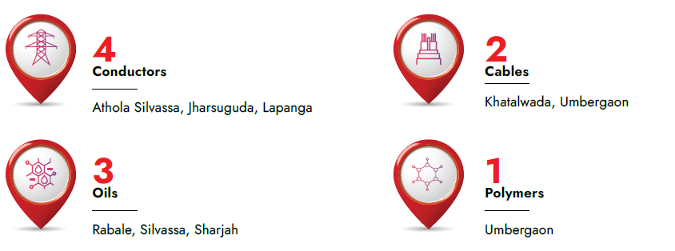

6. OBSERVATION
- The Movable Asset under valuation is located at Khat No. 254/334, Plot Nos. 1383, 1387, 1393, 1388, 1390 & 1385, Off. Pradhanmantri Sadak Yojana Road, Off. Kolabira Road, Mouza/ Village Raghunathpali, P.S. Kolabira, PIN Code- 768 213, District-Jharsuguda, State-Odisha, Country-India.
- The Plant & Machinery installed are of Indigenous & Imported.
- Company has provided the Fixed Asset Register and the same are considered the base of our valuation.
- During the date and time of our visit, the Plant was in operation.
- The Assets under valuation are well maintained by in house maintenance team.
- Mr. Santosish Das (Contact No.- +91 84559 39240) accompanied our Engineer and showed the Movable Assets under valuation.

7. DETAILS OF PLANT AND MACHINERY:-
S. No. | Asset description | Asset Code | Capitalized Date | Age (Yrs) | Residual Life (Yrs) | Capitalized Value (Rs.) | WDV as on 30.09.2023 (Rs.) | Fair Market Value (Rs.)
A | Plant and Machinery
1 | RBD-1 | 1701064 | 15/09/2016 | 8 | 12 | 1,45,36,908 | 48,09,167 | 93,04,000
2 | DG Set 1500Kva | 1701065 | 15/09/2016 | 8 | 12 | 1,07,60,421 | 71,60,876 | 68,87,000
3 | CRANE:CAP. 5MT (No.4) | 1701066 | 15/09/2016 | 8 | 12 | 1,07,52,124 | 35,57,067 | 68,81,000
4 | STEEL SPOOLING MACHINE (6 No.) | 1701068 | 15/09/2016 | 8 | 12 | 44,04,637 | 14,57,162 | 28,19,000
5 | Aluminium Spooler Machine | 1701069 | 15/09/2016 | 8 | 12 | 9,50,886 | 3,14,577 | 6,09,000
6 | Forklift : 3MT (3 No.) | 1701070 | 15/09/2016 | 8 | 12 | 23,72,049 | 7,84,732 | 15,18,000
7 | Tools for utility | 1701071 | 15/09/2016 | 8 | 12 | 12,53,467 | 4,14,678 | 8,02,000
8 | FIRE HYDRANT SYSTEM & Fire Extinguisher | 1701072 | 15/09/2016 | 8 | 12 | 34,58,649 | 11,51,362 | 22,14,000
9 | Forklifts : 8MT (1 no.) | 1701073 | 15/09/2016 | 8 | 12 | 19,21,105 | 6,35,549 | 12,30,000
10 | COMPRESSOR & AIR SYSTEM | 1701074 | 15/09/2016 | 8 | 12 | 19,89,673 | 6,58,233 | 12,73,000
11 | Weigh Bridge | 1701075 | 15/09/2016 | 8 | 12 | 18,33,784 | 6,06,661 | 11,74,000
12 | Forklifts :5MT (1 No.) | 1701077 | 15/09/2016 | 8 | 12 | 13,00,775 | 4,30,328 | 8,32,000
13 | RO Plant | 1701078 | 15/09/2016 | 8 | 12 | 18,78,285 | 6,21,383 | 12,02,000
14 | CRANE CAP: 12MT (Hydra) | 1701079 | 15/09/2016 | 8 | 12 | 9,82,400 | 3,25,002 | 6,29,000
15 | CRANE CAP: 2T | 1701080 | 15/09/2016 | 8 | 12 | 7,09,605 | 2,34,755 | 4,54,000
16 | SHAPER MACHINE | 1701084 | 15/09/2016 | 8 | 12 | 1,95,138 | 64,556 | 1,25,000
17 | LATHE MACHINE : 6 FEET | 1701085 | 15/09/2016 | 8 | 12 | 2,63,367 | 87,128 | 1,69,000
18 | WELDING M/C MODEL: I | 1701086 | 15/09/2016 | 8 | 12 | 1,41,780 | 46,904 | 91,000
19 | HYDRAULIC PRESS Machine | 1701087 | 15/09/2016 | 8 | 12 | 1,31,571 | 43,527 | 84,000
20 | WEIGHING MACHINE CAP: 5000KG | 1701088 | 15/09/2016 | 8 | 12 | 1,28,750 | 42,594 | 82,000
21 | WEIGHING MACHINE CAP: 3000KG | 1701089 | 15/09/2016 | 8 | 12 | 99,500 | 32,917 | 64,000
22 | MS SPOOL 630X225X400MM | 1701090 | 15/09/2016 | 8 | 12 | 92,792 | 30,698 | 59,000
23 | WEDGE TYPE SELF TIGHTENING GRIP 30 KN - 1 No | 1701091 | 15/09/2016 | 8 | 12 | 70,447 | 3,522 | 45,000
24 | WEDGE TYPE SELF TIGHTENING GRIP 5 KN - 1 No. | 1701092 | 15/09/2016 | 8 | 12 | 42,268 | 2,113 | 27,000
25 | SIDEDECK VERSION ASSEMBLY FOR UTM - 1 No. | 1701093 | 15/09/2016 | 8 | 12 | 56,358 | 2,818 | 36,000
26 | Tools For Lab | 1701094 | 15/09/2016 | 8 | 12 | 16,85,345 | 84,267 | 10,79,000
27 | RBD - Jyoti Engineering | 1701121 | 01/12/2016 | 8 | 12 | 2,37,66,299 | 83,38,886 | 1,52,10,000
28 | RST-2- AEI MAKE | 1701124 | 01/11/2016 | 8 | 12 | 84,97,362 | 34,34,815 | 54,38,000
29 | Cooling Tower & Tenk | 1701125 | 01/10/2016 | 8 | 12 | 11,52,682 | 3,86,137 | 7,38,000
30 | WIRE ROPE ELECTRIC HOIST,CAP 0.5MT | 1701126 | 01/11/2016 | 8 | 12 | 11,12,480 | 3,81,648 | 7,12,000
31 | CRANE CAP. 1T | 1701127 | 01/12/2016 | 8 | 12 | 8,02,313 | 2,81,508 | 5,13,000
32 | LATHE MACHINE : 12 FEET | 1701128 | 01/10/2016 | 8 | 12 | 6,62,231 | 2,21,841 | 4,24,000
33 | WEIGHING MACHINE CAP: 10 MT | 1701129 | 01/10/2016 | 8 | 12 | 3,16,000 | 1,05,857 | 2,02,000
34 | WELDING MACHINE 30KVA | 1701130 | 01/10/2016 | 8 | 12 | 2,74,907 | 92,091 | 1,76,000
35 | Fume Hood | 1701131 | 01/11/2016 | 8 | 12 | 1,67,843 | 8,392 | 1,07,000
36 | WELDING MACHINE | 1701132 | 01/11/2016 | 8 | 12 | 1,12,857 | 38,717 | 72,000
37 | Welding Machine 5 KVA | 1701133 | 01/12/2016 | 8 | 12 | 87,568 | 30,725 | 56,000
38 | DRILL MACHINE | 1701134 | 01/12/2016 | 8 | 12 | 83,355 | 29,247 | 53,000
39 | WEIGHING SCALE 220GM LC 0.1MG | 1701135 | 01/12/2016 | 8 | 12 | 43,941 | 15,418 | 28,000
40 | Welding Machine 1 KVA | 1701136 | 01/12/2016 | 8 | 12 | 31,924 | 11,201 | 20,000
41 | Tubular m/c -1 No. | 1701137 | 01/12/2016 | 8 | 12 | 60,72,089 | 21,30,515 | 38,86,000
42 | Oilmax centrifugal oil cleaning system | 1701191 | 01/03/2017 | 7 | 13 | 2,55,625 | 2,15,637 | 1,75,000
43 | Weighing scale 1 mt and 5 mt | 1701151 | 15/03/2017 | 7 | 13 | 37,694 | 14,246 | 26,000
44 | DIGITAL MICROMETER M: 293831 LC- 0.001MM - 4 No. | 1701190 | 01/01/2017 | 7 | 13 | 42,993 | 2,150 | 29,000
45 | Weighing scale for stor Dept. | 1701152 | 15/03/2017 | 7 | 13 | 25,247 | 9,542 | 17,000
46 | Tensile testing machine Capacity 30KN- Fr Silvassa | 1701204 | 01/03/2014 | 10 | 0 | 0 | 9,246 | 0
47 | compressor for packing of F.G. | 1701206 | 01/04/2017 | 7 | 13 | 1,77,072 | 67,707 | 1,21,000
48 | ALUMINIUM SPOOLING 02 Nos | 1701221 | 30/09/2017 | 7 | 13 | 20,49,892 | 8,80,938 | 14,04,000
49 | STEEL SPOOLING -2 Nos. | 1701222 | 30/09/2017 | 7 | 13 | 12,82,806 | 5,51,284 | 8,79,000
50 | TUBULAR MACHINE WITH ACCESSORI | 1701209 | 01/07/2017 | 7 | 13 | 60,78,423 | 19,04,095 | 41,64,000
51 | WIRE DRAWING MACHINE 01NO | 1701224 | 01/09/2016 | 8 | 12 | 1,61,41,165 | 62,53,253 | 1,03,30,000
52 | RBD (From Rakholi) | 1701225 | 01/09/2016 | 8 | 12 | 16,45,172 | 6,36,934 | 10,53,000
53 | 54- BOBBIN RIGID STRANDING MACHINE-jhelum | 1701226 | 31/03/2009 | 15 | 5 | 1,50,79,366 | 7,53,968 | 49,01,000
54 | Double Side loading system on Jhelum M/c | 1701227 | 01/10/2012 | 12 | 8 | 8,01,361 | 1,08,599 | 3,69,000
55 | Wire Break Detection System on Jhelum (MPI) RST Ma | 1701228 | 31/03/2015 | 9 | 11 | 4,37,494 | 2,60,799 | 2,60,000
56 | OLD TENSILE TESTING MACHINE 1700051 TRNS FROM HP | 1701230 | 01/04/2007 | 17 | 3 | 9,94,714 | 99,011 | 2,34,000
57 | Torsion Testing Machine Motorised | 1701231 | 01/09/2010 | 14 | 6 | 2,17,763 | 10,888 | 81,000
58 | TRAPEZOIDIAL CONDUCTOR ATTACHMENTS FOR MSD MACHI | 1701232 | 01/10/2016 | 8 | 12 | 2,09,516 | 81,895 | 1,34,000
59 | Tubular 02 (MAJI) | 1701233 | 01/07/2013 | 11 | 9 | 35,88,307 | 5,87,526 | 18,12,000
60 | MS SPOOL 630X475X224MM - 36NOS | 1701234 | 01/08/2017 | 7 | 13 | 2,65,032 | 1,00,696 | 1,82,000
61 | BULL HEAD-MS SPOOL 630X475X224MM-72 NOS. | 1701235 | 01/08/2017 | 7 | 13 | 5,30,104 | 2,10,927 | 3,63,000
62 | AIR COMPRESSOR 15TE20 | 1701236 | 01/10/2016 | 8 | 12 | 2,71,858 | 1,06,263 | 1,74,000
63 | STEEL PROCESS DRUMS DIA 1420X822 MM, QTY. 22 Nos. | 1701237 | 15/03/2016 | 8 | 12 | 4,71,988 | 1,49,207 | 3,02,000
64 | HVLS fan- 24 - 2 No. | 1701243 | 30/09/2017 | 7 | 13 | 5,66,000 | 2,43,238 | 3,88,000
65 | HOIST FOR MPI (Jhelum) M/c. | 1701244 | 01/03/2015 | 9 | 11 | 1,96,665 | 50,154 | 1,17,000
66 | 13 Die Rod Break Down Machine -Andhra 2 | 1701245 | 31/03/2009 | 15 | 5 | 1,20,30,245 | 8,81,467 | 39,10,000
67 | FORKLIFT TRUCK WITH FORK CAP-3MT | 1701248 | 01/03/2008 | 16 | 4 | 18,25,194 | 91,260 | 5,11,000
68 | FORKLIFT TRUCK WITH FORK CAP-5MT | 1701249 | 01/03/2008 | 16 | 4 | 18,25,194 | 91,260 | 5,11,000
69 | Oil Cleaning m/c & RBD installation | 1701254 | 31/12/2017 | 7 | 13 | 52,97,385 | 24,07,039 | 36,29,000
70 | SPARE MOTORS& DRIVES REQUIRE FOR RBD,RST & TUBUL | 1701255 | 31/12/2017 | 7 | 13 | 13,20,886 | 5,99,283 | 9,05,000
71 | Yaskawa Make Spare AC Driv For RBD(355KW- & 250K | 1701256 | 31/12/2017 | 7 | 13 | 6,96,000 | 3,15,773 | 4,77,000
72 | RBD machine-3 (Heat Exchanger) | 1701257 | 30/11/2017 | 7 | 13 | 9,41,597 | 4,19,602 | 6,45,000
73 | COVERING OF CABLE TRENCH | 1701258 | 31/12/2017 | 7 | 13 | 11,34,743 | 5,18,614 | 7,77,000
74 | Computerised Tensile Testing M/c. - 1 Set. | 1701259 | 31/12/2017 | 7 | 13 | 6,39,910 | 2,90,326 | 4,38,000
75 | COOLING TOWER WITH FRP BASIN,CAPACITY:2500 LP | 1701260 | 01/10/2017 | 7 | 13 | 6,31,593 | 2,46,958 | 4,33,000
76 | STEEL BOBBIN 710MM-276 NOS. | 1701261 | 28/09/2017 | 7 | 13 | 24,40,807 | 9,91,860 | 16,72,000
77 | Rigid Frame STRANDER- Yeuyang | 1701264 | 01/10/2017 | 7 | 13 | 2,83,26,402 | 1,13,39,956 | 1,94,04,000
78 | Rod Break Down Machine With Modification | 1701265 | 01/06/2015 | 9 | 11 | 46,31,311 | 12,29,966 | 27,56,000
79 | Rod Break Down Machine With Modification | 1701251 | 01/06/2015 | 9 | 11 | 1,02,281 | 34,472 | 61,000
80 | AC Drive 315 KW Yaskwa-01 no. | 1701332 | 31/03/2018 | 6 | 14 | 7,05,000 | 3,36,374 | 5,15,000
81 | 355KW AC MOTOR | 1701333 | 31/01/2018 | 6 | 14 | 6,56,433 | 3,03,119 | 4,79,000
82 | Organic Waste Compost Machine | 1701334 | 01/01/2018 | 6 | 14 | 6,25,800 | 2,84,087 | 4,57,000
83 | COOLING REQUIREMENT FOR RBD-1,SKIP-2 & AGING FUR | 1701335 | 31/03/2018 | 6 | 14 | 6,38,015 | 3,04,413 | 4,66,000
84 | Spools for RST-4 - 55nos. | 1701336 | 01/01/2018 | 6 | 14 | 4,15,144 | 1,88,458 | 3,03,000
85 | Cold Pressure butt welding Machine-05 nos | 1701337 | 01/01/2018 | 6 | 14 | 1,35,000 | 61,284 | 99,000
86 | Cold Pressure Butt Welding Machine (Hydraulic) | 1701338 | 01/01/2018 | 6 | 14 | 1,27,226 | 57,755 | 93,000
87 | cold pressure butt welding machine III | 1701339 | 01/01/2018 | 6 | 14 | 1,17,530 | 53,354 | 86,000
88 | HYDRA-16MT -01 no. | 1701340 | 01/01/2018 | 6 | 14 | 14,88,225 | 6,75,591 | 10,86,000
89 | 54 STRAND RST | 1701343 | 31/03/2018 | 6 | 14 | 1,39,06,777 | 67,07,686 | 1,01,52,000
90 | Aluminum Spooling Machine 630MM | 1701344 | 01/01/2018 | 6 | 14 | 2,56,812 | 1,16,582 | 1,87,000
91 | STEEL SPOOLING MACHINE | 1701345 | 01/01/2018 | 6 | 14 | 3,33,285 | 1,51,297 | 2,43,000
92 | RST-3 | 1701346 | 31/03/2018 | 6 | 14 | 61,27,910 | 32,27,083 | 44,73,000
93 | China RBD (R-L) - From Athola | 1701347 | 01/01/2018 | 6 | 14 | 32,36,909 | 14,75,751 | 23,63,000
94 | Ms plate (10mm x 2000mm x 6000mm) - 64 Mt. | 1701350 | 01/01/2018 | 6 | 14 | 27,38,247 | 12,43,049 | 19,99,000
95 | RBD-6 | 1701351 | 01/01/2018 | 6 | 14 | 19,12,292 | 8,68,100 | 13,96,000
96 | MS Plate (10mm X 2000mm X 6000mm)-64MT | 1701352 | 01/01/2018 | 6 | 14 | 19,00,260 | 8,62,638 | 13,87,000
97 | RBD-5 | 1701354 | 01/01/2018 | 6 | 14 | 14,14,752 | 6,42,370 | 10,33,000
98 | RST - 710 - From Athola | 1701356 | 01/01/2018 | 6 | 14 | 20,15,210 | 9,33,243 | 14,71,000
99 | Compressor Screw Type 209 CFM-02 nos. | 1701357 | 01/01/2018 | 6 | 14 | 5,22,963 | 2,37,403 | 3,82,000
100 | RST- 4 Machine | 1701358 | 01/01/2018 | 6 | 14 | 10,26,723 | 4,66,212 | 7,50,000
101 | Aging Oven II - From U 153 | 1701359 | 01/01/2018 | 6 | 14 | 1,27,85,562 | 1,04,03,705 | 93,33,000
102 | 132 Kw Ac motor & 15 Kw Ac Motor - RST 1 & 2 | 1701360 | 01/01/2018 | 6 | 14 | 8,60,976 | 3,90,847 | 6,29,000
103 | Aging Oven III - From Rakholi | 1701361 | 01/01/2018 | 6 | 14 | 63,00,701 | 52,11,233 | 46,00,000
104 | Ageing Furnace | 1701362 | 01/01/2018 | 6 | 14 | 2,03,20,242 | 1,33,22,228 | 1,48,34,000
105 | MPI RBD MACHINE 01 Nos. | 1701363 | 01/01/2018 | 6 | 14 | 19,61,128 | 8,90,269 | 14,32,000
106 | SKIP MACHINE -3 | 1701364 | 01/01/2018 | 6 | 14 | 86,54,870 | 39,32,785 | 63,18,000
107 | PONTING MACHINE FOR 12.00 MM-2.MM | 1701365 | 01/01/2018 | 6 | 14 | 3,68,100 | 1,67,102 | 2,69,000
108 | Magnet wires and strips drum rewinding machine | 1701369 | 31/03/2004 | 20 | 0 | 4,42,000 | 22,100 | 44,000
109 | Rewinding Machine | 1701372 | 01/01/2018 | 6 | 14 | 14,93,727 | 6,78,089 | 10,90,000
110 | Inject printing on steel core wire for lenth mea | 1701373 | 01/01/2018 | 6 | 14 | 2,04,275 | 92,732 | 1,49,000
111 | Spools for Skip Machine-4 - 50nos. | 1701374 | 01/01/2018 | 6 | 14 | 3,76,120 | 1,70,743 | 2,75,000
112 | Butt Welding Machine 5 KVA - 2 No. | 1701379 | 01/01/2018 | 6 | 14 | 57,235 | 25,982 | 42,000
113 | Aging Oven I - From U 153 | 1701380 | 01/01/2018 | 6 | 14 | 39,50,844 | 30,99,733 | 28,84,000
114 | Hydraulic pallet truck for store | 1701381 | 01/01/2018 | 6 | 14 | 17,300 | 7,853 | 13,000
115 | Butt Welding Machine -02 nos (Model-1) | 1701382 | 31/03/2018 | 6 | 14 | 53,499 | 25,526 | 39,000
116 | Cooling Tower 100TR for RBD-8 & 9 -01 no. | 1701388 | 31/03/2018 | 6 | 14 | 5,42,343 | 2,58,955 | 3,96,000
117 | Centrifugal Oil Cleaning Machine-02 nos. | 1701389 | 31/03/2018 | 6 | 14 | 5,00,000 | 2,38,563 | 3,65,000
118 | L & T Make ACB - 1 No. | 1701390 | 28/02/2018 | 6 | 14 | 2,39,455 | 1,12,318 | 1,75,000
119 | Floor Cleaning Machine Model- E4545 | 1701391 | 01/01/2018 | 6 | 14 | 1,08,305 | 49,166 | 79,000
120 | Full Norton Gear Box Centre Lathe M/C-01 no. | 1701392 | 28/02/2018 | 6 | 14 | 87,968 | 41,262 | 64,000
121 | Muffle Furnace- 1 No. | 1701393 | 31/03/2018 | 6 | 14 | 76,000 | 36,262 | 55,000
122 | Forklift Truck With Fork-5MT | 1701411 | 10/05/2018 | 6 | 14 | 12,70,000 | 6,19,174 | 9,27,000
123 | Spool for Skip Machines-150 nos. | 1701412 | 01/06/2018 | 6 | 14 | 11,22,670 | 5,53,774 | 8,20,000
124 | Heat Exchanger 225 Plates | 1701413 | 18/05/2018 | 6 | 14 | 7,81,017 | 3,82,402 | 5,70,000
125 | AC Drive 400 KW Schneider-01 no. | 1701414 | 01/05/2018 | 6 | 14 | 6,00,000 | 2,91,117 | 4,38,000
126 | HVLS FAN- 24FT (04 nos.) | 1701415 | 18/05/2018 | 6 | 14 | 9,48,343 | 4,64,328 | 6,92,000
127 | HVLS FAN-24FT- 2nos. | 1701416 | 18/05/2018 | 6 | 14 | 4,62,171 | 2,26,289 | 3,37,000
128 | Replacement of DC Drive into AC Drive-Ele.Furnace | 1701417 | 10/05/2018 | 6 | 14 | 3,30,000 | 1,60,888 | 2,41,000
129 | Turn Table-01 nos. | 1701418 | 02/05/2018 | 6 | 14 | 81,000 | 39,322 | 59,000
130 | Automation of Weighbridge and Integration to SAP | 1701419 | 01/04/2018 | 6 | 14 | 34,500 | 16,470 | 25,000
131 | RBD-6 | 1701405 | 01/06/2015 | 9 | 11 | 37,39,012 | 10,98,984 | 22,25,000
132 | INSTALLATION OF AGEING FURNACE SL NO. 4 | 1701448 | 01/07/2018 | 6 | 14 | 20,90,008 | 10,47,250 | 15,26,000
133 | INSTALLATION OF RBD M/C SL NO. 10 | 1701449 | 01/07/2018 | 6 | 14 | 19,81,458 | 9,92,858 | 14,46,000
134 | MS PLATE (10MM X 2000MM X 6000MM) - 28MT | 1701450 | 31/07/2018 | 6 | 14 | 14,54,250 | 7,40,044 | 10,62,000
135 | PLATFORM WEIGHING SCALE - 10MT | 1701451 | 04/09/2018 | 6 | 14 | 3,30,000 | 1,70,938 | 2,41,000
136 | ELECTRIC HEATED AGEING OVERN 250 DEG C WITH ACESS | 1701459 | 30/09/2018 | 6 | 14 | 23,30,161 | 9,95,245 | 17,01,000
137 | SKIP STRANDING MACHINE | 1701480 | 01/07/2018 | 6 | 14 | 91,82,791 | 45,27,023 | 67,03,000
138 | EOT CRANE - 5T CAPACITY | 1701481 | 01/10/2018 | 6 | 14 | 39,02,783 | 20,49,051 | 28,49,000
139 | SINGLE GIRDER EOT CRANE - 5MT CAPACITY | 1701482 | 01/09/2018 | 6 | 14 | 37,43,100 | 19,35,983 | 27,32,000
140 | HYD PRESSURE BUTT WELDING MACHINE M-03 : MAKE BABA | 1701483 | 01/07/2018 | 6 | 14 | 1,98,192 | 99,309 | 1,45,000
141 | HYD PRESSURE BUTT WELDING MACHINE M-03 : MAKE BABA | 1701484 | 01/09/2018 | 6 | 14 | 1,03,226 | 53,390 | 75,000
142 | TRANSFORMER 2000KVA 33/0.433 KV WITH VCB & PCC | 1701485 | 01/09/2018 | 6 | 14 | 51,94,148 | 26,86,484 | 37,92,000
143 | APFC PANEL 400 KVA SIZE-2100 X 2075 X 1000MM | 1701486 | 15/12/2018 | 6 | 14 | 5,35,890 | 2,91,817 | 3,91,000
144 | REWINDING MACHINE - MODEL NO SMEPL/RU/2600 | 1701487 | 01/11/2018 | 6 | 14 | 16,90,950 | 9,01,433 | 12,34,000
145 | BAILING PRESS MACHINE - SUPER TURNOUT AUTO | 1701488 | 01/10/2018 | 6 | 14 | 15,88,138 | 8,33,809 | 11,59,000
146 | COLD PRESSURE BUTT WELDING M/C MODEL: I MAKE: BABA | 1701489 | 24/09/2018 | 6 | 14 | 93,000 | 48,658 | 68,000
147 | MS CHEQUERED PLATE - 5MM - 10MT - MAKE-SAIL/JINDAL | 1701490 | 20/09/2018 | 6 | 14 | 5,14,248 | 2,68,520 | 3,75,000
148 | MISTING SYSTEM | 1701491 | 01/11/2018 | 6 | 14 | 2,74,150 | 1,46,147 | 2,00,000
149 | ARC WELDING MACHINE 400AMPS MODEL: RED401S | 1701492 | 09/09/2018 | 6 | 14 | 28,500 | 14,800 | 21,000
150 | ANNELING AGEING FURNACE - ACME MAKE | 1701558 | 01/01/2019 | 5 | 15 | 2,01,97,122 | 1,11,77,018 | 1,56,53,000
151 | RBD NO - 11 | 1701559 | 31/03/2019 | 5 | 15 | 1,65,12,919 | 94,65,840 | 1,27,98,000
152 | Single Girder Gantry Crane-10 MT | 1701560 | 31/03/2019 | 5 | 15 | 33,24,066 | 19,01,826 | 25,76,000
153 | ELECTRIC HOIST 5 MT | 1701561 | 01/03/2019 | 5 | 15 | 8,32,821 | 4,69,985 | 6,45,000
154 | WIRE ROPE ELECTRIC HOIST - 0.5 MT | 1701562 | 01/03/2019 | 5 | 15 | 3,43,777 | 3,06,335 | 2,66,000
155 | Fume Hood in QA Lab. | 1701563 | 01/01/2019 | 5 | 15 | 1,13,735 | 62,449 | 88,000
156 | TWIN WASHING SYSTEM - HAVING 3HP MOTOR | 1701564 | 19/01/2019 | 5 | 15 | 53,550 | 29,654 | 42,000
157 | RBD NO - 12 | 1701662 | 01/04/2019 | 5 | 15 | 1,52,41,341 | 87,24,125 | 1,18,12,000
158 | 1500 KVA DG Set | 1701661 | 01/07/2019 | 5 | 15 | 83,24,490 | 49,61,780 | 64,51,000
159 | Steel Spooler for 500mm to 630mm Dia | 1701733 | 05/07/2019 | 5 | 15 | 5,78,443 | 4,61,922 | 4,48,000
160 | BEARING HOUSE FOR SKIP T/U (UP/DOWN UNIT) | 1701734 | 01/07/2019 | 5 | 15 | 1,14,300 | 68,128 | 89,000
161 | CRADLE ALFA-SK-CR-01-LEFT - SKIP MACHINE | 1701735 | 01/07/2019 | 5 | 15 | 88,110 | 16,910 | 68,000
162 | SCREW TYPE AIR COMPRESSOR-91 CFM,MODEL:GA15 FF | 1701736 | 10/07/2019 | 5 | 15 | 3,60,570 | 2,15,760 | 2,79,000
163 | DIGITAL MICROMETER M:293831 LC-0.001MM-MITUTOYO-QA | 1701796 | 01/10/2019 | 5 | 15 | 6,600 | 1,583 | 5,000
164 | DIGITAL CALIPER 0-200 MM - MITUTOYO-QA LAB | 1701797 | 01/10/2019 | 5 | 15 | 7,600 | 1,822 | 6,000
165 | DIGITAL VERNIER CALIPER 0-300MM-MITUTOYO-QA LAB | 1701798 | 01/10/2019 | 5 | 15 | 16,700 | 4,005 | 13,000
166 | COMPUTRERISED UTS MACHINE SCRIES:9036SD-QA LAB | 1701799 | 01/10/2019 | 5 | 15 | 6,49,890 | 4,02,901 | 5,04,000
167 | WIRE STRAIGHTINING UNIT, DNO: QC/01/02-QA LAB | 1701800 | 01/10/2019 | 5 | 15 | 11,500 | 7,129 | 9,000
168 | REFRIGERATOR CAP.47 LTR-HAIER-QA LAB-MODEL-HR-62VS | 1701801 | 01/10/2019 | 5 | 15 | 6,948 | 1,666 | 5,000
169 | WEIGHING SCALE 10 KGS TABLE TOP-WENSAR-QA LAB | 1701802 | 01/10/2019 | 5 | 15 | 5,100 | 1,223 | 4,000
170 | ELEECTRONIC WEIGHING SCALE-200GM-WENSAR-QA LAB | 1701803 | 01/10/2019 | 5 | 15 | 27,400 | 16,987 | 21,000
171 | TORSION AND WRAP TEST MACHINE-WESTERN-QA LAB | 1701804 | 01/10/2019 | 5 | 15 | 1,60,286 | 99,370 | 1,24,000
172 | MICRO OHM METER 4 1/2 DGT-PRESTIGE-QA LAB | 1701805 | 01/10/2019 | 5 | 15 | 36,575 | 8,771 | 28,000
173 | RESISTANCE BRIDGE 1 MTRS LENGTH-PRESTIGE-QA LAB | 1701806 | 01/10/2019 | 5 | 15 | 8,000 | 1,918 | 6,000
174 | AIR COMPRESSOR-ATLAS COPCO-FOR BAR CODE OF MS DRUM | 1701807 | 01/10/2019 | 5 | 15 | 82,996 | 51,454 | 64,000
175 | WOODEN CUTTER MACHINE:7"-BAR CODE OF MS DRUM-BOSCH | 1701808 | 20/11/2019 | 5 | 15 | 6,200 | 1,648 | 5,000
176 | SCREW AIR COMPRESSOR - DOUBLE ENDED BOGIE FURNACE | 1701836 | 01/12/2019 | 5 | 15 | 7,51,000 | 4,77,487 | 5,82,000
177 | AIR DRYER FXE-11-DOUBLE ENDED BOGIE FURNACE-ATLAS | 1701837 | 01/12/2019 | 5 | 15 | 1,45,000 | 92,191 | 1,12,000
178 | DOUBLE ENDED BOGIE HEARTH ANNEALING FURANCE -02 NO | 1701838 | 01/12/2019 | 5 | 15 | 2,28,24,682 | 1,45,11,976 | 1,76,89,000
179 | COLD PRESSURE BUTT WELDING M/C - PRODUCTION DEP. | 1701839 | 31/12/2019 | 5 | 15 | 9,01,044 | 5,79,909 | 6,98,000
180 | BATTERY BACKUP SYSTEM-30 KVA - ELECTRIC DEPARTMENT | 1701840 | 01/11/2019 | 5 | 15 | 4,50,186 | 2,82,720 | 3,49,000
181 | PLASTIC & PAPER BAILING MACHINE-PRODUCTION DEP. | 1701841 | 01/12/2019 | 5 | 15 | 4,29,000 | 2,72,759 | 3,32,000
182 | COLD PRESSURE BUTT WELDING M/C MODEL: IV-BABA MAKE | 1701842 | 01/10/2019 | 5 | 15 | 2,22,610 | 53,381 | 1,73,000
183 | SCRUBBING M/C-01& FLIPPER M/C-04 No-HOUSKE KEEPING | 1701843 | 05/11/2019 | 5 | 15 | 21,400 | 5,521 | 17,000
184 | DRIVE-132/160KW-01 NO FOR ALL RST | 1701863 | 01/03/2020 | 4 | 16 | 3,63,000 | 2,08,473 | 2,98,000
185 | DRIVE 400KW-01 NO FOR ALL RBD | 1701864 | 01/03/2020 | 4 | 16 | 8,68,000 | 5,72,399 | 7,12,000
186 | MS SPOOL 630X224X390MM DNO: AS-101 | 1701865 | 01/01/2020 | 4 | 16 | 5,05,000 | 1,45,270 | 4,14,000
187 | STEEL BOBBIN 710MM -40 NO | 1701866 | 01/03/2020 | 4 | 16 | 5,75,000 | 1,83,354 | 4,72,000
188 | FUME HOOD - QA LAB | 1701867 | 01/01/2020 | 4 | 16 | 1,27,119 | 36,568 | 1,04,000
189 | CORDLESS IMPACT WRENCH GDS 18 VLI HT-BOSCH | 1701908 | 30/09/2020 | 4 | 16 | 39,767 | 17,089 | 33,000
190 | 60 MT WEIGH BRIDGE-ASSEMBLY DRUM AREA-DISPATCH DEP | 1701939 | 30/12/2020 | 4 | 16 | 21,22,205 | 15,67,365 | 17,40,000
191 | SUBSTATION OF 11KV/43KV | 1701940 | 30/11/2020 | 4 | 16 | 9,91,356 | 8,13,405 | 8,13,000
192 | TAKE UP UNIT - REWINDING - PRODUCTION SHED-1 | 1701946 | 31/12/2020 | 4 | 16 | 6,50,000 | 4,80,230 | 5,33,000
193 | ENVIRONMENT TEST CHAMBER-SET UP OF GREASE TESTNG | 1701952 | 15/03/2021 | 3 | 17 | 7,22,063 | 5,47,378 | 6,25,000
194 | GREASE PENETRO MTR WITH WRKR-SET UP OF GREAS TESTING | 1701953 | 15/03/2021 | 3 | 17 | 1,86,025 | 96,017 | 1,61,000
195 | SALT SPRAY(FOG) FR TST CHMBR-SET UP OF GREAS TSTNG | 1701954 | 15/03/2021 | 3 | 17 | 3,22,591 | 2,44,548 | 2,79,000
196 | AGEING FURNACE TRANSFER FROM RAKHOLI TO J'GUDA | 1701979 | 27/07/2021 | 3 | 17 | 84,71,731 | 54,70,829 | 73,28,000
197 | ANNEALING FURNACE WITH OTHER ACCESSORIES | 1702038 | 30/06/2022 | 2 | 18 | 1,49,37,062 | 1,40,53,295 | 1,35,93,000
198 | RST M/C (U153) WITH HOIST/CRANE STRUCTURE & BOBBIN | 1702039 | 30/06/2022 | 2 | 18 | 84,16,939 | 79,10,597 | 76,59,000
199 | Digital Extensometer-QC dept | 1702052 | 30/06/2022 | 2 | 18 | 1,21,500 | 1,07,032 | 1,11,000
200 | A.C. DRIVE ,RATING-11.2 KW,QTY-16, -7.5 -8 & 5.5 | 1702077 | 30/09/2022 | 2 | 18 | 13,08,219 | 11,83,768 | 11,90,000
201 | Vishwamitri -Wire Drawing Machine Trf from Rakholi | 1702084 | 04/11/2022 | 2 | 18 | 19,08,711 | 1,36,392 | 17,37,000
202 | Forklift- 8 MT - 1 Qty - Dispatch Area | 1702204 | 30/09/2023 | 1 | 19 | 24,91,007 | 24,90,684 | 23,79,000
203 | Roof Top Solar Plant, Capcity- 1.2 Mega Watt | 1702205 | 30/09/2023 | 1 | 19 | 5,39,52,481 | 5,39,45,479 | 5,15,25,000
 |  |  | Total (A) |  |  | 55,46,46,344 | 29,68,52,740 | 39,91,94,000
B | Electrical
1 | Street light | 2100035 | 15/09/2016 | 8 | 7 | 17,00,332 | 5,62,752 | 8,84,000
2 | CCTV Camera | 2100036 | 15/09/2016 | 8 | 7 | 1,49,301 | 7,465 | 78,000
3 | 33kv SUBSTATION & DG ROOM | 2100038 | 01/12/2016 | 8 | 7 | 2,12,54,369 | 74,61,338 | 1,10,52,000
4 | PCC(POWER CONTROL CENTRE) -5 No | 2100039 | 01/10/2016 | 8 | 7 | 63,89,713 | 21,41,385 | 33,23,000
5 | Light in Production Hall | 2100040 | 01/10/2016 | 8 | 7 | 15,63,413 | 5,23,947 | 8,13,000
6 | Electrical Installation | 2100041 | 01/12/2016 | 8 | 7 | 89,27,645 | 31,33,665 | 46,42,000
7 | LED FLOODLIGHT FOR FINISHED GOODS SHED | 2100042 | 31/10/2017 | 7 | 8 | 5,34,110 | 2,33,907 | 3,10,000
8 | Power distribution panel 400 KVR | 2100043 | 01/10/2017 | 7 | 8 | 16,97,110 | 6,63,768 | 9,84,000
9 | High-Mast Lightes | 2100047 | 01/01/2018 | 6 | 9 | 16,98,710 | 7,71,342 | 10,87,000
10 | 3KW Solar Power System | 2100052 | 01/12/2018 | 6 | 9 | 11,43,783 | 6,18,795 | 7,32,000
11 | LED SONY TV FOR CANTEEN | 2100054 | 12/05/2019 | 5 | 10 | 42,890 | 25,007 | 30,000
12 | LED TV 43" - CCTV SURVEILLANCE | 2100073 | 16/09/2019 | 5 | 10 | 33,046 | 20,358 | 23,000
13 | CONTROL PANEL WITH 75 KW & 3PAHSE MOTOR 75KW-RBD 8 | 2100075 | 01/09/2019 | 5 | 10 | 6,78,204 | 4,15,167 | 4,75,000
14 | 24PORT UNMANAG GIGABYTE SWITCH & RACK-BARCODE DRUM | 2100079 | 01/10/2019 | 5 | 10 | 21,300 | 5,108 | 15,000
15 | ELECTRIC FITTING - BAR CODE IMPLEM. MS DRUM CABIN | 2100080 | 01/10/2019 | 5 | 10 | 90,900 | 21,798 | 64,000
16 | 8 PORT GIGA POE SWITCH & 12PORT RACK-CCTV SURVEILL | 2100081 | 01/10/2019 | 5 | 10 | 1,15,045 | 27,588 | 81,000
17 | HIK-VISION 2MP BULLET CAMERA&STAND-CCTV SURVEILLAN | 2100082 | 01/10/2019 | 5 | 10 | 85,670 | 20,543 | 60,000
18 | 2.5 TR A.C for QC Room - 1 Nos | 2200024 | 30/06/2023 | 1 | 14 | 67,188 | 63,944 | 63,000
 |  |  | Total (B) |  |  | 4,61,92,729 | 1,67,17,876 | 2,47,16,000
C | Furniture & Fixture
1 | Almirah-4 No. | 1500415 | 07/07/2016 | 8 | 2 | 43,601 | 5,093 | 12,000
2 | Dining Table set with four chair- 12 No. | 1500416 | 27/08/2016 | 8 | 2 | 1,05,505 | 12,875 | 30,000
3 | Office Table with drawer,Size: 4'x2 1/2' | 1500417 | 05/08/2016 | 8 | 2 | 33,645 | 4,030 | 9,000
4 | Plastic Chair (5 No.) | 1500418 | 01/07/2016 | 8 | 2 | 2,747 | 319 | 1,000
5 | Revolving Chair medium back | 1500419 | 27/08/2016 | 8 | 2 | 61,595 | 7,516 | 17,000
6 | Sofa for Lab | 1500420 | 15/09/2016 | 8 | 2 | 35,441 | 4,394 | 10,000
7 | Table (Furniture) | 1500421 | 15/09/2016 | 8 | 2 | 2,748 | 341 | 1,000
8 | Utility Building (Furniture) | 1500427 | 01/10/2016 | 8 | 2 | 27,58,740 | 3,46,526 | 7,72,000
9 | OFFICE CHAIRS - 12 No. | 1500429 | 15/03/2017 | 7 | 3 | 49,808 | 7,097 | 18,000
10 | STEEL ALMIRAH - 1 No. | 1500428 | 22/02/2017 | 7 | 3 | 15,800 | 2,217 | 6,000
11 | Revolving Chair medium back -1 No. | 1500432 | 01/01/2017 | 7 | 3 | 5,568 | 752 | 2,000
12 | Steel Almirah- 2 No. | 1500434 | 15/06/2017 | 7 | 3 | 31,600 | 4,885 | 12,000
13 | Admin Building -Furniture | 1500442 | 30/09/2017 | 7 | 3 | 17,39,589 | 2,94,821 | 6,44,000
14 | REVOLVING CHAIR - 9 NO. | 1500435 | 22/08/2017 | 7 | 3 | 36,503 | 5,885 | 14,000
15 | CHAIRS FOR HR & PLANT HAED | 1500436 | 13/09/2017 | 7 | 3 | 15,811 | 2,617 | 6,000
16 | Sofa for QC Dept.- 1 No. | 1500438 | 02/09/2017 | 7 | 3 | 14,640 | 2,423 | 5,000
17 | Bench for Reception - 4 No. | 1500437 | 02/09/2017 | 7 | 3 | 28,920 | 4,786 | 11,000
18 | Chair for QC Dept. - 1 No. | 1500439 | 02/09/2017 | 7 | 3 | 7,287 | 1,206 | 3,000
19 | Steel Almirah-02 no. & Dining Tabel Set-10 no. | 1500449 | 01/01/2018 | 6 | 4 | 1,24,868 | 22,750 | 57,000
20 | Sofa-2 no,Wooden dining set-1,Round Dininig Tabl | 1500451 | 31/03/2018 | 6 | 4 | 50,256 | 9,774 | 23,000
21 | Revolving Chair-26 nos.(Conference Room) | 1500454 | 04/05/2018 | 6 | 4 | 1,17,750 | 23,640 | 54,000
22 | STEEL ALMIRAH SIZE 3’x 4’X 18’’ | 1500460 | 22/08/2018 | 6 | 4 | 10,000 | 2,213 | 5,000
23 | STEEL ALMIRAH SIZE: 6' X 4' X 18" | 1500472 | 23/12/2018 | 6 | 4 | 33,200 | 18,152 | 15,000
24 | STEEL ALMIRAH SIZE 3’x 4’X 18’’ | 1500473 | 23/12/2018 | 6 | 4 | 17,530 | 9,584 | 8,000
25 | WALL FILING PARTITION,SIDE TABLE,DOOR-QA ROOM EXT. | 1500478 | 10/07/2019 | 5 | 5 | 5,08,551 | 3,04,309 | 2,80,000
26 | NEW PRODUCTION AREA-WALL PART.,TABLE,POP CELNG WRK | 1500494 | 13/07/2019 | 5 | 5 | 9,59,181 | 5,74,707 | 5,28,000
27 | CABIN- FOR BARCODE IMPLEMENTATION OF MS DRUM | 1500501 | 01/10/2019 | 5 | 5 | 72,478 | 44,933 | 40,000
 |  |  | Total (C ) |  |  | 68,83,363 | 17,17,843 | 25,83,000
D | Office Equips A/c, Water cooler/Refrigerator
D.1 | Office Equipments
1 | SPLIT AIR CONDITIONER-1.5 TON (No.16) | 1600304 | 13/08/2016 | 8 | 2 | 4,82,734 | 24,137 | 1,35,000
2 | WATER COOLER 150/150 | 1600306 | 01/07/2016 | 8 | 2 | 36,236 | 1,812 | 10,000
3 | celling Fans (19 No.) | 1600307 | 13/08/2016 | 8 | 2 | 23,018 | 1,151 | 6,000
4 | Kent System (Water Purifire) | 1600308 | 01/07/2016 | 8 | 2 | 16,500 | 825 | 5,000
5 | REFRIGERATOR CAPACITY 47 LTR | 1600309 | 26/08/2016 | 8 | 2 | 14,600 | 730 | 4,000
6 | CC TV SURVEILLANCE OF PLANT | 1600328 | 01/03/2017 | 7 | 3 | 8,72,955 | 43,648 | 3,23,000
7 | SPLIT AC 2.5 TON 3 PHASE QTY. 03 NOS | 1600313 | 28/12/2016 | 8 | 2 | 1,94,350 | 9,718 | 54,000
8 | Water Cooler - 3 No | 1600329 | 01/01/2017 | 7 | 3 | 1,26,501 | 6,325 | 47,000
9 | SPLIT AC 2.5 TON 3 PHASE QTY. 01 | 1600319 | 15/03/2017 | 7 | 3 | 65,000 | 3,250 | 24,000
10 | Biometric system. | 1600320 | 15/03/2017 | 7 | 3 | 45,285 | 2,264 | 17,000
11 | sony make camera 20 mega pixel | 1600316 | 25/01/2017 | 7 | 3 | 8,473 | 424 | 3,000
12 | Refrigerator - Gueat House | 1600331 | 01/01/2017 | 7 | 3 | 22,100 | 1,105 | 8,000
13 | LCD TV - Guesthouse | 1600332 | 01/01/2017 | 7 | 3 | 23,100 | 1,155 | 9,000
14 | Water Heater - Guesthouse | 1600333 | 01/01/2017 | 7 | 3 | 14,600 | 730 | 5,000
15 | Air Cooler - Gueasthouse | 1600334 | 01/01/2017 | 7 | 3 | 9,000 | 450 | 3,000
16 | SPLIT AC CAPACITY:2.5 TR- PANEL ROOM AGING FURNACE | 1600338 | 05/04/2017 | 7 | 3 | 65,450 | 3,272 | 24,000
17 | Water Cooler- Nr. RO plant (1 No.) | 1600343 | 15/06/2017 | 7 | 3 | 42,650 | 2,132 | 16,000
18 | Refrigerator for canteen (340 LTR- Double Door) | 1600344 | 15/06/2017 | 7 | 3 | 35,500 | 1,775 | 13,000
19 | Air cooler- For Canteen | 1600345 | 15/06/2017 | 7 | 3 | 32,100 | 1,605 | 12,000
20 | Music System- Safety Purpose | 1600346 | 15/06/2017 | 7 | 3 | 20,500 | 1,025 | 8,000
21 | SPLIT AIR CONDITIONER-1.5 TON - LAB | 1600347 | 08/05/2017 | 7 | 3 | 1,24,220 | 6,211 | 46,000
22 | LCD Tv 32" - 1 No. (with Dis Tv) | 1600349 | 19/09/2017 | 7 | 3 | 17,214 | 861 | 6,000
23 | Air Condition 1.5. Tn. - 4 No.(Admin Building) | 1600351 | 30/11/2017 | 7 | 3 | 2,30,400 | 11,520 | 85,000
24 | Split AC -2 Tn. - 5 No. - For Admin Building | 1600352 | 30/11/2017 | 7 | 3 | 2,21,283 | 11,064 | 82,000
25 | Air Condition 2.5. Tn. - 2 No. | 1600363 | 01/01/2018 | 6 | 4 | 1,12,820 | 5,641 | 52,000
26 | WATER COOLER ROOM NR. REST ROOM | 1600364 | 01/01/2018 | 6 | 4 | 81,229 | 4,061 | 37,000
27 | Split AC 2.5 Tn.- For RST Panel | 1600365 | 01/01/2018 | 6 | 4 | 46,875 | 2,344 | 22,000
28 | Split AC -1 Tn. - 1 No. - For Admin Building | 1600366 | 31/01/2018 | 6 | 4 | 33,636 | 1,682 | 15,000
29 | Mini Refrigerator(50Ltr)-1no & Godrej Vending M/ | 1600367 | 23/02/2018 | 6 | 4 | 18,990 | 949 | 9,000
30 | LED TV 32"-01 NO. | 1600368 | 12/10/2017 | 7 | 3 | 14,500 | 725 | 5,000
31 | Refrigerator-180Ltr- 01 no. | 1600369 | 12/02/2018 | 6 | 4 | 10,990 | 550 | 5,000
32 | AIR COOLER- INSIDE THE PRODUCTION HALL | 1600370 | 01/01/2018 | 6 | 4 | 1,51,140 | 7,557 | 70,000
33 | EPBAX- For Internal conmmunication | 1600375 | 01/01/2018 | 6 | 4 | 2,24,752 | 11,238 | 1,03,000
34 | 2.5 Ton 3 Phase AC-04 nos. | 1600376 | 17/03/2018 | 6 | 4 | 1,69,080 | 8,454 | 78,000
35 | 1.5 Ton 1 Phase AC-02 nos. | 1600377 | 17/03/2018 | 6 | 4 | 60,000 | 3,000 | 28,000
36 | Water Cooler 150/150 -02 nos. | 1600385 | 05/05/2018 | 6 | 4 | 73,400 | 3,670 | 34,000
37 | Desert Cooler-21 nos. | 1600386 | 27/04/2018 | 6 | 4 | 1,36,500 | 6,825 | 63,000
38 | SPLIT AIR CONDITIONER-1.5 TON-BLUE STAR | 1600399 | 19/07/2018 | 6 | 4 | 1,18,400 | 5,920 | 54,000
39 | SPLIT AIR CONDITIONER-1.5 TON-BLUE STAR | 1600400 | 31/08/2018 | 6 | 4 | 29,600 | 1,480 | 14,000
40 | SPLIT AIR CONDITIONER-1 TON-BLUE STAR | 1600401 | 19/07/2018 | 6 | 4 | 23,438 | 1,172 | 11,000
41 | CCTV CAMERA - SECURITY GATE (2MP - 30 MTR BULLET) | 1600418 | 01/03/2019 | 5 | 5 | 71,040 | 9,136 | 39,000
42 | DESERT COOLER-FR P.SHED-7,DG ROOM-4,DRUM ASSMBLY-4 | 1600430 | 01/06/2019 | 5 | 5 | 44,100 | 7,775 | 24,000
43 | BARCODE SCANNER TRANSFER FROM ATHOLA | 1600438 | 31/08/2019 | 5 | 5 | 3,31,500 | 74,145 | 1,82,000
44 | PRINTER GT 800 TRANSFER FROM ATHOLA | 1600439 | 31/08/2019 | 5 | 5 | 25,000 | 5,592 | 14,000
45 | SMOKE DETECTION SYSTEM FOR ADMIN BUILDING | 1600446 | 01/09/2019 | 5 | 5 | 7,13,093 | 1,59,866 | 3,92,000
46 | USB EXTERNAL HARD DISK 4TB FOR RST BACK UP | 1600447 | 01/07/2019 | 5 | 5 | 7,700 | 1,478 | 4,000
47 | PAPER SHREDDER-DISPPOSAL OFFICIAL DOCUMENT | 1600448 | 13/07/2019 | 5 | 5 | 13,000 | 2,576 | 7,000
48 | SPLIT A.C.-1.5TON-BLUESTAR-QA,MODEL:3HW18VCU/JCRFU | 1600470 | 01/10/2019 | 5 | 5 | 53,906 | 12,927 | 30,000
49 | DELL VOSTRO 3470 SFF CPU(PC)- TENSIL M/C-RM LAB | 1600471 | 13/10/2019 | 5 | 5 | 30,500 | 1,525 | 17,000
50 | DELL VOSTRO 3470 SFF DESKTOP-DOUBLE ENDED FURNACE | 1600475 | 01/12/2019 | 5 | 5 | 63,000 | 3,150 | 35,000
51 | TABLET FOR ONLINE TESTING(LENOVO MODEL-M10)-QA | 1600487 | 26/06/2020 | 4 | 6 | 14,750 | 738 | 9,000
52 | MOBILE PHONE(VIVO)-MR.PRIYABRATA LENKA | 1600488 | 26/06/2020 | 4 | 6 | 22,881 | 1,144 | 15,000
53 | FULL HD WEB CAMERA & POWER BANK&TP LINK CEILING-QA | 1600491 | 30/09/2020 | 4 | 6 | 17,880 | 894 | 11,000
54 | AIRLESS SPRAY EQUIPMENT & ITS ACCESSORIES - 1 SET | 1600499 | 30/11/2020 | 4 | 6 | 2,03,125 | 10,156 | 1,30,000
55 | DIGITAL MULTIF.PHOTO COPIER M/C (CANON-IR2006N)-QC | 1600501 | 01/01/2021 | 3 | 7 | 84,000 | 40,165 | 61,000
56 | Printer-Online printing of length on Conductor-2no | 1600546 | 30/06/2022 | 2 | 8 | 6,50,000 | 4,95,202 | 5,33,000
57 | Firewall/Getway (JSG)-juniper (SRX320-SYS-JB) | 1600574 | 31/12/2022 | 2 | 8 | 1,75,912 | 1,55,205 | 1,44,000
58 | ADF scanner Brother ADS-3100 40ppm-HR Dept | 1600575 | 27/01/2023 | 1 | 9 | 25,900 | 22,577 | 24,000
 |  |  | Total (D.1) |  |  | 65,96,404 | 12,06,705 | 32,16,000
D.2 | Computers
1 | Lenovo H5050 Decktop for Mr.Suresh Kumar | 1800305 | 05/01/2016 | 8 | 0 | 68,050 | 3,403 | 0
2 | HP laserject printer pro M 126nw | 1800307 | 01/01/2016 | 8 | 0 | 12,000 | 600 | 0
3 | LENOVO H5050 DESKTOP (SECURITY GATE,PUR.DEPT & SEU | 1800309 | 25/02/2016 | 8 | 0 | 1,02,075 | 5,104 | 0
4 | LENOVO LAPTOP FOR BHUSAN MOHANTY | 1800318 | 28/03/2016 | 8 | 0 | 33,038 | 1,652 | 0
5 | Computer-2 No. (Lenovo desktop) | 1800352 | 21/07/2016 | 8 | 0 | 76,801 | 3,840 | 0
6 | Lenovo Desktop- (4 No.) | 1800355 | 12/07/2016 | 8 | 0 | 1,30,820 | 6,541 | 0
7 | Lenovo Desktop-1 No | 1800357 | 01/07/2016 | 8 | 0 | 27,296 | 1,365 | 0
8 | Printer- Dot Matrix-LX310 | 1800358 | 01/07/2016 | 8 | 0 | 16,138 | 807 | 0
9 | Desktop for Mr.Arun kumar Giri | 1800378 | 07/01/2017 | 7 | 0 | 32,860 | 1,643 | 0
11 | Laptop for Mr.Ranjan Kumar das | 1800380 | 07/01/2017 | 7 | 0 | 32,860 | 1,643 | 0
12 | Desktop for Mr. Sunil Kumar (Officer – Prod.) - | 1800402 | 15/03/2017 | 7 | 0 | 31,815 | 1,591 | 0
13 | Desktop for Mr. Prakash Chandra Behera | 1800403 | 15/03/2017 | 7 | 0 | 31,815 | 1,591 | 0
14 | Desktop for New joining at store | 1800404 | 15/03/2017 | 7 | 0 | 31,815 | 1,591 | 0
15 | Desktop for New joining at store | 1800405 | 15/03/2017 | 7 | 0 | 31,815 | 1,591 | 0
16 | PRINTER CUM SCANNER FOR Mr. P SAHOO | 1800408 | 24/03/2017 | 7 | 0 | 18,500 | 925 | 0
17 | PRINTER CUM SCANNER FOR Mr. KUNJ | 1800409 | 24/03/2017 | 7 | 0 | 12,500 | 625 | 0
18 | HP 1020 Printer for Mr. Debiprasad | 1800389 | 01/02/2017 | 7 | 0 | 10,649 | 532 | 0
19 | Lenovo laptop for Mr.Rajesh Rangani | 1800415 | 25/05/2017 | 7 | 0 | 33,284 | 1,664 | 0
20 | HP Laser JET Printer-1020 - Store Dept. | 1800419 | 25/06/2017 | 7 | 0 | 10,649 | 532 | 0
21 | LAPTOP FOR MR.ANIL PATTI | 1800418 | 28/06/2017 | 7 | 0 | 32,150 | 1,608 | 0
22 | LAPTOP FOR MR.S K DAS | 1800422 | 02/08/2017 | 7 | 0 | 29,931 | 1,497 | 0
23 | Lenovo Desktop for Mr.Prasanna Das | 1800435 | 18/08/2017 | 7 | 0 | 30,950 | 1,548 | 0
24 | Lenovo Desktop for Mr.R Krishnan | 1800436 | 18/08/2017 | 7 | 0 | 30,950 | 1,548 | 0
25 | Lenovo Desktop for for Mr.VV Ramana Murthy | 1800437 | 18/08/2017 | 7 | 0 | 30,950 | 1,548 | 0
26 | HP Laserjet 1020 Printer for MR.PV Reddy | 1800448 | 11/10/2017 | 7 | 0 | 8,475 | 424 | 0
27 | Desktop for Mr.Pravin Kumar Jha | 1800464 | 04/08/2017 | 7 | 0 | 30,950 | 1,548 | 0
28 | Desktop for Mr.Om Prakash Saini | 1800465 | 04/08/2017 | 7 | 0 | 30,950 | 1,548 | 0
29 | Desktop for Mr.Adesh Singh | 1800466 | 04/08/2017 | 7 | 0 | 30,950 | 1,548 | 0
30 | Desktop for Mr.Gajapati Sahoo | 1800467 | 04/08/2017 | 7 | 0 | 30,950 | 1,548 | 0
31 | LENOVO S-500 DESKTOP FOR MR.SISHIR | 1800468 | 30/10/2017 | 7 | 0 | 30,700 | 1,535 | 0
32 | HP Color MFP 176N Printer for MR.P Lenka | 1800449 | 11/10/2017 | 7 | 0 | 31,719 | 1,586 | 0
33 | LAPTOP FOR ASHOK PRASAD | 1800429 | 08/08/2017 | 7 | 0 | 29,931 | 1,497 | 0
34 | Lenovo V310 Laptop for Mr.Umesh Mistry | 1800504 | 04/01/2018 | 6 | 0 | 30,750 | 1,538 | 0
35 | LENOVO S-500 DESKTOP FOR TENSILE TESTING MACHINE | 1800505 | 30/10/2017 | 7 | 0 | 30,700 | 1,535 | 0
36 | LENOVO V310 LAPTOP FOR MR.RITESH SINHA | 1800506 | 11/12/2017 | 7 | 0 | 29,181 | 1,459 | 0
37 | Dell Power Edge R530 2U Rack Server | 1800509 | 31/03/2018 | 6 | 0 | 2,71,500 | 17,957 | 0
38 | Skype Call Setup for Jharsuguda | 1800514 | 31/03/2018 | 6 | 0 | 71,472 | 4,727 | 0
39 | Dell Latitude 3480 Laptop for Mr.Ashok Kumar Nayak | 1800550 | 30/06/2018 | 6 | 0 | 29,250 | 1,463 | 0
40 | 6 KVA online UPS single phase - 2 No. | 1800551 | 01/04/2018 | 6 | 0 | 2,71,904 | 13,595 | 0
41 | Dell Latitude 3480 Laptop - Jitendra Tiwari | 1800589 | 28/08/2018 | 6 | 0 | 33,350 | 1,668 | 0
42 | Lenovo V520 Desktop - S K Singh | 1800590 | 13/08/2018 | 6 | 0 | 30,700 | 1,535 | 0
43 | Hp Laserjet Mfp 128 - Debiprasad Mishra | 1800591 | 31/08/2018 | 6 | 0 | 16,525 | 826 | 0
44 | Hp Laserjet Mfp M128fn - Suresh Kumar | 1800592 | 31/08/2018 | 6 | 0 | 16,525 | 826 | 0
45 | Hp Laserjet Mfp 126 - Ramesh Kumar Mohanty | 1800593 | 31/08/2018 | 6 | 0 | 12,288 | 614 | 0
46 | Dell Latitude 3480 Laptop Suresh Kumar | 1800628 | 01/12/2018 | 6 | 0 | 33,350 | 1,668 | 0
47 | Lenovo V520 Tower Desktop - Narasimha Rao Maddali | 1800638 | 22/02/2019 | 5 | 1 | 30,000 | 1,500 | 8,000
48 | Lenovo V520 Tower Desktop For Cctv View | 1800637 | 22/02/2019 | 5 | 1 | 30,000 | 1,500 | 8,000
49 | Epson Workforce Ds770 Scanner - Dms Users | 1800661 | 01/03/2019 | 5 | 1 | 31,500 | 1,575 | 8,000
50 | Lenovo V520 Tower Desktop - P V Reddy | 1800663 | 01/03/2019 | 5 | 1 | 30,000 | 1,500 | 8,000
51 | Dell Latitude 3480 Laptop - Kumar Ranjan Pani | 1800662 | 01/03/2019 | 5 | 1 | 31,100 | 1,555 | 8,000
52 | Latitude 3480-Dell-Laptop-Ghanshyam Ojha | 1800700 | 25.06.2019 | 5 | 1 | 32,350 | 1,618 | 8,000
53 | Scanner - Epson Ds-770 - Store Dep.-Surinder Singh | 1800701 | 02.06.2019 | 5 | 1 | 30,750 | 1,538 | 8,000
54 | V520- Desktop-Lenovo-Barcode System Of Ms Drum | 1800704 | 01/07/2019 | 5 | 1 | 29,000 | 1,450 | 7,000
56 | Vostro 3470 Sff Desktop-Dell- Standby Use | 1800706 | 24/08/2019 | 5 | 1 | 30,500 | 1,525 | 8,000
57 | Latitude 240 G7-Hp-Laptop - Kunjbihari Padhy | 1800799 | 09/10/2020 | 4 | 2 | 36,600 | 2,084 | 15,000
58 | Latitude 240 G7-Hp-Laptop - Ramesh Mohanty | 1800800 | 09/10/2020 | 4 | 2 | 36,600 | 2,084 | 15,000
59 | Hp 247 G7 Laptop-Mr.Debiprsad | 1800810 | 26/05/2021 | 3 | 3 | 32,350 | 8,283 | 18,000
60 | HP 245 G7 LAPTOP - Priyabrata Lenka - Jharsuguda | 1800811 | 02/06/2021 | 3 | 3 | 34,850 | 9,135 | 19,000
61 | HP 245 G7 LAPTOP - Surinder Singh - Jharsuguda | 1800812 | 02/06/2021 | 3 | 3 | 34,850 | 9,135 | 19,000
62 | Lenovo V14 LAPTOP for Mr. Ritesh Sinha -JSG | 1800838 | 29/01/2022 | 2 | 4 | 37,000 | 17,435 | 26,000
63 | Lenovo V14 Laptop- Ashok Prasad - Jharsuguda | 1800852 | 01/01/2022 | 2 | 4 | 35,000 | 15,642 | 25,000
64 | Lenovo Thinkbook 14 LAPTOP- Rajesh Rangani -JSG | 1800853 | 01/01/2022 | 2 | 4 | 46,500 | 20,782 | 33,000
65 | Lenovo V14 Laptop for Mr.Himanshu Mohapatra | 1800895 | 01/08/2022 | 2 | 4 | 37,850 | 23,877 | 26,000
66 | Lenovo Thinkbook Laptop for Mr.Pabitra Kumar Sahu | 1800966 | 27/01/2023 | 1 | 5 | 43,150 | 33,922 | 37,000
67 | Asus B1402CBA-EK0170 Laptop-Anindita Sen-JSG | 1801007 | 15/05/2023 | 1 | 5 | 39,600 | 34,838 | 34,000
68 | Dell Latitude 3420 Laptop for Mr.Suresh Kumar | 1801019 | 24/05/2023 | 1 | 5 | 40,500 | 35,945 | 34,000
69 | Lenovo V14 Laptop for Raja Bhaiya-JSG | 1801038 | 25/06/2023 | 1 | 5 | 40,500 | 37,066 | 34,000
70 | Lenovo Thinkcenter Desktop-Rahul Sharma-HUIL | 1801039 | 28/06/2023 | 1 | 5 | 39,250 | 36,024 | 33,000
71 | Dell Latitude 3420 Laptop for Ms.Sangeeta Pal | 1801052 | 08/08/2023 | 1 | 5 | 41,350 | 39,418 | 35,000
72 | Lenovo V14 Laptop for Sumit Ruj Modak | 1801066 | 12/09/2023 | 1 | 5 | 41,600 | 40,916 | 35,000
 |  |  | Total (D.2) |  |  | 28,94,580 | 4,85,972 | 5,09,000
 |  |  | Total (D=D.1+ D.2) |  |  | 94,90,984 | 16,92,677 | 37,25,000
E | Vehicles
1 | Mahindra Bolero Bs | 1900051 | 01/07/2016 | 8 | 7 | 7,57,446 | 51,760 | 3,94,000
2 | Bike Hero Splendor - New | 1900052 | 01/07/2016 | 8 | 7 | 55,758 | 3,810 | 29,000
3 | Scorpio- Lapanga Project | 1900053 | 25/02/2017 | 7 | 8 | 10,42,477 | 90,265 | 6,05,000
4 | Ambulance Vehical No-Od-23-J-0772-Bolero | 1900067 | 01/07/2019 | 5 | 10 | 8,25,228 | 4,08,514 | 5,78,000
5 | Car--XL6 Zeta- Make- Maruti-Mr. Rajesh Rangani | 1900072 | 30/06/2022 | 2 | 13 | 11,15,623 | 9,49,569 | 9,82,000
 |  |  | Total (E ) |  |  | 37,96,532 | 15,03,919 | 25,88,000
 |  |  |  | Total (A to E) |  | 62,10,09,951 | 31,84,85,055 | 43,28,06,000

Particulars | Fair Market Value | Realizable Value | Distress Sale Value
Movable Assets | ₹ 43.28 Crores | ₹ 38.95 Crores | ₹ 34.62 Crores
Total | ₹ 43.28 Crores | ₹ 38.95 Crores | ₹ 34.62 Crores

DECLARATION CUM UNDERTAKING (Annexure-IV):-
I, Umang Patel son of Shri. Ashwin Patel do hereby solemnly affirm and state that:
- I am a citizen of India.
- I will not undertake valuation of any assets in which I have a direct or indirect interest or become so interested at any time during a period of three years prior to my appointment as valuer or three years after the valuation of assets was conducted by me.
- The information furnished in my valuation report dated 19.04.2024 is true and correct to the best of my knowledge and belief and I have made an impartial and true valuation of the property.
- I/ my authorized representative has personally inspected the property on 24.11.2023. The work is not sub - contracted to any other valuer and carried out by myself.
- Valuation report is submitted in the format as prescribed by the bank.
- I have not been depanelled / delisted by any other bank and in case any such depanelment by other banks during my empanelment with you, I will inform you within 3 days of such depanelment.
- I have not been removed / dismissed from service / employment earlier.
- I have not been convicted of any offence and sentenced to a term of imprisonment
- I have not been found guilty of misconduct in my professional capacity.
- I have not been declared to be unsound mind
- I am not an undischarged bankrupt or has not applied to be adjudicated as a bankrupt.
- I am not an undischarged insolvent.
- I have not been levied a penalty under section 271J of Income-tax Act, 1961 (43 of 1961) and time limit for filing appeal before Commissioner of Income-tax (Appeals) or Income-tax Appellate Tribunal, as the case may has expired, or such penalty has been confirmed by Income-tax Appellate Tribunal, and five years have not elapsed after levy of such penalty
- I have not been convicted of an offence connected with any proceeding under the Income Tax Act 1961, Wealth Tax Act 1957 or Gift Tax Act 1958 and
- My PAN Card number as applicable is AMKPP9341F
- I undertake to keep you informed of any events or happenings which would make me ineligible for empanelment as a valuer.
- I have not concealed or suppressed any material information, facts and records and I have made a complete and full disclosure
- I have read the Handbook on Policy, Standards and procedure for Real Estate Valuation, 2011 of the IBA and this report is in conformity to the "Standards" enshrined for valuation in the Part - B of the above handbook to the best of my ability.
- I have read the International Valuation Standards (IVS) and the report submitted to the Bank for the respective asset class is in conformity to the "Standards" as enshrined for valuation in the IVS in "General Standards" and "Asset Standards" as applicable. The valuation report is submitted in the prescribed format of the bank.
- I abide by the Model Code of Conduct for empanelment of valuer in the Bank. (Annexure V - A signed copy of same to be taken and kept along with this declaration)
- I am valuer registered with Insolvency & Bankruptcy Board of India (IBBI)
- My CIBIL Score and credit worthiness is as per Bank's guidelines.
- I am Director of the company, who is competent to sign this valuation report.
- I will undertake the valuation work on receipt of Letter of Engagement generated from the system (i.e., LLMS / LOS) only.
For preparation of valuation report we have relied upon following information provided to us by the company / Bank and other various sources as well as our data bank:
- The valuation of the machinery available at the said location is worked out by ‘as is where is basis’. After considering its present replacement value, the residual life of the particular machinery.
- The maintenance up-keep and the present condition of the said machinery is considered while estimating the present realizable value for the particular machinery.
- Information available on internet on the subject matter.
- Our engineer visited the company/plant on November 24th, 2023 and has taken photographs of said Machinery which are attached to this report. Technical changes/obsolescence is not considered while preparing this report.
- Further, I hereby provide the following information.
S. No. | Particulars | Valuer comment
1 | Purpose of valuation and appointing authority | To assess the FMV, RV & DSV of Plant & Machinery for loan purpose from State Bank of India, GIFT City Gandhinagar Branch
2 | Identity of the Valuer and any other experts involved in the valuation; | Umang Patel-Regd. Valuer  Avinash Pandey- Valuation Engineer
3 | Disclosure of Valuer interest or conflict, if any; | We have no interest, either direct or indirect, in the property valued. Further to state that we do not have relation or any connection with property owner / applicant directly or indirectly. Further to state that we are an independent Valuer and in no way related to property owner / applicant
4 | Date of appointment, valuation date and date of report; | Date of Appointment-02.11.2023  Valuation Date-19.04.2024  Date of Report-19.04.2024
5 | Inspections and/or investigations undertaken; | Physical Inspection done on date 24.11.2023
6 | Nature and sources of the information used or relied upon; | FAR and Audited Balance Sheet.
7 | Procedures adopted in carrying out the valuation and valuation standards followed; | Cost Approach (Replacement cost Method)
8 | Restrictions on use of the report, if any; | This valuation is for the use of the party to whom it is addressed and for no other purpose. No responsibility is accepted to any third party who may use or rely on the whole or any part of this valuation. The valuer has no pecuniary interest that would conflict with the proper valuation of the property.
9 | Caveats, limitations, and disclaimers to the extent they explain or elucidate the limitations faced by valuer, which shall not be for the purpose of limiting his responsibility for the valuation report. | Attached

Date: 19.04.2024
Place: Thane

For Vastukala Consultants (I) Pvt. Ltd.

Umang Ashwin Patel
Regd. Valuer
Chartered Engineer (India)
Reg. No. IBBI/RV/04/2019/10803

ACTUAL SITE PHOTOGRAPHS

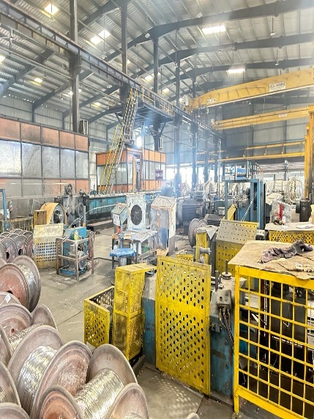
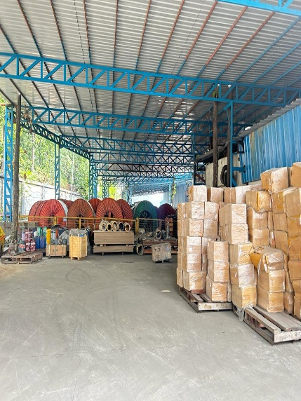
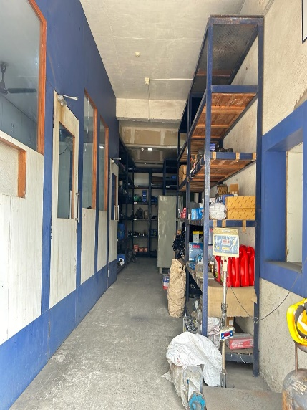

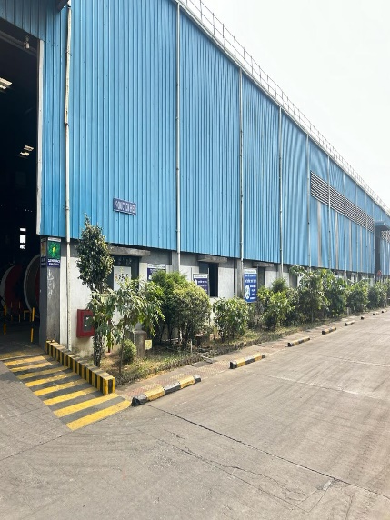
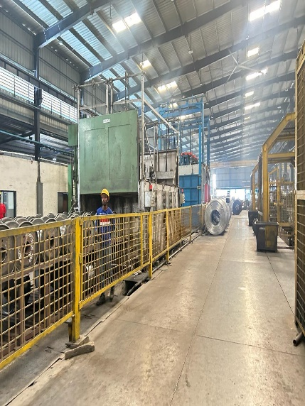
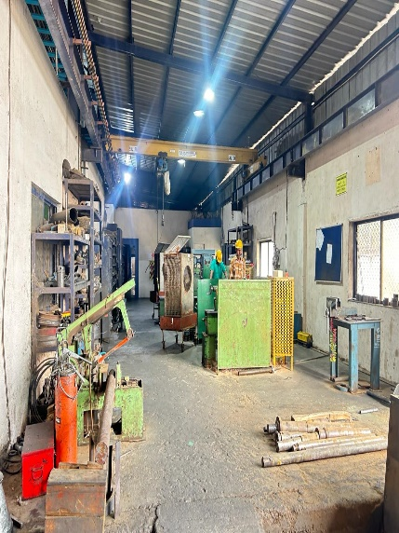

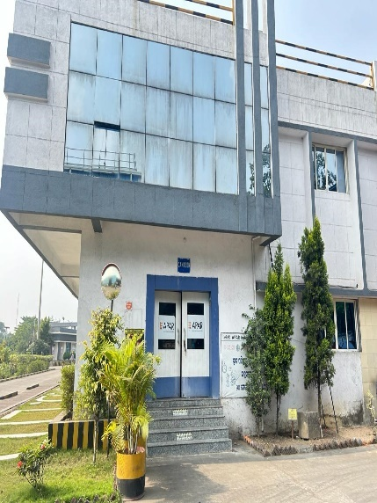
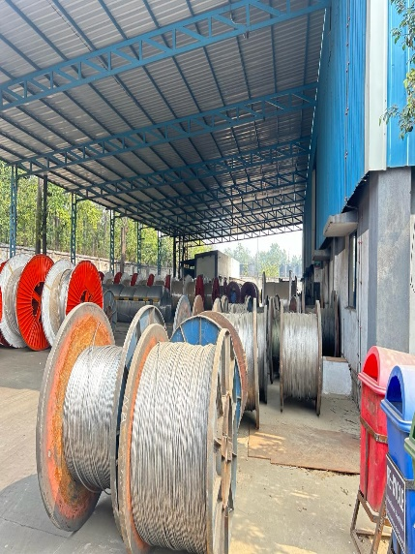
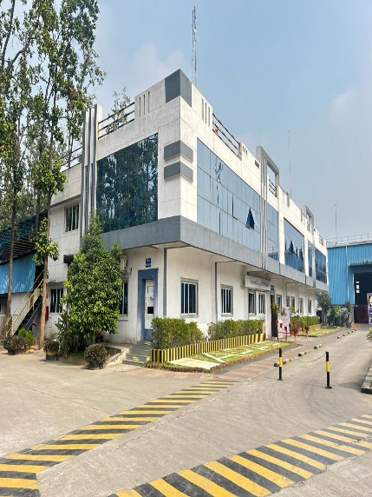

ACTUAL SITE PHOTOGRAPHS

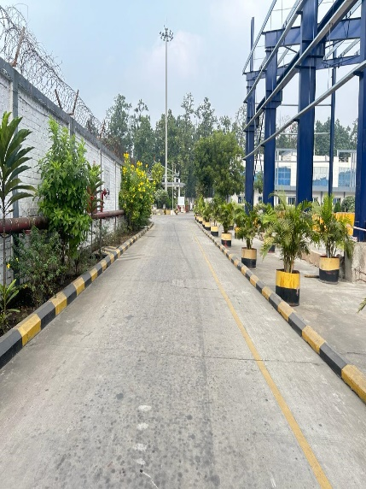
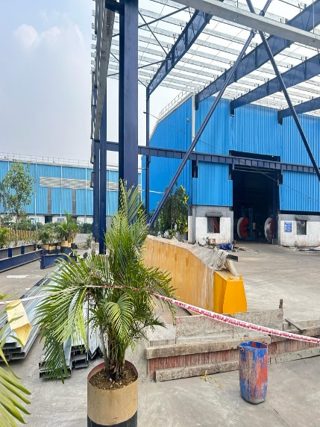
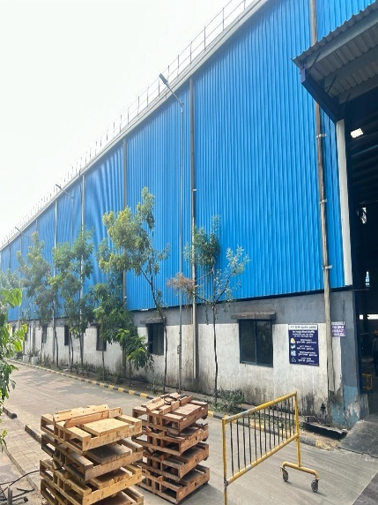

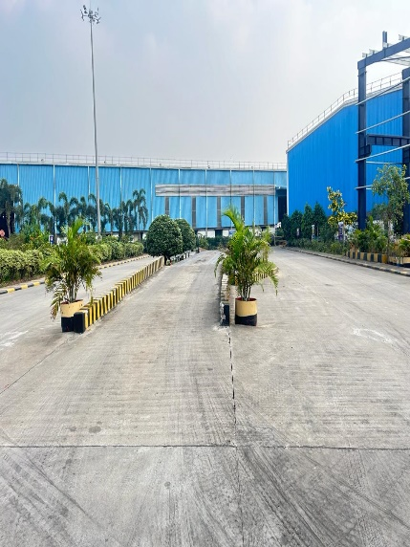
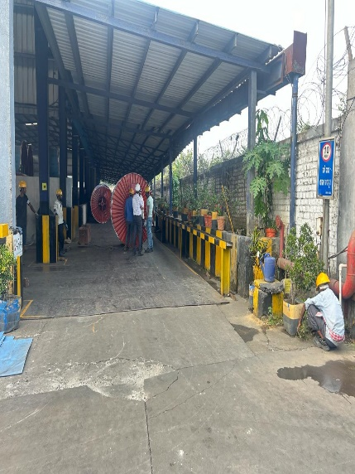
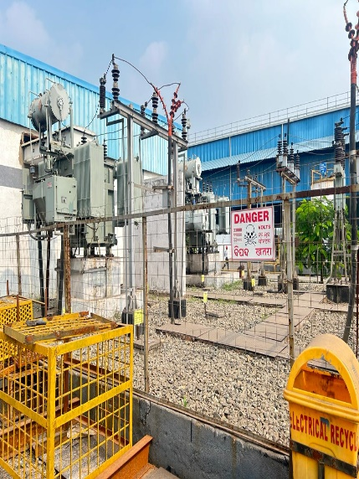

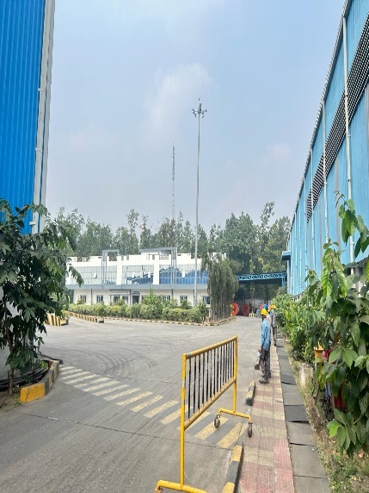
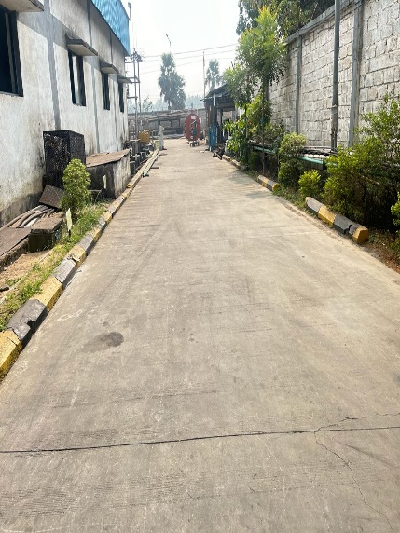
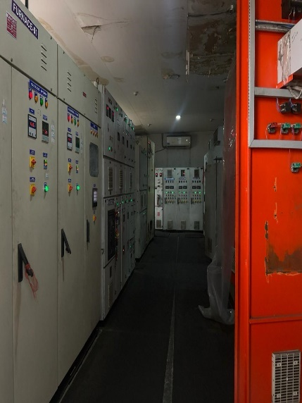

ACTUAL SITE PHOTOGRAPHS

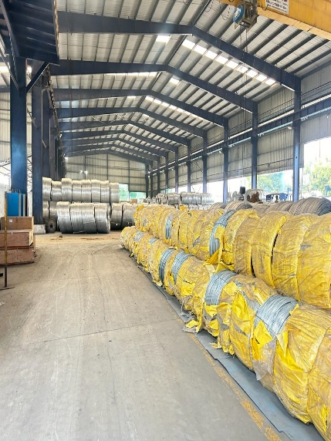
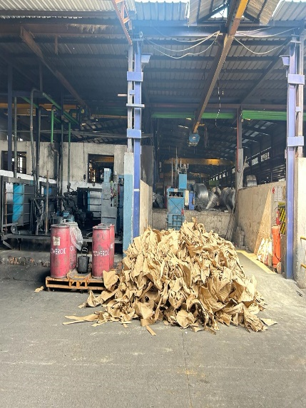
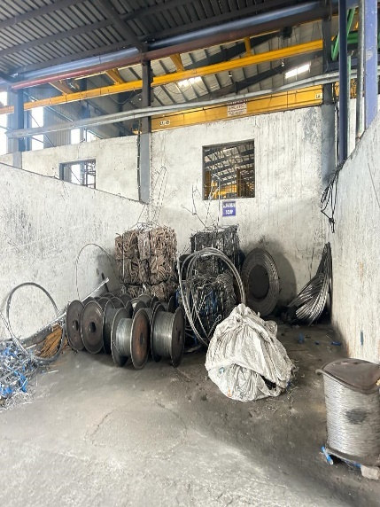

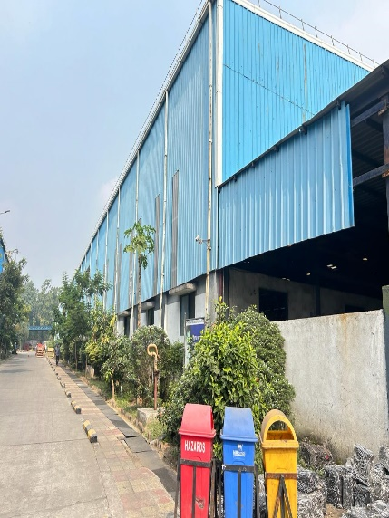
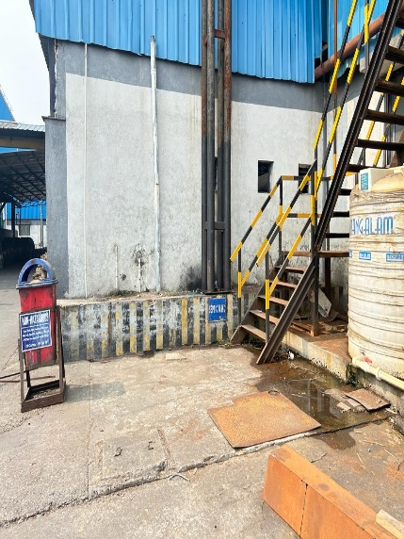
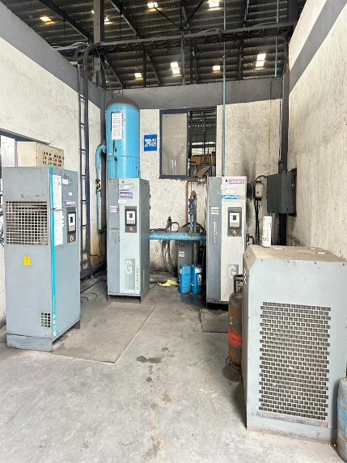

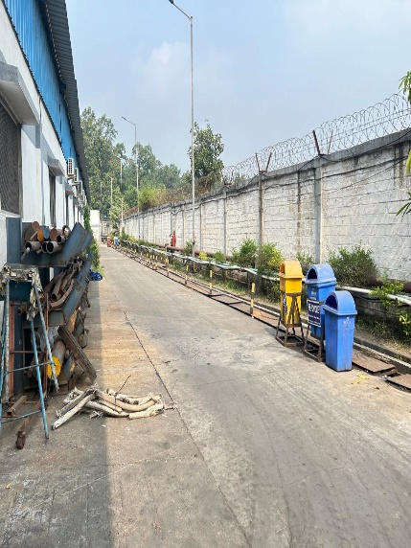
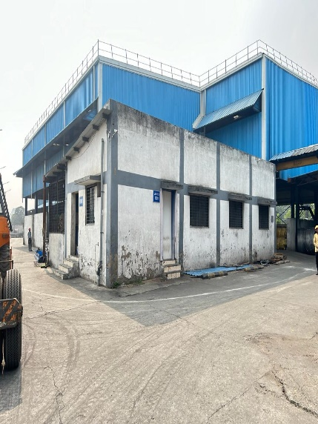
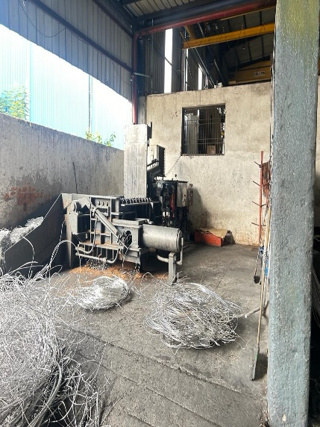

ACTUAL SITE PHOTOGRAPHS

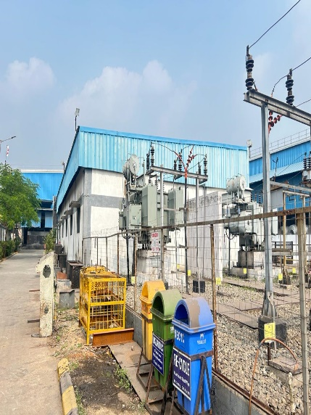
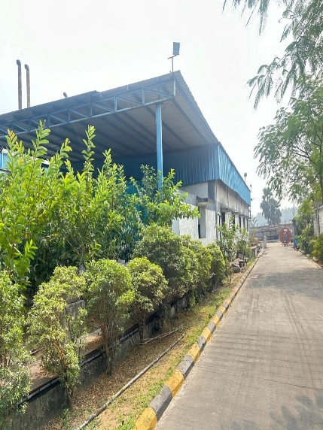
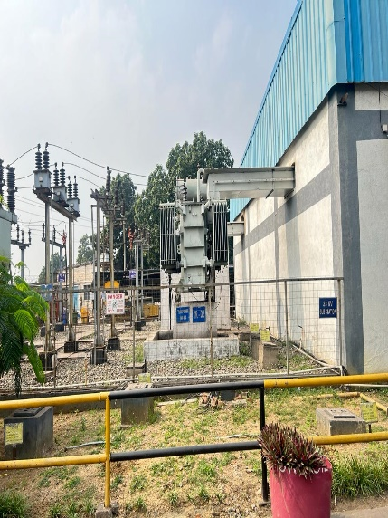

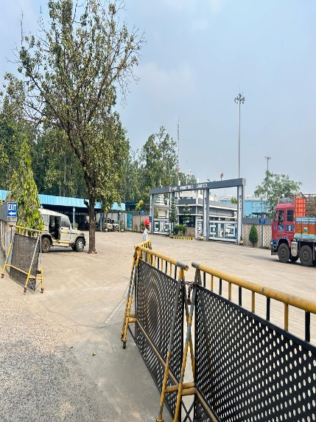
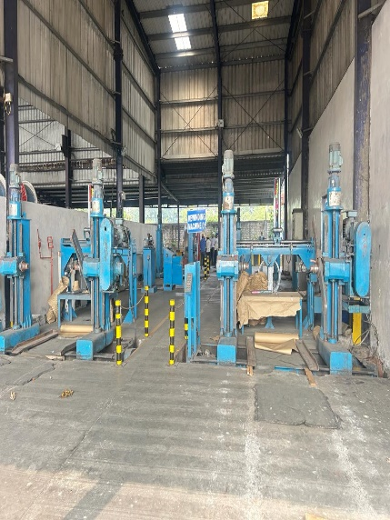
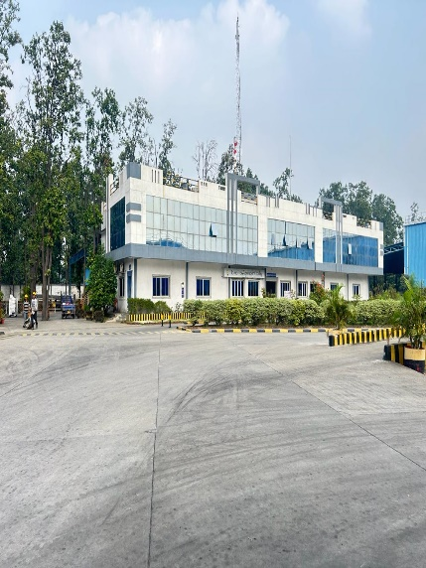

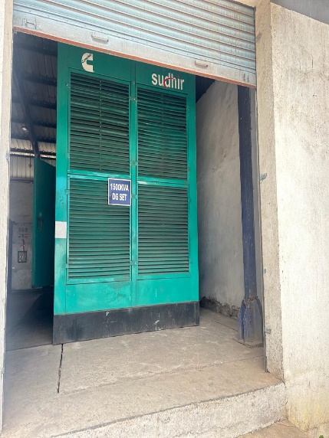
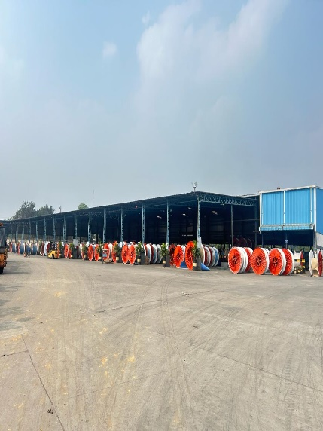
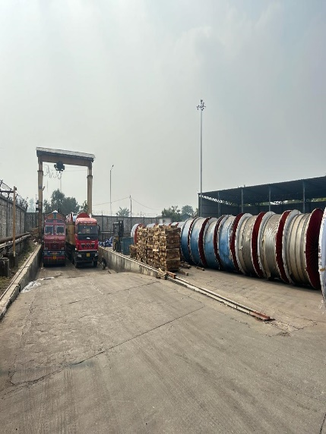

ACTUAL SITE PHOTOGRAPHS

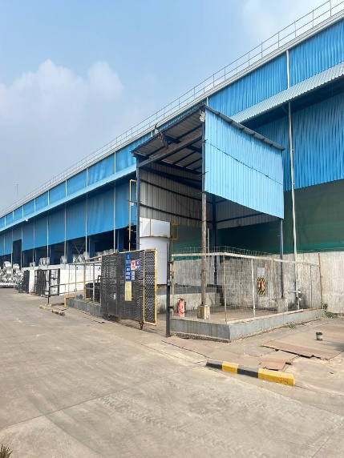
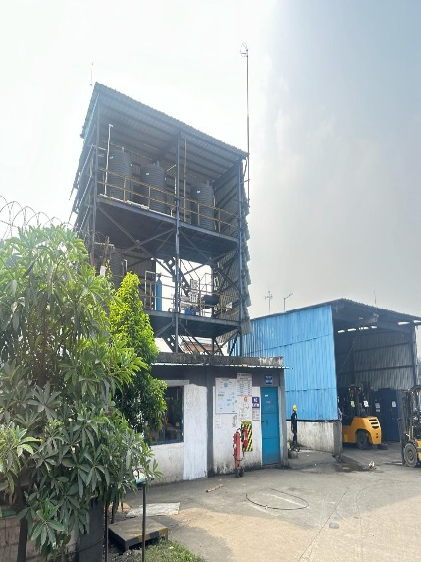
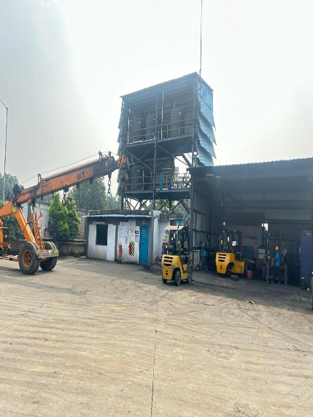

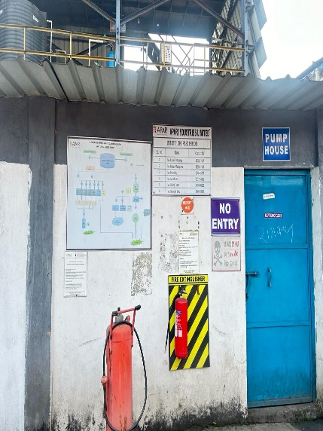
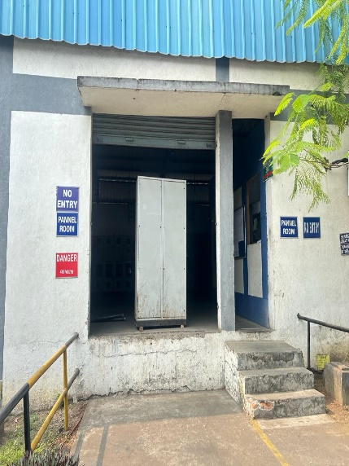
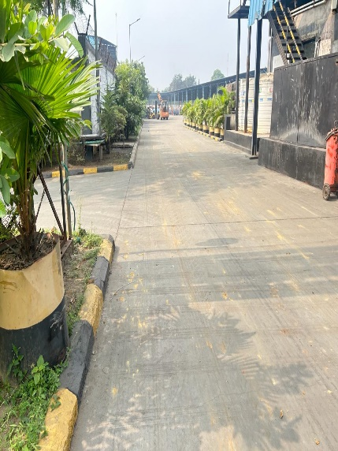

10. ROUTE MAP OF THE PROPERTY
Site u/r
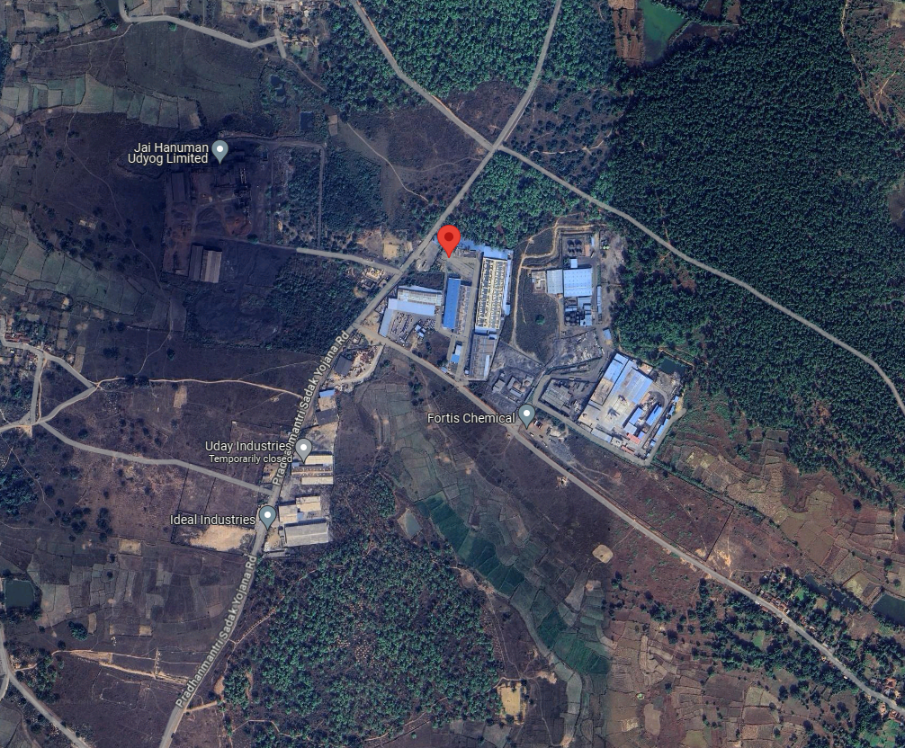

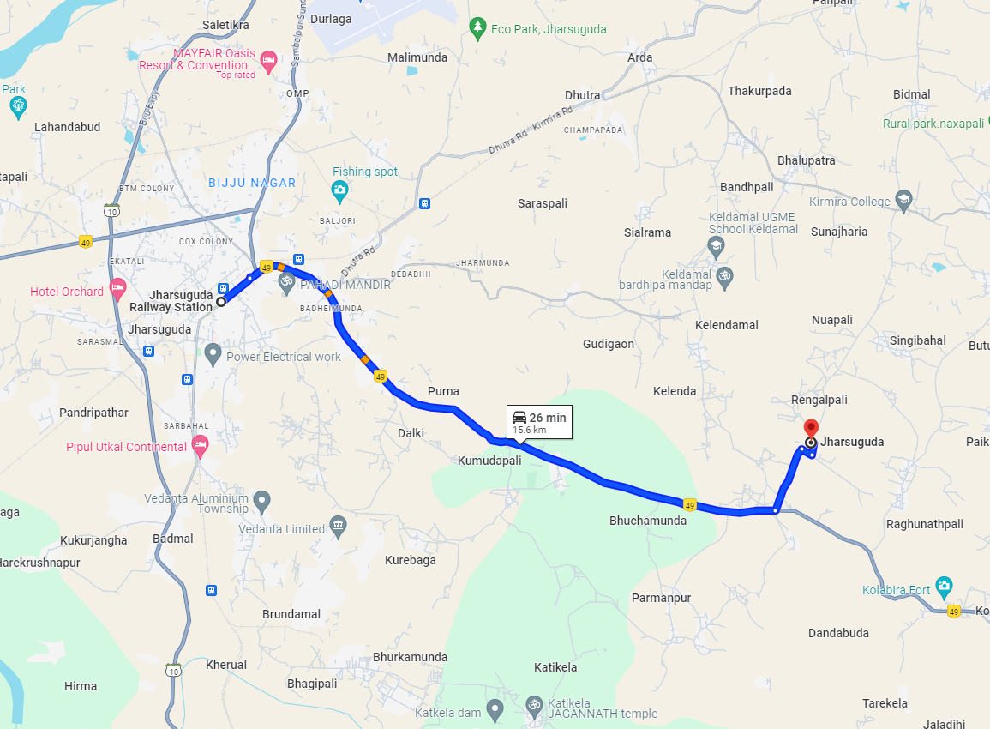

Longitude Latitude: 21°50'04.7"N 84°08'11.7"E
Note: The Blue line shows the route to site from nearest railway station (Jharsuguda– 15.6 Km.)

11. ASSUMPTIONS, CAVEATS, LIMITATION AND DISCLAIMERS
- We assume no responsibility for matters of legal nature affecting the assets appraised or the title thereto, nor do we render our opinion as to the title, which is assumed to be good and marketable.
- The assets are valued as though under responsible ownership.
- It is assumed that the assets are free of liens and encumbrances.
- It is assumed that there are no hidden or unapparent conditions of the subsoil or structure that would render it more or less valuable. No responsibility is assumed for such conditions or for engineering that might be required to discover such factors.
- There is no direct/ indirect interest in the assets valued.
- The rates for valuation of the assets are in accordance with the Govt. Approved rates and prevailing market rates.
- The statements of fact presented in the report are correct to the best of the valuer’s knowledge.
- The “valuer/ appraiser” word implies the valuer him/herself or any authorised representative of the valuer.
- The analysis & conclusions are limited only by the reported assumptions & conditions.
- It is hereby stated that the valuer has followed the professional requirements and standards in this document.
- The valuer has no interest in the subject assets.
- The value’s fee is not contingent upon any aspect of the report.
- The valuation was performed in accordance with an ethical code and performance standards.
- The valuer has satisfied professional education requirements.
- The valuer has experience in the location and category of the assets being valued.
- Both legal description and dimension are taken from sources thought to be authoritative, however, no responsibility is assumed for either unless a survey, by a competent surveyor or engineer, is furnished to the appraiser.
- This report is valid only, subject to a legal search furnished by the Bank’s lawyer or legal advisor, ascertaining the ownership & genuineness of the document and clear & marketable title in the name of the present owner/owners.
- No responsibility is to be assumed for matters legal in nature, nor is any opinion of title rendered by this report. Good title is assumed.
- In no events shall the valuer be held responsible or liable for special, direct or consequential damages, as the assignment has been completed with best efforts, available knowledge & in good intentions following professional ethics.
- I have upon the invoices provided to us by the Client for the technical specification as well as details of manufacturer for the machineries or equipment. I have assumed that no major replacement of components in any of the machineries has been done unless otherwise specific details provided to me.
- Valuation is done on physical verification and external inspection basis. The valuer does not bear any responsibility for any error which is due to the assumptions made for working condition or internal part of machines which are not inspectable without dismantling.
- The Valuer, by reasons of this report, is not required to give testimony in court, with reference to the appraised assets unless arrangements for such contingency have been previously agreed upon.
- The analysis and additional data (like company information, micro-market data) of this report is based on Publicly available information, Industry Benchmark / Standards or my Professional Judgment where the information has not been furnished by the company.
- For the purpose of this exercise, I have assumed (where sufficient ownership data has not been provided) that the assets considered under this exercise are owned by the Company and has a clear and marketable title and is free from any legal and physical encumbrances, disputes, claims and other statutory liabilities and the requisite planning approvals from appropriate authorities has already been pursued; if any, I do not bear any responsibility for the same.
- The condition assessment and the estimation of useful life is based on industry standards as any visual observations / review of maintenance was beyond the scope of work.
- The inspection, due diligence and condition assessment of the asset was made by individuals generally familiar with valuation assessment of such assets. However, I do not opine nor am I responsible for its conformity to any health, safety, environmental or any other regulatory requirements that were not readily apparent to my team of experts during their inspection.
- This valuation is valid only for the purpose mentioned in this report; and neither intended nor valid to be used for any other purposes.
- The valuation is not a precise science and the conclusions arrived at in many cases will be subjective and dependent on the exercise of individual judgement. Hence, there is no indisputable single value. Whilst I consider my conclusions to be both reasonable and defensible based on the information available to us, others may place a different value based on the same information.
- I reserve my rights to change my conclusion at later date, if it is found that the data provided to us was not reliable, complete or accurate in any material aspect.
- For the purpose of this valuation report, the fair market value and fair value of the assets may be considered to be synonymous.
- All figures are in INR, unless mentioned otherwise. Further, round off errors (if any) arising from calculations or conversions to millions/ other units have negligible impact on the final value, therefore, can be ignored.

12. DEFINITION OF VALUE FOR THIS SPECIFIC PURPOSE
This exercise is to assess Fair Market Value of the property under reference as on 19th April 2024.

The term Fair Market Value is defined as
“The most probable price, as of a specified date, in cash, terms equivalent to cash, or in other precisely revealed terms for which the specified property rights would sell after reasonable exposure in a competitive market under all conditions requisite to a fair sale, with the buyer and seller each acting prudently knowledgeably and for self-interest assuming that neither is under undue duress”.
Fundamental assumptions and conditions presumed in this definition are:
- Buyer and seller are motivated by self-interest.
- Buyer and seller are well informed and are acting prudently.
- The property is exposed for a reasonable time on the open market.
- Payment is made in cash or equivalent or in specified financing terms.

DECLARATION OF PROFESSIONAL FEES CHARGED
We hereby declare that our professional fees are not contingent upon the valuation findings. However, if the statute AND/OR client demands that, the fees should be charged on the percentage of assessed value then, with the full knowledge of the AND/OR end user, it is being charged accordingly.

13. VALUATION OF MOVABLE ASSETS

Considering various parameters recorded, existing economic scenario, and the information that is available with reference to the industrial development and method selected for valuation, we are of the opinion that, the assets can be assessed and valued for particular purpose at:
Particulars | Fair Market Value | Realizable Value | Distress Sale Value
Movable Assets | ₹ 43.28 Crores | ₹ 38.95 Crores | ₹ 34.62 Crores
Total | ₹ 43.28 Crores | ₹ 38.95 Crores | ₹ 34.62 Crores

Place: Thane
Date: 19.04.2024
For Vastukala Consultants (I) Pvt. Ltd.

Umang Ashwin Patel
Govt. Reg. Valuer
Chartered Engineer (India)
Reg. No. CAT-VII-A-5062

