Vastu/Nashik/05/2024/008703/2306317
15/7-177-RPBS
Date: 15.05.2024

To, `
The Branch Manager,
Bank of Baroda
Regional Office Nashik Road Branch
BSNL Building, Datta Mandir Road, Nashik Road,
Nashik -422 101, State - Maharashtra, Country - India.

Sub: Vetting of Extra Amenities

Sir,

With reference to above subject, we have evaluated the Extra Amenities for Residential Row House No.5, Ground + First Floor, " Shivdarshan Row House ", Survey No.281/2/2, Plot No.30+31+32+33/4, Near Hotel Nanacha Mala, Konark Nagar, Village – Adgaon, Taluka – Nashik, District - Nashik, PIN Code – 422 003, State – Maharashtra, Country – India belongs to M/s. Akshar Buildcon Name of Proposed Purchaser: Shri.Nilesh Vasant Suryavanshi & Sau.Punam Nilesh Suryavasnshi

We have verified the rates quoted as per current market rates. Details of work and Extra Amenities considered as per copy of Agreement for Extra Amenities issued by Shri.Nilesh Vasant Suryavanshi & Sau.Punam Nilesh Suryavasnshi (First Party) and Shri. Kishor Vallabhbhai Rasdiya. (Second Party) received on dated April 2024. The Extra Amenities amount is Rs.5,20,000/- (Rupees Five Lakh Twenty Thousand Only)

The said Cost Vetting Certificate is valid upto next 6 months Only.

Thanking you

Sincerely yours

Manoj B. Chalikwar
Registered Valuer
Chartered Engineer (India)
Reg. No. CAT-I-F-1763
Reg. No. IBBI/RV/07/2018/10366
BOB Empanelment No.: ZO:MZ:ADV:46:941
Encl: Valuation report.

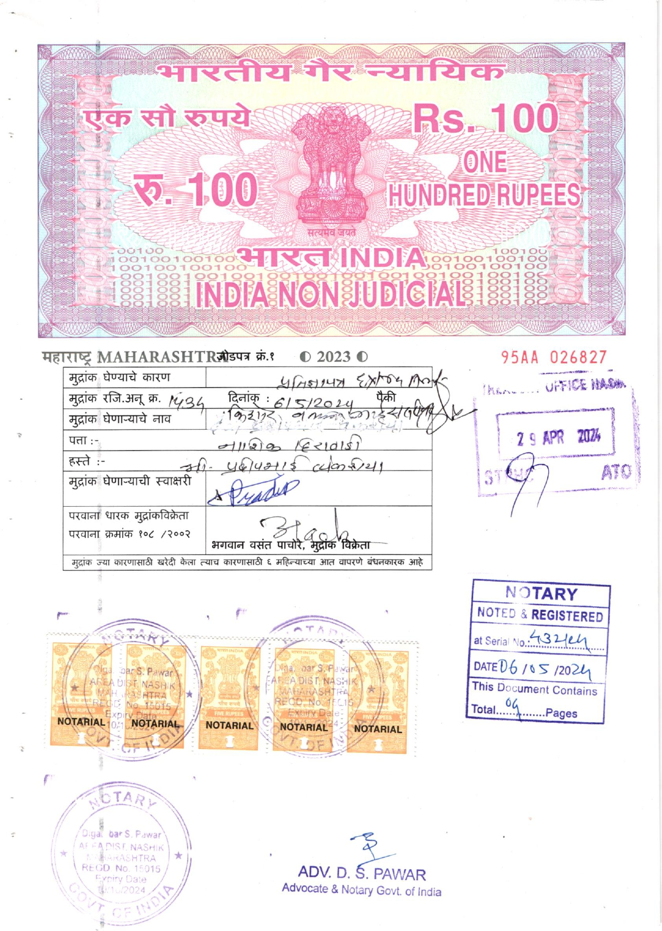
Agreement for Extra Amenities
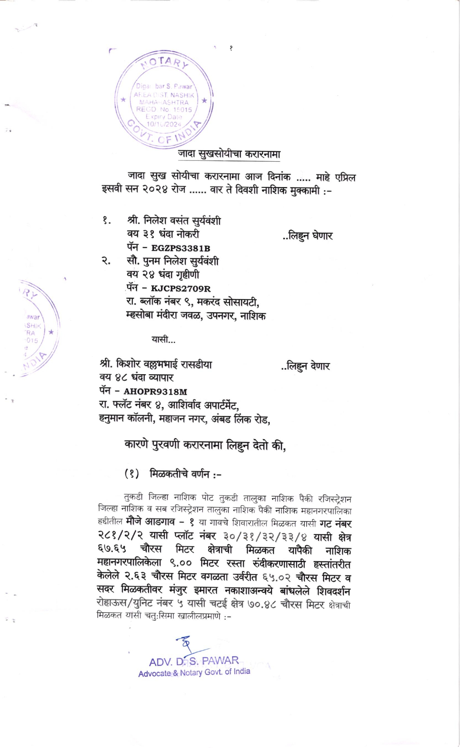

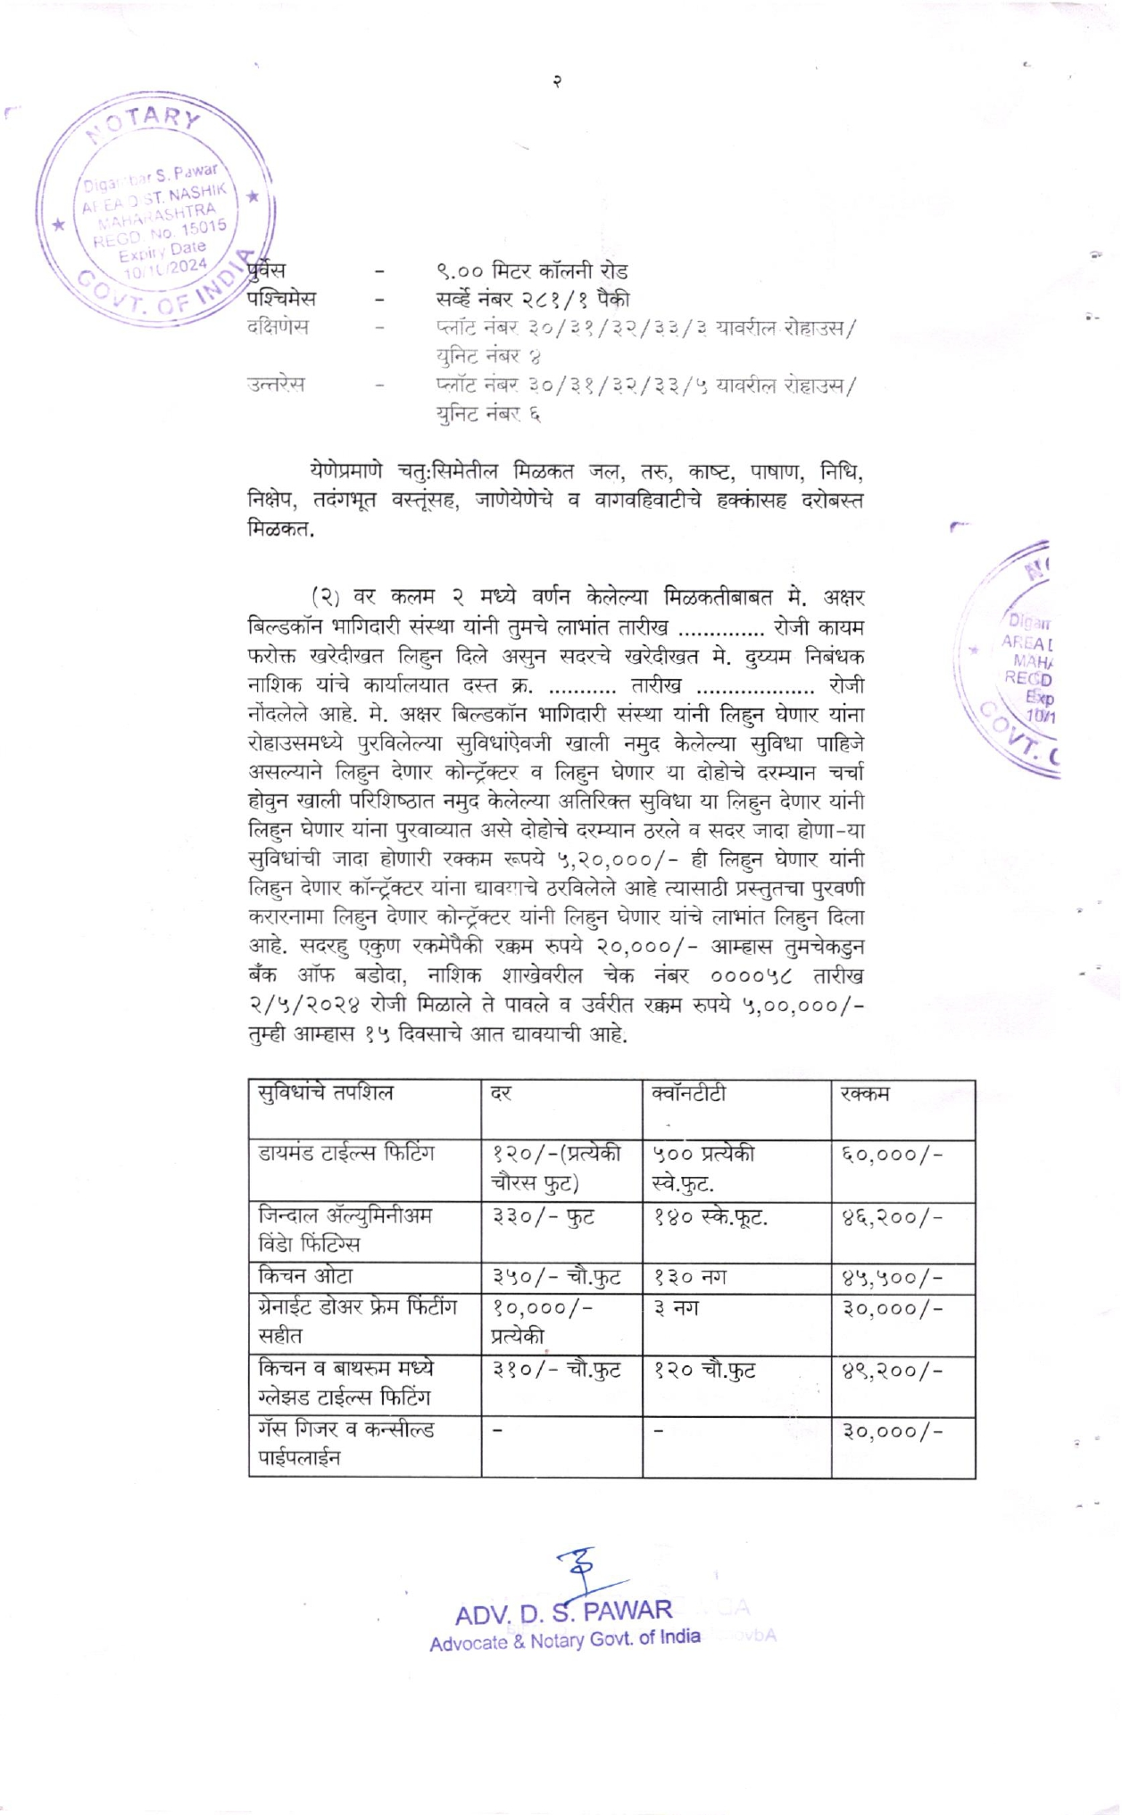
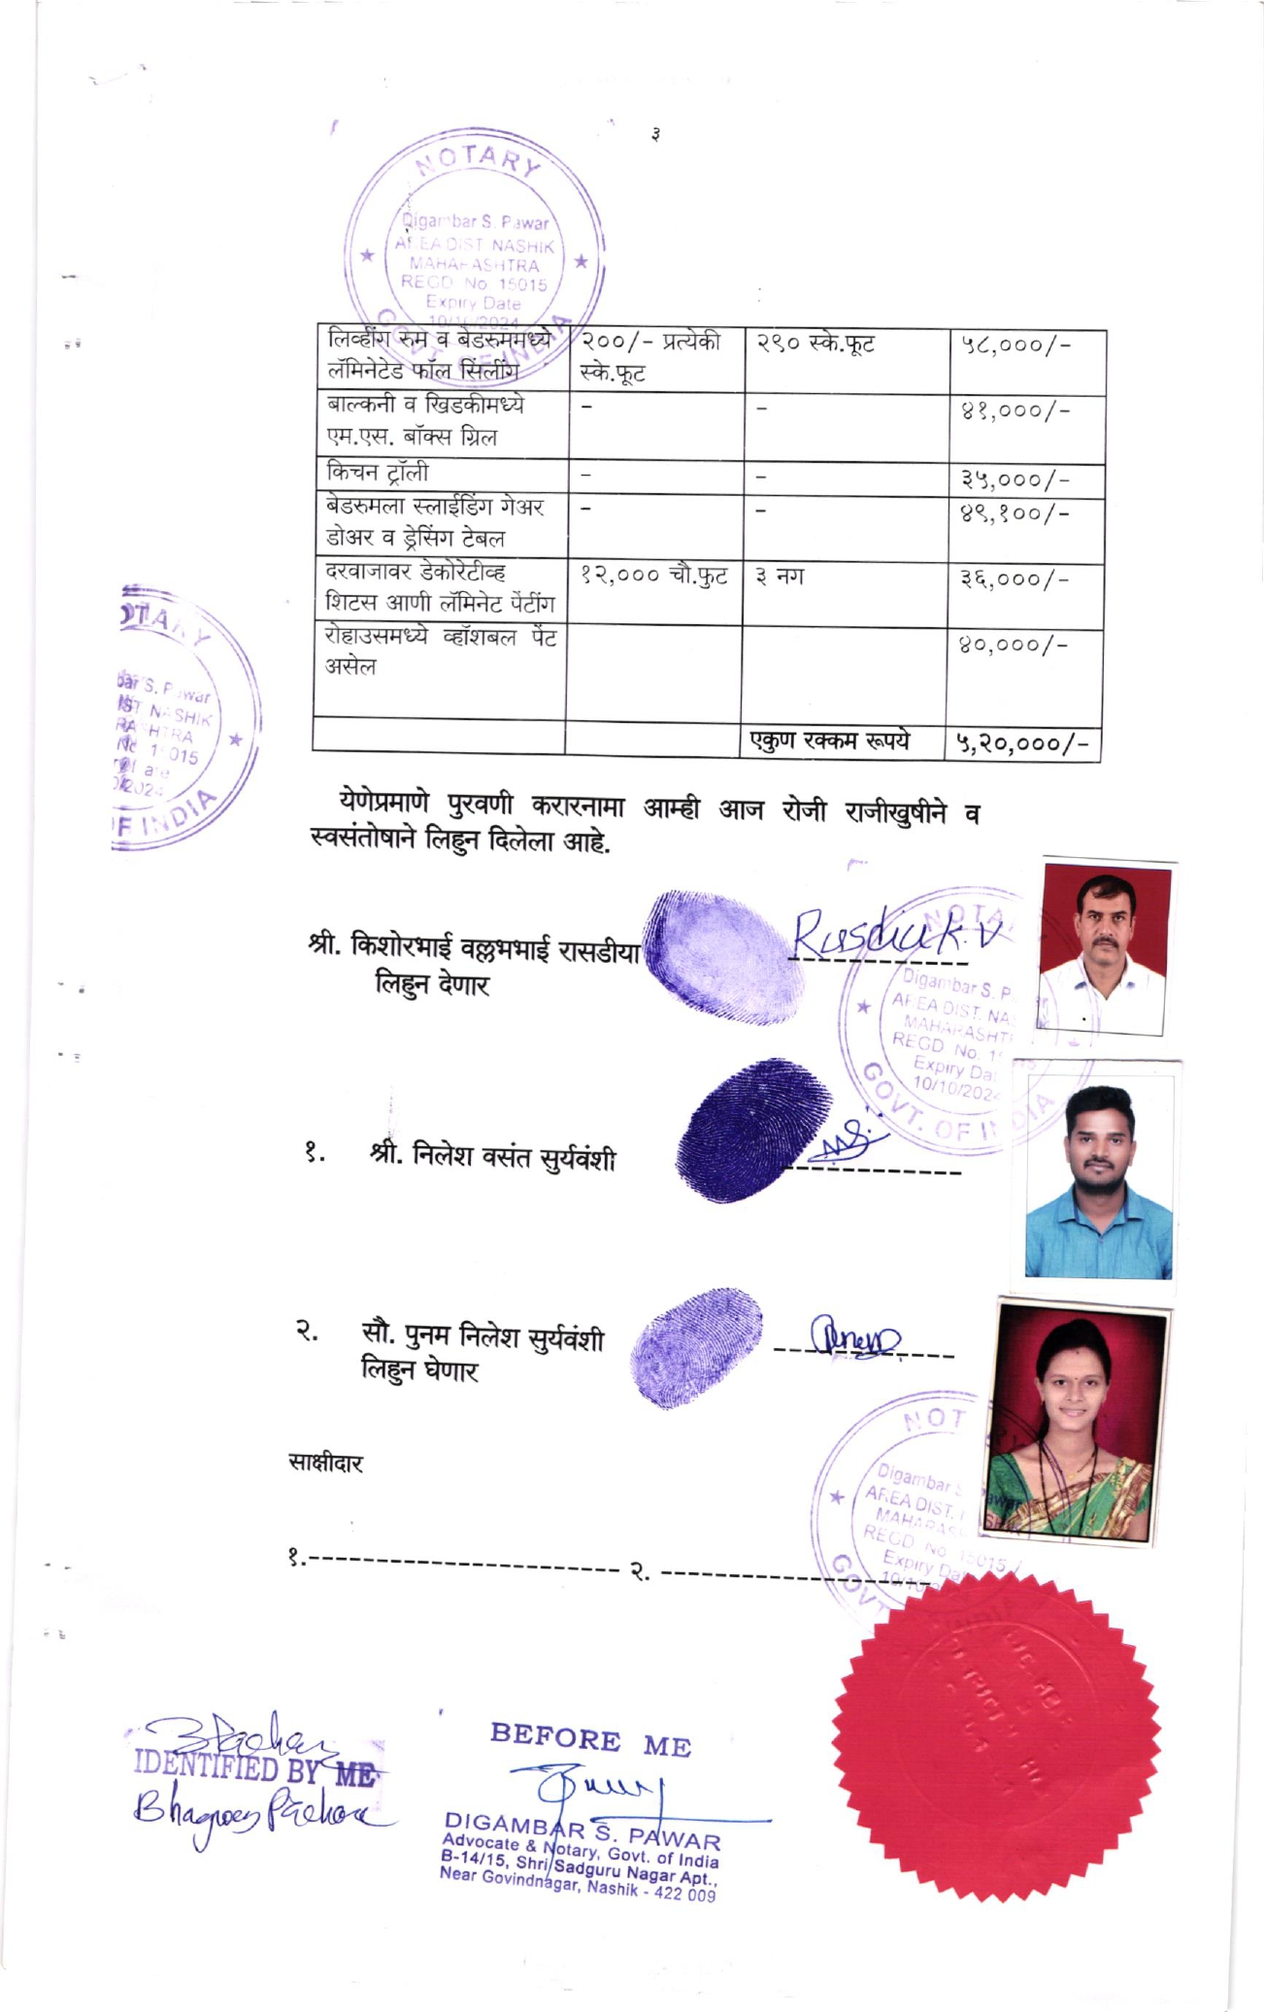

The Extra Amenities amount is Rs.5,20,000/- (Rupees Five Lakh Twenty Thousand Only)

