**Valuation Report of the Immovable Property**

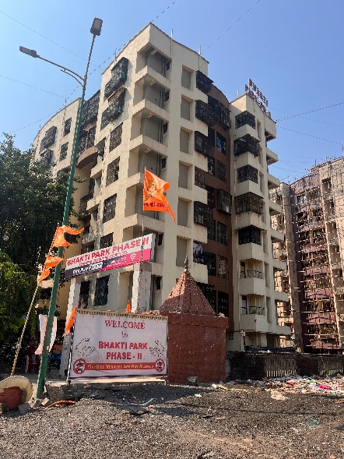

**Details of the property under consideration:**

Name of Owner: **Mr. Avinash Gopi Sharma**

Commercial Shop No. 04, Ground Floor, Building No. 1, Wing – B, **"Bhakti Park Phase – II Building No.1 Co-Op. Hsg. Soc. Ltd.",** Near Anand Nagar Bus Stop, Ghodbunder Road, Village – Owale,

Thane (West), Thane – 400 615, State – Maharashtra, Country – India.

# Latitude Longitude: 19°15’49.8”N 72°57’56.7”E

**Intended User:**

**Cosmos Bank**

**Ghodbandar Road**

Shop No. 4, Cosmos Heritage, Tikujini Wadi, Off Ghodbandar Road, Manpada, Thane (West),

Thane - 400 610, State - Maharashtra, Country - India.

Vastu/Mumbai/05/2024/5648/2304108

21/15-337-PRBS

Date: 15.05.2024

**VALUATION OPINION REPORT**

The property bearing Commercial Shop No. 04, Ground Floor, Building No. 1, Wing – B, **"Bhakti Park Phase – II Building No.1 Co-Op. Hsg. Soc. Ltd.",** Near Anand Nagar Bus Stop, Ghodbunder Road, Village – Owale, Thane (West), Thane – 400 615, State – Maharashtra, Country – India belongs to **Mr. Avinash Gopi Sharma.**

|  |  |
| --- | --- |
| **Boundaries of the property:** | |
| North | Slum Area |
| South | Open Plot |
| East | House Rakesh Apartment |
| West | Internal Road |
|  |  |

Considering various parameters recorded, existing economic scenario, and the information that is available with reference to the development of neighbourhood and method selected for valuation, we are of the opinion that, the property premises can be assessed and valued for banking purpose at **` 1,08,09,040.00 (Rupees One Crore Eight Lakh Nine Thousand Forty Only).**

The valuation of the property is based on the documents produced by the concern. Legal aspects have not been taken into considerations while preparing this report.

Hence certified

**Manoj B. Chalikwar**

Registered Valuer

Chartered Engineer (India)

Reg. No. CAT-I-F-1763

Cosmos Emp. No. H.O./Credit/67/2019-20

Encl: Valuation report in Form – 01

Commercial Shop No. 04, Ground Floor, Building No. 1, Wing – B, **"Bhakti Park Phase – II Building No.1 Co-Op. Hsg. Soc. Ltd.",** Near Anand Nagar Bus Stop, Ghodbunder Road, Village – Owale,

Thane (West), Thane – 400 615, State – Maharashtra, Country – India.

***Form 0-1***

*(See Rule 8 D)*

REPORT OF VALUATION OF IMMOVABLE PROPERTY (OTHER THAN AGRICULTURAL LANDS, PLANTATIONS, FORESTS, MINES AND QUARRIES)

**GENERAL:**

|  |  |  |  |
| --- | --- | --- | --- |
| 1 | Purpose for which the valuation is made | | To assess the Fair Market Value as on 15.05.2024 for Bank Loan Purpose |
| 2 | Date of inspection | | 14.05.2024 |
| 3 | Name of the owner/ owners | | **Mr. Avinash Gopi Sharma** |
| 4 | If the property is under joint Ownership / co-ownership, share of each such owner. Are the shares undivided? | | Sole Ownership |
| 5 | Brief description of the property | | Commercial Shop No. 04, Ground Floor, Building No. 1, Wing – B, **"Bhakti Park Phase – II Building No.1 Co-Op. Hsg. Soc. Ltd.",** Near Anand Nagar Bus Stop, Ghodbunder Road, Village – Owale, Thane (West), Thane – 400 615, State – Maharashtra, Country – India. |
| 6 | Location, street, ward no | | Near Anand Nagar Bus Stop, Ghodbunder Road |
| 7 | Survey/ Plot no. of land | | Old Survey No. 93/3, 93/6, New Survey No. 120/6/A, 120/, 120/3 of Village Owale |
| 8 | Is the property situated in residential/ commercial/ mixed area/ industrial area? | | Residential cum Commercial Area |
| 9 | Classification of locality-high class/ middle class/poor class | | Middle Class |
| 10 | Proximity to civic amenities like schools, Hospitals, Offices, market, cinemas etc. | | All the amenities are available in the vicinity |
| 11 | Means and proximity to surface communication by which the locality is served | | Served by Buses, Taxies, Auto and Private cars |
|  | **LAND** | |  |
| 12 | Area of land supported by documentary proof. Shape, dimension and physical features | | Carpet Area in Sq. Ft. = 360.00  (Area as per Actual site measurement)  **Carpet Area in Sq. Ft. = 358.00**  **(Area as per Agreement for Sale)**  Built up Area in sq. Ft. = 430.00  (Area as per Agreement for Sale) |
| 13 | Roads, Streets or lanes on which the land is abutting | | Near Anand Nagar Bus Stop, Ghodbunder Road |
| 14 | If freehold or leasehold land | | Free hold |
| 15 | If leasehold, the name of Lessor/lessee, nature of lease, date of commencement and termination of lease and terms of renewal of lease.  (i) Initial premium  (ii) Ground rent payable per annum  (iii) Unearned increase payable to the Lessor in the event of sale or transfer | | N.A. |
| 16 | Is there any restriction covenant in regard to use of land? If so attach a copy of the covenant. | | As per documents |
| 17 | Are there any agreements of easements? If so attach a copy of the covenant | | Information not available |
| 18 | Does the land fall in an area included in any Town Planning Scheme or any Development Plan of Government or any statutory body? If so give Particulars. | | Information not available |
| 19 | Has any contribution been made towards development or is any demand for such contribution still outstanding. | | Information not available |
| 20 | Has the whole or part of the land been notified for acquisition by government or any statutory body? Give date of the notification. | | N.A. |
| 21 | Attach a dimensioned site plan | | N.A. |
|  | **IMPROVEMENTS** | |  |
| 22 | Attach plans and elevations of all structures standing on the land and a lay-out plan. | | Information not available |
| 23 | Furnish technical details of the building on a separate sheet (The Annexure to this form may be used) | | Attached |
| 24 | Is the building owner occupied/tenanted/both? | | Vacant |
| 25 | If the property owner occupied, specify portion and extent of area under owner-occupation | | Fully |
| 26 | What is the Floor Space Index permissible and Percentage actually utilized? | | Floor Space Index permissible - As per TMC norms  Percentage actually utilized – Details not available |
|  | **RENTS** | |  |
|  | (i) | Names of tenants/ lessees/ licensees, etc | N.A. |
|  | (ii) | Portions in their occupation | N.A. |
|  | (iii) | Monthly or annual rent /compensation/license fee, etc. paid by each | ` 27,000.00 Expected rental income per month |
|  | (iv) | Gross amount received for the whole property | N.A. |
| 27 | Are any of the occupants related to, or close to business associates of the owner? | | Information not available |
| 28 | Is separate amount being recovered for the use of fixtures, like fans, geysers, refrigerators, cooking ranges, built-in wardrobes, etc. or for services charges? If so, give details | | N.A. |
| 29 | Give details of the water and electricity charges, If any, to be borne by the owner | | N.A. |
| 30 | Has the tenant to bear the whole or part of the cost repairs and maintenance? Give particulars | | N.A. |
| 31 | If a lift is installed, who is to bear the cost of maintenance and operation- owner or tenant? | | N.A. |
| 32 | If a pump is installed, who is to bear the cost of maintenance and operation- owner or tenant? | | N.A. |
| 33 | Who has to bear the cost of electricity charges for lighting of common space like entrance hall, stairs, passage, compound, etc. owner or tenant? | | N.A. |
| 34 | What is the amount of property tax? Who is to bear it? Give details with documentary proof | | Information not available |
| 35 | Is the building insured? If so, give the policy no., amount for which it is insured and the annual premium | | Information not available |
| 36 | Is any dispute between landlord and tenant regarding rent pending in a court of rent? | | N.A. |
| 37 | Has any standard rent been fixed for the premises under any law relating to the control of rent? | | N.A. |
|  | **SALES** | |  |
| 38 | Give instances of sales of immovable property in the locality on a separate sheet, indicating the Name and address of the property, registration No., sale price and area of land sold. | | As per sub registrar of assurance records |
| 39 | Land rate adopted in this valuation | | N. A. as the property under consideration is a Commercial Shop in an apartment. The rate is considered as composite rate. |
| 40 | If sale instances are not available or not relied up on, the basis of arriving at the land rate | | N.A. |
|  | **COST OF CONSTRUCTION** | |  |
| 41 | Year of commencement of construction and year of completion | | Year of Construction – 2008 (As per Occupancy Certificate) |
| 42 | What was the method of construction, by contract/By employing Labour directly/ both? | | N.A. |
| 43 | For items of work done on contract, produce copies of agreements | | N.A. |
| 44 | For items of work done by engaging Labour directly, give basic rates of materials and Labour supported by documentary proof. | | N.A. |
| 45 | **Remarks** | |  |

***PART II- VALUATION***

**GENERAL:**

Under the instruction of Cosmos Bank, Ghodbandar Road Branch, we have valued Commercial Shop No. 04, Ground Floor, Building No. 1, Wing – B, **"Bhakti Park Phase – II Building No.1 Co-Op. Hsg. Soc. Ltd.",** Near Anand Nagar Bus Stop, Ghodbunder Road, Village – Owale, Thane (West), Thane – 400 615, State – Maharashtra, Country – India belongs to **Mr. Avinash Gopi Sharma.**

**We are in receipt of the following documents:**

|  |  |
| --- | --- |
| 1 | Copy of Agreement for Sale dated 18.04.2024 between Mr. Chandulal Bhavanji Nakarani (The Transferor) And Mr. Avinash Gopi Sharma (The Transferee). |
| 2 | Copy of Occupancy Certificate V.P. No. 2005 / 5B / TMC / TDD / 595 Dated 19.12.2008 issued by Thane Municipal Corporation. |
| 3 | Copy of Commencement Certificate V.P. No. 2005 / 58 / TMC / TDD / 36 dated 19.04.2006 issued by issued by Thane Municipal Corporation. |

**LOCATION:**

The said building is located Old Survey No. 93/3, 93/6, New Survey No. 120/6/A, 120/, 120/3 of Village Owale Thane (West), Thane – 400 615. The property falls in Residential cum commercial Zone. It is at a travelling distance 9.2 Km. from Thane railway station.

**BUILDING:**

The building under reference is having Ground + 7th upper floors. It is a R.C.C. Framed Structure framed with 9" thick external walls and 6" thick internal POP finished brick walls. The walls are having sand faced plaster from outside. The staircase is of R.C.C. with R.C.C. trades and risers with chequered tile floor finish. The building external condition is Good. The building is used for residential cum commercial purpose. Ground Floor is having 6 Commercial Shops. The building is having 1 Lift.

**Commercial Shop:**

The Commercial Shop under reference is situated on the Ground Floor. It consists of Working Area only. The Commercial Shop is ﬁnished with Ceramic flooring, M.S. Rolling Shutter, Casing electrification & Open Plumbing.

The internal condition of Shop is normal.

**Valuation as on 15th May 2024**

|  |  |
| --- | --- |
| **The Carpet Area of the Commercial Shop** | **358.00 Sq. Ft.** |

**Deduct Depreciation:**

|  |  |  |
| --- | --- | --- |
| Year of Construction of the building | : | 2008 (As per Occupancy Certificate) |
| Expected total life of building | : | 60 Years |
| Age of the building as on 2024 | : | 16 Years |
| Cost of Construction | : | 430.00 Sq. Ft. X ` 2,800.00 = ` 12,04,000.00 |
| Depreciation | : | 24.00% |
| Amount of depreciation | : | ` 2,88,960.00 |
| Guideline rate obtained from the Stamp Duty Ready Reckoner for new property | : | ` 87,800.00 Sq. M.  i.e., ` 8,157.00 Sq. Ft. |
| Guideline rate (After Depreciate) |  | ` 76,344.00 Sq. M.  i.e., ` 7,093.00 Sq. Ft. |
| Prevailing market rate | : | ₹ 31,000.00 per Sq. Ft. |
| **Value of property as on 15.05.2024** | : | 358.00 Sq. Ft. X ` 31,000.00 = ` 1,10,98,000.00 |

(Area of property x market rate of developed land & Residential premises as on 2022 published in The Indian Valuer’s Directory and Reference Book for purpose of valuation. – Depreciation)

|  |  |  |
| --- | --- | --- |
| **Depreciated fair value of the property**  **as on 15.05.2024** | **:** | **` 1,10,98,000.00 ` - ` 2,88,960.00 =**  **` 1,08,09,040.00** |
| **Value of the property** | **:** | **` 1,08,09,040.00** |
| **The realizable value of the property** | **:** | **` 97,28,136.00** |
| **Distress value of the property** | **:** | **` 86,47,232.00** |
| **Insurable value of the property (430.00 X 2,800.00)** | **:** | **` 12,04,000.00** |
| **Guideline value of the property (430.00 X 7,093.00)** |  | **` 30,49,990.00** |

Taking into consideration above said facts, we can evaluate the value of Commercial Shop No. 04, Ground Floor, Building No. 1, Wing – B, **"Bhakti Park Phase – II Building No.1 Co-Op. Hsg. Soc. Ltd.",** Near Anand Nagar Bus Stop, Ghodbunder Road, Village – Owale, Thane (West), Thane – 400 615, State – Maharashtra, Country – India for this particular purpose at **` 1,08,09,040.00 (Rupees One Crore Eight Lakh Nine Thousand Forty Only).**

**NOTES**

1. I, Manoj B. Chalikwar with my experience and ability to judgment I am of the considered opinion that the fair market value of the property as on 15th May 2024 is ` 1,08,09,040.00 (Rupees One Crore Eight Lakh Nine Thousand Forty Only). Value varies with time and purpose and hence this value should not be referred for any purpose other than mentioned in this report.
2. This valuation is done on the basis of information, which the valuer has obtained by information provided by the client about the premises and location of the surrounding area and also prevailing rates in the surrounding area, and further subject to document as mentioned in valuation report.
3. This valuer should not be held responsible for authentication of documents, clear title and other such related matters. For that purpose Latest Legal Opinion should be sought.

*PART III- DECLARATION*

I hereby declare that

* + 1. The information furnished in part I is true and correct to the best of my knowledge and belief;
    2. I have no direct or indirect interest in the property valued:

ANNEXURE TO FORM 0-1

Technical details Main Building

|  |  |  |
| --- | --- | --- |
| 1. | No. of floors and height of each floor | Ground + 7th upper floors |
| 2. | Plinth area floor wise as per IS 3361-1966 | N.A. as the said property is a Commercial Shop situated on Ground Floor |
| 3 | Year of construction | 2008 (As per Occupancy Certificate) |
| 4 | Estimated future life | 44 Years Subject to proper, preventive periodic maintenance & structural repairs |
| 5 | Type of construction- load bearing walls/RCC frame/ steel frame | R.C.C. Framed Structure |
| 6 | Type of foundations | R.C.C. Foundation |
| 7 | Walls | All external walls are 9" thick and partition walls are 6" thick. |
| 8 | Partitions | 6” thick brick wall |
| 9 | Doors and Windows | M.S. Rolling Shutter |
| 10 | Flooring | Ceramic tiles flooring |
| 11 | Finishing | Cement plastering |
| 12 | Roofing and terracing | R.C.C. Slab |
| 13 | Special architectural or decorative features, if any | No |
| 14 | |  |  | | --- | --- | | (i) | Internal wiring – surface or conduit | | (ii) | Class of fittings: Superior/ Ordinary/ Poor. | | Casing Caping electrification  Open plumbing |
| 15 | Sanitary installations   |  |  | | --- | --- | | (i) | No. of water closets | | (ii) | No. of lavatory basins | | (iii) | No. of urinals | | (iv) | No. of sink | | As per Requirement |
| 16 | Class of fittings: Superior colored / superior white/ordinary. | Ordinary |
| 17 | Compound wall  Height and length  Type of construction | 6'.0" High, R.C.C. column with B. B. masonry wall |
| 18 | No. of lifts and capacity | 1 Lift |
| 19 | Underground sump – capacity and type of construction | R.C.C tank |
| 20 | Over-head tank  Location, capacity  Type of construction | R.C.C tank on terrace |
| 21 | Pumps- no. and their horse power | May be provided as per requirement |
| 22 | Roads and paving within the compound approximate area and type of paving | Cement concrete in open spaces, etc. |
| 23 | Sewage disposal – whereas connected to public sewers, if septic tanks provided, no. and capacity | Connected to Municipal Sewerage System |

**Actual site photographs**

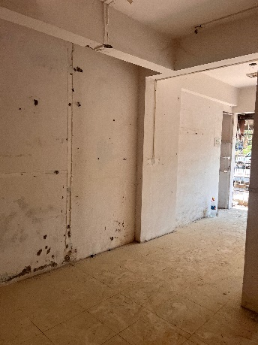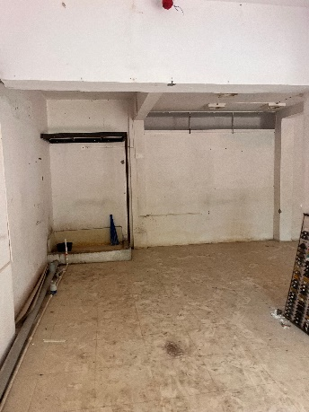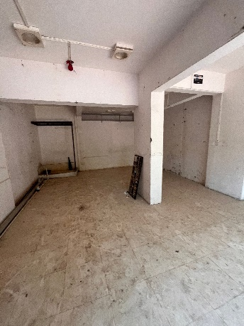

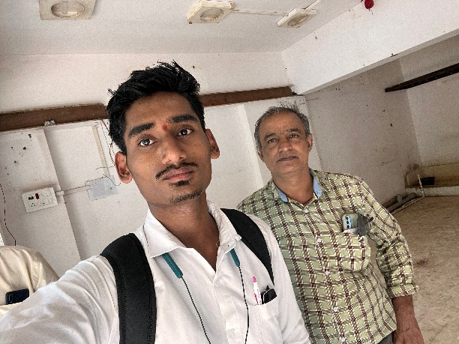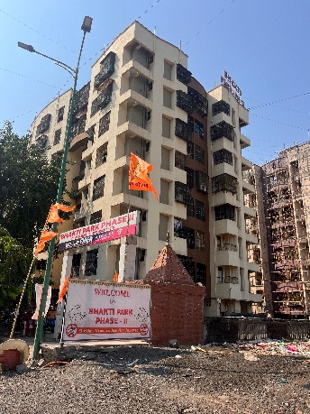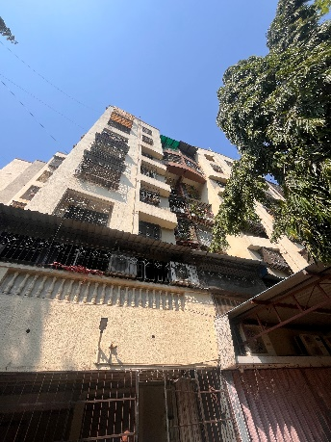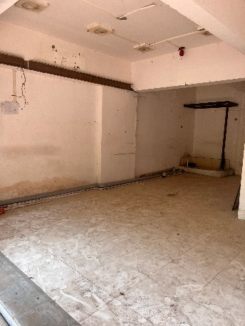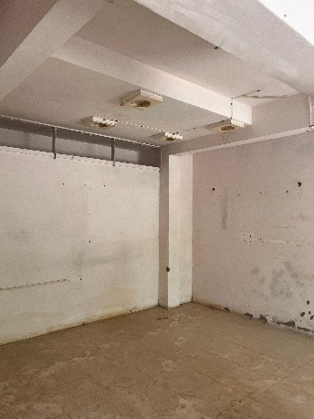

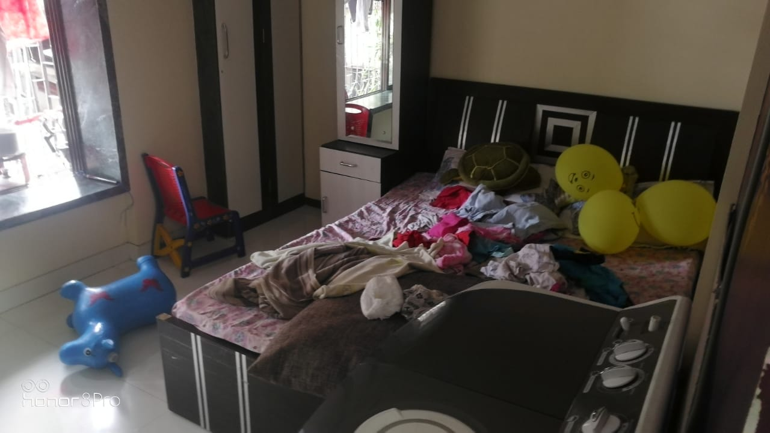**Route Map of the property**

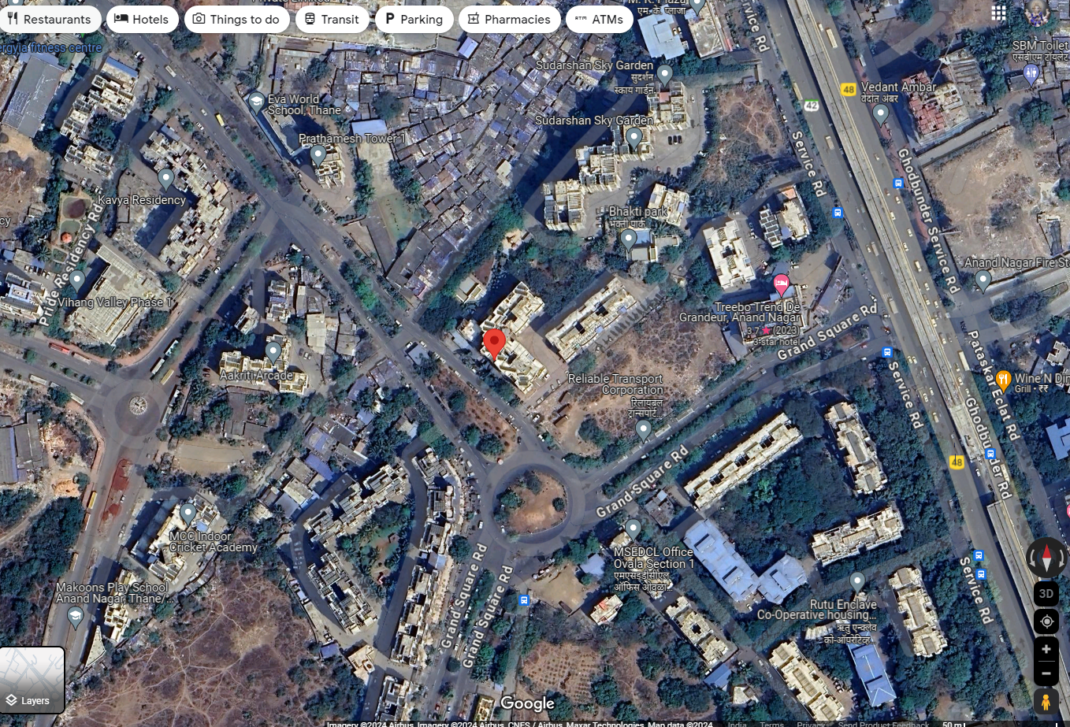**Site u/r**

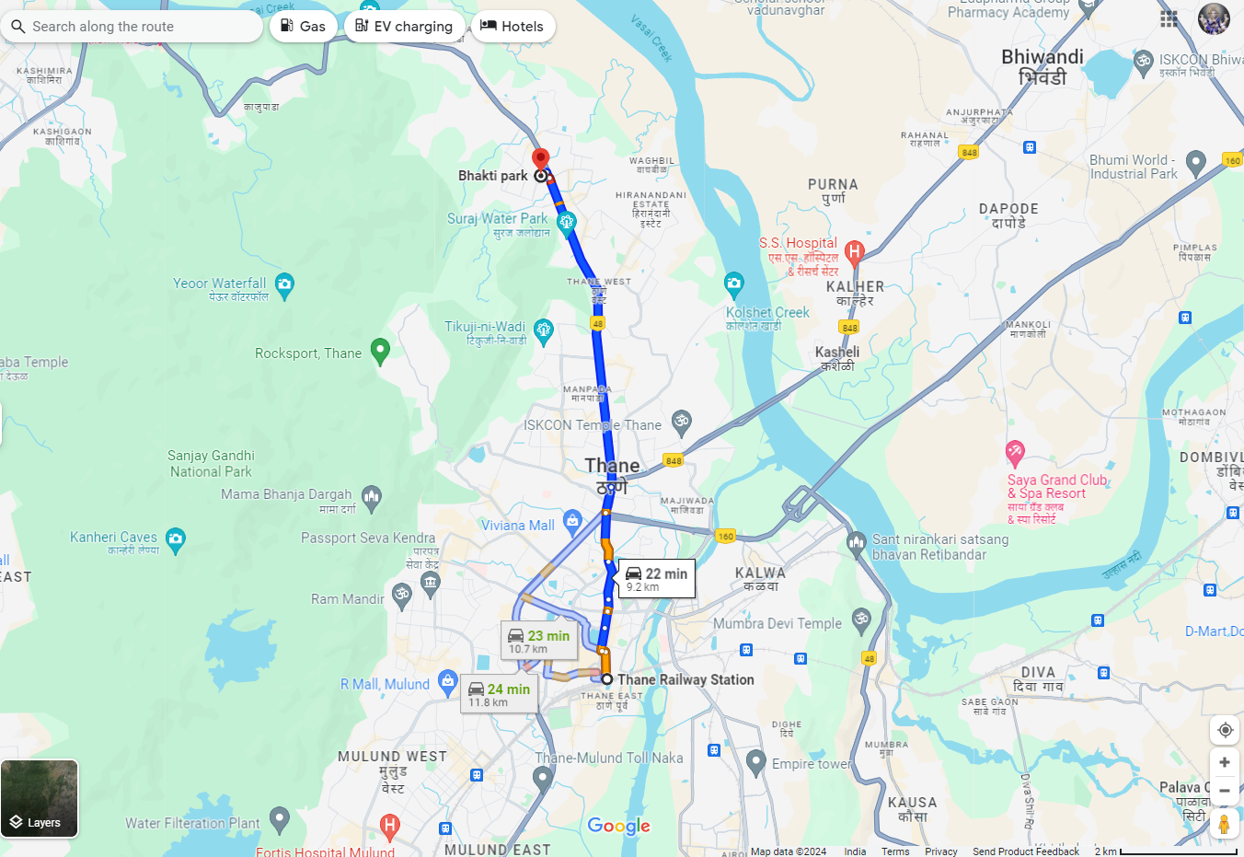

# Latitude Longitude: 19°15’49.8”N 72°57’56.7”E

# Note: The Blue line shows the route to site from nearest railway station (Thane – 9.2 Km.)

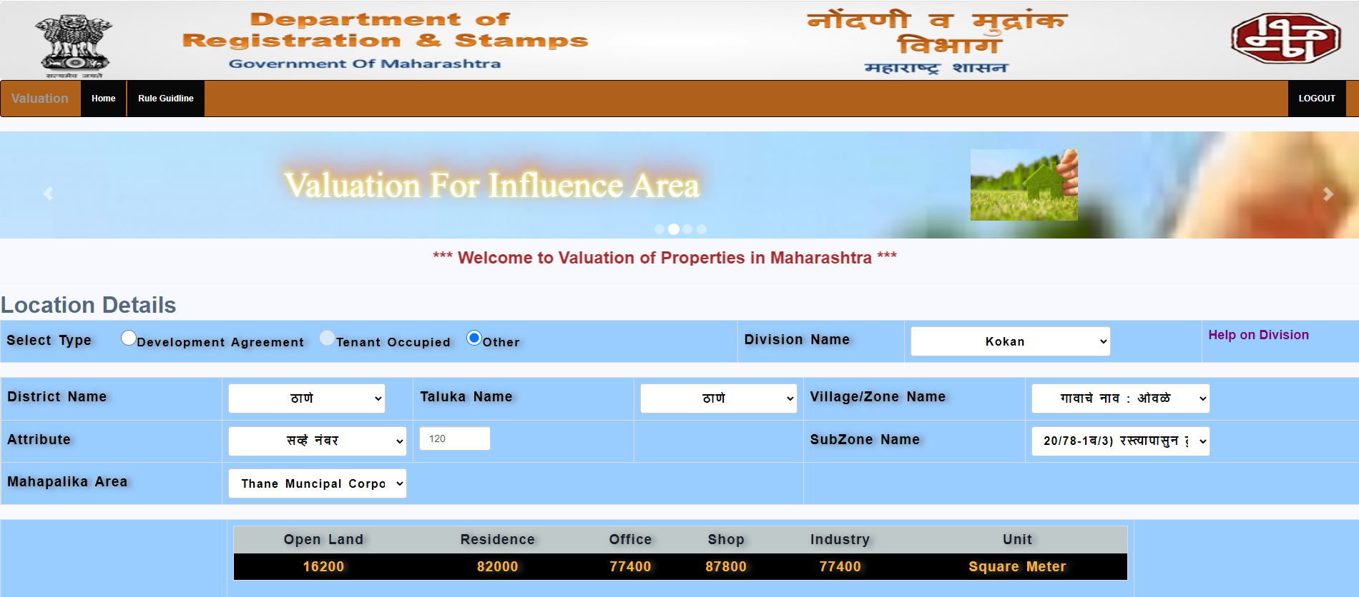**Ready Reckoner**

|  |  |  |  |  |
| --- | --- | --- | --- | --- |
| Stamp Duty Ready Reckoner Market Value Rate for **Shop** | 87,800.00 |  |  |  |
| No Increase by Shop Located on Ground Floor | - |  |  |  |
| **Stamp Duty Ready Reckoner Market Value Rate (After Increase) (A)** | **87,800.00** | **Sq. Mtr.** | **8,157.00** | **Sq. Ft.** |
| Stamp Duty Ready Reckoner Market Value Rate for **Land (B)** | 16,200.00 |  |  |  |
| The difference between land rate and building rate (A – B = C) | 71,600.00 |  |  |  |
| Depreciation Percentage as per table (D) [100% - 16%]  (Age of the Building – 16 Years) | 84% |  |  |  |
| **Rate to be adopted after considering depreciation [B + (C x D)]** | **76,344.00** | **Sq. Mtr.** | **7,093.00** | **Sq. Ft.** |

**Multi-Storied building with Lift**

For residential premises / commercial unit / office on above floor in multistore building, the rate mentioned in the ready reckoner will be increased as under:

|  |  |  |
| --- | --- | --- |
|  | **Location of Flat / Commercial Unit in the building** | **Rate** |
| a) | On Ground to 4 Floors | No increase for all floors from ground to 4 floors |
| b) | 5 Floors to 10 Floors | Increase by 5% on units located between 5 to 10 floors |
| c) | 11 Floors to 20 Floors | Increase by 10% on units located between 11 to 20 floors |
| d) | 21 Floors to 30 Floors | Increase by 15% on units located between 21 to 30 floors |
| e) | 31 Floors and above | Increase by 20% on units located on 31 and above floors |

**Table – D: Depreciation Percentage Table**

|  |  |  |
| --- | --- | --- |
| **Completed Age of Building in Years** | **Value in percent after depreciation** | |
|  | **R.C.C. Structure / other Pukka Structure** | **Cessed Building, Half or Semi – Pukka Structure & Kaccha Structure.** |
| 0 to 2 Years | 100% | 100% |
| Above 2 & up to 5 Years | 95% | 95% |
| Above 5 Years | After initial 5 year for every year 1% depreciation is to be considered. However maximum deduction available as per this shall be 70% of Market Value rate | After initial 5 year for every year 1.5% depreciation is to be considered. However maximum deduction available as per this shall be 85% of Market Value rate |

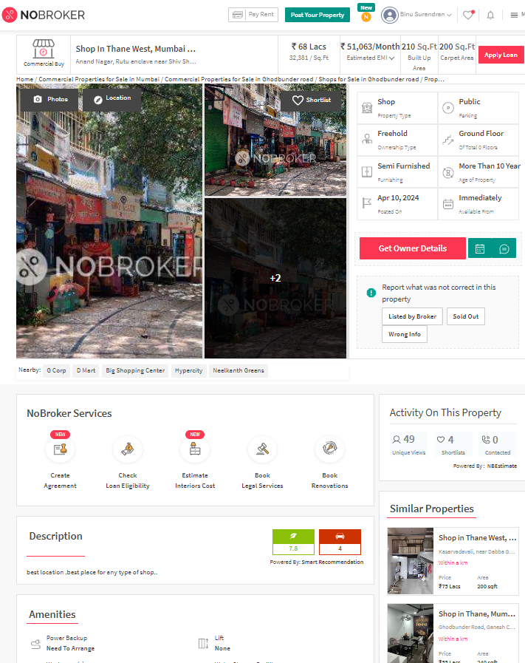**Price Indicators**

**Sales Instance**

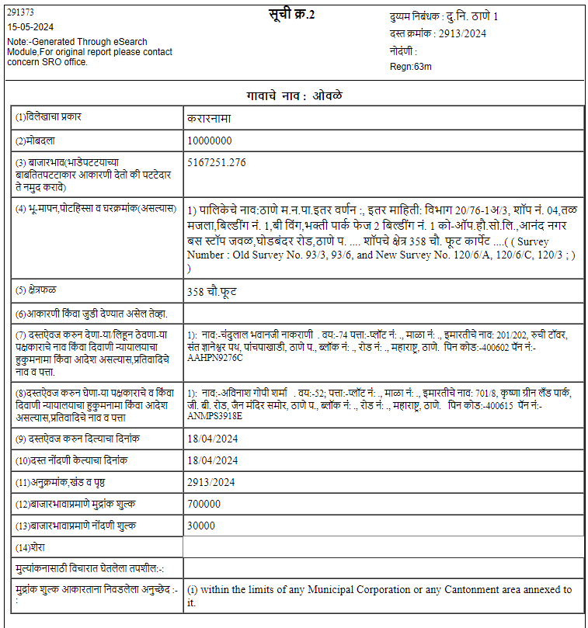

**Sales Instance**

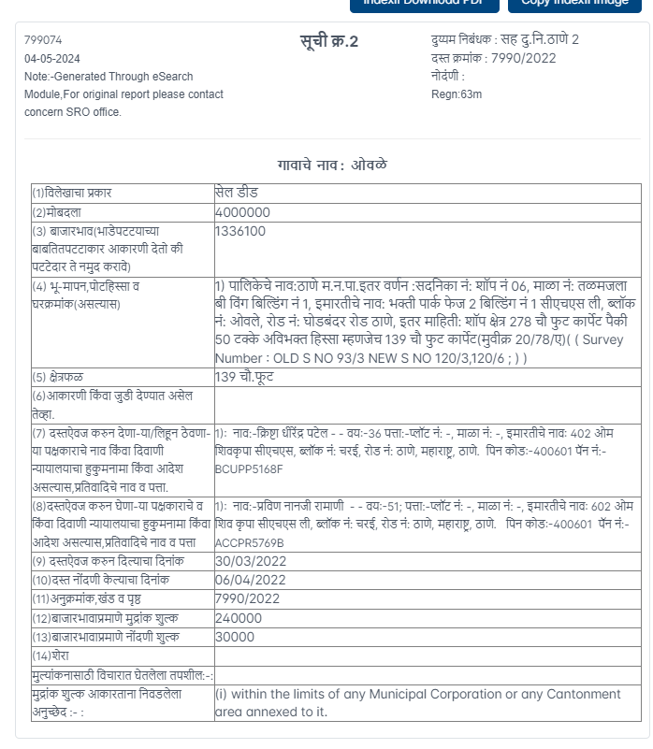

**DEFINITION OF VALUE FOR THIS SPECIFIC PURPOSE**

This exercise is to assess **Fair Market Value** of the property under reference for **Bank Loan** purpose as on date **15th May 2024.**

The term Fair Market Value is defined as

*"The most probable price, as of a specified date, in cash, terms equivalent to cash, or in other precisely revealed terms for which the specified property rights would sell after reasonable exposure in a competitive market under all conditions requisite to a fair sale, with the buyer and seller each acting prudently knowledgeably and for self-interest assuming that neither is under undue duress"*

Fundamental assumptions and conditions presumed in this definition are:

1. Buyer and seller are motivated by self-interest.
2. Buyer and seller are well informed and are acting prudently.
3. The property is exposed for a reasonable time on the open market.
4. Payment is made in cash or equivalent or in specified financing terms.

**UNDER LYING ASSUMPTIONS**

1. We assume no responsibility for matters of legal nature affecting the property appraised or the title thereto, nor do we render our opinion as to the title, which is assumed to be good and marketable
2. The property is valued as though under responsible ownership.
3. It is assumed that the property is free of liens and encumbrances.
4. It is assumed that there are no hidden or unapparent conditions of the subsoil or structure that would render it more or less valuable. No responsibility is assumed for such conditions or for engineering that might be required to discover such factors.

**DECLARATION OF PROFESSIONAL FEES CHARGED**

We hereby declare that; our professional fees are not contingent upon the valuation findings. However, if the statute AND/OR clients demands that, the fees should be charged on the percentage of assessed value then, with the full knowledge of the AND/OR end user, it is being charged accordingly.

**VALUATION OF THE PROPERTY PREMISES**

Considering various parameters recorded herein above, existing economic scenario, and the information that is available with reference to the development of neighbourhood and method selected for valuation, we are of the opinion that, the property premises can be assessed and valued for Banking Purpose as on day for is at **` 1,08,09,040.00 (Rupees One Crore Eight Lakh Nine Thousand Forty Only).**

**Manoj B. Chalikwar**

Registered Valuer

Chartered Engineer (India)

Reg. No. CAT-I-F-1763

Cosmos Emp. No. H.O./Credit/67/2019-20