Vastu/Nashik/05/2024/008664/2306288
13/2-148-RPBS
Date: 13.05.2024

To, `
The Branch Manager,
State Bank of India
RACPC Nashik Branch
1st Floor, Patel Plaza, N.D. Patel Road, Opp. BSNL,
Landmark Seawoods Navratna Hotel, Nashik - 422001,
State – Maharashtra, Country – India.

Sub: Vetting of Extra Amenities

Sir,

With reference to above subject, we have evaluated the Extra Amenities for Residential Row House on Plot No. 40, Ground + First Floor, Survey No.213/1 , Behind State Bank of India , Jaswant Nagar, Shramik Nagar, Gangapur Satpur Link Road, Village – Pimpalgoan Bahula , Taluka & District - Nashik, PIN Code - 422 007, State - Maharashtra, Country - India belongs to M/s.Nirmiti Builders and Developers Name of Proposed Purchaser: Shri. Suresh Rawji Mahyavanshi & Sau. Heena Suresh Mahyavanshi.

We have verified the rates quoted as per current market rates. Details of work and Extra Amenities considered as per copy of Extra Amenities between Shri. Suresh Rawji Mahyavanshi & Sau. Heena Suresh Mahyavanshi (First Party) and Shri. Mahesh Gorakshnath Shinde (Second Party) received on dated 10.01.2024. The Extra Amenities amount is Rs.5,50,000/- (Rupees Five Lakh Fifty Thousand Only. )

The said Cost Vetting Certificate is valid upto next 6 months Only.

Thanking you

Sincerely yours

Manoj B. Chalikwar
Registered Valuer
Chartered Engineer (India)
Reg. No. CAT-I-F-1763
SBI Empanelment No.: SME/TCC/2021-22/86/3
Encl: Valuation report..

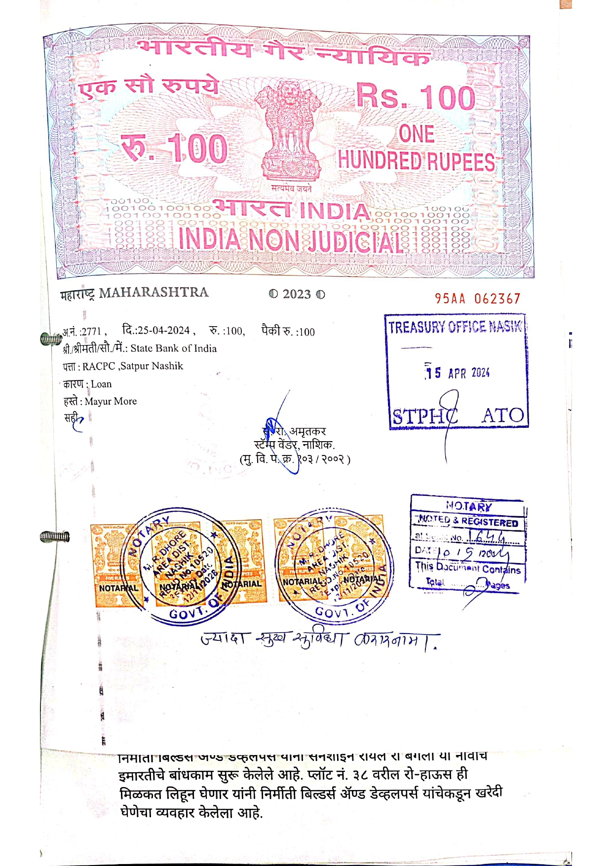
Agreement for Extra Amenities
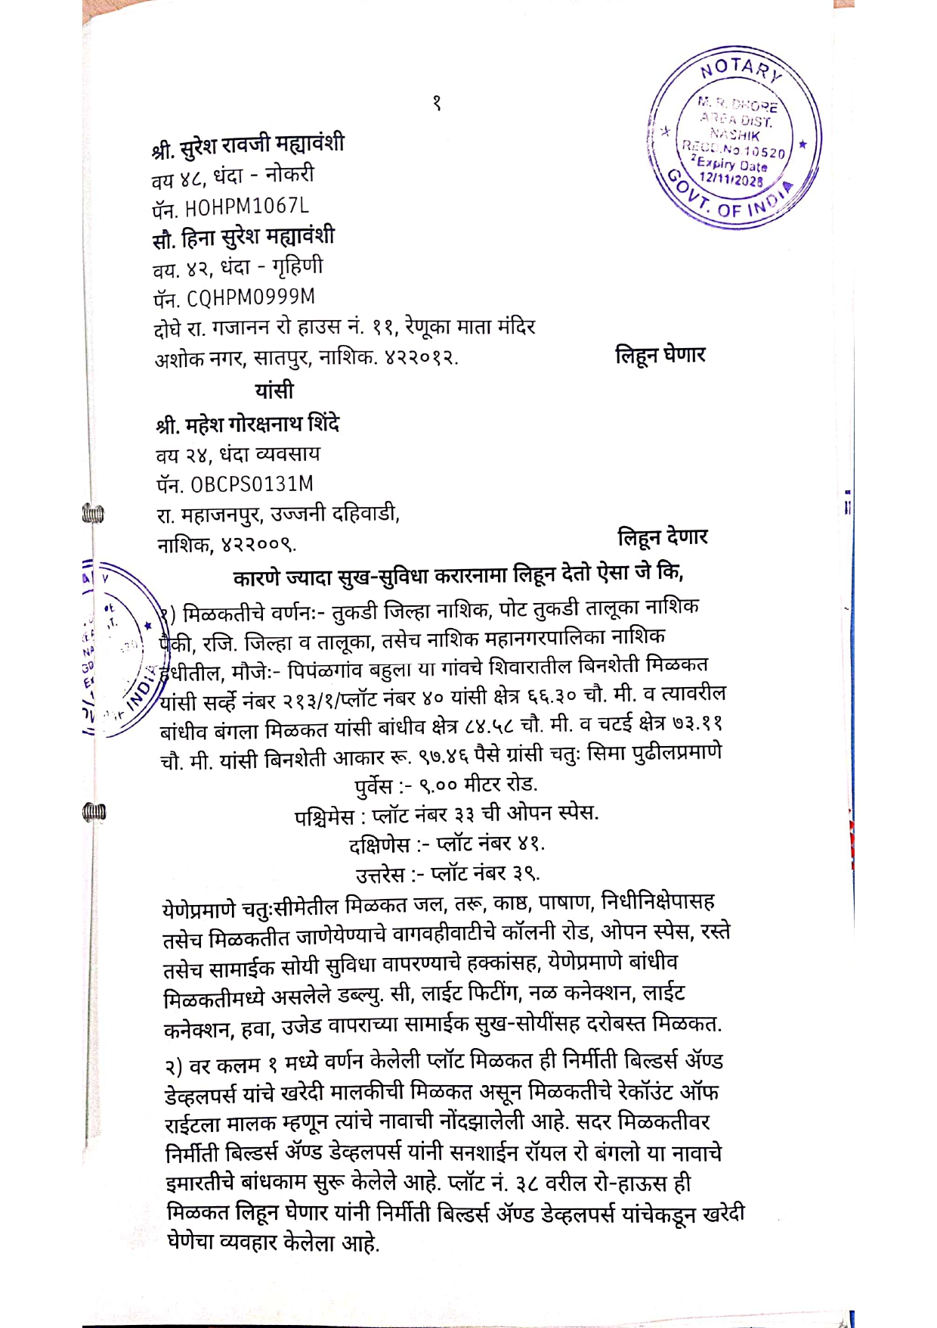

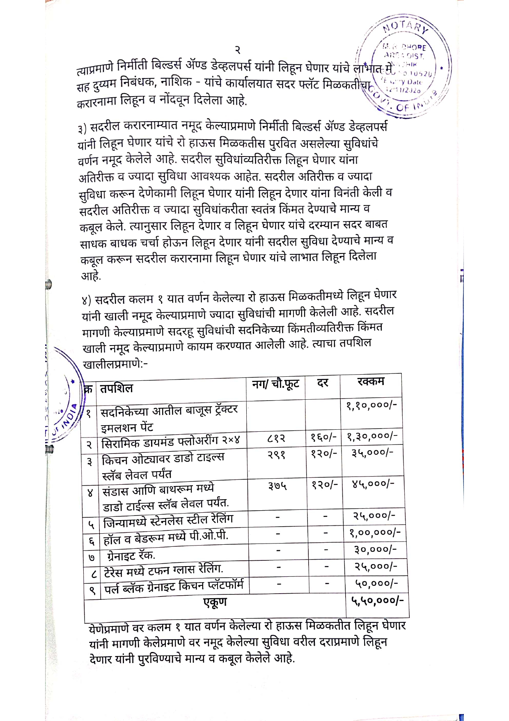
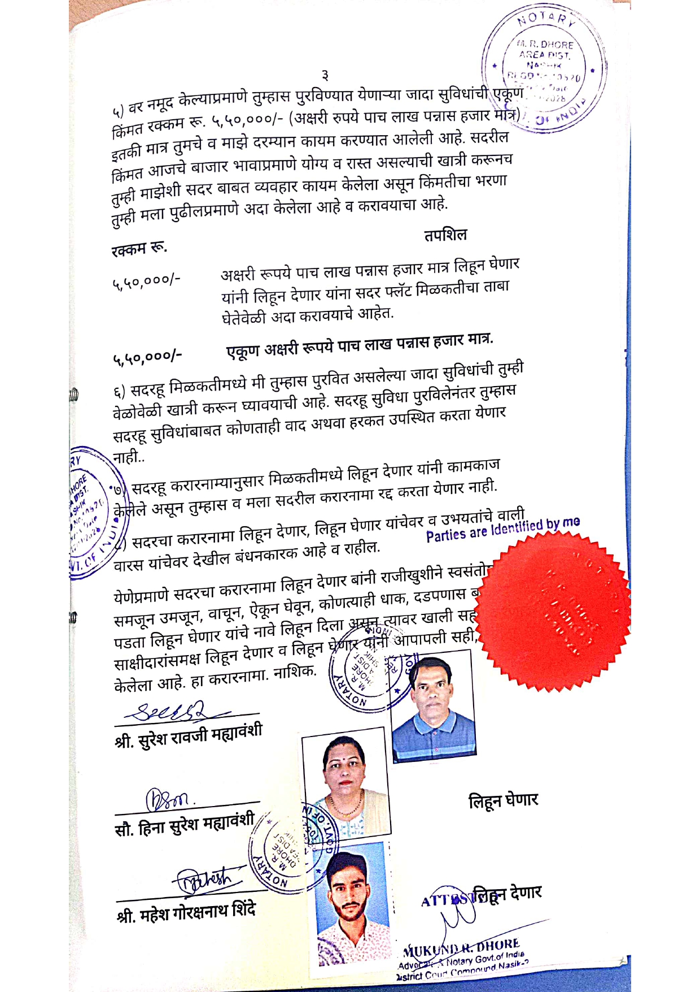

The Extra Amenities amount is Rs.5,50,000/- (Rupees Five Lakh Fifty Thousand Only)

