Vastu/Nashik/05/2024/008656/2306279
11/6-139-RYBS
Date: 11.05.2024

To,
The Branch Manager
Nashik City Branch
NavondarSankul, 1366, M-1 Racca Colony, Sharanpur Road
Nashik – 422 002, State - Maharashtra, Country - lndia.

Sub: Vetting of Home Renovation

Sir,

With reference to above subject, we have evaluated the Vetting of Home Renovation for Residential Flat No. 05, 2nd Floor, " Morya Apartment ", Survey No. 85/ 1B/ 27, Plot No. 2+3+4, Behind Vitthal Rukhmani Hall, Bansali Mala, Janata Raja Colony, Kumavat Nagar, Makhmalabad Rd, Village - Nashik, Taluka & District - Nashik, PIN Code – 422 003, State – Maharashtra, Country – India. belongs to Name of Owner: Swami Mahesh Pagare.

We have verified the rates quoted as per current market rates. Details of Home Renovation considered as per copy of Vetting of Home Renovation between Mr. Swami Mahesh Pagare (First Party). M/s. Bhabad Builders & Developers (Second Party) received on dated 22.04.2024. The Extra Work amount is Rs. 5,00,000/- (Rupees Five Lakh Only)

The said Cost Vetting Certificate is valid upto next 6 months Only.

Thanking you

Sincerely yours

Sharadkumar B. Chalikwar
Govt. Reg. Valuer
Chartered Engineer (India)
Reg. No. (N) CCIT/1-14/52/2008-09

Vetting of Flat Repair Quotation
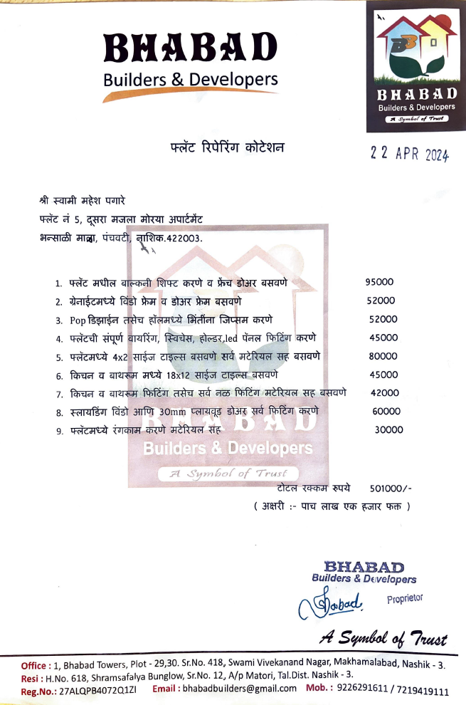

The Extra Work amount is Rs. 5,00,000/- (Rupees Five Lakh Only)

