**Valuation Report of the Immovable Property**

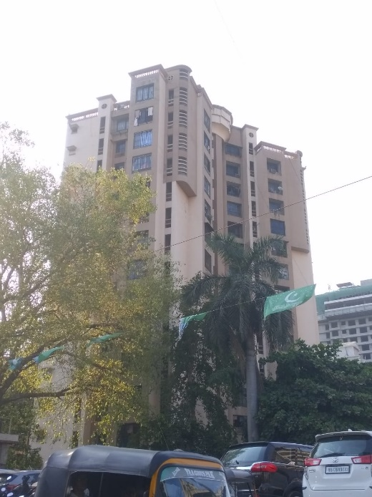

**Details of the property under consideration:**

Name of Owner: **Mr. Ayub Ahmed Patel**

Residential Flat No. 102, 1st Floor, **“Paramount Co-op. Hsg. Soc. Ltd.”,** Sahakar Road, Off. S. V. Road, Jogeshwari (West), Mumbai – 400102, State - Maharashtra, Country – India.

**Latitude Longitude - 19°08’10.7”N 72°50’42.0”E**

**Intended Users:**

**Private Clients**

**Vastukala Consultants (I) Pvt. Ltd.**

Mumbai • Delhi NCR • Aurangabad • Nanded • Indore • Pune

Raipur • Jaipur • Ahmedabad • Rajkot • Thane • Nashik

Vastu/Mumbai/05/2024/008648/35141

08/05/19-SKVS

Date: 11.05.2024

**VALUATION OPINION REPORT**

This is to certify that the property Residential Flat No. 102, 1st Floor, **“Paramount Co-op. Hsg. Soc. Ltd.”,** Sahakar Road, Off. S. V. Road, Jogeshwari (West), Mumbai – 400102, State - Maharashtra, Country – India belongs to **Mr. Ayub Ahmed Patel.**

|  |  |
| --- | --- |
| Boundaries of the property. | |
| North | Magnun Rose CHSL |
| South | Sahakar Road |
| East | Open Plot |
| West | Anmol Apartment |

Considering various parameters recorded, existing economic scenario, and the information that is available with reference to the development of neighbourhood and method selected for valuation, we are of the opinion that, the property premises can be assessed and valued for **Immigration Visa Application** purpose at

**In ` 1,24,80,000.00 (Rupees One Crore Twenty Four Lakh Eighty Thousand Only).**

**In C$ 2,04,236.07 (Canadian Dollar Two Hundred Four Thousand Two Hundred Thirty Six Only).**

**Note: at conversion rate of 1 Indian Rupee equals to 0.016 Canadian Dollar as on 11.05.2024**

The valuation of the property is based on the documents produced by the concern. Legal aspects have not been taken into considerations while preparing this report.

Hence certified

**Manoj B. Chalikwar**

Registered Valuer

Chartered Engineer (India)

Reg. No. CAT-I-F-1763

Encl: Valuation report.

**VALUATION REPORT IN RESPECT OF IMMOVABLE PROPERTY**

|  |  |  |  |  |  |
| --- | --- | --- | --- | --- | --- |
| 1 | Date of Inspection | | 10.05.2024 | | |
| 2 | Purpose of valuation | | As per request from Private Clients, to assess Fair Market Value of the property under reference for **Immigration Visa Application** purpose | | |
| 3 | Name and address of the Valuer | | **Manoj B. Chalikwar**  **Vastukala Consultants (I) Pvt. Ltd.**  121, 1stFloor, Ackruti Star, Central Road, MIDC, Andheri (E), Mumbai - 400 093  Dial: +91 22 28131324/25  Email: mumbai@vastukala.org | | |
| 4 | List of Documents Handed Over to The Valuer By The Customer:   1. Copy of Gift Deed dated 13.02.2013 between Mrs. Fatma Ahmed Patel (the Donor) AND Mr. Ayub Ahmed Patel (the Donee). 2. Copy of Maintenance Bill No. 2 dated 15.04.2024 in the name of Mr. Ayub Ahmed Patel issued by Paramount Co-op. Hsg. Soc. Ltd. 3. Copy of Electricity Bill Consumer No. 9000 0050 7954 dated 25.04.2024 in the name of Mr. Ayub Ahmed Patel issued by Tata Power. 4. Copy of Share Certificate No. 71 transferred date 14.03.2013 in the name of Mr. Ayub Ahmed Patel issued by Paramount Co-op. Hsg. Soc. Ltd. | | | | |
| 5 | Details of enquiries made/ visited to government offices for arriving fair market value. | | Market analysis | | |
| 6 | Factors for determining its market value. | | Location, development of surrounding area, type of construction, construction specifications, age of building, condition of the premises & building, facilities provided and its prevailing market rate. | | |
| 7 | ANY CRITICAL ASPECTS ASSOCIATED WITH PROPERTY | | No | | |
| 8 | Present/Expected Income from the property | | ` 26,000.00 Expected rental income per month.  C$ 425.49 Expected rental income per month. | | |
|  | **Property Details** | |  | | |
| 9 | Name(s) of the Owner | | **Mr. Ayub Ahmed Patel** | | |
|  | Address | | Residential Flat No. 102, 1st Floor, **“Paramount Co-op. Hsg. Soc. Ltd.”,** Sahakar Road, Off. S. V. Road, Jogeshwari (West), Mumbai – 400102, State - Maharashtra, Country – India. | | |
| 10 | If the property is under joint ownership/ co-ownership share of each such owner/ are the share is undivided. | | Sole Ownership | | |
| 11 | Brief description of the property. | | The property is a Residential Flat located on 1st Floor. The composition of flat is 1 Bedroom + Living Room + Kitchen + 2 Toilets + Flowerbed + Passage **(i.e. 1BHK).** It is at 550 M. walkable distance from Jogeshwari railway station. | | |
|  | **If under construction, extent of completion** | | **N.A.** | | |
| 12 | Location of the property (C.T.S. No., Survey No., Hissa No., Plot No., etc.). | | C.T.S. No. 77 of Village – Bandivali | | |
| 13 | **Boundaries** | | **As on site** | | **As per documents** |
|  | North | | Magnun Rose CHSL | | Details not available |
|  | South | | Sahakar Road | | Details not available |
|  | East | | Open Plot | | Details not available |
|  | West | | Anmol Apartment | | Details not available |
| 14 | Matching of Boundaries | | - | | |
| 15 | Route map | | Enclosed | | |
| 16 | Any specific identification marks | | Near Jogeshwari Hospital | | |
| 17 | Whether covered under Corporation/ Panchayat / Municipality. | | MCGM | | |
| 18 | Whether covered under any land ceiling of State/ Central Government. | | No | | |
| 19 | Is the land freehold/ leasehold. | | Freehold | | |
| 20 | Are there any restrictive covenants in regard to use of Land? If so attach a copy of the covenant. | | As Per Agreement | | |
| 21 | Type of the property | | Residential | | |
| 22 | Year of acquisition/ purchase. | | 13.02.2013 | | |
| 23 | Purchase value as per document | | Gift Deed | | |
| 24 | Whether the property is occupied by owner or tenant. If occupied by tenant since how long he is staying and the amount of rent being paid. | | Owner Occupied | | |
| 25 | Classification of the site | |  | | |
|  | 1. Population group | | Urban | | |
|  | 1. High/ Middle/ Poor class | | Middle Class | | |
|  | 1. Residential / Commercial | | Residential | | |
|  | 1. Development of surrounding area | | Developed | | |
|  | 1. Possibility of any threat to the property (Floods, calamities etc.). | | No | | |
| 26 | Proximity of civic amenities (like school, hospital, bus stop, market etc.). | | Near By | | |
| 27 | Level of the land (Plain, rock etc.) | | Plain | | |
| 28 | Terrain of the Land. | | Levelled | | |
| 29 | Shape of the land (Square/ rectangle etc.). | | Irregular | | |
| 30 | Type of use to which it can be put (for construction of house, factory etc.). | | Residential Flat | | |
| 31 | Whether the plot is under town planning approved layout? | | Information not Available | | |
| 32 | Whether the building is intermittent or corner? | | Intermittent | | |
| 33 | Whether any road facility is available? | | Yes | | |
| 34 | Type of road available (B.T/Cement Road etc.). | | B.T. Road | | |
| 35 | Front Width of the Road? | | 9.00 M. Wide Road | | |
| 36 | Source of water & water potentiality. | | Municipal Water Supply | | |
| 37 | Type of Sewerage System. | | Connected to Municipal Sewerage System | | |
| 38 | Availability of power supply. | | Yes | | |
| 39 | Advantages of the site. | | Located in developed area | | |
| 40 | Disadvantages of the site. | | No | | |
| 41 | Give instances of sales of immovable property in the locality on a separate sheet, indicating the name & address of the property, registration No. sale price and area of land sold. | | As per Sub-Registrar of Assurance records | | |
|  | **Valuation of the property:** | | | | |
| 42 | Total area of the Residential Flat | | Carpet Area in Sq. Ft. = 493.00  (Area as per actual site measurement)  **Built Up Area in Sq. Ft. = 640.00**  **(Area as per Gift Deed)** | | |
| 43 | Prevailing market rate. | | ` 19,500.00 per Sq. Ft. on Built Up Area | | |
| 44 | Floor Rise Rate per Sq. Ft. | | ` 0.00 | | |
| 45 | PLC Rate per Sq. Ft. | | ` 0.00 | | |
| 46 | Total Rate per Sq. Ft. | | ` 19,500.00 per Sq. Ft. on Built Up Area | | |
| 47 | Value of the property | | **` 1,24,80,000.00** | | **C$ 2,04,236.07** |
| 48 | The realizable value of the property (90%) | | **` 1,12,32,000.00** | | **C$ 1,83,812.47** |
| 49 | Distress value of the property (80%) | | **` 99,84,000.00** | | **C$ 1,63,338.86** |
| 50 | Insurance value of the property | | **` 17,28,000.00** | | **C$ 28,278.84** |
|  | **Technical details of the building:** | | | | |
| 51 | Type of building (Residential/ Commercial/ Industrial). | | Residential | | |
| 52 | Year of construction. | | 2000 (As per site information) | | |
| 53 | Future life of the property. | | 36 years Subject to proper, preventive periodic maintenance and structural repairs. | | |
| 54 | No. of floors and height of each floor including basement. | | Stilt + Ground + 12 Upper Floors. 1st Floor is having 6 Residential Flats. The building is having 2 Lifts. | | |
|  | **Type of construction** | | | | |
| 55 | (Load bearing/ R.C.C./ Steel framed) | | R.C.C. Framed Structure | | |
|  | **Condition of the building.** | | | | |
| 56 | External (excellent/ good/ normal/ poor) | | Good | | |
| 57 | Internal (excellent/ good/ normal/ poor). | | Good | | |
| 58 | Whether the Residential Flat is constructed strictly according to the sanctioned plan, details of variations noticed if any and effect of the same on the valuation | | Copy of Approved Building plans were not provided and not verified. | | |
| 59 | **Remarks** |  | | | |
|  | **Specifications of Construction:** | | | | |
| **sr.** | **Description** | | **1st Floor** | | |
| A | Foundation | | R.C.C. Foundation | | |
| B | Basement | | No | | |
| C | Superstructure | | R.C.C. frame work with 9 inch thick B. B. Masonry for external walls.6 inch thick B.B. Masonry for internal walls | | |
| D | Joinery/Doors/Windows | | Teakwood door framed with flush doors; Powder coated aluminium sliding windows | | |
| E | RCC Work | | R.C.C. Framed Structure | | |
| F | Plastering | | Cement Plastering + POP finish | | |
| G | Flooring, Skirting | | Verified tiles flooring | | |
| H | Kitchen Platform | | Granite kitchen platform | | |
| I | Whether any proof course is provided? | | Yes | | |
| J | Drainage | | Connected to Municipal Sewerage System | | |
| K | Compound Wall (Height, length and type of construction) | | 5.6" Height | | |
| L | Electric Installation (Type of wire, Class of construction) | | Concealed | | |
| M | Plumbing Installation (No. of closets and wash basins etc.) | | Concealed | | |
| N | Bore Well | | Not Provided | | |
| O | Wardrobes, if any | | Yes | | |
| P | Development of open area | | Open Parking, Chequered tile in open spaces, etc. | | |
|  | **Valuation of proposed construction/ additions/ renovation if any:** | | | | |
| 60 | **SUMMARY OF VALUATION:** | |  | | |
|  | Part I Land | | N.A. as composite method is used for valuation | | |
|  | Part II Building | | **` 1,24,80,000.00** | **C$ 2,04,236.07** | |
|  | Part III Other amenities/ Miscellaneous | | ` 0.00 | | |
|  | Part IV Proposed construction | | ` 0.00 | | |
|  | **TOTAL.** | | **` 1,24,80,000.00** | **C$ 2,04,236.07** | |
|  | **Calculation:** | | | | |
| **1** | **Construction** | |  | | |
| 1.01 | Built up Area of Residential Flat | | 640.00 Sq. Ft. | | |
| 1.02 | Rate per Sq. Ft. | | ` 2,700.00 | | |
| 1.03 | Cost of Construction = (1.01x1.02) | | ` 17,28,000.00 | | |
| **2** | **Value of property** | |  | | |
| 2.01 | Built Up Area of Residential Flat | | 640.00 Sq. Ft. | | |
| 2.02 | Rate per Sq. Ft. | | ` 19,500.00 | | |
| 2.03 | Value of Residential Flat = (2.01x2.02) | | **` 1,24,80,000.00** | **C$ 2,04,236.07** | |
| **3** | **Total value of the property.** | | **` 1,24,80,000.00** | **C$ 2,04,236.07** | |

I certify that,

I/ my authorized representative has inspected the subject property on 10.05.2024.

The rates for valuation of the property are in accordance with the prevailing market rates.

There is no direct/ indirect interest in the property valued.

The fair value of the property as on 11.05.2024 is

**In ` 1,24,80,000.00 (Rupees One Crore Twenty Four Lakh Eighty Thousand Only).**

**In C$ 2,04,236.07 (Canadian Dollar Two Hundred Four Thousand Two Hundred Thirty Six Only).**

**Note: at conversion rate of 1 Indian Rupee equals to 0.016 Canadian Dollar as on 11.05.2024**

Date: 11.05.2024

Place: Mumbai

**Manoj B. Chalikwar**

Registered Valuer

Chartered Engineer (India)

Reg. No. CAT-I-F-17631930

**Actual site photographs**

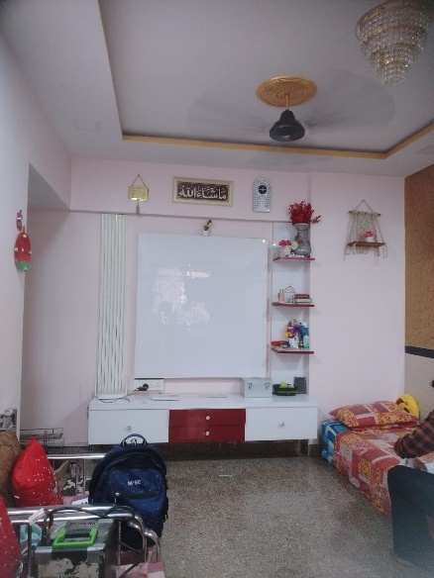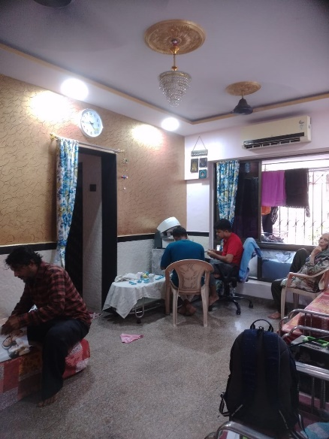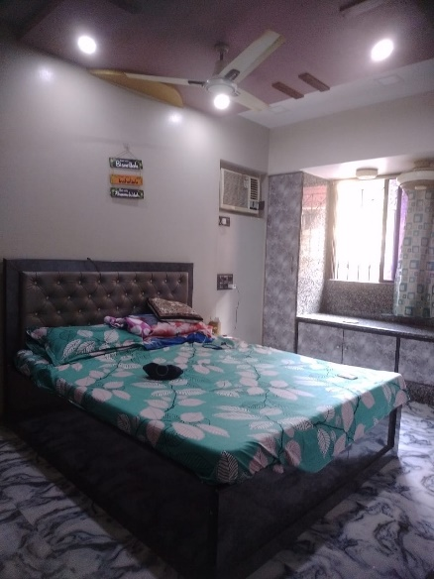

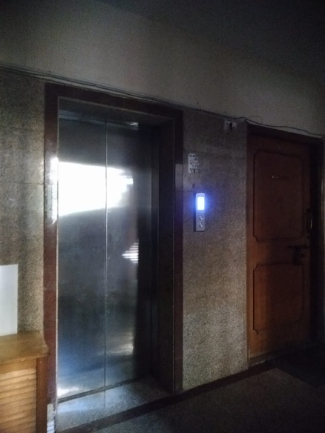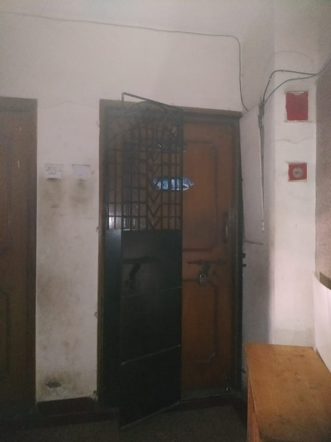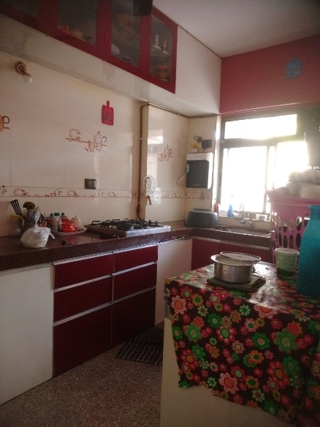

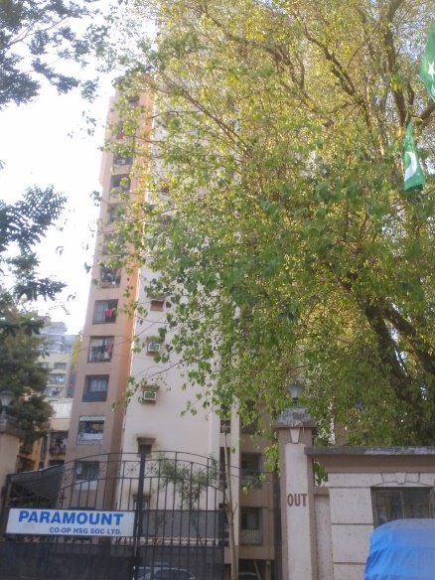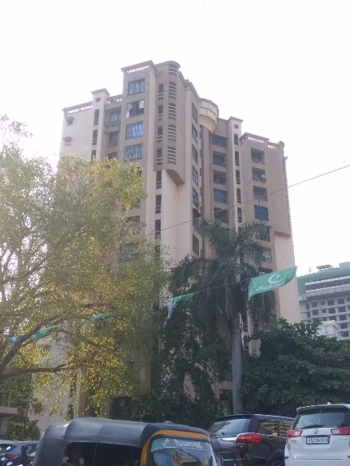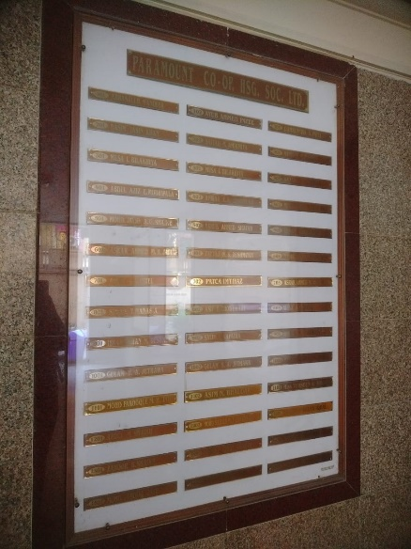

**Route Map of the property**

**Site u/r**

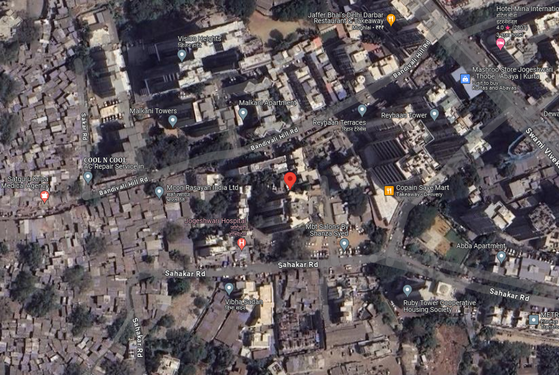

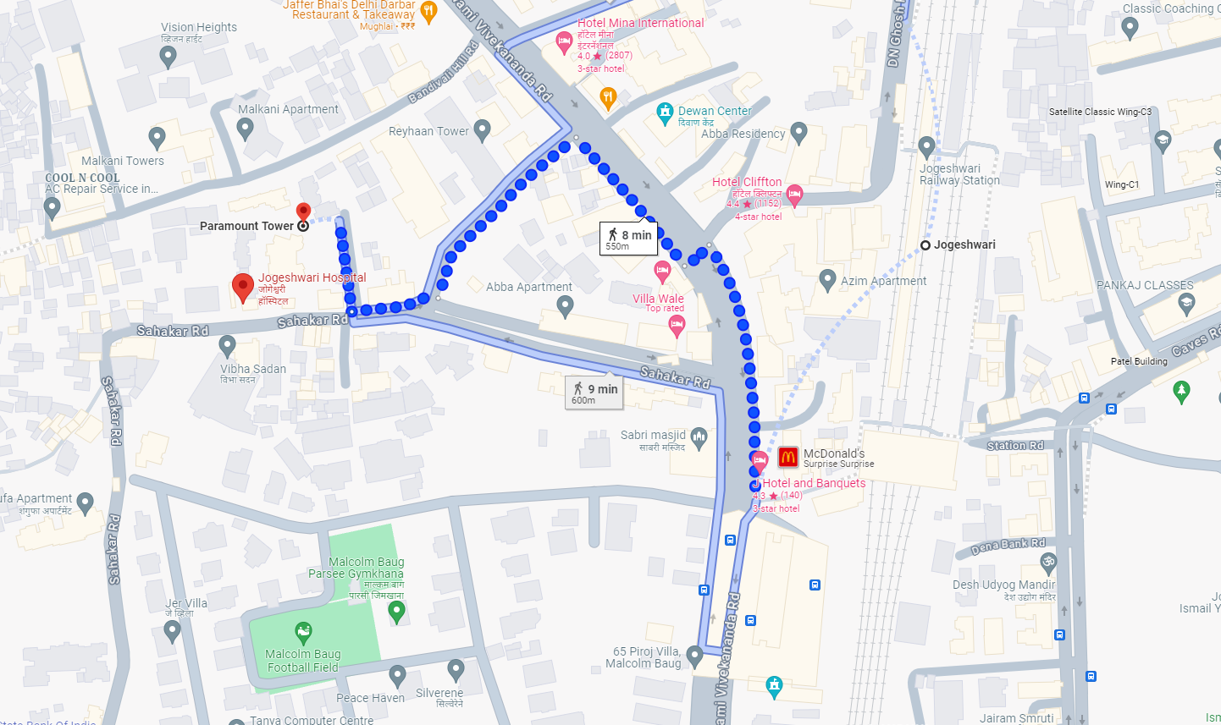

**Latitude Longitude - 19°08’10.7”N 72°50’42.0”E**

**Note**: The Blue line shows the route to site from nearest railway station – (Jogeshwari – 550 M.)

**Currency Rate**

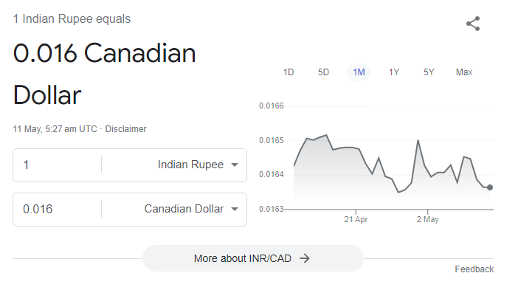

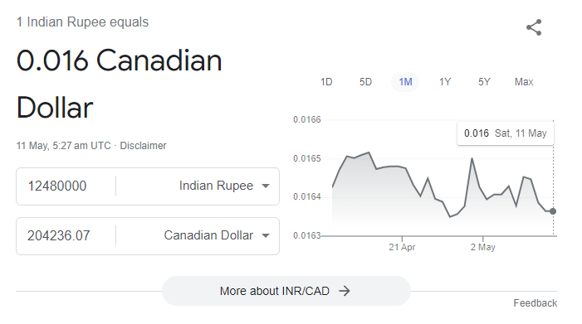

**Price Comparative**

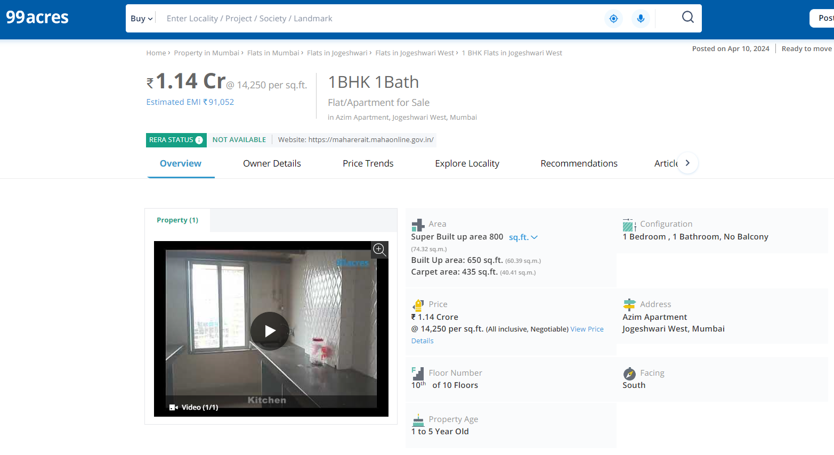

(` 17,538.00 Sq. Ft on Built Up Area)

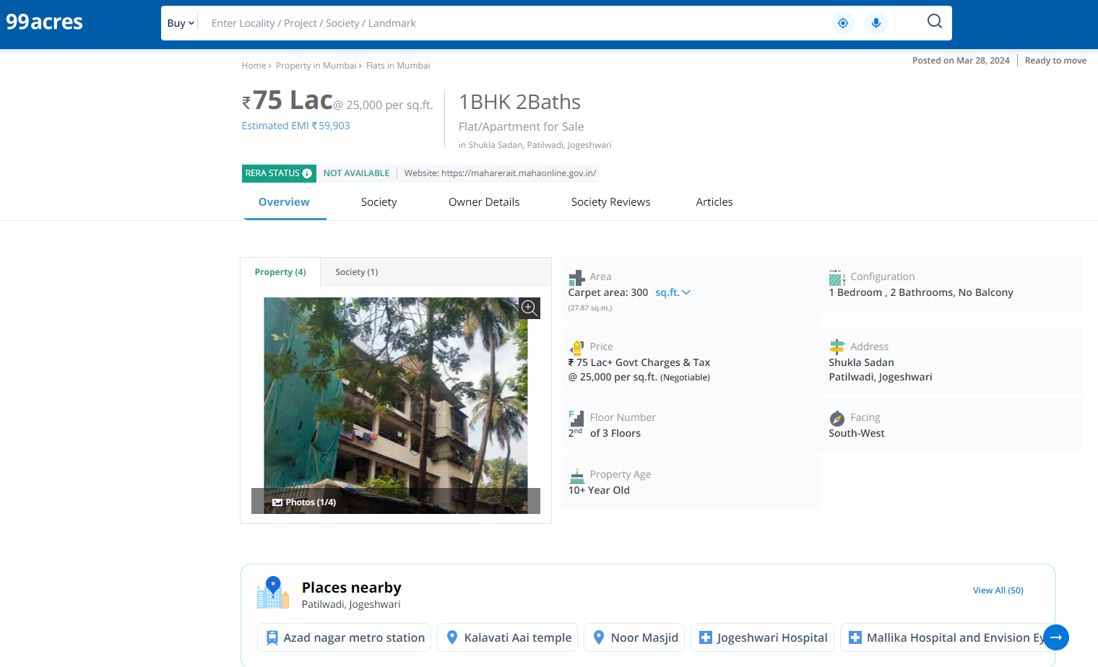

(` 25,000.00 per Sq. Ft. on Carpet Area i.e. ` 20,883.00 Sq. Ft on Built Up Area)

**Price Comparative**

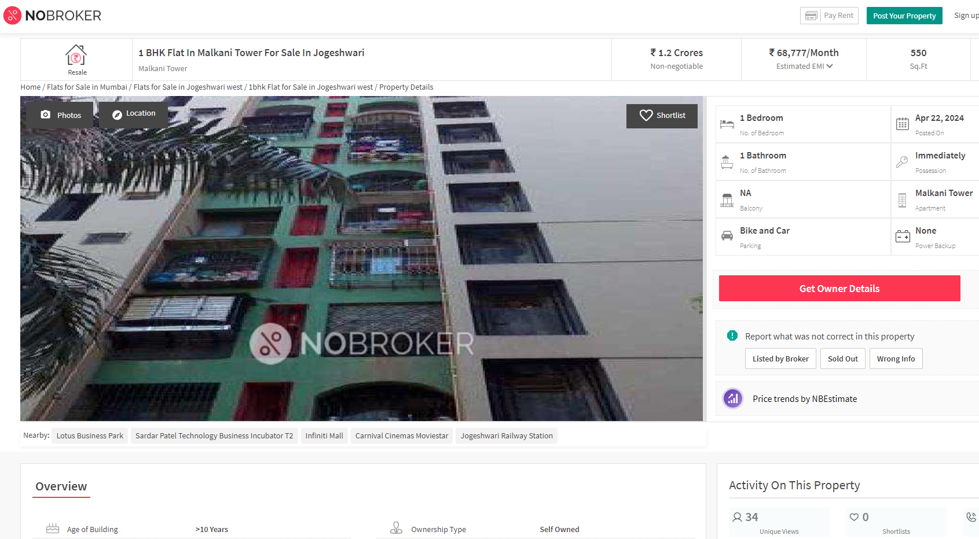

(` 21,818.00 Sq. Ft on Built Up Area)

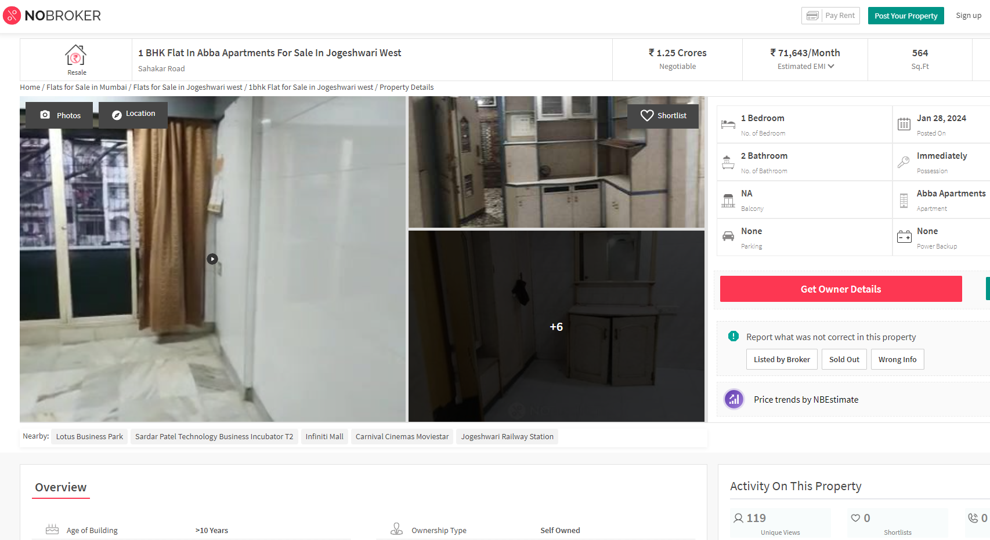

(` 22,163.00 Sq. Ft on Built Up Area)

**It can be seen that the rates of the Residential Apartments in the nearby area ranges from ` 17,500.00 to ` 22,500.00 per Sq. Ft on Built Up Area. Hence, we have considered ` 19,500.00 per Sq. Ft on Built Up Area as Fair Market Rate for Property under Consideration.**

**DEFINITION OF VALUE FOR THIS SPECIFIC PURPOSE**

This exercise is to assess Fair Market Value of the property under reference for **Immigration Visa Application** purpose as on dated **11th May 2024.**

The term Fair Market Value is defined as

*"The most probable price, as of a specified date, in cash, terms equivalent to cash, or in other precisely revealed terms for which the specified property rights would sell after reasonable exposure in a competitive market under all conditions requisite to a fair sale, with the buyer and seller each acting prudently knowledgeably and for self-interest assuming that neither is under undue duress"*

Fundamental assumptions and conditions presumed in this definition are:

1. Buyer and seller are motivated by self-interest.
2. Buyer and seller are well informed and are acting prudently.
3. The property is exposed for a reasonable time on the open market.
4. Payment is made in cash or equivalent or in specified financing terms.

**ASSUMPTIONS, CAVEATS, LIMITATION AND DISCLAIMERS**

1. We assume no responsibility for matters of legal nature affecting the property appraised or the title thereto, nor do we render our opinion as to the title, which is assumed to be good and marketable.
2. The property is valued as though under responsible ownership.
3. It is assumed that there are no hidden or unapparent conditions of the subsoil or structure that would render it more or less valuable. No responsibility is assumed for such conditions or for engineering that might be required to discover such factors.
4. There is no direct/ indirect interest in the property valued.
5. The rates for valuation of the property are in accordance with the prevailing market rates.

**DECLARATION OF PROFESSIONAL FEES CHARGED**

We hereby declare that; our professional fees are not contingent upon the valuation findings. However, if the statute AND/OR clients demands that, the fees should be charged on the percentage of assessed value then, with the full knowledge of the AND/OR end user, it is being charged accordingly.

**VALUATION OF THE PROPERTY PREMISES**

Considering various parameters recorded herein above, existing economic scenario, and the information that is available with reference to the development of neighbourhood and method selected for valuation, we are of the opinion that, the property premises can be assessed and valued for Visa Application Purpose as on day for **In ` 1,42,87,500.00 (Rupees One Crore Forty Tow Lakh Eighty Seven Thousand Five Hundred Only).**

**In C$ 2,38,848.14 (Canadian Two Hundred Thirty Eight Thousand Eight Hundred Forty Eight Only).**

**Note: at conversion rate of 1 Indian Rupee equals to 0.016 Canadian Dollar as on 11.05.2024**

**Manoj B. Chalikwar**

Registered Valuer

Chartered Engineer (India)

Reg. No. CAT-I-F-1763

**Valuer's Certificate**

**The Indian Institution of Valuers Certificate**