2nd LENDER’S INDEPENDENT ENGINEER REPORT

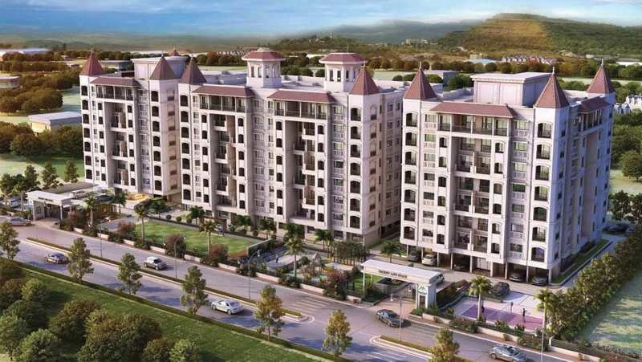

**Details of the property under consideration:**

**Name of Project: Decent Life Space 2 (Wing B named as Skyrise)**

**"Decent Life Space 2 (Wing B named as Skyrise)", Proposed Residential Group Housing Scheme on land bearing S. No. 70/A, H. No. 1 & S. No. 51/A, H. No. 5, C. T. S. No. 2163, 16 (Pt) & 192 (Pt), Palghar – Manor Road, Village – Palghar, Taluka & District – Palghar, Pin Code – 401 404,**

**State – Maharashtra, Country – India**

**Latitude Longitude: 19°42'17.8"N 72°46'15.9"E**

Intended User:

State Bank of India

SME Centre Borivali (West) Branch

SME Centre Borivali (15521) 101, 1st Floor, Landmark Building, S. V. Road, Near Petrol Pump,

Borivali (West), Mumbai – 400 092, State – Maharashtra, Country – India.

Vastu/SBI/Mumbai/05/2024/8609/2306242

09/02-102-PY

Date: - 09.05.2024

SECOND LENDER’S INDEPENDENT ENGINEER REPORT

**To,**

**State Bank of India**

SME Centre Borivali (West) Branch,

SME Centre Borivali (15521),

101, 1st Floor, Landmark Building,

S. V. Road, Near Petrol Pump,

Borivali (West), Mumbai – 400 092,

State – Maharashtra, Country – India

Subject: Construction of Proposed Residential Group Housing Scheme on land bearing S. No. 70/A, H. No. 1 & S. No. 51/A, H. No. 5, C. T. S. No. 2163, 16 (Pt) & 192 (Pt), Palghar – Manor Road, Village – Palghar, Taluka & District – Palghar, Pin Code – 401 404, State – Maharashtra, Country – India

**Ref:** You’re Request for Lenders Independent Engineer Report of under Construction Building.

**Dear Sir,**

1. As per your instruction, we have inspected the under construction residential building situated on plot bearing S. No. 70/A, H. No. 1 & S. No. 51/A, H. No. 5, C. T. S. No. 2163, 16 (Pt) & 192 (Pt), Palghar – Manor Road, Village – Palghar, Taluka & District – Palghar, Pin Code – 401 404, State – Maharashtra, Country – India which is being developed by M/s. Adinath Associates in order to give the physical progress of work completion as on 07/05/2024 as per amended approved plan dated 25.03.2022.
2. While Certifying cost as per plinth area calculation as on 07/05/2024, various important factors such as type & Quality of proposed construction, Specification of building material to be used, grade of the building, height, lead & lift condition, current market price of similar type etc. were given due consideration.
3. As per cost incurred certificate issued by **CA Certificate actual total expenditure occurred as on 31/03/2024 is ` 10.43 Cr.**
4. **Overall physical progress of the building construction as on 07/05/2024 is 50.73% as per physical site inspection.**

**DECLARATION**

1. The information furnished in the report is based on our site visit Dated 28/02/2024 & Document Provided by Client.
2. Vastukala Consultants (I) Pvt. Ltd. 1st LIE Report of the project Ref. No. Vastu/SBI/Mumbai/03/2024/7271/2305804, 29/14-552-PYU dated 28.03.2024.
3. Shailesh Wani & Co. Cost Vetting Report of the project Ref. No. SBI / SME Borivali / 314 dated 03.01.2023.
4. Shailesh Wani & Co. Valuation Report of the project Ref. No. SBI / SME Borivali / 313 dated 03.01.2023.
5. I have no direct and indirect interest in the property examined for report.
6. I have not been found guilty of misconduct in my professional capacity.

**Sharadkumar B. Chalikwar**

Govt. Reg. Valuer

Chartered Engineer (India)

Reg. No. (N) CCIT/1-14/52/2008-09

Encl.: LIE report

# Purpose & Methodology

• State Bank of India Banks and financial institutions require monitoring & an independent review of the progress of the sanctioned projects

**VCIPL** undertakes such study to independently review the progress of the project and put forward a comprehensive analysis

# Advantages:

* Assurance on present practices
* Identification of risk
* Analyzing the performance of third parties
* Recommendations

# The Methodology

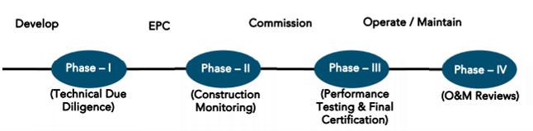

**SECOND LENDER’S INDEPENDENT ENGINEER REPORT**

**OF**

**"Decent Life Space 2 (Wing B named as Skyrise)"**

**"Decent Life Space 2 (Wing B named as Skyrise)", Proposed Residential Group Housing Scheme on land bearing S. No. 70/A, H. No. 1 & S. No. 51/A, H. No. 5, C. T. S. No. 2163, 16 (Pt) & 192 (Pt), Palghar – Manor Road, Village – Palghar, Taluka & District – Palghar, Pin Code – 401 404, State – Maharashtra, Country – India**

**Latitude Longitude: 19°42'17.8"N 72°46'15.9"E**

**NAME OF DEVELOPER: M/s. Adinath Associates**

|  |
| --- |
| Pursuant to instructions from State Bank of India, SME Centre Borivali (West) Branch, Borivali we have duly visited, inspected, surveyed & assessed the above said property on **07th May 2024** to determine the fair & reasonable market value of the said property/project as on Quarter ending **31st March 2024** for LIE purpose.  **1. Location Details:**  Proposed Residential Group Housing Scheme on land bearing S. No. 70/A, H. No. 1 & S. No. 51/A, H. No. 5, C. T. S. No. 2163, 16 (Pt) & 192 (Pt), Palghar – Manor Road, Village – Palghar, Taluka & District – Palghar, Pin Code – 401 404. It is about 1.60 Km. travelling distance from Palghar Railway station. Surface transport to the property is by buses, taxis & private vehicles. The property is in developed locality. All the amenities like shops, banks, hotels, markets, schools, hospitals, etc. are all available in the surrounding locality. The area is higher middle class & developed. |

**2. Developer Details:**

|  |  |
| --- | --- |
| **Name of Developer** | **M/s. Adinath Associates** |
| **Project Rera Registration Number** | **P99000045487** |
| **Registered office address** | 46, Aminabad Building, 7th Floor, Aga Hall, Nesbit Road, Mazgaon, Mumbai, Pin Code – 400 010, State – Maharashtra, Country – India |
| **Contact details** | **Contact Person:**  Mr. Jeet Mehta (Consultant)  Mobile No. +91 7878113580  Mr. Fanil Shah (Owner)  Mobile No. +91 9930128852  Mr. Brijlal Yadav (Accountant)  Mobile No. +91 8329774754 |
| **E – mail ID and website** |  |

**3. Boundaries of the Property:**

|  |  |
| --- | --- |
| **Direction** | **Particulars** |
| **On or towards North** | Residential Chawl |
| **On or towards South** | Under Construction Building |
| **On or towards East** | Open Plot |
| **On or towards West** | Internal Road / Western Railway Track |

# Introduction

**As per Information on site M/s. Adinath Associates** has acquired land by Conveyance Deed dated 17.12.2012 registered vide No. 3340/2013 admeasuring total **area is 2405.00 Sq. M.** bearing **Survey No. 51/A/5 & 70/A/1.**

For the Proposed Residential Building.

# Area Statement:

# Land:

|  |  |  |
| --- | --- | --- |
| **Date** | **Particular** | **Area in Sq. M.** |
| 18.02.2016 | Survey No. 51/A/5 | 32,000.00 |
| Survey No. 70/A/1 | 76,000.00 |
| TOTAL | | 1,08,000.00 |

1. Copy of Legal Title Report dated 07.04.2022 issued by Adv. Avataru R. Gupta.

# Building Area As per Approved Plan:

| AREA STATEMENT | | |
| --- | --- | --- |
| 1 | **Area of plot** |  |
|  | (Minimum area of a, b, c, to be considered) |
|  | a) As per ownership [document (7/12, CTS extract) | 10800 |
|  | b) as per measurement sheet | 9140 |
|  | c) as per site | NILL |
| 2 | **Deductions For** | |
|  | (a) Proposed D.P./D.P. Road widening Area/Service Road / Highway Widening | 1527.74 |
|  | (b) Service Road Area (Reservation Area) | 1174.01 |
|  | © Not in Possession area | NILL |
|  | (Total a + b + c) | 2701.75 |
| 3 | **Balanced area of plot (1-2)** | 6438.25 |
| 4 | Amenity Space (if applicable) | NILL |
|  | (a) Required - |  |
|  | (b) Adjustment of 2 (b), if any - |  |
|  | (c) Balanced Proposed - | NILL |
| 5 | **Net Plot Area (3-4 (c))** | 6438.25 |
| 6 | **Recreational Open Space** |  |
|  | (a) Required - | 703.84 |
|  | (b) Proposed - | 704.02 |
| 7 | **Internal Road area** | NILL |
| 8 | **Plotable Area (if applicable)** |  |
| 9 | **Built up area with reference to Basic F.S.I as per front road width** | 7082.08 |
|  | (Sr. No. 5 x Basic FSI) |
| 10 | **Addition of FSI on payment of premium** |  |
|  | (a) Maximum permissible premium FSI - based on road with / TOD Zone. (9140.00 x 0.30) | 2742 |
|  | (b) Proposed FSI on payment of premium | NILL |
| 11 | **In-situ FSI/TDR Loading** | NILL |
|  | (a) In-Situ area against D.P. Road & Reservation (2.0 x Sr. No. 2 (a)), if any | 5403.5 |
|  | (b) In-situ area against Amenity Space if Handed over | NILL |
|  | [ 2.00 or 1.85 x Sr. No. 4 (b) and / or (c)] | NILL |
|  | (c) TDR Area | NILL |
|  | (d) Total in-situ / TDR loading proposed (11 (a) + (b) + (c)) | 5403.5 |
| 12 | **Total Built up area with reference to Basic F.S.I & Proposed FSI on payment of Premium (9 + 10a)** | 15227.58 |
| 13 | **Total old approval Built up Area** | **3143.16** |
| 14 | **Total (12-13)** | 12084.42 |
| 15 | **Additional FSI area under Chapter No. 7** | NILL |
| 16 | **Total entitlement of FSI in the proposal.** |  |
|  | (a) [9 + 10(a) + 11(d)] or 12 Whichever is applicable | 15227.58 |
|  | (b) Ancillary Area FSI upto 60% with payment of charges (0.60%) (12084.42 X 0.60) | 7250.65 |
|  | (c) Total entitlement (a + b) | **22478.22** |
| 17 | **Maximum utilization limit of FSI (building potential) Permissible as per Road width {(as per Regulation No. 6.1 or 6.2 or 6.3 or 6.4 as applicable) X 1.6** |  |
| 18 | **Total Built-up Area in proposal. (Excluding area at Sr. No. 17b)** | **2.24** |
|  | (a) Existing Built -up area. | 3143.16 |
|  | (b) Proposed Built-up Area (As per 'P-Line') | **16791.62** |
|  | (c) Total (a + b) | **19934.78** |
| 19 | **F.S.I. Consumed (18/16) (should not be more than Serial no.14 above)** | 1.589 |
| 20 | **Total proposed Built-up Area in Proposal (For Payment Calculation)** |  |
|  | (a) Proposed Built-up Area with Reference to Basic F.S.I. | 7082.08 |
|  | (b) Proposed Built-up Area with Reference To premium F.S.I. | 2742 |
|  | (c) Proposed Built-up Area with Reference To D.P Road & reservation F.S.I. | 5403.5 |
|  | (d) Proposed Built-up Area with Reference to Ancillary F.S.I. | 4707.2 |
|  | Total | **19934.78** |
|  | TOTAL BALANCE BUILT UP AREA | **2543.45** |

Floor wise Built – Up Area Statement as per amended approved building plan is as below –

|  |  |  |
| --- | --- | --- |
| Sr. | Floor | Built Up Area in Sq. M. |
| 1 | Ground Floor | 208.96 |
| 2 | 1st Floor | 557.71 |
| 3 | 2nd Floor | 589.66 |
| 4 | 3rd Floor | 589.66 |
| 5 | 4th Floor | 589.66 |
| 6 | 5th Floor | 589.66 |
| 7 | 6th Floor | 589.66 |
| 8 | 7th Floor | 589.66 |
| 9 | 8th Floor | 558.03 |
| 10 | 9th Floor | 589.66 |
| 11 | 10th Floor | 589.66 |
| 12 | 11th Floor | 589.66 |
| 13 | 12th Floor | 589.66 |
| 14 | 13th Floor | 558.03 |
| 15 | 14th Floor | 589.66 |
| 16 | 15th Floor | 589.66 |
| 17 | 16th Floor | 589.66 |
| TOTAL | | 9,548.31 |

# List of Approvals:

1. Copy of Approved Plan No. B. V. 162 dated 08.08.2018 issued by Palghar Nagar Parishad.

Approved upto: Floor + 1st to 7th Upper Floor.

1. Copy of Amend Approved Plan No. NVV 1502 dated 25.03.2022 issued by Palghar Nagar Parishad.

Approved upto: Floor + 1st to 16th Upper Floor.

1. Copy of Commencement Certificate No. PNP/NRV/1502/2021-2022 dated 25.03.2022 issued by Palghar Nagar Parishad.

(This CC is endorsed for the work upto Ground Floor + 1st to 16th Upper Floor)

# LEVEL OF COMPLETION:

# Construction of Building

| Sr. No | Floor No. | Construction Area in Sq. M. | Completed Area in Sq. M. | Work Completion as on 28.02.2024 | Work Completion as on 07.05.2024 |
| --- | --- | --- | --- | --- | --- |
| 1 | Excavation & Shore Piling | | | Work is Completed | Work is completed |
| 2 | Ground Floor | 208.96 | 208.96 | Slab work is completed | Slab work, Block work, Plaster work is completed |
| 3 | 1st Floor | 557.71 | 557.71 | Slab work, Block work, Plaster work & gypsum work is completed | Slab work, Block work, Plaster work & gypsum work is completed |
| 4 | 2nd Floor | 589.66 | 589.66 | Slab work, Block work, Plaster work & gypsum work is completed | Slab work, Block work, Plaster work, gypsum work, Kitchen Platform & Toilet Daddo and Tiling is completed |
| 5 | 3rd Floor | 589.66 | 589.66 | Slab work, Block work, Plaster work & gypsum work is completed | Slab work, Block work, Plaster work, gypsum work, Kitchen Platform & Toilet Daddo and Tiling is completed |
| 6 | 4th Floor | 589.66 | 589.66 | Slab work, Block work, Plaster work is completed, Gypsum work is in progress | Slab work, Block work, Plaster work, gypsum work, Kitchen Platform & Toilet Daddo and Tiling is completed |
| 7 | 5th Floor | 589.66 | 589.66 | Slab work is completed | Slab Work, Block Work & Plastering work is completed |
| 8 | 6th Floor | 589.66 | 589.66 | Slab work is completed | Slab Work, Block Work & Plastering work is completed |
| 9 | 7th Floor | 589.66 | 589.66 | Slab work is completed | Slab Work, Block Work & Plastering work is completed |
| 10 | 8th Floor | 558.03 | 558.03 | Slab work is completed | Slab Work, Block Work & Plastering work is completed |
| 11 | 9th Floor | 589.66 | 589.66 | Slab work is completed | Slab Work completed & Block work is in progress. |
| 12 | 10th Floor | 589.66 | 589.66 |  | Slab work is completed |
| 13 | 11th Floor | 589.66 | 589.66 |  | Slab work is completed |
| 14 | 12th Floor | 589.66 | 589.66 |  | Slab work is completed |
| 15 | 13th Floor | 558.03 |  |  | Shuttering work is in progress |
| 16 | 14th Floor | 589.66 |  |  |  |
| 17 | 15th Floor | 589.66 |  |  |  |
| 18 | 16th Floor | 589.66 |  |  |  |
| 19 | Terrace Floor & OHT & LMR Area | | |  |  |
| Total | | **9,548.31** | **7,221.30** |  |  |

# External Development

|  |  |  |
| --- | --- | --- |
| Particulars | Work Completion as on 28.02.2024 | Work Completion as on 07.05.2024 |
| Meter Room |  |  |
| Sewage Treatment Plant |  |  |
| 24 X 7 Water Supply |  |  |
| Landscaping & Tree Planting |  |  |
| Water Conversation, rain water harvesting |  |  |
| Open Parking |  |  |
| Storm Water Drains |  |  |
| Closed Car Parking |  |  |
| Fire Sprinklers |  |  |

# Details of the Project as Financed By SBI:

# Estimate of the project

|  |  |
| --- | --- |
| Project expenses | Cost as per CA Certificate & Cost Vetting Report in ` Cr. |
| Land Cost | 0.78 |
| Construction Cost of Building & external development cost | 28.44 |
| Approval Cost | 0.79 |
| Professional, Admin & Marketing Cost | 1.58 |
| Contingency Cost | 1.70 |
| Interest Cost | 3.85 |
| Total Cost | **64.54** |

## Note: -

# Project Cost: (as per C.A. Certificate)

|  |  |  |  |
| --- | --- | --- | --- |
| **Particulars** | **Incurred Cost (In ` Cr.) till 31.03.2024 dated 31.03.2024 by M/s. Zenith M Jain & Co.** | **Incurred Cost (In ` Cr.) till 31.12.2023 dated 07.01.2024 by M/s. Zenith M Jain & Co.** | **Diff.** |
| Land Cost | 0.78 | 0.78 | - |
| Construction Cost of Building & external development cost | 8.65 | 5.95 | 2.70 |
| Approval Cost | 0.64 | 0.64 | - |
| Professional, Admin & Marketing Cost | 0.37 | 0.16 | 0.21 |
| Contingency Cost | - | - | - |
| Interest Cost | - | - | - |
| **Total** | **10.43** | **7.53** | **2.91** |

# Cost of Construction as on 07th May 2024:

# Construction Cost of Building:

|  |  |  |  |  |  |  |  |
| --- | --- | --- | --- | --- | --- | --- | --- |
| Sr. | Floor | Built Up Area in Sq. M. | Completed Area in Sq. M. | Rate per Sq. M. | Full Value after completion | % of work completed | Actual Expenditure till date in ` |
| 1 | Ground Floor | 208.96 | 208.96 | 30,000.00 | 62,68,800.00 | 80% | 50,15,040.00 |
| 2 | 1st Floor | 557.71 | 557.71 | 30,000.00 | 1,67,31,300.00 | 75% | 1,25,48,475.00 |
| 3 | 2nd Floor | 589.66 | 589.66 | 30,000.00 | 1,76,89,800.00 | 75% | 1,32,67,350.00 |
| 4 | 3rd Floor | 589.66 | 589.66 | 30,000.00 | 1,76,89,800.00 | 75% | 1,32,67,350.00 |
| 5 | 4th Floor | 589.66 | 589.66 | 30,000.00 | 1,76,89,800.00 | 75% | 1,32,67,350.00 |
| 6 | 5th Floor | 589.66 | 589.66 | 30,000.00 | 1,76,89,800.00 | 70% | 1,23,82,860.00 |
| 7 | 6th Floor | 589.66 | 589.66 | 30,000.00 | 1,76,89,800.00 | 70% | 1,23,82,860.00 |
| 8 | 7th Floor | 589.66 | 589.66 | 30,000.00 | 1,76,89,800.00 | 70% | 1,23,82,860.00 |
| 9 | 8th Floor | 558.03 | 558.03 | 24,000.00 | 1,33,92,720.00 | 70% | 93,74,904.00 |
| 10 | 9th Floor | 589.66 | 589.66 | 30,000.00 | 1,76,89,800.00 | 55% | 97,29,390.00 |
| 11 | 10th Floor | 589.66 | 589.66 | 30,000.00 | 1,76,89,800.00 | 55% | 97,29,390.00 |
| 12 | 11th Floor | 589.66 | 589.66 | 30,000.00 | 1,76,89,800.00 | 55% | 97,29,390.00 |
| 13 | 12th Floor | 589.66 | 589.66 | 30,000.00 | 1,76,89,800.00 | 50% | 88,44,900.00 |
| 14 | 13th Floor | 558.03 |  | 24,000.00 | 1,33,92,720.00 |  |  |
| 15 | 14th Floor | 589.66 |  | 30,000.00 | 1,76,89,800.00 |  |  |
| 16 | 15th Floor | 589.66 |  | 30,000.00 | 1,76,89,800.00 |  |  |
| 17 | 16th Floor | 589.66 |  | 30,000.00 | 1,76,89,800.00 |  |  |
| TOTAL | | **9,548.31** | **5,452.32** |  | **27,97,52,940.00** | **50.73%** | **14,19,22,119.00** |

# External Development:

|  |  |  |  |
| --- | --- | --- | --- |
| Particulars | Cost as per Cost vetting Report dated 03.01.2023 | Percentage of work completed | Actual Expenditure till date in ` |
| Meter Room | 2,00,000.00 |  |  |
| Sewage Treatment Plant | 12,00,000.00 |  |  |
| 24 X 7 Water Supply | 10,00,000.00 |  |  |
| Landscaping & Tree Planting | 6,00,000.00 |  |  |
| Water Conversation, rain water harvesting | 5,00,000.00 |  |  |
| Open Parking | 3,00,000.00 |  |  |
| Storm Water Drains | 4,00,000.00 |  |  |
| Closed Car Parking | 2,00,000.00 |  |  |
| Fire Sprinklers | 2,00,000.00 |  |  |
| TOTAL | 46,00,000.00 |  |  |

##### Note: Details of work completed is as per site visit dated 07.05.2024 but LIE report is prepared for quarter ending on 31st March 2024.

# Means of Finance:

|  |  |  |
| --- | --- | --- |
| **Sr. No.** | **Particulars** | **Exp. Cumulative (Cr.)** |
|  | Equity share capital / Quassi Loan from Promoter | 1.50 |
|  | Unsecured Loan | 1.98 |
|  | Bank Loan Amount | 4.60 |
|  | Sales (Advance from customer) | 4.40 |
|  | **Total** | **12.48** |

The Details of the Means of Finance are provided by Client as on 31.03.2024.

# Mandatory Arrangements:

|  |  |  |
| --- | --- | --- |
| **Sr. No.** | **Particulars** | **Status** |
|  | Rainwater Harvesting | To be executed after RCC Structure |
|  | Firefighting System | To be executed after RCC Structure |
|  | Solid Waste Management | To be executed after RCC Structure |

# Quality of Construction:

|  |  |  |
| --- | --- | --- |
| **Sr. No.** | **Particulars** | **Status** |
|  | Soundness of Structures | Executing as per approved Structural Design |
|  | Look of Structures | Good |
|  | Quality of Material Used | Good |
|  | Safety Measures for Construction/labour | Taken Care by Contractor |

# Schedule V/s. Actual Progress:

| Activity | Date of Implementation | Date of Completion | Status |
| --- | --- | --- | --- |
| Land |  |  | Completed |
| Development of Land |  |  | Completed |
| Foundation Work |  |  | Completed |
| Ground Floor Slab |  |  | Slab work is Completed |
| 1st Floor Slab |  |  | Slab work is Completed |
| 2nd Floor Slab |  |  | Slab work is Completed |
| 3rd Floor Slab |  |  | Slab work is Completed |
| 4th Floor Slab |  |  | Slab work is Completed |
| 5th Floor Slab |  |  | Slab work is Completed |
| 6th Floor Slab |  |  | Slab work is Completed |
| 7th Floor Slab |  |  | Slab work is Completed |
| 8th Floor Slab |  |  | Slab work is Completed |
| 9th Floor Slab |  |  | Slab work is Completed |
| 10th Floor Slab |  |  | Slab work is Completed |
| 11th Floor Slab |  |  | Slab work is Completed |
| 12th Floor Slab |  |  | Slab work is Completed |
| 13th Floor Slab |  |  | Shuttering work is in progress |
| 14th Floor Slab |  |  |  |
| 15th Floor Slab |  |  |  |
| 16th Floor Slab |  |  |  |
| Block work / Internal Plaster work |  |  | 1st to 9th floor blockwork & internal plaster work is completed |
| Terrace Parapet wall / Overhead water tank / Lift Machine room / compound wall / External Plaster work |  |  |  |
| Electric Work |  |  | Work is in progress |
| Water Proofing |  |  | Work is in progress |
| Plumbing Work |  |  | Work is in progress |
| Tiling / Marble Flooring |  |  | Work is in progress |
| Door Frames |  |  | Work is in progress |
| Window Installation |  |  | Work is in progress |
| Staircase Flooring |  |  |  |
| Staircase Railing |  |  |  |
| Refuge Area Flooring |  |  |  |
| Internal Painting |  |  |  |
| External Painting |  |  |  |
| Lift Work |  |  |  |
| Fire Fighting Installation |  |  | Work is in progress |
| Stack Parking |  |  |  |
| CP Fitting & Sanitary Work |  |  |  |
| Final Finishing & Fitting |  |  |  |

# Action initiated to complete the project in time:

**For Sale Building:** Till 12th Slab work is completed & 13th floor shuttering work is in progress.

# Comments related to cost overrun if any:

The cost of Sales Building is ` 37.12 Cr.

# Balance investment required for completion of project:

We opinion amount of **` 26.69 Cr.** Will be required to complete the Project.

# Mandatory Approval Status:

| **Sr. No.** | **Particulars** | **Name of Department** | **Status** | **Order Details** |
| --- | --- | --- | --- | --- |
| **1** | IOD of Building | Palghar Nagar Parishad | Obtained and available at site | No. B. V. 162 dated 08.08.2018  Approved upto: Floor + 1st to 7th Upper Floor. |
| **1A** | 1st Amended | Palghar Nagar Parishad | Obtained and available at site | No. NVV 1502 dated 25.03.2022  Approved upto: Floor + 1st to 16th Upper Floor. |
| **2A** | First C.C. | Palghar Nagar Parishad | Obtained and available at site | No. PNP/NRV/1502/2021-2022 dated 25.03.2022  (This CC is endorsed for the work upto Ground Floor + 1st to 16th Upper Floor) |
| **3** | Occupancy | Palghar Nagar Parishad | Pending (Project is not completed) |  |

# Status Insurance Coverage:

Information not provided

# Assumptions & Remarks:

* The adequacy of Engineering / Structural design is beyond the scope of our assignment.
* Estimated project completion date is 31/12/2026. The cost is certified based on the assumptions that the project will be completed within period. Few assumptions were made regarding inflation & cost rise etc. during construction period.

**Sharadkumar B. Chalikwar**

Govt. Reg. Valuer

Chartered Engineer (India)

Reg. No. (N) CCIT/1-14/52/2008-09

**About the Project:**

|  |  |  |
| --- | --- | --- |
| **1. Introduction** | |  |
| a) | Project Name  (With Address & Phone Nos.) | "**Decent Life Space 2 (Wing B named as Skyrise)**", Proposed Residential Group Housing Scheme on land bearing S. No. 70/A, H. No. 1 & S. No. 51/A, H. No. 5, C. T. S. No. 2163, 16 (Pt) & 192 (Pt), Palghar – Manor Road, Village – Palghar, Taluka & District – Palghar, Pin Code – 401 404, State – Maharashtra, Country – India  Contact Person:  Mr. Jeet Mehta (Consultant)  Mobile No. +91 78781 13580  Mr. Fanil Shah (Owner)  Mobile No. +91 99301 28852  Mr. Brijlal Yadav (Accountant)  Mobile No. +91 83297 74754 |
| b) | Purpose of Valuation | As per request from State Bank of India, SME Centre Borivali (West) Branch, Borivali to assess cost of the Project for LIE purpose. |
| c) | Date of Inspection of Property | 07.05.2024 |
| d) | Date of LIE Report | 09.05.2024 |
| e) | Name of the Developer of Property  (in case of developer built properties) | **M/s. Adinath Associates.**  Shop No. 1, Vardhman Apartment, Lokmanya Tilak Road, Dahisar (West), Mumbai, Pin Code – 400 068, State – Maharashtra, Country – India |
| **2. Physical Characteristics of the Property** | | |
| a) | Location of the Property | "**Decent Life Space 2 (Wing B named as Skyrise)**", Proposed Residential Group Housing Scheme on land bearing S. No. 70/A, H. No. 1 & S. No. 51/A, H. No. 5, C. T. S. No. 2163, 16 (Pt) & 192 (Pt), Palghar – Manor Road, Village – Palghar, Taluka & District – Palghar, Pin Code – 401 404, State – Maharashtra, Country – India |
| Brief description of the property |  |
|  | **TYPE OF THE BUILDING**   1. **Residential Building**  |  |  | | --- | --- | | No. of Floors | Ground Floor + 1st to 16th Upper Floor. | | Building type | Residential building |   Residential Building work is given on contract based for RCC contract. Developer has grant to the contractor do the work of construction and completion includes Concrete work, Reinforcement work, Masonry, Internal Plaster, External Plaster and other miscellaneous work such as repairing, joints b/w concrete and masonry surface, etc. Bill must be paid on measurement of construction area exclusive of Steel, Cement & other construction material.  Lift & lift installation contract is not finalized till now.  Firefighting work contract is not finalized.  **PROPOSED DATE OF COMPLETION & FUTURE LIFE:**  Expected completion date as per developer is 31st December 2026 | |
|  | Nearby landmark | - |
| Postal Address of the Property | "**Decent Life Space 2 (Wing B named as Skyrise)**", Proposed Residential Group Housing Scheme on land bearing S. No. 70/A, H. No. 1 & S. No. 51/A, H. No. 5, C. T. S. No. 2163, 16 (Pt) & 192 (Pt), Palghar – Manor Road, Village – Palghar, Taluka & District – Palghar, Pin Code – 401 404, State – Maharashtra, Country – India |
|  | Area of the plot/land  (Supported by a plan) | Plot Area: 1,08,000.00 Sq. M. |
| Type of Land: Solid, Rocky, Marsh land, reclaimed land, Water-logged, Land locked. | Solid land |
|  | Independent access/approach to the property etc. | Yes |
| Google Map Location of the Property with a neighborhood layout map | Provided |
|  | Details of roads abutting the property |  |
| Description of adjoining property | Located in Middle-class locality |
| Plot No. Survey No. | S. No. 70/A, H. No. 1 & S. No. 51/A, H. No. 5, C. T. S. No. 2163, 16 (Pt) & 192 (Pt) |
| Ward/Village/Taluka | Village – Palghar, Taluka – Palghar |
| Sub-Registry/Block | Palghar |
| District | District – Palghar |
| b) | **Boundaries of the Plot** |  |
|  | |  |  |  | | --- | --- | --- | |  | **As per Agreement** | **Actual** | | **North** | Information not available | Residential Chawl | | **South** | Information not available | Under Construction Building | | **East** | Information not available | Open Plot | | **West** | Information not available | Internal Road / Western Railway Track | | |

|  |  |
| --- | --- |
| **4. Document Details and Legal Aspects of Property:** | |
| a) | Ownership Documents (**Building Permission, Commencement Certificate & Status of Plan)** |
|  | Sale Deed, Gift Deed, Lease Deed |
| 1. Copy of Legal Title Report dated 07.04.2022 issued by Adv. Avataru R. Gupta |
| 1. Copy of Approved Plan No. B. V. 162 dated 08.08.2018 issued by Palghar Nagar Parishad.   **Approved upto: Floor + 1st to 7th Upper Floor.** |
| 1. Copy of Amend Approved Plan No. NVV 1502 dated 25.03.2022 issued by Palghar Nagar Parishad.   **Approved upto: Floor + 1st to 16th Upper Floor.** |
| 1. Copy of Commencement Certificate No. PNP/NRV/1502/2021-2022 dated 25.03.2022 issued by Palghar Nagar Parishad.   **(This CC is endorsed for the work upto Ground Floor + 1st to 16th Upper Floor)** |
| 1. Copy of RERA Certificate No. P99000045487 dated 24.05.2022 issued by Maharashtra Real Estate Regulatory Authority. |
| 1. Copy of Valuation Report Ref. No. SBI/Borivali/312 dated 03.01.2023 issued by Shailesh Wani & Co. |
| 1. Copy of Cost Vetting Report Ref. No. SBI/Borivali/314 dated 03.01.2023 issued by Shailesh Wani & Co. |
| 1. Copy of CA Certificate dated 07.01.2024 issued by M/s. Zenith M Jain & Co. |
| 1. Copy of Engineer Certificate dated 01.01.2024 issued by Darsh Consult. |

|  |  |
| --- | --- |
| b) | **Documents verified for present LIE report** |
|  | 1. Copy of CA Certificate dated 31.03.2024 issued by M/s. Zenith M Jain & Co |

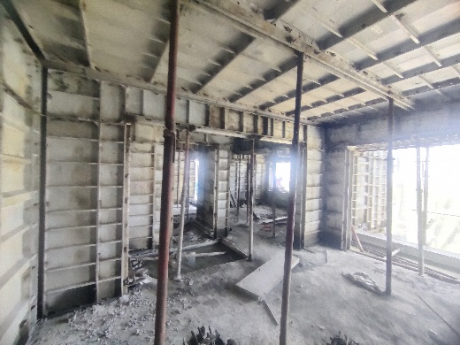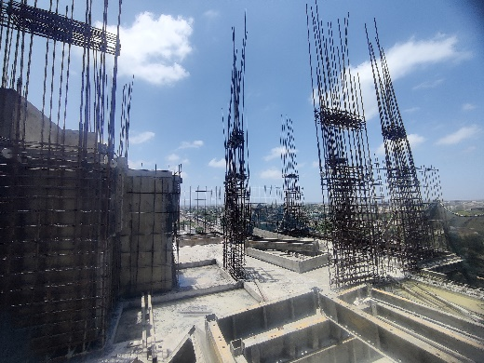**Actual Site Photographs as on 07.05.2024**

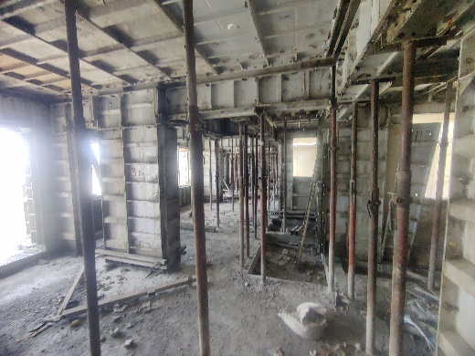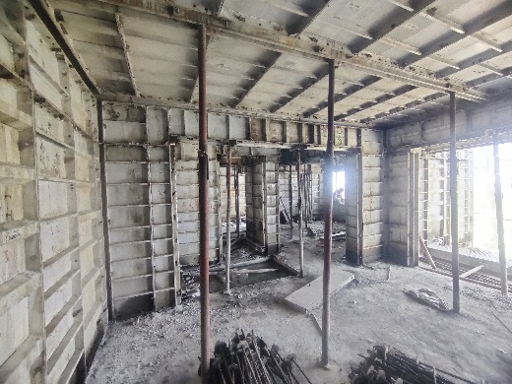

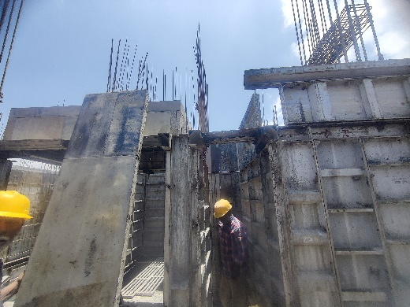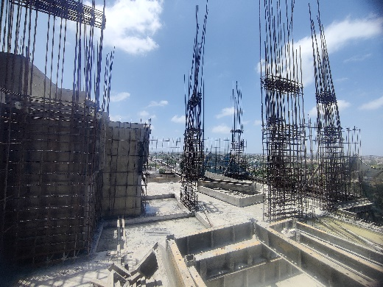

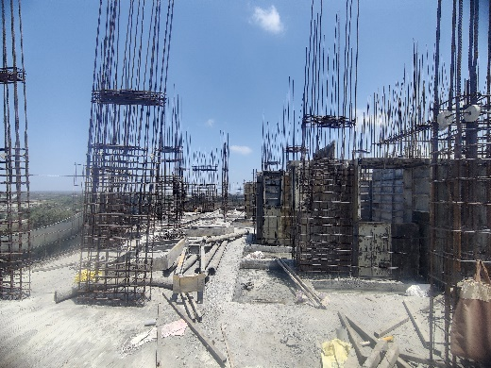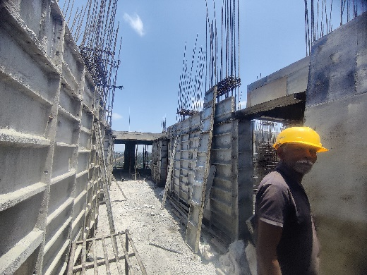

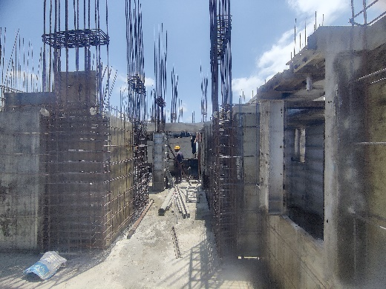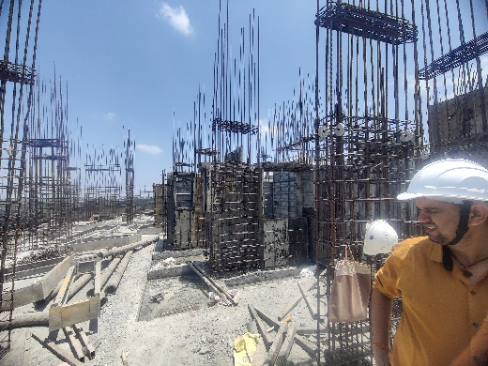

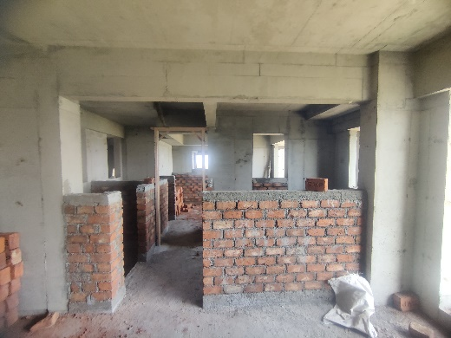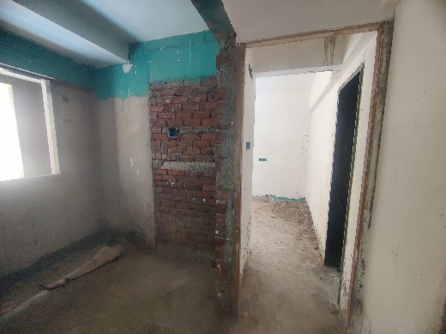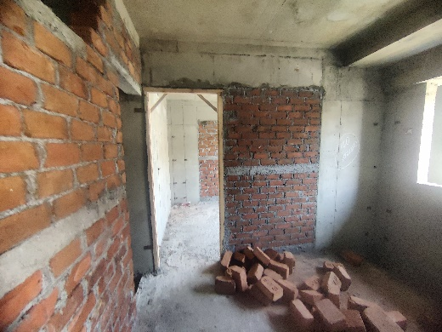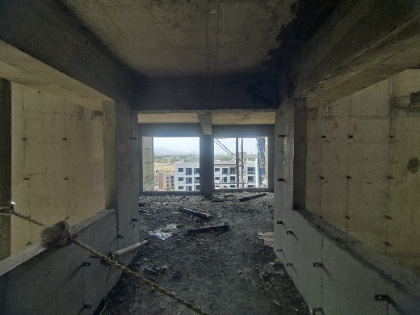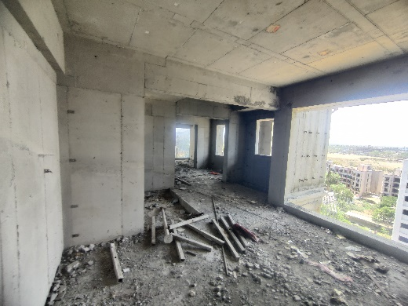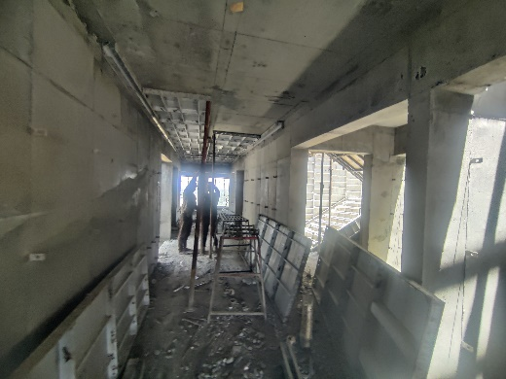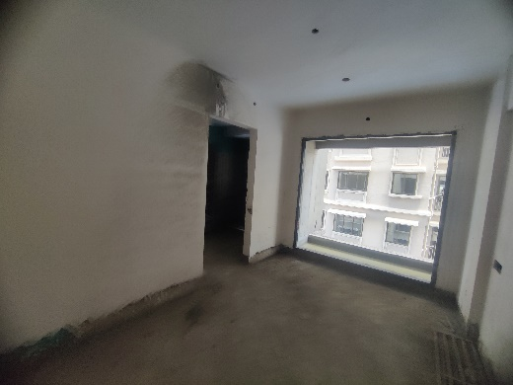**Actual Site Photographs as on 07.05.2024**

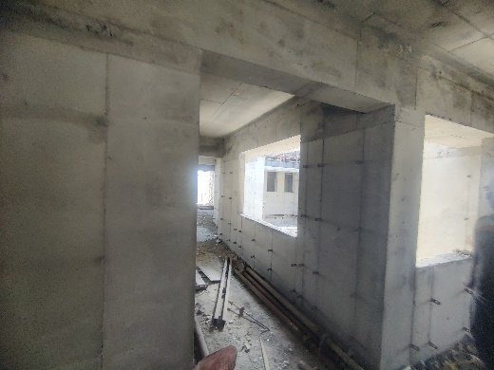

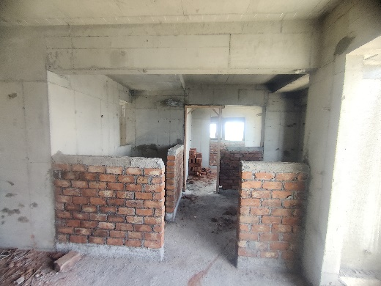

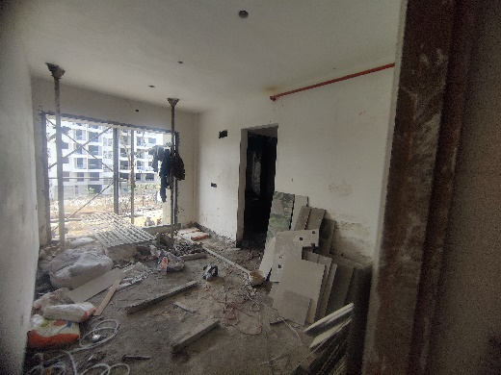

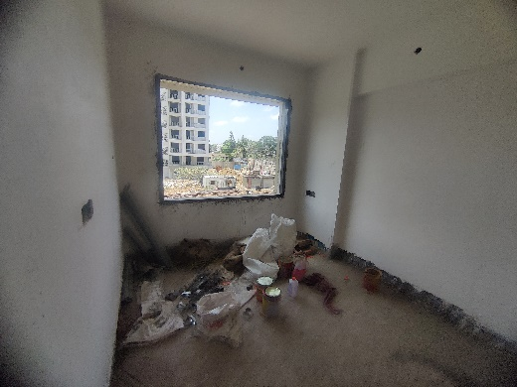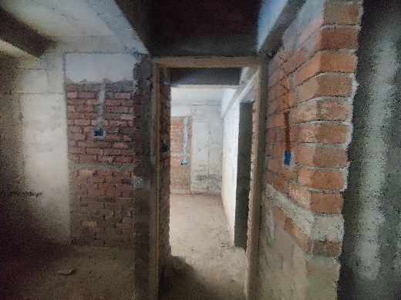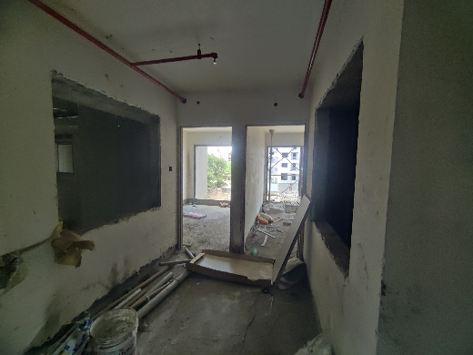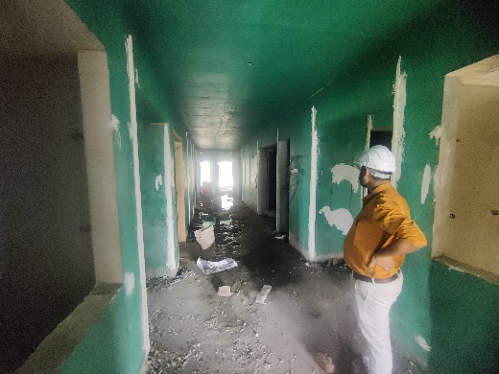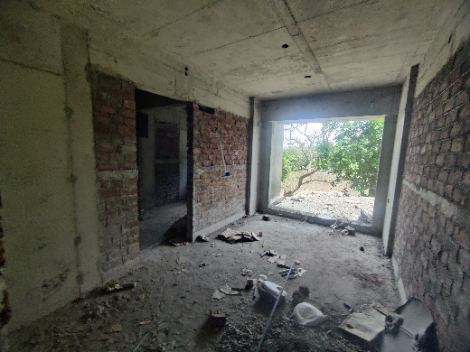**Actual Site Photographs as on 07.05.2024**

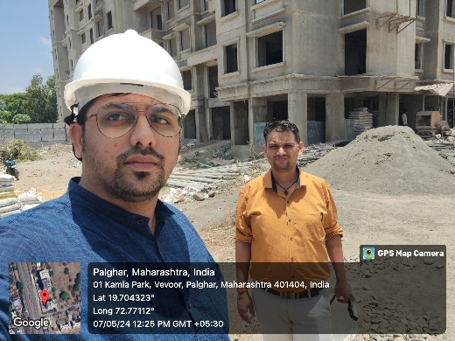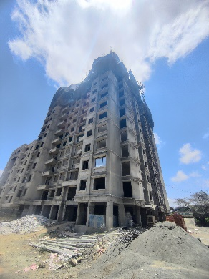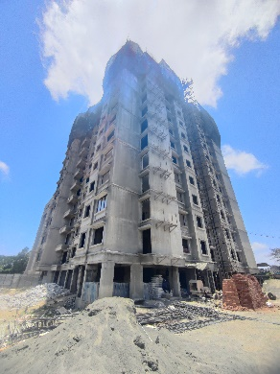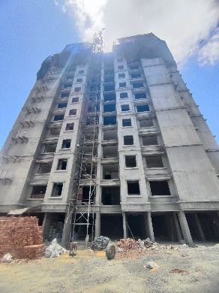

**Route Map of the property**

**Site u/r**

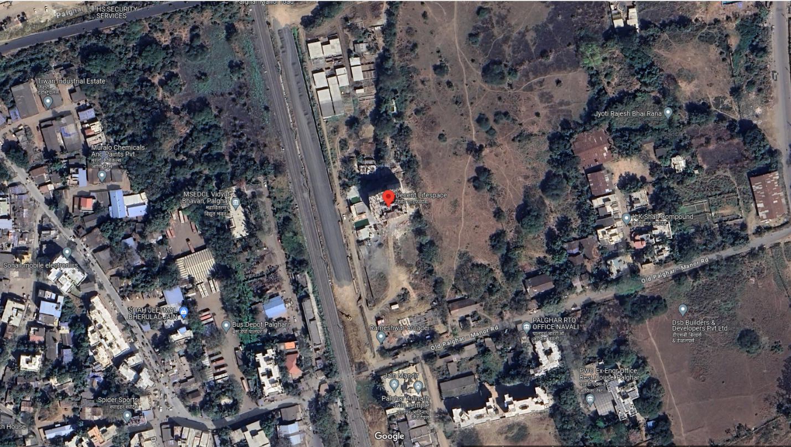

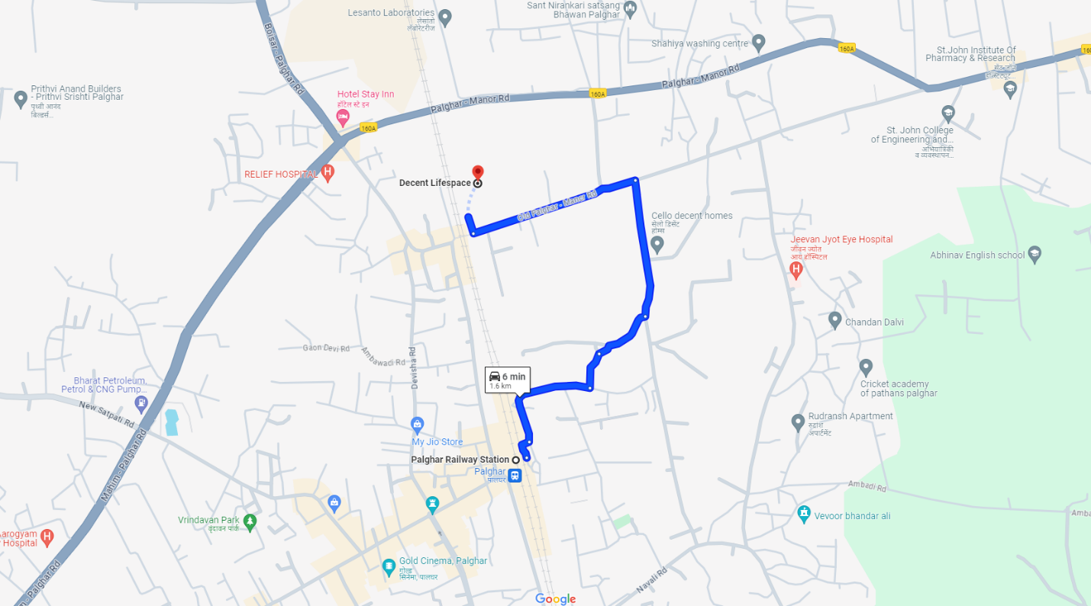

## Latitude Longitude: 19°42'17.8"N 72°46'15.9"E

Note: The Blue line shows the route to site from nearest railway station (Palghar – 1.60 Km.)