MASTER VALUATION REPORT
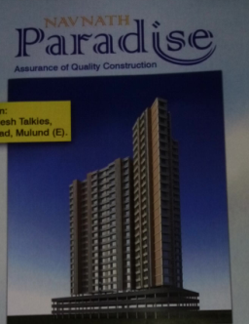

Details of the property under consideration:

Name of Project: Navnath Paradise

“Navnath Paradise”, CTS No. 661/A, 661/B, 665/A, 665/B, 665/C-1, 665/C-2, 667/A & 667/B of Village Mulund,
Azad Nagar, Gokhale Road, Mulund (East), Mumbai – 400 081

Latitude & Longitude: 19°10'13.5"N 72°57'27.9"E

Valuation Done for:
State Bank of India
Belapur Branch
5th Floor, Tower No. 2, Belapur Railway Station,
Navi Mumbai

Vastukala Consultants (I) Pvt. Ltd.
Mumbai • Nanded • Navi Mumbai • Aurangabad

Vastu/SBI/Mumbai/07/2015/010154
10/09-129-VU
Date: 10.07.2015
MASTER VALUATION REPORT
OF
“Navnath Paradise”
“Navnath Paradise”, CTS No. 661/A, 661/B, 665/A, 665/B, 665/C-1, 665/C-2, 667/A & 667/B of Village Mulund, Azad Nagar, Gokhale Road, Mulund (East), Mumbai – 400 081

Latitude & Longitude: 19°10'13.5"N 72°57'27.9"E

NAME OF DEVELOPER: M/s. Navnath Associates

Pursuant to instructions from State Bank of India, Belapur Branch, we have duly visited, inspected, surveyed & assessed the above said property to determine the fair & reasonable market value of the said property as on 08th July 2015 for approval of Advance Processing Facility.

- Location Details:
The property is situated at Azad Nagar, Gokhale Road, Mulund (East). It is about 5 to 7 minutes travel distance from Mulund (East) railway station of Central Railway line. Surface transport to the property is by buses, taxis, Auto & private vehicles. The property is in developed locality. All the amenities like shops, banks, hotels, markets, schools, hospitals, etc. are all available in the surrounding locality. The area is middle class & developed.
- Developer Details:

Name of builder | M/s. Navnath Associates
Register office address | B – 101, Shrirang Niwas, Gokhale Road, Mulund (East), Mumbai – 400 081
Contact Numbers | Contact Person :  Ms. Dipalo – 022 – 21631682  Mr. Vaibhav Joshi - 8691818453
E – mail ID & Website | Navnath.associates@gmail.com

Boundaries of the Property:

Direction | Particulars
On or towards North | Shreeji Building
On or towards South | Jai Bhavani CHSL & Road
On or towards East | Rehab Building No. 1,2 & 3
On or towards West | Mangal Murti Building & Guru Krupa Building

3) TYPE OF THE BUILDING
RCC Framed structure having
A & B – Wing: Proposed Stilt + 20 upper floors.

4) BUILDING PERMISSION, COMMENCEMENT CERTIFICATE & STATUS OF PLAN:
- Copy of Deed of Partnership dated 08.10.2014 between Dr. Anand Arvind Pradhan, Mr. Vaibhav Ballal Joshi, Mr. Shyam P. Repal, Mr. Ravindra Sampat Waghmare the name and style of Navnath Associates
- Copy of Deed of Conveyance dated 31.03.2009 between Mr. Mohmed Ibrahim Ismile Ghone (khatick) (the Owner) AND Navnath Associates (the Purchasers)
- Copy of Deed of Conveyance dated 09.09.2008 between Smt. Radhabai Bhagwan Shetty (the Owner) AND Navnath Associates (the Purchasers)
- Copy of Deed of Declaration dated 11.08.2008 between Smt. Radhabai Bhagwan Shetty & Mr. Ramesh B. Shetty (the Vendor)
- Copy of Deed of Partnership dated 15.09.2007 between Dr. Anand Arvind Pradhan (the party of the 1st part) Mr. Vaibhav Ballal Joshi (the party of the 2nd part) the name and style of Navnath Associates
- Copy of Deed of Retirement dated 23.07.2010 between Dr. Anand Arvind Pradhan (the party of the 1st part) Mr. Vaibhav Ballal Joshi (the party of the 2nd part) Mr. Ravindra Sampat Waghmare (the party of the 3rd part), Mr. Shyam P. Repal (the party of the 4th part) AND Mr. Vijay K. Dani (the party of the 4th part)
- Copy of Reconstitution of Partnership dated 13.08.2009
- Copy of Title Certificate Ad. Mrs. Shamika S. Surve dated 16.09.2013
- Copy of Commencement Certificate No. SRA / ENG / 2446 / T/ PL / AP dated 30.08.2011 C.C is re-endorsed as per amended plans approved dated 09.06.2014 & is further extended from Ground (part) + 1st to top of 7th floor for both with A & B of sale building
- Copy of Approved Plan No. SRA / ENG / 2446 / T/ PL / AP dated 09.06.2014 (Number of Copies –Four - 1/4 to 4/4)
- Copy of 7/12 extract

5) LEVEL OF COMPLETEION:

A & B – Wing: RCC Work upto 2nd floor is completed – 14% (Fourteen Percent)

6) PROPOSED DATE OF COMPLETION & FUTURE LIFE:
Expected completion date as informed by builder is December - 2017
Future estimated life of the Structure is 60 years (after completion) Subject to proper, preventive periodic maintenance & Structural repairs.

7) PROJECT AMENITIES:
- Podium Garden
- Play Area
- Society Gym
- All modern fittings in flats
- Planning according to Vastu Shastra
- Power Backup

8) CONFIGURATION OF PROJECT AS PER DEVELOPER’S INFORMATION:
1) A – Wing:
Sr. No. | Flat No. | Floor No. | Comp. | Carpet Area in  Sq. ft. | Builti up Area in  Sq. ft. | Saleable Area in  Sq. ft. | Rate per  Sq. ft. on Saleable area  in ` | Cost of flat  in ` | Expected Rent per month in `
1 | 101 | 1 | 3 BHK | 850 | 1020 | 1290 | 15000 | 1,93,50,000.00 | 40313
2 | 102 | 1 | 3 BHK | 900 | 1080 | 1368 | 15000 | 2,05,20,000.00 | 42750
3 | 103 | 1 | 2 BHK | 645 | 774 | 978 | 15000 | 1,46,70,000.00 | 30563
4 | 201 | 2 | 3 BHK | 850 | 1020 | 1290 | 15000 | 1,93,50,000.00 | 40313
5 | 202 | 2 | 3 BHK | 900 | 1080 | 1368 | 15000 | 2,05,20,000.00 | 42750
6 | 203 | 2 | 2 BHK | 645 | 774 | 978 | 15000 | 1,46,70,000.00 | 30563
7 | 301 | 3 | 3 BHK | 850 | 1020 | 1290 | 15000 | 1,93,50,000.00 | 40313
8 | 302 | 3 | 3 BHK | 900 | 1080 | 1368 | 15000 | 2,05,20,000.00 | 42750
9 | 303 | 3 | 2 BHK | 645 | 774 | 978 | 15000 | 1,46,70,000.00 | 30563
10 | 401 | 4 | 3 BHK | 850 | 1020 | 1290 | 15000 | 1,93,50,000.00 | 40313
11 | 402 | 4 | 3 BHK | 900 | 1080 | 1368 | 15000 | 2,05,20,000.00 | 42750
12 | 403 | 4 | 2 BHK | 645 | 774 | 978 | 15000 | 1,46,70,000.00 | 30563
13 | 501 | 5 | 3 BHK | 850 | 1020 | 1290 | 15000 | 1,93,50,000.00 | 40313
14 | 502 | 5 | 3 BHK | 900 | 1080 | 1368 | 15000 | 2,05,20,000.00 | 42750
15 | 503 | 5 | 2 BHK | 645 | 774 | 978 | 15000 | 1,46,70,000.00 | 30563
16 | 601 | 6 | 3 BHK | 850 | 1020 | 1290 | 15000 | 1,93,50,000.00 | 40313
17 | 602 | 6 | 3 BHK | 900 | 1080 | 1368 | 15000 | 2,05,20,000.00 | 42750
18 | 603 | 6 | 2 BHK | 645 | 774 | 978 | 15000 | 1,46,70,000.00 | 30563
19 | 701 | 7 | 3 BHK | 850 | 1020 | 1290 | 15000 | 1,93,50,000.00 | 40313
20 | 702 | 7 | 3 BHK | 900 | 1080 | 1368 | 15000 | 2,05,20,000.00 | 42750
21 | 703 | 7 | 2 BHK | 645 | 774 | 978 | 15000 | 1,46,70,000.00 | 30563
22 | 801 | 8 | 3 BHK | 850 | 1020 | 1290 | 15000 | 1,93,50,000.00 | 40313
23 | 802 | 8 | 3 BHK | 900 | 1080 | 1368 | 15000 | 2,05,20,000.00 | 42750
24 | 803 | 8 | Refuge | 0 | 0 | 0 | 0 | 0 | 0
25 | 901 | 9 | 3 BHK | 850 | 1020 | 1290 | 15000 | 1,93,50,000.00 | 40313
26 | 902 | 9 | 3 BHK | 900 | 1080 | 1368 | 15000 | 2,05,20,000.00 | 42750
27 | 903 | 9 | 2 BHK | 645 | 774 | 978 | 15000 | 1,46,70,000.00 | 30563
28 | 1001 | 10 | 3 BHK | 850 | 1020 | 1290 | 15000 | 1,93,50,000.00 | 40313
29 | 1002 | 10 | 3 BHK | 900 | 1080 | 1368 | 15000 | 2,05,20,000.00 | 42750
30 | 1003 | 10 | 2 BHK | 645 | 774 | 978 | 15000 | 1,46,70,000.00 | 30563
31 | 1101 | 11 | 3 BHK | 850 | 1020 | 1290 | 15000 | 1,93,50,000.00 | 40313
32 | 1102 | 11 | 3 BHK | 900 | 1080 | 1368 | 15000 | 2,05,20,000.00 | 42750
33 | 1103 | 11 | 2 BHK | 645 | 774 | 978 | 15000 | 1,46,70,000.00 | 30563
34 | 1201 | 12 | 3 BHK | 850 | 1020 | 1290 | 15000 | 1,93,50,000.00 | 40313
35 | 1202 | 12 | 3 BHK | 900 | 1080 | 1368 | 15000 | 2,05,20,000.00 | 42750
36 | 1203 | 12 | 2 BHK | 645 | 774 | 978 | 15000 | 1,46,70,000.00 | 30563
37 | 1301 | 13 | 3 BHK | 850 | 1020 | 1290 | 15000 | 1,93,50,000.00 | 40313
38 | 1302 | 13 | 3 BHK | 900 | 1080 | 1368 | 15000 | 2,05,20,000.00 | 42750
39 | 1303 | 13 | 2 BHK | 645 | 774 | 978 | 15000 | 1,46,70,000.00 | 30563
40 | 1401 | 14 | 3 BHK | 850 | 1020 | 1290 | 15000 | 1,93,50,000.00 | 40313
41 | 1402 | 14 | 3 BHK | 900 | 1080 | 1368 | 15000 | 2,05,20,000.00 | 42750

42 | 1403 | 14 | 2 BHK | 645 | 774 | 978 | 15000 | 1,46,70,000.00 | 30563
43 | 1501 | 15 | 3 BHK | 850 | 1020 | 1290 | 15000 | 1,93,50,000.00 | 40313
44 | 1502 | 15 | 3 BHK | 900 | 1080 | 1368 | 15000 | 2,05,20,000.00 | 42750
45 | 1503 | 15 | Refuge | 0 | 0 | 0 | 0 | 0 | 0
46 | 1601 | 16 | 3 BHK | 850 | 1020 | 1290 | 15000 | 1,93,50,000.00 | 40313
47 | 1602 | 16 | 3 BHK | 900 | 1080 | 1368 | 15000 | 2,05,20,000.00 | 42750
48 | 1603 | 16 | 2 BHK | 645 | 774 | 978 | 15000 | 1,46,70,000.00 | 30563
49 | 1701 | 17 | 3 BHK | 850 | 1020 | 1290 | 15000 | 1,93,50,000.00 | 40313
50 | 1702 | 17 | 3 BHK | 900 | 1080 | 1368 | 15000 | 2,05,20,000.00 | 42750
51 | 1703 | 17 | 2 BHK | 645 | 774 | 978 | 15000 | 1,46,70,000.00 | 30563
52 | 1801 | 18 | 3 BHK | 850 | 1020 | 1290 | 15000 | 1,93,50,000.00 | 40313
53 | 1802 | 18 | 3 BHK | 900 | 1080 | 1368 | 15000 | 2,05,20,000.00 | 42750
54 | 1803 | 18 | 2 BHK | 645 | 774 | 978 | 15000 | 1,46,70,000.00 | 30563
55 | 1901 | 19 | 3 BHK | 850 | 1020 | 1290 | 15000 | 1,93,50,000.00 | 40313
56 | 1902 | 19 | 3 BHK | 900 | 1080 | 1368 | 15000 | 2,05,20,000.00 | 42750
57 | 1903 | 19 | 2 BHK | 645 | 774 | 978 | 15000 | 1,46,70,000.00 | 30563
58 | 2001 | 20 | 3 BHK | 850 | 1020 | 1290 | 15000 | 1,93,50,000.00 | 40313
59 | 2002 | 20 | 3 BHK | 900 | 1080 | 1368 | 15000 | 2,05,20,000.00 | 42750
Total |  |  |  | 45965 | 55158 | 69786 |  | 1,04,67,90,000.00

2) B – Wing:
Sr. No. | Flat No. | Floor No. | Comp. | Carpet Area in  Sq. ft. | Built up Area in  Sq. ft. | Saleable Area in  Sq. ft. | Rate per  Sq. ft. on Saleable area  in ` | Cost of flat  in ` | Expected Rent per month in `
1 | 101 | 1 | 1 BHK | 465 | 558 | 708 | 15000 | 1,06,20,000.00 | 22125
2 | 102 | 1 | 2 BHK | 650 | 780 | 993 | 15000 | 1,48,95,000.00 | 31031
3 | 103 | 1 | 1 BHK | 445 | 534 | 682 | 15000 | 1,02,30,000.00 | 21313
4 | 201 | 2 | 1 BHK | 465 | 558 | 708 | 15000 | 1,06,20,000.00 | 22125
5 | 202 | 2 | 2 BHK | 650 | 780 | 993 | 15000 | 1,48,95,000.00 | 31031
6 | 203 | 2 | 1 BHK | 445 | 534 | 682 | 15000 | 1,02,30,000.00 | 21313
7 | 301 | 3 | 1 BHK | 465 | 558 | 708 | 15000 | 1,06,20,000.00 | 22125
8 | 302 | 3 | 2 BHK | 650 | 780 | 993 | 15000 | 1,48,95,000.00 | 31031
9 | 303 | 3 | 1 BHK | 445 | 534 | 682 | 15000 | 1,02,30,000.00 | 21313
10 | 401 | 4 | 1 BHK | 465 | 558 | 708 | 15000 | 1,06,20,000.00 | 22125
11 | 402 | 4 | 2 BHK | 650 | 780 | 993 | 15000 | 1,48,95,000.00 | 31031
12 | 403 | 4 | 1 BHK | 445 | 534 | 682 | 15000 | 1,02,30,000.00 | 21313
13 | 501 | 5 | 1 BHK | 465 | 558 | 708 | 15000 | 1,06,20,000.00 | 22125
14 | 502 | 5 | 2 BHK | 650 | 780 | 993 | 15000 | 1,48,95,000.00 | 31031
15 | 503 | 5 | 1 BHK | 445 | 534 | 682 | 15000 | 1,02,30,000.00 | 21313
16 | 601 | 6 | 1 BHK | 465 | 558 | 708 | 15000 | 1,06,20,000.00 | 22125
17 | 602 | 6 | 2 BHK | 650 | 780 | 993 | 15000 | 1,48,95,000.00 | 31031
18 | 603 | 6 | 1 BHK | 445 | 534 | 682 | 15000 | 1,02,30,000.00 | 21313
19 | 701 | 7 | 1 BHK | 465 | 558 | 708 | 15000 | 1,06,20,000.00 | 22125
20 | 702 | 7 | 2 BHK | 650 | 780 | 993 | 15000 | 1,48,95,000.00 | 31031
21 | 703 | 7 | 1 BHK | 445 | 534 | 682 | 15000 | 1,02,30,000.00 | 21313
22 | 801 | 8 | 1 BHK | 465 | 558 | 708 | 15000 | 1,06,20,000.00 | 22125
23 | 802 | 8 | Refuge | 0 | 0 | 0 | 0 | 0 | 0

24 | 803 | 8 | 1 BHK | 445 | 534 | 682 | 15000 | 1,02,30,000.00 | 21313
25 | 901 | 9 | 1 BHK | 465 | 558 | 708 | 15000 | 1,06,20,000.00 | 22125
26 | 902 | 9 | 2 BHK | 650 | 780 | 993 | 15000 | 1,48,95,000.00 | 31031
27 | 903 | 9 | 1 BHK | 445 | 534 | 682 | 15000 | 1,02,30,000.00 | 21313
28 | 1001 | 10 | 1 BHK | 465 | 558 | 708 | 15000 | 1,06,20,000.00 | 22125
29 | 1002 | 10 | 2 BHK | 650 | 780 | 993 | 15000 | 1,48,95,000.00 | 31031
30 | 1003 | 10 | 1 BHK | 445 | 534 | 682 | 15000 | 1,02,30,000.00 | 21313
31 | 1101 | 11 | 1 BHK | 465 | 558 | 708 | 15000 | 1,06,20,000.00 | 22125
32 | 1102 | 11 | 2 BHK | 650 | 780 | 993 | 15000 | 1,48,95,000.00 | 31031
33 | 1103 | 11 | 1 BHK | 445 | 534 | 682 | 15000 | 1,02,30,000.00 | 21313
34 | 1201 | 12 | 1 BHK | 465 | 558 | 708 | 15000 | 1,06,20,000.00 | 22125
35 | 1202 | 12 | 2 BHK | 650 | 780 | 993 | 15000 | 1,48,95,000.00 | 31031
36 | 1203 | 12 | 1 BHK | 445 | 534 | 682 | 15000 | 1,02,30,000.00 | 21313
37 | 1301 | 13 | 1 BHK | 465 | 558 | 708 | 15000 | 1,06,20,000.00 | 22125
38 | 1302 | 13 | 2 BHK | 650 | 780 | 993 | 15000 | 1,48,95,000.00 | 31031
39 | 1303 | 13 | 1 BHK | 445 | 534 | 682 | 15000 | 1,02,30,000.00 | 21313
40 | 1401 | 14 | 1 BHK | 465 | 558 | 708 | 15000 | 1,06,20,000.00 | 22125
41 | 1402 | 14 | 2 BHK | 650 | 780 | 993 | 15000 | 1,48,95,000.00 | 31031
42 | 1403 | 14 | 1 BHK | 445 | 534 | 682 | 15000 | 1,02,30,000.00 | 21313
43 | 1501 | 15 | 1 BHK | 465 | 558 | 708 | 15000 | 1,06,20,000.00 | 22125
44 | 1502 | 15 | Refuge | 0 | 0 | 0 | 0 | 0 | 0
45 | 1503 | 15 | 1 BHK | 445 | 534 | 682 | 15000 | 1,02,30,000.00 | 21313
46 | 1601 | 16 | 1 BHK | 465 | 558 | 708 | 15000 | 1,06,20,000.00 | 22125
47 | 1602 | 16 | 2 BHK | 650 | 780 | 993 | 15000 | 1,48,95,000.00 | 31031
48 | 1603 | 16 | 1 BHK | 445 | 534 | 682 | 15000 | 1,02,30,000.00 | 21313
49 | 1701 | 17 | 1 BHK | 465 | 558 | 708 | 15000 | 1,06,20,000.00 | 22125
50 | 1702 | 17 | 2 BHK | 650 | 780 | 993 | 15000 | 1,48,95,000.00 | 31031
51 | 1703 | 17 | 1 BHK | 445 | 534 | 682 | 15000 | 1,02,30,000.00 | 21313
52 | 1801 | 18 | 1 BHK | 465 | 558 | 708 | 15000 | 1,06,20,000.00 | 22125
53 | 1802 | 18 | 2 BHK | 650 | 780 | 993 | 15000 | 1,48,95,000.00 | 31031
54 | 1803 | 18 | 1 BHK | 445 | 534 | 682 | 15000 | 1,02,30,000.00 | 21313
55 | 1901 | 19 | 1 BHK | 465 | 558 | 708 | 15000 | 1,06,20,000.00 | 22125
56 | 1902 | 19 | 2 BHK | 650 | 780 | 993 | 15000 | 1,48,95,000.00 | 31031
57 | 1903 | 19 | 1 BHK | 445 | 534 | 682 | 15000 | 1,02,30,000.00 | 21313
58 | 20 |  |  | 0 | 0 | 0 | 0 | - | 0
Total |  |  |  | 28340 | 34008 | 43291 |  | 64,93,65,000.00

Wing | Carpet area in  Sq. Ft. | Built up area  in Sq. Ft. | Saleable area in  Sq. ft. | Market Value (`)
A | 45965 | 55158 | 69786 | 1,04,67,90,000.00
B | 28340 | 34008 | 43291 | 64,93,65,000.00
Total | 74305 | 89166 | 113077 | 1,69,61,55,000.00

Particulars | Market Value (`)
Full Value after completion | ` 1,69,61,55,000.00
Market Value for Land (Land Area x Rate as per Ready Reckoner)  4815.10 Sq. M. X ` 53,700/- per Sq. M. | ` 25,85,70,870.00
Cost of Construction  (Total Built up area x Rate)  89166 Sq. Ft. x ` 3000 | ` 26,74,98,000.00

Wing | Percentage of work done as on date | Built up area | Total Cost Of Construction |  | Cost of construction as of today
A | 14% | 55158 | 16,54,74,000.00 |  | 2,31,66,360.00
B | 14% | 34008 | 10,20,24,000.00 |  | 1,42,83,360.00
Total |  | 89166 | 26,74,98,000.00 |  | 3,74,49,720.00
Realizable value as on date  (Cost of Construction as of today + Land Value) |  |  |  | ` 29,60,20,590.00
Distress value as on date  90% of Realizable value |  |  |  | ` 26,64,18,531.00

Sharad B. Chalikwar
Govt. Reg. Valuer & Chartered Engineer (India)
Reg. No. (N) CCIT/1-14/52/2008-09

Actual site photographs

A - Wing
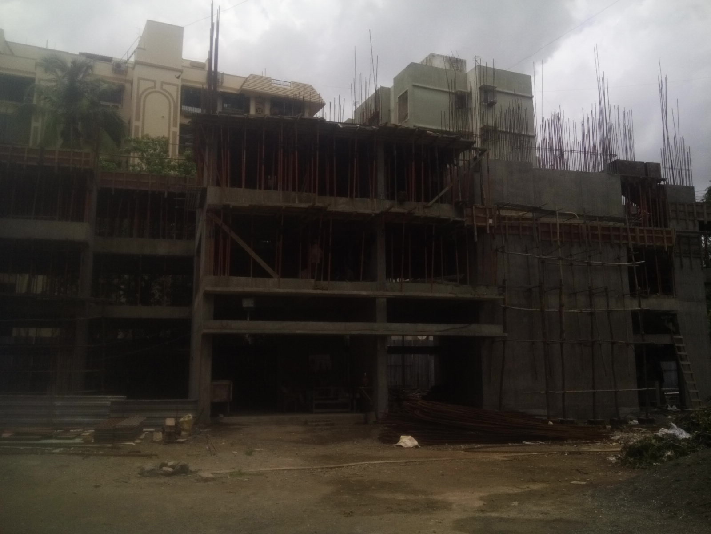
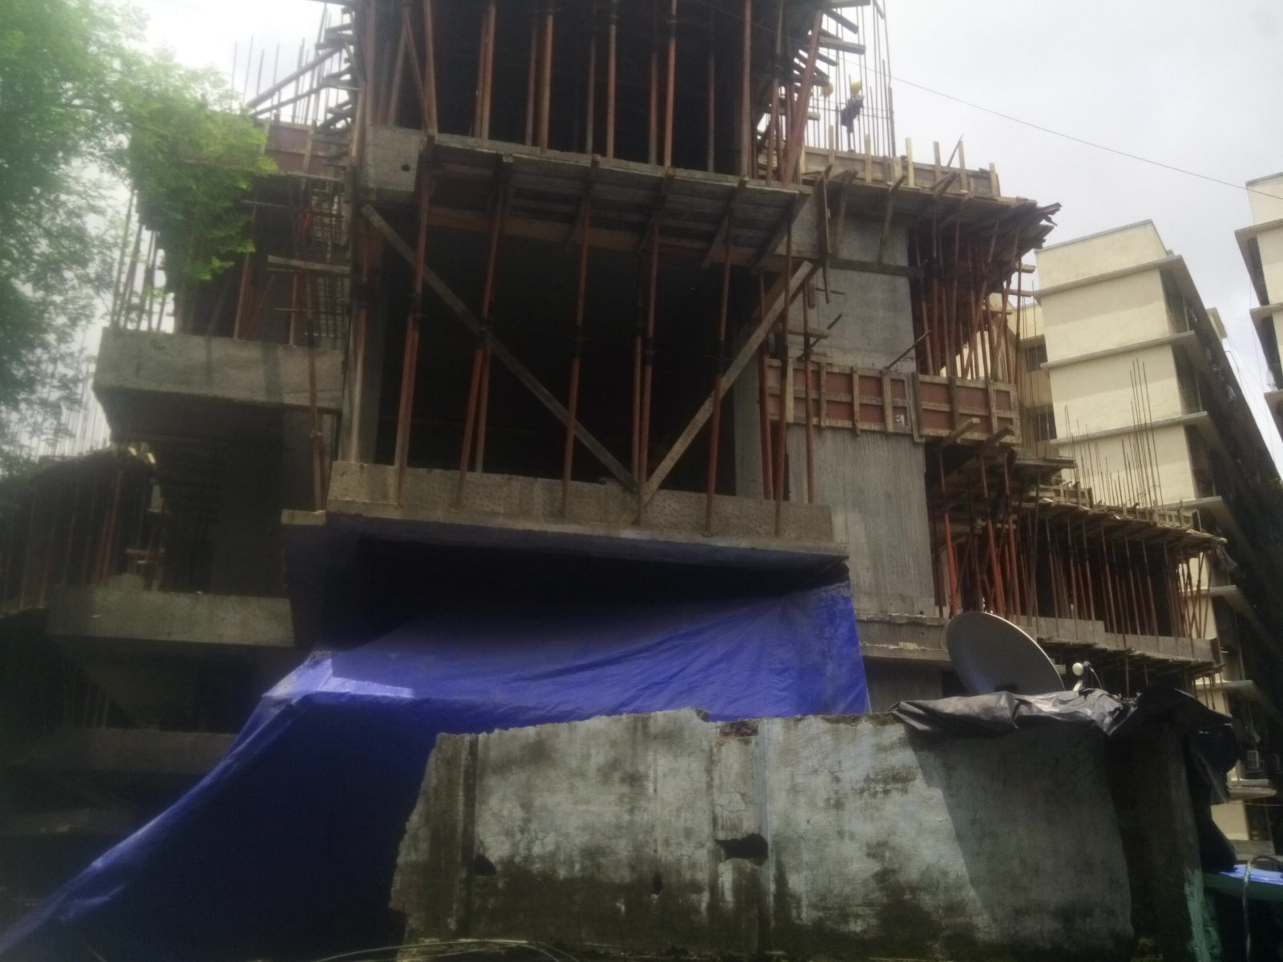

B - Wing
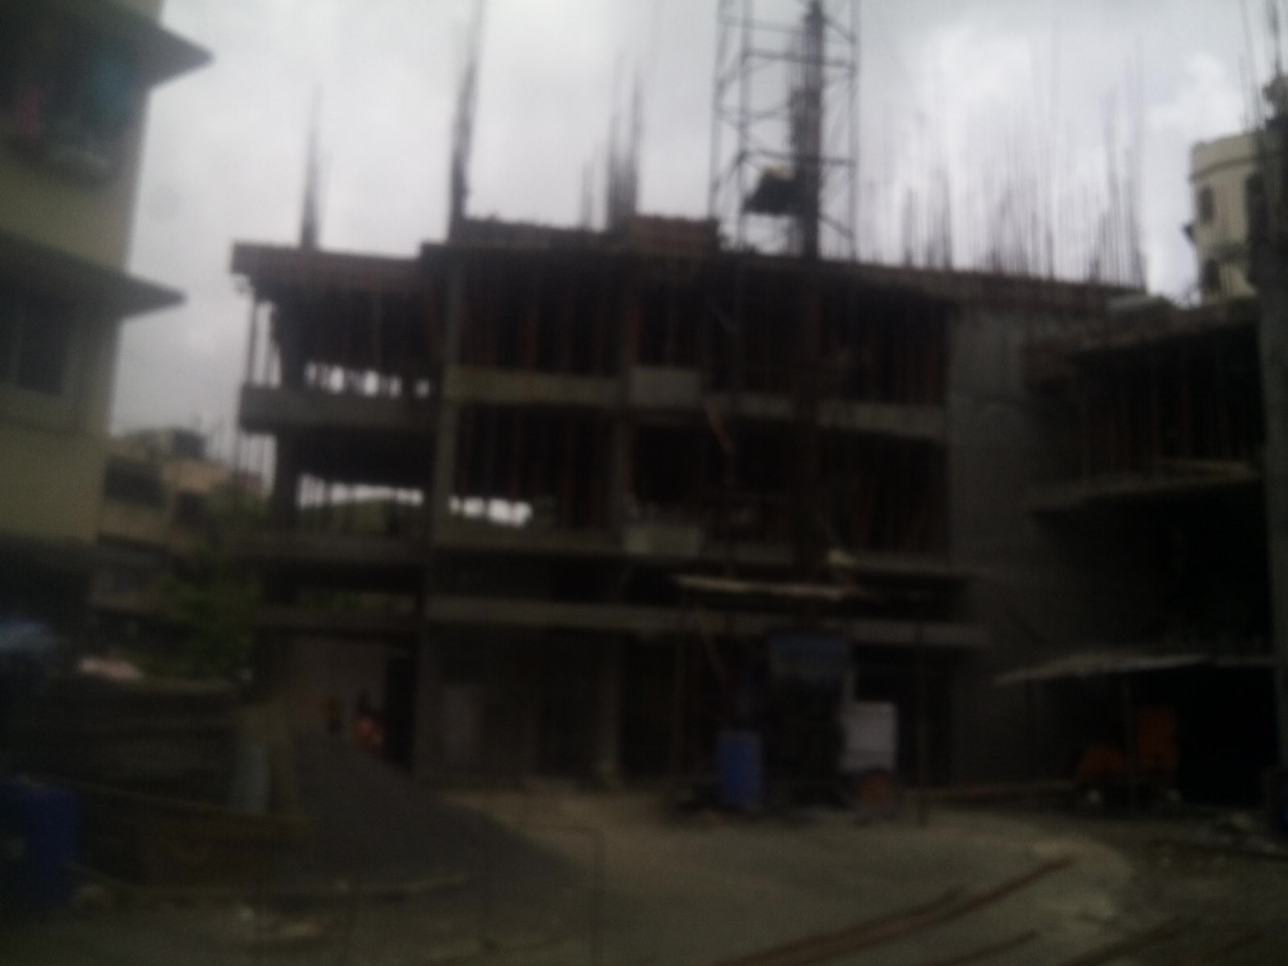

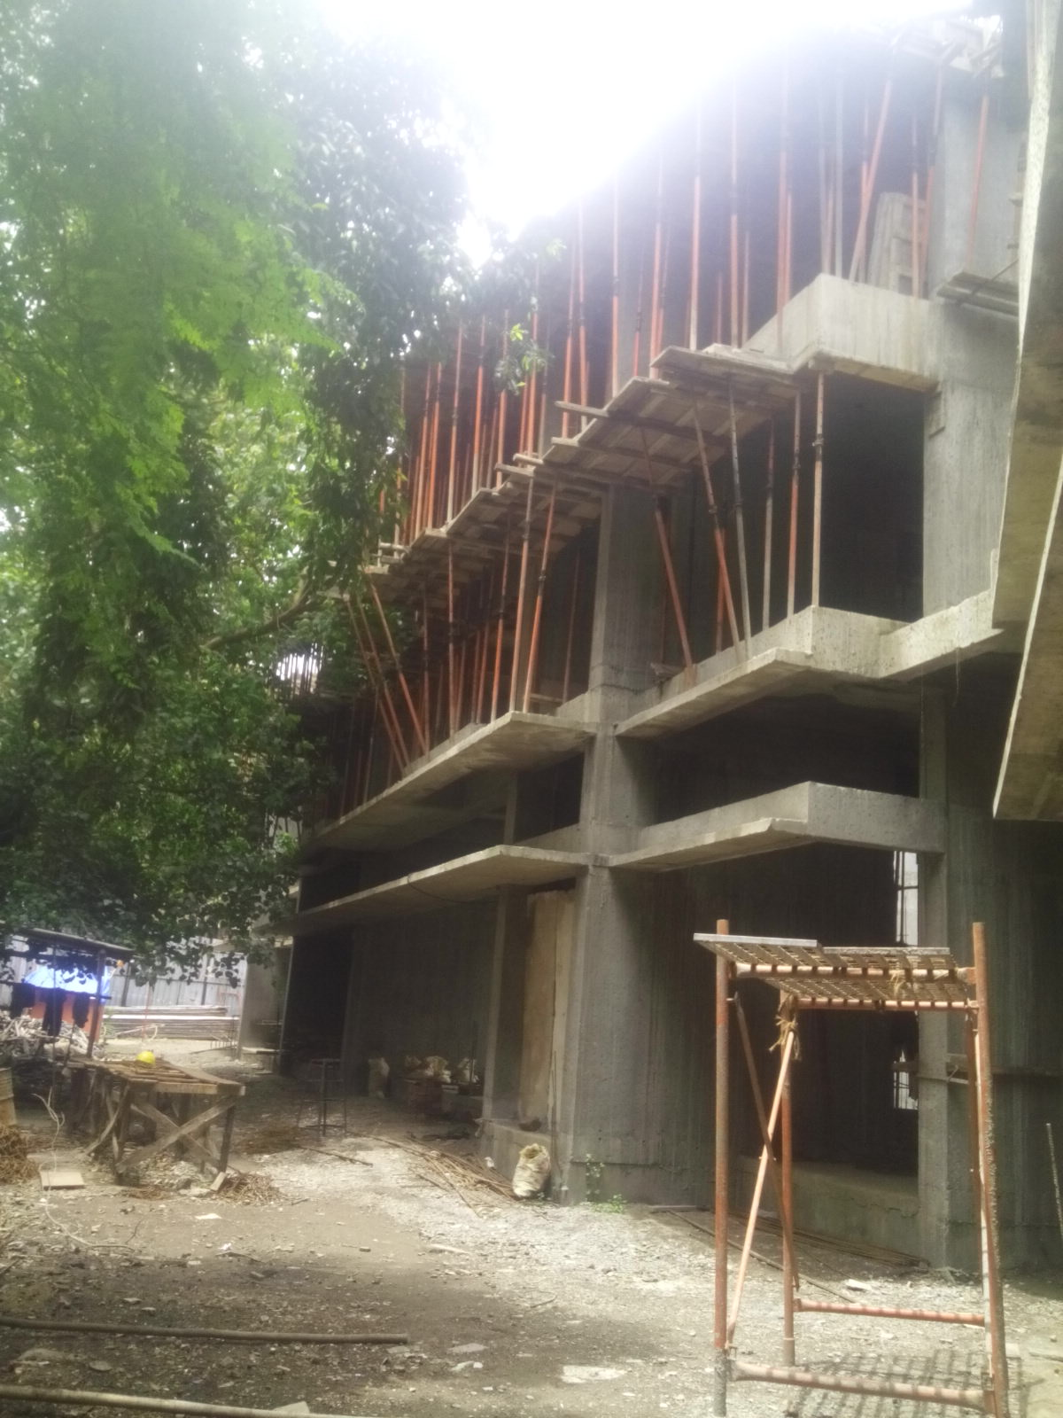

Route Map of the property
Site u/r
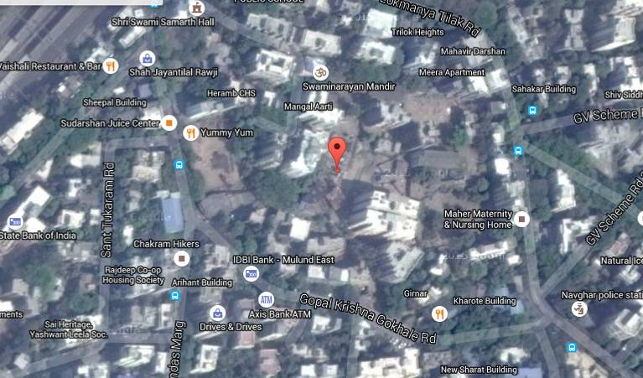

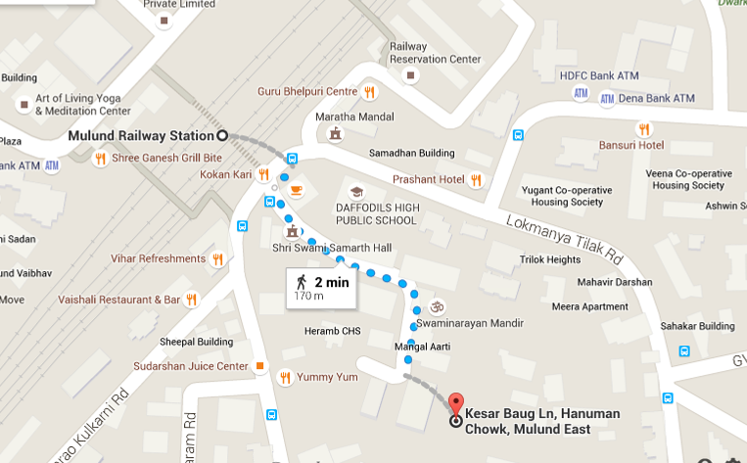

Latitude & Longitude: 19°10'13.5"N 72°57'27.9"E

Note: The Blue line shows the route to site from nearest railway station (Mulund – 170 Mtr.)

DEFINITION OF VALUE FOR THIS SPECIFIC PURPOSE

This exercise is to assess Master Valuation of the property under reference as on 10th July 2015.

The term Fair Market Value is defined as

“The most probable price, as of a specified date, in cash, terms equivalent to cash, or in other precisely revealed terms for which the specified property rights would sell after reasonable exposure in a competitive market under all conditions requisite to a fair sale, with the buyer and seller each acting prudently knowledgeably and for self-interest assuming that neither is under undue duress”.

Fundamental assumptions and conditions presumed in this definition are:

1. Buyer and seller are motivated by self-interest.
2. Buyer and seller are well informed and are acting prudently.
3. The property is exposed for a reasonable time on the open market.
4. Payment is made in cash or equivalent or in specified financing terms.

UNDER LYING ASSUMPTIONS
1. We assume no responsibility for matters of legal nature affecting the property appraised or the title thereto, nor do we render our opinion as to the title, which is assumed to be good and marketable.
2. The property is valued as though under responsible ownership.
3. It is assumed that the property is free of liens and encumbrances.
4. It is assumed that there are no hidden or unapparent conditions of the subsoil or structure that would render it more or less valuable. No responsibility is assumed for such conditions or for engineering that might be required to discover such factors.

Sharad B. Chalikwar
Govt. Reg. Valuer & Chartered Engineer (India)
Reg. No. (N) CCIT/1-14/52/2008-09

DECLARATION OF PROFESSIONAL FEES CHARGED

We hereby declare that, our professional fees are not contingent upon the valuation findings. However, if the statute AND/OR clients demands that, the fees should be charged on the percentage of assessed value then, with the full knowledge of the AND/OR end user, it is being charged accordingly.

VALUATION OF THE PROPERTY PREMISES

Considering various parameters recorded herein above, existing economic scenario, and the information that is available with reference to the development of neighborhood and method selected for valuation, we are of the opinion that, the property premises can be assessed and valued for this particular purpose as per the details provided.

STATEMENT OF LIMITING CONDITIONS

1. Assumptions are made to the best of our knowledge and belief. Reliance is based on the information furnished to us by the identifier AND/OR client.
2. The valuer shall not be responsible for matters of legal nature that affects the value and opinion expressed by us.
3. If our appearance is required, we will be pleased to appear and give the necessary clarification, provided the fees for each appearance (excluding traveling, dearness allowance and out of pocket expenses) is pre-determined before the acceptance of the assignment under reference.
4. In no event shall the valuer be held responsible or liable for special, direct, indirect or consequential damages, as the assignment has been completed on best efforts, available knowledge and in good intentions of persons concerned and belief.
5. If it is proved that there is an apparent negligence on the part of a valuer, liability of this assignment (whether arising from this assignment, negligence or whatsoever) is limited in respect of anyone event or series of events to the actual loss or damage sustained subject to maximum of 80% of the professional fees for the services rendered and in any case not exceeding the amount of ` 1,000/- (Rupees one Thousand Only). All the claims against us shall expire after three month from the date of submission of the valuation report provided by us.
6. We hereby declare that, the information furnished above is true and correct to the best of our knowledge and belief. We have no direct or indirect interest in the assets valued. We have not been convicted of any offence and sentenced to a term of imprisonment. We have not been found guilty of misconduct in our professional capacity.

Sharad B. Chalikwar
Govt. Reg. Valuer & Chartered Engineer (India)
Reg. No. (N) CCIT/1-14/52/2008-09

