Vastu/Nashik/04/2024/008466/2306139
30/9-278-RPBS
Date: 30.04.2024

To,
The Branch Manager,
Union Bank of India
Ambad Branch, Nashik
Ramashray Apartment, Sector C, Plot No. 283,
Near Bhadrpad Sector, Ashwin Nagar, Near Sambhaji
Stadium, Cidco Nashik-422009, State – Maharashtra, Country – India

Sub: Vetting of Extra Work

Sir,

With reference to above subject, we have evaluated the Extra Amenities for Residential Flat No. C2-102, First Floor, “Samraat Apna Ghar”, Phase -1, Survey No.49/1/2, Plot No. 2362/1, Near Rishabh Instruments Limited, Dhruv Nagar, Someshwar Satpur Link Road, Right Canal Road, Village – Gangapur, Taluka & District - Nashik, PIN Code – 422 013, State – Maharashtra, Country – India belongs Mr. Rohit Rajesh More & Mr. Amol Rajesh More.

We have verified the rates quoted as per current market rates. Details of Extra Work considered as per copy of Extra Work Agreement between Mr. Rohit Rajesh More (First Party). Mr. Daniel Prakash (Second Party) received on dated 26.04.2024. The Extra Work amount is Rs. 4,00,000/- (Rupees Four Lakh Only)

The said Cost Vetting Certificate is valid upto next 6 months Only.

Thanking you

Sincerely yours

Sharadkumar B. Chalikwar
Govt. Reg. Valuer
Chartered Engineer (India)
Reg. No. (N) CCIT/1-14/52/2008-09

Vetting of Extra Work

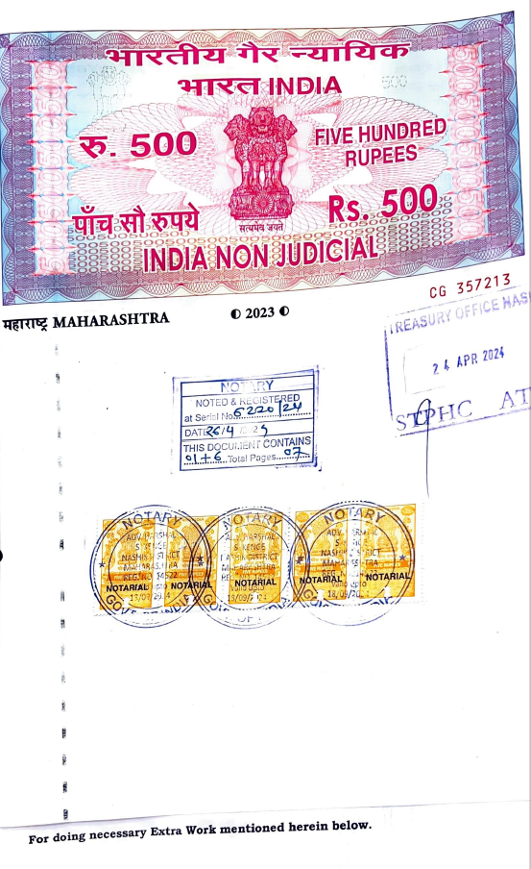
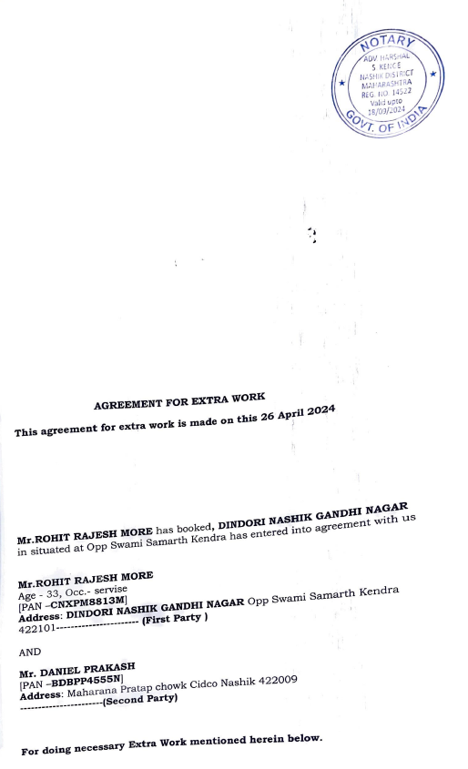

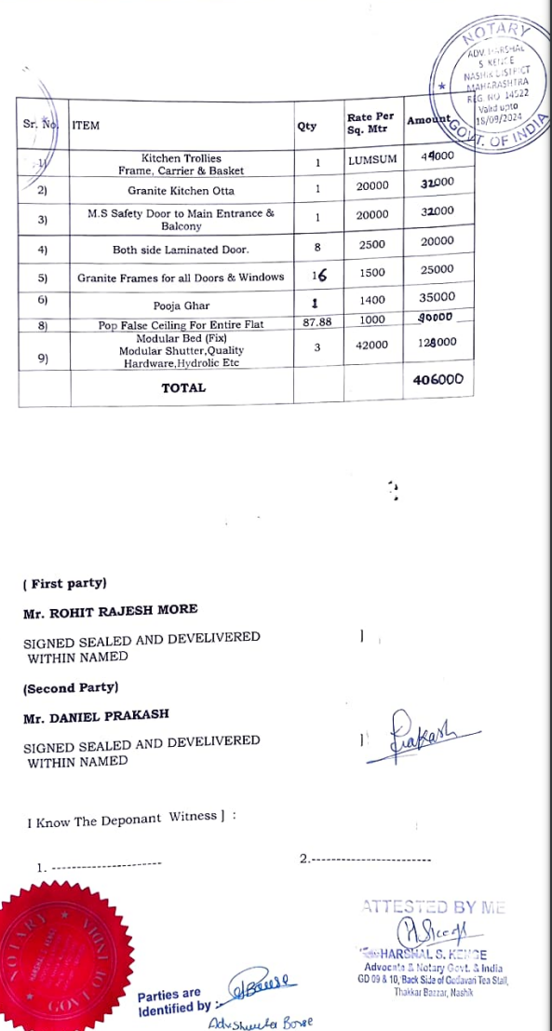

The Extra Work amount is Rs.4,00,000/- (Rupees Four Lakh Only)

