# Valuation Report of the Immovable Property

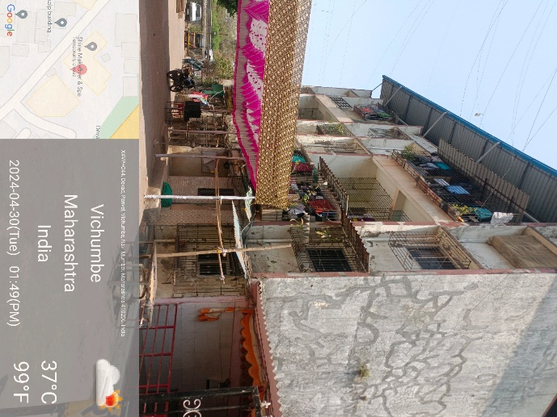

**Details of the property under consideration:**

Name of Owner: **Sandesh B. Valhekar, Sandeep B. Valhekar & Balkrishna A. Valhekar**

Residential Flat No. 02, GroundFloor, **"Shree Krishna",** Shree Krishna – Om Sai Residency Co-op. Hsg. Soc. Ltd.,Plot No. 7, 8 & 9, Gat No. 45 & 58, Hissa No. 2 & 0, Village – Devad – Vichumbe, New Panvel, Taluka – Panvel, District – Raigad, PIN Code – 410221, State - Maharashtra, Country – India.

# Latitude Longitude - 18°59'36.1"N 73°08'07.7"E

**Intended Users:**

**The Zoroastrian Co-operative Bank Ltd**

**Bandra West**

Darvesh Royal, Master Vinayak Road (Perry Road), Bandra (West), Mumbia - 400050,

State - Maharashtra, Country - India

Vastu/Mumbai/05/2024/8450/2306237

08/18-97-PASK

Date: 08.05.2024

**VALUATION OPINION REPORT**

This is to certify that the property bearing Residential Flat No. 02, GroundFloor, **"Shree Krishna",** Shree Krishna – Om Sai Residency Co-op. Hsg. Soc. Ltd.,Plot No. 7, 8 & 9, Gat No. 45 & 58, Hissa No. 2 & 0, Village – Devad – Vichumbe, New Panvel, Taluka – Panvel, District – Raigad, PIN Code – 410 221, State - Maharashtra, Country – India belongs to **Sandesh B. Valhekar, Sandeep B. Valhekar & Balkrishna A. Valhekar.**

|  |  |
| --- | --- |
| **Boundaries of the property.** | |
| North | Mumbai Pune Express Highway |
| South | Road |
| East | Pushpa Narayan Complex |
| West | Om Sai Building |
|  |  |

Considering various parameters recorded, existing economic scenario, and the information that is available with reference to the development of neighbourhood and method selected for valuation, we are of the opinion that, the property premises can be assessed and **Fair Market Value** for this particular purpose at **` 25,27,200.00 (Rupees Twenty Five Lakh Twenty Seven Thousand two Hundred Only).**

The valuation of the property is based on the documents produced by the concern. Legal aspects have not been taken into considerations while preparing this report.

Hence certified

**Sharadkumar B. Chalikwar**

Govt. Reg. Valuer

Chartered Engineer (India)

Reg. No. (N) CCIT/1-14/52/2008-09

Encl.: Valuation report

**VALUATION REPORT IN RESPECT OF IMMOVABLE PROPERTY**

|  |  |  |  |  |  |
| --- | --- | --- | --- | --- | --- |
| 1 | Date of Inspection | : | 08.05.2024 | | |
| 2 | Purpose of valuation | : | As per request from The Zoroastrian Co-operative Bank Ltd, Bandra West Branch, Fair Market Value of the property under reference for Banking purpose | | |
| 3 | Name and address of the Valuer | : | **Sharadkumar B. Chalikwar**  **Vastukala Consultants (I) Pvt. Ltd.**  B1-001, U/B Floor, Boomerang, Chandivali Farm Road, Powai, Andheri (East), Mumbai – 400 072 | | |
| 4 | List of Documents Handed Over to The Valuer By The Bank | : |  | | |
|  | 1. Copy of Agreement for Sale dated 10.10.2012 b/w. Sitaram Krishna Adivarekar proprietor of Kartik Developers (Promoter) and Sandesh B. Valhekar, Sandeep B. Valhekar & Balkrishna A. Valhekar (Purchaser) 2. Copy of Society Share Certificate Document No. 058 dated 30.01.2022 in the name of Sandesh B. Valhekar, Sandeep B. Valhekar & Balkrishna A. Valhekar 3. Copy of Property Tax Receipt No. 2509 dated 16.06.2023 issued by Grampanchayat Devad 4. Copy of Society Maintenance Bill No. 407 dated 01.01.2024 5. Copy of Society Registration Certificate dated 05.04.2014 6. Copy of Builder Possession Letter dated 25.03.2013 issued by Kartik Developers | | | | |
| 5 | Details of enquiries made/ visited to government office for arriving fair market value. | : | Market analysis and as per sub-registrar value. | | |
| 6 | Factors for determining its market value. | : | Location, development of surrounding area, type of construction, construction specifications, age of building, condition of the premises & building, facilities provided and its prevailing market rate. | | |
| 7 | ANY CRITICAL ASPECTS ASSOCIATED WITH PROPERTY | : | No | | |
| 8 | Present/Expected Income from the property | : | ` 5,500.00 Expected rental income per month | | |
|  | **Property Details** | : |  | | |
| 9 | Name(s) of the Owner | : | **Sandesh B. Valhekar, Sandeep B. Valhekar & Balkrishna A. Valhekar** | | |
|  | Address | : | Residential Flat No. 02, GroundFloor, **"Shree Krishna",** Shree Krishna – Om Sai Residency Co-op. Hsg. Soc. Ltd.,Plot No. 7, 8 & 9, Gat No. 45 & 58, Hissa No. 2 & 0, Village – Devad – Vichumbe, New Panvel, Taluka – Panvel, District – Raigad, PIN Code – 410 221, State - Maharashtra, Country – India.  **Contact Person:** Mr. Manish Kumar (Tenant) | | |
| 10 | If the property is under joint ownership/ co-ownership share of each such owner/ are the share is undivided. | : | Joint Ownership  Details of share of ownership is not available | | |
| 11 | Brief description of the property. | : | The property is a Residential Flat No. 02 is located on GroundFloor. The composition of flat is 1 Bedroom + Living Room + Kitchen + Bath + W.C. **(i.e. 1 BHK flat).** The property is at 2.6 Km. travelling distance from nearest railway station Panvel. | | |
| 12 | Location of the property (C.T.S. No., Survey No., Hissa No., Plot No., etc.). | : | Plot No. 7, 8 & 9, Gat No. 45 & 58, Hissa No. 2 & 0 of Village – Devad – Vichumbe, New Panvel | | |
| 13 | **Boundaries** | : | **As on site** | | **As per documents** |
|  | North | : | Mumbai Pune Express Highway | | Gat No. 59 |
|  | South | : | Road | | Internal Layout Road |
|  | East | : | Pushpa Narayan Complex | | Road |
|  | West | : | Om Sai Building | | Internal Layout Road |
| 14 | Matching of Boundaries | : | - | | |
| 15 | Route map | : | Enclosed | | |
| 16 | Any specific identification marks | : | Near Grampanchayat Office Devad | | |
| 17 | Whether covered under Corporation/ Panchayat/ Municipality. | : | Grampanchayat Devad | | |
| 18 | Whether covered under any land ceiling of State/ Central Government. | : | No | | |
| 19 | Is the land freehold/ leasehold? | : | Free Hold | | |
| 20 | Are there any restrictive covenants in regard to use of Land? If so, attach a copy of the covenant. | : | As per Agreement | | |
| 21 | Type of the property | : | Residential | | |
| 22 | Year of acquisition/ purchase. | : | 10.10.2012 | | |
| 23 | Purchase value as per document | : | ` 13,55,400.00 | | |
| 24 | Whether the property is occupied by owner or tenant. If occupied by tenant since how long he is staying and the amount of rent being paid. | : | Tenant Occupied – Mr. Manish Kumar | | |
| 25 | Classification of the site | : |  | | |
|  | 1. Population group | : | Semi - Urban | | |
|  | 1. High/ Middle/ Poor class | : | Middle Class | | |
|  | 1. Residential/ Non-Residential | : | Residential | | |
|  | 1. Development of surrounding area | : | Developing area | | |
|  | 1. Possibility of any threat to the property (Floods, calamities etc.). | : | No | | |
| 26 | Proximity of civic amenities (like school, hospital, bus stop, market etc.). | : | All Available near by | | |
| 27 | Level of the land (Plain, rock etc.) | : | Plain | | |
| 28 | Terrain of the Land. | : | Levelled | | |
| 29 | Shape of the land (Square/ rectangle etc.). | : | Irregular | | |
| 30 | Type of use to which it can be put (for construction of house, factory etc.). | : | Residential purpose | | |
| 31 | Whether the plot is under town planning approved layout? | : | Information not Available | | |
| 32 | Whether the building is intermittent or corner? | : | Corner | | |
| 33 | Whether any road facility is available? | : | Yes | | |
| 34 | Type of road available | : | B.T. Road | | |
| 35 | Front Width of the Road? | : | 24.00 Mt. | | |
| 36 | Source of water & water potentiality. | : | Municipal Water Supply | | |
| 37 | Type of Sewerage System. | : | Connected to Municipal Sewerage System | | |
| 38 | Availability of power supply. | : | Yes | | |
| 39 | Advantages of the site. | : | Located in developing area | | |
| 40 | Disadvantages of the site. | : | No | | |
| 41 | Give instances of sales of immovable property in the locality on a separate sheet, indicating the name & address of the property, registration No. sale price and area of land sold. | : | As per Sub-Registrar of Assurance records | | |
|  | **Valuation of the property:** | | | | |
| 42 | Total area of the Residential Flat | : | Carpet Area in Sq. Ft. = 407.00  (Area as per actual site measurement)  **Carpet Area in Sq. Ft. = 351.00**  **(Area as per Agreement for Sale)**  Built up Area in Sq. Ft. = 421.00  (Carpet Area as per Agreement + 20%) | | |
| 43 | Prevailing market rate. | : | ` 7,200.00 per Sq. Ft. rate on Carpet Area | | |
| 44 | Floor Rise Rate per Sq. Ft. | : | ` 0.00 | | |
| 45 | PLC Rate per Sq. Ft. | : | ` 0.00 | | |
| 46 | Total Rate per Sq. Ft. | : | ` 7,200.00 per Sq. Ft. | | |
| 47 | Guideline rate obtained from the Stamp Duty Ready Reckoner. | : | ` 52,800.00 per Sq. M. i.e.  ` 4,905.00 per Sq. Ft. | | |
|  | Guideline rate (After depreciation) | : | ` 47,645.00 per Sq. M. i.e.  ` 4,426.00 per Sq. Ft. | | |
| 48 | Value of the property | : | **` 25,27,200.00** | | |
| 49 | The realizable value of the property | : | **` 22,74,480.00** | | |
| 50 | Distress value of the property | : | **` 20,21,760.00** | | |
| 51 | Insurable value of the property | : | **` 10,52,500.00** | | |
|  | **Technical details of the building:** | | | | |
| 52 | Type of building (Residential/ Commercial) | : | | Residential | |
| 53 | Year of construction. | : | | 2014 (Approx.) | |
| 54 | Future life of the property. | : | | 50 years Subject to proper, preventive periodic maintenance and structural repairs. | |
| 55 | No. of floors and height of each floor including basement. | : | | Ground + 3Upper Floors.  GroundFloor is having 6 Residential Flats.  No Lift is provided in the building | |
|  | **Type of construction** | | | | |
| 56 | (Load bearing/ R.C.C./ Steel framed) | : | | R.C.C. Framed Structure | |
|  | **Condition of the building.** | | | | |
| 57 | External (excellent/ good/ normal/ poor) | : | | Normal. Cracks, filing cracks were found at external wall of the building. | |
| 58 | Internal (excellent/ good/ normal/ poor). | : | | Normal | |
| 59 | Whether the Residential Flat is constructed strictly according to the sanctioned plan, details of variations noticed if any and effect of the same on the valuation | : | | Copy of Approved plan were not provided and not verified | |
|  | Remarks: | | | | |
| 60 | **Specifications of Construction:** | | | | |
| **sr.** | **Description** | : | | GroundFloor | |
| a | Foundation | : | | R.C.C. Foundation | |
| b | Basement | : | | No | |
| c | Superstructure | : | | R.C.C. frame work with 9-inch-thick B. B. Masonry for external walls.6-inch thick B.B. Masonry for internal walls | |
| d | Joinery/Doors/Windows | : | | Teak wood door framed with flush door, Aluminium Sliding windows | |
| e | RCC Work | : | | R.C.C. Framed Structure | |
| f | Plastering | : | | Cement Plastering | |
| g | Flooring, Skirting | : | | Vitrified tiles flooring | |
| h | Kitchen Platform | : | | Black Granite Kitchen Platform | |
| i | Whether any proof course is provided? | : | | Yes | |
| j | Drainage | : | | Connected to Municipal Sewerage System | |
| k | Compound Wall(Height, length and type of construction) | : | | 5.6" Height | |
| l | Electric Installation (Type of wire, Class of construction) | : | | Casing Capping wiring | |
| m | Plumbing Installation (No. of closets and wash basins etc.) | : | | Concealed plumbing | |
| n | Bore Well | : | | Not Provided | |
| o | Wardrobes, if any | : | | No. | |
| p | Development of open area | : | | Open Car Parking, Cemented road in open spaces, etc. | |
|  | **Valuation of proposed construction/ additions/ renovation if any:** | | | | |
| 61 | **SUMMARY OF VALUATION:** | : | |  | |
|  | Part I Land | : | | ` 0.00 | |
|  | Part II Building | : | | ` **25,27,200.00** | |
|  | Part III Other amenities/ Miscellaneous | : | | ` 0.00 | |
|  | Part IV Proposed construction | : | | ` 0.00 | |
|  | **TOTAL.** | : | | ` **25,27,200.00** | |
|  | **Calculation:** | | | | |
| **1** | **Construction** | : | |  | |
| 1.01 | Built up Area of Residential Flat | : | | 421.00 Sq. Ft. | |
| 1.02 | Rate per Sq. Ft. | : | | ` 2,500.00 per Sq. Ft. | |
| 1.03 | Cost of Construction = (1.01x1.02) | : | | ` 10,52,500.00 | |
| **2** | **Value of property** | : | |  | |
| 2.01 | Carpet Area of Residential Flat | : | | 351.00 Sq. Ft. | |
| 2.02 | Rate per Sq. Ft. | : | | ` 7,200.00 per Sq. Ft. | |
| 2.03 | Floor Rise Rate per Sq. Ft. | : | | ` 0.00 | |
| 2.04 | PLC Rate per Sq. Ft. | : | | ` 0.00 | |
| 2.05 | Total Rate per Sq. Ft. | : | | ` 7,200.00 per Sq. Ft. | |
| 2.06 | Value of Residential Flat = (2.01x2.05) | : | | ` **25,27,200.00** | |
| **3** | **The value of the property.** | : | | ` **25,27,200.00** | |
| **4** | **Remarks** | : | | ***As per Site Inspection, Actual Carpet Area 407.00 Sq. Ft is more than Carpet Area 351.00 Sq. Ft. mentioned in the documents. We have considered area mentioned in the documents.*** | |

I certify that,

I/ my authorized representative, has inspected the subject property on 30.04.2024. Mr. Manish Kumar (Tenant) has shown the property.

The rates for valuation of the property are in accordance with the Govt. approved rates and prevailing market rates.

There is no direct/ indirect interest in the property valued.

**Actual site photographs**

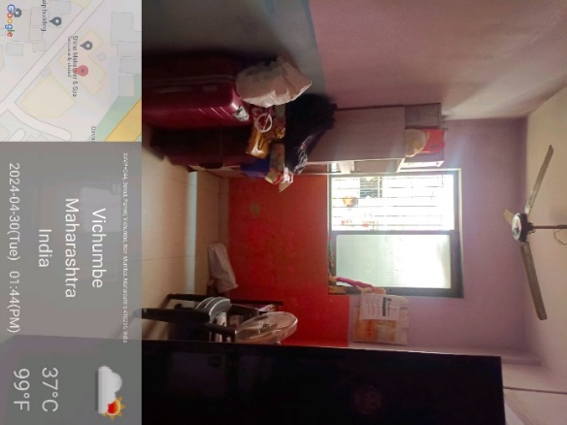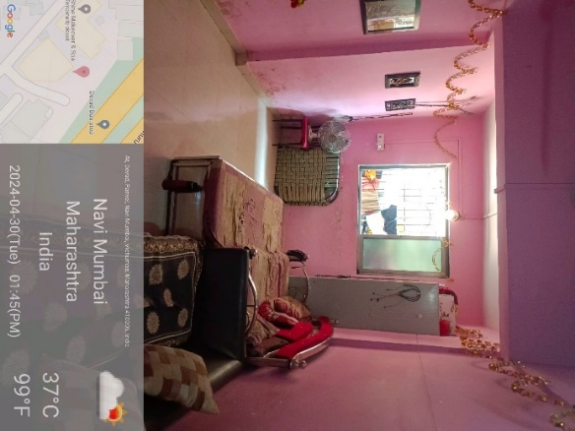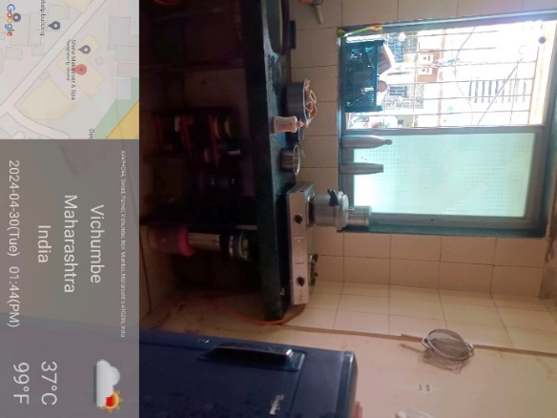

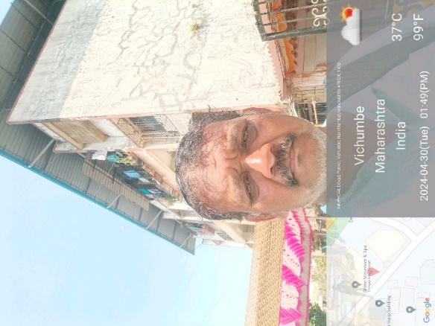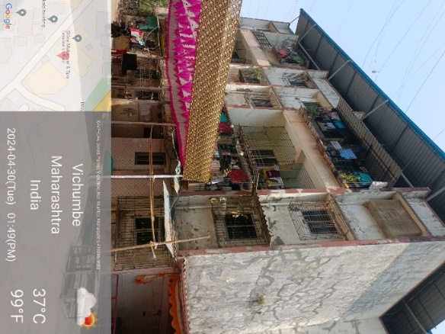

**Route Map of the property**

**Site u/r**

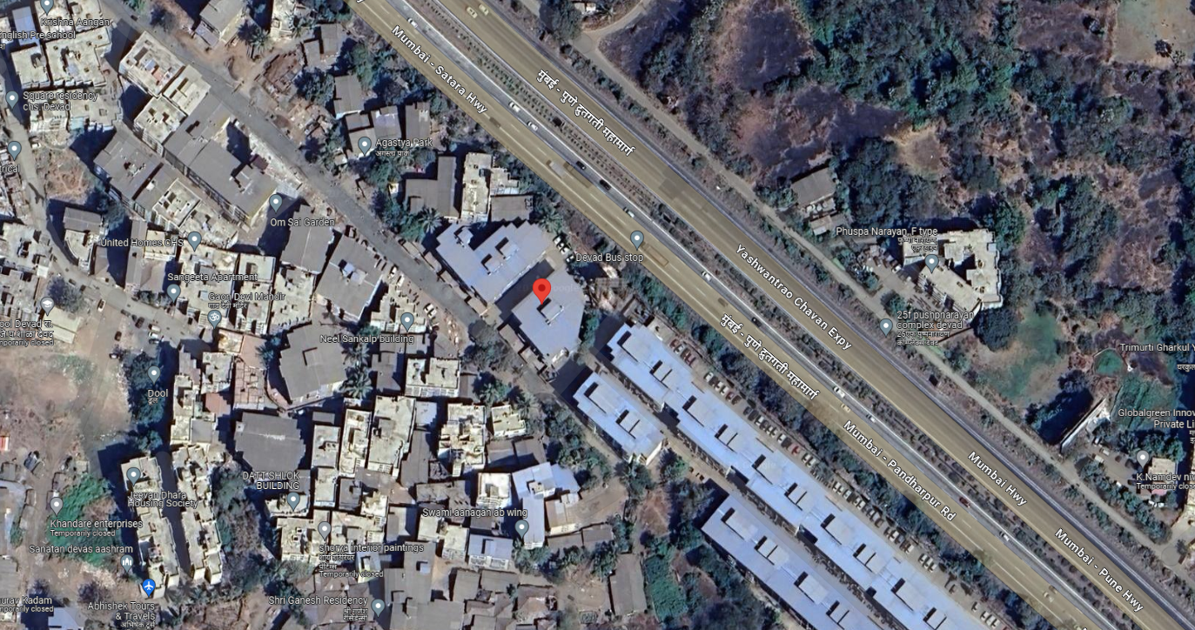

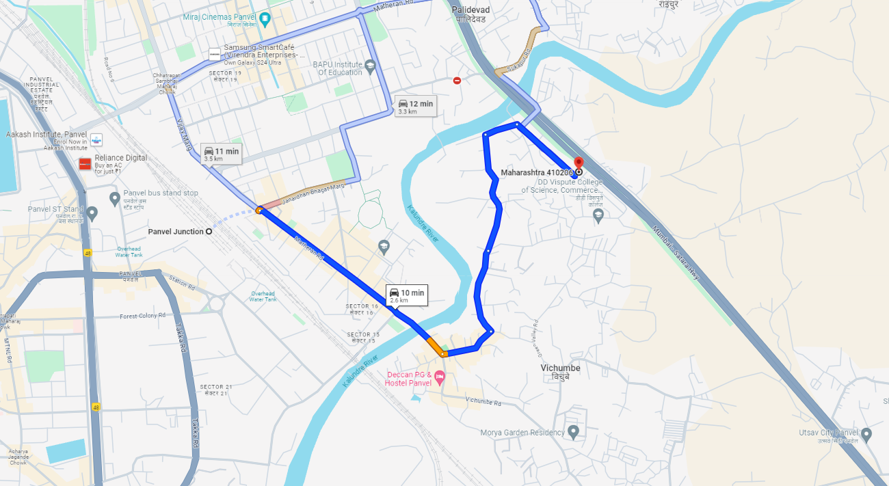

# Latitude Longitude - 18°59'36.1"N 73°08'07.7"E

**Note**: The Blue line shows the route to site from nearest railway station (Panvel – 2.6 Km.)

**Ready Reckoner Rate**

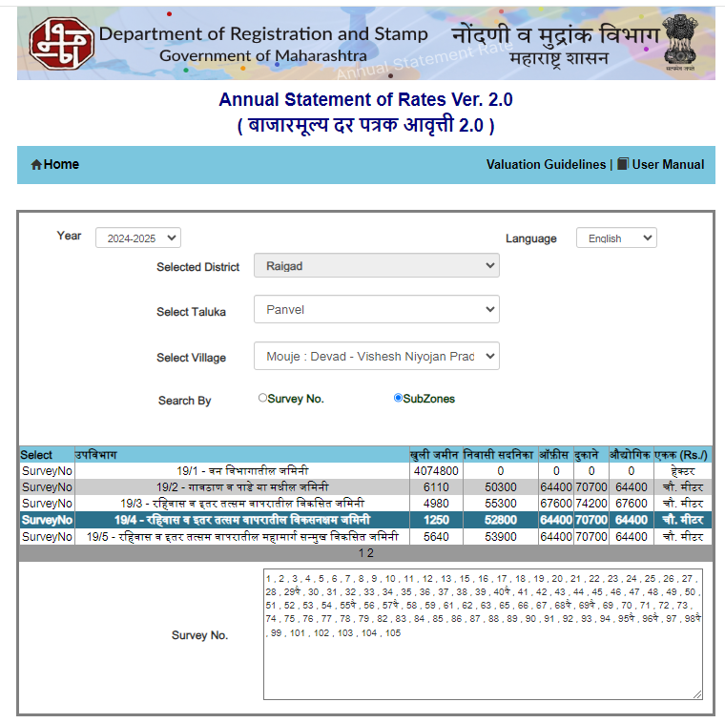

**Price Indicator**

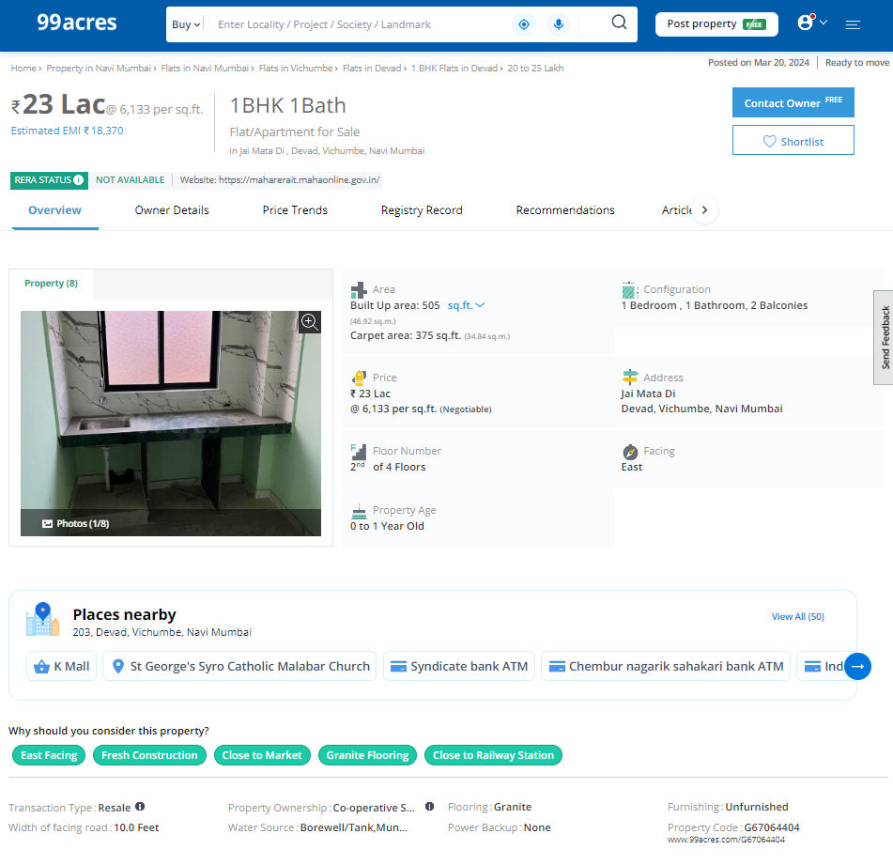

**Price Indicator**

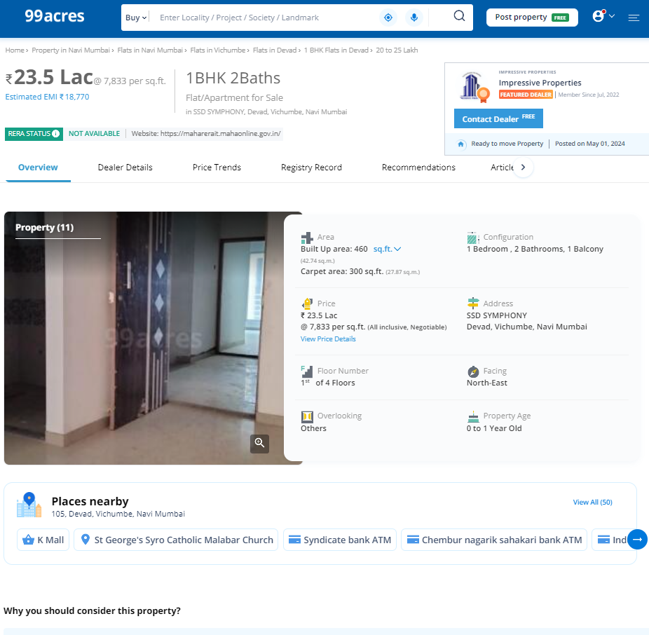

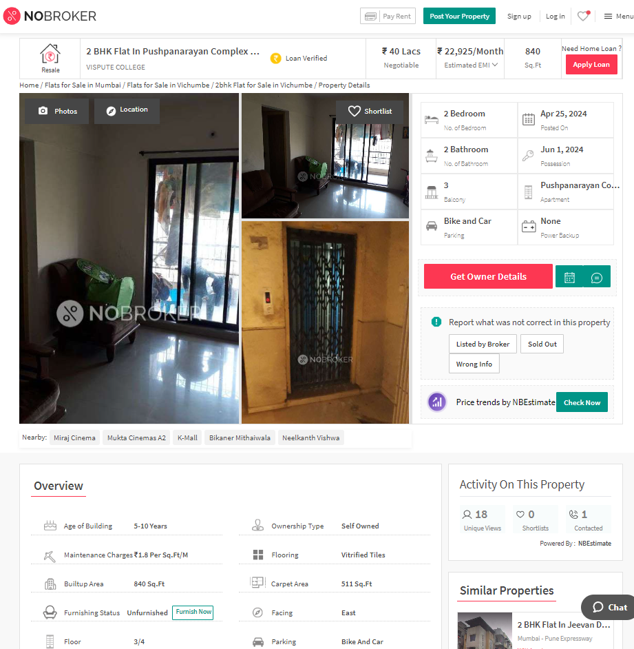**Price Indicators**

**Sale Instances**

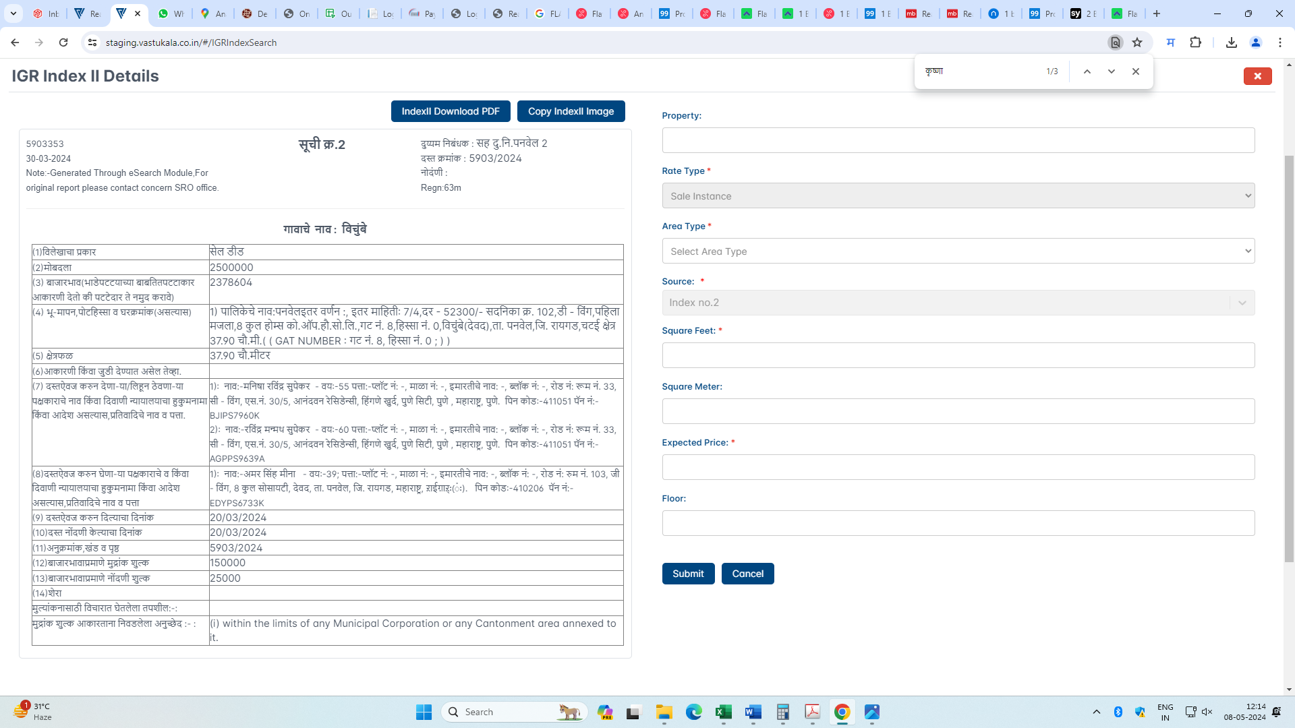

**DEFINITION OF VALUE FOR THIS SPECIFIC PURPOSE**

This exercise is to assess value of the property under reference for **Fair Market Value** purpose as on dated **08th May 2024.**

The term **Fair Market Value** is defined as

*"The most probable price, as of a specified date, in cash, terms equivalent to cash, or in other precisely revealed terms for which the specified property rights would sell after reasonable exposure in a competitive market under all conditions requisite to a fair sale, with the buyer and seller each acting prudently knowledgeably and for self-interest assuming that neither is under undue duress"*

Fundamental assumptions and conditions presumed in this definition are:

1. Buyer and seller are motivated by self-interest.
2. Buyer and seller are well informed and are acting prudently.
3. The property is exposed for a reasonable time on the open market.
4. Payment is made in cash or equivalent or in specified financing terms.

**ASSUMPTIONS, CAVEATS, LIMITATION AND DISCLAIMERS**

1. We assume no responsibility for matters of legal nature affecting the property appraised or the title thereto, nor do we render our opinion as to the title, which is assumed to be good and marketable.
2. The property is valued as though under responsible ownership.
3. It is assumed that there are no hidden or unapparent conditions of the subsoil or structure that would render it more or less valuable. No responsibility is assumed for such conditions or for engineering that might be required to discover such factors.
4. There is no direct/ indirect interest in the property valued.
5. The rates for valuation of the property are in accordance with the Govt. approved rates and prevailing market rates.

**DECLARATION OF PROFESSIONAL FEES CHARGED**

We hereby declare that; our professional fees are not contingent upon the valuation findings. However, if the statute AND/OR clients demand that, the fees should be charged on the percentage of assessed value then, with the full knowledge of the AND/OR end user, it is being charged accordingly.

**VALUATION OF THE PROPERTY PREMISES**

Considering various parameters recorded herein above, existing economic scenario, and the information that is available with reference to the development of neighbourhood and method selected for valuation, we are of the opinion that, the property premises can be assessed and valued for this particular purpose at **` 25,27,200.00 (Rupees Twenty Five Lakh Twenty Seven Thousand two Hundred Only).**

**Sharadkumar B. Chalikwar**

Govt. Reg. Valuer

Chartered Engineer (India)

Reg. No. (N) CCIT/1-14/52/2008-09