Vastu/Nashik/09/3966/2302672
22/9-316-RYBS
Date: 26.04.2024

To,
The Assistant General Manager,
State Bank of India
RACC Nashik Branch
RBO.2, The Wave Building, 1 st Floor, Opposite Shell Petrol Pump, Pathardi Road,
Nashik – 422 010, State – Maharashtra, Country – India.

Sub: Vetting of Estimate

Sir,

With reference to above subject, we have evaluated the Estimate for Residential Land and Proposed Building On Plot No. 05, Ground + Fifth Floor, Survey No. 2224/ P, Nagar Parishad Milkat No. 8045, Behind Panchwad Ganesh Mandir, Vijay Nagar, Devali Mala, Old Janori Road, Village – Ozar, Taluka - Niphad, District - Nashik, PIN Code - 422 006,State - Maharashtra, Country - India. Belongs to Name of Owner: Sau. Pratibha Tushar Shejwal Kale.

We have verified the rates quoted as per current market rates. Details of Estimate considered as per copy of Estimate Provided by Architect Deepak Deore received on dated.26.04.2024. The Estimate amount is Rs.1,42,18,985/- (Rupees One Crore Forty Two Lakh Eighteen Thousand Nine Hundred Eighty Five Only.)

Note:1) The said Cost Vetting Certificate is valid upto next 6 months Only.

Thanking you

Sincerely yours

Manoj B. Chalikwar
Registered Valuer
Chartered Engineer (India)
Reg. No. CAT-I-F-1763
Reg. No. IBBI/RV/07/2018/10366
BOB Empanelment No.: ZO:MZ:ADV:46:941
Encl: Valuation Report

Estimate
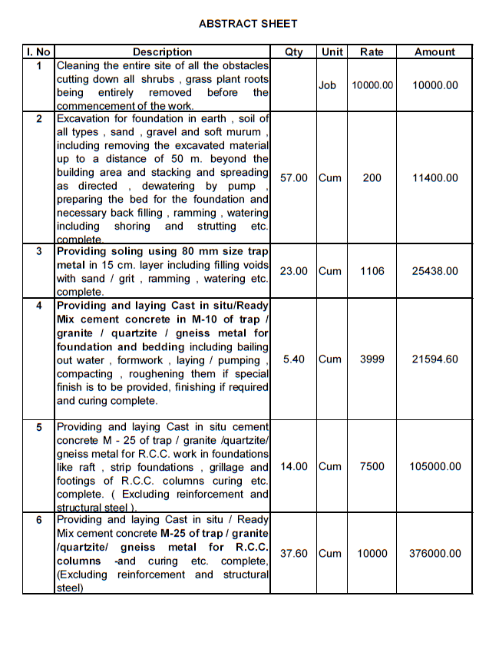
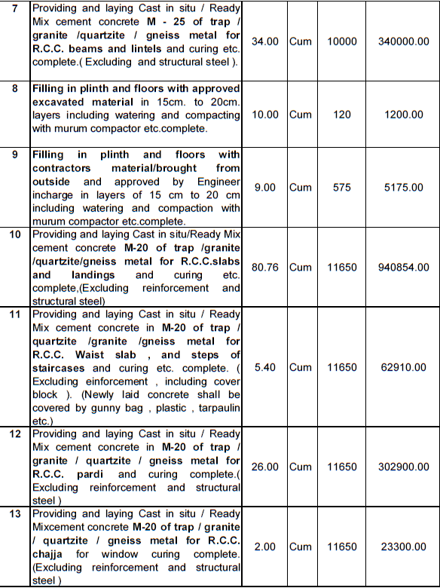

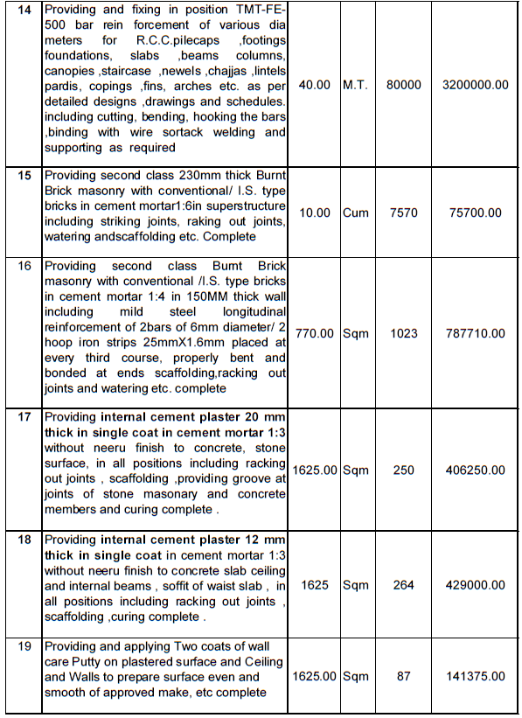
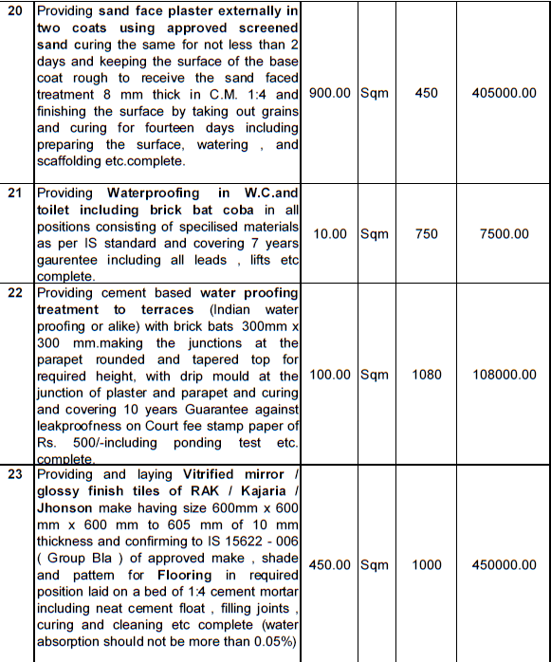
Estimate

Estimate
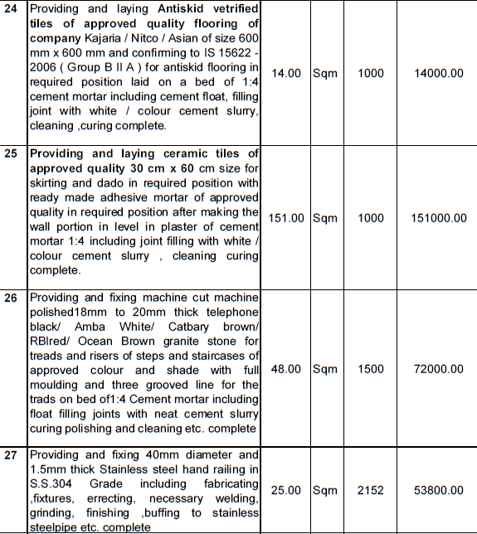
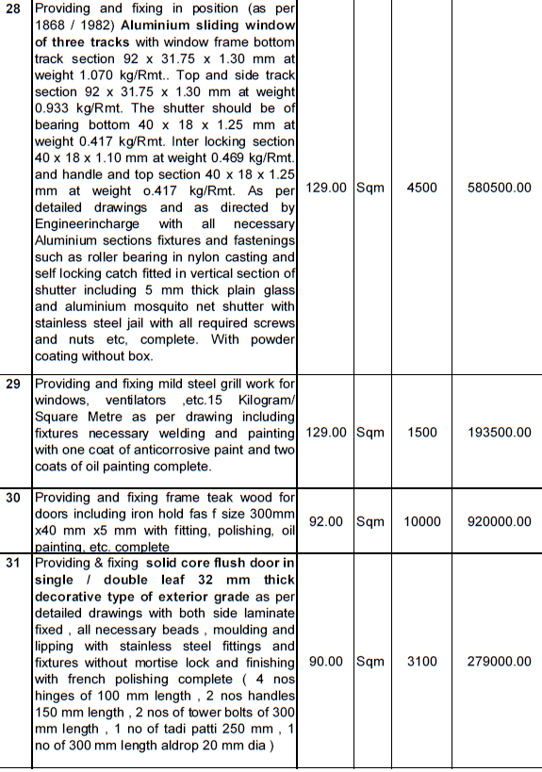

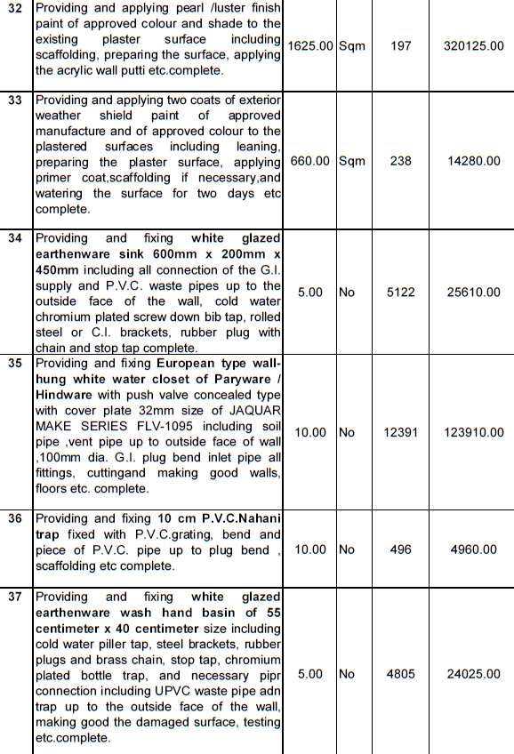
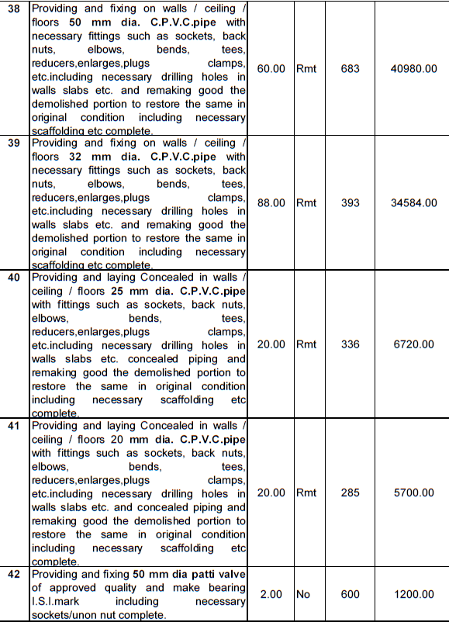

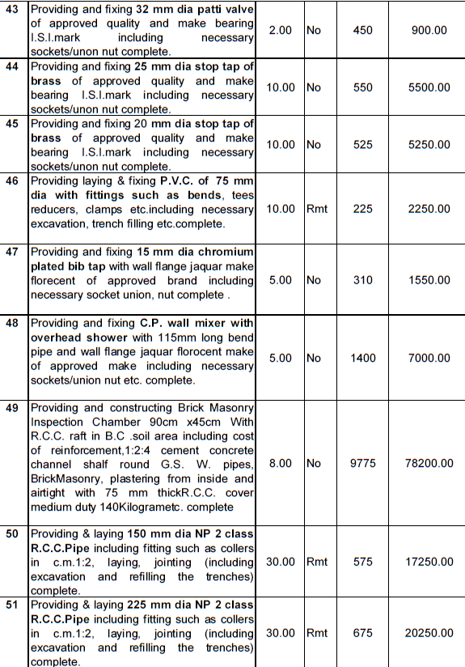
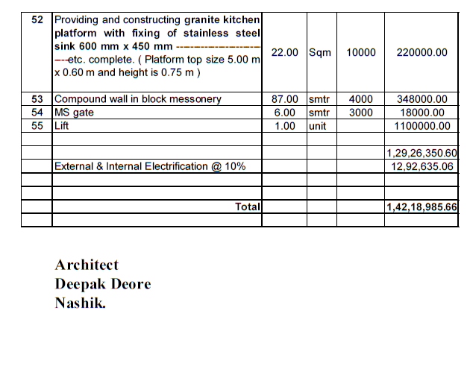

The Estimate amount is Rs.1,42,18,985/- (Rupees One Crore Forty Two Lakh Eighteen Thousand Nine Hundred Eighty Five Only.)

