Asset Verification Report Prepared for: SFSPL / M/s. Reliserv Solution. (8397/2306083)

Vastu/Thane/04/2024/8397/2306083
25/8-222 APU
Date: 25.04.2024

Asset Verification Report

1 General Information
Agreement Number: | A10179540
Label Number: | L1727B
Customer: | M/s. Reliserv Solution
Address of Asset Location: | Commercial Shop No. 3,4 & 5, Ground floor, Plot No. 169, Sector No. 34, May Flower Building, Kamothe, Navi Mumbai - 410209, Maharashtra, India.
Asset/s financed as per Agreement | Sl.no | Asset Description | Model | Supplier | Quantity
 | 1 | 10kv Insulation Tester | S1-1068 | Ruchi Energy Solutions Pvt. Ltd. | 1 No.
Name Plate | ☑ Available ◻ Not Available |  | ☑Visible ◻ Not Visible
Serial number (On Asset) | ☑Available ◻ Not available If Available – Refer Photos
Serial number (in Invoice): (If available) | Not Available
Type of Foundation for Asset (wherever applicable) | ◻ Steel supporting structure |  | ◻ Concrete floor ☑ Other
Level of Bondage | ☑ Asset easy to remove |  | ◻ Asset fixed permanently
Description of the premises : | ◻ Manufacturing Facility ◻ Hospital ◻ Warehouse ☑ Office Premises  ◻Diagnostic ◻ Others (Please specify) : _________________________________
Asset influencing circumstances ( i.e Chemical Zone, Corrosive atmosphere, Highly Polluted location etc.,) : | ◻Yes  If yes, please specify: |  | ☑ No

2 Asset Condition
Optical impression of physical condition of Asset: | ◻ Excellent ☑ Good ◻ Fair ◻ Poor ◻ Very Poor
Was the asset in operation at the time of Inspection | ☑ Yes ◻ No If No Please specify reasons
Age of the Asset at the time of inspection | ~ 7 Months
Asset condition at the time of purchase | ☑ New ◻Used
Any Breakdown in the machine | ◻ Yes ◻ No ☑ Not Known
Photos: | ☑ Yes | ◻ No
3 Information About Onsite Visit
Date of Onsite Visit: | 24.04.2024
Latitude & Longitude | 19°01'17.3"N 73°05'09.8"E
Customer Personnel met at site: | Mr. Hitesh & Manisha madam +91 80975 57535
Report created at | Mumbai

For Vastukala Consultants (I) Pvt. Ltd.

Umang Ashwin Patel
Regd. Valuer
Chartered Engineer (India)
Reg. No. IBBI/RV/04/2019/10803

Photographs

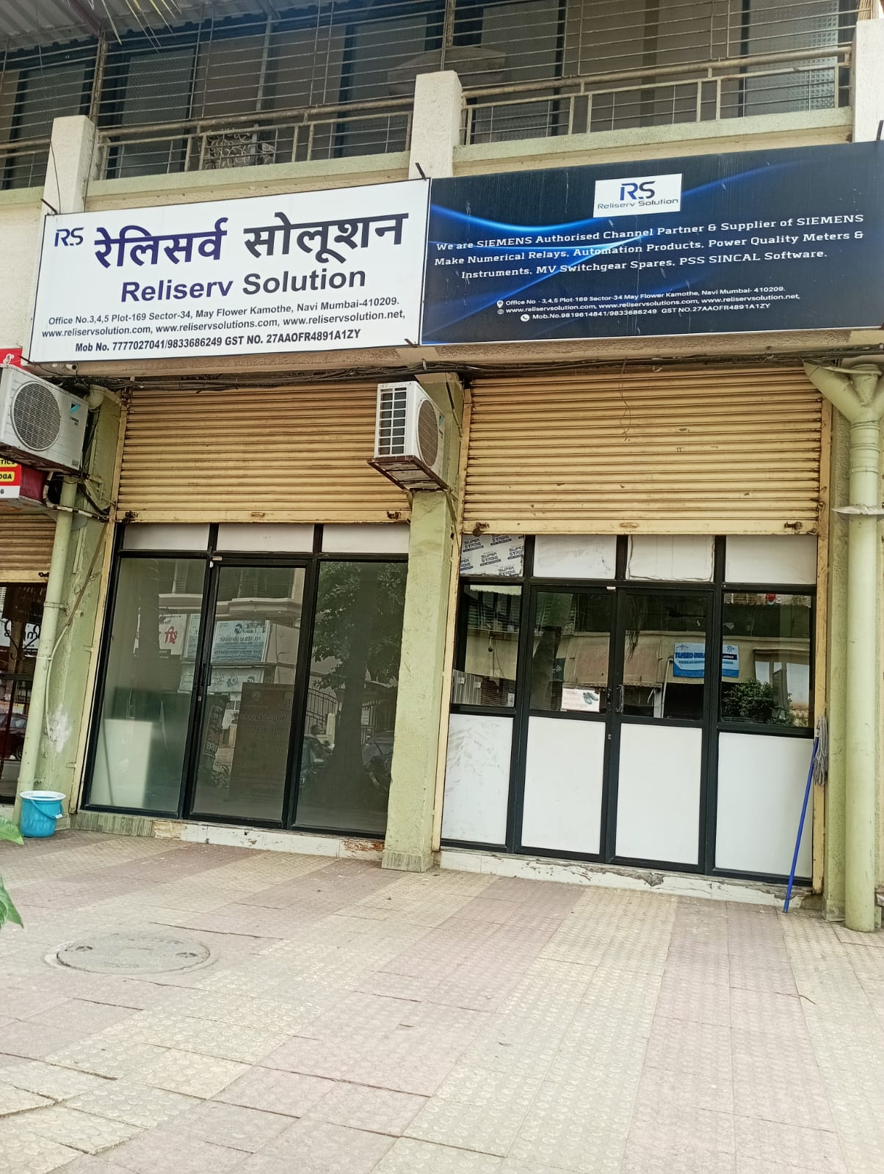 | 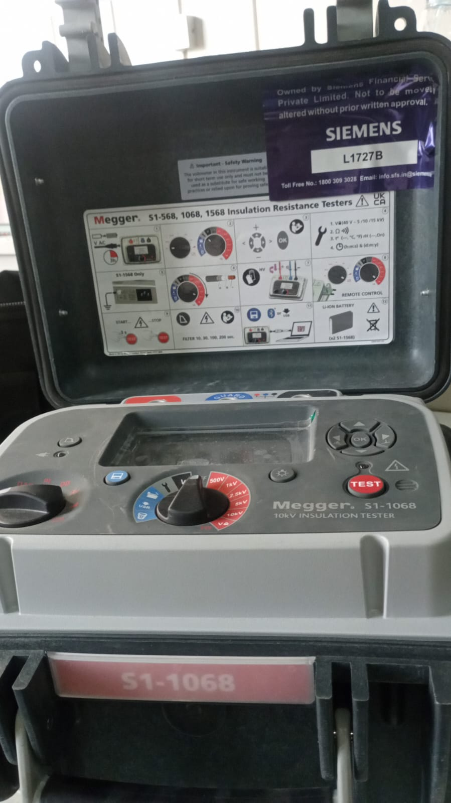
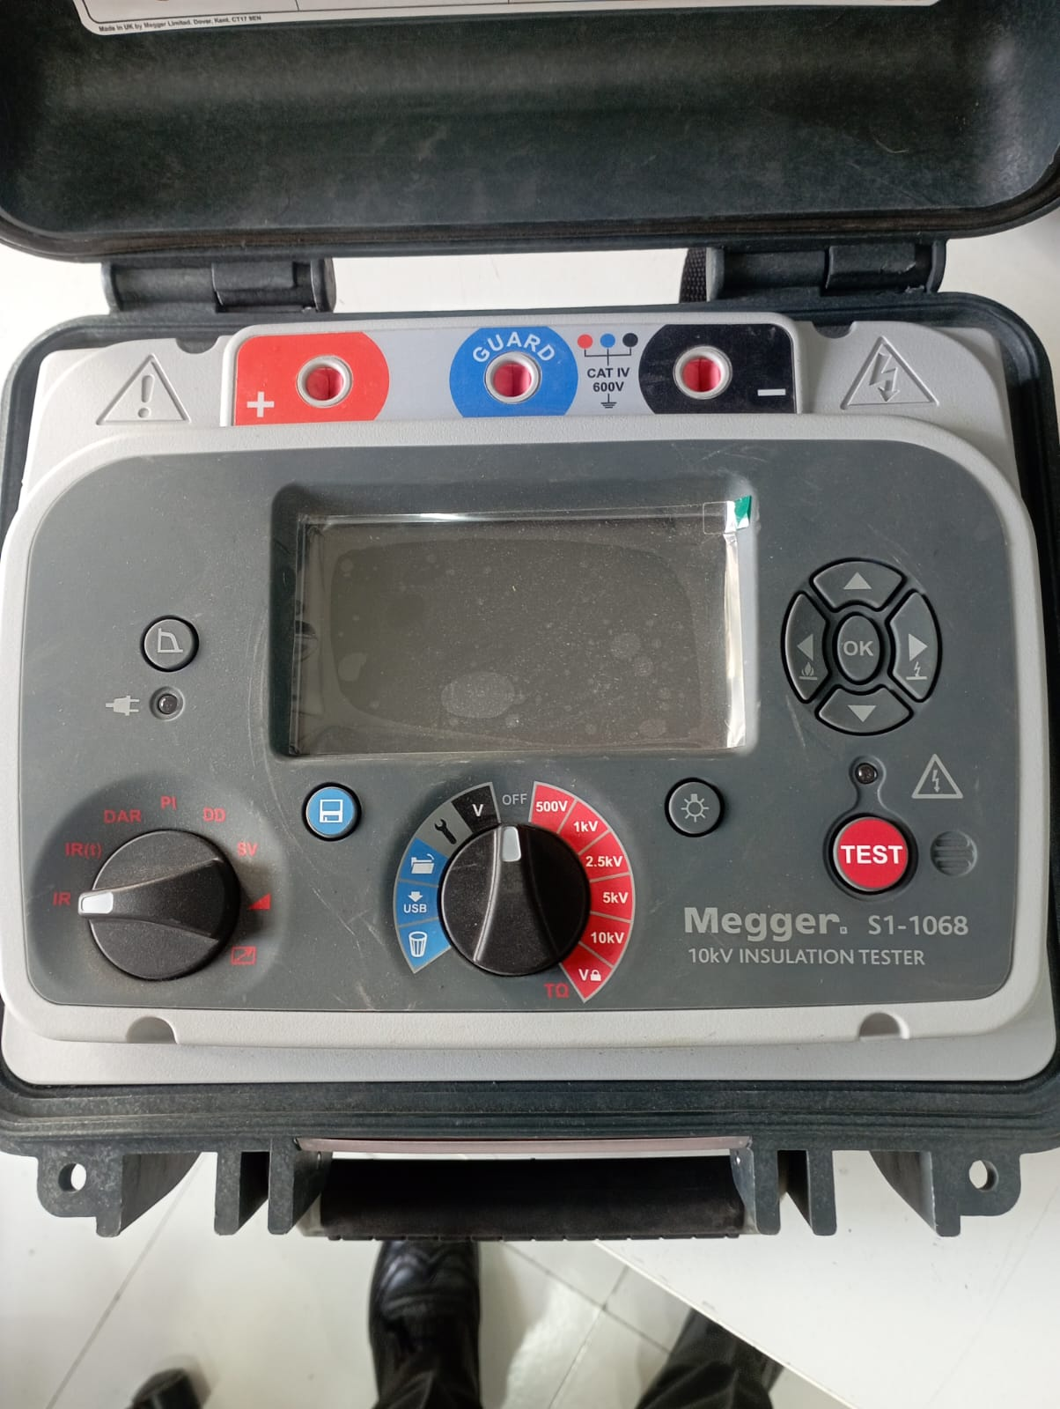 | 