VETTING REPORT

Details of the property under consideration:

Name of Client: Soul 9

Proposed Interior work on Plot Bearing Plot No. 5, Vasai Municipal Industrial Estate, Umela Phata, Vasai (West), Taluka – Vasai, District – Palghar, Pin Code – 401 202, State – Maharashtra, Country – India

Latitude Longitude: 19°03'44.3"N 72°55'20.7"E

Valuation Done for:
State Bank of India
Vasai Tal. Ind. Est. Branch
Gavrai Pada, Vasai (East), Taluka – Vasai, District – Palghar, Pin Code – 401 201,

State - Maharashtra, Country - India.

Vastu/SBI/Mumbai/05/2024/8387/2306060
24/01-199-SSPPY
Date: 04.05.2024

About the Project:
Proposed Interior work on Plot Bearing Plot No. 5, Vasai Municipal Industrial Estate, Umela Phata, Vasai (West), Taluka – Vasai, District – Palghar, Pin Code – 401 202, State – Maharashtra, Country – India

Sanctioned Loan by the Bank
Sr. | Name of the Vendor | Products / Equipment’s | Amount in ` Lakhs
1 | Nirvana Furnitures Pvt. Ltd. | Display Kitchen Cabinet | 12.42
2 | Nirvana Furnitures Pvt. Ltd. | Other Furniture | 10.15
3 | Nirvana Furnitures Pvt. Ltd. | Display Bed | 4.36
4 | Nirvana Furnitures Pvt. Ltd. | TV Unit | 2.84
5 | Nirvana Furnitures Pvt. Ltd. | Office Furniture | 16.78
6 | Nirvana Furnitures Pvt. Ltd. | Conference Room Table | 5.01
7 | Hi – Tech HV AC Engineering | AC | 15.05
8 | Sahara Sales Corporation | Civil Work / Painting / Electrical / Plumbing | 47.00
9 | Vedant Infotech | CCTV | 1.87
10 | Vedant Infotech | Computer / Laptops | 4.62
11 | Vedant Infotech | Server | 2.06
12 | Energia Appliances Pvt. Ltd. | Appliances | 27.84
TOTAL |  |  | 150.00

Work Completion Status as on 25.04.2024
Sr. | Name of the Vendor | Products / Equipment’s | Work Completion Status | Percentage of Work Completed
1 | Nirvana Furnitures Pvt. Ltd. | Display Kitchen Cabinet | Client has purchased the Kitchen Cabinet and Sold to the customer | 100%
2 | Nirvana Furnitures Pvt. Ltd. | Other Furniture | Work has not started yet | 0%
3 | Nirvana Furnitures Pvt. Ltd. | Display Bed | Work has not started yet | 0%
4 | Nirvana Furnitures Pvt. Ltd. | TV Unit | Work has not started yet | 0%
5 | Nirvana Furnitures Pvt. Ltd. | Office Furniture | Work has not started yet | 0%
6 | Nirvana Furnitures Pvt. Ltd. | Conference Room Table | Work has not started yet | 0%
7 | Hi – Tech HV AC Engineering | AC | Work has not started yet | 0%
8 | Sahara Sales Corporation | Civil Work / Painting / Electrical / Plumbing | Civil work is completed, plumbing work is completed, Electrical work is in progress and Plumbing work has not started yet | 50%
9 | Vedant Infotech | CCTV | Work has not started yet | 0%
10 | Vedant Infotech | Computer / Laptops | Work has not started yet | 0%
11 | Vedant Infotech | Server | Work has not started yet | 0%
12 | Energia Appliances Pvt. Ltd. | Appliances | Work has not started yet | 0%

Value of the Fixed Asset as on 25.04.2024
Sr. | Name of the Vendor | Products / Equipment’s | Amount in ` Lakhs | % of Work Completed | Value as on 25.04.2024 in ` Lakhs
1 | Nirvana Furnitures Pvt. Ltd. | Display Kitchen Cabinet | 12.42 | 100% | 12.42
2 | Nirvana Furnitures Pvt. Ltd. | Other Furniture | 10.15 | 0% | 0.00
3 | Nirvana Furnitures Pvt. Ltd. | Display Bed | 4.36 | 0% | 0.00
4 | Nirvana Furnitures Pvt. Ltd. | TV Unit | 2.84 | 0% | 0.00
5 | Nirvana Furnitures Pvt. Ltd. | Office Furniture | 16.78 | 0% | 0.00
6 | Nirvana Furnitures Pvt. Ltd. | Conference Room Table | 5.01 | 0% | 0.00
7 | Hi – Tech HV AC Engineering | AC | 15.05 | 0% | 0.00
8 | Sahara Sales Corporation | Civil Work / Painting / Electrical / Plumbing | 47.00 | 50% | 23.50
9 | Vedant Infotech | CCTV | 1.87 | 0% | 0.00
10 | Vedant Infotech | Computer / Laptops | 4.62 | 0% | 0.00
11 | Vedant Infotech | Server | 2.06 | 0% | 0.00
12 | Energia Appliances Pvt. Ltd. | Appliances | 27.84 | 0% | 0.00
TOTAL |  |  | 150.00 |  | 35.92

Observation and Construction: -
Total estimated cost is ` 1,50,00,000.00 (Rupees One Crore Fifty Lakh Only) i.e., ` 150.00 Lakhs.
Total cost incurred as on 25.04.2024 is ` 35,92,000.00 (Rupees Thirty Five Lakh Ninety Two Thousand Only) i.e., ` 35.92 Lakhs.

Photo copy of following document is provided to us & this report should be read along with it:
- Copy of Invoice
- Copy of Sanctioned letter only 2 Pages

Manoj B. Chalikwar
Registered Valuer
Chartered Engineer (India)
Reg. No. IBBI / RV / 07/2018/10366
Reg. No. CAT-I-F-1763
SBI Empanelment No.: SME/TCC/2021-22/86/3

Actual Site Photographs
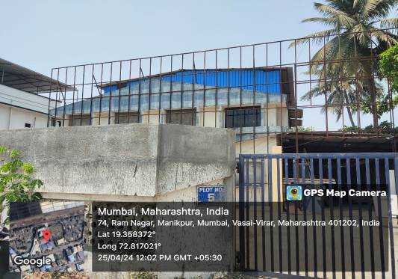
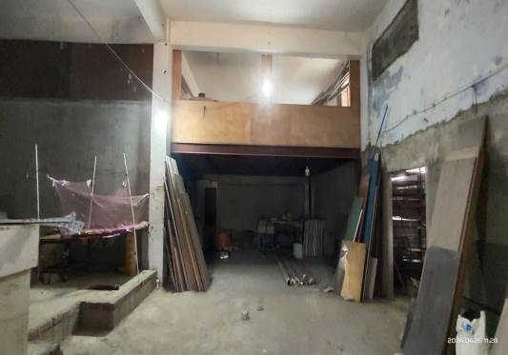
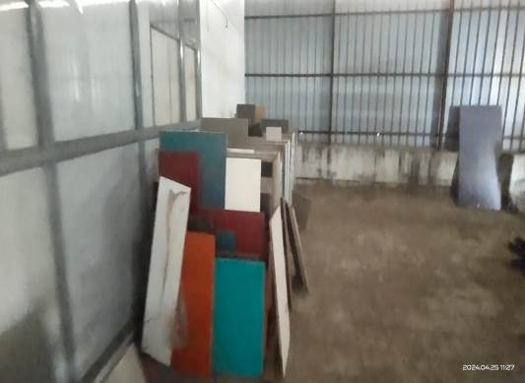
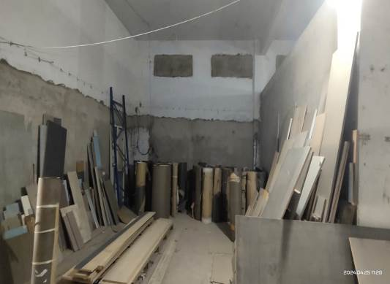
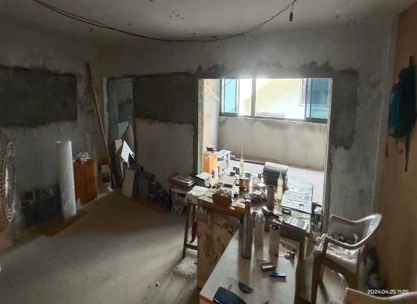
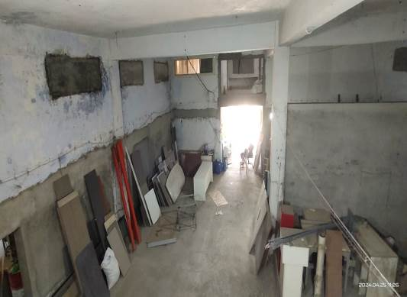
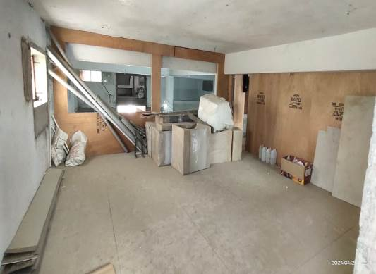

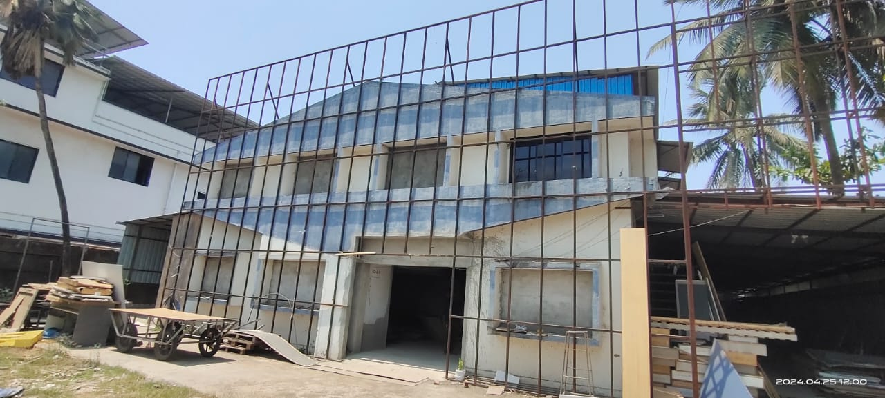
Actual Site Photographs
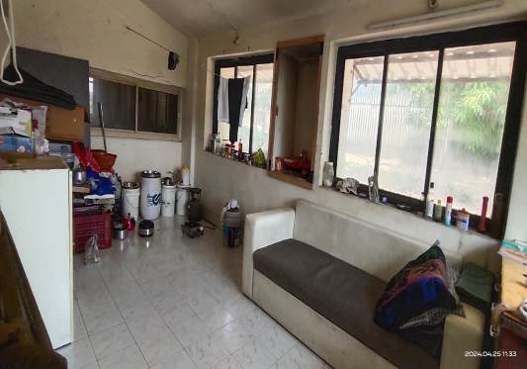
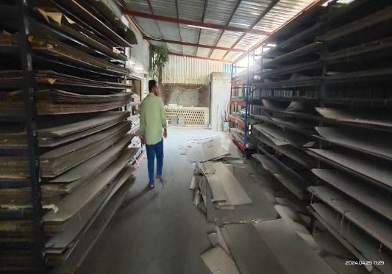
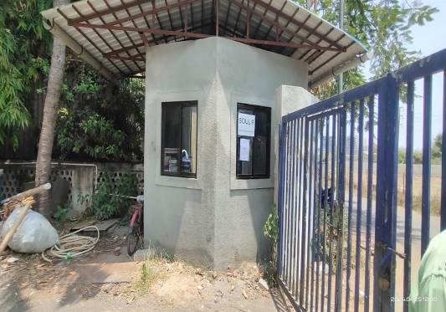
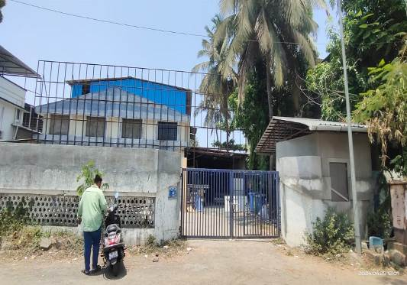
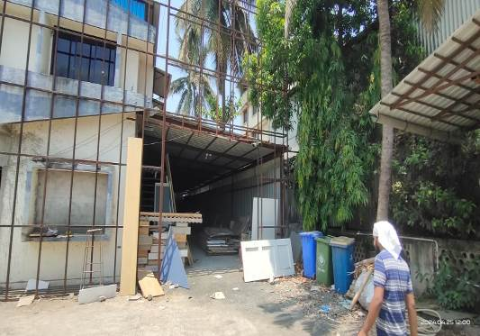
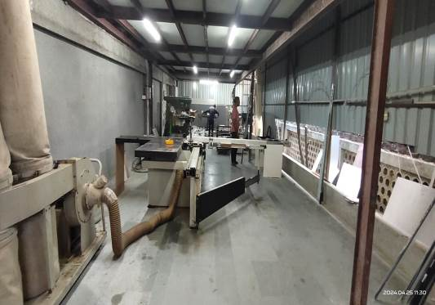

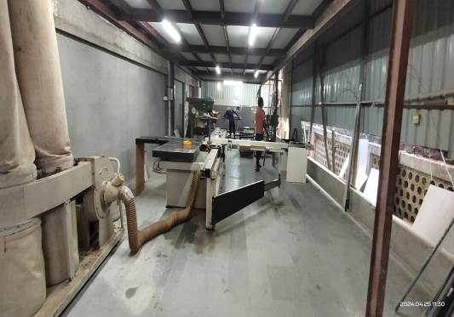
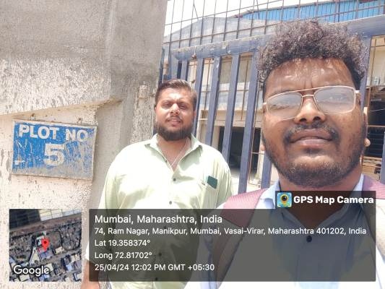
Route Map of the property
Site u/r

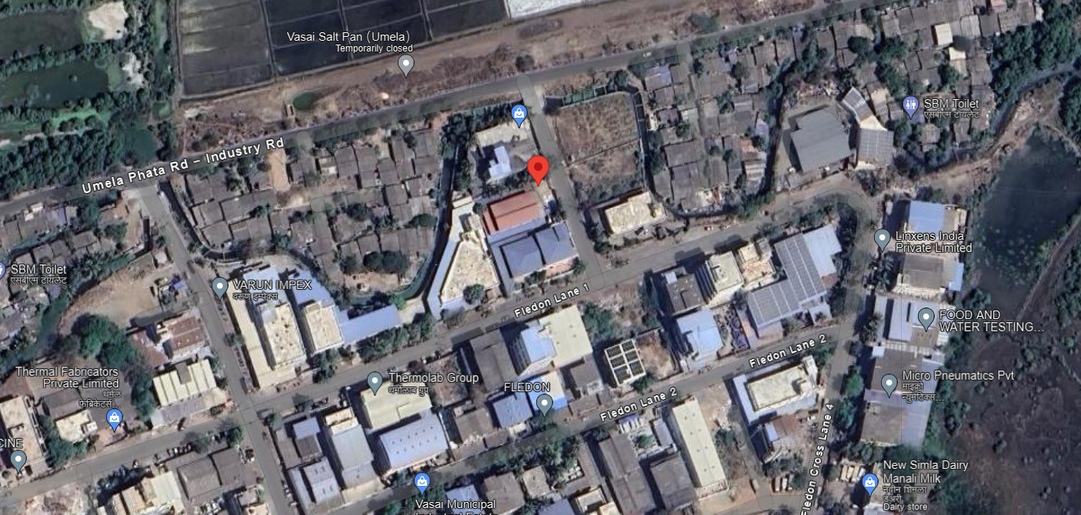

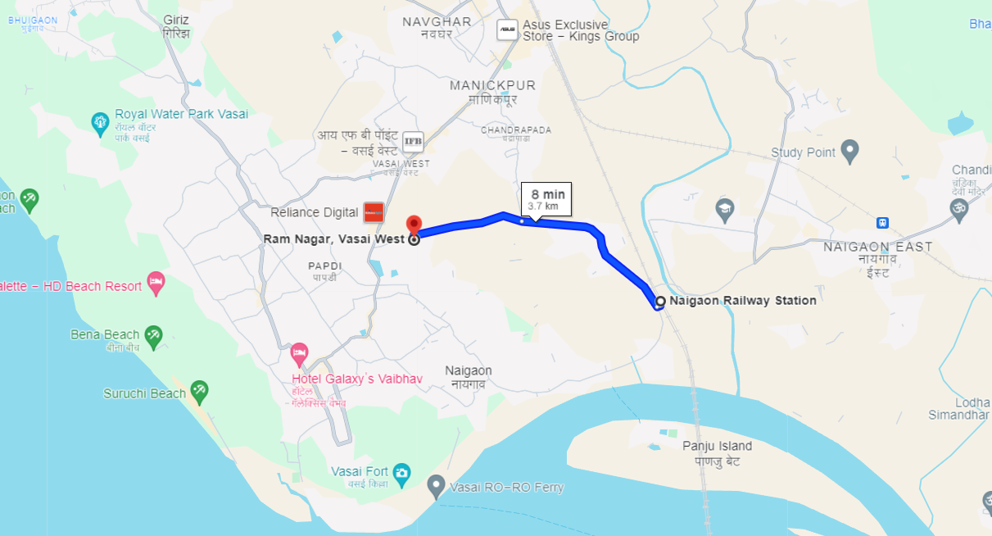

Latitude Longitude: 19°21'30.1"N 72°49'01.3"E
Note: The Blue line shows the route to site from nearest railway station (Naigaon – 3.7 Km.)

