Vastu/Nashik/04/2024/008386/2306070
24/11-209-RYBS
Date: 24.04.2024

To,
The Branch Manager,
State Bank of lndia
Maharashtra Eng. Research Institute Branch
Dindori Road, MERI, Nashik, Maharashtra, Nashik - 422004,
State - Maharashtra, Country - lndia.

Sub: Vetting of Extra Amenities

Sir,

With reference to above subject, we have evaluated the Extra Amenities for Residential Row House On Plot No. 04, “Sai Bhakti Row House ”, Survey No. 248/ 2, Near At Pawar Ashram Shala, Renuka Nagar, Mhasrul Link Road, Village – Mhasrul, Taluka & District – Nashik, PIN – 422 004, State – Maharashtra, Country – India Name of Proposed Purchaser : Shri. Kameshwar Vasant Jopale. Name of Owner: Sau. Bhargiben Kirankumar Patel.

We have verified the rates quoted as per current market rates. Details of Extra Amenities considered as per copy of Extra Amenities Agreement between Shri. Kameshwar Vasant Jopale. (First Party). Shri. Ramani Pratikkumar Shantilal (Second Party) received on dated 23.04.2024. The Extra Amenities amount is Rs. 6,90,000/- (Rupees Six Lakh Ninety Thousand Only)

The said Cost Vetting Certificate is valid upto next 6 months Only.

Thanking you

Sincerely yours

Manoj B. Chalikwar
Registered Valuer
Chartered Engineer (India)
Reg. No. CAT-I-F-1763
SBI Empanelment No.: SME/TCC/2021-22/86/3
Encl. Valuation Report

Agreement for Extra Amenities
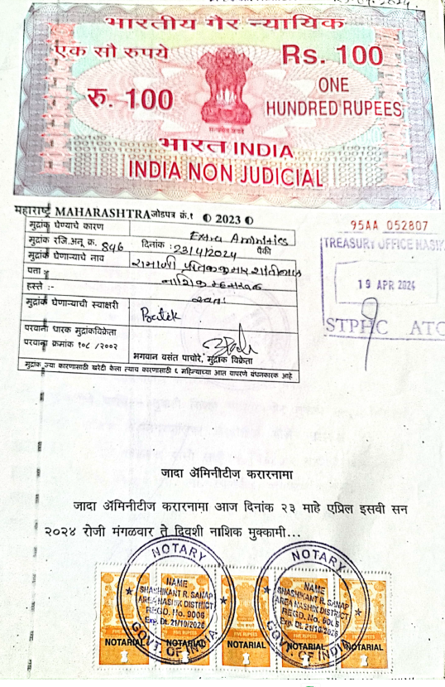
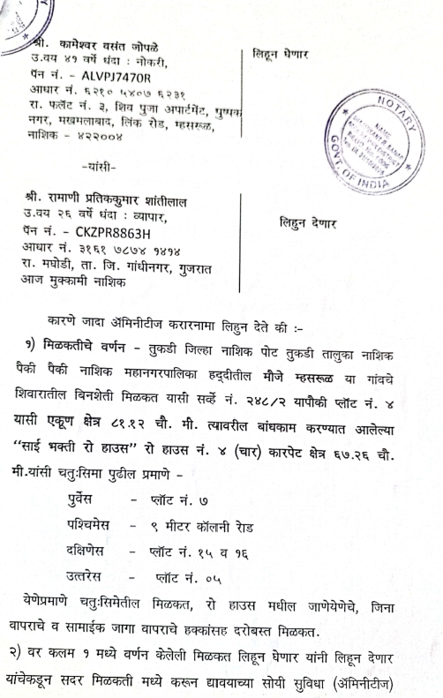

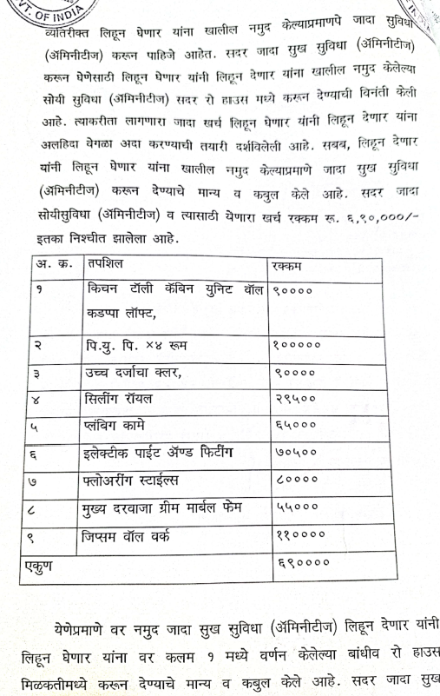
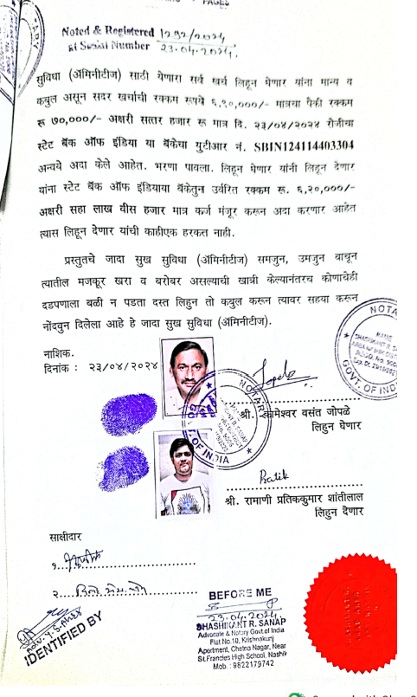

The Extra Amenities amount is Rs. 6,90,000/- (Rupees Six Lakh Ninety Thousand Only)

