COST VETTING REPORT
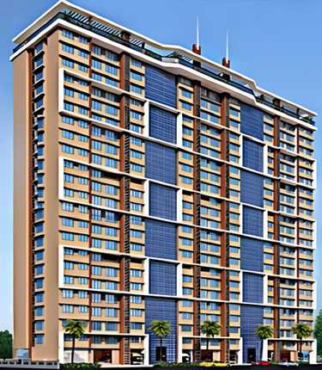

Details of the property under consideration:

Name of Project: "Aventus Heights – Phase 2"

"Aventus Heights – Phase 2", Proposed Slum Redevelopment Scheme on Plot Bearing C.T.S. No. 1A (Part), Survey No. 93 (Part) Plot No. 49, Road No. 5/6, Village Deonar, Shivaji Nagar, Govandi (East), Mumbai – 400 043, State – Maharashtra, Country – India

Latitude Longitude: 19°03'44.3"N 72°55'20.7"E

Valuation Done for:
State Bank of India
SME Chembur Branch
Unit No. 11, Building No. 11, Ground Floor, Corporate Park, Sion Trombay Road,
Chembur, Mumbai, Pin Code – 400 071, State - Maharashtra, Country – India.

Vastu/SBI/Mumbai/04/2024/8367/2306061
24/02-200-PY
Date: 24.04.2024

To,
The Branch Manager,
State Bank of India
SME Chembur Branch
Unit No. 11, Building No. 11,
Ground Floor, Corporate Park,
Sion Trombay Road, Chembur,
Mumbai, Pin Code – 400 071,
State - Maharashtra, Country – India.

Sub: Cost Vetting Report for "Aventus Heights – Phase 2" at Govandi (East) Mumbai, Pin Code – 400 043.

Dear Sir,
In accordance with your letter of engagement as stated above, we enclose our Report on Cost Vetting for "Aventus Heights – Phase 2", Proposed Slum Redevelopment Scheme on Plot Bearing C.T.S. No. 1A (Part), Survey No. 93 (Part) Plot No. 49, Road No. 5/6, Shivaji Nagar, Village Deonar, Govandi (East), Mumbai – 400 043, State – Maharashtra, Country – India.
M/s. Ratnaakar Shelters LLP is proposing Slum redevelopment Scheme on Plot Bearing C.T.S. No. 1A (Part), Survey No. 93 (Part) Plot No. 49, Road No. 5/6, Shivaji Nagar, Village Deonar, Govandi (East), Mumbai – 400 043, State – Maharashtra, Country – India. Project is comprising Sale Building.
Residential of Sale Building is proposed of Basement + Stilt + 1st to 3rd Podium + 4th to 35th Upper Floors with total RERA carpet area of 66,932.00 Sq. Ft. which consists 2 BHK, with 116 nos. of Sell flats providing with Fitness Centre, Society Office, & Other Amenities.
In this regard, SBI, SME Chembur Branch, Unit No. 11, Building No. 11, Ground Floor, Corporate Park, Sion Trombay Road, Chembur, Mumbai, Pin Code – 400 071, has approached Vastukala Consultants (I) Pvt. Ltd. (VCIPL) to conduct a Cost Vetting of the said project.
Our analysis of the cost vetting is enclosed in this report. This Report forms an integral whole and cannot be split in parts. The outcome of the report/ study can only lead to proper conclusions if the Report as a whole is taken into account.

The information used by Vastukala Consultants (I) Pvt. Ltd. (VCIPL) in preparing this report has been obtained from a variety of sources and other relevant documents provided by the client & bank. As agreed, we have performed our cost vetting exercise with the data available related to the business, considering the market prospects and projections. Our results are dependent on documents provided by client & bank, the underlying assumptions, which has been analyzed at a broader level by VCIPL while assessing their reasonableness.
Total Project Cost for the completion of Project will be ` 58.10 Cr.

For Vastukala Consultants (I) Pvt. Ltd.

Manoj B. Chalikwar
Registered Valuer
Chartered Engineer (India)
Reg. No. IBBI / RV / 07/2018/10366
Reg. No. CAT-I-F-1763
SBI Empanelment No.: SME/TCC/2021-22/86/3
About the Project:
Proposed Slum Redevelopment Scheme on Plot Bearing C.T.S. No. 1A (Part), Survey No. 93 (Part) Plot No. 49, Road No. 5/6, Village Deonar, Shivaji Nagar, Govandi (East), Mumbai – 400 043. It is about 2.70 Km. travelling distance from Govandi (East) Railway station

Area Statement as per Approved Plan
A | AREA STATEMENT
1 | Area of the plot | 4423.95
2 | Deduction for
a | Set back area | 88.95
b | Proposed Road | -
c | Any reservation | -
 | Total ( a + b + c ) | 88.95
3 | Net Area of Plot (1 – 2) | 4335.00
4 | Deduction for | -
a | Recreation Ground
5 | Balance Area of Plot (3 – 4) | 4310.00
6 | Additions for FSI  2a. Set Back Area | 88.95
7 | Total Area (5 + 6) | 4423.95
8 | FSI Permissible | 4.00
9 | Proposed Rehab BUA | 9432.85
10 | Proposed Rehab Component Area | 14083.09
11 | Additional 1.15% Component | 2112.46
12 | Total Permissible Sale BUA (10+11) | 16195.55
13 | Proposed Sale BUA | 16065.94
14 | Total Proposed BUA (9+13) | 25498.79
15 | F.S.I. Consumed 14/1 | 5.76
16 | Permissible Rehab Fungible Compensatory FSI  Rehab BUA 9432.85 X 35% = 3301.50 sq.mt. | 3301.50
17 | Proposed Rehab Fungible Compensatory FSI | 1193.57
18 | Permissible Sale Fungible Compensatory FSI  Sale BUA 16065.94 X 35% = 5623.08 sq.mt | 5623.08
19 | Proposed Sale Fungible Compensatory FSI | -------

Construction Area as per Approved Plan for Sale Building

Sr. No. | Floor | Built Up Area in Sq. M. | Staircase Area in Sq. M. | Other Area in Sq. M. | Total Construction Area in Sq. M.
1 | Basement | - | 117.97 | - | 117.97
2 | Ground Floor | - | 117.97 | 3.32 | 121.29
3 | 1st Floor | - | 117.97 | 3.32 | 121.29
4 | 2nd Floor | - | 117.97 | 3.32 | 121.29
5 | 3rd Floor | - | 117.97 | 245.03 | 363.00
6 | 4th Floor | - | 117.97 | 245.03 | 363.00
7 | 5th Floor | 241.71 | 117.97 | 3.32 | 363.00
8 | 6th Floor | 241.71 | 117.97 | 3.32 | 363.00
9 | 7th Floor | 241.71 | 117.97 | 3.32 | 363.00
10 | 8th Floor | 178.74 | 117.97 | 68.87 | 365.58
11 | 9th Floor | 241.71 | 117.97 | 3.32 | 363.00
12 | 10th Floor | 241.71 | 117.97 | 3.32 | 363.00
13 | 11th Floor | 241.71 | 117.97 | 3.32 | 363.00
14 | 12th Floor | 241.71 | 117.97 | 3.32 | 363.00
15 | 13th Floor | 241.71 | 117.97 | 3.32 | 363.00
16 | 14th Floor | 241.71 | 117.97 | 3.32 | 363.00
17 | 15th Floor | 178.74 | 117.97 | 68.87 | 365.58
18 | 16th Floor | 241.71 | 117.97 | 3.32 | 363.00
19 | 17th Floor | 241.71 | 117.97 | 3.32 | 363.00
20 | 18th Floor | 241.71 | 117.97 | 3.32 | 363.00
21 | 19th Floor | 241.71 | 117.97 | 3.32 | 363.00
22 | 20th Floor | 241.71 | 117.97 | 3.32 | 363.00
23 | 21st Floor | 241.71 | 117.97 | 3.32 | 363.00
24 | 22nd Floor | 178.74 | 117.97 | 68.87 | 365.58
25 | 23rd Floor | 241.71 | 117.97 | 3.32 | 363.00
26 | 24th Floor | - | 117.97 | 245.03 | 363.00
27 | 25th Floor | 241.71 | 117.97 | 3.32 | 363.00
28 | 26th Floor | 241.71 | 117.97 | 3.32 | 363.00
29 | 27th Floor | 241.71 | 117.97 | 3.32 | 363.00
30 | 28th Floor | 241.71 | 117.97 | 3.32 | 363.00
31 | 29th Floor | 178.74 | 117.97 | 68.87 | 365.58
32 | 30th Floor | 241.71 | 117.97 | 3.32 | 363.00
33 | 31st Floor | 241.71 | 117.97 | 3.32 | 363.00
34 | 32nd Floor | 241.71 | 117.97 | 3.32 | 363.00
35 | 33rd Floor | 241.71 | 117.97 | 3.32 | 363.00
36 | 34th Floor | 241.71 | 117.97 | 3.32 | 363.00
37 | 35th Floor | 241.71 | 117.97 | 3.32 | 363.00
38 | Terrace / OHT | - | 117.97 | - | 117.97
TOTAL |  | 6,999.42 | 4,482.86 | 1,106.85 | 12,589.13
No. of Stack Parking |  |  |  |  | 96 Nos.

Project Cost
Sr. No. | Particulars | Total Estimated Amount in ` | Total Estimated Amount  in ` Cr.
1 | Land Cost
 | Acquisition Cost of Land or Development Rights, and Legal Cost. | - | -
 | Rent to Tenants, Lease premium, Lease Rent, interest cost incurred or payable on Land Cost | - | -
 | Amount of Premium payable to obtain development rights, FSI, additional FSI, fungible area, and any other incentive under DCR from Local Authority or State Government or any Statutory Authority. | 10,00,00,000.00 | 10.00
 | Acquisition cost of TDR (if any) | - | -
2 | Cost of Construction
 | Estimated construction cost of rehab cum sale building including site development and infrastructure for the same. | 37,35,06,510.00 | 37.35
 | On site expenditure for development of entire project excluding cost of construction as per(i) above,
a. | Architect Fees & Consultant fees | 1,86,75,326.00 | 1.87
b. | Admin Cost includes salaries, site overheads, development works, cost of services (including water, electricity, sewerage, drainage, layout roads etc.), cost of machineries and equipment including its hire and maintenance cost, consumables etc. All costs directly incurred to complete the construction of the entire phase of the project registered. | 2,24,10,391.00 | 2.24
c. | Marketing Cost | 1,52,29,130.00 | 1.52
3 | Interest during the Project | 4,00,00,000.00 | 4.00
4. | Contingency Charges | 1,12,05,195.00 | 1.12
 | GRAND TOTAL: | 58,10,26,552.00 | 58.10

Manoj B. Chalikwar
Registered Valuer
Chartered Engineer (India)
Reg. No. IBBI / RV / 07/2018/10366
Reg. No. CAT-I-F-1763
SBI Empanelment No.: SME/TCC/2021-22/86/3

Comments on each element of Cost of Project: -
- Land Cost:
As per Present Ready Reckoner rate the Project Land Value is ` 39.69 Cr. considering Land Rate @ ` 92,080.00 per Sq. M. & Net Plot Area of 4,310 Sq. M.
As per document purchase cost of land & stamp duty cost is ` 0.00 i.e., ` 0.0 Cr. which is 0% of Total Project Cost.

- Building Cost of Construction for Sale Building:
Construction Area of Sale Building = 12,589.13 Sq. M. i.e., 1,35,509.40 Sq. Ft.
No. of Stack Car Parking = 96 Nos.
Total estimated cost for construction of Building (includes cost of RCC work, manpower, lift, material, painting, finishing work, site development, etc.) is ` 33,99,06,510.00 i.e., ` 33.99 Cr. which comes ` 27,000.00 per Sq. M. on construction area for building, and cost for stack parking is ` 3,36,00,000.00 i.e., ` 3.36 Cr. which comes ` 3,50,000.00 per stack parking.
Hence, total construction cost (Cost of construction of building + Cost of stack parking) (` 33,99,06,510.00 + ` 3,36,00,000.00) = ` 37,35,06,510.00 i.e., ` 37.35 Cr.
The total construction area is 12,589.13 Sq. M. i.e., 1,35,509.40 Sq. Ft., projected cost of ` 37.35 Cr is 64.28% of total project cost
VCIPL opinion the construction cost of 27,000/- Per Sq. M. which is in line with Market-Trend.
Particulars | Rate per Sq. Ft.
Excavation Work | 1500.00
Total RCC Work | 12000.00
Final Finishing Work | 7500.00
Other Work | 6000.00
Cost of Construction | 27000.00
Stack Car Parking Cost | 3,50,000.00 per parking

- Approval Charges:
The Total Approval Cost (Fungible Cost & Development Cess Premium & TDR Cost) as per architect letter will be ` 10,00,00,000.00 i.e., ` 10.00 Cr. which is 17.21% of Total Project Cost.
As per information provided by developer.

- Architect Cost, RCC & Other Professional Charges:
The total Architect charges of ` 1,86,75,326.00 i.e., ` 1.87 Cr. is 5.0% of total construction cost building & it is line up with Market trend.
The professional charge consists of Architect & Legal which in market is in the range of 2% - 5% of Total Construction cost of the project.

- Administrative Expenses:
Salaries, site overheads, development works, cost of services (including water, electricity, sewerage, drainage, layout roads etc.), cost of machineries and equipment including its hire and maintenance cost, consumables etc. All costs directly incurred to complete the construction of the entire phase of the project registered is estimated 6% of total construction cost Building which comes to ` 2,24,10,391.00 i.e., ` 2.24Cr.
The admin charges which in market is in the range of 4% - 6% of Total Construction cost of the project.

- Marketing Expenses:
Marketing costs directly incurred to complete the construction of the entire phase of the project registered is estimated at 2% of total Sale income from the project which comes to ` 1,52,29,130.00 i.e., ` 1.52 Cr.
The marketing charge consists of brokerage & commission which in market is in the range of 1% - 3% of Total Sale income of the property.

- Interest Costs:
The Interest cost for the term loan is ` 4,00,00,000.00 i.e., ` 4.00 Cr., which is 6.88% of total project cost.
As per information provided by the client.

- Contingency Costs:
The contingency charges estimated at 3% of total cost of construction which comes to ` 1,12,05,195.00 i.e., ` 1.12 Cr.
Observation and Construction: -
Total estimated cost of project i.e., ` 58,10,26,552.00 (Rupees Fifty – Eight Crore Ten Lakh Twenty – Six Thousand Five Hundred Fifty – Two Only) i.e., ` 58.10 Cr. is fair & reasonable.
The project cost is including land premium payable to concern authorities, Fungible FSI Premium, Cost of Construction of Sale Building, on site expenses including admin & marketing expenses, premiums / charges to be paid to competent authority and Bank interest, etc. we have not independently verified interest cost hence not consider in cost vetting.
As per present sanctioned building plan, permissible built-up area on the said plot is 5,623.08 Sq. M. The sale building is presently approved for Basement + Stilt Floor + 1st to 3rd Podium Floors + 4th to 16th Upper Floors only. The Developer has submitted the concession drawing plan to the competent authority for utilization of total permissible Built-up area and fungible FSI. The sale building is presently sanctioned for Basement + Stilt Floor + 1st to 3rd Podium Floors + 4th to 35th Upper Floors only. Estimated cost of entire project of 35th upper floors are considered.
Total estimated cost of construction of Sales building is ` 49,21,73,724.00 i.e., ` 49.22 Cr. which comes ` 30,000.00 per Sq. M. on construction area for building, cost for deep excavation & shore piling is ` 2,46,08,686.00 i.e., ` 2.46 Cr. which comes 5% of cost of construction of building and cost for stack parking is ` 5,55,00,000.00 i.e., ` 5.55 Cr. which comes ` 5,00,000.00 per stack parking. Hence, total construction cost (Cost of construction of building + Cost of deep excavation & shore piling + Cost of stack parking) (` 49,21,73,724.00 + ` 2,46,08,686.00 + ` 5,55,00,000.00) = ` 57,22,82,410.00 i.e., ` 57.23 Cr., which is fair & reasonable considering the present status of project, type & quality of construction & specification of the building materials to be used, height of the structure, amenities to be provided in proposed building.

Assumptions & Remarks-
- The adequacy of Engineering / Structural design is beyond the scope of our assignment.
- Estimated project completion date is 31/12/2027. The cost is certified based on the assumptions that the project will be completed within time frame. Few assumptions are made regarding inflation & cost rise etc. during construction period.

Photo copy of following document is provided to us & this report should be read along with it:
- Copy of Developer Agreement dated 15.03.2015 between M/s. Devkrupa Co-operative Housing Society Ltd. (The Society) and M/s. Ratnaakar Shelters LLP (The Developers) through registered agreement Notary R No. 001/2015
- Copy of Legal Title Report dated 20.10.2022 issued by Anant Narayan Advocate High Court.
- Copy of Intimation of Approval (IOA) Letter No. SRA/ENG/3834/ME/MCGM/AP dated 03.11.2021 issued by Slum Rehabilitation Authority (SRA).
- Copy of Approved Plan No. SRA/ENG/3834/ME/MCGM/AP dated 03.11.2021 issued by Slum Rehabilitation Authority (SRA).
Approved upto: Basement + Stilt Floor + 1st to 3rd Podium floor + 4th to 16th Upper Floors
- Copy of Commencement Certificate No. SRA/ENG/3834/ME/MCGM/AP dated 03.11.2021 issued by Slum Rehabilitation Authority (SRA).
(This CC is endorsed for the work for up to 5 floors as per approved plan dated 03.11.2021)
- Copy of Architect Drawing Plan issued by M/s. Consultants Combined Architects.
Approval upto: Basement + Stilt Floor + 1st to 3rd Podium + 4th to 35th Upper Floors
- Copy of Fire NOC Certificate No. FB / HRC / R – V / 67 dated 25.10.2019 issued Municipal Corporation of Greater Mumbai, Mumbai Fire Brigade.
- Copy of Engineer’s Certificate dated 11.10.2023 issued by optimal Consultancy Services Pvt. Ltd.
- Copy of CA Certificate dated 01.10.2022 issued by M/s. Vinod Sukhraj Mehta.
- Copy of RERA Certificate No. P51800047961 dated 02.12.2022 issued by Maharashtra Real Estate Regulatory Authority (MAHRERA).
- Copy of Architect’s Certificate dated 20.04.2023 issued by Consultants Combined Architects.

Actual Site Photographs

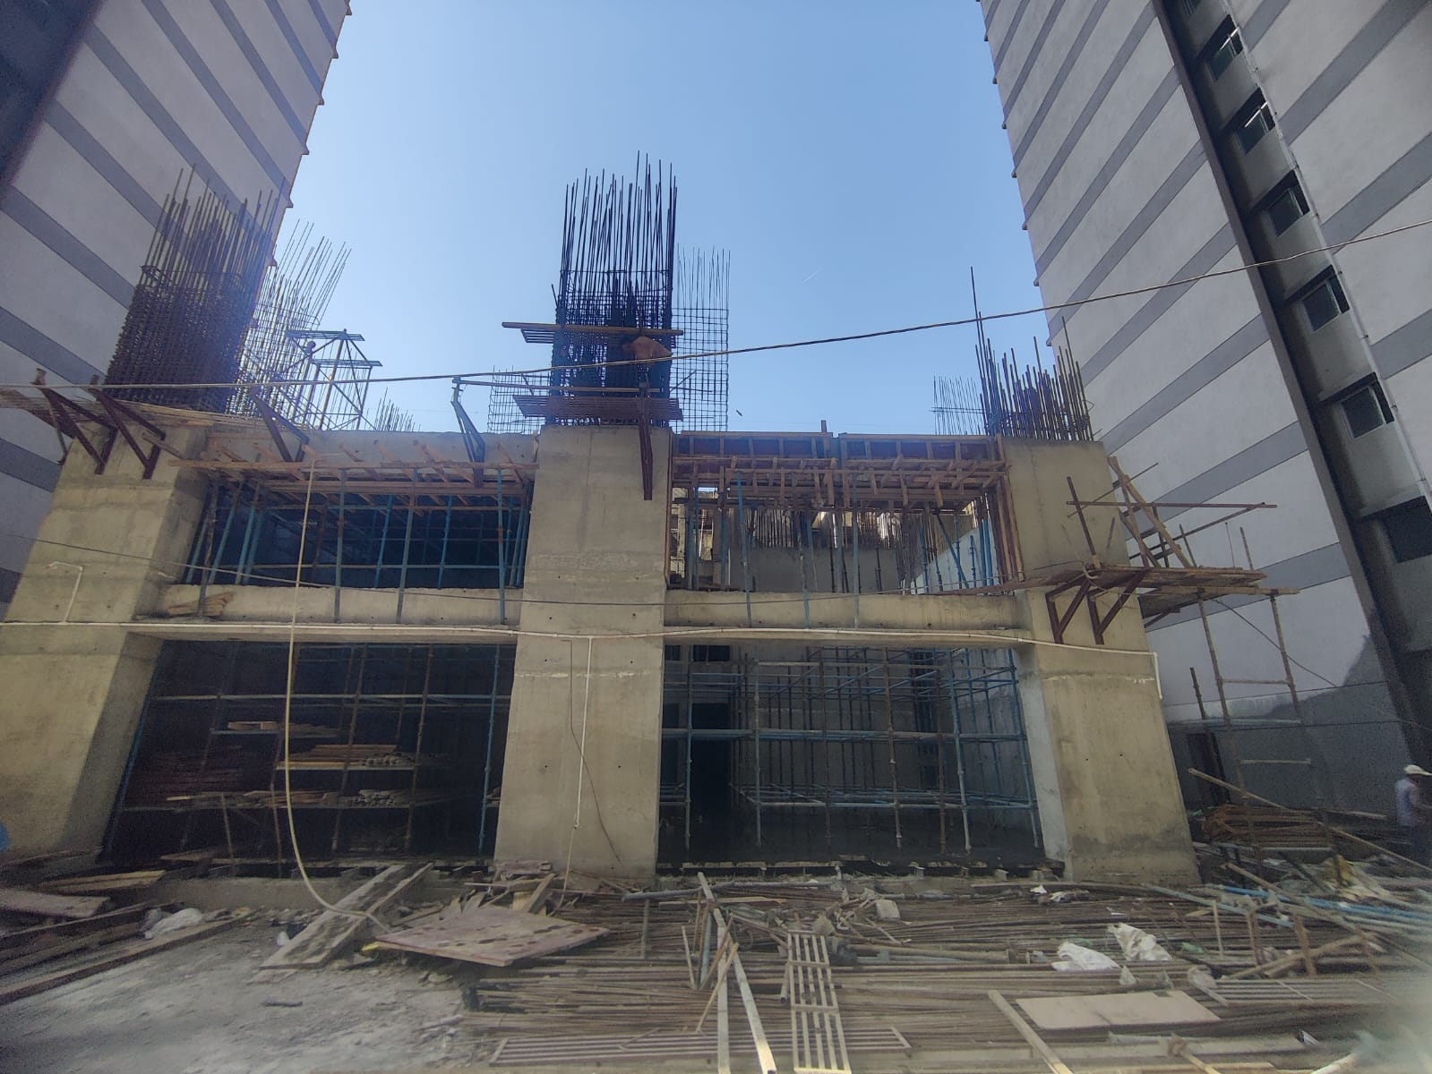
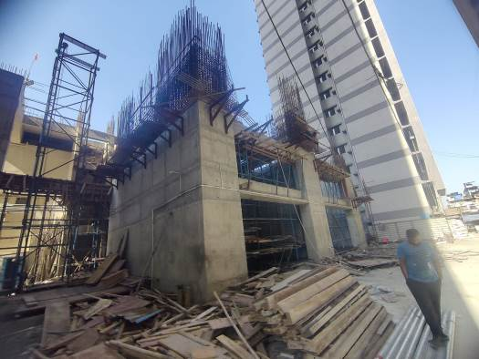
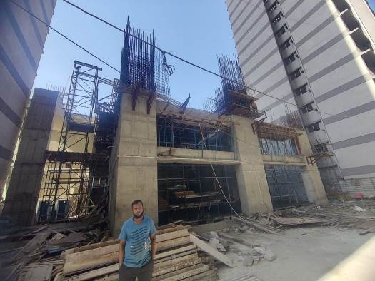
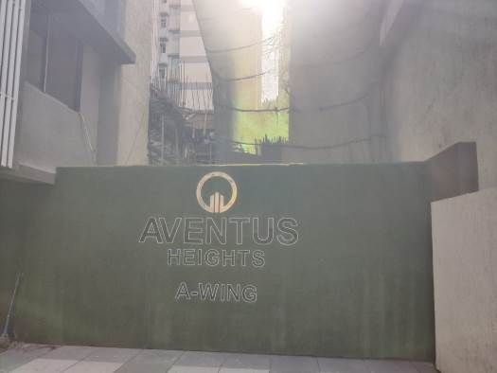
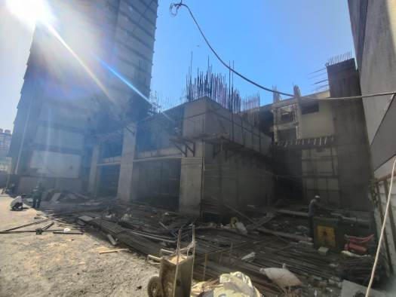
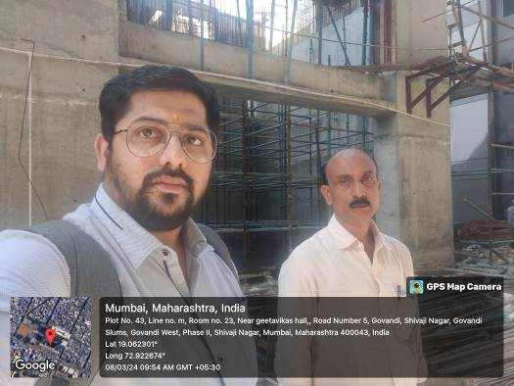

Route Map of the property
Site u/r

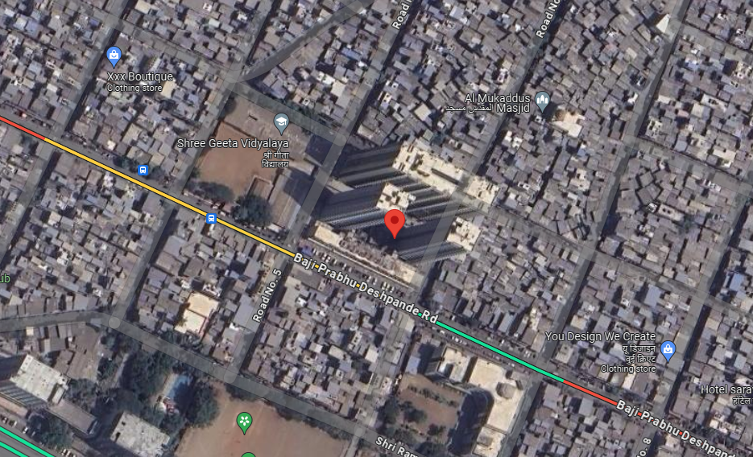

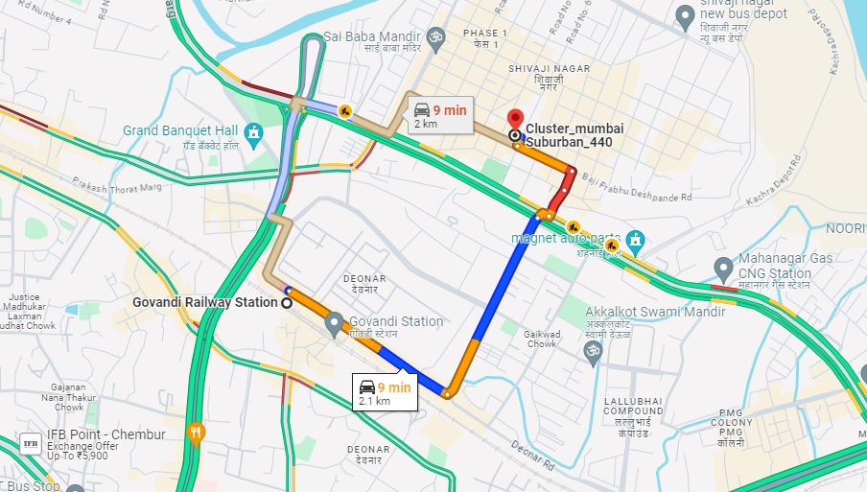

Latitude Longitude: 19°03'44.3"N 72°55'20.7"E
Note: The Blue line shows the route to site from nearest railway station (Govandi – 2.1 Km.)

