Valuation Report of Balance FSI
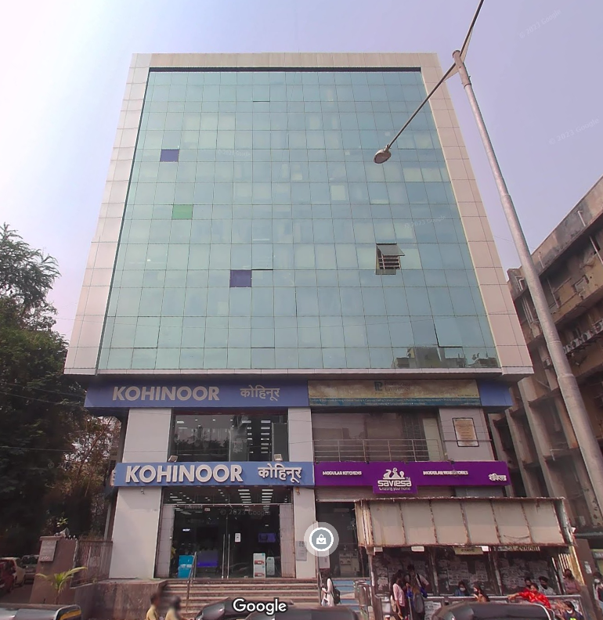

Details of the property under consideration:

Name of Client: M/s. Reliable Developer’s Pvt. Ltd.

Project named “Mahalaxmi Center”, Proposed redevelopment of residential cum commercial building on
plot bearing Old C. T. S. No. 340, 340/1, to 14 & New C.T.S. No. 340/A, 340/B & 340/C, S V Road,
Village - Malad (North), Kandivali (West), Mumbai – 400 067, State – Maharashtra, Country - India

Longitude Latitude: 19°12'01.8"N 72°50'55.2"E

Intended User:

Private Clients

1. VALUATION OPINION REPORT 3
2. VALUATION REPORT (IN RESPECT OF BALANCE FSI) 4
3. TOTAL ABSTRACT OF THE ENTIRE PROPERTY 11
4. ACTUAL SITE PHOTOGRAPHS 14
5. ROUTE MAP OF THE PROPERTY 16
6. READY RECKONER RATE 17
7. JUSTIFICATION FOR PRICE /RATE 17
8. ASSUMPTIONS, DISCLAIMERS, LIMITATIONS & QUALIFICATIONS 19
9. ASSUMPTIONS, CAVEATS, LIMITATION AND DISCLAIMERS 22
10. DEFINITION OF VALUE FOR THIS SPECIFIC PURPOSE 22

This report contains total 22 pages

Vastu/Mumbai/04/2024/3004/2301957
08/09-103-SSPPYU
Date: 19.04.2024

VALUATION OPINION REPORT

This is to certify that the property bearing Project named “Mahalaxmi Center”, Proposed redevelopment of residential cum commercial building on plot bearing Old C. T. S. No. 340, 340/1, to 14 & New C.T.S. No. 340/A, 340/B & 340/C, S V Road, Village - Malad (North), Kandivali (West), Mumbai – 400 067, State – Maharashtra, Country - India belongs M/s. Reliable Developer’s Pvt. Ltd.

Boundaries of the property.

North | : | Shree Kandivalin Hitwardhak Mandal Hospital (KHM Hospital).
South | : | Sangeeta Building.
East | : | Balbharati College of Commerce.
West | : | Ration Card Office.
Considering various parameters recorded, existing economic scenario, and the information that is available with reference to the development of neighborhood and method selected for valuation, we are of the opinion that, the Balance Potantial FSI can be valued not more then as Follows:
Present Value of the project potential As on Date | Rs. 7.11
The realizable value of the property | Rs. 6.40
Distress value of the property | Rs. 5.69

The valuation of the property is based on the documents produced by the concern & entire Balance FSI to be utilized on the existing Project. Legal aspects have not been taken into considerations while preparing this valuation report.

Hence certified

Manoj B. Chalikwar
Registered Valuer
Chartered Engineer (India)
Reg. No. IBBI/RV/07/2018/10366
Encl: Valuation Report

Vastukala Consultants (I) Pvt. Ltd.
B1-001, U/B Floor, Boomerang, Chandivali Farm Road, Powai, Andheri (East), Mumbai – 400 072

VALUATION REPORT (IN RESPECT OF BALANCE FSI)

I | General
1. | Purpose for which the valuation is made |  |  | : |  | As per the request from client to assess Fair market value of the Balance FSI to be loaded on the existing Building.
2. | a) | Date of inspection |  | : |  | 15.04.2024
 | b) | Date on which the valuation is made |  | : |  | 19.04.2024
3. | List of documents produced for perusal
- Copy of Property Card, issued by City Survey office Malad, Doc No. 94137470684.
- Copy of Amended payment sheet, date 18.11.2022, issued by Municipal Corporation of Greater Mumbai (MCGM), Doc. No. CHE / A-4107 / BP(WS) / AR.
- Copy of No Objection certificate from Mahalaxmi Heights CHSL for work carried out beyond approval addition of units and construct additional floor by consuming Additional FSI, date 13.12.2022.
- Copy of Amended Plan date 29.07.2009, issued by Executive Engineer Building Proposal Municipal Corporation Of Greater Mumbai (MCGM), Doc. No. CHE / A-4107 / BP(WS) / AR.
- Copy of Proforma Area Statement for the project dated 22.03.2024 issued by Teearch Architects & Consultants Pvt. Ltd.
4. | Name of the owner(s) and his / their address (es) with Phone no. (details of share of each owner in case of joint ownership) |  |  | : |  | M/s. Reliable Developers Private Ltd.  Address:  Project named “Mahalaxmi Center”, Proposed redevelopment of residential cum commercial building on plot bearing Old C. T. S. No. 340, 340/1, to 14 & New C.T.S. No. 340/A, 340/B & 340/C, S V Road, Village - Malad (North), Kandivali (West), Mumbai – 400 067, State – Maharashtra, Country - India  Contact Person:  Mr. Chintan (Company representative)  Mb. No.: +91 - 9987788588
5. | Brief description of the property (Including Leasehold / freehold etc.):
The property is located in a developed residential cum commercial area having good infrastructure, well connected by road and train. The immovable property comprises of freehold land with two Structures (one Residential Tower and Other Commercial Structure. It is located at about 650 Meter walking distance from Kandivali Western Railway Station.

About Location:
Kandivali formerly Khandolee is a suburb in the north of Mumbai, Maharashtra, India and has a large Marathi, Koli, Gujarati population followed by others. British records highlight a fact which is different from what is suggested in the rest of the article. The area names that end with "Vali" were the actual valleys to the small hills surrounding the area, and that's how we have Kandolee Valley to Kandivali.

In the 16th century, Kandivali consisted of a number of villages including Kandivali [is also known as Kando] Bunder Pakhadi Koliwada, and Charkop. The other old settlements in Kandivali were villages occupied by the local community, East Indian Community, Bhandari’s and Koli - who are recognized as the original native inhabitants of Mumbai, these communities are still living in Kandivali. Artifacts found near Kandivali indicate that the region was inhabited in the Stone Age.
The Kandivali railway station was built more than 100 years ago in 1907, then known as Khandolee. The station derived its name from the East Indian village of Candolim. Earth and stones from Paran, a hillock east of the Kandivali railway station were quarried to reclaim the Bombay Back Bay. On this account a railway line was opened, a workshop erected and a number of dwelling houses were constructed for officers and workmen numbering thousands. The area around Western Urban Road between Malad and Kandivali had numerous stone quarries and was once famous for Malad Stone. Many heritage buildings in Mumbai were constructed with Malad stone between 1860 and 1930, most notable among them are David Sassoon library, Bombay House and the Western Railway building at Churchgate.

About Group:
Reliable Developers Private Limited is a Private incorporated on 27 May 1998. It is classified as non-govt company and is registered at Registrar of Companies, Mumbai. Its authorized share capital is Rs. 500,000 and its paid-up capital is Rs. 104,100. It is involved in Real estate activities with own or leased property. [This class includes buying, selling, renting and operating of self-owned or leased real estate such as apartment building and dwellings, non-residential buildings, developing and subdividing real estate into lots etc. Also included are development and sale of land and cemetery lots, operating of apartment hotels and residential mobile home sites. (Development on own account involving construction is classified in class 4520).
Reliable Developers Private Limited's Annual General Meeting (AGM) was last held on N/A and as per records from Ministry of Corporate Affairs (MCA), its balance sheet was last filed on 31 March 2021.
Directors of Reliable Developers Private Limited are Nanalal Velji Gangar.
Reliable Developers Private Limited's Corporate Identification Number is (CIN) U70100MH1998PTC115115 and its registration number is 115115.Its Email address is jrt1952@gmail.com and its registered address is 604/605-C, HETAL ARCH, S. V. ROAD, MALAD (WEST), OPP. NATRAJ MUMBAI MH 400064 IN.
Current status of Reliable Developers Private Limited is - Active.

About Property:
The developer is proposing the complex named “Mahalaxmi Center”. They are developing the property having Old C. T. S. No. 340, 340/1, to 14 & New C.T.S. No. 340/A, 340/B & 340/C which are involved 2 blocks One for Residential purpose and another one is for Commercial purpose,
The Structure was built in the year 2007 last amended Approval was revised on 29/07/2009.
The Residential Tower Comprise of Basement + Stilt + 10 upper Floor. (As per Architect Certificate building will receive Occupancy with few Regularizations and utilizing about additional 647.90 Sq. M.)
The Commercial Building comprises of Basement + Ground + first Commercial Shop + 2- 6 Part floor Office Units.
Now as per TeeArch Architect & Consultants P. Ltd. Certificate dated 22.03.2024 MCGM DCPR 2034
The plot is having following balance FSI.
Plot Area | 2,082.5 | Sq. M.
Set Back | 26.5 | Sq. M.
Net plot Area | 2,056 | Sq. M.
50% Govt FSI | 1,028 | Sq. M.
100% TDR | 2,056 | Sq. M.
Permissible Area | 5,140 | Sq. M.
35% Fungible Area | 1,799 | Sq. M.
Gross Permissible Area | 6,939 | Sq. M.
Proposed Resi Area | 1,975.01 | Sq. M.
Reg. Area for Resi (Balcony + Elevation Feature) | 647.9 | Sq. M.
Total Resi. Area | 2,622.91 | Sq. M.
Proposed Comm. Area | 2,523.09 | Sq. M.
Reg. Area for Comm. | 341.71 | Sq. M.
Total Comm. Area | 2,864.8 | Sq. M.
Balance Area for Development | 1,451.29 | Sq. M.

During site inspection, Residential tower was not allowed to visit. We have visited Commercial Building. As per architect sketch plan for Second floor. There will be 9 Unit per floor. The unit to be constructed is as follows:

Sr. No. | Floor | Flat No. | Comp. | RERA Carpet Area in Sq. M. | Total Carpet Area in Sq. M. | Total Carpet Area in Sq. Ft. | Built Up Area in Sq. Ft. | Unsold / Sold Inventory
1 | 2nd Floor | 209 | Office | 43.26 | 43.26 | 465.65 | 512.22 | Unsold
2 | 2nd Floor | 210 | Office | 43.26 | 43.26 | 465.65 | 512.22 | Unsold
3 | 3rd Floor | 309 | Office | 43.26 | 43.26 | 465.65 | 512.22 | Unsold
4 | 3rd Floor | 310 | Office | 43.26 | 43.26 | 465.65 | 512.22 | Unsold
5 | 4th Floor | 409 | Office | 43.26 | 43.26 | 465.65 | 512.22 | Unsold
6 | 4th Floor | 410 | Office | 43.26 | 43.26 | 465.65 | 512.22 | Unsold
7 | 5th Floor | 509 | Office | 43.26 | 43.26 | 465.65 | 512.22 | Unsold
8 | 5th Floor | 510 | Office | 43.26 | 43.26 | 465.65 | 512.22 | Unsold
9 | 6th Floor | 601 | Office | 32.91 | 32.91 | 354.24 | 389.67 | Unsold
10 | 6th Floor | 602 | Office | 27.35 | 27.35 | 294.40 | 323.83 | Unsold
11 | 6th Floor | 608 | Office | 48.33 | 48.33 | 520.22 | 572.25 | Unsold
12 | 6th Floor | 609 | Office | 43.26 | 43.26 | 465.65 | 512.22 | Unsold
13 | 6th Floor | 610 | Office | 43.26 | 43.26 | 465.65 | 512.22 | Unsold
14 | 7th Floor | 701 | Office | 32.91 | 32.91 | 354.24 | 389.67 | Unsold
15 | 7th Floor | 702 | Office | 27.35 | 27.35 | 294.40 | 323.83 | Unsold
16 | 7th Floor | 703 | Office | 27.35 | 27.35 | 294.40 | 323.83 | Unsold
17 | 7th Floor | 704 | Office | 27.35 | 27.35 | 294.40 | 323.83 | Unsold
18 | 7th Floor | 705 | Office | 27.35 | 27.35 | 294.40 | 323.83 | Unsold
19 | 7th Floor | 706 | Office | 32.91 | 32.91 | 354.24 | 389.67 | Unsold
20 | 7th Floor | 708 | Office | 48.33 | 48.33 | 520.22 | 572.25 | Unsold
21 | 7th Floor | 709 | Office | 43.26 | 43.26 | 465.65 | 512.22 | Unsold
22 | 7th Floor | 710 | Office | 43.26 | 43.26 | 465.65 | 512.22 | Unsold
23 | 8th Floor | 801 | Office | 32.91 | 32.91 | 354.24 | 389.67 | Unsold
24 | 8th Floor | 802 | Office | 27.35 | 27.35 | 294.40 | 323.83 | Unsold
25 | 8th Floor | 803 | Office | 27.35 | 27.35 | 294.40 | 323.83 | Unsold
26 | 8th Floor | 804 | Office | 27.35 | 27.35 | 294.40 | 323.83 | Unsold
27 | 8th Floor | 805 | Office | 27.35 | 27.35 | 294.40 | 323.83 | Unsold
28 | 8th Floor | 806 | Office | 32.91 | 32.91 | 354.24 | 389.67 | Unsold
29 | 8th Floor | 808 | Office | 48.33 | 48.33 | 520.22 | 572.25 | Unsold
30 | 8th Floor | 809 | Office | 43.26 | 43.26 | 465.65 | 512.22 | Unsold
31 | 8th Floor | 810 | Office | 43.26 | 43.26 | 465.65 | 512.22 | Unsold
32 | 9th Floor | 901 | Office | 32.91 | 32.91 | 354.24 | 389.67 | Unsold
33 | 9th Floor | 902 | Office | 27.35 | 27.35 | 294.40 | 323.83 | Unsold
34 | 9th Floor | 903 | Office | 27.35 | 27.35 | 294.40 | 323.83 | Unsold
35 | 9th Floor | 904 | Office | 27.35 | 27.35 | 294.40 | 323.83 | Unsold
36 | 9th Floor | 905 | Office | 27.35 | 27.35 | 294.40 | 323.83 | Unsold
37 | 9th Floor | 906 | Office | 32.91 | 32.91 | 354.24 | 389.67 | Unsold
38 | 9th Floor | 908 | Office | 48.33 | 48.33 | 520.22 | 572.25 | Unsold
39 | 9th Floor | 909 | Office | 43.26 | 43.26 | 465.65 | 512.22 | Unsold
40 | 9th Floor | 910 | Office | 23.15 | 23.15 | 249.19 | 274.11 | Unsold
TOTAL |  |  |  | 1,451.29 | 1,451.29 | 15,621.69 | 17,183.85

Note:
As balance Potential is to be utilize on the Existing structure only.
The Structural certificate from the Project Structural Consultant need to provide to load additional three floors. At the time of visit pre structure testing work was in progress.
Revised drawing is yet to be prepare & concession drawing need to be approved from MCGM.
Consent is only provided from Mahalaxmi Heights only.
This is Maximum Balance Potential available for the plot.
Project time line is yet not ascertained as this is preliminary study.
6. | Location of property |  |  | :
 | a) | Plot No. / Survey No. |  | : |  | -
 | b) | Door No. |  | : |  | Not applicable
 | c) | C.T.S. No. / Village |  | : |  | Old C. T. S. No. 340, 340/1, to 14 &  New C.T.S. No. 340/A, 340/B & 340/C,  Village - Malad North
 | d) | Ward / Taluka |  | : |  | Kandivali (West), Taluka – Borivali,
 | e) | Mandal / District |  | : |  | District – Mumbai Suburban
7. | Postal address of the property |  |  | : |  | Project named “Mahalaxmi Center”, Proposed redevelopment of residential cum commercial building on plot bearing Old C. T. S. No. 340, 340/1, to 14 & New C.T.S. No. 340/A, 340/B & 340/C, S V Road, Village - Malad (North), Kandivali (West), Mumbai – 400 067, State – Maharashtra, Country - India
8. | City / Town |  |  | : |  | Kandivali (West)
 | Residential area |  |  | : |  | Yes
 | Commercial area |  |  | : |  | Yes
 | Industrial area |  |  | : |  | No
9. | Classification of the area |  |  | :
 | i) High / Middle / Poor |  |  | : |  | Higher Middle Class
 | ii) Urban / Semi Urban / Rural |  |  | : |  | Urban
10. | Coming under Corporation limit / Village Panchayat / Municipality |  |  | : |  | Kandivali (West),  Municipal Corporation of Greater Mumbai
11. | Whether covered under any State / Central Govt. enactments (e.g., Urban Land Ceiling Act) or notified under agency area/ scheduled area / cantonment area |  |  | : |  | No
12. | In Case it is Agricultural land, any conversion to house site plots is contemplated |  |  | : |  | N.A.
13. | Boundaries of the property
 | As per Agreement | As per Actual Boundaries
North | Information not available | Shree Kandivalin Hitwardhak Mandal Hospital (KHM Hospital)
South | Information not available | Sangeeta Building.
East | Information not available | Balbharati College of Commerce.
West | Information not available | Ration Card Office.

14.1 | Dimensions of the site |  |  |  |  | N. A. as the plot under consideration is irregular in shape.
14.2 | Latitude, Longitude & Co-ordinates of property |  |  | : |  | 19°12'01.8"N 72°50'55.2"E
14. | Extent of the site |  |  | : |  | Total Built Up Area = 6939 Sq. M.  Balance FSI = 1,451.29 Sq. M.
15. | Extent of the site considered for Valuation (least of 14A& 14B) |  |  | :
16 | Whether occupied by the owner / tenant? If occupied by tenant since how long? Rent received per month. |  |  | : |  | Existing Unit / Flat Sold to Different Owner.
II | CHARACTERSTICS OF THE SITE
 | Classification of locality |  |  | : |  | Well Developed Locality
 | Development of surrounding areas |  |  | : |  | Normal
 | Possibility of frequent flooding/ sub-merging |  |  | : |  | No
 | Feasibility to the Civic amenities like School, Hospital, Bus Stop, Market etc. |  |  | : |  | All available near by
 | Level of land with topographical conditions |  |  | : |  | Plain
 | Shape of land |  |  | : |  | Irregular Shape
 | Type of use to which it can be put |  |  | : |  | For residential cum commercial hotel purpose
 | Any usage restriction |  |  | : |  | Residential cum Commercial
 | Is plot in town planning approved layout? |  |  | : |  | N.A.
 | Corner plot or intermittent plot? |  |  | : |  | Intermittent
 | Road facilities |  |  | : |  | Yes
 | Type of road available at present |  |  | : |  | B.T. Road
 | Width of road – is it below 20 ft. or more than 20 ft. |  |  | : |  | 24 M wide road
 | Is it a Land – Locked land? |  |  | : |  | No
 | Water potentiality |  |  | : |  | Connected to Municipal Supply Line
 | Underground sewerage system |  |  | : |  | Connected to Septic Tank
 | Is Power supply is available in the site |  |  | : |  | Yes
 | Advantages of the site |  |  | : |  | Located in developed area
 | Special remarks, if any like threat of acquisition of land for publics service purposes, road widening or applicability of CRZ provisions etc. (Distance from sea-cost / tidal level must be incorporated) |  |  | : |  | No
Part – A (Valuation of land)
1 | Size of plot |  | : |  | As per valuation table
 | North & South |  | : |  | -
 | East & West |  | : |  | -
2 | Total extent of the plot |  | : |  | As per valuation table
3 | Prevailing market rate (Along With details / reference of at least two latest deals / transactions with respect to adjacent properties in the areas) |  | : |  | ` 22,000.00 – ` 25,000.00 per Sq. Ft. for Office Premises.  (Composite Rate)
4 | Govt. Ready Reckoner rate obtained from the Circle Rate for Land |  | : |  | ` 63,280.00 per Sq. M. for Basic 1 FSI  ` 1,45,860.00 per Sq. M. for Office Premises
 | In case of variation of 20% or more in the valuation proposed by the valuer and the Guideline value provided in the State Govt. notification or Income Tax Gazette justification on variation has to be given. |  | : |  | It is a foregone conclusion that market value is always more than RR prices. As the RR rates are fixed by respective state governments for computing stamp duty / regn. Fees. Thus, the rates differ from place to place and location. Amenities per se as evident from the fact that even RR rates decided by Govt. differ.
5 | Assessed / adopted rate of valuation |  | : |  | ` 24,000.00 per Sq. Ft. on Carpet Area for Office area
6 | Estimated value of land |  | :
Part – B (Valuation of Building)
1 | Technical details of the building |  | :
 | - Type of Building (Residential / Commercial / Industrial) |  | : |  | Residential cum Commercial
 | - Type of construction (Load bearing / RCC / Steel Framed) |  | : |  | Existing Building are type of Load Bearing Structure
 | - Year of construction |  | : |  | Old Building – Approx. 2010 Approx
 | - Number of floors and height of each floor including basement, if any |  | : |  | There are 2 buildings
 | - Plinth area floor-wise |  | : |  | As per valuation table
 | - Condition of the building |  | :
 | - Exterior – Excellent, Good, Normal, Poor |  | : |  | Good
 | - Interior – Excellent, Good, Normal, Poor |  | : |  | Good
 | - Date of issue and validity of layout of approved map |  | : |  | Not Provided
 | - Approved map / plan issuing authority |  | :
 | - Whether genuineness or authenticity of approved map / plan is verified |  | : |  | Copy of Approved Plan were not provided and not verified
 | - Any other comments by our empanelled valuers on authentic of approved plan |  | : |  | No

Specifications of construction (floor-wise) in respect of

Sr. No. | Description
 | Foundation | : | Proposed R.C.C. Footing
 | Basement | : | Yes
 | Superstructure | : | Extension to Existing Structure.
 | Joinery / Doors & Windows (Please furnish details about size of frames, shutters, glazing, fitting etc. and specify the species of timber | : | Proposed
 | RCC Works | : | N.A. Building Construction work as not started yet
 | Plastering | : | N.A. Building Construction work as not started yet
 | Flooring, Skirting, dado | : | N.A. Building Construction work as not started yet
 | Special finish as marble, granite, wooden paneling, grills etc. | : | N.A. Building Construction work as not started yet
 | Roofing including weather proof course | : | N.A. Building Construction work as not started yet
 | Drainage | : | Proposed connection to be connected to existing Connection.
2. | Compound Wall | :
 | Height | : | 5’-0” Height RCC wall on all three sides.
 | Length | : | 5’-0” Height RCC wall on all three sides.
 | Type of construction | : | 5’-0” Height RCC wall on all three sides.
3. | Electrical installation | : | Proposed connection to be connected to existing Connection.
 | Type of wiring | : | Proposed connection to be connected to existing Connection.
 | Class of fittings (superior / ordinary / poor) | : | Proposed connection to be connected to existing Connection.
 | Number of light points | : | Proposed connection to be connected to existing Connection.
 | Fan points | : | Proposed connection to be connected to existing Connection.
 | Spare plug points | : | Proposed connection to be connected to existing Connection.
 | Any other item | : | -
4. | Plumbing installation
 | - No. of water closets and their type | : | As per MCGM Requirement.
 | - No. of wash basins | : | As per MCGM Requirement.
 | - No. of urinals | : | As per MCGM Requirement.
 | - No. of bath tubs | : | As per MCGM Requirement.
 | - Water meters, taps etc. | : | As per MCGM Requirement.
 | - Any other fixtures | : | As per MCGM Requirement.
Remarks:
- This is preliminary study for project to be created on existing structure.
- As balance Potential is to be utilize on the Existing structure only.
- The Structural certificate from the Project Structural Consultant need to provide to load additional three floors. At the time of visit pre structure testing work was in progress.
- Revised drawing is yet to be prepare & concession drawing need to be approved from MCGM.
- Consent is only provided from Mahalaxmi Heights only.
- Project time line is yet not ascertained as this is preliminary study.

Part – C (Extra Items) |  | : | Amount in `
 | Portico | : | As per existing design
 | Ornamental front door | : | As per existing design
 | Sit out / Verandah with steel grills | : | As per existing design
 | Overhead water tank | : | As per existing design
 | Extra steel / collapsible gates | : | As per existing design
 | Total |  | As per existing design
Part – D (Amenities) |  | : | Amount in `
 | Wardrobes | : | As per existing design
 | Glazed tiles | : | As per existing design
 | Extra sinks and bath tub | : | As per existing design
 | Marble / ceramic tiles flooring | : | As per existing design
 | Interior decorations | : | As per existing design
 | Architectural elevation works |  | As per existing design
 | Paneling works |  | As per existing design
 | Aluminum works |  | As per existing design
 | Aluminum hand rails |  | As per existing design
 | False ceiling |  | As per existing design
 | Total |  | As per existing design
Part – E (Miscellaneous) |  | : | Amount in `
 | Separate toilet room | : | As per existing design
 | Separate lumber room | : | As per existing design
 | Separate water tank / sump | : | As per existing design
 | Trees, gardening | : | As per existing design
 | Total |  | As per existing design
Part – F (Services) |  | : | Amount in `
 | Water supply arrangements | : | As per existing design
 | Drainage arrangements | : | As per existing design
 | Compound wall | : | As per existing design
 | C.B. deposits, fittings etc. | : | As per existing design
 | Pavement |  | As per existing design
 | Total |  | As per existing design

TOTAL ABSTRACT OF THE ENTIRE PROPERTY

Sr. No. | Floor | Flat No. | Comp. | Total Carpet Area in Sq. Ft. | Built Up Area in Sq. Ft. | Rate per Sq. Ft. on Carpet Area | Value in `
1 | 2nd Floor | 209 | Office | 465.65 | 512.22 | 24,000.00 | 11,175,615.00
2 | 2nd Floor | 210 | Office | 465.65 | 512.22 | 24,000.00 | 11,175,615.00
3 | 3rd Floor | 309 | Office | 465.65 | 512.22 | 24,000.00 | 11,175,615.00
4 | 3rd Floor | 310 | Office | 465.65 | 512.22 | 24,000.00 | 11,175,615.00
5 | 4th Floor | 409 | Office | 465.65 | 512.22 | 24,000.00 | 11,175,615.00
6 | 4th Floor | 410 | Office | 465.65 | 512.22 | 24,000.00 | 11,175,615.00
7 | 5th Floor | 509 | Office | 465.65 | 512.22 | 24,000.00 | 11,175,615.00
8 | 5th Floor | 510 | Office | 465.65 | 512.22 | 24,000.00 | 11,175,615.00
9 | 6th Floor | 601 | Office | 354.24 | 389.67 | 24,000.00 | 8,501,838.00
10 | 6th Floor | 602 | Office | 294.40 | 323.83 | 24,000.00 | 7,065,490.00
11 | 6th Floor | 608 | Office | 520.22 | 572.25 | 24,000.00 | 12,485,379.00
12 | 6th Floor | 609 | Office | 465.65 | 512.22 | 24,000.00 | 11,175,615.00
13 | 6th Floor | 610 | Office | 465.65 | 512.22 | 24,000.00 | 11,175,615.00
14 | 7th Floor | 701 | Office | 354.24 | 389.67 | 24,000.00 | 8,501,838.00
15 | 7th Floor | 702 | Office | 294.40 | 323.83 | 24,000.00 | 7,065,490.00
16 | 7th Floor | 703 | Office | 294.40 | 323.83 | 24,000.00 | 7,065,490.00
17 | 7th Floor | 704 | Office | 294.40 | 323.83 | 24,000.00 | 7,065,490.00
18 | 7th Floor | 705 | Office | 294.40 | 323.83 | 24,000.00 | 7,065,490.00
19 | 7th Floor | 706 | Office | 354.24 | 389.67 | 24,000.00 | 8,501,838.00
20 | 7th Floor | 708 | Office | 520.22 | 572.25 | 24,000.00 | 12,485,379.00
21 | 7th Floor | 709 | Office | 465.65 | 512.22 | 24,000.00 | 11,175,615.00
22 | 7th Floor | 710 | Office | 465.65 | 512.22 | 24,000.00 | 11,175,615.00
23 | 8th Floor | 801 | Office | 354.24 | 389.67 | 24,000.00 | 8,501,838.00
24 | 8th Floor | 802 | Office | 294.40 | 323.83 | 24,000.00 | 7,065,490.00
25 | 8th Floor | 803 | Office | 294.40 | 323.83 | 24,000.00 | 7,065,490.00
26 | 8th Floor | 804 | Office | 294.40 | 323.83 | 24,000.00 | 7,065,490.00
27 | 8th Floor | 805 | Office | 294.40 | 323.83 | 24,000.00 | 7,065,490.00
28 | 8th Floor | 806 | Office | 354.24 | 389.67 | 24,000.00 | 8,501,838.00
29 | 8th Floor | 808 | Office | 520.22 | 572.25 | 24,000.00 | 12,485,379.00
30 | 8th Floor | 809 | Office | 465.65 | 512.22 | 24,000.00 | 11,175,615.00
31 | 8th Floor | 810 | Office | 465.65 | 512.22 | 24,000.00 | 11,175,615.00
32 | 9th Floor | 901 | Office | 354.24 | 389.67 | 24,000.00 | 8,501,838.00
33 | 9th Floor | 902 | Office | 294.40 | 323.83 | 24,000.00 | 7,065,490.00
34 | 9th Floor | 903 | Office | 294.40 | 323.83 | 24,000.00 | 7,065,490.00
35 | 9th Floor | 904 | Office | 294.40 | 323.83 | 24,000.00 | 7,065,490.00
36 | 9th Floor | 905 | Office | 294.40 | 323.83 | 24,000.00 | 7,065,490.00
37 | 9th Floor | 906 | Office | 354.24 | 389.67 | 24,000.00 | 8,501,838.00
38 | 9th Floor | 908 | Office | 520.22 | 572.25 | 24,000.00 | 12,485,379.00
39 | 9th Floor | 909 | Office | 465.65 | 512.22 | 24,000.00 | 11,175,615.00
40 | 9th Floor | 910 | Office | 249.19 | 274.11 | 24,000.00 | 5,980,478.00
TOTAL |  |  |  | 15,621.69 | 17,183.85 |  | 374,920,455.00

Total Expenses :
Project expenses | To be Incurred Cost in ` | Total (` in Cr.) | Total in `
Land Cost + Stamp Duty | 2.00 | 2.00 | 20,000,000.00
Construction Cost for Building | 8.97 | 8.97 | 89,659,350.00
Approval Cost | 11.59 | 11.59 | 115,894,440.00
Architect Cost, RCC & other Professional fees | 1.29 | 0.09 | 896,594.00
Administrative Expenses | 1.29 | 0.45 | 4,482,968.00
Marketing Expenses | 1.29 | 0.75 | 7,498,409.00
Interest Cost | - | - | -
Contiguous Cost | 0.45 | 0.45 | 4,482,968.00
Total Cost | 24.29 | 24.29 | 242,914,729.00

Total Income :
Particulars | Total Carpet Area in Sq. Ft. | No. of Units | Rate in ` | Market Value in ` | Received Amount in `
Unsold Office | 15,621.69 | 40.00 | 24,000.00 | 37,49,20,455.00 | -
Total | 15,621.69 | 40.00 |  | 37,49,20,455.00 | -
Total Income from Sale in Cr. |  |  |  | 37.49 | -

Particulars | Amount (` in Cr.)
Gross Estimated Revenue | 37.49
Less: Total projected Expenses | 24.29
Estimated Surplus | 13.20
Project Cost and Developer Profit
Developer Profit @ 30% of estimated surplus | 3.96
Net Surplus (3-4) | 9.24
PV (discounted @ 14% for 2 years) | Rs. 7.11
Add:
Expenses already incurred as on date | -
(as per the certified Trial Balance Sheet of the project)
Less: | -
Present Value of the project potential/ Land Value As on Date | Rs. 7.11
The realizable value of the property | Rs. 6.40
Distress value of the property | Rs. 5.69

Revised Sketch Plan

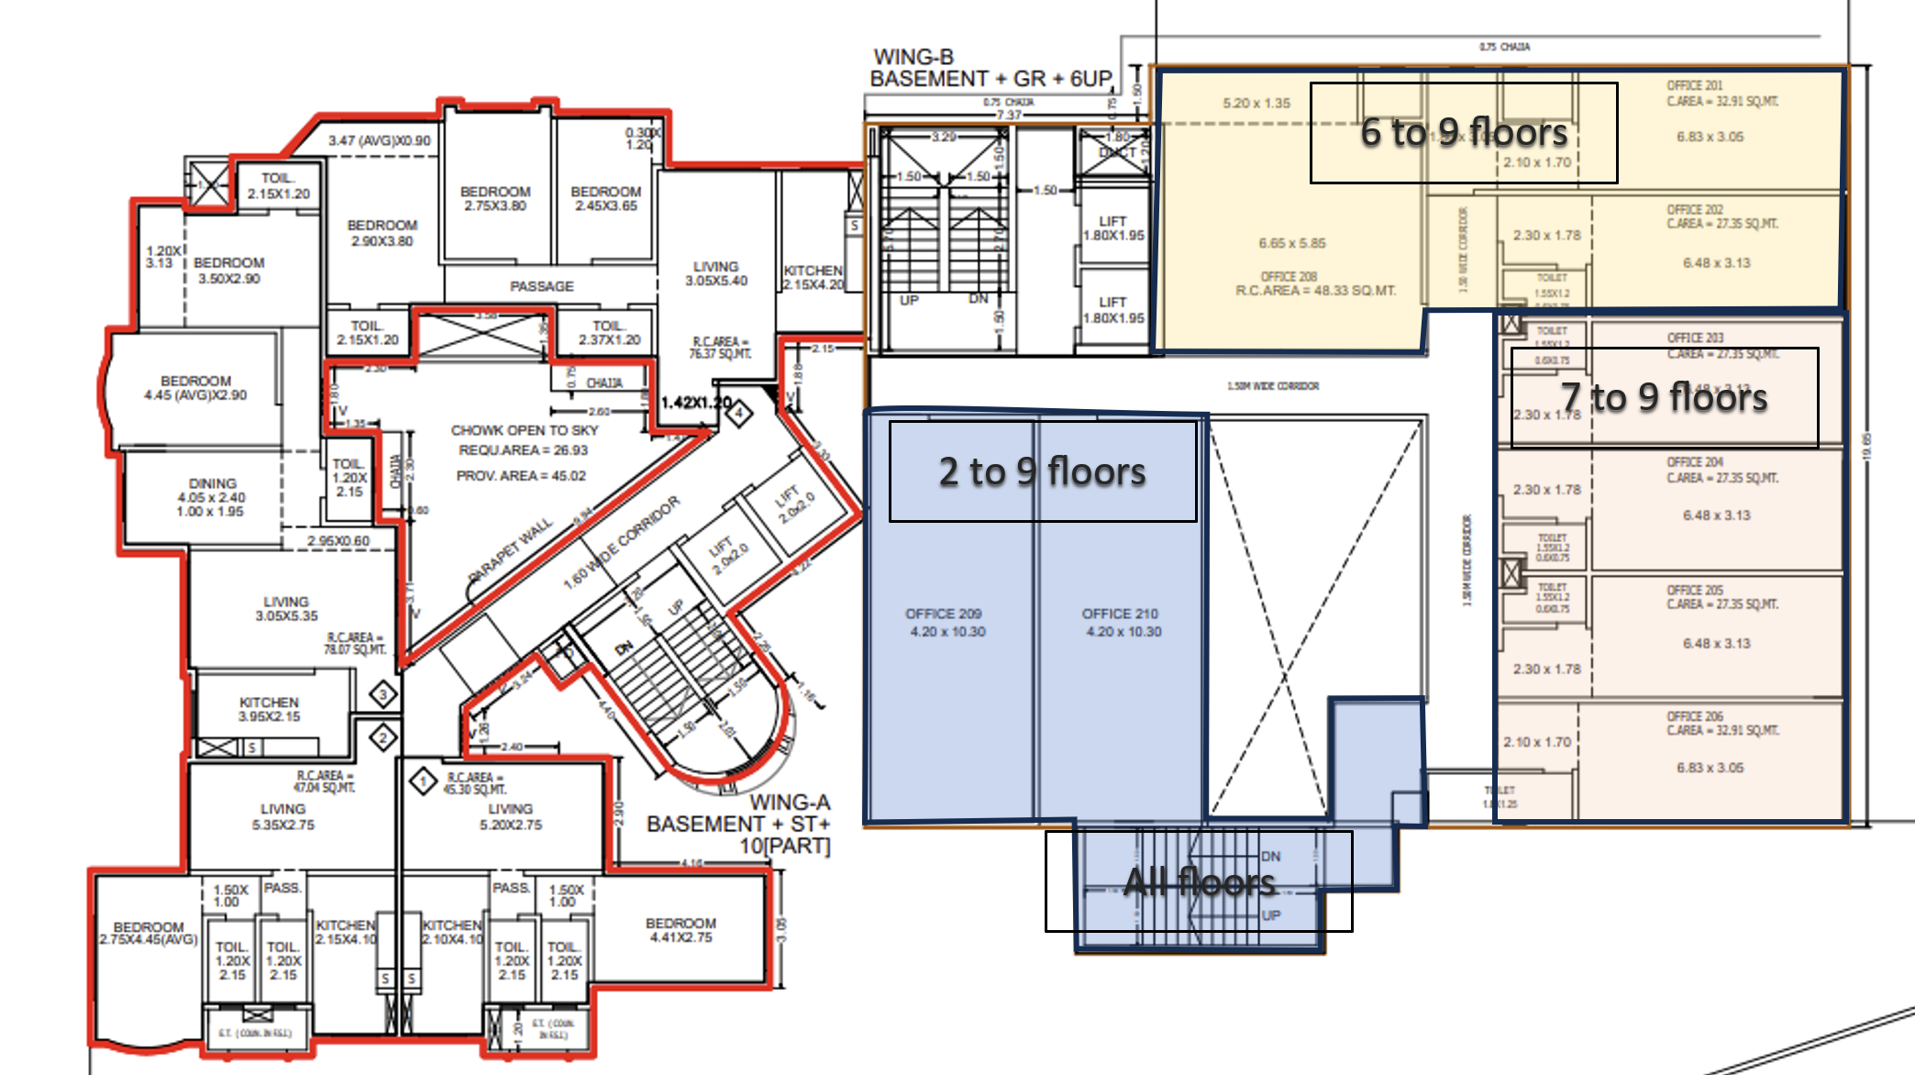

ACTUAL SITE PHOTOGRAPHS
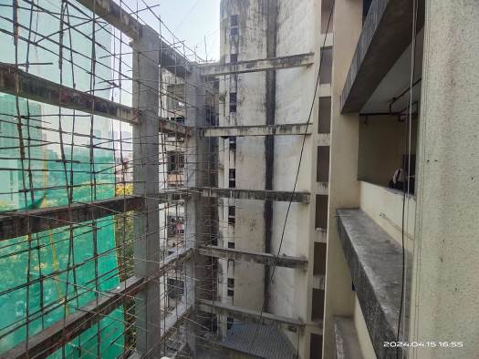
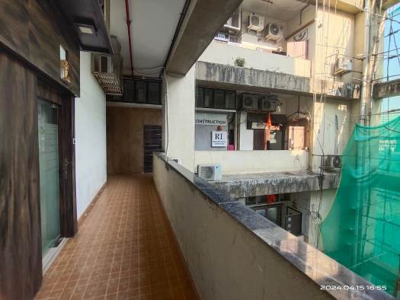
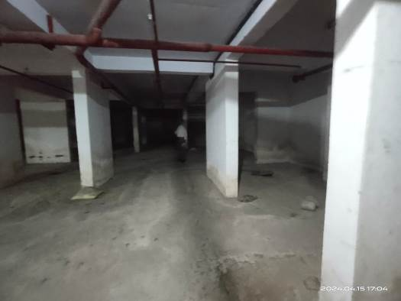
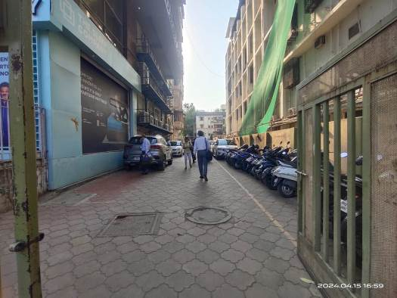
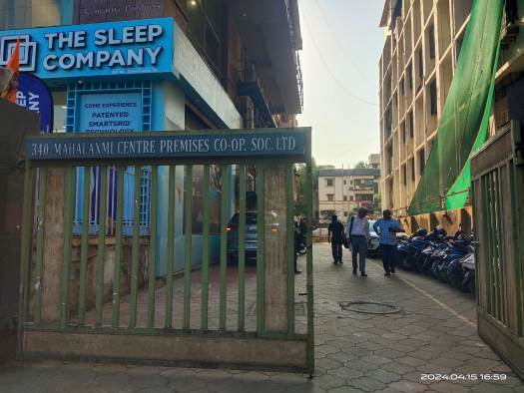
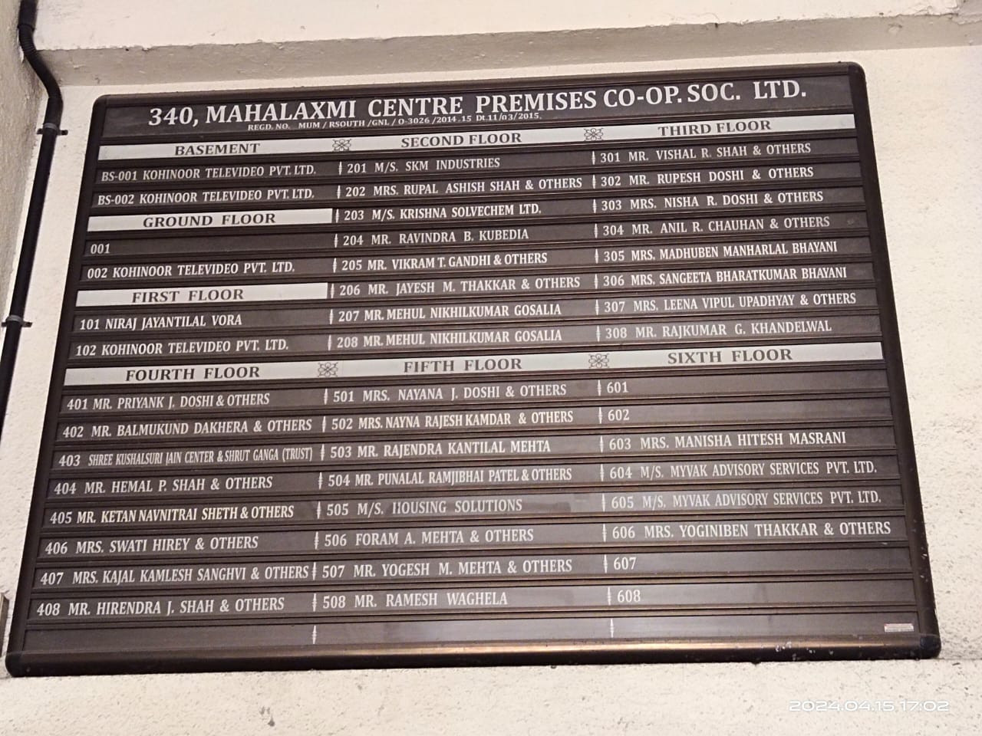

Actual Site Photographs
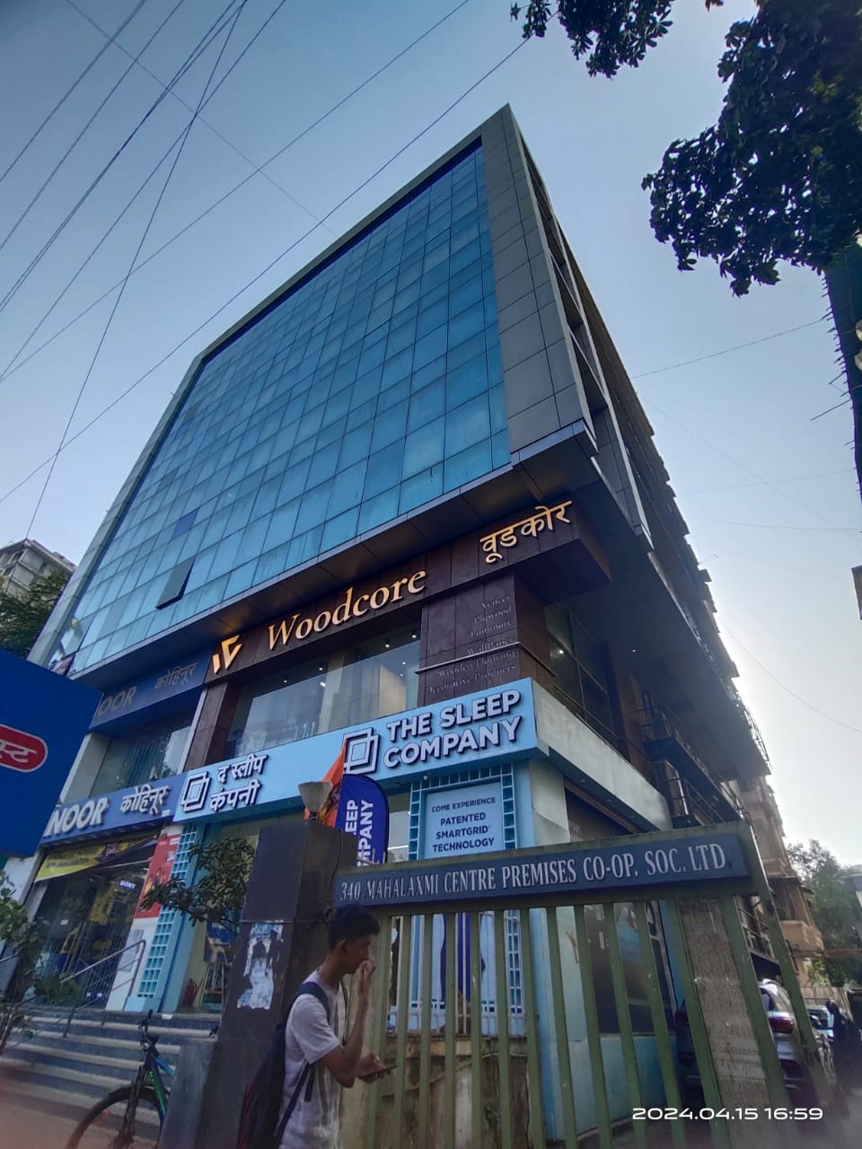
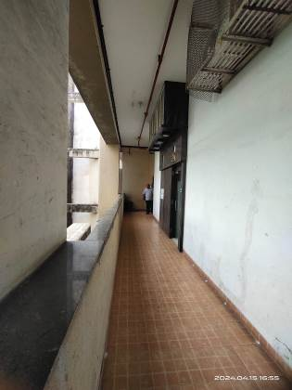
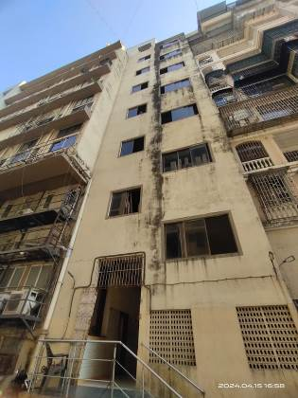
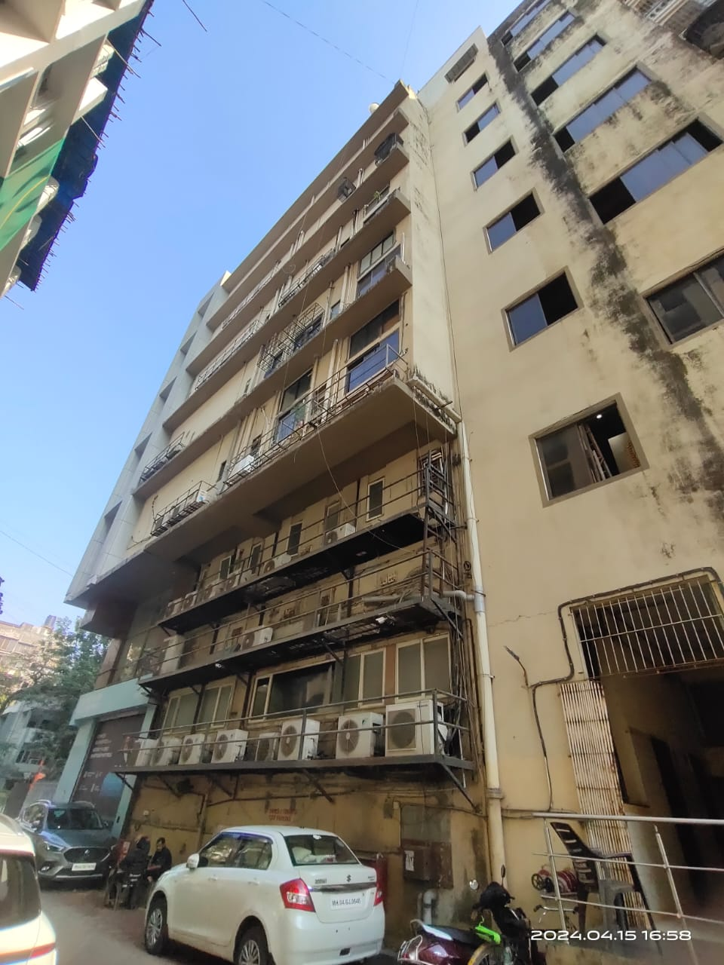
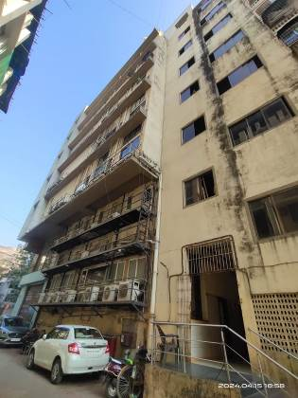
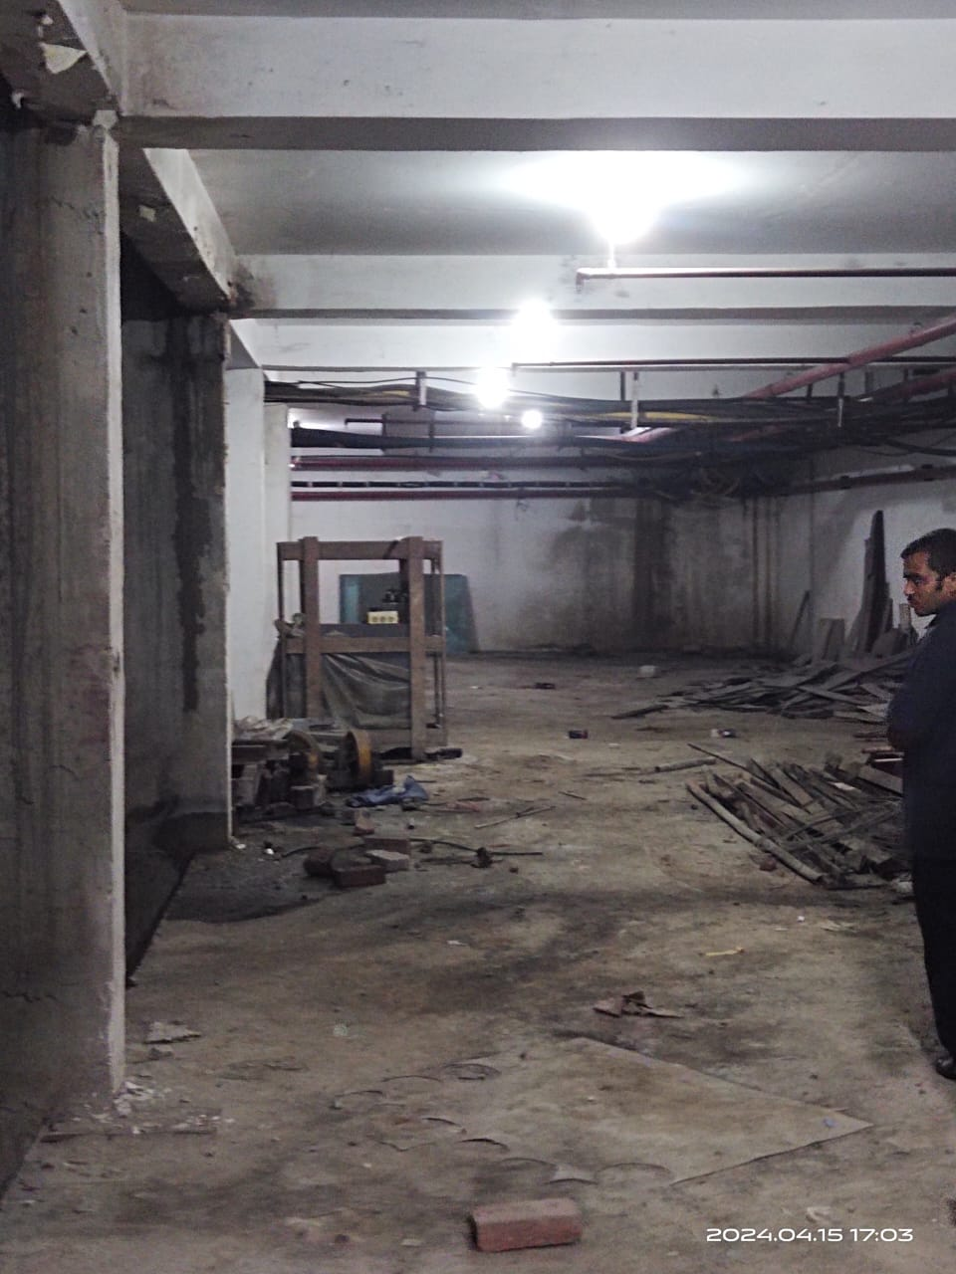

ROUTE MAP OF THE PROPERTY
Site u/r
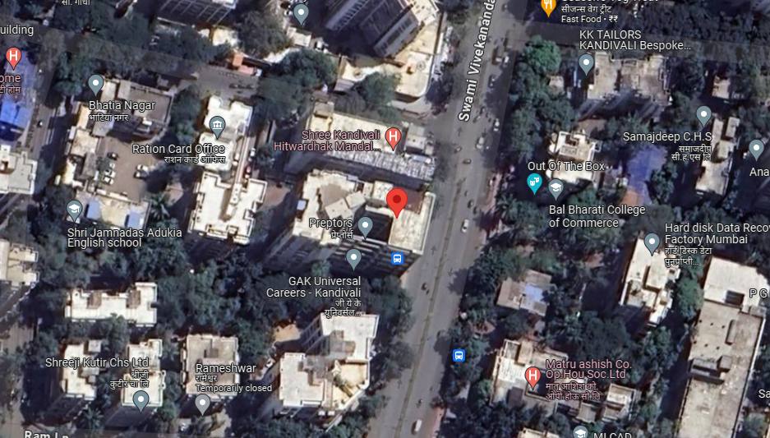

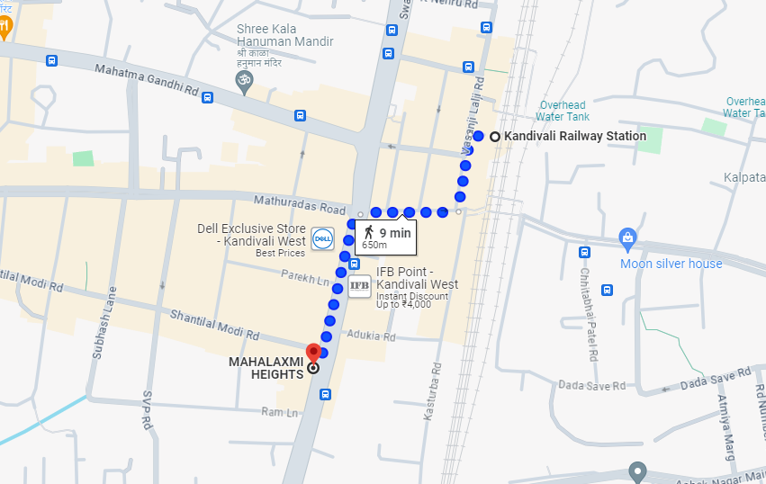

Longitude Latitude: 19°12'01.8"N 72°50'55.2"E
Note: The Blue line shows the route to site from nearest Railway station (Kandivali – 650 Meter)

READY RECKONER RATE

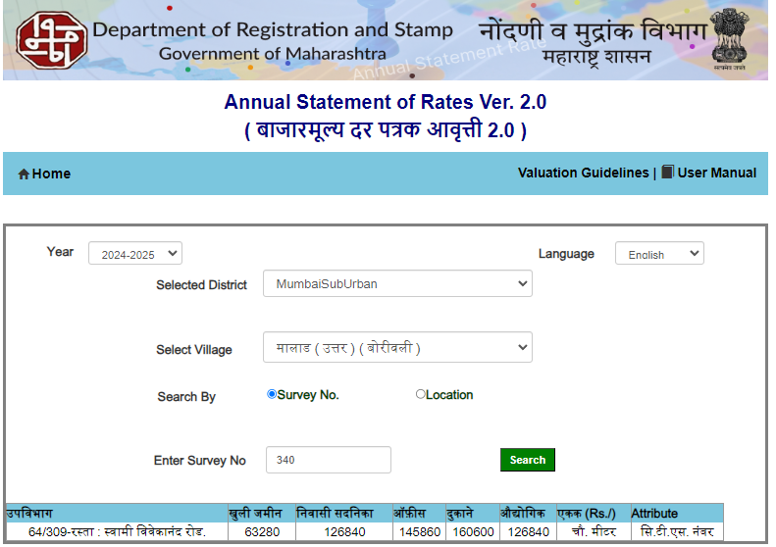

JUSTIFICATION FOR PRICE /RATE

The Market Value of the property is based on facts of markets discovered by us during our enquiries, however the government rate value in this case is less than the market value arrived by us. We are of the opinion that the value arrive by us will prove to be correct if an Auction of the subject property is carried out. As far as Market Value in Index II / Property Documents is concerned, it is not possible to comment on same, may be government rates are fixed by sampling during same point of time in part and whereas, Market values change every month.
In most of the cases the actual deal amount or Transaction value is not reflected in Index II / Property Documents because of various Market practices. As Valuer, we always try to give a value which is correct reflection of actual transaction value irrespective of any factors in market.
We Hope this will satisfy your requirements.

Sr. | Particulars | Valuer comment
 | Background information of the asset being valued; | Property is owned by M/s. Reliable Developer’s Pvt. Ltd.
 | Purpose of valuation and appointing authority | As per the request from client to assess Fair market value of the property for determination of land FSI value.
 | Identity of the Valuer and any other experts involved in the valuation; | Manoj B. Chalikwar – Regd. Valuer  Umang Patel – Regd. Valuer  Prayush P. Parekh – Senior Valuation Engineer  Saiprasad Patil – Valuation Engineer
 | Disclosure of Valuer interest or conflict, if any; | We have no interest, either direct or indirect, in the property valued. Further to state that we do not have relation or any connection with property owner / applicant directly or indirectly. Further to state that we are an independent Valuer and in no way related to property owner / applicant
 | Date of appointment, valuation date and date of report; | Date of Appointment – 15.04.2024  Valuation Date – 19.04.2024  Date of Report – 19.04.2024
 | Inspections and/or investigations undertaken; | Physical Inspection done on date 15.04.2024
 | Nature and sources of the information used or relied upon; | - Market Survey at the time of site visit  - Ready Reckoner rates / Circle rates  - Enquiries with Real estate consultants  - Existing data of Valuation assignments carried out by us
 | Procedures adopted in carrying out the valuation and valuation standards followed; | Residual Sale Method
 | Restrictions on use of the report, if any; | This valuation is for the use of the party to whom it is addressed and for no other purpose. No responsibility is accepted to any third party who may use or rely on the whole or any part of this valuation. The valuer has no pecuniary interest that would conflict with the proper valuation of the property.
 | Major factors that were taken into account during the valuation; | Current market conditions, demand and supply position, industrial land size, location, sustained demand for industrial land, all round development of commercial and industrial application in the locality etc.
 | Caveats, limitations and disclaimers to the extent they explain or elucidate the limitations faced by valuer, which shall not be for the purpose of limiting his responsibility for the valuation report. | Attached

ASSUMPTIONS, DISCLAIMERS, LIMITATIONS & QUALIFICATIONS

Value Subject to Change
The subject appraisal exercise is based on prevailing market dynamics as on 19th April 2024 and does not take into account any unforeseeable developments which could impact the same in the future.

Our Investigations
We are not engaged to carry out all possible investigations in relation to the subject property. Where in our report we identify certain limitations to our investigations, this is to enable the reliant party to instruct further investigations where considered appropriate or where we recommend as necessary prior to reliance. Vastukala Consultants India Pvt. Ltd. (VCIPL) is not liable for any loss occasioned by a decision not to conduct further investigations

Assumptions
Assumptions are a necessary part of undertaking valuations. VCIPL adopts assumptions for the purpose of providing valuation advise because some matters are not capable of accurate calculations or fall outside the scope of our expertise, or out instructions. The reliant party accepts that the valuation contains certain specific assumptions and acknowledge and accept the risk of that if any of the assumptions adopted in the valuation are incorrect, then this may have an effect on the valuation.

Information Supplied by Others
The appraisal is based on the information provided by the client. The same has been assumed to be correct and has been used for appraisal exercise. Where it is stated in the report that another party has supplied information to VCIPL, this information is believed to be reliable but VCIPL can accept no responsibility if this should prove not to be so.

Future Matters
To the extent that the valuation includes any statement as to a future matter, that statement is provided as an estimate and/or opinion based on the information known to VCIPL at the date of this document. VCIPL does not warrant that such statements are accurate or correct.

Map and Plans
Any sketch, plan or map in this report is included to assist the reader while visualizing the property and assume no responsibility in connection with such matters.

Site Details
Based on inputs received from Client's representative and site visit conducted, we understand that the subject property is currently a contiguous and non-agricultural land parcel FSI admeasuring 1451.29 Sq. M. The property is owned by M/s. Reliable Developer’s Pvt. Ltd. At present, the property is Owner Occupied. Further, VCIPL has assumed that the subject property is free from any encroachment and is available as on the date of the appraisal.

Property Title
Based on our discussion with the Client, we understand that the property is owned by M/s. Reliable Developer’s Pvt. Ltd. For the purpose of this appraisal exercise, we have assumed that the subject property has a clear title and is free from any encumbrances, disputes and claims. VCIPL has made no further enquiries with the relevant local authorities in this regard and does not certify the property as having a clear and marketable title. Further, no legal advice regarding the title and ownership of the subject property has been obtained for the purpose of this appraisal exercise. It has been assumed that the title deeds are clear and marketable.

Environmental Conditions
We have assumed that the subject property is not contaminated and is not adversely affected by any existing or proposed environmental law and any processes which are carried out on the property are regulated by environmental legislation and are properly licensed by the appropriate authorities.

Town Planning
The permissible land use, zoning, achievable FSI, area statement adopted for purpose of this valuation is based on the information provided by the Client's representative and the same has been adopted for this valuation purpose. VCIPL has assumed the same to be correct and permissible. VCIPL has not validated the same from any authority.

Area
Based on the documents, we understand that the subject property is contiguous and non-agricultural land parcel FSI admeasuring 1451.29 Sq. M.

Condition & Repair
In the absence of any information to the contrary, we have assumed that there are no abnormal ground conditions, nor archaeological remains present which might adversely affect the current or future occupation, development or value of the property. The property is free from rat, infestation, structural or latent defect. No currently known deleterious or hazardous materials or suspect techniques will be used in the construction of or subsequent alteration or additions to the property and comments made in the property details do not purport to express an opinion about, or advise upon, the condition of uninspected parts and should not be taken as making an implied representation or statement about such parts

Valuation Methodology
For the purpose of this valuation exercise, the valuation methodology used is Direct Comparison Approach Method and proposed Highest and Best Use model is used for analysing development potential.
The Direct Comparison Approach involves a comparison of the property being valued to similar properties that have actually been sold in arms - length transactions or are offered for sale. This approach demonstrates what buyers have historically been willing to pay (and sellers willing to accept) for similar properties in an open and competitive market and is particularly useful in estimating the value of the land and properties that are typically traded on a unit basis.
In case of inadequate recent transaction activity in the subject micro-market, the appraiser would collate details of older transactions. Subsequently, the appraiser would analyse rental / capital value trends in the subject micro-market in order to calculate the percentage increase / decrease in values since the date of the identified transactions. This percentage would then be adopted to project the current value of the same.
Where reliance has been placed upon external sources of information in applying the valuation methodologies, unless otherwise specifically instructed by Client and/or stated in the valuation, VCIPL has not independently verified that information and VCIPL does not advise nor accept it as reliable. The person or entity to whom the report is addressed acknowledges and accepts the risk that if any of the unverified information in the valuation is incorrect, then this may have an effect on the valuation.

Not a Structural Survey
We state that this is a valuation report and not a structural survey

Other
All measurements, areas and ages quoted in our report are approximate

Legal
We have not made any allowances with respect to any existing or proposed local legislation relating to taxation on realization of the sale value of the subject property. VCIPL is not required to give testimony or to appear in court by reason of this appraisal report, with reference to the property in question, unless arrangement has been made thereof. Further, no legal advice on any aspects has been obtained for the purpose of this appraisal exercise

Property specific assumptions
Based on inputs received from the client and site visit conducted, we understand that the subject property is currently tenant occupied, contiguous and non-agricultural land parcel FSI admeasuring 1451.29 Sq. M.

ASSUMPTIONS, CAVEATS, LIMITATION AND DISCLAIMERS

- We assume no responsibility for matters of legal nature affecting the property appraised or the title thereto, nor do we render our opinion as to the title, which is assumed to be good and marketable.
- The property is valued as though under responsible ownership.
- It is assumed that the property is free of liens and encumbrances.
- It is assumed that there are no hidden or unapparent conditions of the subsoil or structure that would render it more or less valuable. No responsibility is assumed for such conditions or for engineering that might be required to discover such factors.
- There is no direct/ indirect interest in the property valued.
- The rates for valuation of the property are in accordance with the Govt. approved rates and prevailing market rates

DEFINITION OF VALUE FOR THIS SPECIFIC PURPOSE

This exercise is to assess Fair Market Value of the property under reference as on 19th April 2024.

The term Fair Market Value is defined as

“The most probable price, as of a specified date, in cash, terms equivalent to cash, or in other precisely revealed terms for which the specified property rights would sell after reasonable exposure in a competitive market under all conditions requisite to a fair sale, with the buyer and seller each acting prudently knowledgeably and for self interest assuming that neither is under undue duress”.

Fundamental assumptions and conditions presumed in this definition are:

1. Buyer and seller are motivated by self-interest.
2. Buyer and seller are well informed and are acting prudently.
3. The property is exposed for a reasonable time on the open market.
4. Payment is made in cash or equivalent or in specified financing terms.
DECLARATION OF PROFESSIONAL FEES CHARGED

We hereby declare that, our professional fees are not contingent upon the valuation findings. However, if the statute AND/OR clients demands that, the fees should be charged on the percentage of assessed value then, with the full knowledge of the AND/OR end user, it is being charged accordingly.

Manoj B. Chalikwar
Registered Valuer
Chartered Engineer (India)
Reg. No. IBBI/RV/07/2018/10366

