**SITE VISIT DETAILS OF - ANGELIQUE INTERNATIONAL LIMITED**

Premises Details : Entire 12th floor, the building Know as “**The Ruby**”,

Final Plot No. 29, C.S.No. 231 & 1/231

Mahim Division, Near Bank of Baroda,

Dadar (West) Mumbai – 400 028

Building Details : 3 Basement + Ground floor + 1 Podium + Lobby +

Mezzanine Floor + 17th upper floors

Year of construction : 2011 (as per Occupancy certificate)

Person Met at Site : Mr.Sanket (Admin)

**Boundaries of the building**

East : Senapati Bapat Marg

West : The Ruby Mills Ltd

North : Apple Plaza

South : Prabhat Chawl

Nearest Railway station : 750 M away from Dadar Western Railway station

Land Mark : Near Bank of Baroda

Flooring : Vitrified

Nearest bus Stop : Ruby Mills bus stop

Nearest Hospital : Dhanwantari Hospital & Research Centre.

Name of Society Name Board : Not available

Name on the door : Not available

Carpet area as per

Measurement : Internal measurement not allowed

Agreement Carpet Area : 14305.00 sq.ft

Site Engineer : Mr.Suraj Zore

**Coordinate : 19°01'27.3"N 72°50'41.7"E**

**Remarks:**

1. The said property internal measurement not allowed.

**Fair Market Value on Built Up Area** : **Rs.35,000/- to 40,000/-**

**Photographs**

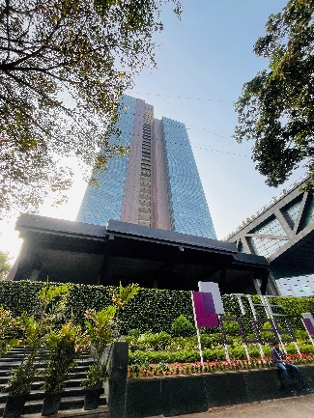 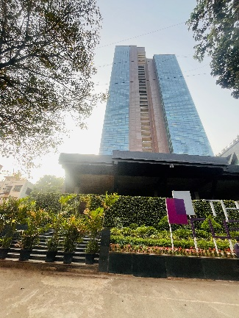 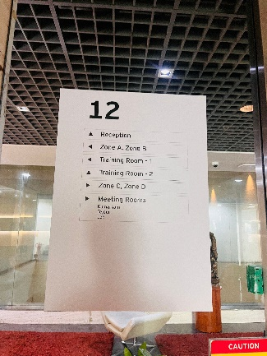 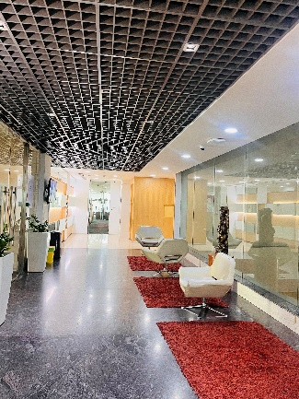

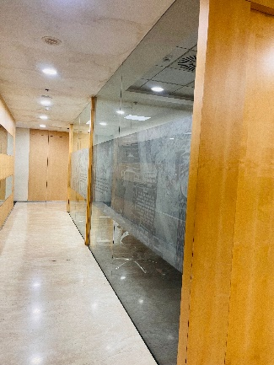 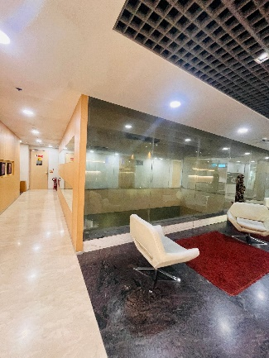 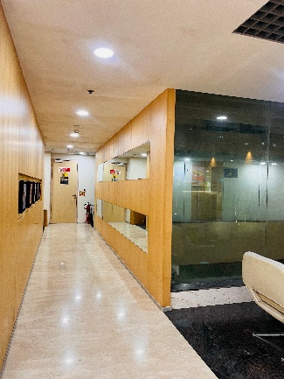 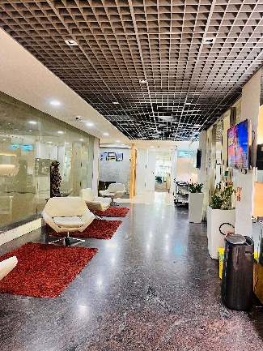

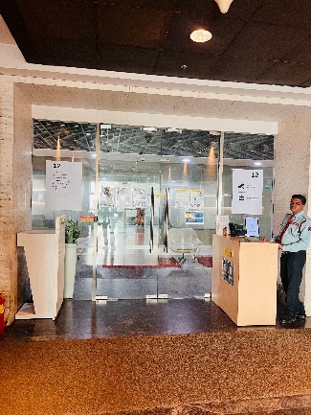 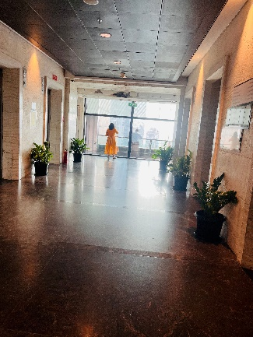 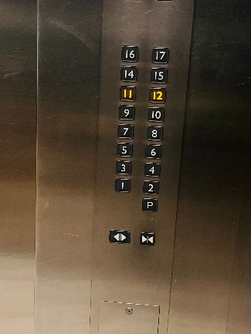

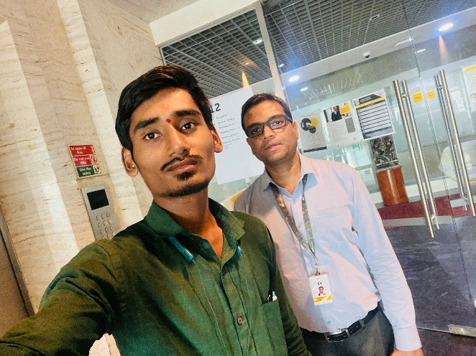

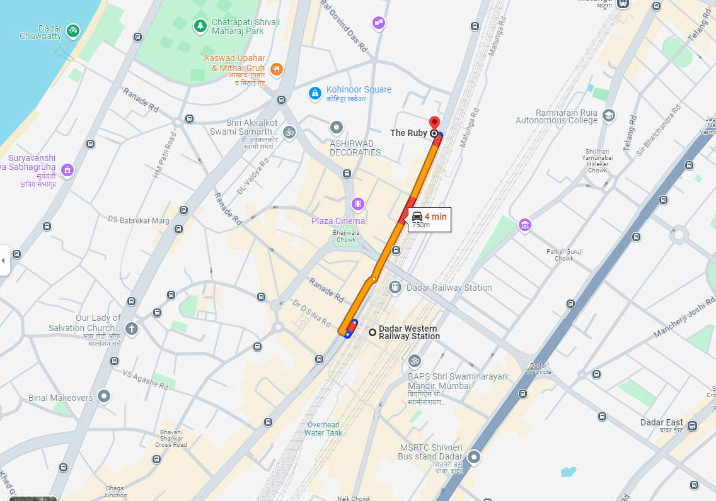**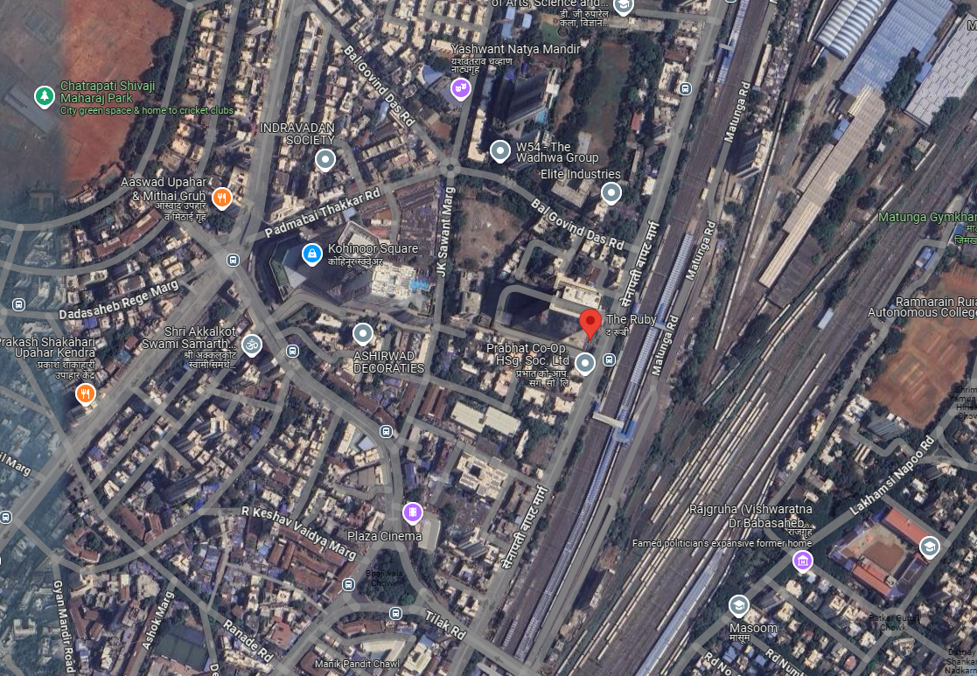Location Map**

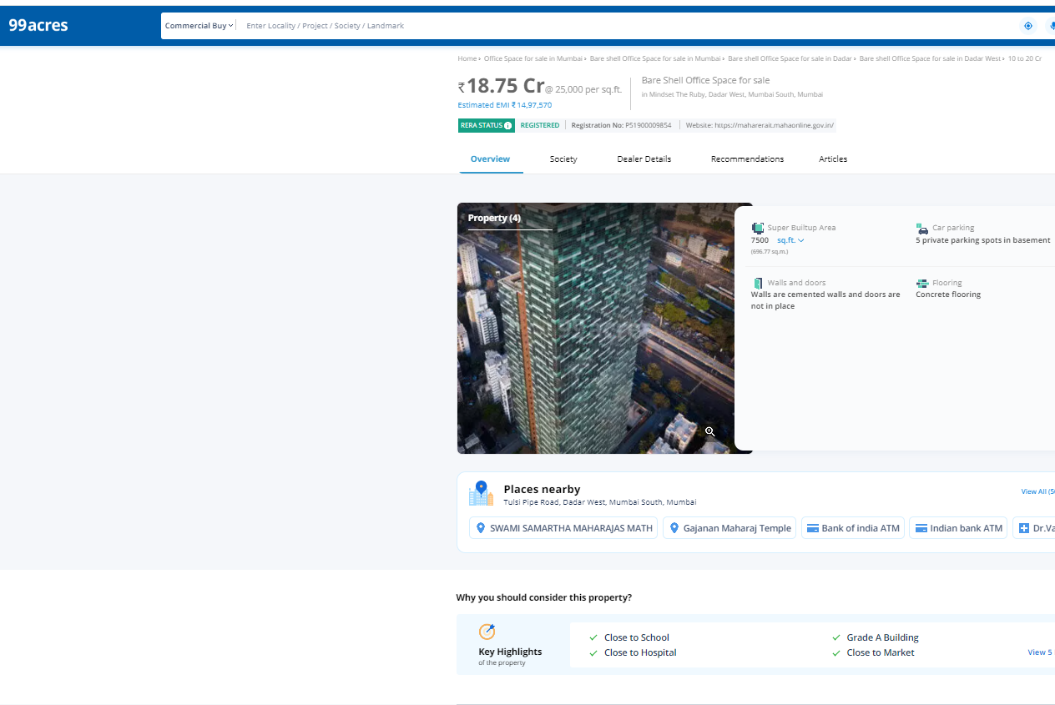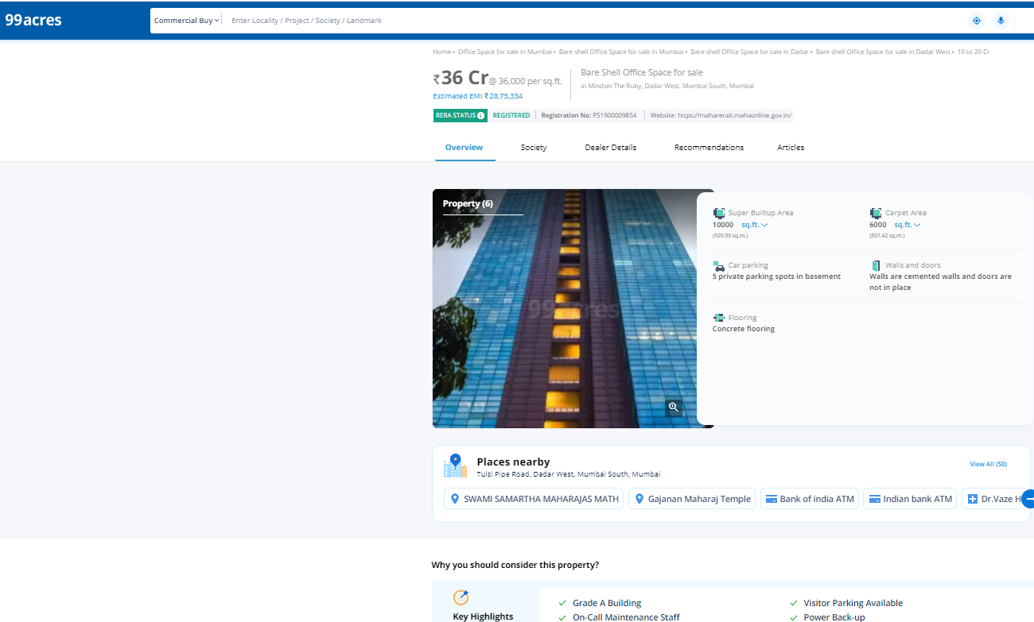**Price Indicators**

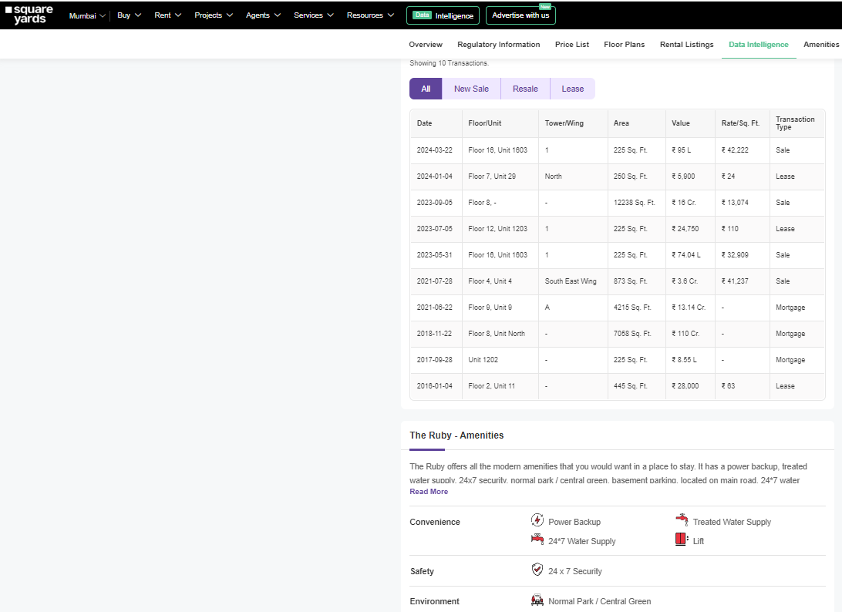**Price Indicators**

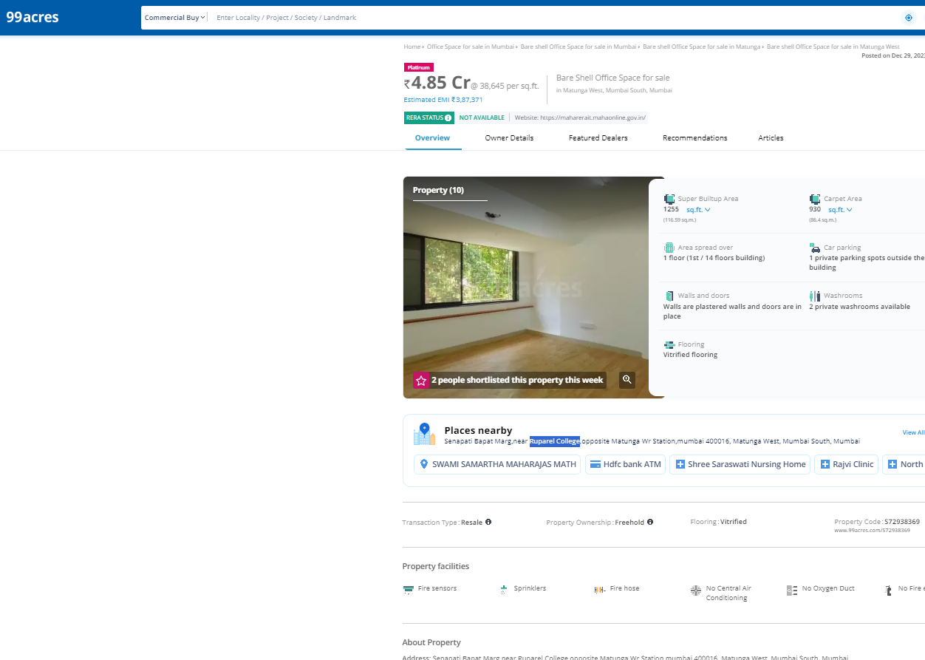

**Sale Instance**

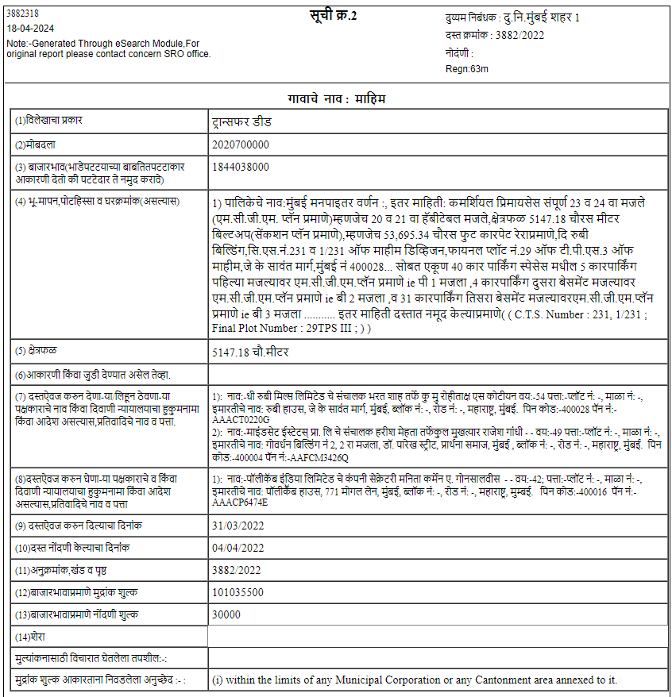

**Sale Instance**

