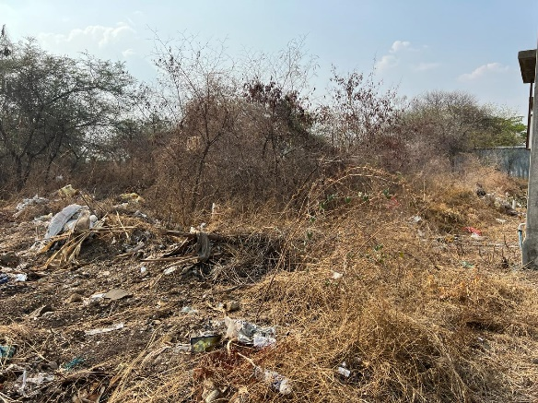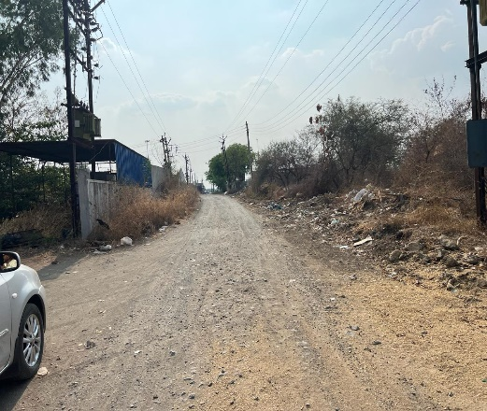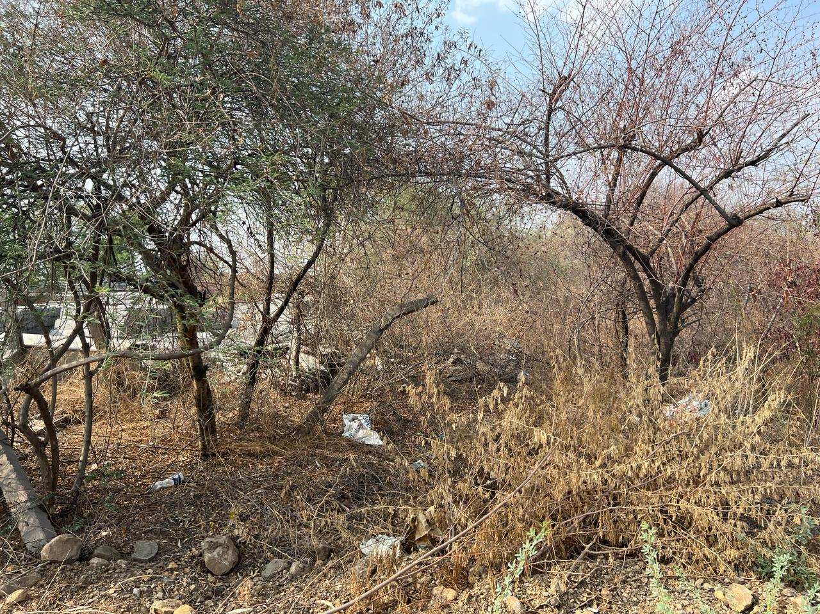

Report Prepared for : CA Nethi Mallikarjuna Setty - Resolution Professional

CP(IB) No. : 20/KOB/2023.

Report Prepared By : Manoj B. Chalikwar

Report Prepared By Manoj Baburao Chalikwar Umang Ashwin Patel Prashant Jain

Report Prepared By Manoj Baburao Chalikwar Umang Ashwin Patel Prashant Jain

Assets Valuation of Kasargod Power Corporation Limited (008267/ 30506 - 10/10-68-AM)

Table of Contents

1. EXECUTIVE SUMMARY OF VALUATION 3

1.1. Assets to be Valued: 3

1.2. Purpose of valuation: 3

1.3. Date of Site inspection / site Visit: 3

1.4. Valuation Date and Report 4

1.5. Valuation of Assets 4

2. VALUATION REPORT IN RESPECT OF IMMOVABLE PROPERTY- (OPEN LAND – TAMALWADI) 5

2.1. Valuation Report 5

2.2. Actual site photographs 10

2.3. Route Map of the property 11

2.4. Ready Reckoner Rate 12

2.5. Online 7/12 Extract 13

2.6. Price Indicator 14

2.7. Sale Instance 15

2.8. Sale Instance 16

3. DEFINITION OF VALUE FOR THIS SPECIFIC PURPASE 17

4. UNDER LYING ASSUMPTIONS 17

5. DECLARATION OF PROFESSIONAL FEES CHARGED 18

6. STATEMENT OF LIMITING CONDITIONS 18

# EXECUTIVE SUMMARY OF VALUATION

## Assets to be Valued:

Kasargod Power Corporation Limited is a public company, incorporated on 01 September 1994. It’s CIN is U40102KL1994PLC008127 and Registered office address is 332, Bare Village, Mylatti Post, Kasargod – 671123, State Kerala, India. Hereafter Kasargod Power Corporation Limited shall be referred as **“KPCL”.**

KPCL is involved into Production, Collection and Distribution of electricity.

KPCL was admitted under CIRP by NCLT, Kochi Bench on 19th January 2024 as per order C.P. No. 20/KOB/2023.

The assets of the company is as follows:

|  |  |
| --- | --- |
| Unit Details | Type of Property |
| Open Land bearing Plot No. 18, Survey No. 219, Village Tamalwadi, Taluka Tuljapur, District Osmanabad, State – Maharashtra, Country -India. | Open Land |

## Purpose of valuation:

We have been appointed by CA Nethi Mallikarjuna Setty IRP or Acting RP of KPCL, to carry out valuation of KPCL as Corporate Insolvency Resolution Process for assets category as follows:

|  |  |
| --- | --- |
| Type Of Assets | Land and Building |
| Name of the Valuer | Manoj Baburao Chalikwar |
| Registration number of the Valuer | IBBI/RV/07/2018/10366 |
| E-mail Id | [manoj@vastukala.co.in](mailto:manoj@vastukala.co.in) |
| Address | Vastukala Consultants (I) Pvt. Ltd., B1-001, U/B Floor, Boomerang, Chandivali Farm Road, Powai, Andheri (East), Mumbai – 400 072. |

As per regulation 27 of Insolvency and Bankruptcy Board of India (Insolvency Resolution Process for Corporate Persons) Regulations, 2016.

## Date of Site inspection / site Visit:

In view to have first-hand information regarding the assets situated at Plot No. 18, Survey No. 219, Village Tamalwadi, Taluka Tuljapur, District Osmanabad, State – Maharashtra, Country -India of **KPCL**, Mr. Manoj Baburao Chalikwar visited the facilities of **KPCL,** in presence of representatives of company as per given below schedule.

|  |  |  |  |
| --- | --- | --- | --- |
| Unit Details | Type of Property | Date of Visit | Contact Person |
| Open Land bearing Plot No. 18, Survey No. 219, Village Tamalwadi, Taluka Tuljapur, District Osmanabad, State – Maharashtra, Country -India. | Open Land | 16.04.2024 | Mr. Vidhyadhar Gotipamul  (Owner’s Representative) |

## Valuation Date and Report

|  |  |  |  |  |
| --- | --- | --- | --- | --- |
| Unit Details | Appointment Date | Date of Visit | Date of Valuation | Date of Report |
| Open Land bearing Plot No. 18, Survey No. 219, Village Tamalwadi, Taluka Tuljapur, District Osmanabad, State – Maharashtra, Country -India. | 16.04.2024 | 16.04.2024 | 19.01.2024 | 23.04.2024 |

## Valuation of Assets

|  |  |  |  |
| --- | --- | --- | --- |
| Unit Details | Type of Property | Fair Value Amount in ` | Liquidation Value Amount in ` |
| Open Land bearing Plot No. 18, Survey No. 219, Village Tamalwadi, Taluka Tuljapur, District Osmanabad, State – Maharashtra, Country -India. | Open Land | 23,75,000.00 | 16,62,500.00 |
|  | **Total** | 23,75,000.00 | 16,62,500.00 |

|  |
| --- |
| Manoj B. Chalikwar |
| Registered Valuer  Chartered Engineer (India)  Reg. No. IBBI/RV/07/2018/10366 |

# VALUATION REPORT IN RESPECT OF IMMOVABLE PROPERTY- (OPEN LAND – TAMALWADI)

## Valuation Report

|  |  |  |  |  |
| --- | --- | --- | --- | --- |
|  | Date of Inspection | : | 16.04.2024 | |
|  | Purpose of valuation | : | For assessing Fair Value & Liquidation value for Corporate Insolvency Resolution Process (CIRP) under Insolvency & Bankruptcy Code, 2016 (IBC 2016) | |
|  | Name and address of the Valuer. | : | **Manoj B. Chalikwar**  B1-001, U/B Floor, Boomerang, Chandivali Farm Road, Powai, Andheri (East), Mumbai – 400 072. | |
|  | List Of Documents Handed Over to the Valuer | : | 1. *Copy of Deed of Sale dated 10.10.2000* 2. *Copy of Fresh Certificate of Incorporation Consequent on Change of name from Kasargod Power Corporation Private Limited to Kasargod Power Corporation Limited, Issue Date - 09.10.2001* 3. *Final Work Order dated 06.04.2024 issued by Nethi Mallikarjuna Setty* 4. *Copy of 7/12 Extract.* | |
|  | Details of enquiries made/ visited to govt. Offices for arriving fair market value. | : | Market analysis and as per sub-registrar value. | |
|  | Factors for determining its market value. | : | Location, development of surrounding area, facilities provided and its prevailing market rate. | |
|  | Any Critical Aspects Associated With Property | : | No | |
|  | **Property Details:** | : |  | |
|  | Name(s) and Postal address of the owner(s). | : | **M/s. Kasargod Power Corporation Limited** | |
|  |  | : | Open Land bearing Plot No. 18, Survey No. 219, Village Tamalwadi, Taluka Tuljapur, District Osmanabad, State – Maharashtra, Country -India. | |
|  | If the property is under joint ownership/ co-ownership share of each such owner/ are the share is undivided. | : | Sole Ownership | |
|  | Brief description of the property. | : | Open N.A Land | |
|  | The property is located in a developing area and well connected by train and road. The immovable property comprises of Freehold N.A. open land. It is located at about 24.5 km. travelling distance from Solapur Railway Station.  As per Deed of Sale, the dimension of the Plot No. 18 is as below -  Length: - North – South towards East side 39 Mtrs., towards West side 38 Mtrs., and Breadth: - East West 25 Mtrs.  **As per 7/12 Extract, the area of land is 950.00 Sq. M. which is considered for valuation.**  As per site inspection, The Land is not having compound wall. It is partly demarcated by Wire fencing. | | | |
|  | Location of the property.  (C.T.S. No., Survey No., Hissa No., Plot No., etc.). | : | Open Land bearing Plot No. 18, Survey No. 219, Village Tamalwadi, Taluka Tuljapur, District Osmanabad, State – Maharashtra, Country -India. | |
|  | **Boundaries of the property** | : | **Actual Site** | **As per Agreement** |
| North | : | Other Industrial Structures | Survey No. 217 and 218 |
| South | : | 9.00 M. Access Road | Road and remaining part of the said land |
| East | : | Industrial Structure of Vilas Patange  (Vikrant Plastic) | Plot No. 17 |
| West | : | Open Plot | Plot No. 19 |
|  | Route map | : | Enclosed | |
|  | Any specific identification marks | : | Near Tamalwadi Toll Plaza | |
|  | Whether covered under Corporation/ Panchayat/ Municipality. | : | Village Tamalwadi, Taluka Tuljapur, District Osmanabad. | |
|  | Whether covered under any land ceiling of State/ Central Government. | : | No | |
|  | Is the land freehold/ leasehold. | : | Freehold land | |
|  | Are there any restrictive covenants in regard to use of Land? If so attach a copy of the covenant. | : | Industrial | |
|  | Type of the property- Whether | : |  | |
|  | 1) Agriculture | : | N.A. | |
|  | 2) Industrial | : | Yes | |
|  | 3) Commercial | : | N.A. | |
|  | 4) Institutional | : | N.A. | |
|  | 5) Government | : | N.A. | |
|  | 6) Non – Government | : | N.A. | |
|  | 7) Other (Specify) | : | N.A. | |
|  | In case of Agricultural land |  |  | |
|  | 1) Any conversion to House site is obtained | : | N.A. | |
|  | 2)Whether the land is dry or wet. | : | N.A. | |
|  | 3)Availability of irrigation facilities | : | N.A. | |
|  | 4)Type of crops grown | : | N.A. | |
|  | 5)Annual yield or income. | : | N.A. | |
|  | Year of acquisition/ purchase. | : | 10.10.2000 | |
|  | Whether the property is occupied by owner or tenant. If occupied by tenant since how long he is staying and the amount of rent being paid. | : | N.A., as the property is open land | |
|  | Classification of the site. | : |  | |
|  | a. Population group. | : | Modern | |
|  | b. High/ Middle/ Poor class | : | Middle class | |
|  | c. Residential/ nonresidential. | : | Industrial | |
|  | d. Development of surrounding area. | : | Developing | |
|  | e. Possibility of any threat to the property. (Floods, calamities etc.). | : | No | |
|  | Proximity of civic amenities.  (Like school, hospital, bus stop, market etc.). | : | All Available near by | |
|  | Level of the land (Plain, rock etc.) | : | Plain | |
|  | Terrain of the Land. | : | Levelled | |
|  | Shape of the land (Square/ rectangle etc.). | : | Irregular | |
|  | Type of use to which it can be put (for construction of house, factory etc.). | : | Industrial Purpose | |
|  | Any usage restrictions on the property. | : | N.A | |
|  | Whether the plot is under town planning approved layout? | : | Information not available | |
|  | Whether the building is intermittent or corner? | : | Intermittent | |
|  | Whether any road facility is available? | : | Yes | |
|  | Type of road available (B.T. / Cement Road etc.). | : | B.T. Road | |
|  | Front Width of the Road? | : | 9.00 M. wide road | |
|  | Source of water & water potentiality. | : | Presently not available at site | |
|  | Type of Sewerage System. | : | N.A. | |
|  | Availability of power supply. | : | Yes | |
|  | Advantages of the site. | : | 1. Located in developing area 2. Near National Highway. | |
|  | Disadvantages of the site. | : | No | |
|  | Give instances of sales of immovable property in the locality on a separate sheet, indicating the name & address of the property, registration No. sale price and area of land sold. | : | As per Sub-Registrar of Assurance records | |
|  | **Valuation of the property:** | | | |
|  | Dimensions of the plot | : | As per Brief Description | |
|  | Total area of the plot | : | 950.00 Sq. M. | |
|  | Prevailing market rate of land | : | ` 2,000/- to ` 3,000/- per Sq. M. | |
|  | Guideline Rate obtained from the Stamp Duty Ready Reckoner | : | ` 1,470.00 per Sq. M. for Land | |
|  | Assessed/ adopted rate of valuation. | : | ` 2,500 per Sq. M. | |
|  | Estimated value of the land. | : | **` 23,75,000.00** | |
|  | **a. Technical details of the Plot:** | | | |
|  | Type of Plot (Residential/ Commercial/ Industrial). | : | Open N.A. Plot | |
|  | Year of construction. | : | N.A. | |
|  | Future life of the property. | : | N.A. | |
|  | No. of floors and height of each floor including basement. | : | N.A. | |
|  | Plinth area of each floor | : | N.A. | |
|  | **Type of construction.**  (Load bearing/ R.C.C./ Steel framed). |  | N.A., as the property is open land | |
|  | **Condition of the building.** | : |  | |
|  | External (excellent/ good/ normal/ poor). | : | N.A., as the property is open land | |
|  | Internal (excellent/ good/ normal/ poor). | : | N.A., as the property is open land | |
|  | Remarks | : | The Land is not having compound wall. It is partly demarcated by Wire fencing. | |

|  |  |  |  |
| --- | --- | --- | --- |
|  | **b. Specifications of Construction** | **:** |  |
|  | Foundation. | : | N.A. |
|  | Basement. | : | N.A. |
|  | Superstructure. | : | N.A. |
|  | Joinery/ Doors & Windows. | : | N.A. |
|  | RCC work. | : | N.A. |
|  | Plastering. | : | N.A. |
|  | Flooring, Skirting. | : | N.A. |
|  | Kitchen Pantry Platform | : | N.A. |
|  | Whether any weather proof course is provided. | : | N.A. |
|  | Drainage. | : | N.A. |
|  | Compound wall (Height, length and type of construction). | : | N.A. |
|  | Electric installation (Type of wire, Class of fittings) | : | N.A. |
|  | Plumbing installation (No. of water closets & wash basins etc.) | : | N.A. |
|  | Bore well. | : | N.A. |
|  | Wardrobes, if any. | : | N.A. |
|  | Development of open area | : | N.A. |

|  |  |  |  |
| --- | --- | --- | --- |
| **53.** | **SUMMARY OF VALUATION:** |  |  |
|  | Part 1: Land |  | **` 23,75,000.00** |
|  | Part 2: Building |  | ` 0.00 |
|  | Part 3: Land Development |  | ` 0.00 |
|  | Part 4: Interior |  | ` 0.00 |
|  | Part 5: Other Amenities/ Miscellaneous |  | ` 0.00 |
|  | Fair Value of Property |  | **` 23,75,000.00** |
|  | Liquidation Value of the property |  | **` 16,62,500.00** |

,

I certify that,

I/ my authorized representative, has inspected the subject property on 16.04.2024.

The rates for valuation of the property are in accordance with the Govt. approved rates and prevailing market rates.

There is no direct/ indirect interest in the property valued.

The fair value of the property as on 19.01.2024 is **` 23,75,000.00 (Rupees Twenty Three Lakhs Seventy Five Thousand Only).**

Date: 23.04.2024

Place: Mumbai

|  |
| --- |
| Manoj B. Chalikwar |
| Registered Valuer  Chartered Engineer (India)  Reg. No. IBBI/RV/07/2018/10366 |

## Actual site photographs

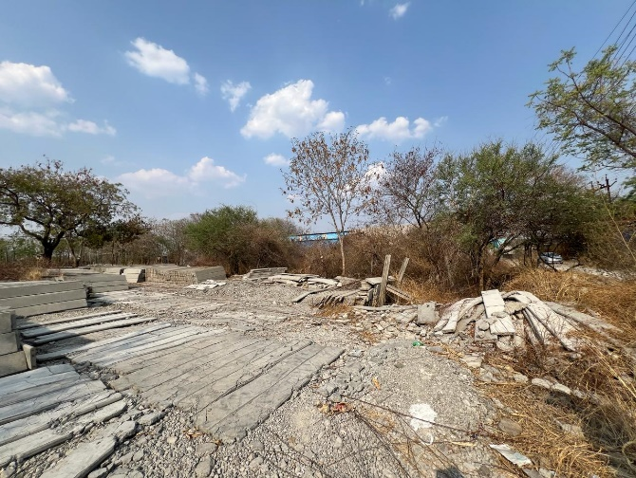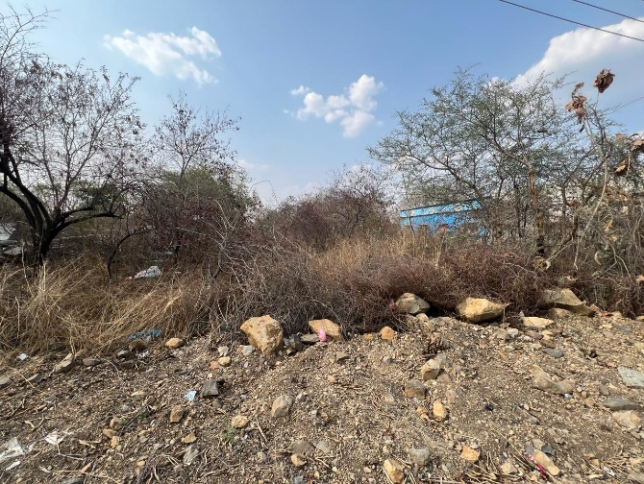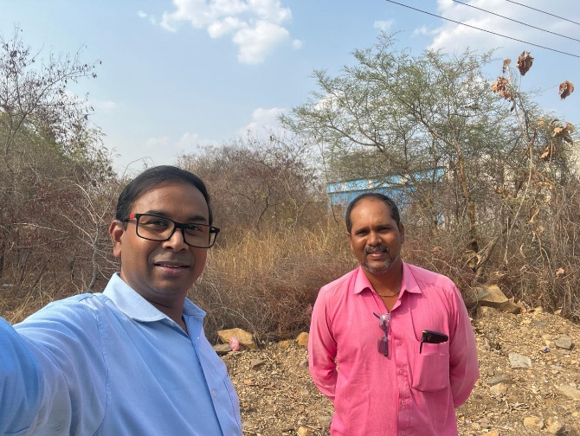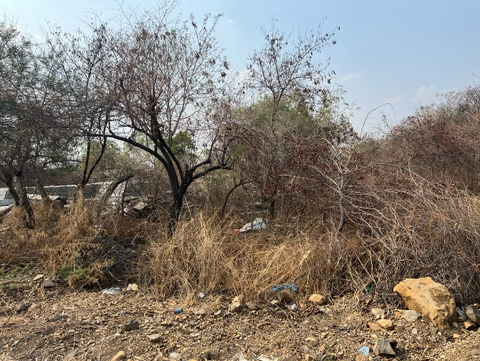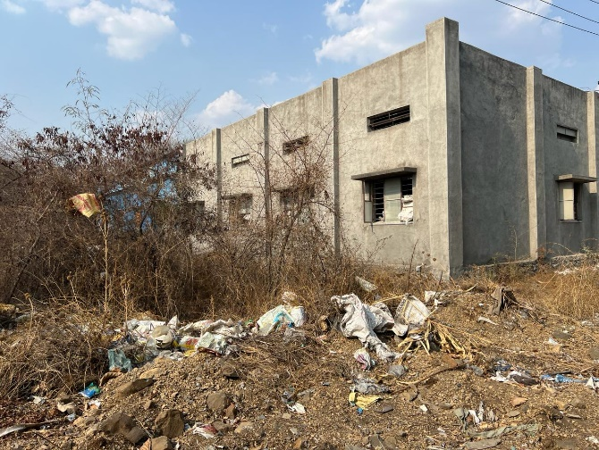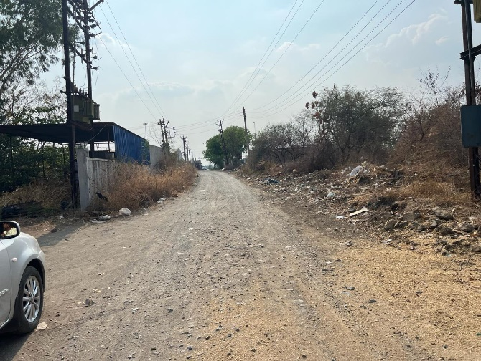

## Route Map of the property

**Site u/r**

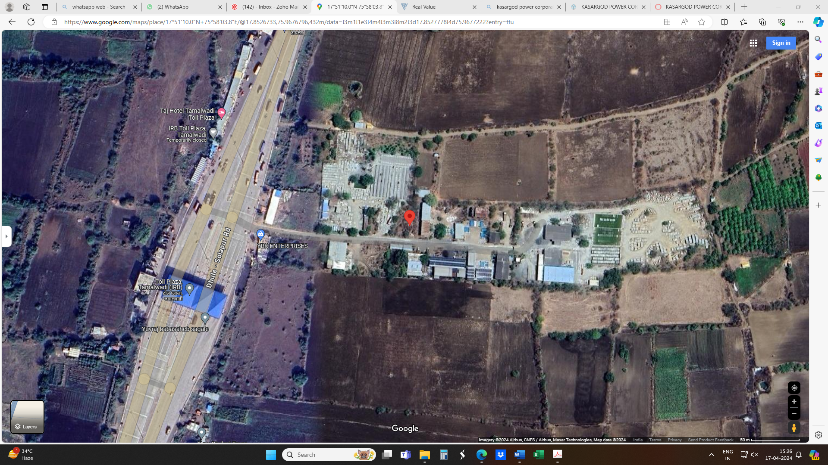

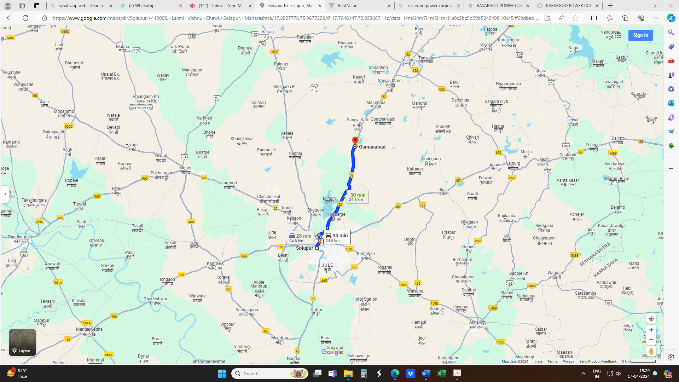

**Latitude Longitude - 17°51'10.0"N 75°58'03.8"E**

**Note:** The Blue line shows the route to site from nearest Railway Station (Solapur – 24.5 Km.)

## Ready Reckoner Rate

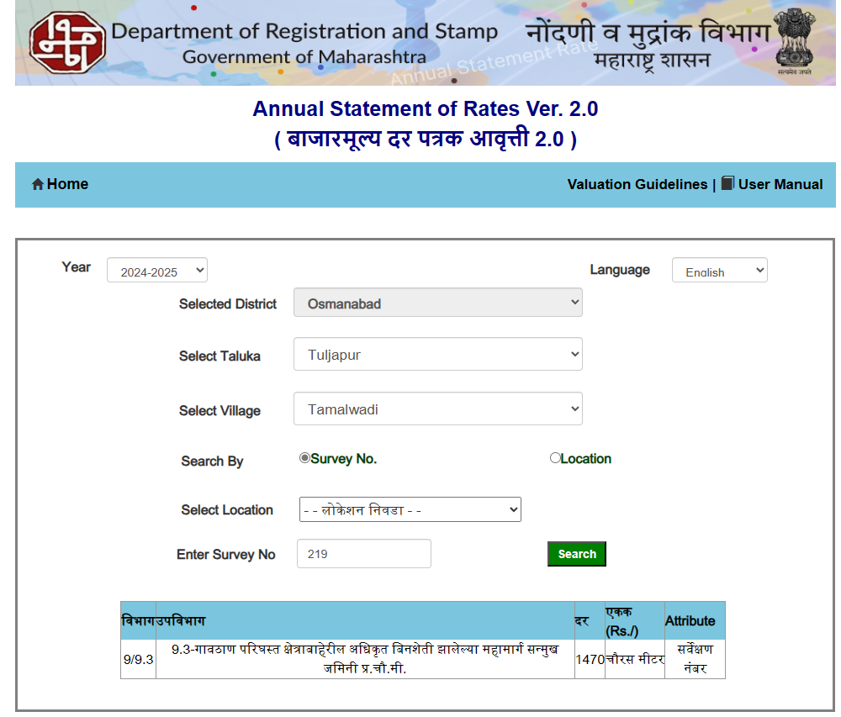

## Online 7/12 Extract

## Price Indicator

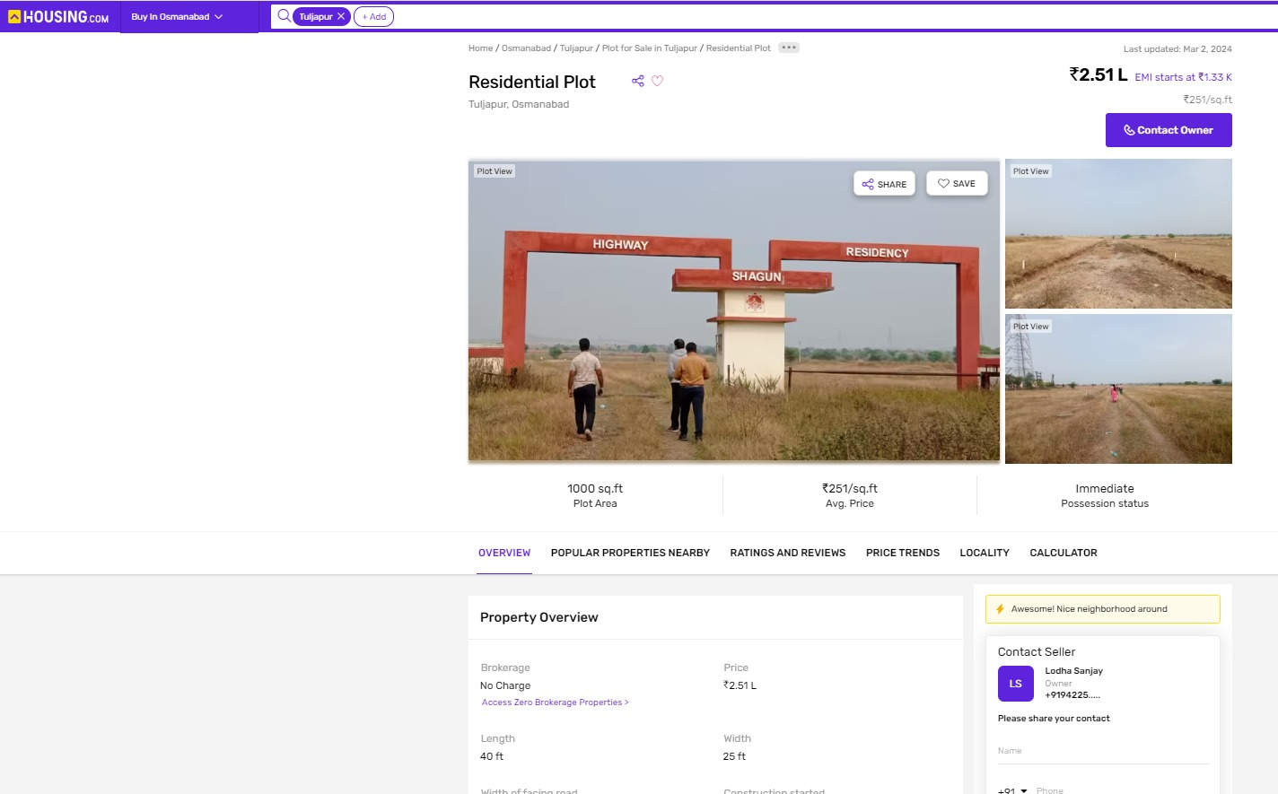

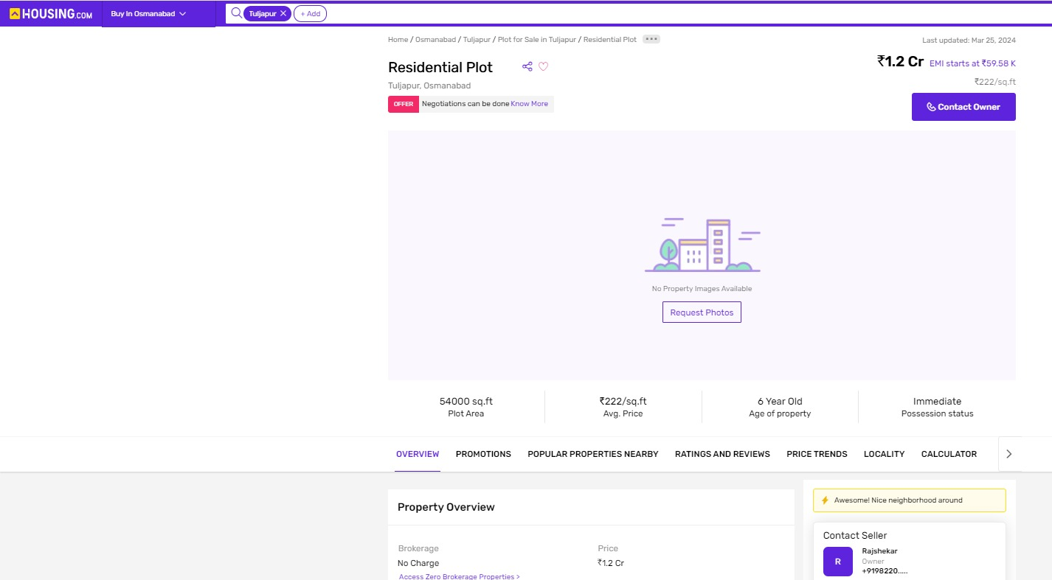

## Sale Instance

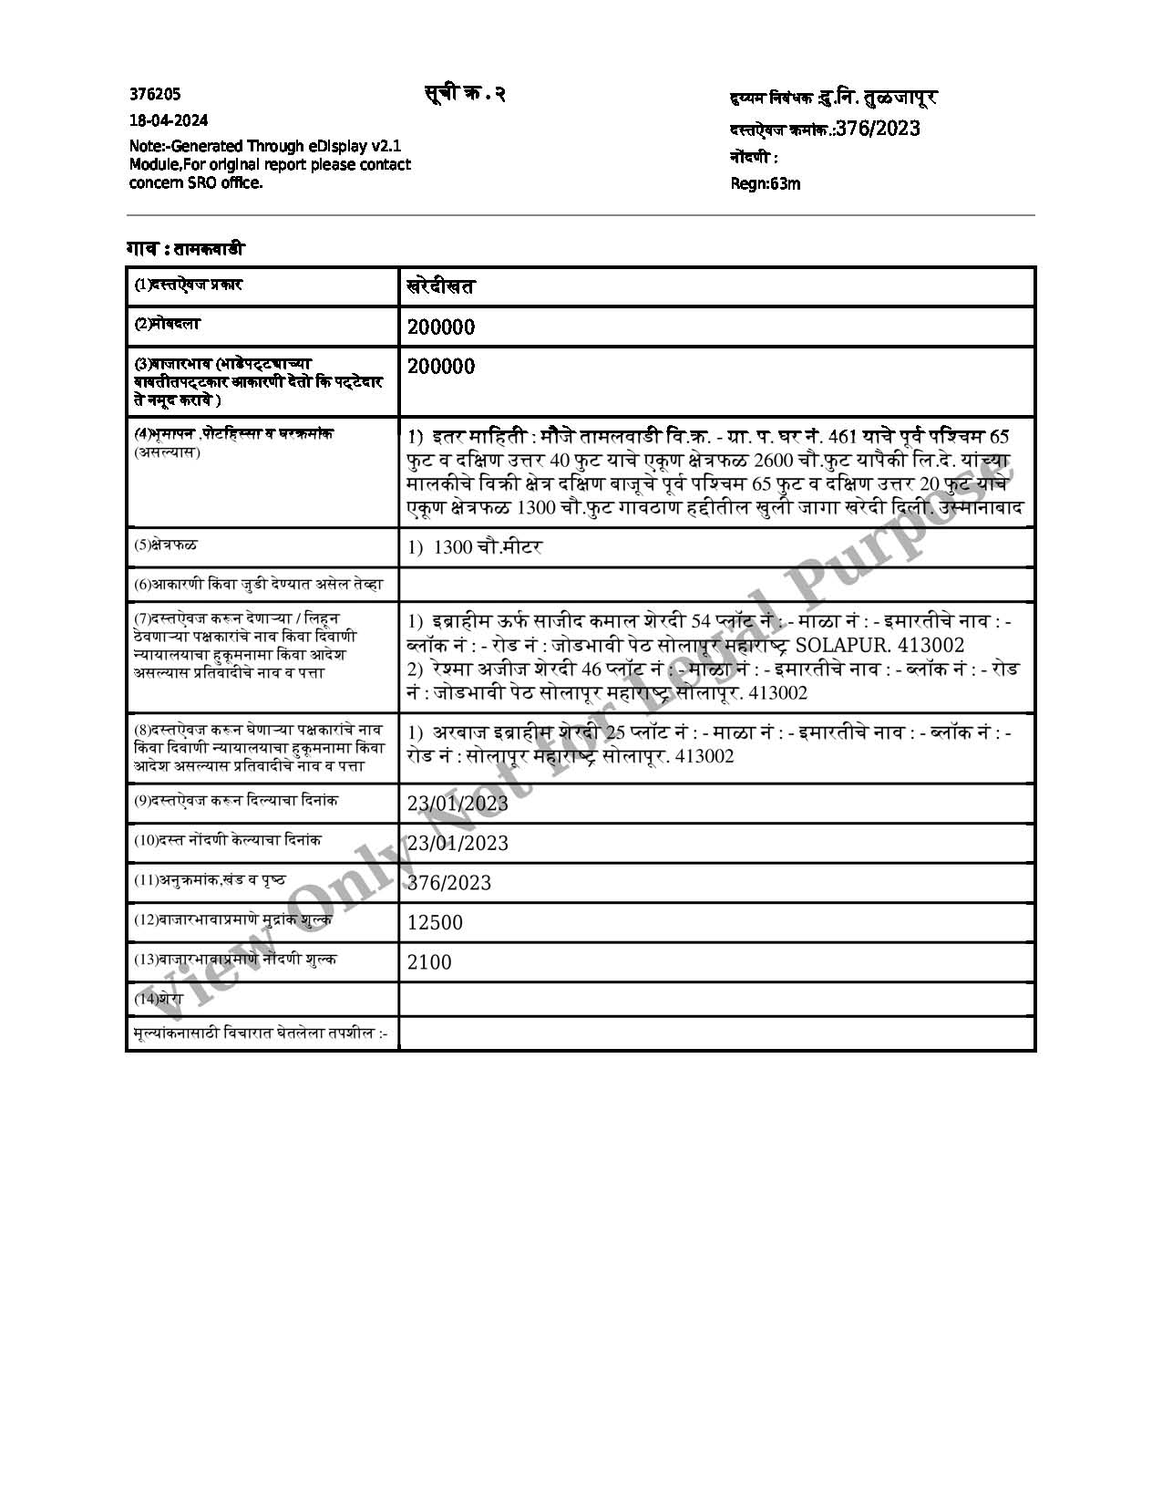

## Sale Instance

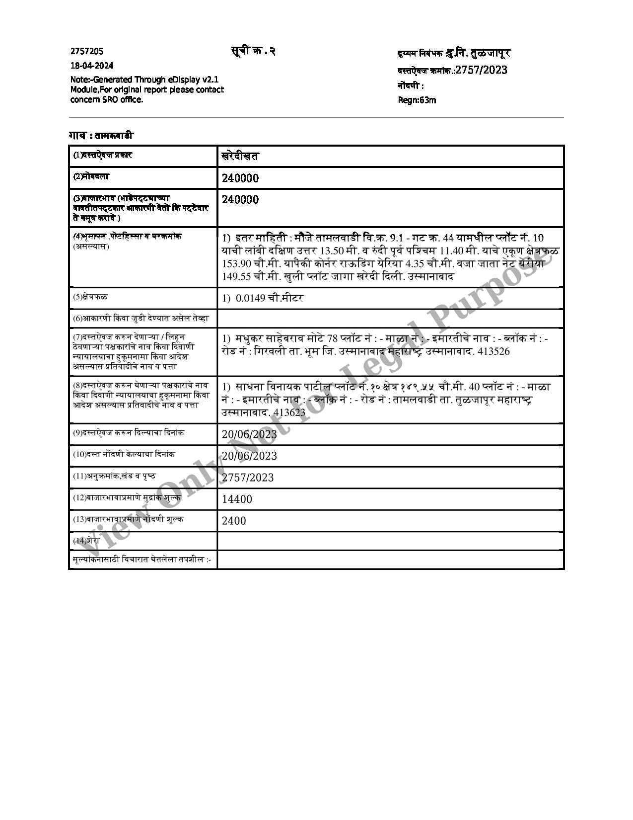

# DEFINITION OF VALUE FOR THIS SPECIFIC PURPASE

This exercise is for assessing **Fair Value & Liquidation value** of the property for **Corporate Insolvency Resolution Process (CIRP) under Insolvency & Bankruptcy Code, 2016 (IBC 2016)** purpose as on dated **19th January 2024.**

The term **Fair Value** is defined as

IFRS 13 defines Fair Value as the price that would be received to sell an asset or paid to transfer a liability in an orderly transaction between market participants at the measurement date

The term **Liquidation Value** is defined as

Liquidation Value is the amount that would be realised when an asset or group of assets are sold on a piecemeal basis. Liquidation Value should take into account the costs of getting the assets into saleable condition as well as those of the disposal activity. Liquidation Value can be determined under two different premises of value:

(a) An orderly transaction with a typical marketing period (see section 160), or

(b) A forced transaction with a shortened marketing period (see section 170)

“The mast probable price, as of a specified date, in cash, terms equivalent to cash, or in other precisely revealed terms for which the specified property rights would sell after reasonable exposure in a competitive market under all conditions requisite to a fair sale, with the buyer and seller each acting prudently knowledgeably and for self-interest assuming that neither is under undue duress”.

Fundamental assumptions and conditions presumed in this definition are:

1. Buyer and seller are motivated by self-interest.

2. Buyer and seller are well informed and are acting prudently.

3. The property is exposed for a reasonable time on the open market.

4. Payment is made in cash or equivalent or in specified financing terms.

# UNDER LYING ASSUMPTIONS

1. We assume no responsibility for matters of legal nature affecting the property appraised or the title thereto, nor do we render our opinion as to the title, which is assumed to be good and marketable.

2. The property is valued as though under responsible ownership.

3. It is assumed that the property is free of liens and encumbrances.

4. It is assumed that there are no hidden or unapparent conditions of the subsoil or structure that would render it more or less valuable. No responsibility is assumed for such conditions or for engineering that might be required to discover such factors.

|  |
| --- |
| Manoj B. Chalikwar |
| Registered Valuer  Chartered Engineer (India)  Reg. No. IBBI/RV/07/2018/10366 |

# DECLARATION OF PROFESSIONAL FEES CHARGED

We hereby declare that; our professional fees are not contingent upon the valuation findings. However, if the statute AND/OR clients demand that, the fees should be charged on the percentage of assessed value then, with the full knowledge of the AND/OR end user, it is being charged accordingly.

# STATEMENT OF LIMITING CONDITIONS

1. Assumptions are made to the best of our knowledge and belief. Reliance is based on the information furnished to us by the identifier AND/OR client.

2. The valuer shall not be responsible for matters of legal nature that affects the value and opinion expressed by us.

3. If our appearance is required, we will be pleased to appear and give the necessary clarification, provided the fees for each appearance (excluding travelling, dearness allowance and out of pocket expenses) is pre-determined before the acceptance of the assignment under reference.

4. In no event shall the Valuer be held responsible or liable for special, direct, indirect or consequential damages, as the assignment has been completed on best efforts, available knowledge and in good intentions of persons concerned and belief.

5. **If it is proved that there is an apparent negligence on the part of a Valuer,** liability of this assignment (whether arising from this assignment, negligence or whatsoever) is limited in respect of anyone event or series of events to the actual lass or damage sustained subject to maximum of 80% of the professional fees for the services rendered and, in any case, not exceeding the amount of ` 1,000/- (Rupees one Thousand Only). **All the claims against us shall expire after three months from the date of submission of the valuation report provided by us.**

6. We hereby declare that, the information furnished above is true and correct to the best of our knowledge and belief. We have no direct or indirect interest in the assets valued. We have not been convicted of any offence and sentenced to a term of imprisonment. We have not been found guilty of misconduct in our professional capacity.

|  |
| --- |
| Manoj B. Chalikwar |
| Registered Valuer  Chartered Engineer (India)  Reg. No. IBBI/RV/07/2018/10366 |