Valuation Report of the Immovable Property

Details of the property under consideration:

Name of Owner: Mrs. Neena Vijay Kakad

Amalgamated Shop No. 27 & 28, Ground Floor, “Shreeji Sangh”, Plot No. 15/16, Sector 7,
New Panvel, Navi Mumbai, Dist. - Raigad

Valuation Done for:

State Bank of Hyderabad, RASMECCC
Warden House (G.F.), Plot No. 65,
Sector – 11, Near “K” Star Hotel,
CBD Belapur, Navi Mumbai – 400 614

Vastukala Consultants (I) Pvt. Ltd.
Mumbai • Nanded • Navi Mumbai • Aurangabad

Vastu/SBH/Mumbai/07/2013/003236
27/06-217-VA
Date: 27.07.2013

CERTIFICATE

This is to certify that the property bearing Amalgamated Shop No. 27 & 28, Ground Floor, “Shreeji Sangh”, Plot No. 15/16, Sector 7, New Panvel, Navi Mumbai, Dist. - Raigad belongs to Mrs. Neena Vijay Kakad.
Boundaries of the property.
North | : | Marvel CHSL
South | : | Internal Road, Shree Darshan Building
East | : | E - Wing, Shri Sai Sadan Building
West | : | Internal Road, Suryauday CHSL
Considering various parameters recorded, existing economic scenario, and the information that is available with reference to the development of neighborhood and method selected for valuation, we are of the opinion that, the property premises can be assessed and valued for this particular purpose at ` 1,22,44,500/- (Rupees One Crore Twenty Two Lac Forty Four Thousand & Five Hundred Only).

The valuation of the property is based on the documents produced by the concern. Legal aspects have not been taken into considerations while preparing this valuation report.

Hence certified

For Vastukala Consultants (I) Pvt. Ltd.

Manoj B. Chalikwar
Approved Valuer & Chartered Engineer
Reg. No. CAT-I-F-1763
Encl: Valuation report.

VALUATION REPORT IN RESPECT OF IMMOVABLE PROPERTY

1 | Date of Inspection | : | 27th July 2013
 | Purpose of valuation | : | As per State Bank of Hyderabad, RASMECCC CBD Belapur Branch request to assess fair market value of the property
2 | Name and address of the Valuer. | : | S. B. Chalikwar
2 | Name and address of the Valuer. | : | Vastukala Consultants (I) Pvt. Ltd.
2 | Name and address of the Valuer. | : | Office No. 002, Ground Floor, Yashshree, Bandra Kurla Complex, Opp. Income Tax Office, Bandra (East), Mumbai - 400 051
3 | List Of Documents Handed Over To The Valuer By The Bank
 | a. | : | Copy of Previous valuation report dated 30.07.2008
 | b. | : | Copy of Occupancy Certificate No. EE/BP/ATPO/408 dated 01.08.1996
 | c. | : | Copy of approved plan no. EE(BP)/1141 dated 19.09.1994
4 | Details of enquiries made/ visited to govt. Offices for arriving fair market value.
 | a. | : | Market analysis and as per sub-registrar value.
5 | Factors for determining its market value. | : | Location, development of surrounding area, type of construction, construction specifications, age of building, condition of the premises & building, facilities provided and its prevailing market rate.
6 | ANY CRITICAL ASPECTS ASSOCIATED WITH PROPERTY : No.
7 | Present/Expected Income from the property | : | ` 72,500/- present rental income per month
8 | Property Details : | :
 | Name(s) and Postal address of the owner(s). | : | Mrs. Neena Vijay Kakad
 |  | : | Amalgamated Shop No. 27 & 28, Ground Floor, “Shreeji Sangh”, Plot No. 15/16, Sector 7, New Panvel, Navi Mumbai, Dist. - Raigad.
 | If the property is under joint ownership/ co-ownership share of each such owner/ are the share is undivided. | : | Sole Ownership
 | Brief description of the property. | : | Commercial Shop
 |  | : | The property is a Commercial Amalgamated Shop located on Ground floor. The property is at 5 - 7 minutes travel distance from Khandeshwar Railway Station.
 | Location of the property. | : | Plot No. 15/16, Sector - 7, Khanda Colony, New Panvel (West), Navi Mumbai - 410 206
 | (C.T.S. No., Survey No., Hissa No., Plot No., etc.).
 | Boundaries of the property. | :
 | North | : | Marvel CHSL
 | South | : | Internal Road, Shree Darshan Building
 | East | : | E - Wing, Shri Sai Sadan Building
 | West | : | Internal Road, Suryauday CHSL
 | Route map | : | Enclosed
 | Any specific identification marks | : | Near Abhyudaya Bank, Bank of Baroda & Central Bank of India
 | Whether covered under Corporation/ Panchayat/ Municipality. | : | CIDCO
 | Whether covered under any land ceiling of State/ Central Government. | : | No
 | Is the land freehold/ leasehold. | : | Leasehold
 | Are there any restrictive covenants in regard to use of Land? If so attach a copy of the covenant. | : | No
 |  | :
 | Type of the property | : | Commercial
 | Year of acquisition/ purchase. | : | 11.05.2004
 | Whether the property is occupied by owner or tenant. If occupied by tenant since how long he is staying and the amount of rent being paid. | : | Tenant occupied – Bank of Baroda
 | Classification of the site. | :
 | a. Population group. | : | Urban
 | b. High/ Middle/ Poor class. | : | Middle class
 | c. Residential/ nonresidential. | : | Non residential
 | d. Development of surrounding area. | : | Good
 | e. Possibility of any threat to the property. | : | No
 | (Floods, calamities etc.). | :
 | Proximity of civic amenities. | : | All available near by
 | (like school, hospital, bus stop, market etc.). | : | Plain
 | Terrain of the Land. | : | Levelled
 | Shape of the land (Square/ rectangle etc.). | : | Rectangular
 | Type of use to which it can be put (for construction of house, factory etc.). | : | For Commercial purpose
 | Any usage restrictions on the property. | : | For commercial purpose
 | Whether the plot is under town planning approved layout? | : | CIDCO Approved Layout
 | Whether the building is intermittent or corner? | : | Corner
 | Whether any road facility is available? | : | Yes
 | Type of road available (B.T./ Cement Road etc.). | : | B. T. Road
 | Front Width of the Road? | : | 20.00 M. wide road
 | Source of water & water potentiality. | : | Municipal Water supply
 | Type of Sewerage System. | : | Connected to Municipal sewer
 | Availability of power supply. | : | Yes
 | Advantages of the site. | : | Located in developed area
 | Disadvantages of the site. | : | No.
 | Give instances of sales of immovable property in the locality on a separate sheet, indicating the name & address of the property, registration No. sale price and area of land sold. | : | As per Sub-Registrar of Assurance records

9. | Valuation of the property :
 | Part-I: (Valuation of Shop ) :
 | 1) Total area of the shop | : | Carpet area = 564.00 Sq. ft.  Loft area = 81.00 Sq. ft. (Area as per previous valuation report)
 |  | : | Built up area = 677.00 Sq. ft. (Carpet area as per previous valuation report + 20%)
 |  | : | Saleable area = 907.00 Sq. ft. (Built up area + 30%) + (1/3 of Loft area)
 | 2) Prevailing market rate. | : | ` 13,500/- per Sq. ft.
 | 3) Guideline rate obtained from the Stamp Duty Ready Reckoner. | : | ` 84,000.00 per Sq.mt. i.e. ` 7,803.79 per sq. ft.
 | 4) Value of the property | : | ` 1,22,44,500/-
 | 5) The realizable value of the property | : | ` 1,10,20,050/-
 | 6) Distress value of the property | : | ` 97,95,600/-
 | a. Technical details of the building :
 | Type of building (Residential/ Commercial/ Industrial). | : | Commercial cum Residential Building
 | Year of construction. | : | 2004
 | Future life of the property. | : | 51 years subject to proper, preventive periodic maintenance & Structural repairs
 | No. of floors and height of each floor including basement. | : | Ground + 6 upper floors. Ground floor is having 38 shops. The building is having 1 lift.
 | Type of construction.
 | (Load bearing/ R.C.C./ Steel framed). | : | R.C.C. Framed Structure
 | Condition of the building. | :
 | External (excellent/ good/ normal/ poor). | : | Good
 | Internal (excellent/ good/ normal/ poor).  Whether the building/ property is constructed strictly according to the sanctioned plan, details of variations noticed if any and effect of the same on the valuation | :  : | Good  Yes
 | General Remarks | : | As per site inspection, Shop nos. 25, 26, 27 & 28 are internally amalgamated with single entrance. Tenant (Bank of Baroda) has not allowed for Internal photographs.
 | b. Specifications of Construction :
Sr. | Description |  | Ground Floor
a | Foundation. | : | R.C.C. Footing.
b | Basement. | : | N.A.
c | Superstructure. | : | R.C.C. frame work with 9" thick B. B. Masonry for external walls. 6" Thk. B.B. Masonry for internal walls.
d | Joinery/ Doors & Windows. | : | M.S. Rolling Shutter
e | RCC work. | : | Footing, Column, Beam, Slab
f | Plastering. | : | Cement plastering + POP finish internally, sand faced plaster externally
g | Flooring, Skirting. | : | Shop is finished with Vitrified tiles flooring.
h | Kitchen Platform | : | No
i | Whether any weather proof course is provided. | : | Yes
j | Drainage. | : | By Municipal Drainage.
k | Compound wall (Height, length and type of construction). | : | 5'.0" High, R.C.C. columns with B. B. Masonry walls
l | Electric installation (Type of wire, Class of fittings) | : | Concealed, class-two type wiring.
m | Plumbing installation (No. of water closets & wash basins etc.) | : | No
n | Bore well. | : | Not provided
o | Wardrobes, if any. | : | No
p | Development of open area | : | Chequered tiles in open spaces & Open parking etc.

 | Part-IV: Valuation of proposed construction/ additions/ renovation if any :
 | SUMMARY OF VALUATION :
 | Part I Land | ` | 0.00
 | Part II Building | ` | 1,22,44,500.00
 | Part III Other amenities/ Miscellaneous | ` | 0.00
 | Part IV Proposed construction | ` | 0.00
 | TOTAL. | ` | 1,22,44,500.00
 | Calculation:
1.00 | Construction
1.01 | Area of Shop = 677.00 Sq. ft.  (Built up Area)
1.02 | Rate per Sq.ft. = 1,500/-
1.03 | Cost of Construction = (1.01x1.02) | ` | 10,15,500.00
2.00 | Value of property
2.01 | Area of Shop = 907.00 Sq. ft.  (Saleable Area)
2.02 | Rate per Sq.ft. = 13,500/-
2.03 | Value of Shop = (2.01x2.02) | ` | 1,22,44,500.00
3.00 | The value of the property. | ` | 1,22,44,500.00
I certify that,

The property is inspected by our Site Engineer Mr. Niranjan Shetty personally. Mr. Somnath (Owner’s Staff - Mobile No. 9833526114) has shown the property.

The rates for valuation of the property are in accordance with the Govt. approved rates and prevailing market rates.
There is no direct/ indirect interest in the property valued.

The fair value of the property as on today is ` 1,22,44,500/- (Rupees One Crore Twenty Two Lac Forty Four Thousand & Five Hundred Only).

Manoj B. Chalikwar
Date: 27.07.2013
Approved Valuer & Chartered Engineer | Place: Mumbai
Reg. No. CAT-I-F-1763

Actual site photographs
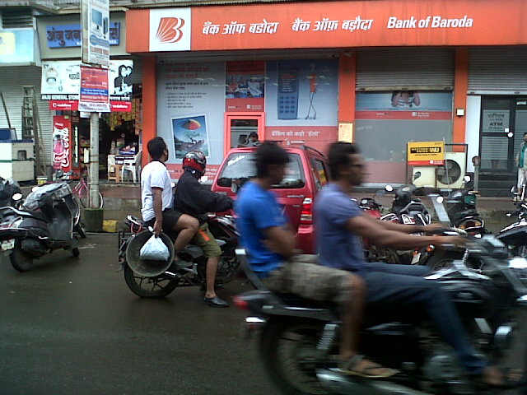
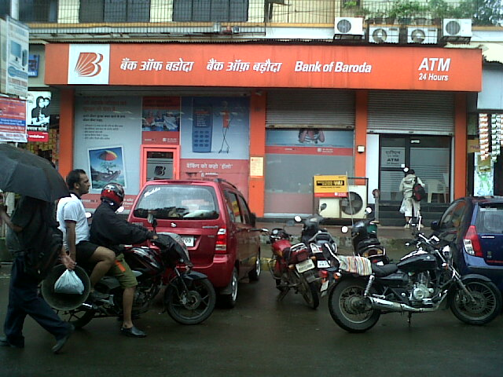

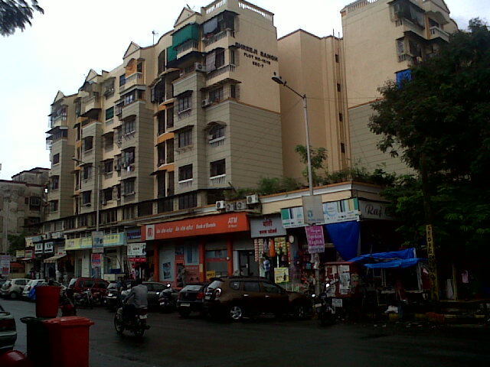

Route Map of the property

Site u/r
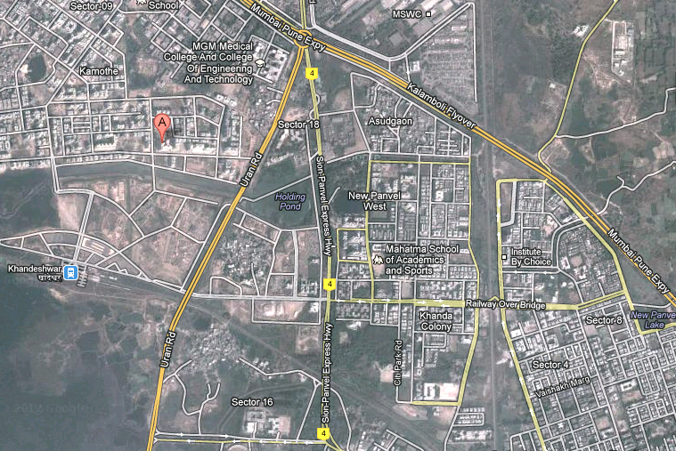

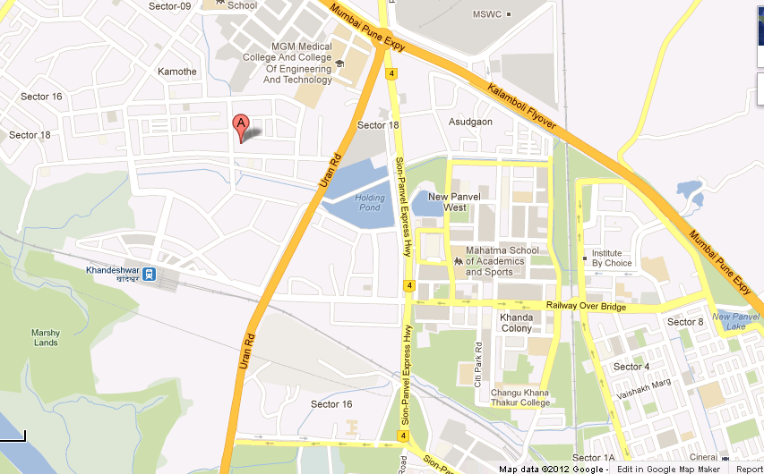

Note: The Red line shows the route to site from nearest railway station (Khandeshwar)

DEFINITION OF VALUE FOR THIS SPECIFIC PURPOSE

This exercise is to assess Fair Market Value of the property under reference as on 27th July 2013.

The term Fair Market Value is defined as

“The most probable price, as of a specified date, in cash, terms equivalent to cash, or in other precisely revealed terms for which the specified property rights would sell after reasonable exposure in a competitive market under all conditions requisite to a fair sale, with the buyer and seller each acting prudently knowledgeably and for self-interest assuming that neither is under undue duress”.

Fundamental assumptions and conditions presumed in this definition are:

1. Buyer and seller are motivated by self-interest.
2. Buyer and seller are well informed and are acting prudently.
3. The property is exposed for a reasonable time on the open market.
4. Payment is made in cash or equivalent or in specified financing terms.

UNDER LYING ASSUMPTIONS
1. We assume no responsibility for matters of legal nature affecting the property appraised or the title thereto, nor do we render our opinion as to the title, which is assumed to be good and marketable.
2. The property is valued as though under responsible ownership.
3. It is assumed that the property is free of liens and encumbrances.
4. It is assumed that there are no hidden or unapparent conditions of the subsoil or structure that would render it more or less valuable. No responsibility is assumed for such conditions or for engineering that might be required to discover such factors.

For Vastukala Consultants (I) Pvt. Ltd.

Manoj B. Chalikwar
Approved Valuer & Chartered Engineer
Reg. No. CAT-I-F-1763

DECLARATION OF PROFESSIONAL FEES CHARGED

We hereby declare that, our professional fees are not contingent upon the valuation findings. However, if the statute AND/OR clients demands that, the fees should be charged on the percentage of assessed value then, with the full knowledge of the AND/OR end user, it is being charged accordingly.

VALUATION OF THE PROPERTY PREMISES

Considering various parameters recorded herein above, existing economic scenario, and the information that is available with reference to the development of neighborhood and method selected for valuation, we are of the opinion that, the property premises can be assessed and valued for this particular purpose at ` 1,22,44,500/- (Rupees One Crore Twenty Two Lac Forty Four Thousand & Five Hundred Only).

STATEMENT OF LIMITING CONDITIONS
1. Assumptions are made to the best of our knowledge and belief. Reliance is based on the information furnished to us by the identifier AND/OR client.
2. The valuer shall not be responsible for matters of legal nature that affects the value and opinion expressed by us.
3. If our appearance is required, we will be pleased to appear and give the necessary clarification, provided the fees for each appearance (excluding traveling, dearness allowance and out of pocket expenses) is pre-determined before the acceptance of the assignment under reference.
4. In no event shall the valuer be held responsible or liable for special, direct, indirect or consequential damages, as the assignment has been completed on best efforts, available knowledge and in good intentions of persons concerned and belief.
5. If it is proved that there is an apparent negligence on the part of a valuer, liability of this assignment (whether arising from this assignment, negligence or whatsoever) is limited in respect of anyone event or series of events to the actual loss or damage sustained subject to maximum of 80% of the professional fees for the services rendered and in any case not exceeding the amount of ` 1,000/- (Rupees one Thousand Only). All the claims against us shall expire after three month from the date of submission of the valuation report provided by us.
6. We hereby declare that, the information furnished above is true and correct to the best of our knowledge and belief. We have no direct or indirect interest in the assets valued. We have not been convicted of any offence and sentenced to a term of imprisonment. We have not been found guilty of misconduct in our professional capacity.
For Vastukala Consultants (I) Pvt. Ltd.

Manoj B. Chalikwar
Approved Valuer & Chartered Engineer
Reg. No. CAT-I-F-1763

