Valuation Report of the Immovable Property

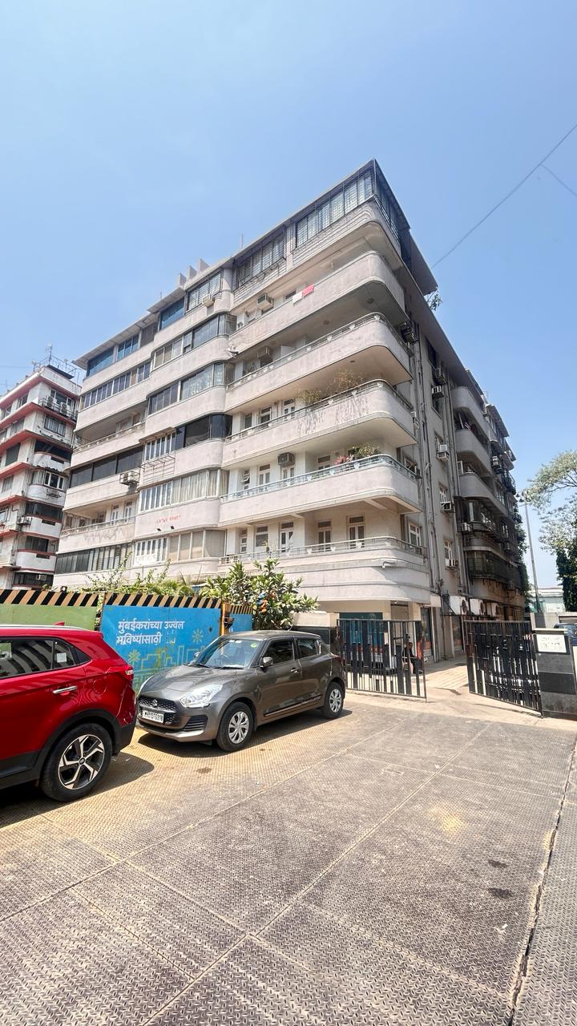

Details of the property under consideration:

Name of Owner: UTI Asset Management Company Limited

Residential Flat No. 24, 4th Floor, “Lotus Court”, Plot No. 196, C.S. No. 1632 of Fort Division,
Jamshedji Tata Road, Backbay Reclamation, Churchgate, Mumbai - 400 020,
State - Maharashtra, Country – India.

Longitude Latitude: 18°55’51.6”N 72°49’34.2”E

Valuation Done for:

UTI Asset Management Company Limited
BKC – Bandra (East) Branch
"UTI Tower", Plot No. C-1, 'Gn' Block, Bandra - Kurla Complex, Behind Asian Heart Institute,
Bharat Nagar Road, Bandra (East), Mumbai - 400 051, State – Maharashtra, Country – India

Private Valuation

Vastu/Thane/04/2024/8178/46372
25/22-565-PSSK
Date: 10.04.2024

VALUATION OPINION REPORT

This is to certify that the property bearing Residential Flat No. 24, 4th Floor, “Lotus Court”, Plot No. 196, C.S. No. 1632 of Fort Division, Jamshedji Tata Road, Backbay Reclamation, Churchgate, Mumbai - 400 020, State - Maharashtra, Country – India belongs to UTI Asset Management Company Limited.

Boundaries of the property.

North | : | National Insurance Building
South | : | Moti Mahal
East | : | Jamshedji Tata Road
West | : | The Cricket Club of India Limited

Considering various parameters recorded, existing economic scenario, and the information that is available with reference to the development of neighborhood and method selected for valuation, we are of the opinion that, the property premises can be assessed for this particular purpose at ` 10,26,97,000.00 (Rupees Ten Crore Twenty Six Lakh Ninety Seven Thousand Only).

The valuation of the property is based on the documents produced by the concern. Legal aspects have not been taken into considerations while preparing this valuation report.

Hence certified

Manoj B. Chalikwar
Registered Valuer
Chartered Engineer (India)
Reg. No. IBBI / RV / 07/2018/10366
Reg. No. CAT-I-F-1763
Encl: Valuation report.

Vastukala Consultants (I) Pvt. Ltd.
B1-001, U/B Floor, Boomerang, Chandivali Farm Road, Powai, Andheri (East), Mumbai – 400 072.

VALUATION REPORT (IN RESPECT OF FLAT)
I | General
1. | Purpose for which the valuation is made |  |  | : | To assess Fair Market Value of the property for UTI Asset Management Company Limited, BKC – Bandra (East) Branch.
2. | a) |  | Date of inspection | : | 04.04.2024
 | b) |  | Date on which the valuation is made | : | 10.04.2024
3. | List of documents produced for perusal:  - Copy of Deed of Transfer dated 08.07.2010 between The Administrator of The Specified Undertaking of The Unit Trust of India (the Transferor) AND UTI Asset Management Company Limited (the Transferee).  - Copy of Property Tax Assessment No. AX1900670050000 dated 01.01.2020 in the name of M/s. Lotus Court Pvt. Ltd. issued by Municipal Corporation of Greater Mumbai.  - Copy of Maintenance Bill No. 14497 dated 08.01.2021 in the name of UTI-AMC Ltd. issued by M/s. Lotus Court Ltd. for Flat No. 24.  - Copy of Letter dated 28.07.2009 for Issuance of No Objection Certificate for the sale and transfer of share in respect of premises at Ground Floor (Show Room & Store Room) & Guest House Flat No. 23 & 24 issued by Lotus Court Ltd.  - Share Certificate No. 25 in the name of M/s. Peico Electronics & Electricals Ltd. and other dated 15.07.1957 and transferred to M/s. Unit Trust of India issued by Lotus Court Ltd. for Flat No. 24.
4. | Name of the owner(s) and his / their address (es) with Phone no. (details of share of each owner in case of joint ownership) |  |  | : | UTI Asset Management Company Limited  Address: Residential Flat No. 24, 4th Floor, “Lotus Court”, Plot No. 196, C.S. No. 1632 of Fort Division, Jamshedji Tata Road, Backbay Reclamation, Churchgate, Mumbai - 400 020, State - Maharashtra, Country – India.  Contact Person:  Mr. Kashiram (Employee of Owner)  Contact No.: 7304898940  Limited Company Ownership
5. | Brief description of the property (Including Leasehold / freehold etc.) |  |  | : | The property is a Residential Flat located on 4th Floor. As per site inspection, Flat No. 23 & 24 are internally amalgamated to form a single flat having separate entrance door and it is used as Company Guest House. The composition of amalgamated flat consists of 6 Bedrooms + Living Room + Kitchen + 6 Toilets (i.e. 6BHK + 6 Toilets). The property is at 350 M. walking distance from nearest railway station Churchgate.
6. | Location of property |  |  | :
 | a) | Plot No. / Survey No. |  | : | Plot No. 196
 | b) | Door No. |  | : | Residential Flat No. 24
 | c) | C.T.S. No. / Village |  | : | C.S. No. 1632 of Fort Division
 | d) | Ward / Taluka |  | : | W - Ward
 | e) | Mandal / District |  | : | Mumbai
 | f) | Date of issue and validity of layout of approved map / plan |  | : | Copy of Approved Plan & Occupancy Certificate not provided for our verification.
 | g) | Approved map / plan issuing authority |  | :
 | h) | Whether genuineness or authenticity of approved map/ plan is verified |  | :
 | i) | Any other comments by our empanelled valuers on authentic of approved plan |  | : | No
7. | Postal address of the property |  |  | : | Residential Flat No. 24, 4th Floor, “Lotus Court”, Plot No. 196, C.S. No. 1632 of Fort Division, Jamshedji Tata Road, Backbay Reclamation, Churchgate, Mumbai - 400 020, State - Maharashtra, Country – India.
8. | City / Town |  |  | : | Churchgate, Mumbai
 | Residential area |  |  | : | Yes
 | Commercial area |  |  | : | No
 | Industrial area |  |  | : | No
9. | Classification of the area |  |  | :
 | i) High / Middle / Poor |  |  | : | Middle Class
 | ii) Urban / Semi Urban / Rural |  |  | : | Urban
10. | Coming under Corporation limit / Village Panchayat / Municipality |  |  | : | Fort Division  Municipal Corporation of Greater Mumbai
11. | Whether covered under any State / Central Govt. enactments (e.g., Urban Land Ceiling Act) or notified under agency area/ scheduled area / cantonment area |  |  | : | No
12. | Boundaries of the property
 |  |  |  |  | As per Site |  | As per Documents
 | North |  |  | : | National Insurance Building |  | Details not available
 | South |  |  | : | Moti Mahal |  | Details not available
 | East |  |  | : | Jamshedji Tata Road |  | Details not available
 | West |  |  | : | The Cricket Club of India Limited |  | Details not available
13 | Dimensions of the site |  |  |  | N. A. as property under consideration is a Residential Flat in a building.
 |  |  |  |  | A As per the Deed | B Actuals
 | North |  |  | : | - | -
 | South |  |  | : | - | -
 | East |  |  | : | - | -
 | West |  |  | : | - | -
14. | Extent of the site |  |  | : | Carpet Area in Sq. Ft. = 1,438.00  (Area as per Deed of Transfer)  Built Up Area in Sq. Ft. = 1,726.00  (Area as per Deed of Transfer)
14.1 | Latitude, Longitude & Co-ordinates of Flat |  |  | : | 18°55’51.6”N 72°49’34.2”E
15. | Extent of the site considered for Valuation (least of 13A& 13B) |  |  | : | Built Up Area in Sq. Ft. = 1,726.00  (Area as per Deed of Transfer)
16 | Whether occupied by the owner / tenant? If occupied by tenant since how long? Rent received per month. |  |  | : | Company Ownership – The said flat is used as Guest House
II | APARTMENT BUILDING
 | Nature of the Apartment |  |  | : | Residential
 | Location |  |  | :
 | C.T.S. No. |  |  | : | Plot No. 196, C.S. No. 1632
 | Block No. |  |  | : | -
 | Ward No. |  |  | : | A Ward
 | Village / Municipality / Corporation |  |  | : | Fort Division  Municipal Corporation of Greater Mumbai
 | Door No., Street or Road (Pin Code) |  |  | : | Residential Flat No. 24, 4th Floor, “Lotus Court”, Plot No. 196, C.S. No. 1632 of Fort Division, Jamshedji Tata Road, Backbay Reclamation, Churchgate, Mumbai - 400 020, State - Maharashtra, Country – India.
 | Description of the locality Residential / Commercial / Mixed |  |  | : | Residential
 | Year of Construction |  |  | : | 1949 (As per No Objection Certificate)
 | Number of Floors |  |  | : | Ground + 6 Upper Floors
 | Type of Structure |  |  | : | R.C.C. Framed Structure
 | Number of Dwelling units in the building |  |  | : | 4 Flats on 4th Floor
 | Quality of Construction |  |  | : | Good
 | Appearance of the Building |  |  | : | Good
 | Maintenance of the Building |  |  | : | Good
 | Facilities Available |  |  | :
 | Lift |  |  | : | 2 Lifts
 | Protected Water Supply |  |  | : | Municipal Water supply
 | Underground Sewerage |  |  | : | Connected to Municipal sewer
 | Car parking - Open / Covered |  |  | : | Open Car Parking
 | Is Compound wall existing? |  |  | : | Yes
 | Is pavement laid around the building |  |  | : | Yes

III | Residential Flat
1 | The floor in which the Flat is situated | : | 4th Floor
2 | Door No. of the Flat | : | Residential Flat No. 24
3 | Specifications of the Flat | :
 | Roof | : | R.C.C. Slab
 | Flooring | : | Italian Marble, Wooden & Vitrified tiles flooring
 | Doors | : | Teak wood door framed with flush doors
 | Windows | : | Powder coated aluminum sliding windows
 | Fittings | : | Concealed plumbing with C.P. fittings. concealed wiring
 | Finishing | : | Cement Plastering with POP false ceiling
4 | House Tax | :
 | Assessment No. | : | Property Tax Assessment No. AX1900670050000
 | Tax paid in the name of: | : | M/s. Lotus Court Pvt. Ltd.
 | Tax amount: | : | ` 4,54,914.00
5 | Electricity Service connection No.: | : | Details not available
 | Meter Card is in the name of: | : | Details not available
6 | How is the maintenance of the Flat? | : | Good
7 | Sale Deed executed in the name of | : | UTI Asset Management Company Limited
8 | What is the undivided area of land as per Sale Deed? | : | Details not available
9 | What is the plinth area of the Flat? | : | Built Up Area in Sq. Ft. = 1,726.00  (Area as per Deed of Transfer)
10 | What is the floor space index (app.) | : | As per MCGM norms
11 | What is the Carpet Area of the Flat? | : | Carpet Area in Sq. Ft. = 1,438.00  (Area as per Deed of Transfer)
12 | Is it Posh / I Class / Medium / Ordinary? | : | Medium
13 | Is it being used for Residential or Commercial purpose? | : | Residential Purpose
14 | Is it Owner-occupied or let out? | : | Company Ownership – The said flat is used as Guest House
15 | If rented, what is the monthly rent? | : | ` 2,19,000.00 Expected rental income per month
IV | MARKETABILITY | :
1 | How is the marketability? | : | Good
2 | What are the factors favoring for an extra Potential Value? | : | Located in developed area
3 | Any negative factors are observed which affect the market value in general? | : | No
V | Rate | :
1 | After analyzing the comparable sale instances, what is the composite rate for a similar Flat with same specifications in the adjoining locality? - (Along with details / reference of at - least two latest deals / transactions with respect to adjacent properties in the areas) | : | ` 59,000.00 to ` 61,000.00 per Sq. Ft. on Built up Area
2 | Assuming it is a new construction, what is the adopted basic composite rate of the Flat under valuation after comparing with the specifications and other factors with the Flat under comparison (give details). | : | ` 59,500.00 per Sq. Ft.
3 | Break – up for the rate | :
 | I. Building + Services | : | ` 3,000.00 per Sq. Ft.
 | II. Land + others | : | ` 56,500.00 per Sq. Ft.
4 | Guideline rate obtained from the Registrar's Office | : | ` 6,56,640.00 per Sq. M. i.e.  ` 61,003.00 per Sq. Ft.
 | Guideline rate (after deprecation) | : | ` 3,95,519.00 per Sq. M. i.e.  ` 36,745.00 per Sq. Ft.
VI | COMPOSITE RATE ADOPTED AFTER DEPRECIATION
a | Depreciated building rate | :
 | Replacement cost of Flat with Services (v (3)i) | : | ` 3,000.00 per Sq. Ft.
 | Age of the building | : | 75 Year
 | Life of the building estimated | : | Total Life span of R.C.C. Framed structure is considered 60 years, but life of building is already 73 years. As per site inspection, Future life can be 10 to 15 years, Subject to proper, preventive periodic maintenance and structural repairs.
 | Depreciation percentage assuming the salvage value as 10% | : | 90% as building have already completed its design Life.
 | Depreciated Ratio of the building | :
b | Total composite rate arrived for Valuation | :
 | Depreciated building rate VI (a) | : | ` 3,000.00 per Sq. Ft.
 | Rate for Land & other V (3) ii | : | ` 56,500.00 per Sq. Ft.
 | Total Composite Rate | : | ` 59,500.00 per Sq. Ft.
Remarks:
- As per site inspection, Flat No. 23 & 24 are internally amalgamated to form a single flat having separate entrance door and it is used as Company Guest House.
- We valued individual Flat No. 24 only.
- For the purpose of valuation, we have considered the Built Up Area as per documents.

Details of Valuation:

Sr. No. | Description | Qty. | Rate per  unit (`) | Estimated  Value (`)
1 | Present value of the Flat | 1,726.00 Sq. Ft. | 59,500.00 | 10,26,97,000.00
2 | Wardrobes
3 | Showcases /
4 | Kitchen arrangements
5 | Superfine finish
6 | Interior Decorations
7 | Electricity deposits / electrical fittings, etc.
8 | Extra collapsible gates / grill works etc.
9 | Potential value, if any
10 | Others
 | Total value of the property |  |  | 10,26,97,000.00
 | Realizable value of the property |  |  | 9,24,27,300.00
 | Distress Value of the property |  |  | 8,21,57,600.00
 | Insurable value of the property (1,726.00 X 3,000.00) |  |  | 51,78,000.00
 | Guideline value of the property (1,726.00 X 36,745.00) |  |  | 6,34,21,870.00
 | Rental Valuation |  |  | 2,19,000.00
  Built Up Area | 1,726.00
  Rate adopted for valuation | ` 127.00
  Rental Value | ` 2,19,202.00 Say ` 2,19,000.00

The sales comparison approach uses the market data of sale prices to estimate the value of a real estate property. Property valuation in this method is done by comparing a property to other similar properties that have been recently sold. Comparable properties, also known as comparables, or comps, must share certain features with the property in question. Some of these include physical features such as square footage, number of rooms, condition, and age of the building; however, the most important factor is no doubt the location of the property. Adjustments are usually needed to account for differences as no two properties are exactly the same. To make proper adjustments when comparing properties, real estate appraisers must know the differences between the comparable properties and how to value these differences. The sales comparison approach is commonly used for Residential Flat, where there are typically many comparables available to analyze. As the property is a Residential Flat, we have adopted Sale Comparison Approach Method for the purpose of valuation. The Price for similar type of property in the nearby vicinity is in the range of ` 59,000.00 to ` 62,000.00 per Sq. Ft. on Built up area. Considering the rate with attached report, current market conditions, demand and supply position, Flat size, location, upswing in real estate prices, sustained demand for Residential Flat, all-round development of Residential and Commercial application in the locality etc. We estimate ` 59,500.00 per Sq. Ft. for valuation.
Impending threat of acquisition by government for road widening / publics service purposes, sub merging & applicability of CRZ provisions (Distance from sea-cost / tidal level must be incorporated) and their effect on | -
- Saleability | Good
- Likely rental values in future in | ` 2,19,000.00 Expected rental income per month
- Any likely income it may generate | Rental Income

Actual Site Photographs
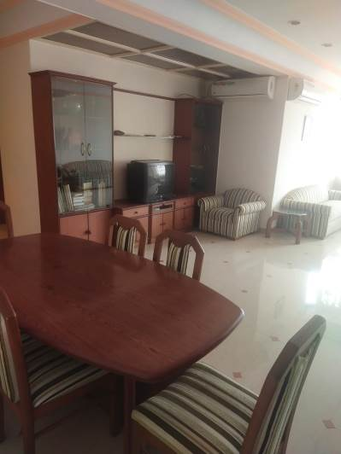
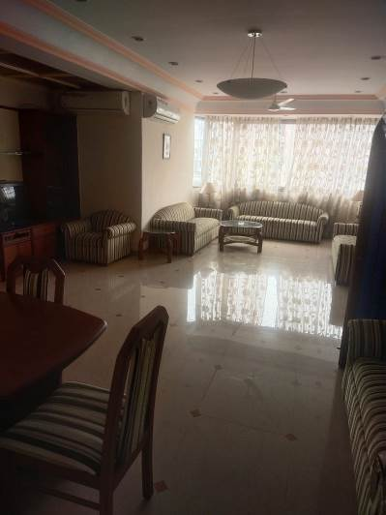
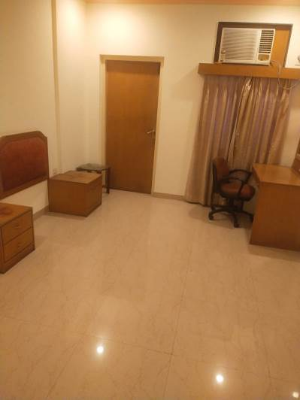

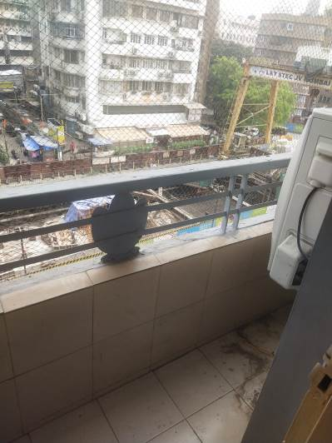
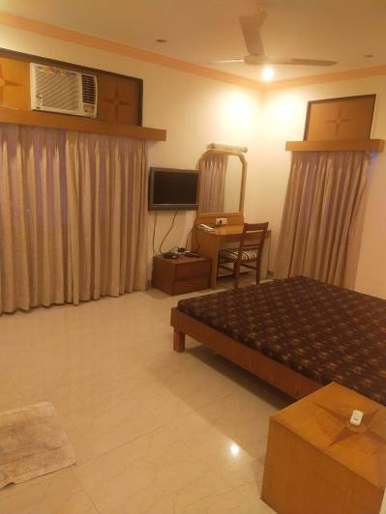
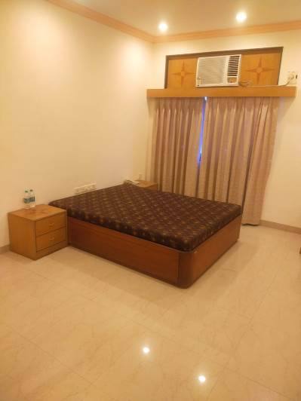
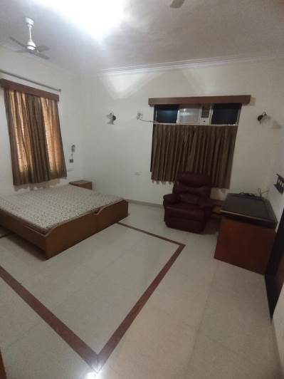
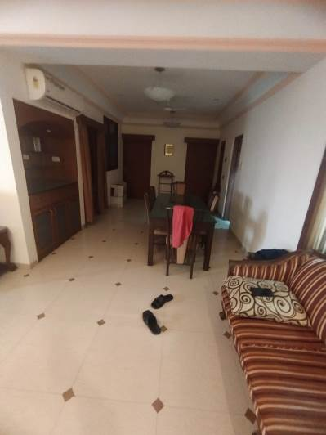
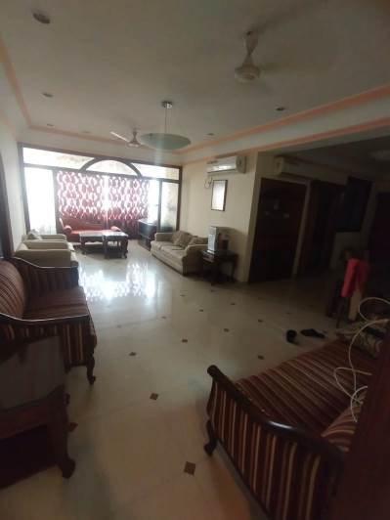
Actual Site Photographs
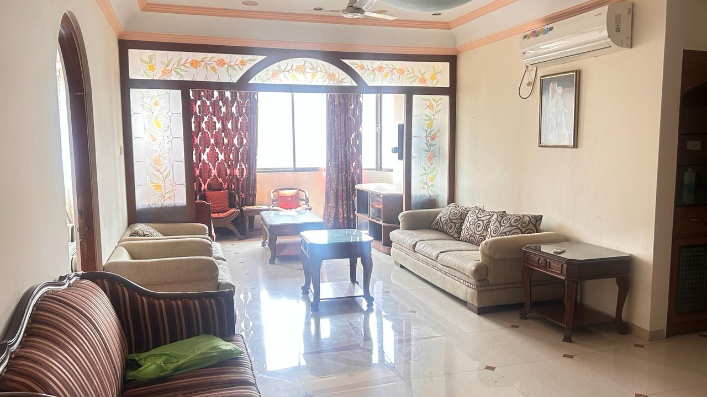
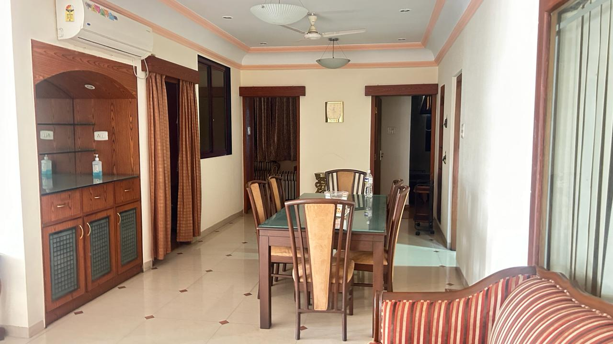

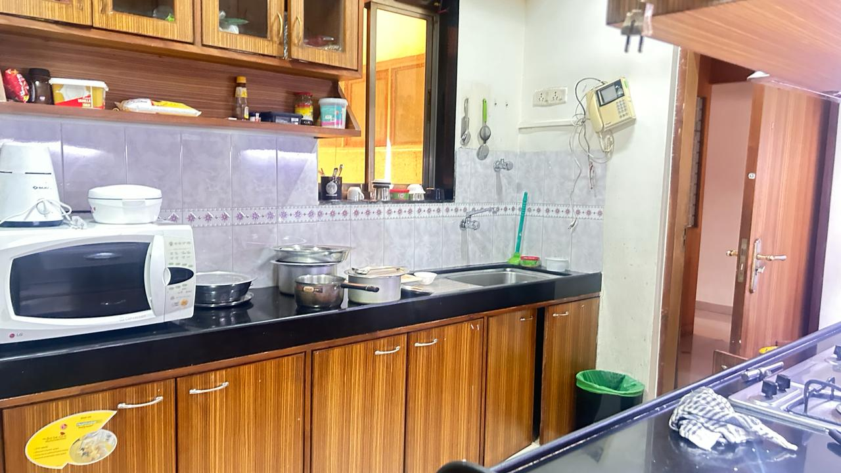
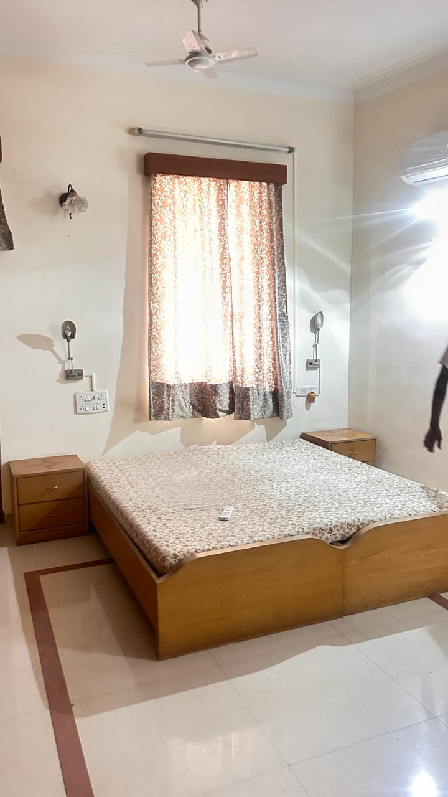
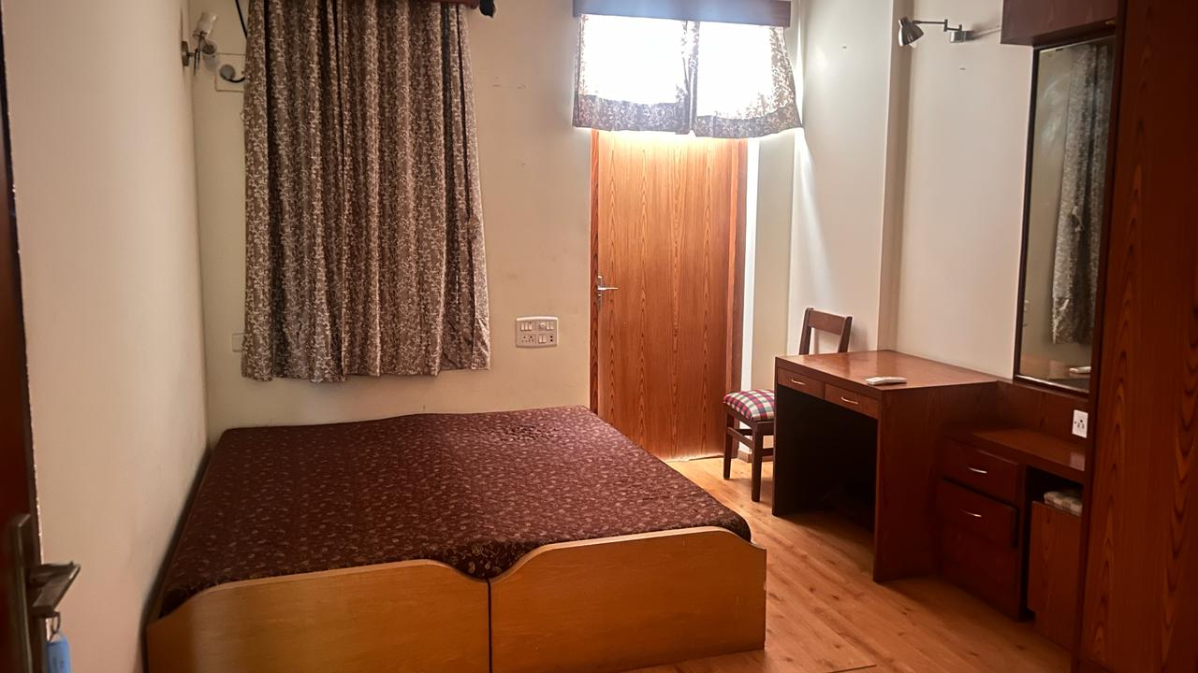
Actual Site Photographs
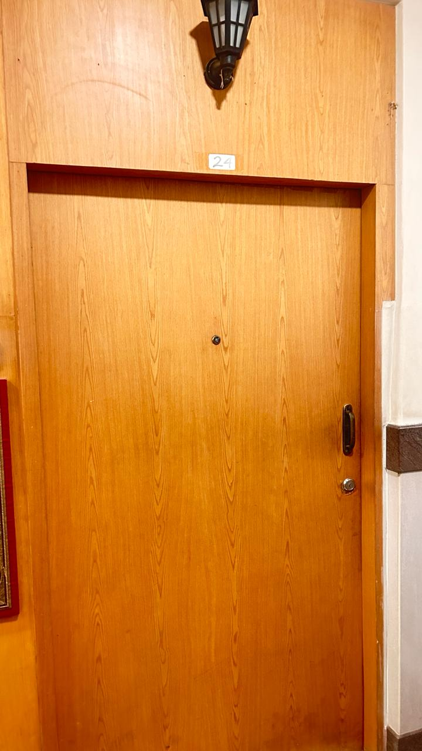
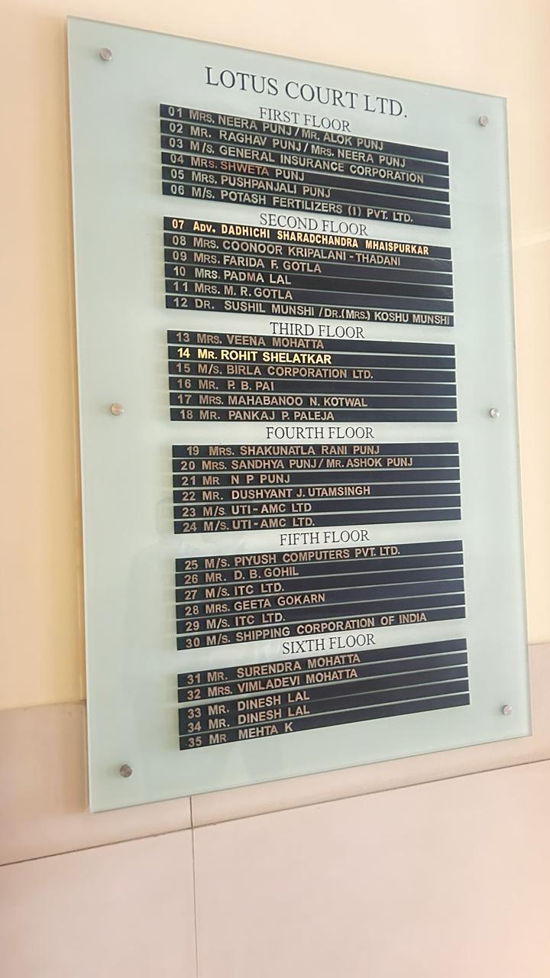

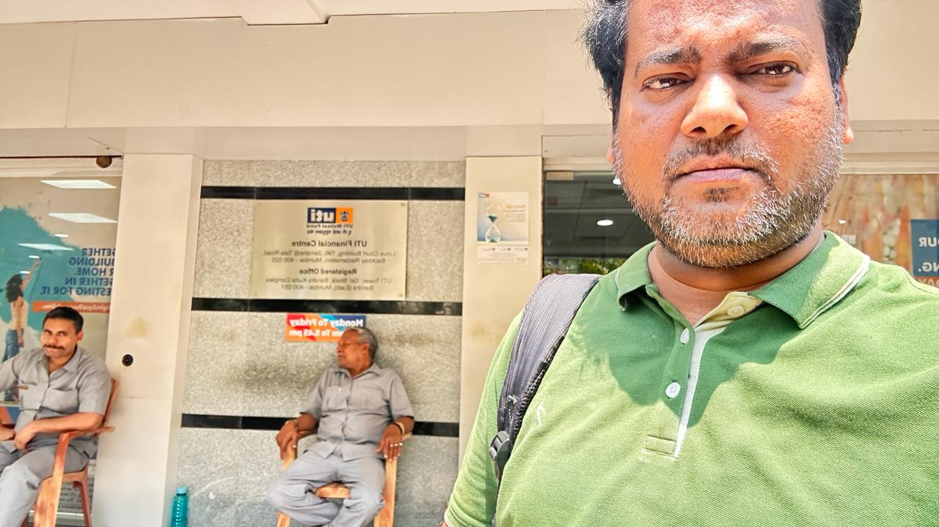

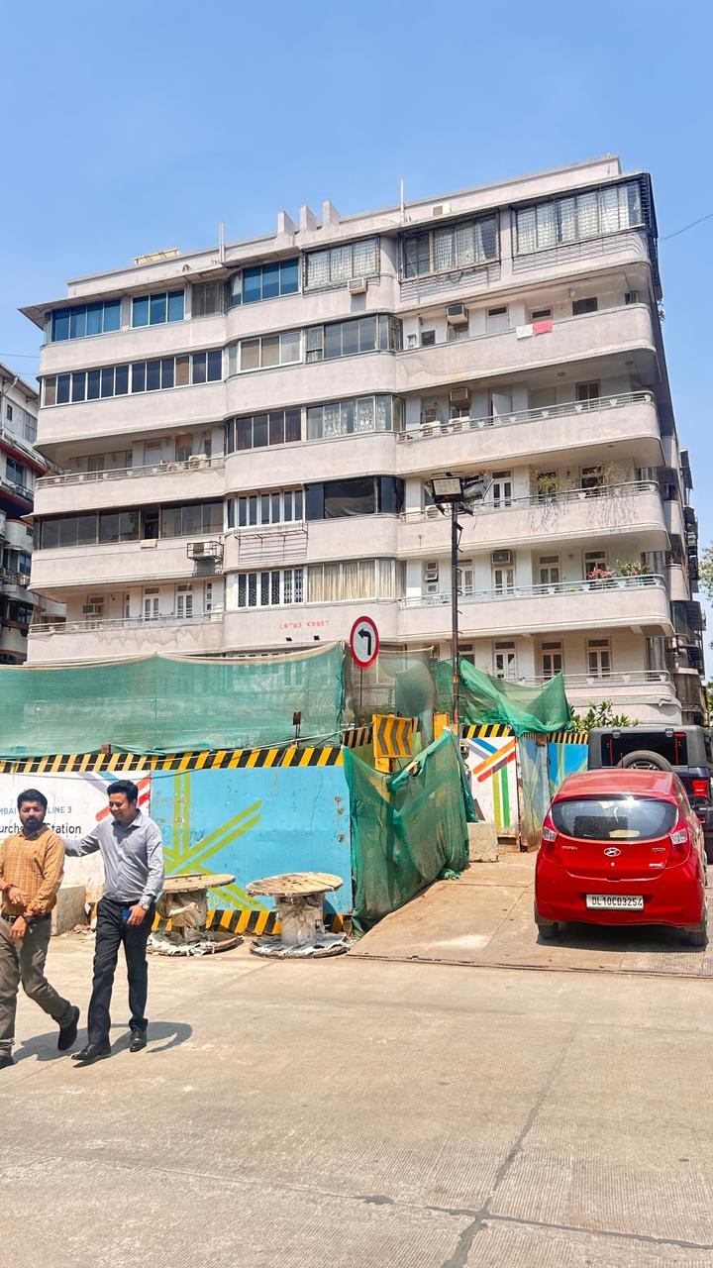

Route Map of the property
(Site url)
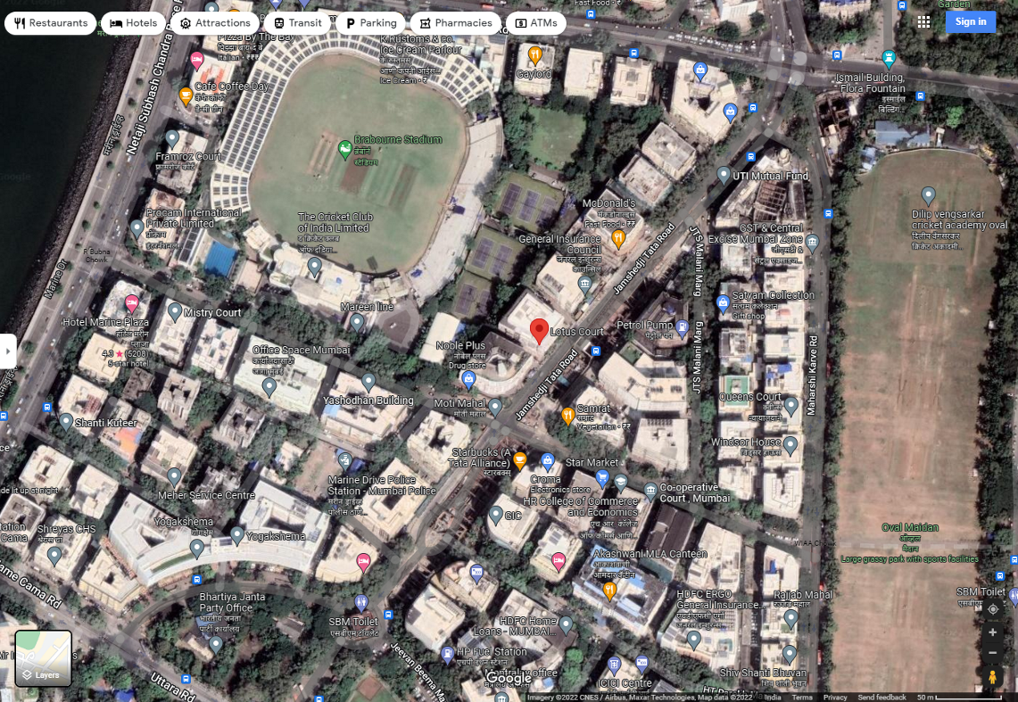

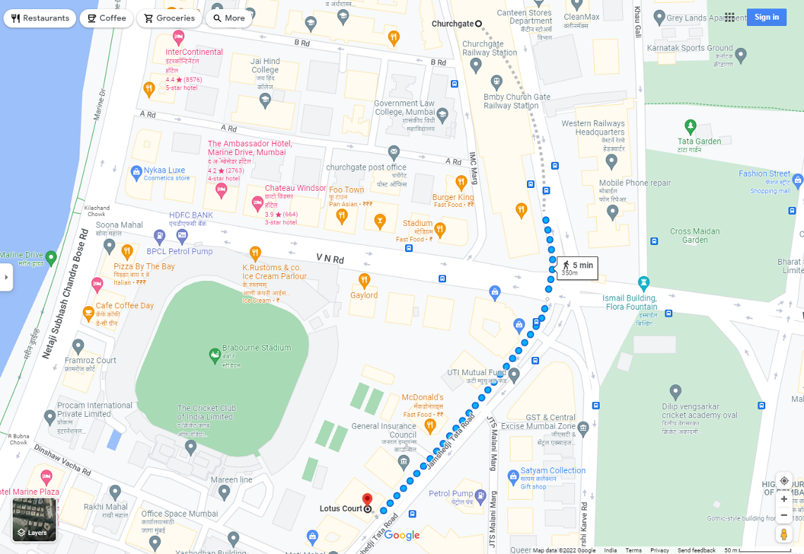

Longitude Latitude: 18°55’51.6”N 72°49’34.2”E
Note: The Blue line shows the route to site from nearest railway station (Churchgate – 350 M.)
Ready Reckoner
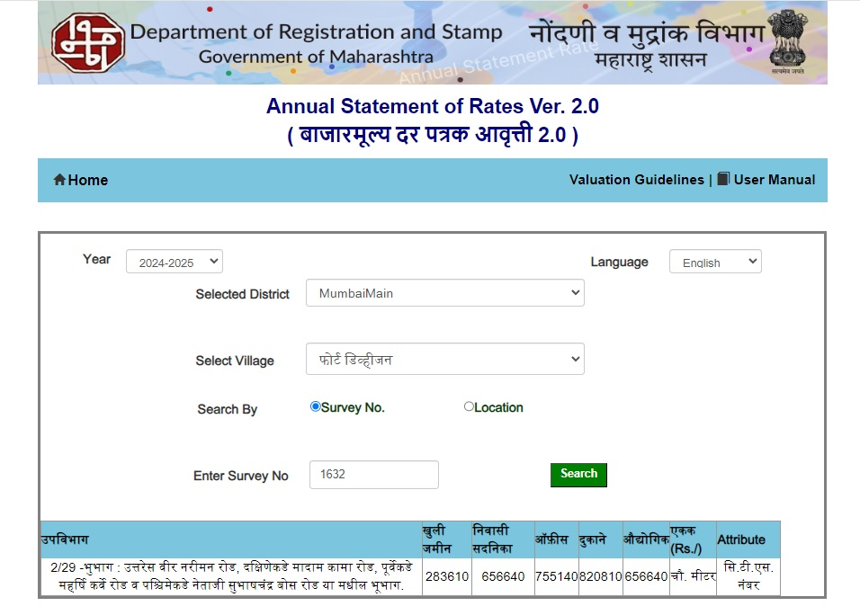

Stamp Duty Ready Reckoner Market Value Rate for Flat | 6,56,640.00
No increase for all floors from ground to 4 floors | -
Stamp Duty Ready Reckoner Market Value Rate (After Increase) (A) | 6,56,640.00 | Sq. Mtr. | 61,003.00 | Sq. Ft.
Stamp Duty Ready Reckoner Market Value Rate for Land (B) | 2,83,610.00
The difference between land rate and building rate (A – B = C) | 3,73,030.00
Depreciation Percentage as per table (D) [100% - 75%]  (Age of the Building – 75 Years) maximum deduction 70% | 70%
Rate to be adopted after considering depreciation [B + (C x D)] | 3,95,519.00 | Sq. Mtr. | 36,745.00 | Sq. Ft.

Multi-Storied building with Lift
For residential premises / commercial unit / office on above floor in multistoried building, the rate mentioned in the ready reckoner will be increased as under:

 | Location of Flat / Commercial Unit in the building | Rate
a) | On Ground to 4 Floors | No increase for all floors from ground to 4 floors
b) | 5 Floors to 10 Floors | Increase by 5% on units located between 5 to 10 floors
c) | 11 Floors to 20 Floors | Increase by 10% on units located between 11 to 20 floors
d) | 21 Floors to 30 Floors | Increase by 15% on units located between 21 to 30 floors
e) | 31 Floors and above | Increase by 20% on units located on 31 and above floors

Table – D: Depreciation Percentage Table

Completed Age of Building in Years | Value in percent after depreciation
 | R.C.C. Structure / other Pukka Structure | Cessed Building, Half or Semi – Pukka Structure & Kaccha Structure.
0 to 2 Years | 100% | 100%
Above 2 & up to 5 Years | 95% | 95%
Above 5 Years | After initial 5 year for every year 1% depreciation is to be considered. However maximum deduction available as per this shall be 70% of Market Value rate | After initial 5 year for every year 1.5% depreciation is to be considered. However maximum deduction available as per this shall be 85% of Market Value rate
Price Indicators
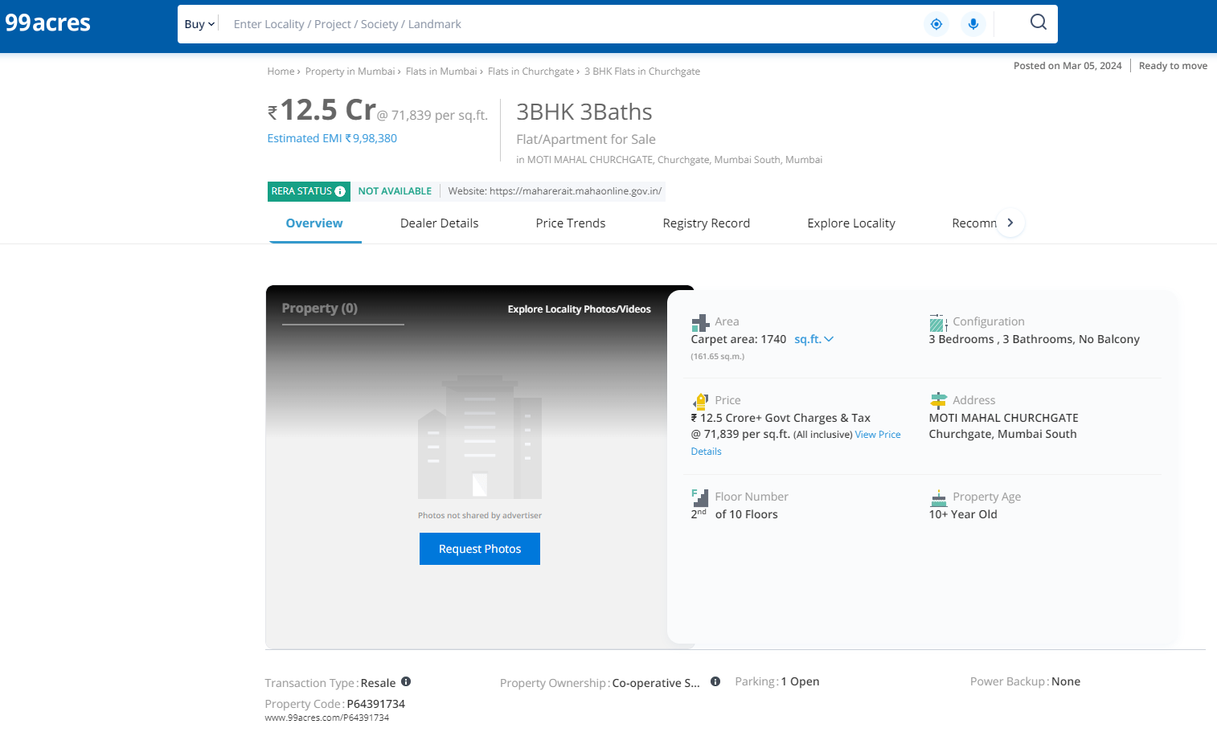
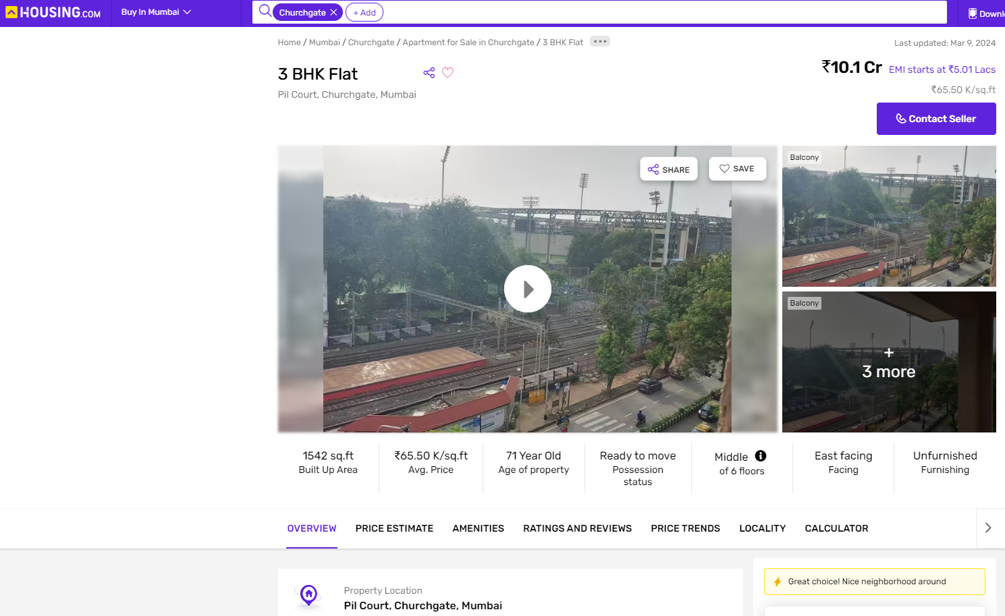

As a result of my appraisal and analysis, it is my considered opinion that of the above property in the prevailing condition with aforesaid specifications is ` 10,26,97,000.00 (Rupees Ten Crore Twenty Six Lakh Ninety Seven Thousand Only). The Realizable Value of the above property is ` 9,24,27,300.00 (Rupees Nine Crore Twenty Four Lakh Twenty Seven Thousand Three Hundred Only). The Distress Value ` 8,21,57,600.00 (Rupees Eight Crore Twenty One Lakh Fifty Seven Thousand Six Hundred Only). The Rental Value ` 2,19,000.00 (Rupees Two Lakh Nineteen Thousand Only).

Place: Thane
Date: 10.04.2024

Manoj B. Chalikwar
Registered Valuer
Chartered Engineer (India)
Reg. No. IBBI / RV / 07/2018/10366
Reg. No. CAT-I-F-1763

Sr.  No. | Particulars | Valuer comment
 | background information of the asset being valued; | The property under consideration was owned by UTI Asset Management Company Limited vide Deed of Transfer dated 08.07.2010.
 | purpose of valuation and appointing authority | As per the request of UTI Asset Management Company Limited, BKC – Bandra (East) Branch to assess fair market value of the property for
 | identity of the valuer and any other experts involved in the valuation; | Manoj B. Chalikwar – Regd. Valuer  Avinash Pandey – Valuation Engineer  Pratibha Shilvanta – Technical Officer  Shyam Kajvilkar– Technical Manager
 | disclosure of valuer interest or conflict, if any; | We have no interest, either direct or indirect, in the property valued. Further to state that we do not have relation or any connection with property owner / applicant directly or indirectly. Further to state that we are an independent Valuer and in no way related to property owner / applicant
 | date of appointment, valuation date and date of  report; | Date of Appointment – 04.04.2024  Valuation Date – 10.04.2024  Date of Report – 10.04.2024
 | inspections and/or investigations undertaken; | Physical Inspection done on 04.04.2024
 | nature and sources of the information used or relied upon; | - Market Survey at the time of site visit  - Ready Reckoner rates / Circle rates  - Online search for Registered Transactions  - Online Price Indicators on real estate portals  - Enquiries with Real estate consultants  - Existing data of Valuation assignments carried out by us
 | Procedures adopted in carrying out the valuation and valuation standards followed; | Sales Comparison Method
 | restrictions on use of the report, if any; | This valuation is for the use of the party to whom it is addressed and for no other purpose. No responsibility is accepted to any third party who may use or rely on the whole or any part of this valuation. The valuer has no pecuniary interest that would conflict with the proper valuation of the property.
 | major factors that were taken into account during the valuation; | current market conditions, demand and supply position, Residential Flat size, location, upswing in real estate prices, sustained demand for Residential Flat, all-round development of commercial and Commercial application in the locality etc.
 | Caveats, limitations and disclaimers to the extent they explain or elucidate the limitations faced by valuer, which shall not be for the purpose of limiting his responsibility for the valuation report. | Attached

Assumptions, Disclaimers, Limitations & Qualifications
Value Subject to Change
The subject appraisal exercise is based on prevailing market dynamics as on 10th April 2024 and does not take into account any unforeseeable developments which could impact the same in the future.
Our Investigations
We are not engaged to carry out all possible investigations in relation to the subject property. Where in our report we identify certain limitations to our investigations, this is to enable the reliant party to instruct further investigations where considered appropriate or where we recommend as necessary prior to reliance. Vastukala Consultants India Pvt. Ltd. (VCIPL) is not liable for any loss occasioned by a decision not to conduct further investigations
Assumptions
Assumptions are a necessary part of undertaking valuations. VCIPL adopts assumptions for the purpose of providing valuation advice because some matters are not capable of accurate calculations or fall outside the scope of our expertise, or out instructions. The reliant party accepts that the valuation contains certain specific assumptions and acknowledge and accept the risk of that if any of the assumptions adopted in the valuation are incorrect, then this may have an effect on the valuation.
Information Supplied by Others
The appraisal is based on the information provided by the client. The same has been assumed to be correct and has been used for appraisal exercise. Where it is stated in the report that another party has supplied information to VCIPL, this information is believed to be reliable but VCIPL can accept no responsibility if this should prove not to be so.
Future Matters
To the extent that the valuation includes any statement as to a future matter, that statement is provided as an estimate and/or opinion based on the information known to VCIPL at the date of this document. VCIPL does not warrant that such statements are accurate or correct.
Map and Plans
Any sketch, plan or map in this report is included to assist the reader while visualising the property and assume no responsibility in connection with such matters.
Site Details
Based on inputs received from Client's representative and site visit conducted, we understand that the subject property is Residential Flat, admeasuring Built up Area in Sq. Ft. = 1,726.00 in the name of UTI Asset Management Company Limited Further, VCIPL has assumed that the subject property is free from any encroachment and is available as on the date of the appraisal.
Property Title
Based on our discussion with the Client, we understand that the subject property is owned by UTI Asset Management Company Limited For the purpose of this appraisal exercise, we have assumed that the subject property has a clear title and is free from any encumbrances, disputes and claims. VCIPL has made no further enquiries with the relevant local authorities in this regard and does not certify the property as having a clear and marketable title. Further, no legal advice regarding the title and ownership of the subject property has been obtained for the purpose of this appraisal exercise. It has been assumed that the title deeds are clear and marketable.

Environmental Conditions
We have assumed that the subject property is not contaminated and is not adversely affected by any existing or proposed environmental law and any processes which are carried out on the property are regulated by environmental legislation and are properly licensed by the appropriate authorities.
Area
Based on the information provided by the Client's representative, we understand that the Residential Flat, admeasuring Built up Area in Sq. Ft. = 1,726.00
Condition & Repair
In the absence of any information to the contrary, we have assumed that there are no abnormal ground conditions, nor archaeological remains present which might adversely affect the current or future occupation, development or value of the property. The property is free from rat, infestation, structural or latent defect. No currently known deleterious or hazardous materials or suspect techniques will be used in the construction of or subsequent alteration or additions to the property and comments made in the property details do not purport to express an opinion about, or advise upon, the condition of uninspected parts and should not be taken as making an implied representation or statement about such parts
Valuation Methodology
For the purpose of this valuation exercise, the valuation methodology used is Direct Comparison Approach Method and proposed Highest and Best Use model is used for analysing development potential.
The Direct Comparison Approach involves a comparison of the property being valued to similar properties that have actually been sold in arms - length transactions or are offered for sale. This approach demonstrates what buyers have historically been willing to pay (and sellers willing to accept) for similar properties in an open and competitive market and is particularly useful in estimating the value of the Flat and properties that are typically traded on a unit basis.
In case of inadequate recent transaction activity in the subject micro-market, the appraiser would collate details of older transactions. Subsequently, the appraiser would analyse rental / capital value trends in the subject micro-market in order to calculate the percentage increase / decrease in values since the date of the identified transactions. This percentage would then be adopted to project the current value of the same.
Where reliance has been placed upon external sources of information in applying the valuation methodologies, unless otherwise specifically instructed by Client and/or stated in the valuation, VCIPL has not independently verified that information and VCIPL does not advise nor accept it as reliable. The person or entity to whom the report is addressed acknowledges and accepts the risk that if any of the unverified information in the valuation is incorrect, then this may have an effect on the valuation.
Not a Structural Survey
We state that this is a valuation report and not a structural survey
Other
All measurements, areas and ages quoted in our report are approximate
Legal
We have not made any allowances with respect to any existing or proposed local legislation relating to taxation on realization of the sale value of the subject property. VCIPL is not required to give testimony or to appear in court by reason of this appraisal report, with reference to the property in question, unless arrangement has been made thereof. Further, no legal advice on any aspects has been obtained for the purpose of this appraisal exercise

Property specific assumptions
Based on inputs received from the client and site visit conducted, we understand that the subject property is Residential Flat, admeasuring Built up Area in Sq. Ft. = 1,726.00.

ASSUMPTIONS, CAVEATS, LIMITATION AND DISCLAIMERS
- We assume no responsibility for matters of legal nature affecting the property appraised or the title thereto, nor do we render our opinion as to the title, which is assumed to be good and marketable.
- The property is valued as though under responsible ownership.
- It is assumed that the property is free of liens and encumbrances.
- It is assumed that there are no hidden or unapparent conditions of the subsoil or structure that would render it more or less valuable. No responsibility is assumed for such conditions or for engineering that might be required to discover such factors.
- There is no direct/ indirect interest in the property valued.
- The rates for valuation of the property are in accordance with the Govt. approved rates and prevailing market rates.

Manoj B. Chalikwar
Registered Valuer
Chartered Engineer (India)
Reg. No. IBBI / RV / 07/2018/10366
Reg. No. CAT-I-F-1763

