Vastu/Nashik/04/2024/008173/2305919
10/3-58-RYBS
Date: 10.04.2024

To,
The Branch Manager,
Union Bank of India
Govind Nagar Branch
1,2,3,4 Thakkar Enclave, B/H/ Karmayogi Nagar, Govind Nagar,
Nashik - 422 008, State - Maharashtra, Country - lndia.

Sub: Vetting of Extra Work

Sir,

With reference to above subject, we have evaluated the Extra Work For Residential Flat No. 302, Third Floor, “ Ashapuri Imperial ”, Survey No. 866/ B/ 50, Plot No. 50A+50B, Behind Vinay Nagar Police Station, Deepali Nagar, Wadala - Pathardi Road, Village – Nashik, Taluka & District – Nashik, Nashik - 422 009, State – Maharashtra, Country – India. belongs to Name of Owner: Yogita Mahendra Nikam.

We have verified the rates quoted as per current market rates. Details of Extra Work considered as per copy of Cost Sheet Agreement between Yogita Mahendra Nikam. (First Party). Mr. Deepak Keshav Rajput (Second Party) received on dated.20.03.2024. The Extra Work amount is Rs. 7,50,000/- (Rupees Seven Lakh Fifty Thousand Only)

The said Cost Vetting Certificate is valid upto next 6 months Only.

Thanking you

Sincerely yours

Sharadkumar B. Chalikwar
Registered Valuer
Chartered Engineer (India)
Reg. No. CAT-I-F-1763
UBI Emp No. ROS: ADV: Valuer/033:008:2021-22
.

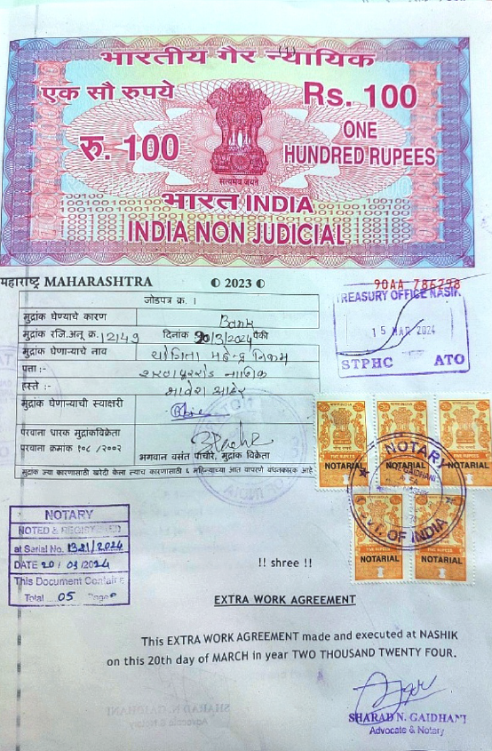
Agreement for Extra Work
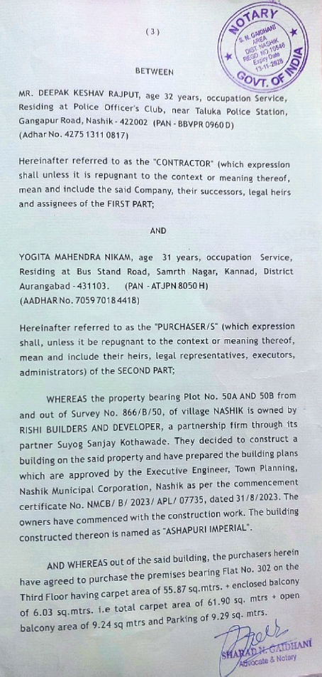

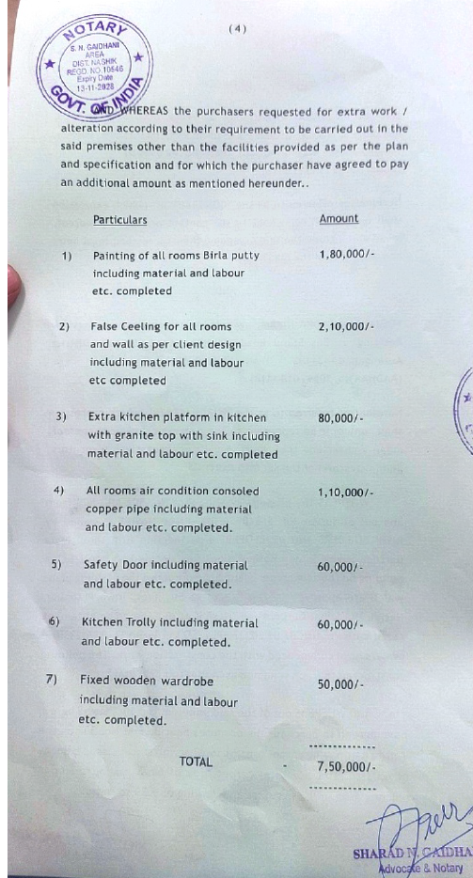
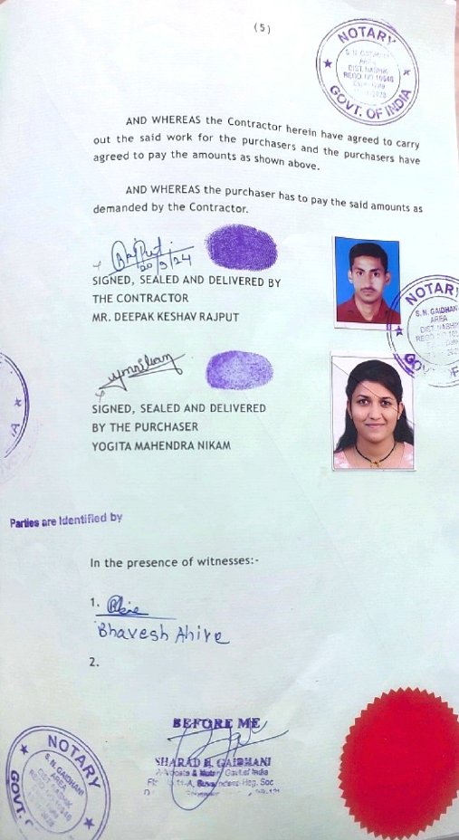

The Extra Work amount is Rs. 7,50,000/- (Rupees Seven Lakh Fifty Thousand Only)

