Vastu/Nashik/04/2024/008172/2305939
11/14-78-RYBS
Date: 11.04.2024

To,
State Bank of India
Adgaon Branch
Vibhuti, Plot No. 1, Survey No.501, Nashik-Agra Road, Adgaon Shivar,
Nashik - 422003, State – Maharashtra, Country – India.

Sub: Vetting of Estimate

Sir,

With reference to above subject, we have evaluated the Estimate for Residential Land and Row House on Plot No.27, Proposed Ground + First Floor, Survey No.229/1, Near Siddhivinyak Park, Asha Nagar, Rasbihari Link Road, Village – Nashik, Pincode – 422 003, Taluka & District – Nashik, State – Maharashtra, Country – India belongs to Shri. Samadhan Sunil Gurav.

We have verified the rates quoted as per current market rates. Details of Estimate considered as per copy of Estimate Provided by Lab Associates received on dated.10.04.2024. The Estimate amount is Rs.29,00,000/- (Rupees Twenty-Nine Lakh Only.)

Note:1) The said Cost Vetting Certificate is valid upto next 6 months Only.

Thanking you

Sincerely yours

Manoj B. Chalikwar
Registered Valuer
Chartered Engineer (India)
Reg. No. CAT-I-F-1763
Reg. No. IBBI/RV/07/2018/10366
BOB Empanelment No.: ZO:MZ:ADV:46:941
Encl: Valuation Report

Estimate
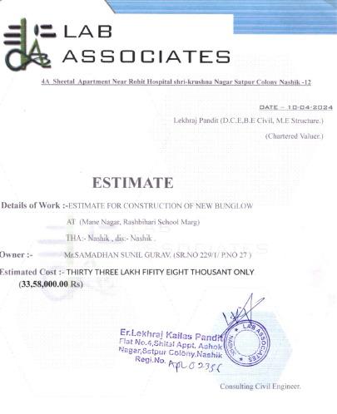
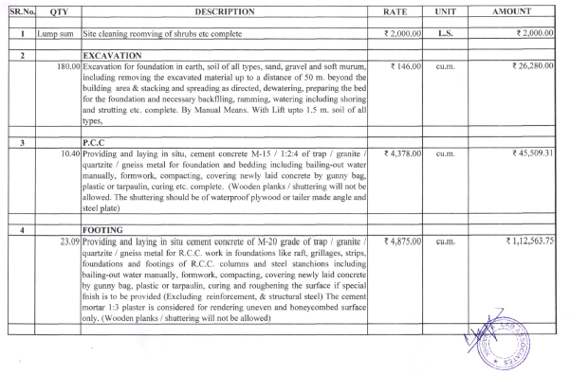

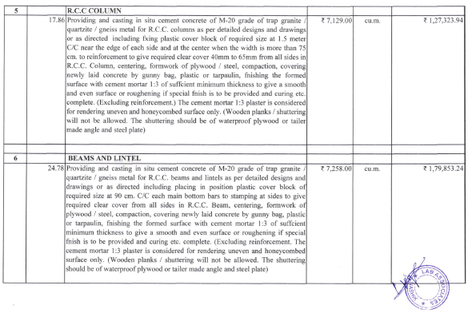
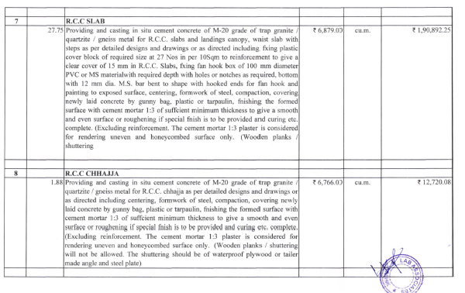

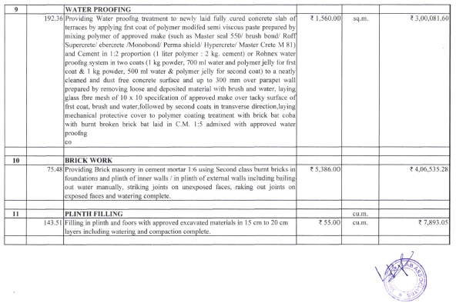
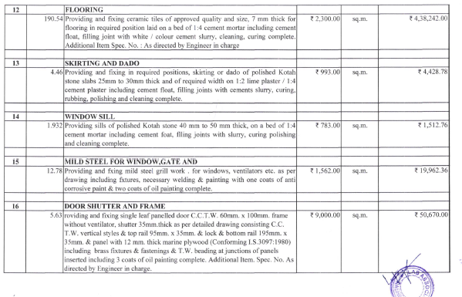

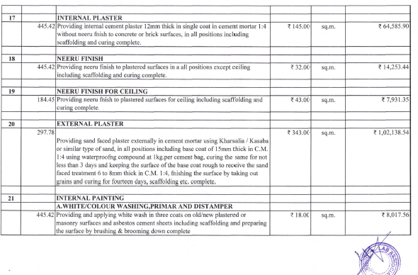
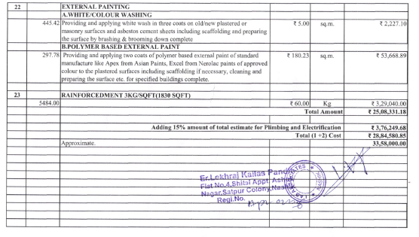

The Estimate amount is Rs.29,00,000/- (Rupees Twenty-Nine Lakh Only.)

