Vastu/Nashik/03/2023833/30490/46262
22/24-455-SGV
Date: 04.04.2024

To,
The Branch Manager,
State Bank of India
RACC Nashik Branch
RBO.2, The Wave Building, 1st Floor, Opposite Shell Petrol Pump,
Pathardi Road,Nashik – 422 010, State – Maharashtra, Country – India.

Sub: Vetting of Estimate
Sir,

With reference to above subject, we have evaluated the Estimates for Residential Land and Proposed Bungalow on Plot No.18, Ground + First Floor, Gat No.2245/A,Near MVP Samaj Arts,Vijay Nagar , Shejwalwadi, At - Ozar ( Mig ) , Pincode – 422 206, Taluka – Niphad , District – Nashik, State – Maharashtra, Country – India belongs to Shri.Nanasaheb Sahebrao Waghmare & Shri.Ramdas Sahebrao Waghmare.

We have verified the rates quoted as per current market rates. Details of Estimates considered as per copy of Estimate Provided by Anand Sonawane & Associates received on dated 04.04.2024. The Estimate amount is Rs.15,00,000/- ( Rupees Fifteen Lakh Only. )

The said Cost Vetting Certificate is valid upto next 6 months Only.

Thanking you

Sincerely yours

Manoj B. Chalikwar
Registered Valuer
Chartered Engineer (India)
Reg. No. CAT-I-F-1763
SBI Empanelment No.: SME/TCC/2021-22/86/3

Estimate
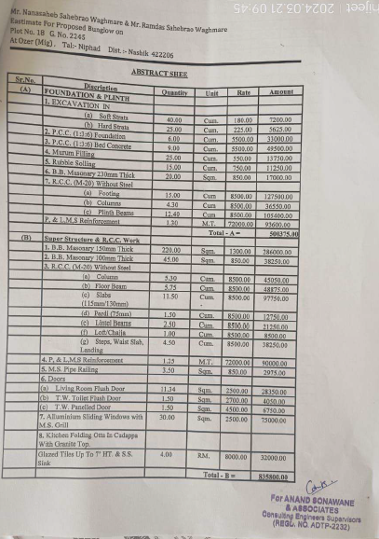
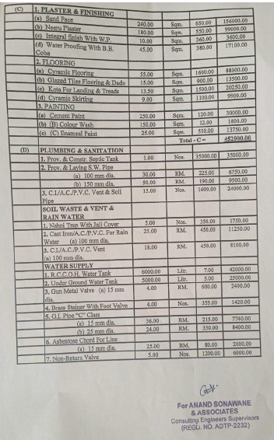

Estimate

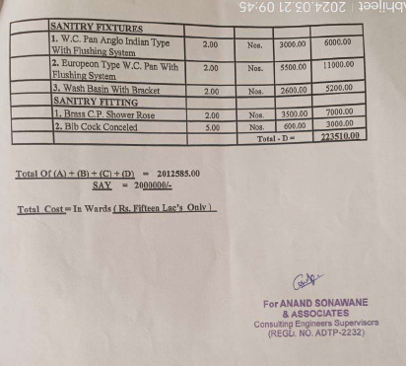

Rs.15,00,000/- ( Rupees Fifteen Lakh Only. )

