1st LENDERS INDEPENDENT ENGINEER REPORT

**Details of the property under consideration:**

**Name of Project: “Shankeshwar Heights”**

**"Shankeshwar Heights", Proposed Slum Rehabilitation Scheme on Plot bearing CTS. No. 576, 576/1 to 15, 578, 578/1 to 11, 579, 579/1 to 15 & 580, Patil Gulli, Purav Marg, Village – Kurla – 3, Chunabhatti, Sion (West), Mumbai – 400 022, State – Maharashtra, Country – India**

**Latitude Longitude: 19°03'08.4"N 72°52'14.5"E**

Intended User:

State Bank of India

SME Chembur Branch

Unit No. 11, Building No. 11, Ground Floor, Corporate Park, Sion Trombay Road,

Chembur, Mumbai, Pin Code – 400 071, State - Maharashtra, Country – India

Vastu/SBI/Mumbai/04/2024/8088/2305874

03/02-13-PY

Date: - 28.02.2024

FIRST LENDERS INDEPENDENT ENGINEER REPORT

**To,**

**State Bank of India**

SME Chembur Branch

Unit No. 11, Building No. 11,

Ground Floor, Corporate Park,

Sion Trombay Road, Chembur,

Mumbai, Pin Code – 400 071,

State - Maharashtra, Country – India

Subject: Construction of Proposed Slum Rehabilitation Scheme on Plot bearing CTS. No. 576, 576/1 to 15, 578, 578/1 to 11, 579, 579/1 to 15 & 580, Patil Gulli, Purav Marg, Village – Kurla – 3, Chunabhatti, Sion (West), Mumbai – 400 022, State – Maharashtra, Country – India.

**Ref:** You’re Request for Lenders Independent Engineer Report of under Construction Building.

**Dear Sir,**

1. As per your instruction, we have inspected the under-construction Proposed Slum Rehabilitation Scheme on Plot bearing CTS. No. 576, 576/1 to 15, 578, 578/1 to 11, 579, 579/1 to 15 & 580, Patil Gulli, Purav Marg, Village – Kurla – 3, Chunabhatti, Sion (West), Mumbai – 400 022, State – Maharashtra, Country – India which is being developed by M/s. Siddheshwar Construction Co. in order to give the physical progress at site and to certify cost incurred towards project as on 31/01/2024.
2. **The Construction work as per approved plan was in progress during the site visit on 06th February 2024.**
3. **Status of work:**
4. **For Sales Building (Wing B & C):** 21st floor slab work is completed, Ground to 10th Floor Blockwork, 1st to 4th Floor plaster work, Door frames & windows frames are completed. 22nd floor slab work is in progress.
5. **For Rehab Building (Wing D):** 21st floor slab work is completed, Ground to 12th Floor Blockwork, 1st to 4th Floor plaster work, Door frames & windows frames are completed. 22nd floor slab work is in progress.
6. As per cost incurred certificate issued by **CA Certificate actual total expenditure occurred as on 31/12/2023 is ` 71.35 Cr. for Sale Building (Wing B & C) & Rehab Building (wing D) is proposed of Ground Floor + 1st to 22nd Upper Floors.**
7. **Overall financial progress as per C.A. certificate including land cost as on 31/12/2024 is 67.98% estimated cost of project.**
8. Overall Physical progress of the sale building construction as on 06/02/2024 is 54.46% as per physical site inspection.
9. Overall Physical progress of the sale building construction including Other Material on Site as on 06/02/2024 is 68.30%.
10. Construction Cost of the sale building construction including other material on site & Advance payment to the Vendors till 31/01/2024 is 74.23% as per bills.

**DECLARATION**

1. The information furnished in the report is based on our 1st site visit Dated 06/02/2024 & Document Provided by Client.
2. Vastukala Cost Vetting Report dated 28/02/2024.
3. I have no direct and indirect interest in the property examined for report.
4. I have not been found guilty of misconduct in my professional capacity.

**Sharadkumar B. Chalikwar**

Govt. Reg. Valuer

Chartered Engineer (India)

Reg. No. (N) CCIT/1-14/52/2008-09

Encl.: LIE report

# Purpose & Methodology

• State Bank of India Banks and financial institutions require monitoring & an independent review of the progress of the sanctioned projects

**VCIPL** undertakes such study to independently review the progress of the project and put forward a comprehensive analysis

# Advantages:

* Assurance on present practices
* Identification of risk
* Analyzing the performance of third parties
* Recommendations

# The Methodology

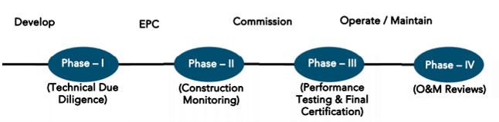

**FIRST LENDERS INDEPENDENT ENGINEER REPORT**

**OF**

**"SHANKESHWAR HEIGHTS"**

**"Shankeshwar Heights", Proposed Slum Rehabilitation Scheme on Plot bearing CTS. No. 576, 576/1 to 15, 578, 578/1 to 11, 579, 579/1 to 15 & 580, Patil Gulli, Purav Marg, Village – Kurla – 3, Chunabhatti, Sion (West), Mumbai – 400 022, State – Maharashtra, Country – India.**

**Latitude Longitude: 19°03'08.4"N 72°52'14.5"E**

**NAME OF DEVELOPER: M/s. DGS Township Pvt. Ltd.**

|  |
| --- |
| Pursuant to instructions from State of India, SME Chembur Branch, Chembur we have duly visited, inspected, surveyed & assessed the above said property on **06th February 2024** to determine the fair & reasonable market value of the said property/project as on Quarter ending **31st January 2024** for LIE purpose.  **1. Location Details:**  Proposed Slum Rehabilitation Scheme on Plot bearing CTS. No. 576, 576/1 to 15, 578, 578/1 to 11, 579, 579/1 to 15 & 580, Patil Gulli, Purav Marg, Village – Kurla – 3, Chunabhatti, Sion (West), Mumbai – 400 022. It is about 400 M. travelling distance from Chunnabatti Railway station. Surface transport to the property is by buses, taxis & private vehicles. The property is in developed locality. All the amenities like shops, banks, hotels, markets, schools, hospitals, etc. are all available in the surrounding locality. The area is higher middle class & developed. |

**2. Developer Details:**

|  |  |
| --- | --- |
| **Name of builder** | **M/s. Siddheshwar Construction Co.** |
| **Project Rera Registration Number** | **P519000186161** |
| **Registered office address** | Shop No. 6, Aditya Hertiage Building, V N Purav Marg, Sion, Chunnabatti, Mumbai – 400 022, State - Maharashtra, Country – India |
| **Contact details** | **Contact Person:**  Mr. Prabudh Khandelwal (Consultants)  Mobile No. 7738001775  Mr. Deep Shah (Consultants)  Mobile No. 7977861026 |
| **E – mail ID and website** |  |

**3. Boundaries of the Property:**

|  |  |
| --- | --- |
| **Direction** | **Particulars** |
| **On or towards North** | Slum Area |
| **On or towards South** | Wing A |
| **On or towards East** | Patil Galli |
| **On or towards West** | RKS House & Slum Area |

# Introduction

**As per Information on site M/s. Siddheshwar Construction Co.** has acquired land by Conveyance Deed & multiple Surrender Deed from Tenant’s admeasuring **area is 2,163.00 Sq. M.** bearing **CTS. No. 576, 576/1 to 15, 578, 578/1 to 11, 579, 579/1 to 15 & 580.** For the Proposed Residential (Rehab cum Sale) Building.

# List of Approvals:

1. Copy of Approved Plan No. SRA/ENG/L/PVT/007712018/206/AP dated 17.01.2022 issued by Slum Rehabilitation Authority (SRA)

Approved Upto: - (Wing B, C & D) – Ground Floor + 1st to 22nd Upper Floors

1. Copy of 1st Commencement Certificate No. L/PVT/0077/20181206/AP/C dated 17.06.2021 issued by Slum Rehabilitation Authority (SRA)

This is C. C. is granted upto plinth level of sale wing B & C and rehab wing D of composite building as per last approved plan dated 08.02.2021.

1. Copy of 2nd Commencement Certificate No. L/PVT/0077/20181206/AP/C dated 01.07.2022 issued by Slum Rehabilitation Authority (SRA)

This is C. C. is granted upto Ground Floor + 1st to 9th floor + OHWT + LMR of sale wing B & C and Ground Floor + 1st to 17th Upper floors for rehab wing D of composite building as per last approved plan dated 17.01.2022.

# LEVEL OF COMPLETION:

**For Sales Building (Wing B & C): 21st floor slab work is completed, Ground to 10th Floor Blockwork, 1st to 4th Floor plaster work, Door frames & windows frames are completed. 22nd floor slab work is in progress.**

**For Rehab Building (Wing D): 21st floor slab work is completed, Ground to 12th Floor Blockwork, 1st to 4th Floor plaster work, Door frames & windows frames are completed. 22nd floor slab work is in progress.**

# Sales Building (Wing B & C)

| Sr. | Floor No. | Construction Area in Sq. M. | Completed Area in Sq. M. | Work Completion as on 16.03.2024 |
| --- | --- | --- | --- | --- |
| 1 | Excavation & Shore Piling | | | Work is completed |
| 2 | Ground Floor | 279.80 | 279.80 | Slab work is completed |
| 3 | 1st Floor | 349.90 | 349.90 | Slab work, block work, plaster work, door & windows frames work are completed |
| 4 | 2nd Floor | 451.11 | 451.11 | Slab work, block work, plaster work, door & windows frames work are completed |
| 5 | 3rd Floor | 451.11 | 451.11 | Slab work, block work, plaster work, door & windows frames work are completed |
| 6 | 4th Floor | 451.11 | 451.11 | Slab work, block work, plaster work, door & windows frames work are completed |
| 7 | 5th Floor | 451.11 | 451.11 | Slab work, block work, door & windows frames work are completed |
| 8 | 6th Floor | 451.11 | 451.11 | Slab work, block work, door & windows frames work are completed |
| 9 | 7th Floor | 451.11 | 451.11 | Slab work, block work, door & windows frames work are completed |
| 10 | 8th Floor | 451.11 | 451.11 | Slab work, block work, door & windows frames work are completed |
| 11 | 9th Floor | 451.11 | 451.11 | Slab work, block work, door & windows frames work are completed |
| 12 | 10th Floor | 451.11 | 451.11 | Slab work, block work, door & windows frames work are completed |
| 13 | 11th Floor | 451.11 | 451.11 | Slab work is completed |
| 14 | 12th Floor | 451.11 | 451.11 | Slab work is completed |
| 15 | 13th Floor | 451.11 | 451.11 | Slab work is completed |
| 16 | 14th Floor | 451.11 | 451.11 | Slab work is completed |
| 17 | 15th Floor | 451.11 | 451.11 | Slab work is completed |
| 18 | 16th Floor | 451.11 | 451.11 | Slab work is completed |
| 19 | 17th Floor | 451.11 | 451.11 | Slab work is completed |
| 20 | 18th Floor | 451.11 | 451.11 | Slab work is completed |
| 21 | 19th Floor | 451.11 | 451.11 | Slab work is completed |
| 22 | 20th Floor | 451.11 | 451.11 | Slab work is completed |
| 23 | 21st Floor | 451.11 | 451.11 | Slab work is completed |
| 24 | 22nd Floor | 451.11 |  |  |
| 25 | Terrace Floor / OHT / LMR | 103.13 |  |  |
| Total | | 10,206.14 | 9,651.90 |  |

# Rehab Building (Wing D)

| Sr. | Floor No. | Construction Area in Sq. M. | Completed Area in Sq. M. | Work Completion as on 16.03.2024 |
| --- | --- | --- | --- | --- |
| 1 | Excavation & Shore Piling | | | Work is completed |
| 2 | Ground Floor | 486.07 | 486.07 | Slab work is completed |
| 3 | 1st Floor | 514.07 | 514.07 | Slab work, block work, plaster work, door & windows frames work are completed |
| 4 | 2nd Floor | 514.07 | 514.07 | Slab work, block work, plaster work, door & windows frames work are completed |
| 5 | 3rd Floor | 514.07 | 514.07 | Slab work, block work, plaster work, door & windows frames work are completed |
| 6 | 4th Floor | 459.08 | 459.08 | Slab work, block work, plaster work, door & windows frames work are completed |
| 7 | 5th Floor | 459.08 | 459.08 | Slab work, block work, door & windows frames work are completed |
| 8 | 6th Floor | 465.64 | 465.64 | Slab work, block work, door & windows frames work are completed |
| 9 | 7th Floor | 459.08 | 459.08 | Slab work, block work, door & windows frames work are completed |
| 10 | 8th Floor | 459.08 |  | Slab work, block work, door & windows frames work are completed |
| 11 | 9th Floor | 459.08 |  | Slab work, block work, door & windows frames work are completed |
| 12 | 10th Floor | 459.08 |  | Slab work, block work, door & windows frames work are completed |
| 13 | 11th Floor | 459.08 |  | Slab work, block work, door & windows frames work are completed |
| 14 | 12th Floor | 459.08 |  | Slab work, block work, door & windows frames work are completed |
| 15 | 13th Floor | 465.64 |  | Slab work is completed |
| 16 | 14th Floor | 459.08 |  | Slab work is completed |
| 17 | 15th Floor | 459.08 |  | Slab work is completed |
| 18 | 16th Floor | 459.08 |  | Slab work is completed |
| 19 | 17th Floor | 459.08 |  | Slab work is completed |
| 20 | 18th Floor | 459.08 |  | Slab work is completed |
| 21 | 19th Floor | 459.08 |  | Slab work is completed |
| 22 | 20th Floor | 468.19 |  | Slab work is completed |
| 23 | 21st Floor | 459.08 |  | Slab work is completed |
| 24 | 22nd Floor | 459.08 |  |  |
| 25 | Terrace Floor / OHT / LMR | 114.39 |  |  |
| Total | | 16,405.79 | 1,81,710.40 |  |

# Details of the Project as Financed By SBI:

# Estimated Project Cost: (As per Cost Vetting Report)

|  |  |
| --- | --- |
| **Particulars** | **Estimated Cost (in Cr.)** |
| Land & Stamp Cost | 6.37 |
| Rent Cost | 16.31 |
| Construction Cost of Rehab cum Sale Building | 57.79 |
| Approval Cost including Premium Cost / FSI / GOM Charges / fees & TDR Cost | 5.29 |
| Architect Cost, RCC & Other Professional Cost | 2.31 |
| Administrative Cost | 2.89 |
| Marketing Cost | 2.55 |
| Interest Cost (Bank Loan) | 9.72 |
| Contingency Cost | 1.73 |
| **Total** | **104.96** |

# Project Cost: (as per C.A. Certificate)

|  |  |
| --- | --- |
| **Particulars** | **Incurred Cost (In Cr.) till 31.12.2024 by M/s. S M Bhat & Associates** |
| Land & Stamp Cost | 6.53 |
| Rent Cost | 9.34 |
| Construction Cost of Rehab cum Sale Building | 40.76 |
| Approval Cost including Premium Cost / FSI / GOM Charges / fees & TDR Cost | 4.90 |
| Architect Cost, RCC & Other Professional Cost | 1.98 |
| Administrative Cost | 2.20 |
| Marketing Cost | 2.30 |
| Interest Cost (Bank Loan) | 2.43 |
| Contingency Cost | 0.91 |
| **Total** | **71.35** |

* **The Builder has incurred about 6.53 Cr. as land cost, 9.34 Cr. as Rent Cost, 40.76 Cr. as construction cost of Rehab cum Sale building, 4.90 Cr. for approval of project, 1.98 Cr. for professional cost, 2.20 Cr. for admin cost, 2.30 as marketing Cost, 2.43 Cr. for Interest Cost & 0.91 Cr. for contingency cost till 13.12.2023 as per C.A. certificate issued by M/s. S M Bhat & Associates dated 04.01.2024.**

# Project Cost: (as per Bills):

|  |  |
| --- | --- |
| Particulars | **Incurred Cost in ` Cr.** |
| **31.01.2024 as per Bill (Inclusive GST)** |
| Land Cost | 6.37 |
| Rent Cost | 9.34 |
| Construction cost of Rehab cum Sale Building | 41.45 |
| Approval Cost including Premium Cost / FSI / GOM Charges / fees & TDR Cost | 4.90 |
| Architect Cost, RCC & Other Professional Cost | 1.98 |
| Administrative Cost | 2.20 |
| Marketing Cost | 2.30 |
| Interest Cost | 2.43 |
| Contingency Cost | 0.91 |
| **Total** | **71.88** |

Note:.

# Land Cost:

**Land Cost:**

|  |  |  |  |  |  |  |
| --- | --- | --- | --- | --- | --- | --- |
| Agreement Type | Date | Survey No. | Area in Sq. M. | Particulars | Total Land Cost in ` | Incurred in ` |
| Deed of conveyance | 23-12-2020 | 576, 576/1-15 | 702.50 | Stamp Duty | 5,08,290.00 | 5,08,290.00 |
| Deed of conveyance | 06-10-2015 | 578, 578/1 to 11, 579, 579/1 to 15 & 580 | 1,460.60 | Purchase Cost | 3,77,00,000.00 | 3,77,00,000.00 |
| Stamp Duty | 18,85,000.00 | 18,85,000.00 |
| Reg. Cost | 33,560.00 | 33,560.00 |
|  | Other Charges | 1,20,000.00 | 1,20,000.00 |
| Total land cost for CTS No. 576, 578, 579 & 580 | | | **2,163.10** | **-** | **4,02,46,850.00** | **4,02,46,850.00** |
| Less: Plot area relating to Wing-A which consist of CTS No. 580 | | 580 | 395.60 | Purchase Cost | 1,02,10,954.00 | 1,02,10,954.00 |
| Stamp Duty | 5,10,548.00 | 5,10,548.00 |
| Reg. Cost | 9,090.00 | 9,090.00 |
| Other Charges | 32,502.00 | 32,502.00 |
| TOTAL DEDUCTION AMOUNT | | | | | **1,07,63,094.00** | **1,07,63,094.00** |
| Net Land cost for CTS No. 576, 578 & 579 (relating to Building- B, C and D) | | | **2,558.70** |  | **2,94,83,756.00** | **2,94,83,756.00** |

**Surrender Agreement:**

|  |  |  |  |  |
| --- | --- | --- | --- | --- |
| Agreement Type | Date | Particulars | Total Cost in ` | Incurred in ` |
| Deed of Surrender of Lease Agreement | 25-08-2020 | Purchase Cost | 1,30,00,000.00 | 1,30,00,000.00 |
| Stamp Duty | 11,62,750.00 | 11,62,750.00 |
| Reg. Cost | 30,000.00 | 30,000.00 |
| Other Charges | 4,240.00 | 4,240.00 |
| Deed of Surrender of Lease Agreement | 30-12-2021 | Purchase Cost | 40,00,000.00 | 40,00,000.00 |
| Stamp Duty | 4,23,100.00 | 4,23,100.00 |
| Reg. Cost | 30,000.00 | 30,000.00 |
| Other Charges | 2,000.00 | 2,000.00 |
| Deed of Surrender of Lease Agreement | 16-06-2021 | Purchase Cost | 65,00,000.00 | 65,00,000.00 |
| Stamp Duty | 4,73,790.00 | 4,73,790.00 |
| Reg. Cost | 30,000.00 | 30,000.00 |
| Other Charges | 2,120.00 | 2,120.00 |
| Deed of Surrender of Lease Agreement | 16-06-2021 | Purchase Cost | 17,00,000.00 | 17,00,000.00 |
| Stamp Duty | 4,18,425.00 | 4,18,425.00 |
| Reg. Cost | 30,000.00 | 30,000.00 |
| Other Charges | 1,920.00 | 1,920.00 |
| Deed of Surrender of Lease Agreement | 16-06-2021 | Purchase Cost | 15,00,000.00 | 15,00,000.00 |
| Stamp Duty | 75,000.00 | 75,000.00 |
| Reg. Cost | 30,000.00 | 30,000.00 |
| Other Charges | 1,520.00 | 1,520.00 |
| Deed of Surrender of Lease Agreement |  | Purchase Cost | 9,57,000.00 | 9,57,000.00 |
| Deed of Surrender of Lease Agreement |  | Purchase Cost | 36,88,000.00 | 36,88,000.00 |
| Deed of Surrender of Lease Agreement |  | Purchase Cost | 1,50,000.00 | 1,50,000.00 |
| TOTAL | | | **3,42,09,865.00** | **3,42,09,865.00** |

**Summary:**

|  |  |  |
| --- | --- | --- |
| Particulars | Total Cost in ` | Incurred in ` |
| Net Land Cost as per Conveyance Deed | 2,94,83,756.00 | 2,94,83,756.00 |
| Surrender Cost as per Surrender Lease Agreement | 3,42,09,865.00 | 3,42,09,865.00 |
| Total | **6,36,93,621.00** | **6,36,93,621.00** |

As per agreement.

|  |  |  |  |
| --- | --- | --- | --- |
|  | **Summary of Bills** |  |  |
| **Sr. No.** | **Particulars** | **Amount in `**  **(till 31.01.2024)** | **Amount in ` (in Cr.)** |
| **1** | Construction Cost of Rehab cum Sale Building | 93,362,252.00 | 9.34 |
| **2** | Rent Cost | 414,529,920.00 | 41.45 |
| **3** | Premium Cost / FSI / GOM Charges / fees / security Deposits & TDR Cost | 48,952,064.00 | 4.90 |
| **4** | Professional Cost | 19,775,678.00 | 1.20 |
| **5** | Administrative Cost | 22,045,654.00 | 2.20 |
| **6** | Marketing Cost | 23,025,672.00 | 2.30 |
| **7** | Contingency Cost | 9,100,000.00 | 0.91 |
| **TOTAL** | | **63,07,91,240.00** | **63.08** |

Note: Bills were provided by the client up to 31.01.2024

# Interest Cost:

|  |  |  |  |  |
| --- | --- | --- | --- | --- |
| **Sr. No** | **Particulars** | **Estimate Amount in `** | **Incurred Amount in ` (till 31.01.2024)** | **Balance Amount in `** |
| **1** | Interest Cost | 9,72,00,000.00 | 2,42,89,764.00 | 7,29,10,236.00 |
| **TOTAL** | | **9,72,00,000.00** | **2,42,89,764.00** | **7,29,10,236.00** |

# Cost of Construction as on 06th February 2024

# Sales Building (Wing B & C)

|  |  |  |  |  |  |  |  |
| --- | --- | --- | --- | --- | --- | --- | --- |
| Sr. No | Floor | Construction Area in Sq. M. | Completed Area in Sq. M. | Rate per Sq. M. | Full Value After Completion | % of work completed | Actual Expenditure till date in ` |
| 1 | Excavation |  | | | 30,618,420.00 | 100% | 30,618,420.00 |
| 2 | Ground Floor | 279.80 | 279.80 | 30,000.00 | 8,394,000.00 | 50% | 4,197,000.00 |
| 3 | 1st Floor | 349.90 | 349.90 | 30,000.00 | 10,497,000.00 | 64% | 6,718,080.00 |
| 4 | 2nd Floor | 451.11 | 451.11 | 30,000.00 | 13,533,300.00 | 64% | 8,661,312.00 |
| 5 | 3rd Floor | 451.11 | 451.11 | 30,000.00 | 13,533,300.00 | 66% | 8,931,978.00 |
| 6 | 4th Floor | 451.11 | 451.11 | 30,000.00 | 13,533,300.00 | 66% | 8,931,978.00 |
| 7 | 5th Floor | 451.11 | 451.11 | 30,000.00 | 13,533,300.00 | 60% | 8,119,980.00 |
| 8 | 6th Floor | 451.11 | 451.11 | 30,000.00 | 13,533,300.00 | 60% | 8,119,980.00 |
| 9 | 7th Floor | 451.11 | 451.11 | 30,000.00 | 13,533,300.00 | 60% | 8,119,980.00 |
| 10 | 8th Floor | 451.11 | 451.11 | 30,000.00 | 13,533,300.00 | 60% | 8,119,980.00 |
| 11 | 9th Floor | 451.11 | 451.11 | 30,000.00 | 13,533,300.00 | 60% | 8,119,980.00 |
| 12 | 10th Floor | 451.11 | 451.11 | 30,000.00 | 13,533,300.00 | 60% | 8,119,980.00 |
| 13 | 11th Floor | 451.11 | 451.11 | 30,000.00 | 13,533,300.00 | 55% | 7,443,315.00 |
| 14 | 12th Floor | 451.11 | 451.11 | 30,000.00 | 13,533,300.00 | 50% | 6,766,650.00 |
| 15 | 13th Floor | 451.11 | 451.11 | 30,000.00 | 13,533,300.00 | 50% | 6,766,650.00 |
| 16 | 14th Floor | 451.11 | 451.11 | 30,000.00 | 13,533,300.00 | 50% | 6,766,650.00 |
| 17 | 15th Floor | 451.11 | 451.11 | 30,000.00 | 13,533,300.00 | 50% | 6,766,650.00 |
| 18 | 16th Floor | 451.11 | 451.11 | 30,000.00 | 13,533,300.00 | 50% | 6,766,650.00 |
| 19 | 17th Floor | 451.11 | 451.11 | 30,000.00 | 13,533,300.00 | 50% | 6,766,650.00 |
| 20 | 18th Floor | 451.11 | 451.11 | 30,000.00 | 13,533,300.00 | 50% | 6,766,650.00 |
| 21 | 19th Floor | 451.11 | 451.11 | 30,000.00 | 13,533,300.00 | 50% | 6,766,650.00 |
| 22 | 20th Floor | 451.11 | 451.11 | 30,000.00 | 13,533,300.00 | 50% | 6,766,650.00 |
| 23 | 21st Floor | 451.11 | 451.11 | 30,000.00 | 13,533,300.00 | 50% | 6,766,650.00 |
| 24 | 22nd Floor | 451.11 |  | 30,000.00 | 13,533,300.00 |  | - |
| 25 | Terrace / OHT / LMR | 103.13 |  | 30,000.00 | 3,093,900.00 |  | - |
| SUB - TOTAL | | **10,206.14** | **9,651.90** |  | **306,184,200.00** | **62.67%** | **191,888,463.00** |
| Stack Parking | | **84.00** |  | **450,000.00** | **37,800,000.00** | **0.00%** |  |
| TOTAL | |  |  |  | **343,984,200.00** | **55.78%** | **191,888,463.00** |

# Rehab Building (Wing D)

|  |  |  |  |  |  |  |  |
| --- | --- | --- | --- | --- | --- | --- | --- |
| **Sr. No** | **Floor** | **Construction Area in Sq. M.** | **Completed Area in Sq. M.** | **Rate per Sq. M.** | **Full Value After Completion** | **% of work completed** | **Actual Expenditure till date in `** |
| 1 | Excavation |  | | | 17,666,220.00 | 100% | 17,666,220.00 |
| 2 | Ground Floor | 107.32 | 107.32 | 30,000.00 | 3,219,600.00 | 50% | 1,609,800.00 |
| 3 | 1st Floor | 261.31 | 261.31 | 30,000.00 | 7,839,300.00 | 60% | 4,703,580.00 |
| 4 | 2nd Floor | 261.31 | 261.31 | 30,000.00 | 7,839,300.00 | 64% | 5,017,152.00 |
| 5 | 3rd Floor | 261.31 | 261.31 | 30,000.00 | 7,839,300.00 | 64% | 5,017,152.00 |
| 6 | 4th Floor | 261.31 | 261.31 | 30,000.00 | 7,839,300.00 | 64% | 5,017,152.00 |
| 7 | 5th Floor | 261.31 | 261.31 | 30,000.00 | 7,839,300.00 | 64% | 5,017,152.00 |
| 8 | 6th Floor | 261.31 | 261.31 | 30,000.00 | 7,839,300.00 | 60% | 4,703,580.00 |
| 9 | 7th Floor | 261.31 | 261.31 | 30,000.00 | 7,839,300.00 | 60% | 4,703,580.00 |
| 10 | 8th Floor | 261.31 | 261.31 | 30,000.00 | 7,839,300.00 | 60% | 4,703,580.00 |
| 11 | 9th Floor | 261.31 | 261.31 | 30,000.00 | 7,839,300.00 | 60% | 4,703,580.00 |
| 12 | 10th Floor | 261.31 | 261.31 | 30,000.00 | 7,839,300.00 | 60% | 4,703,580.00 |
| 13 | 11th Floor | 261.31 | 261.31 | 30,000.00 | 7,839,300.00 | 60% | 4,703,580.00 |
| 14 | 12th Floor | 261.31 | 261.31 | 30,000.00 | 7,839,300.00 | 60% | 4,703,580.00 |
| 15 | 13th Floor | 261.31 | 261.31 | 30,000.00 | 7,839,300.00 | 50% | 3,919,650.00 |
| 16 | 14th Floor | 261.31 | 261.31 | 30,000.00 | 7,839,300.00 | 50% | 3,919,650.00 |
| 17 | 15th Floor | 261.31 | 261.31 | 30,000.00 | 7,839,300.00 | 50% | 3,919,650.00 |
| 18 | 16th Floor | 261.31 | 261.31 | 30,000.00 | 7,839,300.00 | 50% | 3,919,650.00 |
| 19 | 17th Floor | 261.31 | 261.31 | 30,000.00 | 7,839,300.00 | 50% | 3,919,650.00 |
| 20 | 18th Floor | 261.31 | 261.31 | 30,000.00 | 7,839,300.00 | 50% | 3,919,650.00 |
| 21 | 19th Floor | 261.31 | 261.31 | 30,000.00 | 7,839,300.00 | 50% | 3,919,650.00 |
| 22 | 20th Floor | 261.31 | 261.31 | 30,000.00 | 7,839,300.00 | 50% | 3,919,650.00 |
| 23 | 21st Floor | 261.31 | 261.31 | 30,000.00 | 7,839,300.00 | 50% | 3,919,650.00 |
| 24 | 22nd Floor | 261.31 |  | 30,000.00 | 7,839,300.00 |  | - |
| 25 | Terrace / OHT / LMR | 32.60 |  | 30,000.00 | 978,000.00 |  | - |
| **SUB - TOTAL** | | **5,888.74** | **5,594.83** |  | **176,662,200.00** | **63.54%** | **112,250,118.00** |
| **Stack Parking** | | **84.00** |  | **450,000.00** | **37,800,000.00** | **0.00%** |  |
| **TOTAL** | |  |  |  | **214,462,200.00** | **52.34%** | **112,250,118.00** |

# SUMMARY

|  |  |  |  |  |  |
| --- | --- | --- | --- | --- | --- |
| **Sr. No.** | **Particulars** | **Construction Area in Sq. M.** | **Full Value After Completion** | **% of work completed** | **Actual Expenditure till date in `** |
| 1 | Wing B & C | 10,206.14 | 306,184,200.00 | 62.67% | 191,888,463.00 |
| 2 | Wing D | 5,888.74 | 176,662,200.00 | 63.54% | 112,250,118.00 |
| **Sub Total of construction Cost** | | **16,094.88** | **482,846,400.00** | **62.99%** | **304,138,581.00** |
| 3 | Stack Parking in Wing B & C | 84.00 | 37,800,000.00 | 0.00% | - |
| 4 | Stack Parking in Wing D | 20.00 | 37,800,000.00 | 0.00% | - |
| **Sub Total of Stack Parking** | | **104.00** | **75,600,000.00** | 0.00% | **-** |
| **TOTAL Cost of Construction** | | | **558,446,400.00** | **54.46%** | **304,138,581.00** |

##### Note: Details of work completed is as per site visit dated 06.02.2024 but report is prepared for 31st January 2024.

|  |  |  |  |  |
| --- | --- | --- | --- | --- |
| **Particulars** | **Estimated Cost**  **(In Cr.)** | **Incurred Cost (in Cr.)** | | |
| **Issued dated 04.01.2024 till 31.12.2023 as per CA** | **As per Bills upto 31.01.2024** | **Net** |
| Land Cost | 6.37 | 6.53 | 6.37 | -0.16 |
| Rent Cost | 16.31 | 9.34 | 9.34 | - |
| Construction cost of Rehab cum Sale Building | 57.79 | 40.76 | 41.45 | 0.69 |
| Approval Cost including Premium Cost / FSI / GOM Charges / fees & TDR Cost | 5.29 | 4.90 | 4.90 | - |
| Architect Cost, RCC & Other Professional Cost | 2.31 | 1.98 | 1.98 | - |
| Administrative Cost | 2.89 | 2.20 | 2.20 | - |
| Marketing Cost | 2.55 | 2.30 | 2.30 | - |
| Interest Cost | 9.72 | 2.43 | 2.43 | - |
| Contingency Cost | 1.73 | 0.91 | 0.91 | - |
| **Total** | **104.96** | **71.35** | **71.88** | **0.53** |

Note:

We have considered bills upto 31.01.2024 but CA have considered bills upto 31.12.2023

For Sale Building:

As per plinth area, calculation the work completed is up to 54.46% of total work, which comes to ` 30.41 Cr. for Rehab cum Sale building. However, company has incurred cost of ` 41.45 Cr. till 31.01.2024 as per bill which is inclusive of major purchase cost of 7.73 Cr. for onsite material and 3.31 Cr. for advance payment against vendors.

# Comparison of Cost incurred on dated 31.01.2024 & CA Certificate

|  |  |  |  |  |
| --- | --- | --- | --- | --- |
| Particulars | 31.01.2024 as per Bill | CA Certificate till 31.12.2023 | Net | % of net amount |
| Land Cost | 6.37 | 6.53 | -0.16 | -0.22% |
| Rent Cost | 9.34 | 9.34 | - | 0.00% |
| Construction cost of Rehab cum Sale Building | 41.45 | 40.76 | 0.69 | 0.96% |
| Approval Cost including Premium Cost / FSI / GOM Charges / fees & TDR Cost | 4.90 | 4.90 | - | 0.00% |
| Architect Cost, RCC & Other Professional Cost | 1.98 | 1.98 | - | 0.00% |
| Administrative Cost | 2.20 | 2.20 | - | 0.00% |
| Marketing Cost | 2.30 | 2.30 | - | 0.00% |
| Interest Cost | 2.43 | 2.43 | - | 0.00% |
| Contingency Cost | 0.91 | 0.91 | - | 0.00% |
| Total | **71.88** | **71.35** | **0.53** | **0.74%** |

# % of Fund Utilised till 31st January 2024

|  |  |  |  |  |
| --- | --- | --- | --- | --- |
| Particulars | Estimated Cost (in Cr.) | Incurred Cost as on 31.01.2024 | % of Incurred Cost | % of Estimated Project Cost |
| Land & Stamp Cost | 6.37 | 6.37 | 99.99% | 6.07% |
| Rent Cost | 16.31 | 9.34 | 57.24% | 8.90% |
| Construction Cost of Sale Building | 57.79 | 41.45 | 71.73% | 39.49% |
| Approval Cost including Premium Cost / FSI / GOM Charges / fees & TDR Cost | 5.29 | 4.90 | 92.54% | 4.66% |
| Architect Cost, RCC & Other Professional Cost | 2.31 | 1.98 | 85.61% | 1.88% |
| Administrative Cost | 2.89 | 2.20 | 76.28% | 2.10% |
| Marketing Cost | 2.55 | 2.30 | 90.30% | 2.19% |
| Interest Cost (Bank Loan) | 9.72 | 2.43 | 24.99% | 2.31% |
| Contingency Cost | 1.73 | 0.91 | 52.60% | 0.87% |
| Total | **104.96** | **71.88** | **68.48%** | **68.48%** |

Based on above Calculation it is found that total Project cost incurred is 68.48% of the Total Project Cost.

# Means of Finance:

|  |  |  |
| --- | --- | --- |
| **Sr. No.** | **Particulars** | **Exp. Cumulative (Cr.)** |
|  | Equity share capital / Quassi Loan from Promoter | 17.70 |
|  | Unsecured Loan | - |
|  | Sales (Advance from customer) | 28.90 |
|  | Bank Laon Amount | 26.50 |
|  | **Total** | **71.84** |

The Details of the Means of Finance are provided by Client as on 31.12.2023.

# Mandatory Arrangements:

|  |  |  |
| --- | --- | --- |
| **Sr. No.** | **Particulars** | **Status** |
|  | Rainwater Harvesting | To be executed after RCC Structure |
|  | Firefighting System | To be executed after RCC Structure |
|  | Solid Waste Management | To be executed after RCC Structure |

# Quality of Construction:

|  |  |  |
| --- | --- | --- |
| **Sr. No.** | **Particulars** | **Status** |
|  | Soundness of Structures | Executing as per approved Structural Design |
|  | Look of Structures | Good |
|  | Quality of Material Used | Good |
|  | Safety Measures for Construction/labour | Taken Care by Contractor |

# Schedule V/s. Actual Progress:

| Activity | Date of Implementation | Date of Completion | Status |
| --- | --- | --- | --- |
| Land |  |  | Completed |
| Development of Land |  | Completed |
| Foundation Work |  | Completed |
| Ground Floor Slab |  | Slab work is Completed |
| 1st Floor Slab |  |  | Slab work is Completed |
| 2nd Floor Slab |  |  | Slab work is Completed |
| 3rd Floor Slab | Slab work is Completed |
| 4th Floor Slab | Slab work is Completed |
| 5th Floor Slab |  |  | Slab work is Completed |
| 6th Floor Slab |  | Slab work is Completed |
| 7th Floor Slab |  |  | Slab work is Completed |
| 8th Floor Slab |  | Slab work is Completed |
| 9th Floor Slab |  | Slab work is Completed |
| 10th Floor Slab |  | Slab work is Completed |
| 11th Floor Slab |  |  | Slab work is Completed |
| 12th Floor Slab |  | Slab work is Completed |
| 13th Floor Slab |  | Slab work is Completed |
| 14th Floor Slab |  | Slab work is Completed |
| 15th Floor Slab |  |  | Slab work is Completed |
| 16th Floor Slab |  | Slab work is Completed |
| 17th Floor Slab |  | Slab work is Completed |
| 18th Floor Slab |  |  | Slab work is Completed |
| 19th Floor Slab |  | Slab work is Completed |
| 20th Floor Slab |  | Slab work is Completed |
| 21st Floor Slab |  |  | Slab work is Completed |
| 22nd Floor Slab |  |  |
| Block work / Internal Plaster work |  |  | 1st Floor + 10th Floor blockwork is completed  1st floor to 4th floor internal plaster work is completed |
| Terrace Parapet wall / Overhead water tank / Lift Machine room / compound wall / External Plaster work |  |  |  |
| Electric Work |  |  |  |
| Water Proofing |  |  |
| Plumbing Work |  |  |
| Tiling / Marble Flooring |  |  |
| Door Frames |  | Ground Floor + 10th Floor work is completed |
| Window Installation |  |  |
| Staircase Flooring |  |  |  |
| Staircase Railing |  |  |
| Refuge Area Flooring |  |  |
| Internal Painting |  |  |  |
| External Painting |  |  |
| Lift Work |  |  |  |
| Fire Fighting Installation |  |  |
| Stack Parking |  |  |
| CP Fitting & Sanitary Work |  |  |
| Final Finishing & Fitting |  |  |

Developer has not provided the work schedule.

# Action initiated to complete the project in time:

**For Sales Building (Wing B & C): 21st floor slab work is completed, Ground to 10th Floor Blockwork, 1st to 4th Floor plaster work, Door frames & windows frames are completed. 22nd floor slab work is in progress.**

**For Rehab Building (Wing D): 21st floor slab work is completed, Ground to 12th Floor Blockwork, 1st to 4th Floor plaster work, Door frames & windows frames are completed. 22nd floor slab work is in progress.**

# Comments related to cost overrun if any:

The cost of Project is ` 104.96 Cr.

# Balance investment required for completion of project:

We opinion amount of **` 33.08 Cr.** Will be required to complete the Project.

# Mandatory Approval Status:

| **Sr. No.** | **Particulars** | **Name of Department** | **Status** | **Order Details** |
| --- | --- | --- | --- | --- |
| **1** | Amended Rehab cum Sale Building Approved Plan | Slum Rehabilitation Authority (SRA) | Obtained and available at site | SRA/ENG/L/PVT/007712018/206/AP dated 17.01.2022 issued by Approved Upto: - (Wing B, C & D) – Ground Floor + 1st to 22nd Upper Floors |
| **2A** | First C.C. of Rehab cum Sale Building | Slum Rehabilitation Authority (SRA) | Obtained and available at site | 1. No. L/PVT/0077/20181206/AP/C dated 17.06.2021. This is C. C. is granted upto plinth level of sale wing B & C and rehab wing D of composite building as per last approved plan dated 08.02.2021. |
| **2B** | Second C.C. of Rehab cum Sale Building | Slum Rehabilitation Authority (SRA) | Obtained and available at site | 1. No. L/PVT/0077/20181206/AP/C dated 01.07.2022. This is C. C. is granted upto Ground Floor + 1st to 9th floor + OHWT + LMR of sale wing B & C and Ground Floor + 1st to 17th Upper floors for rehab wing D of composite building as per last approved plan dated 17.01.2022. |
| **2C** | Third C.C. of Rehab cum Sale Building | Slum Rehabilitation Authority (SRA) | Pending |  |
| **3** | Occupancy of Rehab cum Sale Building | Slum Rehabilitation Authority (SRA) | Pending (Project is not completed) |  |

# Status Insurance Coverage:

Information not provided

# Assumptions & Remarks:

* The adequacy of Engineering / Structural design is beyond the scope of our assignment.
* Estimated project completion date is 30/06/2026 for Rehab cum Sales Building respectively. The cost is certified based on the assumptions that the project will be completed within period. Few assumptions were made regarding inflation & cost rise etc. during construction period.

**Sharadkumar B. Chalikwar**

Govt. Reg. Valuer

Chartered Engineer (India)

Reg. No. (N) CCIT/1-14/52/2008

**About the Project:**

|  |  |  |
| --- | --- | --- |
| **1. Introduction** | |  |
| a) | Project Name  (With Address & Phone Nos.) | **"Shankeshwar Heights",** Proposed Slum Rehabilitation Scheme on Plot bearing CTS. No. 576, 576/1 to 15, 578, 578/1 to 11, 579, 579/1 to 15 & 580, Patil Gulli, Purav Marg, Village – Kurla – 3, Chunabhatti, Sion (West), Mumbai – 400 022, State – Maharashtra, Country – India.  Contact Person:  Mr. Prabudh Khandelwal (Consultants)  Mobile No. 7738001775  Mr. Deep Shah (Consultants)  Mobile No. 7977861026 |
| b) | Purpose of Valuation | As per request from State Bank of India, SME Chembur Branch to assess fair market value of the Project for LIE purpose. |
| c) | Date of Inspection of Property | 06.02.2024 |
| d) | Date of LIE Report | 28.02.2024 |
| e) | Name of the Developer of Property  (in case of developer built properties) | M/s. Siddheshwar Construction Co.  Shop No. 6, Aditya Hertiage Building, V N Purav Marg, Sion, Chunnabatti, Mumbai – 400 022, State - Maharashtra, Country – India |
| **2. Physical Characteristics of the Property** | | |
| a) | Location of the Property | **"Shankeshwar Heights",** Proposed Slum Rehabilitation Scheme on Plot bearing CTS. No. 576, 576/1 to 15, 578, 578/1 to 11, 579, 579/1 to 15 & 580, Patil Gulli, Purav Marg, Village – Kurla – 3, Chunabhatti, Sion (West), Mumbai – 400 022, State – Maharashtra, Country – India. |
| Brief description of the property |  |
|  | **TYPE OF THE BUILDING**   1. **Sale Building (Wing B & C) and Rehab Building (Wing D)**  |  |  | | --- | --- | | No. of Floors | Ground Floor + 1st to 22nd Upper Floors | | Building type | Residential of Rehab cum Sale Building |   Rehab cum Sale Building work is given on contract based for RCC contract. Developer has grant to the contractor do the work of construction and completion includes Concrete work, Reinforcement work, Masonry, Internal Plaster, External Plaster and other miscellaneous work such as repairing, joints b/w concrete and masonry surface, etc. Bill must be paid on measurement of construction area exclusive of Steel, Cement & other construction material.  Lift & lift installation contract is not finalized till now.  Firefighting work contract is not finalized.  **PROPOSED DATE OF COMPLETION & FUTURE LIFE:**  Expected completion date as per RERA is 30th June 2026 | |
|  | Postal Address of the Property | **"Shankeshwar Heights",** Proposed Slum Rehabilitation Scheme on Plot bearing CTS. No. 576, 576/1 to 15, 578, 578/1 to 11, 579, 579/1 to 15 & 580, Patil Gulli, Purav Marg, Village – Kurla – 3, Chunabhatti, Sion (West), Mumbai – 400 022, State – Maharashtra, Country – India. |
|  | Area of the plot/land  (Supported by a plan) | Net Plot area = 1799.00 Sq. M. |
| Type of Land: Solid, Rocky, Marsh land, reclaimed land, Water-logged, Land locked. | Solid land |
|  | Independent access/approach to the property etc. | Yes |
| Google Map Location of the Property with a neighborhood layout map | Provided |
|  | Details of roads abutting the property | Proposed road of 12 M wide road |
| Description of adjoining property | Located in Higher Middle-class locality |
| Plot No. Survey No. | CTS. No. 576, 576/1 to 15, 578, 578/1 to 11, 579, 579/1 to 15 & 580 |
| Ward/Village/Taluka | Village – Kurla - 3, Taluka – Kurla |
| Sub-Registry/Block | Kurla |
| District | District - Mumbai Suburban |

|  |  |
| --- | --- |
| **4. Document Details and Legal Aspects of Property:** | |
| a) | Ownership Documents (Building Permission, Commencement Certificate & Status of Plan) |
|  | Sale Deed, Gift Deed, Lease Deed |
|  | * Copy of Deed of Conveyance dated 23.12.2020 between Creative Construction Co. (The Vendors) and Siddheshwar Construction Co. through registered Doc. No. KRL-1/2467/52021dated 05.02.2021. |
|  | * Copy of Deed of Conveyance dated 06.10.2015 between A. H. Wadia Trust (The Vendors) and Siddheshwar Construction Co. through registered Doc. No. KRL-1/2793/2021 dated 16.03.2016. |
|  | * Copy of Deed of Surrender with Structure dated 25.08.2020 between Smt. Isragibai Devadatta Yadav & 3 Others (The Protected Sub – Tenants) and M/s. Creative Construction Co. (The Landlords) through registred Doc. No. KRL-1/5687/2020 dated 25.08.2020. |
|  | * Copy of Deed of Surrender of Lease dated 16.06.2021 between Mrs. Premadevi Jilajeet Yadav and Siddeshwar Construction Co. (The Developer / Lessor) through registered Doc. No. KRL-1/9140/2021 dated 16.06.2021. |
|  | * Copy of Deed of Surrender of Lease with Structure dated 16.06.2021 between Mr. Rajpat Ramnarayan Patel & 5 Others (Lessees) and M/s. Siddeshwar Construction Co. (The lessors) through registred Doc. No. KRL-1/9144/2021 dated 16.06.2021. |
|  | * Copy of Deed of Assignment dated 30.12.2020 between Mr. Rampat Ramnarayan Patel & 2 Others (Assignors) and M/s. Siddheshwar Construction Company (Assignees) through registred Doc. No. KRL-1/1000/2021 dated 15.01.2021. |
|  | * Copy of Deed of Assignment dated 10.02.2021 between Mr. Umashankar D Yadav & 3 Others (Assignors) and M/s. Siddheshwar Construction Comapnay (Assignees) through registred Doc. No. KRL-1/2818/2021 dated 10.02.2021. |
|  | * Copy of Approved Plan No. SRA/ENG/L/PVT/007712018/206/AP dated 17.01.2022 issued by Slum Rehabilitation Authority (SRA)   **Approved Upto: - (Wing B, C & D) – Ground Floor + 1st to 22nd Upper Floors** |
|  | * Copy of 1st Commencement Certificate No. L/PVT/0077/20181206/AP/C dated 17.06.2021 issued by Slum Rehabilitation Authority (SRA)   **This is C. C. is granted upto plinth level of sale wing B & C and rehab wing D of composite building as per last approved plan dated 08.02.2021.** |
|  | * Copy of 2nd Commencement Certificate No. L/PVT/0077/20181206/AP/C dated 01.07.2022 issued by Slum Rehabilitation Authority (SRA)   **This is C. C. is granted upto Ground Floor + 1st to 9th floor + OHWT + LMR of sale wing B & C and Ground Floor + 1st to 17th Upper floors for rehab wing D of composite building as per last approved plan dated 17.01.2022.** |
|  | * Copy of Fire NOC Certificate No. FB/LR/RV/46 dated 21.11.2016 issued by Municipal Corporation of Greater Mumbai, Mumbai Fire Brigade. |
|  | * Copy of RERA Certificate RERA No. P519000186161 dated 09.09.2021 issued by Maharashtra Real Estate Regulatory Authority (MAHRERA). |
|  | * Copy of CA Certificate dated 04.01.2024 issued by M/s. S. M. Bhat & Associates. |
|  | * Bills upto 31.01.2024 |

**Actual Site Photographs as on 06.02.2024**

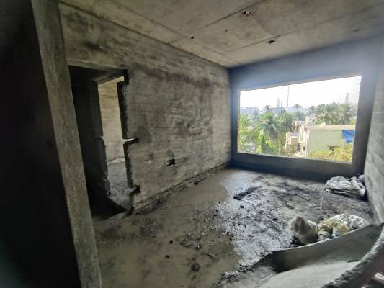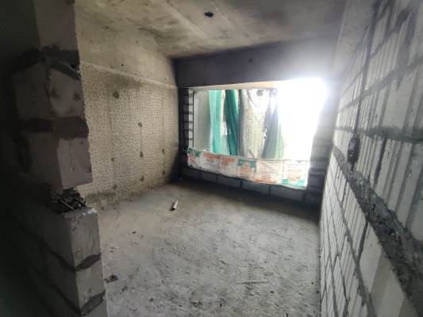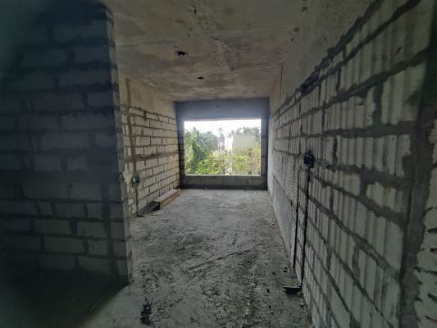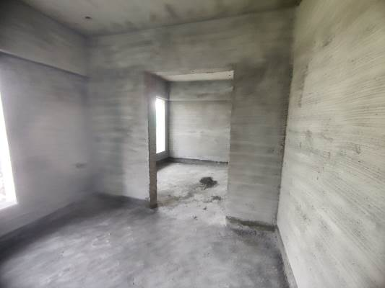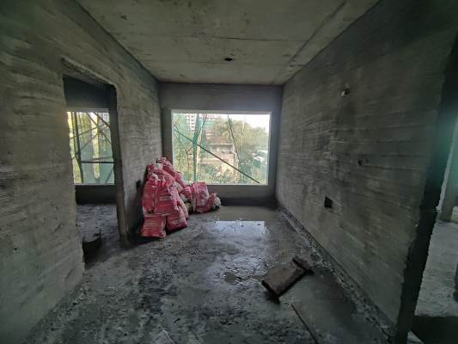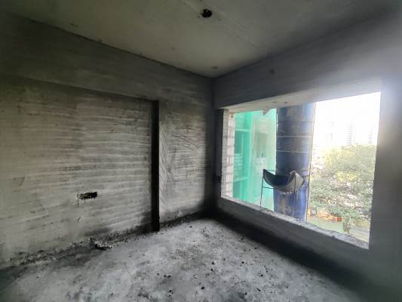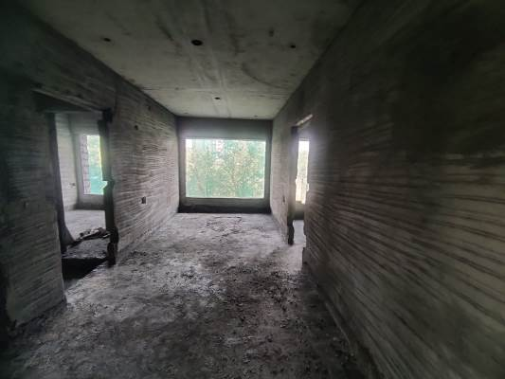

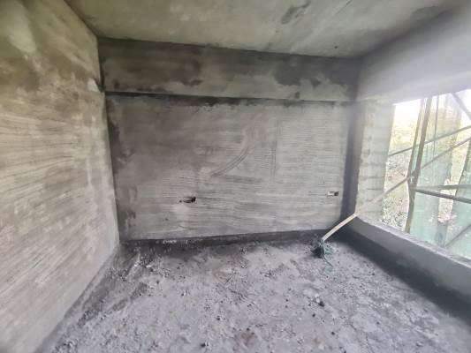**Actual Site Photographs**

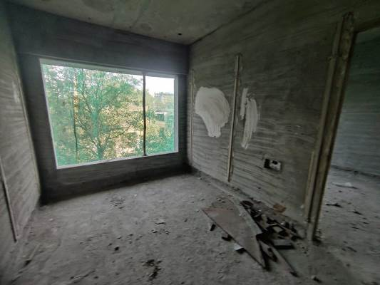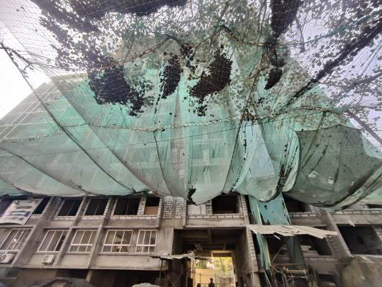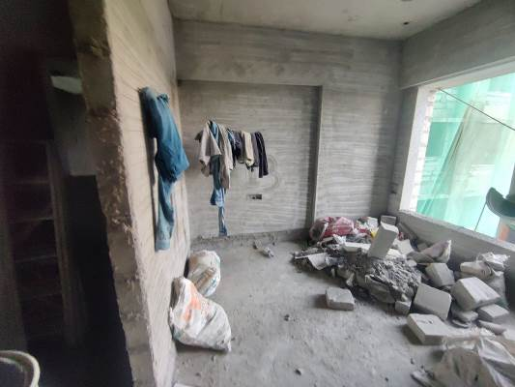

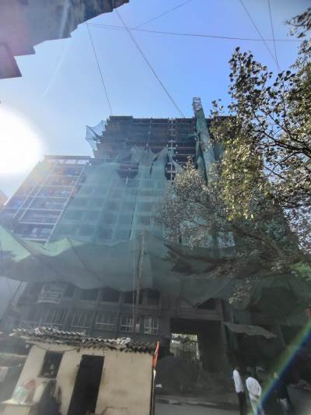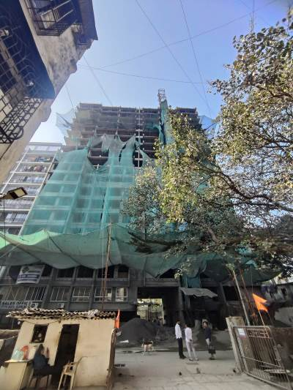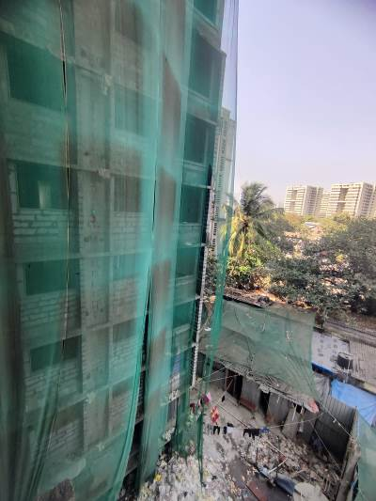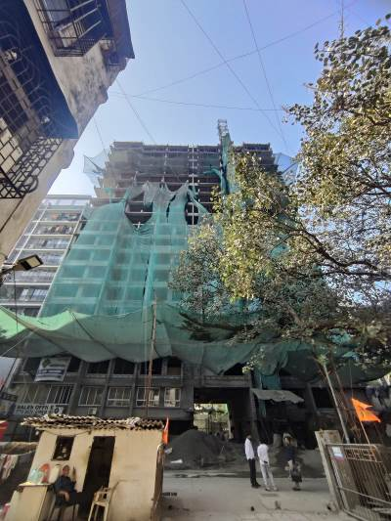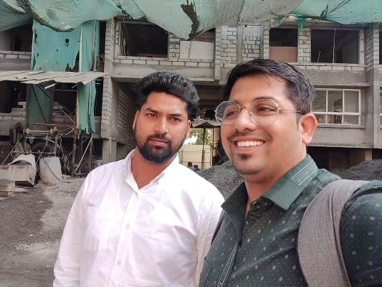

**Route Map of the property**

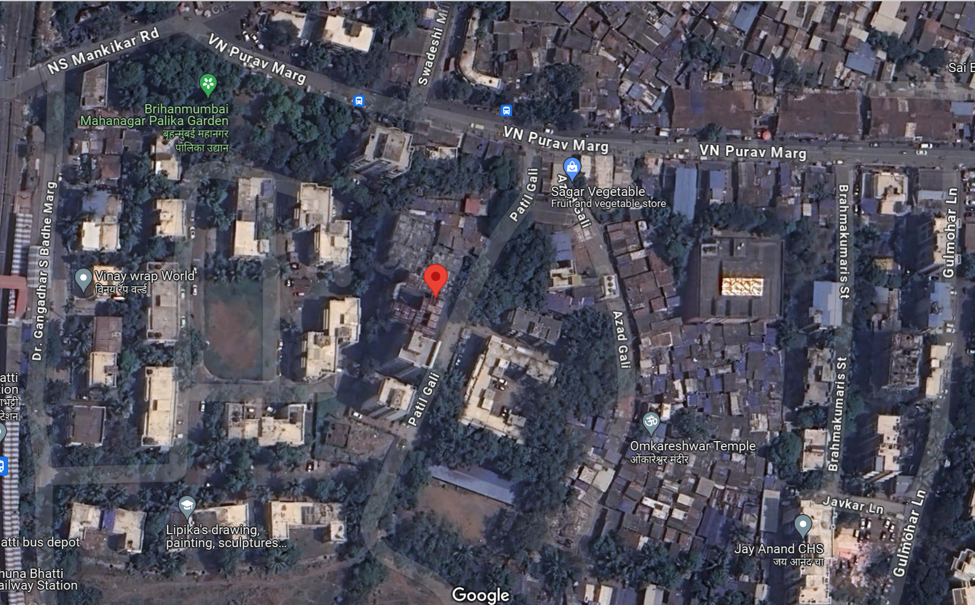**Site u/r**

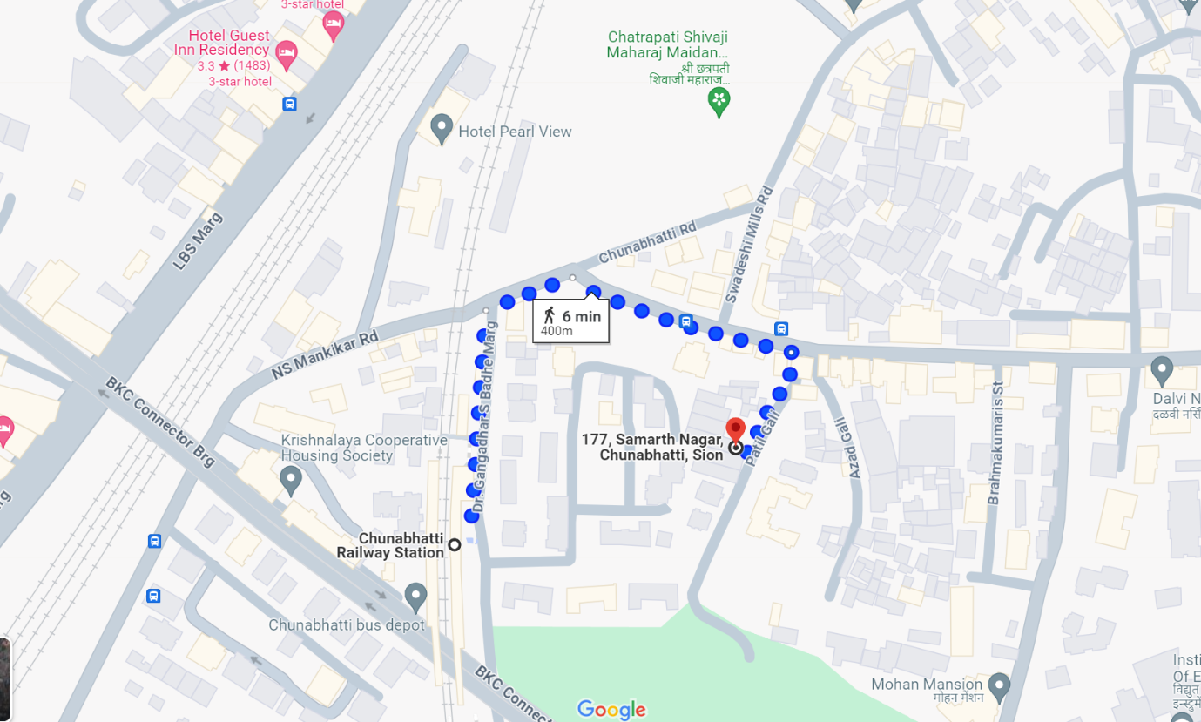

## Latitude Longitude: 19°03'08.4"N 72°52'14.5"E

Note: The Blue line shows the route to site from nearest railway station (Chunnbatti – 400 M.)

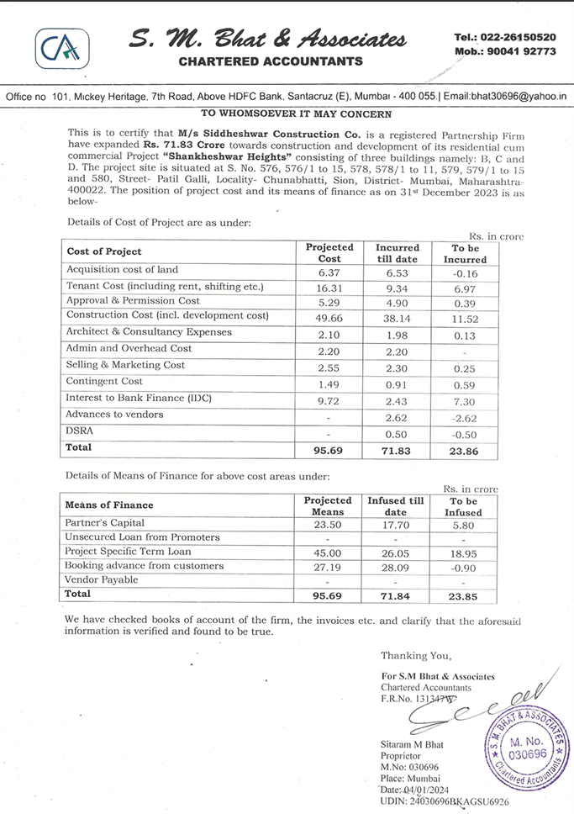**CA Certificate Dated 04.01.2024 till 31.01.2024**