COST VETTING REPORT

Details of the property under consideration:

Name of Project: "Shankeshwar Heights"

"Shankeshwar Heights", Proposed Slum Rehabilitation Scheme on Plot bearing CTS. No. 576, 576/1 to 15, 578, 578/1 to 11, 579, 579/1 to 15 & 580, Patil Gulli, Purav Marg, Village – Kurla – 3, Chunabhatti, Sion (West), Mumbai – 400 022, State – Maharashtra, Country – India

Latitude Longitude: 19°03'08.4"N 72°52'14.5"E

Valuation Done for:
State Bank of India
SME Chembur Branch
Unit No. 11, Building No. 11, Ground Floor, Corporate Park, Sion Trombay Road,
Chembur, Mumbai, Pin Code – 400 071, State - Maharashtra, Country – India.

Vastu/SBI/Mumbai/04/2024/5368/2304028
18/11-257-PY
Date: 28/02/2024

To,
The Branch Manager,
State Bank of India
SME Chembur Branch
Unit No. 11, Building No. 11,
Ground Floor, Corporate Park,
Sion Trombay Road, Chembur,
Mumbai, Pin Code – 400 071,
State - Maharashtra, Country – India.

Sub: Cost Vetting Report for "Shankeshwar Heights" at Chunabhatti, Sion (West) Mumbai, Pin Code – 400022.

Dear Sir,

In accordance with your letter of engagement as stated above, we enclose our Report on Cost Vetting for "Shankeshwar Heights", Proposed Slum Rehabilitation Scheme on Plot bearing CTS. No. 576, 576/1 to 15, 578, 578/1 to 11, 579, 579/1 to 15 & 580, Patil Gulli, Purav Marg, Village – Kurla – 3, Chunabhatti, Sion (West), Mumbai – 400 022, State – Maharashtra, Country – India.
M/s. Siddheshwar Construction Co. is proposing "Shankeshwar Heights", Proposed Slum Rehabilitation Scheme on Plot bearing CTS. No. 576, 576/1 to 15, 578, 578/1 to 11, 579, 579/1 to 15 & 580, Patil Gulli, Purav Marg, Village – Kurla – 3, Chunabhatti, Sion (West), Mumbai – 400 022, State – Maharashtra, Country – India. Project is comprising Rehab cum Sale Building.
Rehab cum Sale Building is proposed of (Wing B & C) is Ground Floor + 1st to 22nd Upper Floors & (Wing D) is Ground Floor + 1st to 22nd Upper Floors.
In this regard, SBI, SME Chembur Branch, Unit No. 11, Building No. 11, Ground Floor, Corporate Park, Sion Trombay Road, Chembur, Mumbai, Pin Code – 400 071, has approached Vastukala Consultants (I) Pvt. Ltd. (VCIPL) to conduct a Cost Vetting of the said project.
Our analysis of the cost vetting is enclosed in this report. This Report forms an integral whole and cannot be split in parts. The outcome of the report/ study can only lead to proper conclusions if the Report as a whole is taken into account.

The information used by Vastukala Consultants (I) Pvt. Ltd. (VCIPL) in preparing this report has been obtained from a variety of sources and other relevant documents provided by the client & bank. As agreed, we have performed our cost vetting exercise with the data available related to the business, considering the market prospects and projections. Our results are dependent on documents provided by client & bank, the underlying assumptions, which has been analyzed at a broader level by VCIPL while assessing their reasonableness.
Total Project Cost for the completion of Project will be ` 104.97 Cr.

For Vastukala Consultants (I) Pvt. Ltd.

Manoj B. Chalikwar
Registered Valuer
Chartered Engineer (India)
Reg. No. IBBI / RV / 07/2018/10366
Reg. No. CAT-I-F-1763
SBI Empanelment No.: SME/TCC/2021-22/86/3

About the Project:
Proposed Slum Rehabilitation Scheme on Plot bearing CTS. No. 576, 576/1 to 15, 578, 578/1 to 11, 579, 579/1 to 15 & 580, Patil Gulli, Purav Marg, Village – Kurla – 3, Chunabhatti, Sion (West), Mumbai – 400 022. It is about 400 M. walking distance from Chunabhatti Railway station.
Nearby Sion Railway Station

Construction Area as per Approved Plan for Rehab cum Sale Building

Wing B & C
Sr. No. | Floor | Construction Area in Sq. M.
1 | Ground Floor | 279.80
2 | 1st Floor | 349.90
3 | 2nd Floor | 451.11
4 | 3rd Floor | 451.11
5 | 4th Floor | 451.11
6 | 5th Floor | 451.11
7 | 6th Floor | 451.11
8 | 7th Floor | 451.11
9 | 8th Floor | 451.11
10 | 9th Floor | 451.11
11 | 10th Floor | 451.11
12 | 11th Floor | 451.11
13 | 12th Floor | 451.11
14 | 13th Floor | 451.11
15 | 14th Floor | 451.11
16 | 15th Floor | 451.11
17 | 16th Floor | 451.11
18 | 17th Floor | 451.11
19 | 18th Floor | 451.11
20 | 19th Floor | 451.11
21 | 20th Floor | 451.11
22 | 21st Floor | 451.11
23 | 22nd Floor | 451.11
24 | Terrace / OHT / LMR | 103.13
TOTAL |  | 10,206.14
Stack Parking |  | 84.00

Wing D
Sr. No. | Floor | Construction Area in Sq. M.
1 | Ground Floor | 107.32
2 | 1st Floor | 261.31
3 | 2nd Floor | 261.31
4 | 3rd Floor | 261.31
5 | 4th Floor | 261.31
6 | 5th Floor | 261.31
7 | 6th Floor | 261.31
8 | 7th Floor | 261.31
9 | 8th Floor | 261.31
10 | 9th Floor | 261.31
11 | 10th Floor | 261.31
12 | 11th Floor | 261.31
13 | 12th Floor | 261.31
14 | 13th Floor | 261.31
15 | 14th Floor | 261.31
16 | 15th Floor | 261.31
17 | 16th Floor | 261.31
18 | 17th Floor | 261.31
19 | 18th Floor | 261.31
20 | 19th Floor | 261.31
21 | 20th Floor | 261.31
22 | 21st Floor | 261.31
23 | 22nd Floor | 261.31
24 | Terrace / OHT / LMR | 32.60
TOTAL |  | 5,888.74
Stack Parking |  | 20.00

SUMMARY

Sr. No. | Particulars | Construction Area in Sq. M.
1 | Wing B & C | 10,206.14
2 | Wing D | 5,888.74
TOTAL CONSTRUCTION AREA in Sq. m. |  | 16,094.88
3 | Stack Parking in Wing B & C | 84.00
4 | Stack Parking in Wing D | 20.00
TOTAL STACK PARKING |  | 104.00

Project Cost
Sr. No. | Particulars | Total Estimated Amount in ` | Total Estimated Amount  in ` Cr.
1 | Land Cost
 | Acquisition Cost of Land or Development Rights, and Legal Cost. | 6,36,93,622.00 | 6.37
 | Rent to Tenants, Lease premium, Lease Rent, interest cost incurred or payable on Land Cost | 16,30,81,040.00 | 16.31
 | Amount of Premium payable to obtain development rights, FSI, additional FSI, fungible area, and any other incentive under DCR from Local Authority or State Government or any Statutory Authority. | 5,29,03,139.00 | 5.29
 | Acquisition cost of TDR (if any) | - | -
2 | Cost of Construction
 | Estimated construction cost of rehab cum sale building including site development and infrastructure for the same. | 57,79,31,040.00 | 57.79
 | On site expenditure for development of entire project excluding cost of construction as per(i) above,
a. | Architect Fees & Consultant fees | 2,31,17,242.00 | 2.31
b. | Admin Cost includes salaries, site overheads, development works, cost of services (including water, electricity, sewerage, drainage, layout roads etc.), cost of machineries and equipment including its hire and maintenance cost, consumables etc. All costs directly incurred to complete the construction of the entire phase of the project registered. | 2,88,96,552.00 | 2.89
c. | Marketing Cost | 2,55,06,815.00 | 2.55
3 | Interest during the Project | 9,72,00,000.00 | 9.72
4. | Contingency Charges | 1,73,37,931.00 | 1.73
 | GRAND TOTAL: | 104,96,67,381.00 | 104.97

Manoj B. Chalikwar
Registered Valuer
Chartered Engineer (India)
Reg. No. IBBI / RV / 07/2018/10366
Reg. No. CAT-I-F-1763
SBI Empanelment No.: SME/TCC/2021-22/86/3

Comments on each element of Cost of Project: -
- Land Cost:
As per document conveyance deed of land & stamp duty cost & surrender lease agreement is ` 6,36,93,622.00 i.e., ` 6.37 Cr. which is 6.07% of Total Project Cost.
Land Cost:
Agreement Type | Date | Survey No. | Area in Sq. M. | Particulars | Total Land Cost in ` | Incurred in `
Deed of conveyance | 23-12-2020 | 576, 576/1-15 | 702.50 | Stamp Duty | 5,08,290.00 | 5,08,290.00
Deed of conveyance | 06-10-2015 | 578, 578/1 to 11, 579, 579/1 to 15 & 580 | 1,460.60 | Purchase Cost | 3,77,00,000.00 | 3,77,00,000.00
 |  |  |  | Stamp Duty | 18,85,000.00 | 18,85,000.00
 |  |  |  | Reg. Cost | 33,560.00 | 33,560.00
Deed of conveyance | 06-10-2015 | 578, 578/1 to 11, 579, 579/1 to 15 & 580 |  | Other Charges | 1,20,000.00 | 1,20,000.00
Total land cost for CTS No. 576, 578, 579 & 580 |  |  | 2,163.10 | - | 4,02,46,850.00 | 4,02,46,850.00
Less: Plot area relating to Wing-A which consist of CTS No. 580 |  | 580 | 395.60 | Purchase Cost | 1,02,10,954.00 | 1,02,10,954.00
 |  | 580 | 395.60 | Stamp Duty | 5,10,548.00 | 5,10,548.00
 |  | 580 | 395.60 | Reg. Cost | 9,090.00 | 9,090.00
 |  | 580 | 395.60 | Other Charges | 32,502.00 | 32,502.00
TOTAL DEDUCTION AMOUNT |  |  |  |  | 1,07,63,094.00 | 1,07,63,094.00
Net Land cost for CTS No. 576, 578 & 579 (relating to Building- B, C and D) |  |  | 2,558.70 |  | 2,94,83,756.00 | 2,94,83,756.00

Surrender Agreement:
Agreement Type | Date | Particulars | Total Cost in ` | Incurred in `
Deed of Surrender of Lease Agreement | 25-08-2020 | Purchase Cost | 1,30,00,000.00 | 1,30,00,000.00
Deed of Surrender of Lease Agreement | 25-08-2020 | Stamp Duty | 11,62,750.00 | 11,62,750.00
Deed of Surrender of Lease Agreement | 25-08-2020 | Reg. Cost | 30,000.00 | 30,000.00
Deed of Surrender of Lease Agreement | 25-08-2020 | Other Charges | 4,240.00 | 4,240.00
Deed of Surrender of Lease Agreement | 30-12-2021 | Purchase Cost | 40,00,000.00 | 40,00,000.00
Deed of Surrender of Lease Agreement | 30-12-2021 | Stamp Duty | 4,23,100.00 | 4,23,100.00
Deed of Surrender of Lease Agreement | 30-12-2021 | Reg. Cost | 30,000.00 | 30,000.00
Deed of Surrender of Lease Agreement | 30-12-2021 | Other Charges | 2,000.00 | 2,000.00
Deed of Surrender of Lease Agreement | 16-06-2021 | Purchase Cost | 65,00,000.00 | 65,00,000.00
Deed of Surrender of Lease Agreement | 16-06-2021 | Stamp Duty | 4,73,790.00 | 4,73,790.00
Deed of Surrender of Lease Agreement | 16-06-2021 | Reg. Cost | 30,000.00 | 30,000.00
Deed of Surrender of Lease Agreement | 16-06-2021 | Other Charges | 2,120.00 | 2,120.00
Deed of Surrender of Lease Agreement | 16-06-2021 | Purchase Cost | 17,00,000.00 | 17,00,000.00
Deed of Surrender of Lease Agreement | 16-06-2021 | Stamp Duty | 4,18,425.00 | 4,18,425.00
Deed of Surrender of Lease Agreement | 16-06-2021 | Reg. Cost | 30,000.00 | 30,000.00
Deed of Surrender of Lease Agreement | 16-06-2021 | Other Charges | 1,920.00 | 1,920.00
Deed of Surrender of Lease Agreement | 16-06-2021 | Purchase Cost | 15,00,000.00 | 15,00,000.00
Deed of Surrender of Lease Agreement | 16-06-2021 | Stamp Duty | 75,000.00 | 75,000.00
Deed of Surrender of Lease Agreement | 16-06-2021 | Reg. Cost | 30,000.00 | 30,000.00
Deed of Surrender of Lease Agreement | 16-06-2021 | Other Charges | 1,520.00 | 1,520.00
Deed of Surrender of Lease Agreement |  | Purchase Cost | 9,57,000.00 | 9,57,000.00
Deed of Surrender of Lease Agreement |  | Purchase Cost | 36,88,000.00 | 36,88,000.00
Deed of Surrender of Lease Agreement |  | Purchase Cost | 1,50,000.00 | 1,50,000.00
TOTAL |  |  | 3,42,09,865.00 | 3,42,09,865.00

Summary:
Particulars | Total Cost in ` | Incurred in `
Net Land Cost as per Conveyance Deed | 2,94,83,756.00 | 2,94,83,756.00
Surrender Cost as per Surrender Lease Agreement | 3,42,09,865.00 | 3,42,09,865.00
Total | 6,36,93,621.00 | 6,36,93,621.00

- Payment Payable to Rehab Tenants (Rent Cost):
Since it is a having some redevelopment flat from the date of shifting of 140 Tenants till handing over their respective new flats as per the Tenant Agreement but rent to be paid to 115 Tenants. Further the rent keeps on increasing as per agreement. The existing Tenants has to be given total rental of ` 16,30,81,040.00 i.e., ` 16.31 Cr.
Existing Tenants Rent per month for Flat are as follows:
Particulars | Amount in ` | Unit
No. of Tenants | 140.00 | Nos.
No. of Tenants to whom rent is to pay | 115.00 | Nos.
Monthly Rent for Feb - 21 to Jan - 22 per Tenant | 20,000.00 | Rupees
Yearly Rent for Feb - 21 to Jan - 22 | 2,76,00,000.00 | Rupees
Monthly Rent for Feb - 22 to Jan - 23 per Tenant | 22,000.00 | Rupees
Yearly Rent for Feb - 22 to Jan - 23 | 3,03,60,000.00 | Rupees
Monthly Rent for Feb - 23 to Jan - 24 per Tenant | 24,200.00 | Rupees
Yearly Rent for Feb - 23 to Jan - 24 | 3,33,96,000.00 | Rupees
Monthly Rent for Feb - 24 to Jan - 25 per Tenant | 26,620.00 | Rupees
Yearly Rent for Feb - 24 to Jan - 25 | 3,67,35,600.00 | Rupees
Monthly Rent for Feb - 25 to Sept - 25 per Tenant | 29,282.00 | Rupees
Yearly Rent for Feb - 25 to Sept - 25 | 2,69,39,440.00 | Rupees
TOTAL Rent Charges | 15,50,31,040.00 | Rupees
Shifting Charges Per Tenant | 25000 | Rupees
Total Shifting Cost | 28,75,000.00 | Rupees
Brokerage Cost per Tenant | 15000 | Rupees
Total Brokerage Cost | 17,25,000.00 | Rupees
Settlement Charges per Tenant | 30000 | Rupees
Total Settlement Charges | 34,50,000.00 | Rupees
TOTAL RENT COST | 16,30,81,040.00 | Rupees

- Building Cost of Construction for Rehab cum Sale Building:
Construction Area of Building (Wing b, C & D) = 16,094.88 Sq. M. i.e., 1,73,245.29 Sq. Ft.
No. of Stack Car Parking = 104 Nos.
Total estimated cost for construction of Building (includes cost of RCC work, manpower, lift, material, painting, finishing work, site development, etc.) is ` 48,28,46,400.00 i.e., ` 48.28 Cr. which comes ` 30,000.00 per Sq. M. on construction area for building, cost for deep excavation & shore piling is ` 4,82,84,640.00 i.e., ` 4.83 Cr. which comes 10% of cost of construction of building and cost for stack parking is ` 4,68,00,000.00 i.e., ` 4.68 Cr. which comes ` 4,50,000.00 per stack parking.
Hence, total construction cost (Cost of construction of building + Cost of deep excavation & shore piling + Cost of stack parking) (` 48,28,46,400.00 + ` 4,82,84,640.00 + ` 4,68,00,000.00) = ` 57,79,31,040.00 i.e., ` 57.79 Cr.
The total construction area is 16,094.88 Sq. M., projected cost of ` 57.79 Cr is 55.06% of total project cost

VCIPL opinion the construction cost of 30,000/- Per Sq. M. which is in line with Market-Trend.
Particulars | Rate per Sq. M.
Excavation Work | 1,500.00
Total RCC Work | 15,000.00
Final Finishing Work | 7,500.00
Other Work | 6,000.00
Cost of Construction | 30,000.00
Deep Excavation & Shore Piling Cost | 10% of construction cost of building
Stack Car Parking Cost | 4,50,000.00 per parking

- Approval Charges:
The Total Approval Cost (Fungible Cost & Development Cess Premium & TDR Cost) as per architect letter will be ` 5,29,03,139.00 i.e., ` 5.29 Cr. which is 5.04% of Total Project Cost.
S. No. | Nature of Charges | Estimated Cost in ` | Incurred Cost in ` | Balance Amount in `
1 | Scrutiny Fee - LOI | 1,600 | 1,600 | -
2 | Website Charges (Receipts) | 5,000 | 5,000 | -
3 | Maintenance Deposit (Society) | 7,70,000 | 7,70,000 | -
4 | Scrutiny Fee - LOI | 1,600 | 1,600 | -
5 | Legal Charges | 2,50,000 | 2,50,000 | -
6 | Additional FSI Premium | 6,02,000 | 6,02,000 | -
7 | Scrutiny Fee-Layout Proposal | 4,000 | 4,000 | -
8 | IOA Deposit | 1,01,500 | 1,01,500 | -
9 | Scrutiny Fees for IOA | 76,500 | 76,500 | -
10 | Labour Welfare Cess | 2,75,600 | 2,75,600 | -
11 | Staircase Premium | 2,57,000 | 2,57,000 | -
12 | Open Space Deficiency Premium | 1,25,025 | 1,25,025 | -
13 | Infrastructure Charges | 2,11,925 | 2,11,925 | -
14 | MRTP Development Charges | 3,66,000 | 3,66,000 | -
15 | Infrastructure Charges | 16,23,450 | 16,23,450 | -
16 | MRTP Development Charges | 24,60,875 | 24,60,875 | -
17 | Labour Welfare Cess | 38,44,800 | 38,44,800 | -
18 | Fungible Compensatory FSI Premium | 53,89,000 | 53,89,000 | -
19 | Additional FSI Premium | 6,02,000 | 6,02,000 | -
20 | MRTP Development Charges | 3,66,000 | 3,66,000 | -
21 | Infrastructural Development Charges | 2,11,925 | 2,11,925 | -
22 | Open space Deficiency Premium | 1,25,025 | 1,25,025 | -
23 | Fungible Compensatory FSI Premium | 53,88,976 | 53,88,976 | -
24 | Scrutiny Fee - LOI | 1,600 | 1,600 | -
25 | Infrastructure Development Charges | 16,23,450 | 16,23,450 | -
26 | MRTP Development Charges | 24,60,875 | 24,60,875 | -
27 | Fungible Compensatory FSI | 25,48,000 | 25,48,000 | -
28 | Amended Plan Deposit | 45,400 | 45,400 | -
29 | IOA Deposit | 34,500 | 34,500 | -
30 | Additional FSI Premium | 6,02,000 | 6,02,000 | -
31 | Fungible Compensatory FSI Premium | 55,52,278 | 55,52,278 | -
32 | Infrastructure Development Charges | 16,23,450 | 16,23,450 | -
33 | Fungible Compensatory FSI | 24,60,875 | - | 24,60,875
34 | Additional FSI Premium | 6,02,000 | - | 6,02,000
35 | MRTP Development Charges | 3,66,000 | - | 3,66,000
36 | Infrastructure Development Charges | 2,11,925 | - | 2,11,925
37 | Open Space Deficiency Premium | 1,25,025 | - | 1,25,025
38 | MRTP Development Charges | 5,35,570 | - | 5,35,570
39 | Infrastructure Development Charges | 1,85,250 | - | 1,85,250
40 | Staircase Premium | 7,54,500 | - | 7,54,500
41 | MRTP Development Charges | 5,35,570 | - | 5,35,570
42 | Infrastructure Development Charges | 1,85,250 | - | 1,85,250
43 | Staircase Premium | 7,54,500 | - | 7,54,500
44 | MRTP Development Charges | 5,35,570 | - | 5,35,570
45 | Infrastructure Development Charges | 1,85,250 | - | 1,85,250
46 | Staircase Premium | 7,54,500 | - | 7,54,500
47 | Deposit to SRA for tenant building | 51,60,000 | - | 51,60,000
48 | Completion Certificate related formalities | 20,00,000 | - | 20,00,000
 | Total | 5,29,03,139 | 3,75,51,354 | 1,53,51,785
As per information & challan provided by developer.

- Architect Cost, RCC & Other Professional Charges:
The total Architect charges of ` 2,31,17,242.00 i.e., ` 2.31 Cr. is 4% of total construction cost building & it is on lower side because developer have their inhouse team for professional work.
The professional charge consists of Architect & Legal which in lower side than the market trend which is in the range of 2% - 5% of Total Construction cost of the project.

- Administrative Expenses:
Salaries, site overheads, development works, cost of services (including water, electricity, sewerage, drainage, layout roads etc.), cost of machineries and equipment including its hire and maintenance cost, consumables etc. All costs directly incurred to complete the construction of the entire phase of the project registered is estimated 5% of total construction cost Building which comes to ` 2,88,96,552.00 i.e., ` 2.89 Cr.
The admin charges which in market is in the range of 4% - 6% of Total Construction cost of the project.

- Marketing Expenses:
Marketing costs directly incurred to complete the construction of the entire phase of the project registered is estimated at 2% of total Sale income from the project which comes to ` 2,55,06,815.00 i.e., ` 2.55 Cr.
The marketing charge consists of brokerage & commission which in market is in the range of 1% - 3% of Total Sale income of the property.

- Interest Costs:
The Interest cost for the term loan is ` 9,72,00,000.00 i.e., ` 9.72 Cr., which is 9.26% of total project cost.
As per information provided by the client.

- Contingency Costs:
The contingency charges estimated at 3% of total cost of construction which comes to ` 1,73,37,931.00 i.e., ` 1.73 Cr.

Observation and Construction: -
Total estimated cost of project i.e., ` 104,96,67,381.00 (One Hundred Four Crore Ninety – Six Lakh Sixty – Seven Thousand Three Hundred Eighty – One Only) i.e., ` 104.97 Cr. is fair & reasonable.
The project cost is including land premium payable to concern authorities, Fungible FSI Premium, Cost of Construction of rehab & Sale Building, on site expenses including admin & marketing expenses, premiums / charges to be paid to competent authority and Bank interest, etc. we have not independently verified interest cost hence not consider in cost vetting.
As per present sanctioned building plan, permissible built-up area on the said plot is 11,712.45 Sq. M. The rehab cum sale building is presently approved for Ground Floor + 1st to 22nd Upper Floors only. Estimated cost of entire project of 22nd upper floors are considered.
Total estimated cost of construction of Rehab cum Sales building is ` 48,28,46,400.00 i.e., ` 48.28 Cr. which comes ` 30,000.00 per Sq. M. on construction area for building, cost for deep excavation & shore piling is ` 4,82,84,640.00 i.e., ` 4.83 Cr. which comes 10% of cost of construction of building and cost for stack parking is ` 4,68,00,000.00 i.e., ` 4.68 Cr. which comes ` 4,50,000.00 per stack parking. Hence, total construction cost (Cost of construction of building + Cost of deep excavation & shore piling + Cost of stack parking) (` 48,28,46,400.00 + ` 4,82,84,640.00 + ` 4,68,00,000.00) = ` 57,79,31,040.00 i.e., ` 57.79 Cr., which is fair & reasonable considering the present status of project, type & quality of construction & specification of the building materials to be used, height of the structure, amenities to be provided in proposed building.

Assumptions & Remarks-
- The adequacy of Engineering / Structural design is beyond the scope of our assignment.
- Estimated project completion date is 30/06/2026. The cost is certified based on the assumptions that the project will be completed within time frame. Few assumptions are made regarding inflation & cost rise etc. during construction period.

Photo copy of following document is provided to us & this report should be read along with it:

- Copy of Deed of Conveyance dated 23.12.2020 between Creative Construction Co. (The Vendors) and Siddheshwar Construction Co. through registered Doc. No. KRL-1/2467/52021dated 05.02.2021.
- Copy of Deed of Conveyance dated 06.10.2015 between A. H. Wadia Trust (The Vendors) and Siddheshwar Construction Co. through registered Doc. No. KRL-1/2793/2021 dated 16.03.2016.
- Copy of Deed of Surrender with Structure dated 25.08.2020 between Smt. Isragibai Devadatta Yadav & 3 Others (The Protected Sub – Tenants) and M/s. Creative Construction Co. (The Landlords) through registred Doc. No. KRL-1/5687/2020 dated 25.08.2020.
- Copy of Deed of Surrender of Lease dated 16.06.2021 between Mrs. Premadevi Jilajeet Yadav and Siddeshwar Construction Co. (The Developer / Lessor) through registered Doc. No. KRL-1/9140/2021 dated 16.06.2021.
- Copy of Deed of Surrender of Lease with Structure dated 16.06.2021 between Mr. Rajpat Ramnarayan Patel & 5 Others (Lessees) and M/s. Siddeshwar Construction Co. (The lessors) through registred Doc. No. KRL-1/9144/2021 dated 16.06.2021.
- Copy of Deed of Assignment dated 30.12.2020 between Mr. Rampat Ramnarayan Patel & 2 Others (Assignors) and M/s. Siddheshwar Construction Company (Assignees) through registred Doc. No. KRL-1/1000/2021 dated 15.01.2021.
- Copy of Deed of Assignment dated 10.02.2021 between Mr. Umashankar D Yadav & 3 Others (Assignors) and M/s. Siddheshwar Construction Comapnay (Assignees) through registred Doc. No. KRL-1/2818/2021 dated 10.02.2021.
- Copy of Approved Plan No. SRA/ENG/L/PVT/007712018/206/AP dated 17.01.2022 issued by Slum Rehabilitation Authority (SRA)
Approved Upto: - (Wing B, C & D) – Ground Floor + 1st to 22nd Upper Floors
- Copy of 1st Commencement Certificate No. L/PVT/0077/20181206/AP/C dated 17.06.2021 issued by Slum Rehabilitation Authority (SRA)
This is C. C. is granted upto plinth level of sale wing B & C and rehab wing D of composite building as per last approved plan dated 08.02.2021.
- Copy of 2nd Commencement Certificate No. L/PVT/0077/20181206/AP/C dated 01.07.2022 issued by Slum Rehabilitation Authority (SRA)
This is C. C. is granted upto Ground Floor + 1st to 9th floor + OHWT + LMR of sale wing B & C and Ground Floor + 1st to 17th Upper floors for rehab wing D of composite building as per last approved plan dated 17.01.2022.
- Copy of Fire NOC Certificate No. FB/LR/RV/46 dated 21.11.2016 issued by Municipal Corporation of Greater Mumbai, Mumbai Fire Brigade.
- Copy of RERA Certificate RERA No. P519000186161 dated 09.09.2021 issued by Maharashtra Real Estate Regulatory Authority (MAHRERA).
- Copy of CA Certificate dated 04.01.2024 issued by M/s. S. M. Bhat & Associates.
Actual Site Photographs
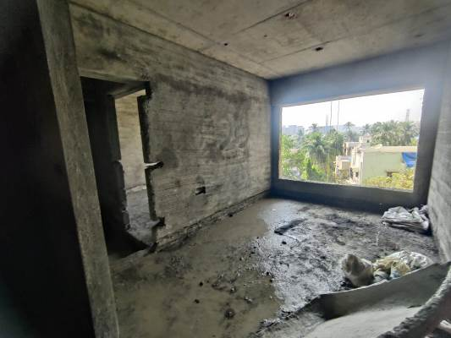
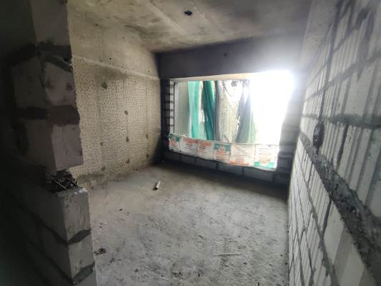
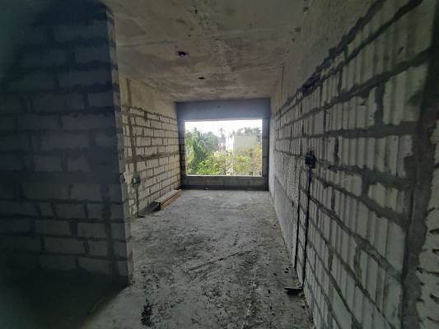
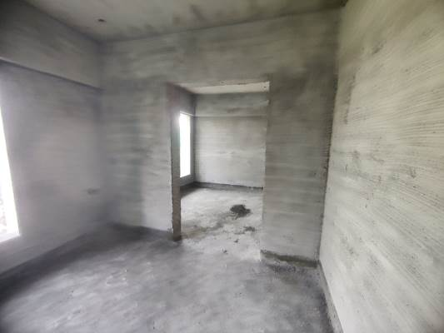
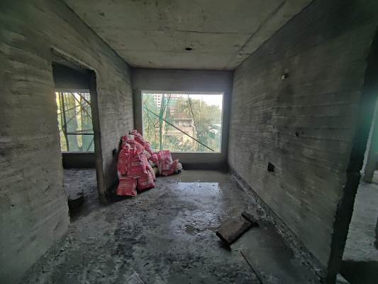
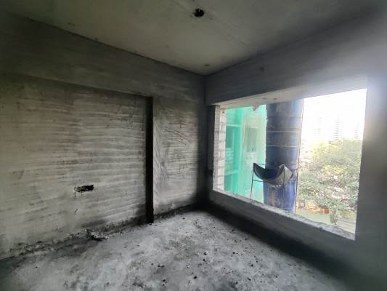
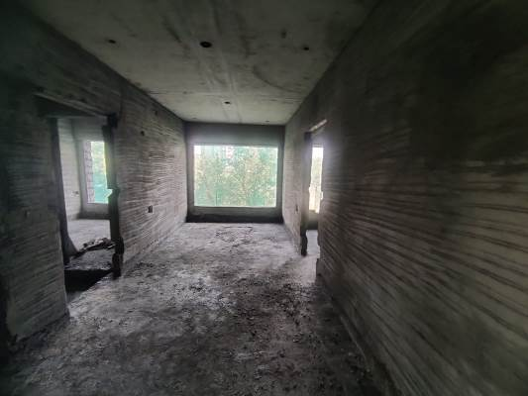

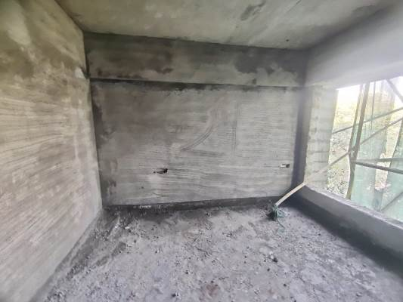
Actual Site Photographs
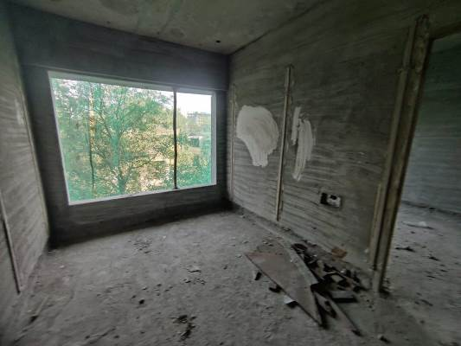
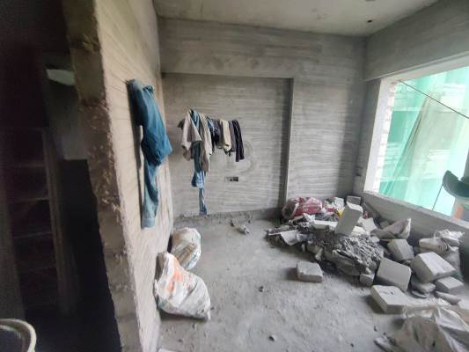
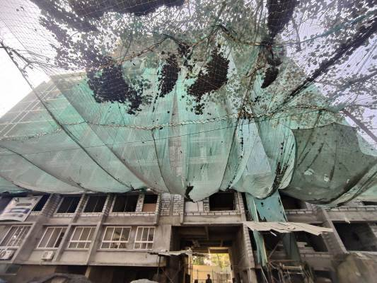

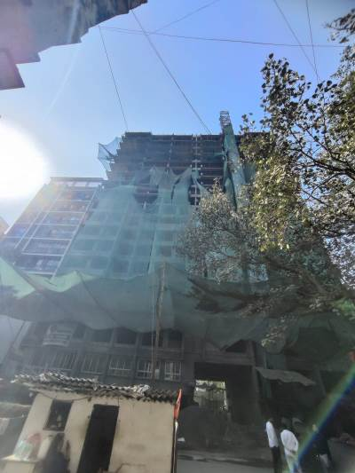
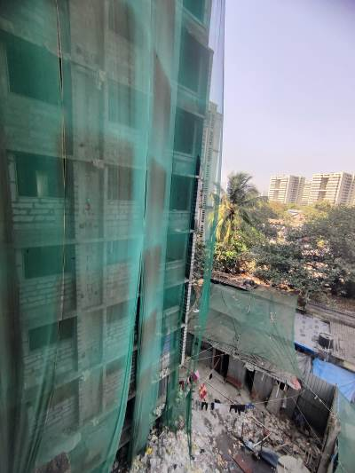
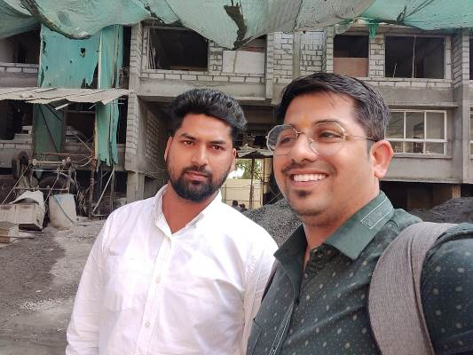
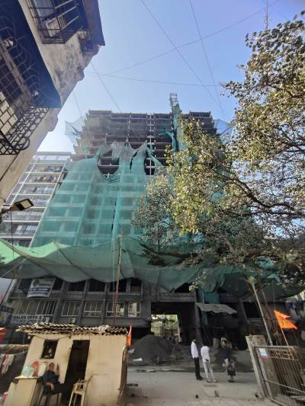
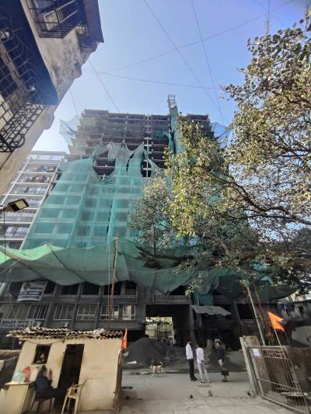
Route Map of the property
Site u/r
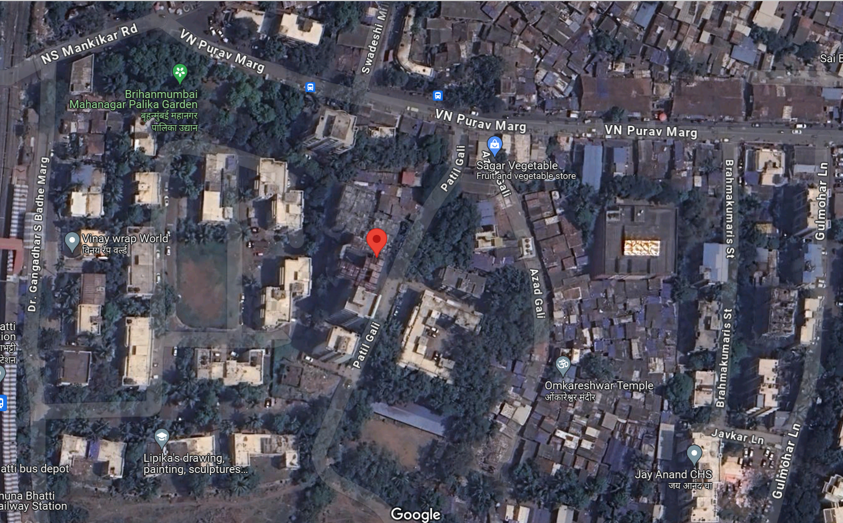

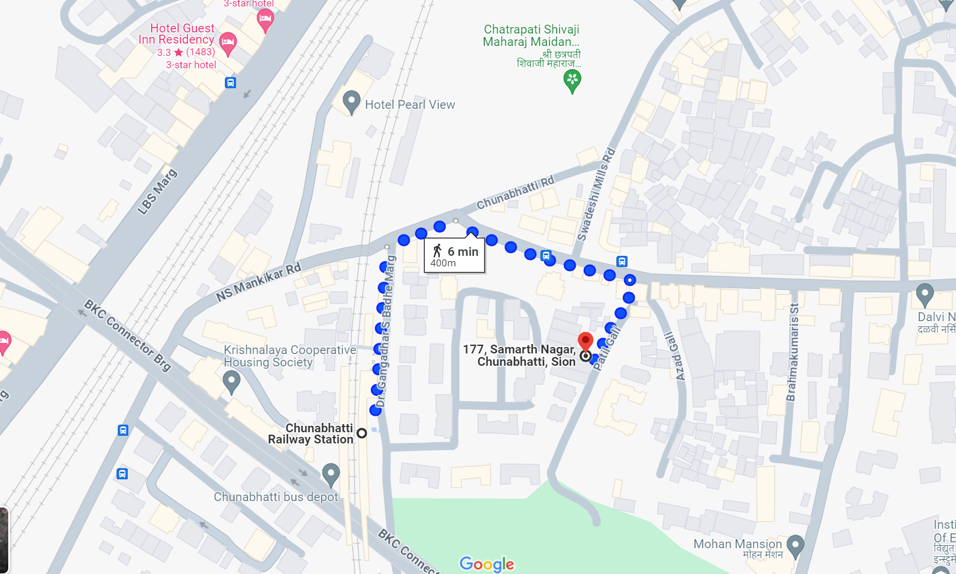

Latitude Longitude: 19°03'08.4"N 72°52'14.5"E
Note: The Blue line shows the route to site from nearest railway station (Chunabhatti – 400 M.)

