1st LENDERS INDEPENDENT ENGINEER REPORT
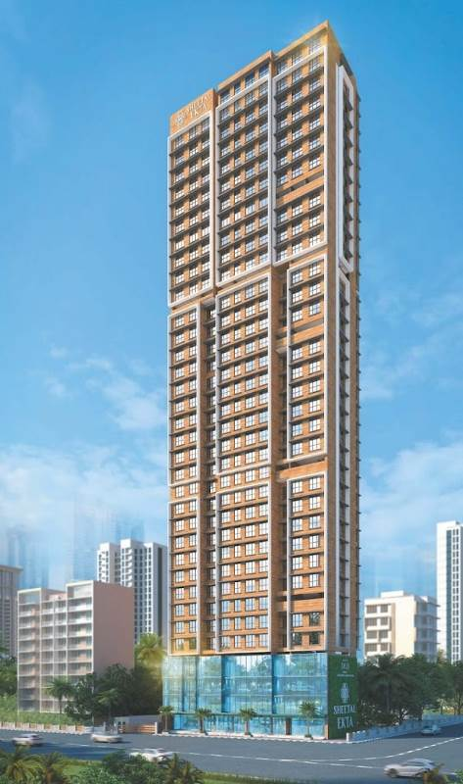

Details of the property under consideration:

Name of Project: “Sheetal Ekta”

"Sheetal Ekta", Proposed Redevelopment of existing building No. 18 – A & B, known as
Dindoshi Ekta CHSL on Plot bearing S. No. 31 & 39, CTS. No. 110(pt.) & 146 (pt.),
Shivdham Complex, Gen. A. K. Vaidya Marg, Village – Dindoshi, Malad (East),
Mumbai – 400 097, State – Maharashtra, Country – India

Latitude Longitude: 19°10'32.1"N 72°51'40.3"E

Intended User:

State Bank of India
SME Chembur Branch
Unit No. 11, Building No. 11, Ground Floor, Corporate Park, Sion Trombay Road,
Chembur, Mumbai, Pin Code – 400 071, State - Maharashtra, Country – India

Vastu/SBI/Mumbai/04/2024/8086/2305872
02/10-11-PY
Date: - 31.03.2024

FIRST LENDERS INDEPENDENT ENGINEER REPORT

To,
State Bank of India
SME Chembur Branch
Unit No. 11, Building No. 11,
Ground Floor, Corporate Park,
Sion Trombay Road, Chembur,
Mumbai, Pin Code – 400 071,
State - Maharashtra, Country – India

Subject: Construction of Proposed Redevelopment of existing building No. 18 – A & B, known as Dindoshi Ekta CHSL on Plot bearing S. No. 31 & 39, CTS. No. 110(pt.) & 146 (pt.), Shivdham Complex, Gen. A. K. Vaidya Marg, Village – Dindoshi, Malad (East), Mumbai – 400 097, State – Maharashtra, Country – India.

Ref: You’re Request for Lenders Independent Engineer Report of under Construction Building.
Dear Sir,
- As per your instruction, we have inspected the under-construction Rehab and Sale Building project situated on plot bearing C S. No. 31 & 39, CTS. No. 110(pt.) & 146 (pt.), Shivdham Complex, Gen. A. K. Vaidya Marg, Village – Dindoshi, Malad (East), Mumbai – 400 097, State – Maharashtra, Country – India which is being developed by M/s. DGS Township Pvt. Ltd. in order to give the physical progress at site and to certify cost incurred towards project as on 30/03/2024.
- The Construction work as per approved plan was in progress during the site visit on 16th March 2024.
- Status of work:
- For Sales Building (Wing A & B): 7th floor slab work is completed, Ground to 2nd Floor, Blockwork, plaster work, tiling, flooring, door and windows, electrical work, plumbing work are completed. 8th floor slab work is in progress.
- As per cost incurred certificate issued by CA Certificate actual total expenditure occurred as on 29/02/2024 is ` 39.88 Cr. for Commercial cum Residential of Sale Building (Wing A & B) is proposed of Basement + Ground Floor + 1st to 33rd Upper Floors.
- Overall financial progress as per C.A. certificate including land cost as on 29/03/2024 is 34.24% estimated cost of project.
- Overall Physical progress of the sale building construction as on 16/03/2024 is 20.31% as per physical site inspection.

- Overall Physical progress of the sale building construction including Mivan Material on Site as on 16/03/2024 is 22.69%.

- Construction Cost of the sale building construction including Mivan Material, other material on site & Advance payment to the Vendors till 30/03/2024 is 35.44 % as per bills.

DECLARATION
- The information furnished in the report is based on our 1st site visit Dated 16/03/2024 & Document Provided by Client.
- Vastukala Project Report of the project dated 18/09/2023.
- Vastukala Cost Vetting Report dated 18/09/2023.
- I have no direct and indirect interest in the property examined for report.
- I have not been found guilty of misconduct in my professional capacity.

Sharadkumar B. Chalikwar
Govt. Reg. Valuer
Chartered Engineer (India)
Reg. No. (N) CCIT/1-14/52/2008-09

Encl.: LIE report

Purpose & Methodology
• State Bank of India Banks and financial institutions require monitoring & an independent review of the progress of the sanctioned projects
VCIPL undertakes such study to independently review the progress of the project and put forward a comprehensive analysis

Advantages:
- Assurance on present practices
- Identification of risk
- Analyzing the performance of third parties
- Recommendations

The Methodology
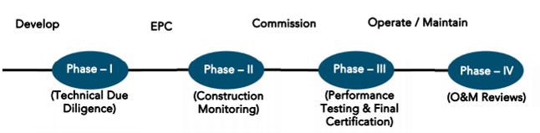
FIRST LENDERS INDEPENDENT ENGINEER REPORT
OF
"SHEETAL EKTA"

"Sheetal Ekta", Proposed Redevelopment of existing building No. 18 – A & B, known as Dindoshi Ekta CHSL on Plot bearing S. No. 31 & 39, CTS. No. 110(pt.) & 146 (pt.), Shivdham Complex, Gen. A. K. Vaidya Marg, Village – Dindoshi, Malad (East), Mumbai – 400 097, State – Maharashtra, Country – India

Latitude Longitude: 19°10'32.1"N 72°51'40.3"E

NAME OF DEVELOPER: M/s. DGS Township Pvt. Ltd.
Pursuant to instructions from State of India, SME Chembur Branch, Chembur we have duly visited, inspected, surveyed & assessed the above said property on 16th March 2024 to determine the fair & reasonable market value of the said property/project as on Quarter ending 30th March 2024 for LIE purpose.

1. Location Details:
Proposed Redevelopment of existing building No. 18 – A & B, known as Dindoshi Ekta CHSL on Plot bearing S. No. 31 & 39, CTS. No. 110(pt.) & 146 (pt.), Shivdham Complex, Gen. A. K. Vaidya Marg, Village – Dindoshi, Malad (East), Mumbai – 400 097. It is about 2.60 Km. travelling distance from Malad (East) Railway station. Surface transport to the property is by buses, taxis & private vehicles. The property is in developed locality. All the amenities like shops, banks, hotels, markets, schools, hospitals, etc. are all available in the surrounding locality. The area is higher middle class & developed.

2. Developer Details:
Name of builder | M/s. DGS Township Pvt. Ltd.
Project Rera Registration Number | P51800051884
Registered office address | DGS house, 1st floor, Sheetal Krupa, Aarey Road, Walawalkar Street, Goregaon (E), Mumbai – 400 063, State - Maharashtra, Country – India
Contact details | Contact Person:  Mr. Prabudh Khandelwal (Consultants)  Mobile No. 7738001775  Mr. Deep Shah (Consultants)  Mobile No. 7977861026
E – mail ID and website
3. Boundaries of the Property:
Direction | Particulars
On or towards North | Aster Tower
On or towards South | Road & Omkar CHSL
On or towards East | Sagar Society
On or towards West | Khatu Shyam Mandir Road

Introduction
As per Information on site M/s. DGS Township Pvt. Ltd. has acquired land by Developer Agreement dated 27.03.2021 through registered agreement vide No. BRL-9-4567-2021 dated 27.03.2021 admeasuring area is 1,128.58 Sq. M. bearing S. No. 31 & 39, CTS. No. 110(pt.) & 146 (pt.).
For the Proposed Commercial cum Residential (Rehab cum Sale) Building.

Area Statement:

Land:
Date | Particular | Area in Sq. M.
27.03.2021 | S. No. 31 & 39, CTS. No. 110(pt.) & 146 (pt.) | 1,128.58
TOTAL |  | 1,128.58

- Copy of Developer Agreement dated 27.03.2021 between M/s. Dindoshi Ekta Co-operative Housing Society Ltd. (The Society) and M/s. DGS Township Pvt. Ltd. (The Developers) through registered agreement vide No. BRL-9-4567-2021 dated 27.03.2021.
- Copy of Deed of Rectification cum Supplementary Agreement dated 29.04.2022 between M/s. Dindoshi Ekta Co-operative Housing Society Ltd. (The Owner) and M/s. DGS Township Pvt. Ltd. (The Developers) through registered agreement vide No. BLR-9-7335-2022 dated 29.04.2022.
- Copy of Special Power of Attorney through registered agreement vide No. BLR-9-12120-2021 dated 24.09.2021, M/s. Dindoshi Ekta Co-operative Housing Society Ltd. (The Society/ Executants) appoints Mr. Surajdev D. Shukla director of M/s. DGS Township Pvt. Ltd.

Building Area:

As per Approved Plan:
A | AREA STATEMENT
1 | Area of the plot (As per MHADA NOC & Demarcation) | 1,128.58
2 | Deduction for
a | Road Set back area | 34.25
b | Proposed Road | -
c | Any reservation | -
d | % Amenity space as per DCR 56 / 57 (Sub plot) | -
e | Other
 | Total ( a + b + c + d + e) | 34.25
3 | Balance Area of the plot (1 – 2) | 1,094.33
4 | Deduction for 15% recreational ground | -
 | 10% Amenity space (If deductible for IND)
5 | Net Area of Plot (3 – 4) | 1,094.33
6 | Additions for FSI purpose
2a | 100% for DP Road
2b | 100% for Set – back | 34.25
 | Total (2a + 2b) | 34.25
7 | Total Area (5 + 6) | 1,128.58
8 | FSI Permissible | 3.00
9 | - Permissible Floor Area (7 X 8) | 3,385.74
 | - Additional Layout FSI | 3,760.00
 | Total Permissible Area 9 (i) + 9 (ii) | 7,145.74
10 | Proposed Built up Area | 6,436.21
11 | Excess Balcony Area taken in floor space index | N.A.
12 | Total Proposed Area (10 + 11) | 6,436.21
B | Details of FSI Availed as per DCR 35 (4)
1 | Fungible Built up area component proposed vide DCR 35 (4) for purely residential = OR < (D(i) X 0.35) | 172.82
2 | Fungible Built up area component proposed vide DCR 35 (4) for non – residential = OR < (12 X 0.20) | 615.34
3 | Total Fungible Built up area vide DCR 35 (4) | 788.16
4 | Total BUA proposed including fungible compensatory area (12 + B(3)) | 7,224.37
5 | Permissible fungible area | 2,501.00
C | Prorata shares as per MHADA
1 | Prorata share as per letter No. CO/MB/REE/NOC/F-337/84 X 40 = 3,360 M. | 3,760.00
2 | Total Gross Built up area permissible | 9,646.74
3 | Total Gross Built up area proposed | 7,224.37
4 | No. CO/MB/REF/NOC/F-337/1047/2019
D | Tenement Statement
i | Total Gross Built up area proposed | 7,224.37
ii | Less Deduction of Non – Residential area (Shop, etc.) | 1,799.71
iii | Area available for tenements | 5,424.66
iv | FSI consumed on net holding | -
v | Fungible FSI consumed on net holding | -
vi | Tenements permissible | 381 nos.
vii | Tenements proposed | 60 nos.
viii | Tenements existing
 | Total Tenements on the plot
E | Parking Statement
i | Parking required by regulations for | 51 nos.
 | Car / Scooter / Motor cycle | As per area statement
 | Outsiders (visitors)
ii | Covered garages permissible
iii | Covered garages provided
 | Car
 | Scooter / Motor Cycle
 | Outsiders (visitors)
iv | Total Parking Provided | 77 nos.
F | Transport Vehicles parking
i | Spaces for transport vehicles parking required by regulations
ii | Total no. of transport vehicles parking spaces provided

As per Architect Drawing Plan/ Concession Plan:
A | AREA STATEMENT
1 | Area of the plot (As per MHADA NOC & Demarcation) | 1,128.58
2 | Deduction for
a | Road Set back area | 34.25
b | Proposed Road | -
c | Any reservation | -
d | % Amenity space as per DCR 56 / 57 (Sub plot) | -
e | Other
 | Total ( a + b + c + d + e) | 34.25
3 | Balance Area of the plot (1 – 2) | 1,094.33
4 | Deduction for 15% recreational ground | -
 | 10% Amenity space (If deductible for IND)
5 | Net Area of Plot (3 – 4) | 1,094.33
6 | Additions for FSI purpose
2a | 100% for DP Road
2b | 100% for Set – back | 34.25
 | Total (2a + 2b) | 34.25
7 | Total Area (5 + 6) | 1,128.58
8 | FSI Permissible | 3.00
9 | - FSI credit available by development right (restricted to % of the balance area vide 3 above) | -
 | Additions for FSI purpose
 | - 33% as per DCR 32 (2754.57 X 33%)
 | - External TDR (As per App. VII – B) (67%)
 | - Other
 | Total
10 | - Permissible Floor Area (7 X 8) + 9 | 3,385.74
 | - Additional Layout FSI | 3,760.00
 | Total Permissible Area 10 (i) + 10 (ii) | 7,145.74
11 | Proposed Built up Area | 7,120.51
 | - Existing Floor Area | N.A.
12 | Excess Balcony Area taken in floor space index | N.A.
13 | Total Proposed Area (10 + 11 + 12)
B | Details of FSI Availed as per DCR 35 (4)
1 | Fungible Built up area component proposed vide DCR 35 (4) for purely residential = OR < (D(i) X 0.35) | 2,124.31
2 | Fungible Built up area component proposed vide DCR 35 (4) for non – residential = OR < (12 X 0.20) | 367.87
3 | Total Fungible Built up area vide DCR 35 (4) | 2,492.18
4 | Total BUA proposed including fungible compensatory area (12 + B(3)) | 9,612.69
C | Prorata shares as per MHADA
1 | Prorata share as per letter No. CO/MB/REE/NOC/F-337/84 X 40 = 3,360 M. | 3,760.00
2 | Total Gross Built up area permissible | 13,372.69
3 | Total Gross Built up area proposed | 9,612.69
4 | No. CO/MB/REF/NOC/F-337/1047/2019
D | Tenement Statement
i | Total Gross Built up area proposed | 9,612.69
ii | Less Deduction of Non – Residential area (Shop, etc.) | 1,418.94
iii | Area available for tenements | 8,193.75
iv | FSI consumed on net holding | -
v | Fungible FSI consumed on net holding | -
vi | Tenements permissible | 381 nos.
vii | Tenements proposed | 125 nos.
viii | Tenements existing
 | Total Tenements on the plot
E | Parking Statement
i | Parking required by regulations for | 79 nos.
 | Car / Scooter / Motor cycle | As per area statement
 | Outsiders (visitors)
ii | Covered garages permissible
iii | Covered garages provided
 | Car
 | Scooter / Motor Cycle
 | Outsiders (visitors)
iv | Total Parking Provided | 111 nos.
F | Transport Vehicles parking
i | Spaces for transport vehicles parking required by regulations
ii | Total no. of transport vehicles parking spaces provided

List of Approvals:

- Copy of Intimation of Approval (IOA) Letter No. MH / EE / B. P. Cell / GM / MHADA – 61 / 1216 / 2022 dated 23.12.2022 issued by Maharashtra Housing and Area Development Authority (MHADA).
- Copy of Approved Plan No. MHADA – 61 / 1216 / 2022 dated 23.12.2022 issued by Maharashtra Housing and Area Development Authority (MHADA).
Approved upto: Basement + Ground Floor + 1st to 18th Upper Floors
- Copy of Building Concession Plan dated 30.07.2022 issued by Maharashtra Housing and Area Development Authority (MHADA).
Sanctioned Upto: Basement + Ground Floor + 1st to 33rd Upper Floors
- Copy of 1st Commencement Certificate No. MH/EE/(BP)/GM/MHADA-61/1216/2023/CC/1/New dated 22.05.2023 valid upto 21.05.2024 issued by Maharashtra Housing and Area Development Authority (MHADA).
(This CC is endorsed for the work for Top of Plinth level (i.e., height upto 0.30. mts AGL) as per approved IOA dated 23.12.2022)
- Copy of 2nd Further Commencement Certificate No. MH/EE/(BP)/GM/MHADA-61/1216/2023/FCC/1/New dated 20.09.2023 valid upto 21.05.2024 issued by Maharashtra Housing and Area Development Authority (MHADA).
(This CC is Further extended upto Top of 8th upper floor i.e., for building comprising of Basement for Shops with separate internal staircase from above shops + Ground Floor for Shops and parking tower system for Car – Parks + 1st to 3rd floor Offices (Rehab & Sales) + Service Floor (Between 3rd & 4th Floor and) + 4th Floor to 8th Floor for residential users having BUA adm. 3,585.01 Sq. M. with height 33.25 M. as per last approved IOA plans issued vide / no. MH/EE/(B.P.) Cell/GM/MHADA – 61/1216/2022 dated 23.12.2022)

LEVEL OF COMPLETION:
For Sales Building (Wing A & B): 7th floor slab work is completed, Ground to 2nd Floor, Blockwork, plaster work, tiling, flooring, door and windows, electrical work, plumbing work are completed. 8th floor slab work is in progress.

Sales Building (Wing A & B)
Sr. | Floor No. | Construction Area in Sq. M. | Completed Area in Sq. M. | Work Completion as on 16.03.2024
1 | Excavation & Shore Piling |  |  | Work is completed
2 | Basement Floor | 438.74 | 438.74 | Slab work is completed
3 | Ground Floor | 486.07 | 486.07 | Slab work, block work, plaster work, flooring, tiling work, electrical & plumbing, door & windows work are completed
4 | 1st Floor | 514.07 | 514.07 | Slab work, block work, plaster work, flooring, tiling work, electrical & plumbing, door & windows work are completed
5 | 2nd Floor | 514.07 | 514.07 | Slab work, block work, plaster work, flooring, tiling work, electrical & plumbing, door & windows work are completed
6 | 3rd Floor | 514.07 | 514.07 | Slab work is completed
7 | 4th Floor | 459.08 | 459.08 | Slab work is completed
8 | 5th Floor | 459.08 | 459.08 | Slab work is completed
9 | 6th Floor | 465.64 | 465.64 | Slab work is completed
10 | 7th Floor | 459.08 | 459.08 | Slab work is completed
11 | 8th Floor | 459.08
12 | 9th Floor | 459.08
13 | 10th Floor | 459.08
14 | 11th Floor | 459.08
15 | 12th Floor | 459.08
16 | 13th Floor | 465.64
17 | 14th Floor | 459.08
18 | 15th Floor | 459.08
19 | 16th Floor | 459.08
20 | 17th Floor | 459.08
21 | 18th Floor | 459.08
22 | 19th Floor | 459.08
23 | 20th Floor | 468.19
24 | 21st Floor | 459.08
25 | 22nd Floor | 459.08
26 | 23rd Floor | 459.08
27 | 24th Floor | 460.45
28 | 25th Floor | 460.45
29 | 26th Floor | 460.45
30 | 27th Floor | 467.98
31 | 28th Floor | 462.33
32 | 29th Floor | 462.33
33 | 30th Floor | 462.33
34 | 31st Floor | 462.33
35 | 32nd Floor | 462.33
36 | 33rd Floor | 459.65
37 | Terrace Floor / OHT / LMR | 114.39
Total |  | 16,405.79 | 1,81,710.40

Details of the Project as Financed By SBI:

Estimated Project Cost: (As per Cost Vetting Report)
Particulars | Estimated Cost (in Cr.)
Land & Stamp Cost | 1.56
Rent Cost | 14.71
Construction Cost of Rehab cum Sale Building | 57.23
Approval Cost including Premium Cost / FSI / GOM Charges / fees & TDR Cost | 27.73
Architect Cost, RCC & Other Professional Cost | 1.14
Administrative Cost | 2.86
Marketing Cost | 2.75
Interest Cost (Bank Loan) | 8.49
Total | 116.47

Project Cost: (as per C.A. Certificate)
Particulars | Incurred Cost (In Cr.) 29.02.2024 by M/s. Rajpurohit & Tiwari
Land & Stamp Cost | 1.56
Rent Cost | 8.28
Construction Cost of Rehab cum Sale Building | 8.31
Approval Cost including Premium Cost / FSI / GOM Charges / fees & TDR Cost | 19.54
Architect Cost, RCC & Other Professional Cost | 0.70
Administrative Cost | 0.58
Marketing Cost | 0.91
Interest Cost (Bank Loan) | -
Total | 39.88
- The Builder has incurred about 1.56 Cr. as land cost, 8.28 Cr. as Rent Cost, 8.31 Cr. as construction cost of Rehab cum Sale building, 19.54 Cr. for approval of project, 0.70 Cr. for professional cost, 0.58 Cr. for admin cost, 0.91 as marketing Cost till 29.02.2024 as per C.A. certificate issued by M/s. Rajpurohit & Tiwari dated 29.03.2024.

Project Cost: (as per Bills):
Particulars | Incurred Cost in ` Cr.
 | 30.03.2024 as per Bill (Inclusive GST)
Land Cost | 1.56
Rent Cost | 8.28
Construction cost of Rehab cum Sale Building | 20..28
Approval Cost including Premium Cost / FSI / GOM Charges / fees & TDR Cost | 19.54
Architect Cost, RCC & Other Professional Cost | 0.70
Administrative Cost | 0.58
Marketing Cost | 0.91
Interest Cost | -
Total | 51.86
Note:.

Land Cost:
Sr. No. | Agreement Name | Date | Particulars | Total Cost in ` | Incurred Cost in `
1 | Development Agreement | 3/27/2019 | Stamp Duty | 1,44,97,980.00 | 1,44,97,980.00
2 |  |  | Reg. Fees | 30,000.00 | 30,000.00
3 |  |  |  | 2,000.00 | 2,000.00
4 | Rectification Cum Supplementary Deed | 4/29/2022 | Stamp Duty | 10,86,200.00 | 10,86,200.00
5 |  |  | Reg. Fees | 30,000.00 | 30,000.00
6 | Special Power of Attorney | 3/27/2021 | Stamp Duty | 500.00 | 500.00
7 |  |  | Reg. Fees | 740.00 | 740.00
 | TOTAL |  |  | 1,56,47,420.00 | 1,56,47,420.00
As per agreement.
 | Summary of Bills
Sr. No. | Particulars | Amount in `  (till 30.03.2024) | Amount in ` (in Cr.)
1 | Construction Cost of Rehab cum Sale Building | 20,28,23,885.00 | 20.28
2 | Rent Cost | 8,27,90,820.00 | 8.28
3 | Premium Cost / FSI / GOM Charges / fees / security Deposits & TDR Cost | 19,54,46,000.00 | 19.54
4 | Professional Cost | 69,78,000.00 | 0.70
5 | Administrative Cost | 58,04,000.00 | 0.58
6 | Marketing Cost | 91,14,000.00 | 0.91
TOTAL |  | 50,29,56,705.00 | 50.30
Note: Bills were provided by the client up to 30.03.2024

Interest Cost:
Sr. No | Particulars | Estimate Amount in ` | Incurred Amount in ` (till 30.03.2024) | Balance Amount in `
1 | Interest Cost | 8,49,00,000.00 |  | 8,49,00,000.00
TOTAL |  | 8,49,00,000.00 |  | 8,49,00,000.00

Cost of Construction as on 16th March 2024

Rehab cum Sales Building (Wing A & B)
Sr. | Floor | Total Construction Area in Sq. M. | Completed Area in Sq. Ft. | Rate per Sq. Ft. | Full Value after completion | % of work completed | Actual Expenditure till date in `
1 | Excavation Cost |  |  |  | 24,608,686.00 | 100% | 24,608,686.00
2 | Basement Floor | 438.74 | 438.74 | 30,000.00 | 13,162,092.00 | 90% | 11,845,882.80
3 | Ground Floor | 486.07 | 486.07 | 30,000.00 | 14,581,992.00 | 90% | 13,123,792.80
4 | 1st Floor | 514.07 | 514.07 | 30,000.00 | 15,421,992.00 | 90% | 13,879,792.80
5 | 2nd Floor | 514.07 | 514.07 | 30,000.00 | 15,421,992.00 | 90% | 13,879,792.80
6 | 3rd Floor | 514.07 | 514.07 | 30,000.00 | 15,421,992.00 | 55% | 8,482,095.60
7 | 4th Floor | 459.08 | 459.08 | 30,000.00 | 13,772,292.00 | 55% | 7,574,760.60
8 | 5th Floor | 459.08 | 459.08 | 30,000.00 | 13,772,292.00 | 55% | 7,574,760.60
9 | 6th Floor | 465.64 | 465.64 | 30,000.00 | 13,969,200.00 | 55% | 7,683,060.00
10 | 7th Floor | 459.08 | 459.08 | 30,000.00 | 13,772,292.00 | 55% | 7,574,760.60
11 | 8th Floor | 459.08 |  | 30,000.00 | 13,772,292.00 |  | -
12 | 9th Floor | 459.08 |  | 30,000.00 | 13,772,292.00
13 | 10th Floor | 459.08 |  | 30,000.00 | 13,772,292.00
14 | 11th Floor | 459.08 |  | 30,000.00 | 13,772,292.00
15 | 12th Floor | 459.08 |  | 30,000.00 | 13,772,292.00
16 | 13th Floor | 465.64 |  | 30,000.00 | 13,969,200.00
17 | 14th Floor | 459.08 |  | 30,000.00 | 13,772,292.00
18 | 15th Floor | 459.08 |  | 30,000.00 | 13,772,292.00
19 | 16th Floor | 459.08 |  | 30,000.00 | 13,772,292.00
20 | 17th Floor | 459.08 |  | 30,000.00 | 13,772,292.00
21 | 18th Floor | 459.08 |  | 30,000.00 | 13,772,292.00
22 | 19th Floor | 459.08 |  | 30,000.00 | 13,772,292.00
23 | 20th Floor | 468.19 |  | 30,000.00 | 14,045,700.00
24 | 21st Floor | 459.08 |  | 30,000.00 | 13,772,292.00
25 | 22nd Floor | 459.08 |  | 30,000.00 | 13,772,292.00
26 | 23rd Floor | 459.08 |  | 30,000.00 | 13,772,292.00
27 | 24th Floor | 460.45 |  | 30,000.00 | 13,813,500.00
28 | 25th Floor | 460.45 |  | 30,000.00 | 13,813,500.00
29 | 26th Floor | 460.45 |  | 30,000.00 | 13,813,500.00
30 | 27th Floor | 467.98 |  | 30,000.00 | 14,039,400.00
31 | 28th Floor | 462.33 |  | 30,000.00 | 13,869,900.00
32 | 29th Floor | 462.33 |  | 30,000.00 | 13,869,900.00
33 | 30th Floor | 462.33 |  | 30,000.00 | 13,869,900.00
34 | 31st Floor | 462.33 |  | 30,000.00 | 13,869,900.00
35 | 32nd Floor | 462.33 |  | 30,000.00 | 13,869,900.00
36 | 33rd Floor | 459.65 |  | 30,000.00 | 13,789,500.00
37 | Terrace / OHT | 114.39 |  | 30,000.00 | 3,431,700.00
38 | Sub Total | 16,405.79 | 4,309.87 |  | 516,782,410.00 | 22.49% | 116,227,384.60
39 | Parking | 111.00 |  | 500,000.00 | 55,500,000.00
TOTAL |  | 16,405.79 | 4,309.87 |  | 572,282,410.00 | 20.31% | 116,227,385.00

Note: Details of work completed is as per site visit dated 16.03.2024 but report is prepared for 30th March 2024.

Particulars | Estimated Cost  (In Cr.) | Incurred Cost (in Cr.)
 |  | Issued dated 29.03.2024 till 29.02.2024 as per CA | As per Bills upto 30.03.2024 | Net
Land Cost | 1.56 | 1.56 | 1.56 | -
Rent Cost | 14.71 | 8.28 | 8.28 | -
Construction cost of Rehab cum Sale Building | 57.23 | 8.31 | 20.28 | 11.97
Approval Cost including Premium Cost / FSI / GOM Charges / fees & TDR Cost | 27.73 | 19.54 | 19.54 | -
Architect Cost, RCC & Other Professional Cost | 1.14 | 0.70 | 0.70 | -
Administrative Cost | 2.86 | 0.58 | 0.58 | -
Marketing Cost | 2.75 | 0.91 | 0.91 | -
Interest Cost | 8.49 | - | - | -
Total | 116.47 | 39.88 | 51.86 | 11.97

Note:
We have considered bills upto 30.03.2024 but CA have considered bills upto 29.02.2024.
We have considered Other Expenses, Printing & Stationery is consider in Admininstrative cost header but CA has considered them in cost of construction header .
We have considered Testing Charges, Geotechinal Report cost is consider in Professional sot header but CA has considered them in cost of construction header .

For Sale Building:
As per plinth area, calculation the work completed is up to 20.31% of total work, which comes to ` 11.62 Cr. for Rehab cum Sale building. However, company has incurred cost of ` 20.28 Cr. till 30.03.2024 as per bill which is inclusive of major purchase cost of 1.36 Cr. for Mivan Shuttering material, 7.30 Cr. for onsite material.

Comparison of Cost incurred on dated 30.03.2024 & CA Certificate
Particulars | 31.12.2023 as per Bill | CA Certificate till 29.02.2024 | Net | % of net amount
Land Cost | 1.56 | 1.56 | - | 0.00%
Rent Cost | 8.28 | 8.28 | - | 0.00%
Construction cost of Rehab cum Sale Building | 20..28 | 8.31 | 11.97 | 23.08%
Approval Cost including Premium Cost / FSI / GOM Charges / fees & TDR Cost | 19.54 | 19.54 | - | 0.00%
Architect Cost, RCC & Other Professional Cost | 0.70 | 0.70 | - | 0.00%
Administrative Cost | 0.58 | 0.58 | - | 0.00%
Marketing Cost | 0.91 | 0.91 | - | 0.00%
Interest Cost | - | - | - | 0.00%
Total | 51.86 | 39.88 | 11.97 | 23.08%

% of Fund Utilised till 30th March 2024
Particulars | Estimated Cost (in Cr.) | Incurred Cost as on 31.10.2023 | % of Incurred Cost | % of Estimated Project Cost
Land & Stamp Cost | 1.56 | 1.56 | 100.30% | 1.34%
Rent Cost | 14.71 | 8.28 | 56.28% | 7.11%
Construction Cost of Sale Building | 57.23 | 20..28 | 35.44% | 17.41%
Approval Cost including Premium Cost / FSI / GOM Charges / fees & TDR Cost | 27.73 | 19.54 | 70.48% | 16.78%
Architect Cost, RCC & Other Professional Cost | 1.14 | 0.70 | 61.21% | 0.60%
Administrative Cost | 2.86 | 0.58 | 20.29% | 0.50%
Marketing Cost | 2.75 | 0.91 | 33.14% | 0.78%
Interest Cost (Bank Loan) | 8.49 | - | 0.00% | 0.00%
Total | 116.47 | 51.86 | 44.53% | 44.53%
Based on above Calculation it is found that total Project cost incurred is 44.53% of the Total Project Cost.

Means of Finance:
Sr. No. | Particulars | Exp. Cumulative (Cr.)
 | Equity share capital / Quassi Loan from Promoter | 21.71
 | Unsecured Loan
 | Sales (Advance from customer) | 11.81
 | Bank Laon Amount
 | Vendors Payable | -6.36
 | Total | 39.88
The Details of the Means of Finance are provided by Client as on 29.02.2024.

Mandatory Arrangements:
Sr. No. | Particulars | Status
 | Rainwater Harvesting | To be executed after RCC Structure
 | Firefighting System | To be executed after RCC Structure
 | Solid Waste Management | To be executed after RCC Structure

Quality of Construction:
Sr. No. | Particulars | Status
 | Soundness of Structures | Executing as per approved Structural Design
 | Look of Structures | Good
 | Quality of Material Used | Good
 | Safety Measures for Construction/labour | Taken Care by Contractor

Schedule V/s. Actual Progress:
Activity | Date of Implementation | Date of Completion | Status
Land |  |  | Completed
Development of Land |  |  | Completed
Foundation Work |  |  | Completed
Ground Floor Slab |  |  | Slab work is Completed
1st Floor Slab |  |  | Slab work is Completed
2nd Floor Slab |  |  | Slab work is Completed
3rd Floor Slab |  |  | Slab work is Completed
4th Floor Slab |  |  | Slab work is Completed
5th Floor Slab |  |  | Slab work is Completed
6th Floor Slab |  |  | Slab work is Completed
7th Floor Slab |  |  | Slab work is Completed
8th Floor Slab
9th Floor Slab
10th Floor Slab
11th Floor Slab
12th Floor Slab
13th Floor Slab
14th Floor Slab
15th Floor Slab
16th Floor Slab
17th Floor Slab
18th Floor Slab
19th Floor Slab
20th Floor Slab
21st Floor Slab
22nd Floor Slab
23rd Floor Slab
24th Floor Slab
25th Floor Slab
26th Floor Slab
27th Floor Slab
28th Floor Slab
30th Floor Slab
31st Floor Slab
32nd Floor Slab
33rd Floor Slab
Block work / Internal Plaster work |  |  | Ground Floor + 2nd Floor work is completed
Terrace Parapet wall / Overhead water tank / Lift Machine room / compound wall / External Plaster work
Electric Work |  |  | Ground Floor + 2nd Floor work is completed
Water Proofing |  |  | Ground Floor + 2nd Floor work is completed
Plumbing Work |  |  | Ground Floor + 2nd Floor work is completed
Tiling / Marble Flooring |  |  | Ground Floor + 2nd Floor work is completed
Door Frames |  |  | Ground Floor + 2nd Floor work is completed
Window Installation |  |  | Ground Floor + 2nd Floor work is completed
Staircase Flooring
Staircase Railing
Refuge Area Flooring
Internal Painting
External Painting
Lift Work
Fire Fighting Installation
Stack Parking
CP Fitting & Sanitary Work
Final Finishing & Fitting
Developer has not provided the work schedule.

Action initiated to complete the project in time:
For Sales Building (Wing A & B): 7th floor slab work is completed, Ground to 2nd Floor, Blockwork, plaster work, tiling, flooring, door and windows, electrical work, plumbing work are completed. 8th floor slab work is in progress.

Comments related to cost overrun if any:
The cost of Project is ` 116.47 Cr.

Balance investment required for completion of project:
We opinion amount of ` 64.61Cr. Will be required to complete the Project.

Mandatory Approval Status:
Sr. No. | Particulars | Name of Department | Status | Order Details
1 | Letter of Intent (LOI) Building | Slum Rehabilitation Authority (SRA) | Obtained and available at site | No. MH / EE / B. P. Cell / GM / MHADA – 61 / 1216 / 2022 dated 23.12.2022
2A | Rehab cum | Maharashtra Housing and Area Development Authority (MHADA). | Obtained and available at site | MHADA – 61 / 1216 / 2022 dated 23.12.2022 Ap  proved upto:  Wing A & B: Ground Floor + 1st to 33rd Upper Floors
2B | Amended Rehab cum Sale Building Approved Plan | Maharashtra Housing and Area Development Authority (MHADA). | Pending
3A | First C.C. of Rehab cum Sale Building | Maharashtra Housing and Area Development Authority (MHADA). | Obtained and available at site | MH/EE/(BP)/GM/MHADA-61/1216/2023/CC/1/New dated 22.05.2023 valid upto 21.05.2024.  (This CC is endorsed for the work for Top of Plinth level (i.e., height upto 0.30. mts AGL) as per approved IOA dated 23.12.2022)
3B | Second C.C. of Rehab cum Sale Building | Maharashtra Housing and Area Development Authority (MHADA). | Obtained and available at site | MH/EE/(BP)/GM/MHADA-61/1216/2023/FCC/1/New dated 20.09.2023 valid upto 21.05.2024.  (This CC is Further extended upto Top of 8th upper floor i.e., for building comprising of Basement for Shops with separate internal staircase from above shops + Ground Floor for Shops and parking tower system for Car – Parks + 1st to 3rd floor Offices (Rehab & Sales) + Service Floor (Between 3rd & 4th Floor and) + 4th Floor to 8th Floor for residential users having BUA adm. 3,585.01 Sq. M. with height 33.25 M. as per last approved IOA plans issued vide / no. MH/EE/(B.P.) Cell/GM/MHADA – 61/1216/2022 dated 23.12.2022)
3C | Third C.C. of Rehab cum Sale Building | Maharashtra Housing and Area Development Authority (MHADA). | Pending
5A | Occupancy of Rehab cum Sale Building | Maharashtra Housing and Area Development Authority (MHADA). | Pending (Project is not completed)

Status Insurance Coverage:
Information not provided

Assumptions & Remarks:
- The adequacy of Engineering / Structural design is beyond the scope of our assignment.
- Estimated project completion date is 31/05/2027 for Rehab cum Sales Building respectively. The cost is certified based on the assumptions that the project will be completed within period. Few assumptions were made regarding inflation & cost rise etc. during construction period.

Sharadkumar B. Chalikwar
Govt. Reg. Valuer
Chartered Engineer (India)
Reg. No. (N) CCIT/1-14/52/2008

About the Project:
1. Introduction
a) | Project Name  (With Address & Phone Nos.) | "Sheetal Ekta", Proposed Redevelopment of existing building No. 18 – A & B, known as Dindoshi Ekta CHSL on Plot bearing S. No. 31 & 39, CTS. No. 110(pt.) & 146 (pt.), Shivdham Complex, Gen. A. K. Vaidya Marg, Village – Dindoshi, Malad (East), Mumbai – 400 097, State – Maharashtra, Country – India.  Contact Person:  Mr. Prabudh Khandelwal (Consultants)  Mobile No. 7738001775  Mr. Deep Shah (Consultants)  Mobile No. 7977861026
b) | Purpose of Valuation | As per request from State Bank of India, SME Chembur Branch to assess fair market value of the Project for LIE purpose.
c) | Date of Inspection of Property | 16.03.2024
d) | Date of LIE Report | 31.03.2024
e) | Name of the Developer of Property  (in case of developer built properties) | M/s. DGS Township Pvt. Ltd.  DGS house, 1st floor, Sheetal Krupa, Aarey Road, Walawalkar Street, Goregaon (E), Mumbai – 400 063, State - Maharashtra, Country – India
2. Physical Characteristics of the Property
a) | Location of the Property | "Sheetal Ekta", Proposed Redevelopment of existing building No. 18 – A & B, known as Dindoshi Ekta CHSL on Plot bearing S. No. 31 & 39, CTS. No. 110(pt.) & 146 (pt.), Shivdham Complex, Gen. A. K. Vaidya Marg, Village – Dindoshi, Malad (East), Mumbai – 400 097, State – Maharashtra, Country – India.
 | Brief description of the property
TYPE OF THE BUILDING
- Sale Building
No. of Floors | Ground Floor + 1st to 33rd Upper Floors
Building type | Commercial cum Residential of Rehab cum Sale Building

Rehab cum Sale Building work is given on contract based for RCC contract. Developer has grant to the contractor do the work of construction and completion includes Concrete work, Reinforcement work, Masonry, Internal Plaster, External Plaster and other miscellaneous work such as repairing, joints b/w concrete and masonry surface, etc. Bill must be paid on measurement of construction area exclusive of Steel, Cement & other construction material.
Lift & lift installation contract is not finalized till now.
Firefighting work contract is not finalized.

PROPOSED DATE OF COMPLETION & FUTURE LIFE:
Expected completion date as per RERA is 31st March 2027

ABOUT PROJECT:
Nestled in the heart of Mumbai's bustling Goregaon East, DGS Sheetal Regalia stands as a remarkable residential complex that combines luxury, convenience, and modern living. Situated in close proximity to the renowned Oberoi Mall, this upscale residential development offers a range of amenities and features that cater to the desires of discerning urban dwellers. With its strategic location, impeccable design, and top-notch facilities, for those seeking a lavish and comfortable lifestyle.
DGS Sheetal Ekta by D G S Township is a newly launched project in the Mumbai Andheri-Dahisar, offering spacious apartments in a mid-range budget. This affordable luxury project brings you apartments in Dindoshi, which are scheduled for possession in May, 2027. DGS Sheetal Ekta Mumbai Andheri-Dahisar is a RERA-registered project with registration number P51800051884. With all the basic amenities available, DGS Sheetal Ekta offers comfort and a lifestyle at a reasonable price.
 | Postal Address of the Property | "Sheetal Ekta", Proposed Redevelopment of existing building No. 18 – A & B, known as Dindoshi Ekta CHSL on Plot bearing S. No. 31 & 39, CTS. No. 110(pt.) & 146 (pt.), Shivdham Complex, Gen. A. K. Vaidya Marg, Village – Dindoshi, Malad (East), Mumbai – 400 097, State – Maharashtra, Country – India.
 | Area of the plot/land  (Supported by a plan) | Net Plot area = 1,094.33 Sq. M.
 | Type of Land: Solid, Rocky, Marsh land, reclaimed land, Water-logged, Land locked. | Solid land
 | Independent access/approach to the property etc. | Yes
 | Google Map Location of the Property with a neighborhood layout map | Provided
 | Details of roads abutting the property | Proposed road of 30 M wide road
 | Description of adjoining property | Located in Higher Middle-class locality
 | Plot No. Survey No. | S. No. 31 & 39, CTS. No. 110(pt.) & 146 (pt.),
 | Ward/Village/Taluka | Village – Dindoshi, Taluka – Borivali
 | Sub-Registry/Block | Mumbai Suburban
 | District | District - Mumbai Suburban
b) | Boundaries of the Plot
 | As per Agreement | As per RERA Certificate | Actual
North | Aster Tower CHS & Road | CTS No. 146 | Aster Tower
South | Onkar CHS | Road | Road & Omkar CHSL
East | Darshan CHS | Road | Sagar Society
West | Khaatu Shyam Mandir Marg | CTS No. 104A | Khatu Shyam Mandir Road

4. Document Details and Legal Aspects of Property:
a) | Ownership Documents (Building Permission, Commencement Certificate & Status of Plan)
 | Sale Deed, Gift Deed, Lease Deed
 | - Copy of Developer Agreement dated 27.03.2021 between M/s. Dindoshi Ekta Co-operative Housing Society Ltd. (The Society) and M/s. DGS Township Pvt. Ltd. (The Developers) through registered agreement vide No. BRL-9-4567-2021 dated 27.03.2021.
 | - Copy of Deed of Rectification cum Supplementary Agreement dated 29.04.2022 between M/s. Dindoshi Ekta Co-operative Housing Society Ltd. (The Owner) and M/s. DGS Township Pvt. Ltd. (The Developers) through registered agreement vide No. BLR-9-7335-2022 dated 29.04.2022.
 | - Copy of Special Power of Attorney through registered agreement vide No. BLR-9-12120-2021 dated 24.09.2021, M/s. Dindoshi Ekta Co-operative Housing Society Ltd. (The Society/ Executants) appoints Mr. Surajdev D. Shukla director of M/s. DGS Township Pvt. Ltd.
 | - Copy of Intimation of Approval (IOA) Letter No. MH / EE / B. P. Cell / GM / MHADA – 61 / 1216 / 2022 dated 23.12.2022 issued by Maharashtra Housing and Area Development Authority (MHADA).
- Copy of Approved Plan No. MHADA – 61 / 1216 / 2022 dated 23.12.2022 issued by Maharashtra Housing and Area Development Authority (MHADA).

Approved upto: Basement + Ground Floor + 1st to 18th Upper Floors
- Copy of Building Concession Plan dated 30.07.2022 issued by Maharashtra Housing and Area Development Authority (MHADA).

Sanctioned Upto: Basement + Ground Floor + 1st to 33rd Upper Floors
- Copy of 1st Commencement Certificate No. MH/EE/(BP)/GM/MHADA-61/1216/2023/CC/1/New dated 22.05.2023 valid upto 21.05.2024 issued by Maharashtra Housing and Area Development Authority (MHADA).

(This CC is endorsed for the work for Top of Plinth level (i.e., height upto 0.30. mts AGL) as per approved IOA dated 23.12.2022)
- Copy of 2nd Further Commencement Certificate No. MH/EE/(BP)/GM/MHADA-61/1216/2023/FCC/1/New dated 20.09.2023 valid upto 21.05.2024 issued by Maharashtra Housing and Area Development Authority (MHADA).

(This CC is Further extended upto Top of 8th upper floor i.e., for building comprising of Basement for Shops with separate internal staircase from above shops + Ground Floor for Shops and parking tower system for Car – Parks + 1st to 3rd floor Offices (Rehab & Sales) + Service Floor (Between 3rd & 4th Floor and) + 4th Floor to 8th Floor for residential users having BUA adm. 3,585.01 Sq. M. with height 33.25 M. as per last approved IOA plans issued vide / no. MH/EE/(B.P.) Cell/GM/MHADA – 61/1216/2022 dated 23.12.2022)
 | - Copy of Fire NOC Certificate No. FB/HR/R-4/81 dated 14.07.2022 issued Municipal Corporation of Greater Mumbai, Mumbai Fire Brigade.
 | - Copy of No Objection Certificate for Height Clearance NOC ID No. JUHU/WEST/B/010523/735495 dated 30.01.2023 valid upto 29.01.2031 issued by Airports Authority of India.
 | - Copy of Geotechnical Investigation Report dated April 2023 issued by M/s. Geocon International Pvt. Ltd.
 | - Copy of CA Certificate dated 17.12.2023 issued by M/s. Rajpurohit & Tiwari Chartered Accountants.
 | - Copy of RERA Certificate No. P51800051884 dated 07.07.2023 issued by Maharashtra Real Estate Regulatory Authority (MAHRERA).
 | - Copy of Sewerage NOC Certificate No. Dy.CWE/SP/125/P/N dated 08.02.2023 issued by Municipal Corporation of Greater Mumbai, Chief Engineer (Sewerage Project).
 | - Copy of Hydraulic NOC Certificate No. HE/744/EEWW (P & R)/NOC dated 27.01.2023 issued by Municipal Corporation of Greater Mumbai, Hydraulic Engineer’s Department.
 | - Copy of CA Certificate dated 30.03.2024 till 29.02.2024 issued by M/s. Rajpurohit & Tiwari Chartered Accountants.
 | - Bills upto 30.03.2024

Actual Site Photographs As on 16.03.2024
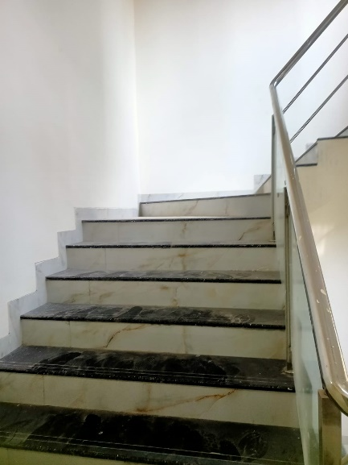
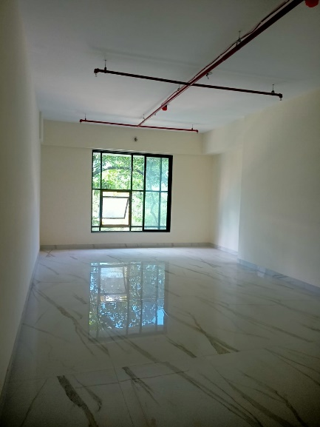
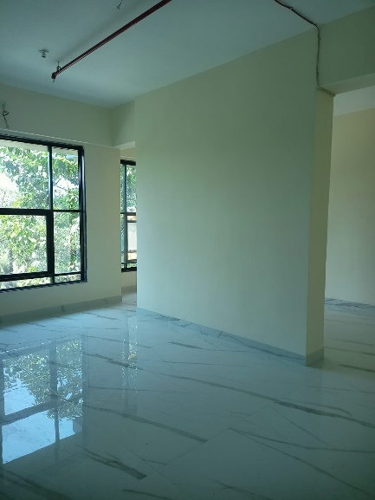
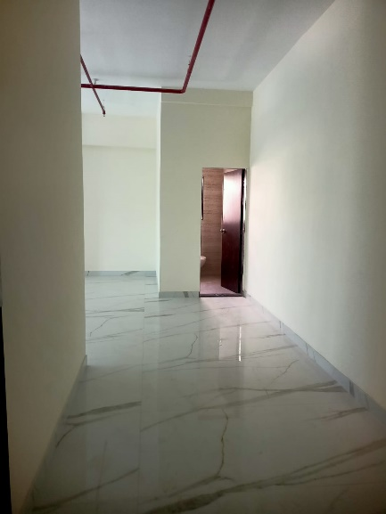
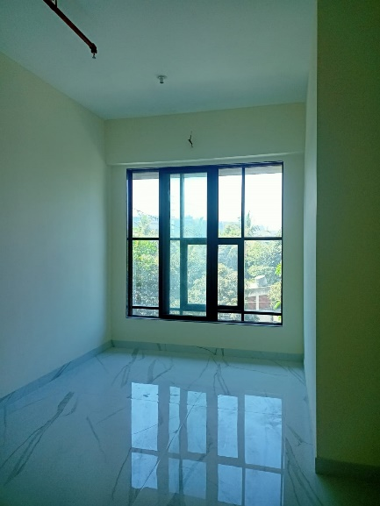
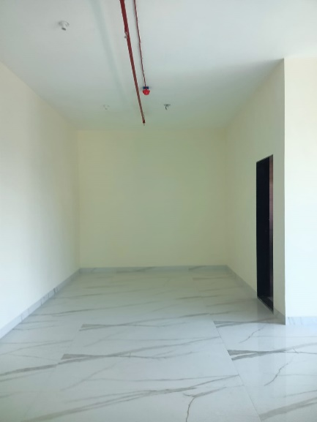
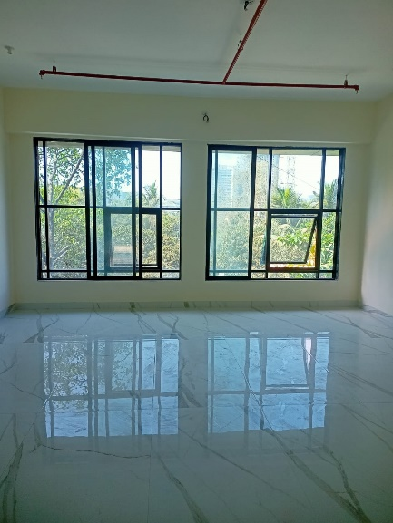
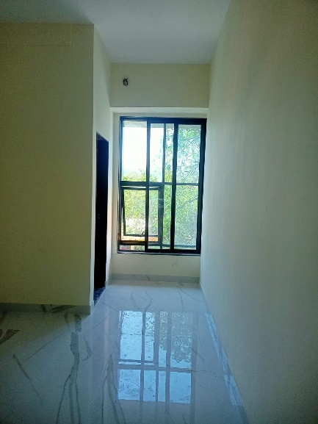
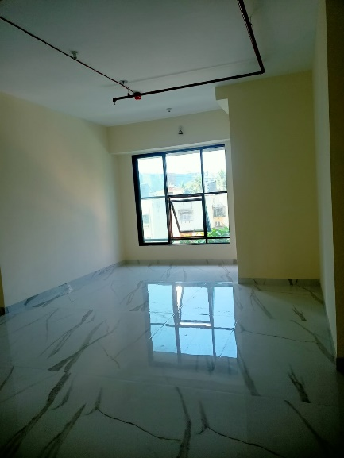

Actual Site Photographs As on 16.03.2024
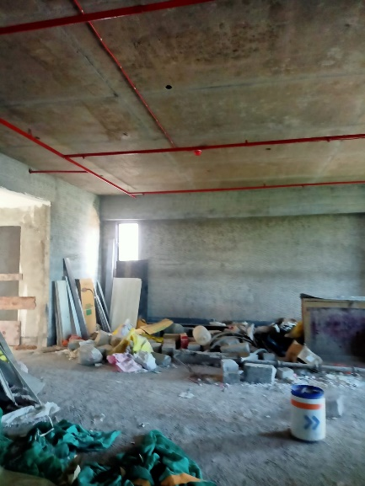
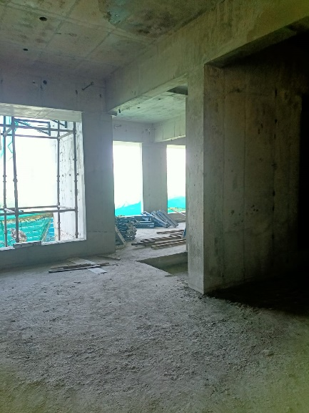
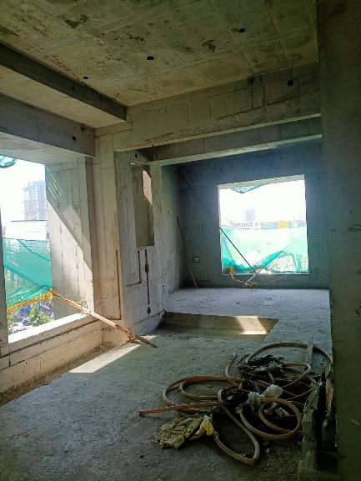
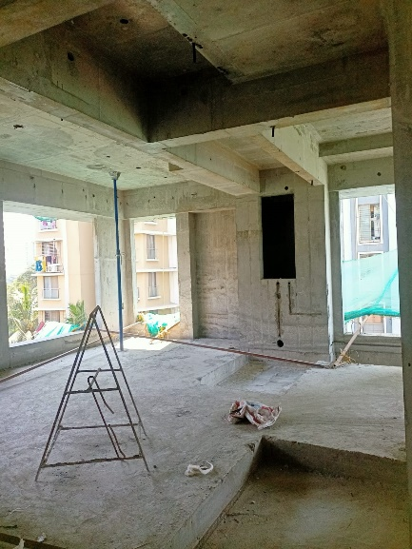
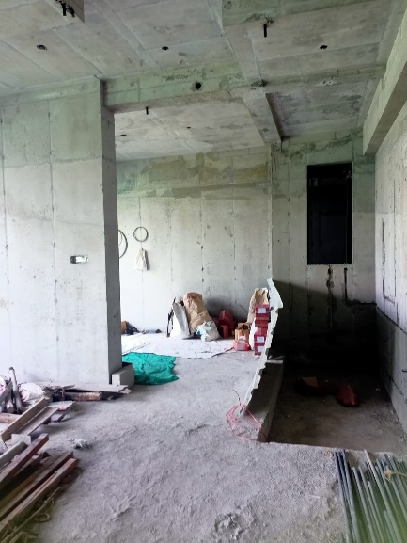
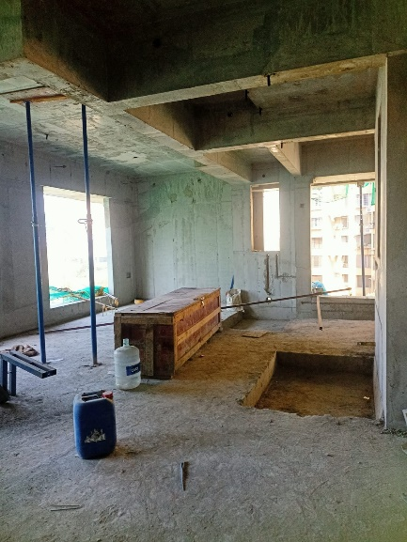
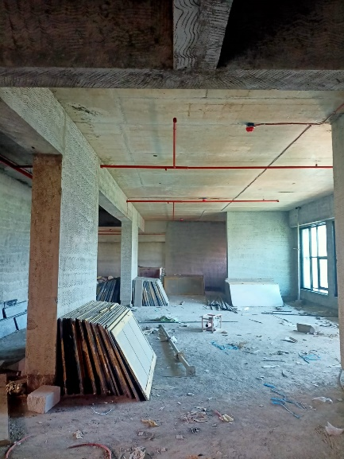
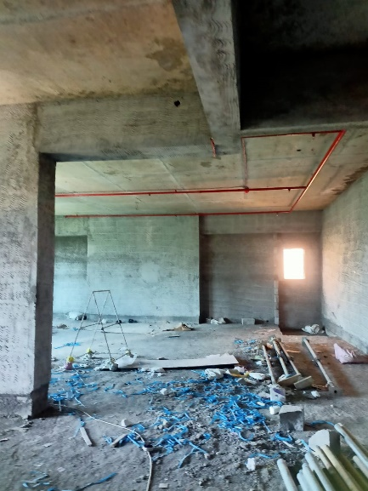
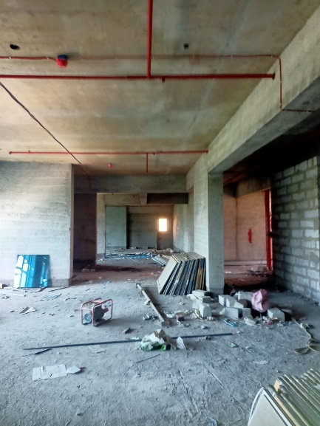

Actual Site Photographs As on 16.03.2024
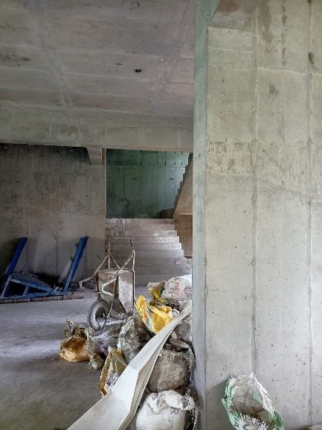
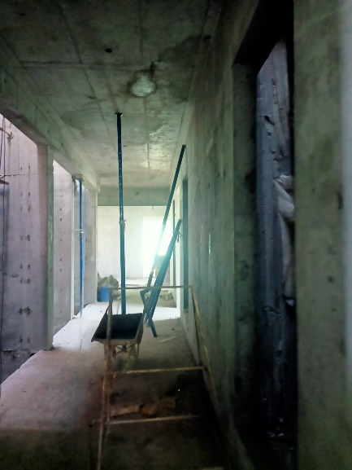
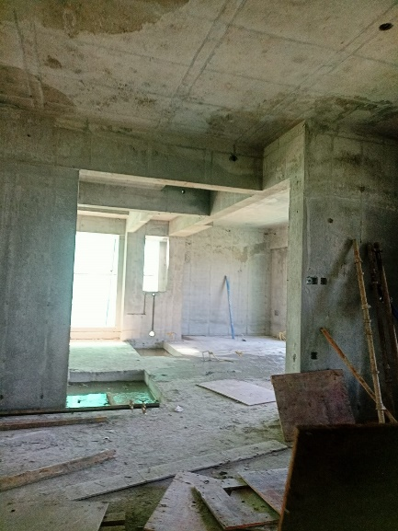
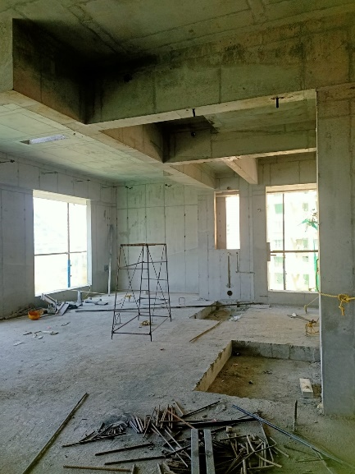
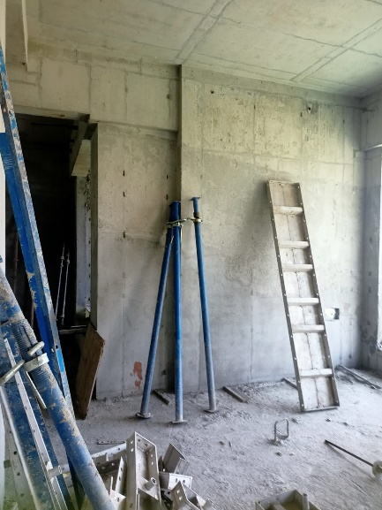
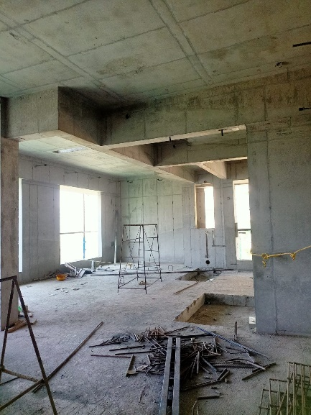
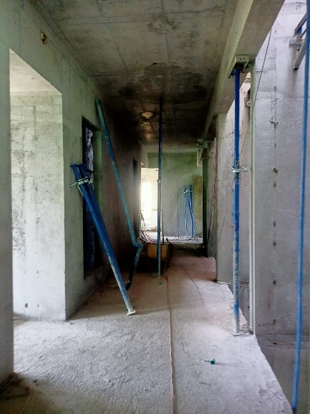
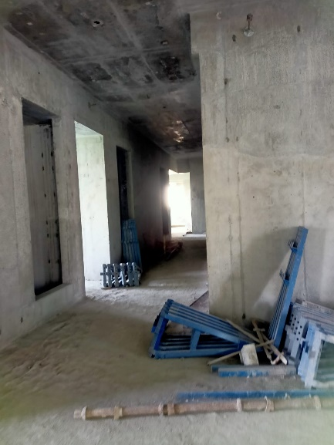
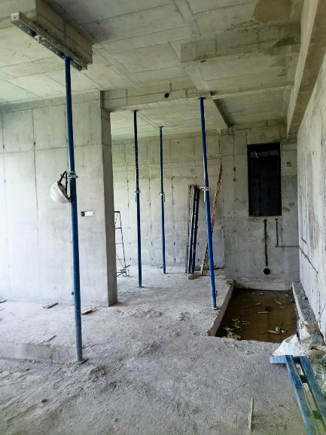

Actual Site Photographs As on 16.03.2024
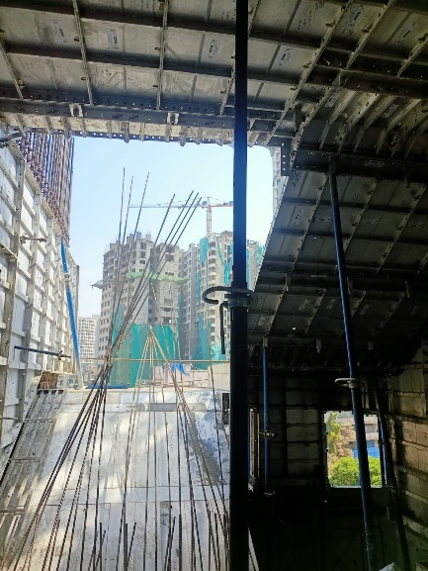
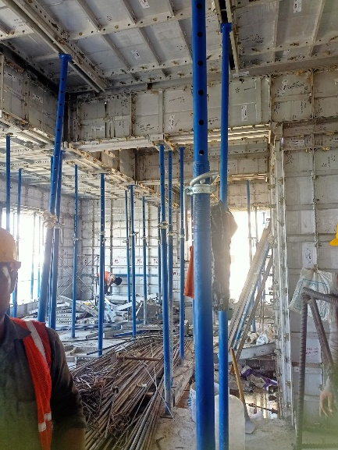
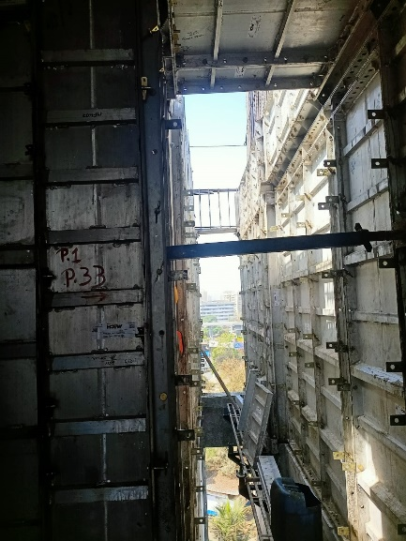
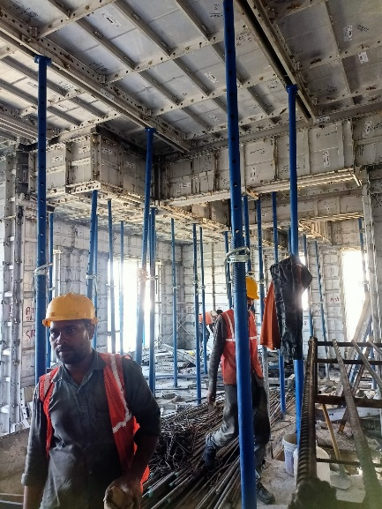
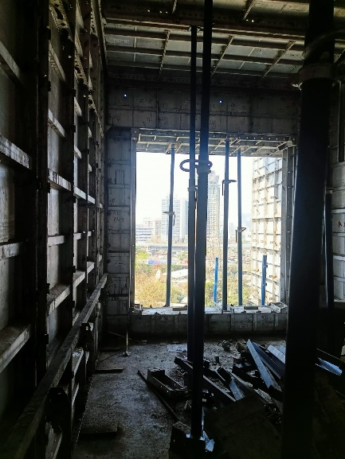
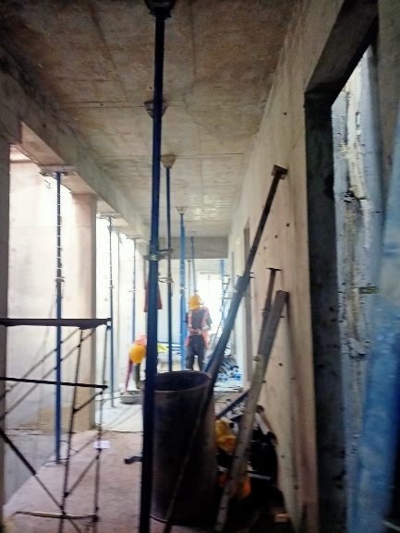
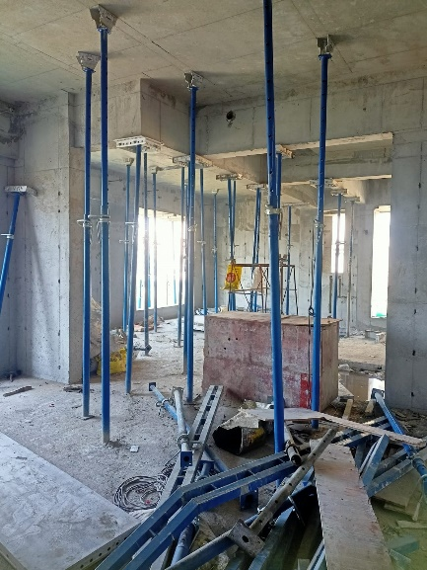
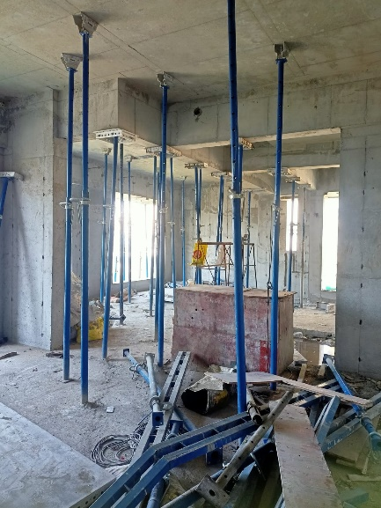

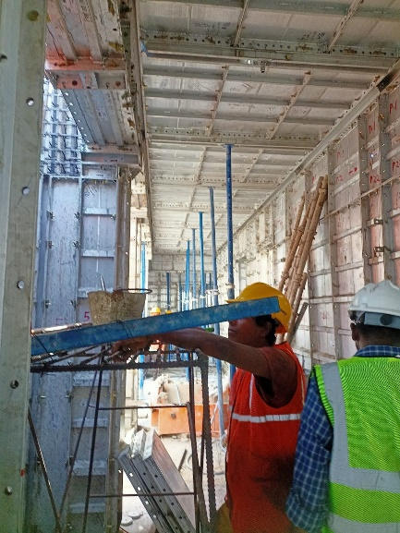
Actual Site Photographs As on 16.03.2024
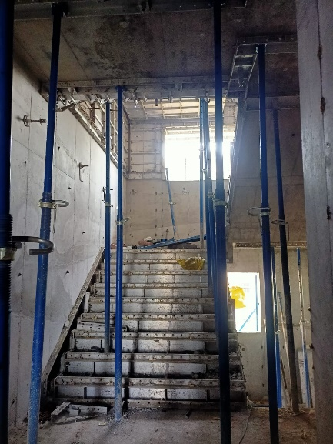
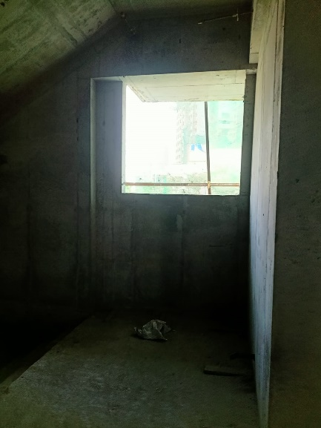
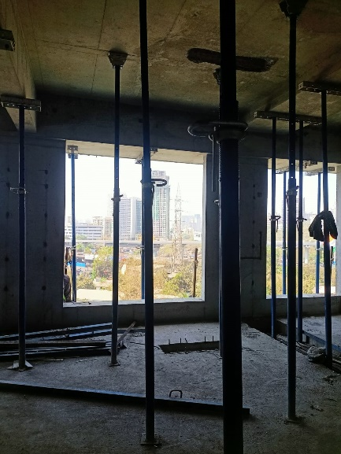
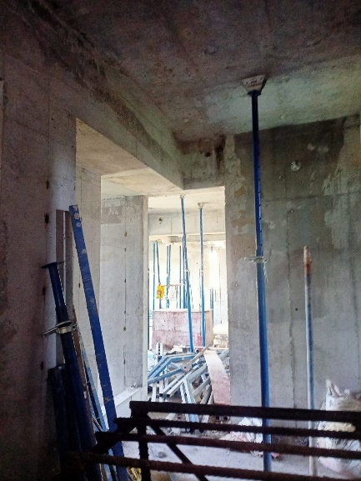
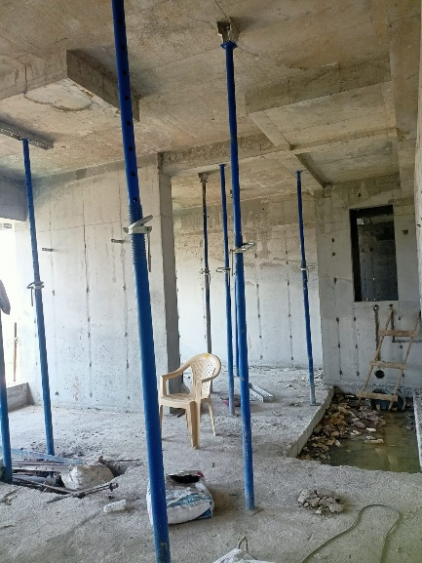
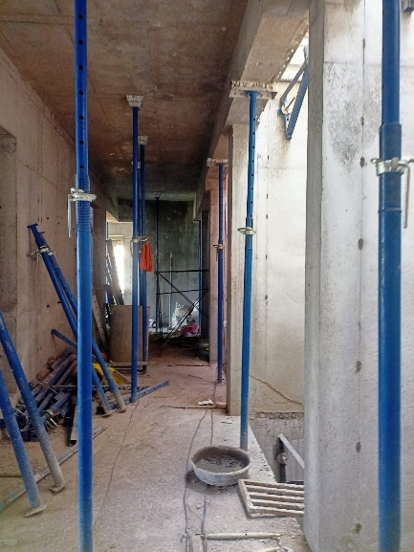
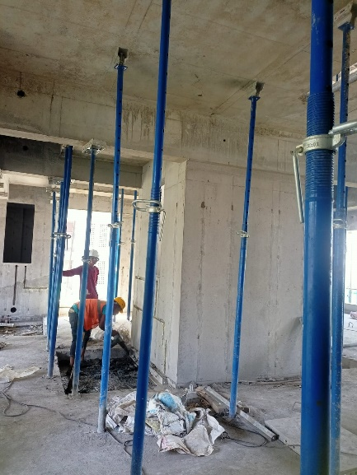
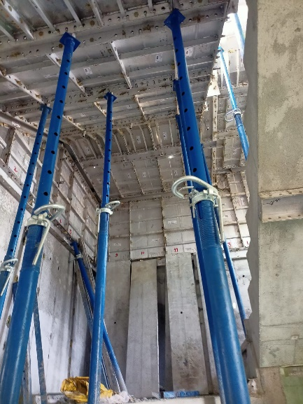
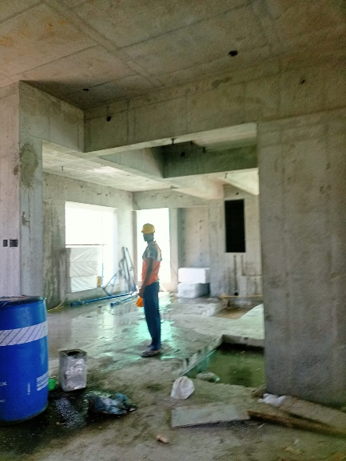

Route Map of the property
Site u/r
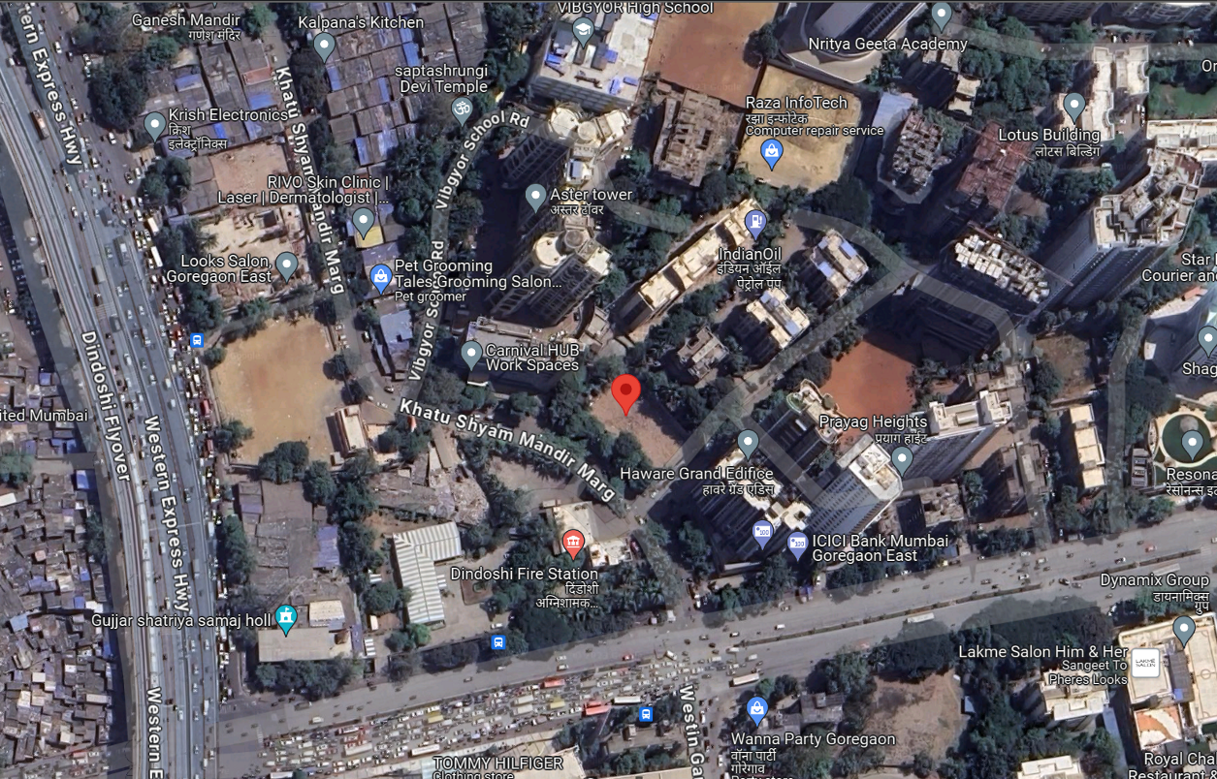

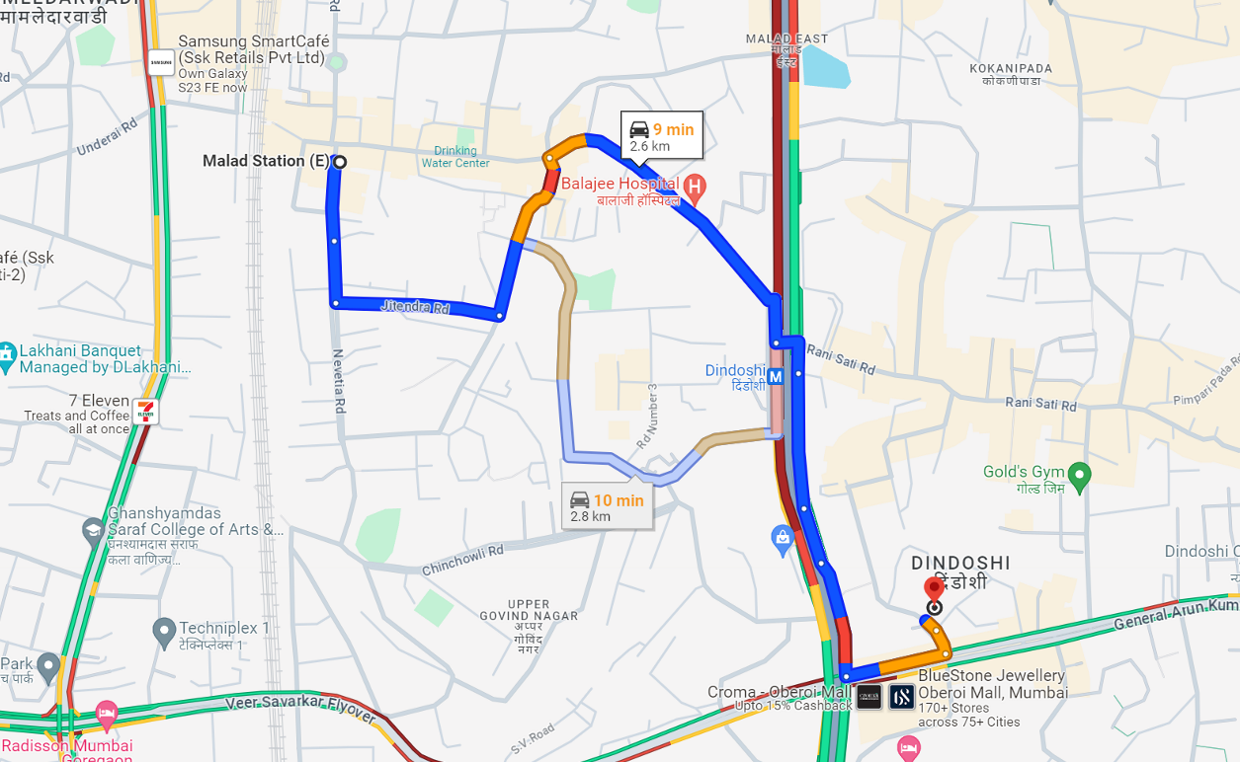

Latitude Longitude: 19°10'32.1"N 72°51'40.3"E

Note: The Blue line shows the route to site from nearest railway station (Malad– 2.60 Km.)
CA Certificate Dated 30.03.2024 till 29.02.2024
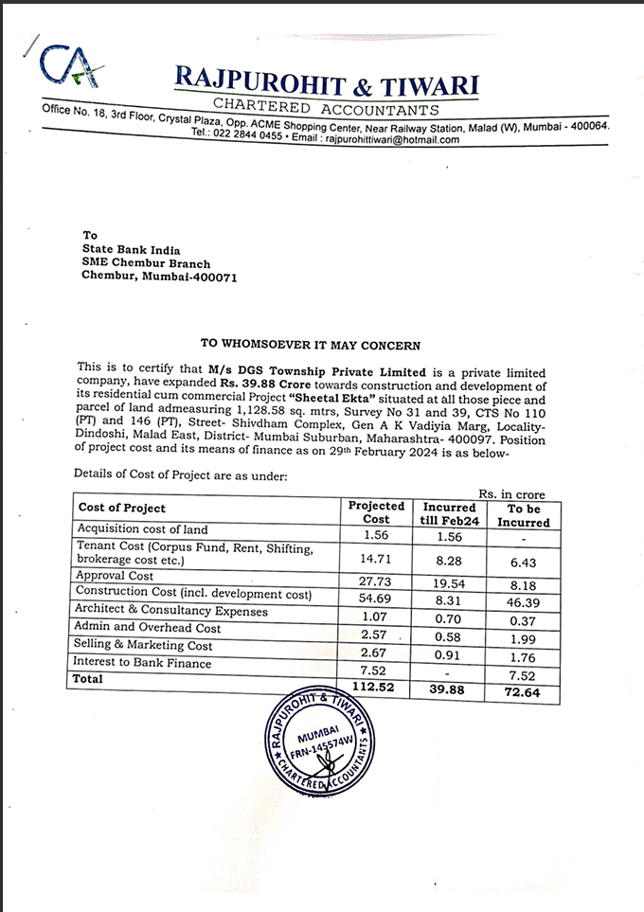

CA Certificate Dated 30.03.2024 till 29.02.2024
