1st LENDERS INDEPENDENT ENGINEER REPORT

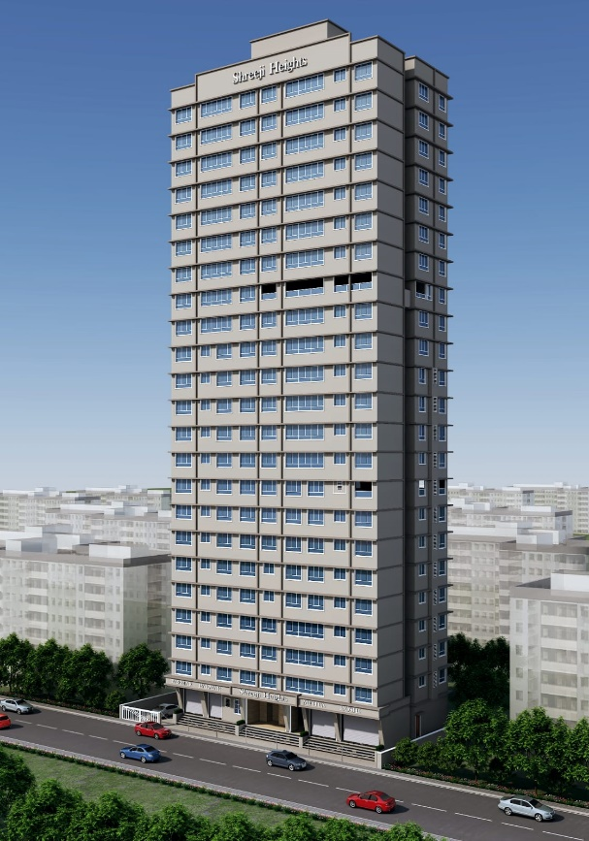

**Details of the property under consideration:**

**Name of Project: Shreeji Heights**

**"Shreeji Heights", Proposed Redevelopment of existing building known as Ram Niwas, Nath Niwas, & Gool Sorab on Plot bearing CTS. No. 802, 803 & 804, Khetwadi 7th Lane, Girgaon Division, Girgaon, Mumbai – 400 004, State – Maharashtra, Country – India**

**Latitude Longitude: 18°57'31.2"N 72°49'23.5"E**

Intended User:

State Bank of India

SME Chembur Branch

Unit No. 11, Building No. 11, Ground Floor, Corporate Park, Sion Trombay Road,

Chembur, Mumbai, Pin Code – 400 071, State - Maharashtra, Country – India

Vastu/SBI/Mumbai/03/2023/8048/2305834

30/15-582-PY

Date: - 30.03.2024

FIRST LENDERS INDEPENDENT ENGINEER REPORT

**To,**

**State Bank of India**

Unit No. 11, Building No. 11, Ground Floor,

Corporate Park, Sion Trombay Road, Chembur,

Mumbai, Pin Code – 400 071,

State - Maharashtra, Country – India.

Subject: Construction of Proposed Redevelopment of existing building known as Ram Niwas, Nath Niwas, & Gool Sorab on Plot bearing CTS. No. 802, 803 & 804, Khetwadi 7th Lane, Girgaon Division, Girgaon, Mumbai – 400 004, State – Maharashtra, Country – India

**Ref:** You’re Request for Lenders Independent Engineer Report of under Construction Building.

**Dear Sir,**

**The Construction work as per approved plan was in progress during the site visit on 21st March 2024. Total expenditure occurred as on 29/02/2024 on this project by M/s. Anupam Creation is ` 17.24 Cr. & as per CA Certificate actual total expenditure occurred as on 29/02/2024 is ` 16.66 Cr. Hence, release of Balance Amount as requested by M/s. Anupam Creation is hereby recommended.**

**DECLARATION**

1. The information furnished in the report is based on our 1st site visit Dated 21/03/2024 & Document Provided by Client.
2. Vastukala Project Report of the project dated 15/12/2023.
3. Vastukala Cost Vetting Report of the project dated 15/12/2023.
4. I have no direct and indirect interest in the property examined for report.
5. I have not been found guilty of misconduct in my professional capacity.

**Sharadkumar B. Chalikwar**

Govt. Reg. Valuer

Chartered Engineer (India)

Reg. No. (N) CCIT/1-14/52/2008-09

Encl.: LIE report

# Purpose & Methodology

• State Bank of India Banks and financial institutions require monitoring & an independent review of the progress of the sanctioned projects

**VCIPL** undertakes such study to independently review the progress of the project and put forward a comprehensive analysis

# Advantages:

* Assurance on present practices
* Identification of risk
* Analyzing the performance of third parties
* Recommendations

# The Methodology

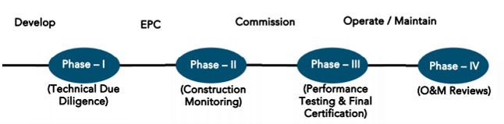

**FIRST LENDERS INDEPENDENT ENGINEER REPORT**

**OF**

**"SHREEJI HEIGHTS"**

**"Shreeji Heights",** Proposed Redevelopment of existing building known as Ram Niwas, Nath Niwas, & Gool Sorab on Plot bearing CTS. No. 802, 803 & 804, Khetwadi 7th Lane, Girgaon Division, Girgaon, Mumbai – 400 004,

State – Maharashtra, Country – India

**Latitude Longitude: 18°57'31.2"N 72°49'23.5"E**

**NAME OF DEVELOPER: M/s. Anupam Creation**

|  |
| --- |
| Pursuant to instructions from State of India, SME Chembur Branch, Chembur we have duly visited, inspected, surveyed & assessed the above said property on **21st March 2024** to determine the fair & reasonable market value of the said property/project as on Quarter ending **29th February 2024** for LIE purpose.  **1. Location Details:**  Proposed Redevelopment of existing building known as Ram Niwas, Nath Niwas, & Gool Sorab on Plot bearing CTS. No. 802, 803 & 804, Khetwadi 7th Lane, Girgaon Division, Girgaon, Mumbai – 400 004. It is about 1.20 Km. travelling distance from Charni Road Railway station. Surface transport to the property is by buses, taxis & private vehicles. The property is in developed locality. All the amenities like shops, banks, hotels, markets, schools, hospitals, etc. are all available in the surrounding locality. The area is higher middle class & developed. |

**2. Developer Details:**

|  |  |
| --- | --- |
| **Name of builder** | **M/s. Anupam Creation** |
| **Project Rera Registration Number** | **P51900052017** |
| **Registered office address** | 2nd Floor, Anupam Residency Building, V. P. Road, Prathna Samaj, Girgaon, Mumbai – 400 004, State - Maharashtra, Country – India |
| **Contact details** | **Contact Person:**  Mr. Yogesh (Accountant)  Mobile No. +91 9920825249  Mr. Deepak Agarwal (Consultants)  Mobile No. +91 88986 49465 |
| **E – mail ID and website** |  |

**3. Boundaries of the Property:**

|  |  |
| --- | --- |
| **Direction** | **Particulars** |
| **On or towards North** | Golawala Building |
| **On or towards South** | 7th Lane Road |
| **On or towards East** | Khatri Mansion |
| **On or towards West** | Shree Ganesh Apartment |

# Introduction

**As per Information on site M/s. Anupam Creation** has acquired land by multiple Conveyance Deed dated 28.01.2021, 07.12.2021 & 07.12.2021 registered vide No. BBE–4-1460/2021 dated 28.01.2021, BBE – 4 - 16805/2021 dated 07.12.2021 & BBE – 4 - 16803/2021 dated 07.12.2021 respectively admeasuring **area 685.62 Sq. M.** bearing **CTS No. 802, 803 & 804.** For the Proposed Redevelopment Residential cum Commercial Building.

# Area Statement:

# Land:

|  |  |  |
| --- | --- | --- |
| **Date** | **Particular** | **Area in Sq. M.** |
| 28.01.2021 | CTS No. 802 | 306.02 |
| 07.12.2021 | CTS No. 803 | 239.97 |
| 07.12.2021 | CTS No. 804 | 139.63 |
| TOTAL | | 685.62 |

1. Copy of Conveyance Deed dated 28.01.2021 Mrs. Rafia Mohamed Iqbal Jumani & 2 Others (The Vendors) and M/s. Anupam Creation (The Purchasers) through registered agreement vide No. BBE–4-1460/2021 dated 28.01.2021
2. Copy of Conveyance Deed dated 07.12.2021 between Mr. Bharat Dhirajlal Shah & 2 Others (The Vendors) and M/s. Anupam Creation (The Purchasers) through registered agreement vide No. BBE – 4 - 16805/2021 dated 07.12.2021
3. Copy of Conveyance Deed dated 07.12.2021 between Mr. Bharat Dhirajlal Shah & 2 Others (The Vendors) and M/s. Anupam Creation (The Purchasers) through registered agreement vide No. BBE – 4 - 16803/2021 dated 07.12.2021

# Building Area As per Approved Plan:

| **A** | **AREA STATEMENT** | | **In Sq. M.** | |
| --- | --- | --- | --- | --- |
| **1** | Area of Plot (Plot Area of CS No. 802 = 306.02 Sq. M. + Plot Area of CS No. 803 = 239.97 Sq. M. + Plot Area of CS No. 804 = 139.63 Sq. M.) | | 685.62 | |
| **a** | Area of Reservation in plot | | - | |
| **b** | Area of Road Set back | | 36.28 | |
| **c** | Any Reservation | | - | |
| **2** | Deduction for | | - | |
| **A** | For Reservation / Road Area | |  | |
| **a** | Road Setback Area to be handed over (100%) (Regulation No. 16) | | - | |
| **b** | Proposed DP Road to be handed over (100%) (Regulation No. 16) | | - | |
| **c i)** | Reservation area to be handed over (100%) (Regulation No. 17) | | - | |
| **c ii)** | Reservation area to be handed over as per AP (Regulation No. 17) | | - | |
| **B** | For Amenity area | |  | |
| **a** | Area of amenity plot / plots to be handed over as per DCPR 14(A) | | - | |
| **b** | Area of amenity plot / plots to be handed over as per DCPR 14(B) | | - | |
| **c** | Area of amenity plot / plots to be handed over as per DCPR 35 (abeyance) | | - | |
| **C** | Deductions for existing BUA to be retained if any / land component of existing BUA / existing BUA as per regulation under which the development was allowed | | - | |
| **3** | Total deductions: [{2(A) + 2(B)} + (C) as and when applicable] | | 36.28 | |
| **4** | Balance area of plot (1 – 3) | | 649.34 | |
| **5** | Additions for Floor Space Index | | - | |
| **2a** | 100% | | 36.28 | |
| **2b** | 100% | | - | |
|  | Plot area under development after areas to be handed over to MCGM / appropriate authority as per Sr. No. 4 above | | - | |
| **6** | Total Area (4 + 5) | | 685.62 | |
| **7** | Zonal basic FSI {0.50 or 0.75 or 1 or 1.33 or 3 or incentive as per DCPR 33 (7)] (As per Table – III) appropriate authority as per Sr. No. 4 above | | INCENTIVE | |
| **8** | Floor Space Index Permissible as per DCPR 33 97) (As per Table III) | | 4,910.43 | |
| **9** | Built Up equal to area of land handed over as per Regulation 30(A) | | - | |
| **i** | As per 2(A) and 2(B) except 2 (A) (c) (ii) above with in cap of “Admissible TDR” as column 6 of table – 12 on remaining / balance plot.) | | - | |
| **ii** | In case of 2 (A) (c) ii permissible over and above permissible BUA on remaining / balance plot | | - | |
| **10** | Built up area in lieu of cost of construction of built-up area amenity to be handed over (within the limit of permissible BUA on remaining plot) | | - | |
| **11** | Built up area due to Additional FSI on payment premium as per Table No. 12 of regulations no. 30(A) on remaining /balance plot | | - | |
| **12** | Built up area due to admissible TDR as per Table No. 12 of regulations no. 30(A) and 32 on remaining /balance plot | | - | |
| **13** | Permissible BUA as per Incentive FSI | | 4,910.43 | |
| **14** | Proposed BUA | | 4,910.43 | |
| **14A** | Existing Floor Area | | - | |
| **14B** | Purely residential built-up area | | 4,792.88 | |
| **14C** | Remaining non – residential built-up area | | 117.55 | |
| **15** | Fungible compensatory area as per regulation no. 31 (3) |  | Permissible | Proposed |
| **a** | Permissible / proposed fungible compensatory area for rehab component without charging premium | REHAB RESI. | 863.41 | 677.31 |
| REHAB N. R. | 41.14 | 38.48 |
| TOTAL | 904.55 | 715.79 |
| **b** | Permissible / proposed fungible compensatory area by charging premium | SALE RESI. | 814.10 | 810.98 |
| SALE N. R. | - | - |
| TOTAL | 814.10 | 810.98 |
|  | Total fungible built-up area vides dcr 33(3) = (15a + 15b) |  | 1,718.65 | 1,526.77 |
| **16** | Total Built – up area proposed including fungible compensatory area (14 + 15) | | 6,629.08 | 6,437.20 |
|  | Rehab Deficit Area | |  | 188.76 |
|  | Sale Balance Area | |  | 3.12 |
| **17** | FSI consumed on Gross Plot [14/1] | | 7.16 | |
| **(II)** | Other requirements | | - | |
| **(A)** | Reservation / Designation | | - | |
| **a)** | Name of reservation | | - | |
| **b)** | Area of reservation affecting the plot | | - | |
| **c)** | Area of reservation land to be handed / handed over as per regulation no. 17 | | - | |
| **d)** | Built-up area of amenity to be handed over as per regulation no. 17 | | - | |
| **e)** | Area / Built-up area of designation | | - | |
| **(B)** | Plot area / built-up amenity to be handed over as per regulation no. | | - | |
| **i)** | 14 (A) | | - | |
| **ii)** | 14 (B) | | - | |
| **iii)** | 15 | | - | |
| **(C)** | Requirement of recreational open space in layout / plot as per regulation no. 27 | | As per Statement | |
| **(D)** | Tenement Statement | |
| **i)** | Proposed built – up area | |
| **ii)** | Less deduction of non – residential area (shop, etc.) | |
| **iii)** | Area available for tenements [(i) minus (ii)] | |
| **iv)** | Tenements permissible (Density of tenements / hectare) | |
| **v)** | Total number of tenements proposed on the plot | |
| **(E)** | Parking Statement | |
| **i)** | Parking required by regulations for Car Scooter / Motor cycle outsiders (visitors) | |
| **ii)** | Covered garage permissible | |
| **iii)** | Covered garages proposed Car / Scooter / Motor Cycle Outsiders (visitors) | |
| **iv)** | Total parking provided | |
| **(F)** | Transport Vehicles Parking | |
| **i)** | Spaces for transport vehicles parking required by regulations | |
| **ii)** | Total no. of transport vehicles parking spaces provided | |

# List of Approvals:

1. Copy of Approved Plan No. P-12578/2022/(802 And Other)/D Ward/GIRGAUM/1/New dated 16.11.2022 issued by Municipal Corporation of Greater Mumbai (MCGM).

**Approved Upto: Basement + Ground Floor + 1st to 22nd Upper Floors**

1. Copy of 1st Commencement Certificate No. P-12578/2022/(802 And Other)/D Ward/GIRGAUM/CC/1/New dated 11.04.2023 valid upto 10.04.2024 issued by Municipal Corporation of Greater Mumbai (MCGM).

**(This CC is endorsed for the work up to Plinth Level only as per IOD issued dated 16.11.2022).**

1. Copy of 2nd Commencement Certificate No. P-12578/2022/(802 And Other)/D Ward/GIRGAUM/FCC/1/New dated 08.12.2023 valid upto 10.04.2024 issued by Municipal Corporation of Greater Mumbai (MCGM).

**(This CC is endorsed for the work up to top of 22nd Floor + LMR + OHT i.e., CC for entire work as per IOD issued dated 16.11.2022).**

1. Copy of No Objection Certificate NO. R/NOC/F-2811/4478/MBR &R Board-2022 dated 14.06.2022 issued by Maharashtra Housing and Area Development Authority (MHADA).

# LEVEL OF COMPLETION:

# Rehab cum Sales Building

| Sr. No | Floor No. | Construction Area in Sq. M. | Completed Area in Sq. M. | Work Completion as on 21.03.2024 |
| --- | --- | --- | --- | --- |
| 1 | Excavation & Shore Piling | | | Work is Completed |
| 2 | Basement | 365.64 | 365.64 | Slab Work is completed |
| 3 | Ground Floor | 365.64 | 365.64 | Slab Work is completed |
| 4 | 1st Floor | 393.26 | 393.26 | Slab Work is completed |
| 5 | 2nd Floor | 391.88 | 391.88 | Slab Work is completed |
| 6 | 3rd Floor | 391.88 | 391.88 | Slab Work is completed |
| 7 | 4th Floor | 391.88 | 391.88 | Slab Work is completed |
| 8 | 5th Floor | 391.88 |  |  |
| 9 | 6th Floor | 391.88 |  |  |
| 10 | 7th Floor | 391.88 |  |  |
| 11 | 8th Floor | 408.52 |  |  |
| 12 | 9th Floor | 408.52 |  |  |
| 13 | 10th Floor | 412.47 |  |  |
| 14 | 11th Floor | 415.53 |  |  |
| 15 | 12th Floor | 415.53 |  |  |
| 16 | 13th Floor | 415.53 |  |  |
| 17 | 14th Floor | 415.83 |  |  |
| 18 | 15th Floor | 422.27 |  |  |
| 19 | 16th Floor | 422.25 |  |  |
| 20 | 17th Floor | 411.10 |  |  |
| 21 | 18th Floor | 411.10 |  |  |
| 22 | 19th Floor | 411.10 |  |  |
| 23 | 20th Floor | 411.10 |  |  |
| 24 | 21st Floor | 411.10 |  |  |
| 25 | 22nd Floor | 411.10 |  |  |
| 26 | Terrace Floor | 43.87 |  |  |
| Total | | **9,722.80** | **2,300.18** |  |
| Stack Parking | | **49.00** | **-** |  |

# Details of the Project as Financed By SBI:

# Project Cost: (as per C.A. Certificate)

|  |  |  |
| --- | --- | --- |
| **Particulars** | **Estimated Cost (in Cr.)** | **Incurred Cost (In Cr.) till 29.02.2024 dated 28.03.2024 by M/s. S C Vora & Co.** |
| Land Cost | 1.48 | 1.48 |
| Rent Cost | 5.87 | 2.24 |
| Construction cost of Building | 33.80 | 4.50 |
| Premium Cost / FSI / GOM Charges / fees / security Deposits | 9.69 | 7.84 |
| Architect Cost, RCC & Other Professional Cost | 1.69 | 0.56 |
| Administrative Cost | 2.03 | 0.03 |
| Marketing Cost | 3.50 | 0.00 |
| Interest Cost | 4.03 | - |
| Contingency Cost | 1.01 | - |
| **Total** | **63.10** | **16.66** |

* **The Builder has incurred about 1.48 Cr. as land cost, 2.24 Cr. Rent Cost, 4.50 Cr. as construction cost, 7.84 Cr. for approval of project, 0.56 Cr. for professional charges, 0.03 Cr. for admin cost in last quarter till 29.02.2024 as per C.A. certificate issued by M/s. S C Vora & Co. dated 28.03.2024.**

# Project Cost: (as per Bills):

|  |  |
| --- | --- |
| **Particulars** | **Incurred Cost (in Cr.)** |
| **29.02.2024 as per Bill (Inclusive GST)** |
| Land Cost | 1.48 |
| Rent Cost | 2.24 |
| Construction cost of Building | 4.84 |
| Premium Cost / FSI / GOM Charges / fees / security Deposits | 7.84 |
| Architect Cost, RCC & Other Professional Cost | 0.45 |
| Administrative Cost | 0.38 |
| Marketing Cost | 0.00 |
| Interest Cost | 0.00 |
| Contingency Cost | - |
| **Total** | **17.24** |

Note:

# Land Cost:

|  |  |  |  |  |  |
| --- | --- | --- | --- | --- | --- |
| Sr. No. | Agreement Name | Date | Particulars | Total Cost in ` | Incurred Cost in ` |
| 1 | Conveyance Deed | 07.12.2021 | Stamp Duty | 13,97,300.00 | 13,97,300.00 |
| 2 | Reg. Fees | 30,000.00 | 30,000.00 |
| 3 | 2,840.00 | 2,840.00 |
| 4 | Conveyance Deed | 07.12.2021 | Stamp Duty | 13,97,300.00 | 13,97,300.00 |
| 5 | Reg. Fees | 30,000.00 | 30,000.00 |
| 6 | 3,300.00 | 3,300.00 |
| 7 | Conveyance Deed | 28.01.2021 | Purchase Cost | 1,16,00,000.00 | 1,16,00,000.00 |
| 8 | Stamp Duty | 3,48,000.00 | 3,48,000.00 |
| 9 | Reg. Fees | 30,000.00 | 30,000.00 |
| 10 | 1,600.00 | 1,600.00 |
|  | **TOTAL** | | | **1,48,40,340.00** | **1,48,40,340.00** |

As per developer agreement.

|  |  |  |  |
| --- | --- | --- | --- |
| **Summary of Bills** | | | |
| **Sr. No.** | **Particulars** | **Amount in `**  **(till 29.02.2024)** | **Amount in ` (in Cr.)** |
| **1** | Construction Cost | 4,84,37,952.00 | 4.84 |
| **2** | Rent Cost | 2,24,29,806.00 | 2.24 |
| **3** | Premium Cost / FSI / GOM Charges / fees / security Deposits | 7,83,89,148.00 | 7.84 |
| **4** | Professional Cost | 44,86,737.00 | 0.45 |
| **5** | Administrative Cost | 37,78,634.00 | 0.38 |
| **6** | Marketing Cost | - | - |
| **7** | Contingency Cost | - | - |
| **TOTAL** | | **15,75,22,276.00** | **15.75** |

Note: Bills were provided by the client up to 29.02.2024

# Interest Cost:

|  |  |  |  |  |
| --- | --- | --- | --- | --- |
| **Sr. No** | **Particulars** | **Estimate Amount in `** | **Incurred Amount in ` (till 29.02.2024)** | **Balance Amount in `** |
| **1** | Interest Cost | 4,03,00,000.00 | - | 4,03,00,000.00 |
| **TOTAL** | | **4,03,00,000.00** | **-** | **4,03,00,000.00** |

Interest Cost is based on discussion with the client.

# Cost of Construction as on 21st March 2024:

|  |  |  |  |  |  |  |  |
| --- | --- | --- | --- | --- | --- | --- | --- |
| Sr. No. | Floor | Total Construction Area in Sq. M. | Completed Area in Sq. M. | Rate per Sq. M. | Full Value after completion | % of work completed | Actual Expenditure till date in ` |
| 1 | Excavation Cost |  |  |  | 2,91,68,399.00 | 100% | 2,91,68,399.00 |
| 2 | Basement | 365.64 | 365.64 | 30,000.00 | 1,09,69,200.00 | 50% | 54,84,600.00 |
| 3 | Ground Floor | 365.64 | 365.64 | 30,000.00 | 1,09,69,200.00 | 50% | 54,84,600.00 |
| 4 | 1st Floor | 393.26 | 393.26 | 30,000.00 | 1,17,97,830.00 | 50% | 58,98,915.00 |
| 5 | 2nd Floor | 391.88 | 391.88 | 30,000.00 | 1,17,56,430.00 | 50% | 58,78,215.00 |
| 6 | 3rd Floor | 391.88 | 391.88 | 30,000.00 | 1,17,56,430.00 | 50% | 58,78,215.00 |
| 7 | 4th Floor | 391.88 | 391.88 | 30,000.00 | 1,17,56,430.00 | 40% | 47,02,572.00 |
| 8 | 5th Floor | 391.88 |  | 30,000.00 | 1,17,56,430.00 |  | - |
| 9 | 6th Floor | 391.88 |  | 30,000.00 | 1,17,56,430.00 |  | - |
| 10 | 7th Floor | 391.88 |  | 30,000.00 | 1,17,56,430.00 |  | - |
| 11 | 8th Floor | 408.52 |  | 30,000.00 | 1,22,55,705.00 |  | - |
| 12 | 9th Floor | 408.52 |  | 30,000.00 | 1,22,55,705.00 |  | - |
| 13 | 10th Floor | 412.47 |  | 30,000.00 | 1,23,74,205.00 |  | - |
| 14 | 11th Floor | 415.53 |  | 30,000.00 | 1,24,66,005.00 |  | - |
| 15 | 12th Floor | 415.53 |  | 30,000.00 | 1,24,66,005.00 |  | - |
| 16 | 13th Floor | 415.53 |  | 30,000.00 | 1,24,66,005.00 |  | - |
| 17 | 14th Floor | 415.83 |  | 30,000.00 | 1,24,75,005.00 |  | - |
| 18 | 15th Floor | 422.27 |  | 30,000.00 | 1,26,68,205.00 |  | - |
| 19 | 16th Floor | 422.25 |  | 30,000.00 | 1,26,67,605.00 |  | - |
| 20 | 17th Floor | 411.10 |  | 30,000.00 | 1,23,33,105.00 |  | - |
| 21 | 18th Floor | 411.10 |  | 30,000.00 | 1,23,33,105.00 |  | - |
| 22 | 19th Floor | 411.10 |  | 30,000.00 | 1,23,33,105.00 |  | - |
| 23 | 20th Floor | 411.10 |  | 30,000.00 | 1,23,33,105.00 |  | - |
| 24 | 21st Floor | 411.10 |  | 30,000.00 | 1,23,33,105.00 |  | - |
| 25 | 22nd Floor | 411.10 |  | 30,000.00 | 1,23,33,105.00 |  | - |
| 26 | OHT / LMR | 43.87 |  | 30,000.00 | 13,16,100.00 |  | - |
| Sub - Total (A) | | **9,722.80** | **2,300.18** |  | **32,08,52,384.00** |  | **6,24,95,516.00** |
| STACK PARKING Nos. | | **49.00** |  | **3,50,000.00** | **1,71,50,000.00** |  | **-** |
| TOTAL COST OF CONSTRUCTION (A + B) | | | | | **33,80,02,384.00** | **18%** | **6,24,95,516.00** |

##### Note: Details of work completed is as per site visit dated 21.03.2024 but report is prepared for 29th February quarter 2024.

|  |  |  |  |  |
| --- | --- | --- | --- | --- |
| **Particulars** | **Estimated Cost**  **(In Cr.)** | **Incurred Cost (in Cr.)** | | **Net** |
| **Issued dated 28.03.2024 till 29.02.2024 as per CA** | **As per Bills upto 29.02.2024** |
| Land Cost | 1.48 | 1.48 | 1.48 | - |
| Rent Cost | 5.87 | 2.24 | 2.24 | - |
| Construction cost of Building | 33.80 | 4.50 | 4.84 | 0.34 |
| Premium Cost / FSI / GOM Charges / fees / security Deposits | 9.69 | 7.84 | 7.84 | - |
| Architect Cost, RCC & Other Professional Cost | 1.69 | 0.56 | 0.45 | -0.11 |
| Administrative Cost | 2.03 | 0.03 | 0.38 | 0.35 |
| Marketing Cost | 3.50 | 0.00 | 0.00 | - |
| Interest Cost | 4.03 | - | 0.00 | - |
| Contingency Cost | 1.01 | - | - | - |
| **Total** | **63.10** | **16.66** | **17.24** | **0.58** |

Note:

* We have considered Other Expenses, Printing & Stationery, and Water Bills cost is consider in on-site expenditure cost header but CA has considered them in cost of construction header .
* As per plinth area, calculation the work completed is up to 18% of total work, which comes to ` 6.25 Cr. However, company has incurred cost of ` 4.84 Cr. till 29.02.2024 as per bill .

# Comparison of Cost incurred on dated 29.02.2024 & CA Certificate

|  |  |  |  |  |
| --- | --- | --- | --- | --- |
| Particulars | 29.02.2024 as per Bill | As per CA Certiifcate | Net | % of net amount |
| Land Cost | 1.48 | 1.48 | - | 0.00% |
| Rent Cost | 2.24 | 2.24 | - | 0.00% |
| Construction cost of Building | 4.84 | 4.50 | 0.34 | 1.97% |
| Premium Cost / FSI / GOM Charges / fees / security Deposits | 7.84 | 7.84 | - | 0.00% |
| Architect Cost, RCC & Other Professional Cost | 0.45 | 0.56 | -0.11 | -0.64% |
| Administrative Cost | 0.38 | 0.03 | 0.35 | 2.03% |
| Marketing Cost | 0.00 | 0.00 | - | 0.00% |
| Interest Cost | 0.00 | - | - | 0.00% |
| Contingency Cost | - | - | - | 0.00% |
| Total | **17.24** | **16.66** | **0.58** | **3.36%** |

# % of Fund Utilised till 29th February 2024

|  |  |  |  |  |
| --- | --- | --- | --- | --- |
| Particulars | Estimated Project Cost  (in Cr.) | Incurred cost as on 31.07.2022 | % of Incurred Cost | % of Estimated Project Cost |
| Land Cost | 1.48 | 1.48 | 100.27% | 2.35% |
| Rent Cost | 5.87 | 2.24 | 38.21% | 3.55% |
| Construction cost of Building | 33.80 | 4.84 | 14.33% | 7.68% |
| Premium Cost / FSI / GOM Charges / fees / security Deposits | 9.69 | 7.84 | 80.90% | 12.42% |
| Architect Cost, RCC & Other Professional Cost | 1.69 | 0.45 | 26.55% | 0.71% |
| Administrative Cost | 2.03 | 0.38 | 18.61% | 0.60% |
| Marketing Cost | 3.50 | 0.00 | 0.00% | 0.00% |
| Interest Cost | 4.03 | 0.00 | 0.00% | 0.00% |
| Contingency Cost | 1.01 | - | 0.00% | 0.00% |
| Total | **63.10** | **17.24** | **27.32%** | **27.32%** |

Based on above Calculation it is found that total Project cost incurred is 27.32% of the Total Project Cost.

# Means of Finance:

|  |  |  |
| --- | --- | --- |
| **Sr. No.** | **Particulars** | **Exp. Cumulative (Cr.)** |
|  | Equity share capital / Quassi Loan from Promoter | 16.66 |
|  | Sales (Advance from customer) | - |
|  | Bank Laon Amount | - |
|  | Unsecured Loan amount | - |
|  | **Total** | **16.66** |

The Details of the Means of Finance are provided by Client as on 29.02.2024.

# Mandatory Arrangements:

|  |  |  |
| --- | --- | --- |
| **Sr. No.** | **Particulars** | **Status** |
|  | Rainwater Harvesting | To be executed after RCC Structure |
|  | Firefighting System | To be executed after RCC Structure |
|  | Solid Waste Management | To be executed after RCC Structure |

# Quality of Construction:

|  |  |  |
| --- | --- | --- |
| **Sr. No.** | **Particulars** | **Status** |
|  | Soundness of Structures | Executing as per approved Structural Design |
|  | Look of Structures | Good |
|  | Quality of Material Used | Good |
|  | Safety Measures for Construction/labour | Taken Care by Contractor |

# Schedule V/s. Actual Progress:

| Activity | Date of Implementation | Date of Completion | Status |
| --- | --- | --- | --- |
| Land |  |  | Completed |
| Development of Land |  |  | Completed |
| Foundation Work |  |  | Completed |
| Ground Floor Slab |  |  | Slab work is Completed |
| 1st Floor Slab |  |  | Slab work is Completed |
| 2nd Floor Slab |  |  | Slab work is Completed |
| 3rd Floor Slab |  |  | Slab work is Completed |
| 4th Floor Slab |  |  | Slab work is Completed |
| 5th Floor Slab |  |  | Slab work is in progress |
| 6th Floor Slab |  |  |  |
| 7th Floor Slab |  |  |  |
| 8th Floor Slab |  |  |  |
| 9th Floor Slab |  |  |  |
| 10th Floor Slab |  |  |  |
| 11th Floor Slab |  |  |  |
| 12th Floor Slab |  |  |  |
| 13th Floor Slab |  |  |  |
| 14th Floor Slab |  |  |  |
| 15th Floor Slab |  |  |  |
| 16th Floor Slab |  |  |  |
| 17th Floor Slab |  |  |  |
| 18th Floor Slab |  |  |  |
| 19th Floor Slab |  |  |  |
| 20th Floor Slab |  |  |  |
| 21st Floor Slab |  |  |  |
| 22nd Floor Slab |  |  |  |
| Block work / Internal Plaster work |  |  |  |
| Terrace Parapet wall / Overhead water tank / Lift Machine room / compound wall / External Plaster work |  |  |  |
| Electric Work |  |  |  |
| Water Proofing |  |  |  |
| Plumbing Work |  |  |  |
| Tiling / Marble Flooring |  |  |  |
| Door Frames |  |  |  |
| Window Installation |  |  |  |
| Staircase Flooring |  |  |  |
| Staircase Railing |  |  |  |
| Refuge Area Flooring |  |  |  |
| Internal Painting |  |  |  |
| External Painting |  |  |  |
| Lift Work |  |  |  |
| Fire Fighting Installation |  |  |  |
| Stack Parking |  |  |  |
| CP Fitting & Sanitary Work |  |  |  |
| Final Finishing & Fitting |  |  |  |

# Action initiated to complete the project in time:

**For Rehab Cum Sales Building:** 4th Floor Slab work is completed, 5th floor slab work is in progress.

# Comments related to cost overrun if any:

The cost of Sales Building is ` 63.10 Cr.

# Balance investment required for completion of project:

We opinion amount of **` 45.86 Cr.** Will be required to complete the Project.

# Mandatory Approval Status:

| **Sr. No.** | **Particulars** | **Name of Department** | **Status** | **Order Details** |
| --- | --- | --- | --- | --- |
| **1** | IOD of Building | Municipal Corporation of Greater Mumbai (MCGM). | Obtained and available at site | P-12578/2022/(802 And Other)/D Ward/GIRGAUM/1/New dated 16.11.2022 |
| **1A** | 1st Amended | Municipal Corporation of Greater Mumbai (MCGM). | Obtained and available at site | P-12578/2022/(802 And Other)/D Ward/GIRGAUM/1/New dated 16.11.2022 |
| **2A** | First C.C. | Municipal Corporation of Greater Mumbai (MCGM). | Obtained and available at site | * P-12578/2022/(802 And Other)/D Ward/GIRGAUM/CC/1/New dated 11.04.2023 valid upto 10.04.2024. (This CC is endorsed for the work up to Plinth Level only as per IOD issued dated 16.11.2022). |
| **2B** | Second C.C. | Municipal Corporation of Greater Mumbai (MCGM). | Obtained and available at site | * P-12578/2022/(802 And Other)/D Ward/GIRGAUM/FCC/1/New dated 08.12.2023 valid upto 10.04.2024. (This CC is endorsed for the work up to top of 22nd Floor + LMR + OHT i.e., CC for entire work as per IOD issued dated 16.11.2022). |
| **3B** | Occupancy | Municipal Corporation of Greater Mumbai (MCGM). | Pending (Project is not completed) |  |

# Status Insurance Coverage:

Information not provided

# Assumptions & Remarks:

* The adequacy of Engineering / Structural design is beyond the scope of our assignment.
* Estimated project completion date is 31/12/2030 for Rehab cum Sales Building respectively. The cost is certified based on the assumptions that the project will be completed within period. Few assumptions were made regarding inflation & cost rise etc. during construction period.

**Sharadkumar B. Chalikwar**

Govt. Reg. Valuer

Chartered Engineer (India)

Reg. No. (N) CCIT/1-14/52/2008

**About the Project:**

|  |  |  |
| --- | --- | --- |
| **1. Introduction** | |  |
| a) | Project Name  (With Address & Phone Nos.) | **"Shreeji Heights",** Proposed Redevelopment of existing building known as Ram Niwas, Nath Niwas, & Gool Sorab on Plot bearing CTS. No. 802, 803 & 804, Khetwadi 7th Lane, Girgaon Division, Girgaon, Mumbai – 400 004, State – Maharashtra, Country – India  Contact Person:  Mr. Yogesh (Accountant)  Mobile No. +91 99208 25249  Mr. Deepak Agarwal (Consultants)  Mobile No. +91 88986 49465 |
| b) | Purpose of Valuation | As per request from State Bank of India, SME Chembur Branch to assess fair market value of the Project for LIE purpose. |
| c) | Date of Inspection of Property | 21.03.2024 |
| d) | Date of LIE Report | 30.03.2024 |
| e) | Name of the Developer of Property  (in case of developer built properties) | **M/s. Anupam Creation**  2nd Floor, Anupam Residency Building, V. P. Road, Prathna Samaj, Girgaon, Mumbai – 400 004, State - Maharashtra, Country – India |
| **2. Physical Characteristics of the Property** | | |
| a) | Location of the Property | **"Shreeji Heights",** Proposed Redevelopment of existing building known as Ram Niwas, Nath Niwas, & Gool Sorab on Plot bearing CTS. No. 802, 803 & 804, Khetwadi 7th Lane, Girgaon Division, Girgaon, Mumbai – 400 004, State – Maharashtra, Country – India |
| Brief description of the property |  |
|  | **TYPE OF THE BUILDING**  **Rehab cum Sales Building**   |  |  | | --- | --- | | No. of Floors | Basement + Ground Floor + 1st to 22nd Upper Floors | | Building type | Residential Rehab cum Sale building |   Rehab cum Sales Building work is given on contract based for RCC contract. Developer has grant to the contractor do the work of construction and completion includes Concrete work, Reinforcement work, Masonry, Internal Plaster, External Plaster and other miscellaneous work such as repairing, joints b/w concrete and masonry surface, etc. Bill must be paid on measurement of construction area exclusive of Steel, Cement & other construction material.  Lift & lift installation contract is not finalized till now.  Firefighting work contract is not finalized.  **PROPOSED DATE OF COMPLETION & FUTURE LIFE:**  Expected completion date as per RERA is 31st December 2030.  **ABOUT PROJECT:**  Anupam Shreeji Heights is among the newest addresses for homebuyers. This is an under – construction project right now, and is expected to be delivered by Dec, 2030. It has a variety of options to choose from that too in a varied budget range.  Anupam Shreeji Heights South Mumbai is a RERA registered housing society, which means all projects details are also available on state RERA website for end-users and investors. The RERA registration number of this project is P51900052017. | |
|  | Nearby landmark |  |
| Postal Address of the Property | **"Shreeji Heights",** Proposed Redevelopment of existing building known as Ram Niwas, Nath Niwas, & Gool Sorab on Plot bearing CTS. No. 802, 803 & 804, Khetwadi 7th Lane, Girgaon Division, Girgaon, Mumbai – 400 004, State – Maharashtra, Country – India |
|  | Area of the plot/land  (Supported by a plan) | Net Plot Area: 649.34 Sq. M. |
| Type of Land: Solid, Rocky, Marsh land, reclaimed land, Water-logged, Land locked. | Solid land |
|  | Independent access/approach to the property etc. | Yes |
| Google Map Location of the Property with a neighborhood layout map | Provided |
|  | Details of roads abutting the property | 12 M wide road |
| Description of adjoining property | Located in Higher Middle-class locality |
| Plot No. Survey No. | CTS. No. 802, 803 & 804 |
| Ward/Village/Taluka | Girgaon Division, Taluka – Mumbai |
| Sub-Registry/Block | Girgaon |
| District | District - Mumbai |
| b) | **Boundaries of the Plot** |  |
|  | |  |  |  |  | | --- | --- | --- | --- | |  | **As per Agreement** | **As per RERA Certificate** | **Actual** | | **North** | Information not available | CS No. 805 | Golawala Building | | **South** | Information not available | CS No. 806 | Khetwadi 7th Lane Road | | **East** | Information not available | 797 to 1800 | Khatri Mansion | | **West** | Information not available | Khetwadi 7th Lane | Shree Ganesh Apartment | | |

|  |  |
| --- | --- |
| **4. Document Details and Legal Aspects of Property:** | |
| a) | Ownership Documents (**Building Permission, Commencement Certificate & Status of Plan)** |
|  | Sale Deed, Gift Deed, Lease Deed |
| 1. Copy of Indenture Agreement dated 29.11.1990 between Jamila Syed Rehman Khan and Smt. Vasu Manjeshwar (The Vendors) and Dhirajlal Amichand Shah & Others (The Purchasers). |
| 1. Copy of Conveyance Deed dated 10.05.2001 between Bhaskar Bapulal Shah & Other (The Vendors) and Rafia Mohamed Iqbal Jumani & 4 Others (The Purchasers). |
| 1. Copy of Conveyance Deed dated 28.01.2021 Mrs. Rafia Mohamed Iqbal Jumani & 2 Others (The Vendors) and M/s. Anupam Creation (The Purchasers) through registered agreement vide No. BBE–4-1460/2021 dated 28.01.2021 |
| 1. Copy of Conveyance Deed dated 07.12.2021 between Mr. Bharat Dhirajlal Shah & 2 Others (The Vendors) and M/s. Anupam Creation (The Purchasers) through registered agreement vide No. BBE – 4 - 16805/2021 dated 07.12.2021 |
| 1. Copy of Conveyance Deed dated 07.12.2021 between Mr. Bharat Dhirajlal Shah & 2 Others (The Vendors) and M/s. Anupam Creation (The Purchasers) through registered agreement vide No. BBE – 4 - 16803/2021 dated 07.12.2021 |
| 1. Copy of Indemnity Deed dated 10.12.2018 between Mr. Bharat Dhirajlal Shah & 2 Others (The Obligors) and The Collector of Mumbai/City survey and Superintendent of Land Records of Mumbai and Sub Registrar Office of Assurances at Mumbai (The Obligees) through registered agreement vide No. BBE – 4 –11032/2018 dated 10.12.2018 |
| 1. Copy of Approved Plan No. P-12578/2022/(802 And Other)/D Ward/GIRGAUM/1/New dated 16.11.2022 issued by Municipal Corporation of Greater Mumbai (MCGM).   **Approved Upto: Basement + Ground Floor + 1st to 22nd Upper Floors** |
| 1. Copy of 1st Commencement Certificate No. P-12578/2022/(802 And Other)/D Ward/GIRGAUM/CC/1/New dated 11.04.2023 valid upto 10.04.2024 issued by Municipal Corporation of Greater Mumbai (MCGM).   **(This CC is endorsed for the work up to Plinth Level only as per IOD issued dated 16.11.2022).** |
| 1. Copy of 2nd Commencement Certificate No. P-12578/2022/(802 And Other)/D Ward/GIRGAUM/FCC/1/New dated 08.12.2023 valid upto 10.04.2024 issued by Municipal Corporation of Greater Mumbai (MCGM).   **(This CC is endorsed for the work up to top of 22nd Floor + LMR + OHT i.e., CC for entire work as per IOD issued dated 16.11.2022).** |
| 1. Copy of No Objection Certificate NO. R/NOC/F-2811/4478/MBR &R Board-2022 dated 14.06.2022 issued by Maharashtra Housing and Area Development Authority (MHADA). |
| 1. Copy of CA Certificate dated 15.11.2023 issued by SC Vora & Co. |
| 1. Copy of Title Certificate dated 19.02.2022 issued by Mr. Vikas R. Hirlekar. |
| 1. Copy of RERA Certificate RERA No. P51900052017 dated 19.07.2023 issued by Maharashtra Real Estate Regulatory Authority (MAHRERA). |
| 1. Copy of Title Report dated 27.04.2023 issued by Sunil S. Vichare. |
| 1. Copy of Engineer’s Certificate dated 30.01.2024 issued by Rohan Kishor Raut |
| 1. Copy of Bills till 29.02.2024 |
| 1. Copy of CA Certificate dated 28.03.2024 issued by M/s. S C Vora & Co. |

**Actual Site Photographs as on 21.03.2024**

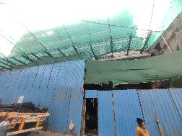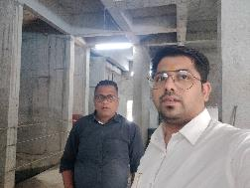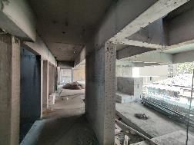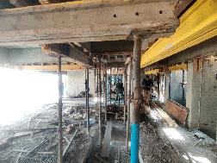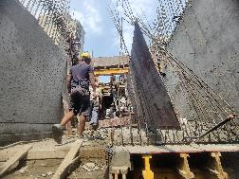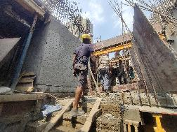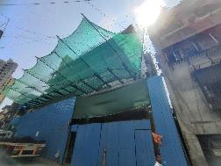

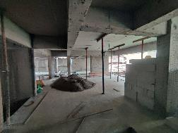

**Actual Site Photographs as on 21.03.2024**

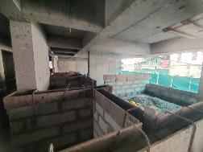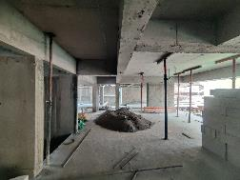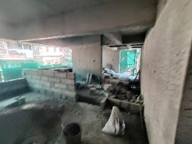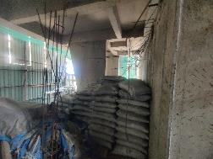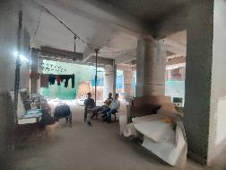

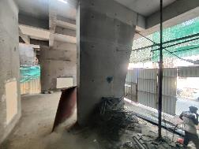

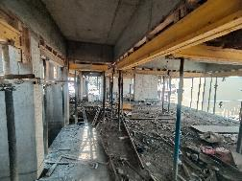

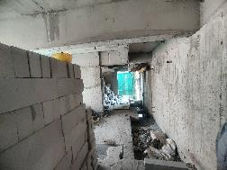

**Route Map of the property**

**Site u/r**

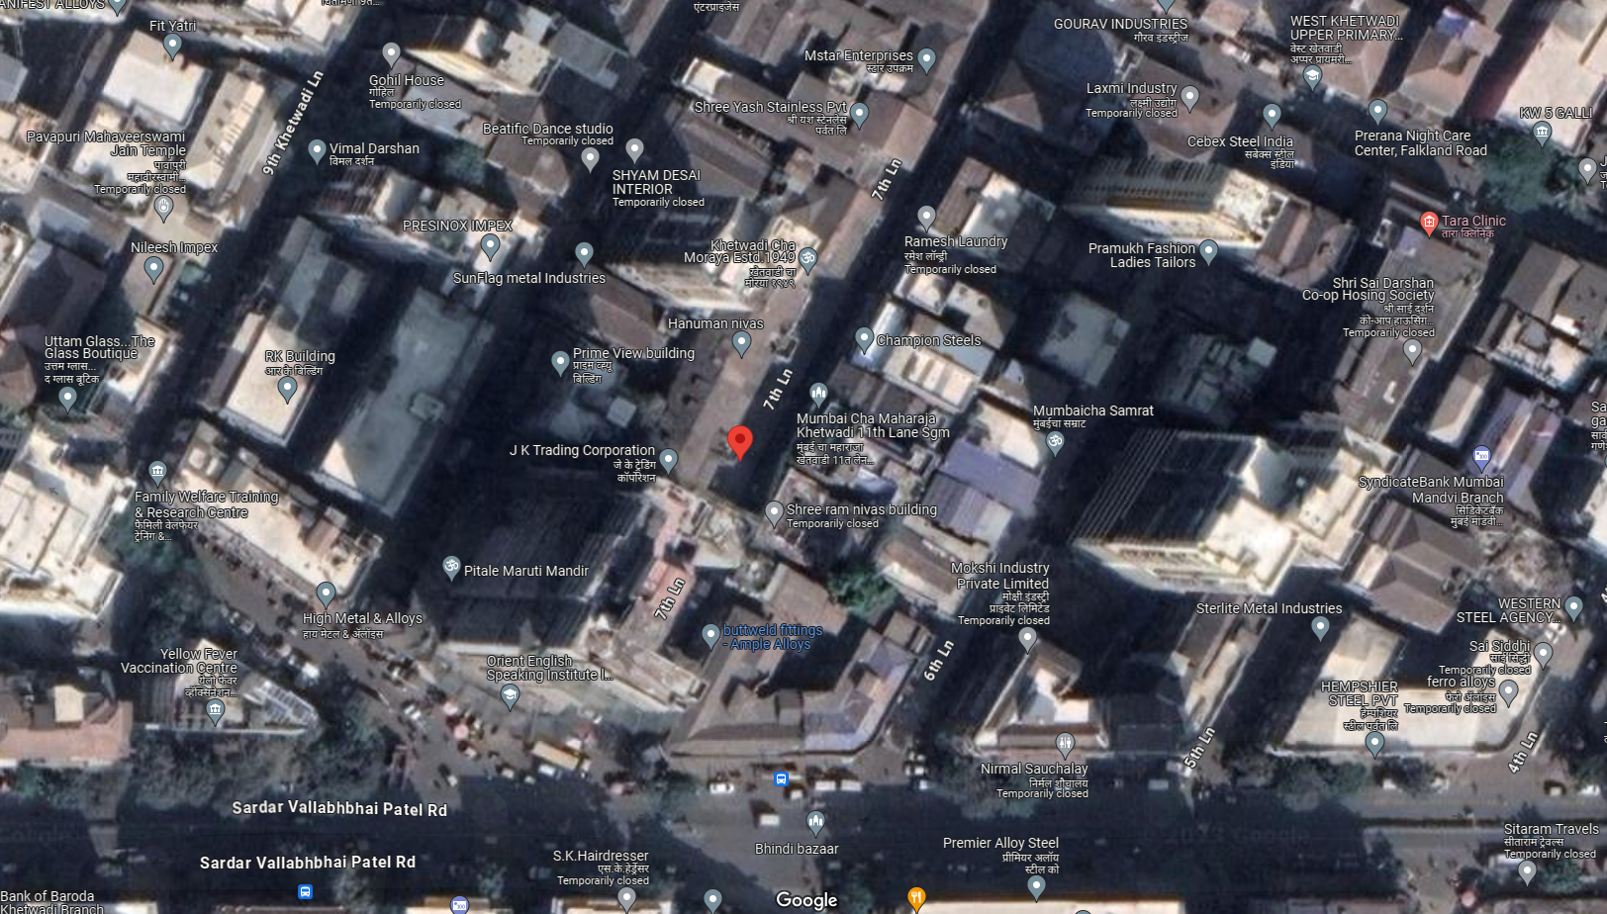

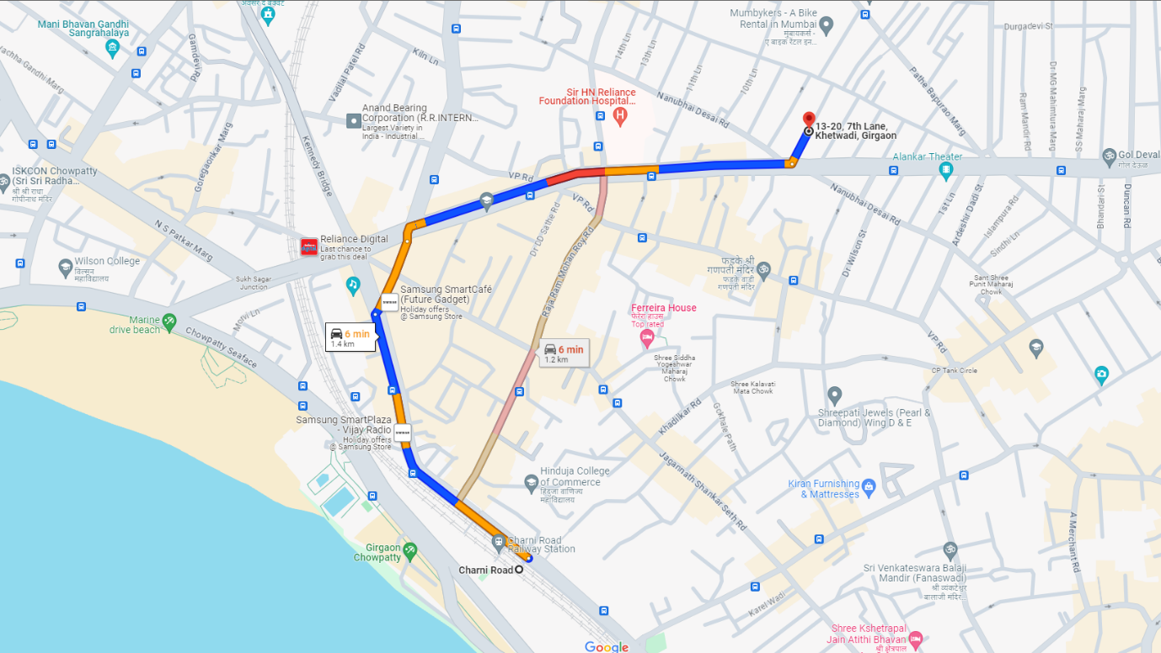

## Latitude Longitude: 18°57'31.2"N 72°49'23.5"E

Note: The Blue line shows the route to site from nearest railway station (Charni Road – 1.20 Km.)

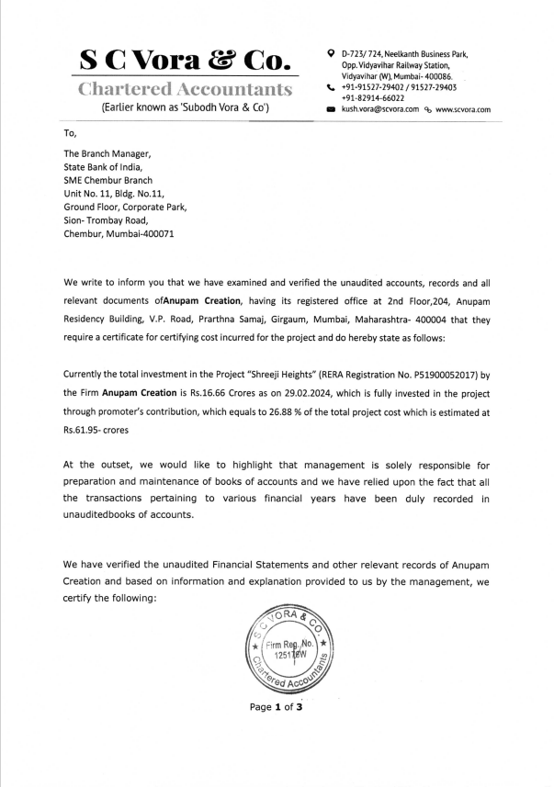**CA Certificate Dated 28.03.2024 till 29.02.2024**

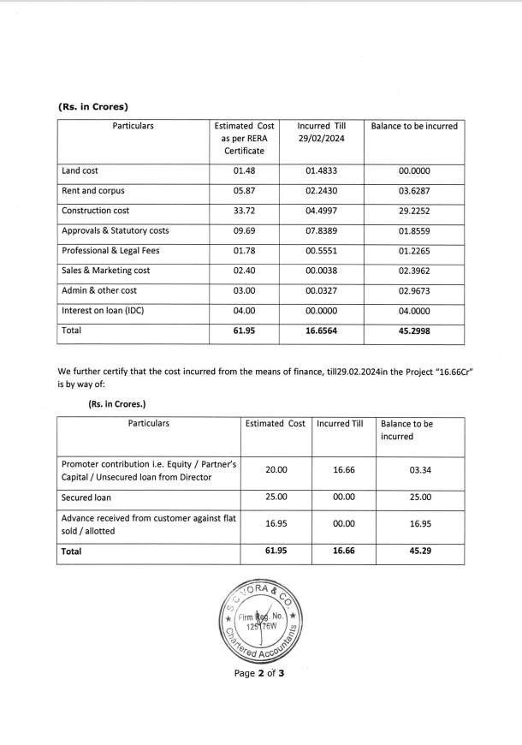**CA Certificate Dated 28.03.2024 till 29.02.2024**

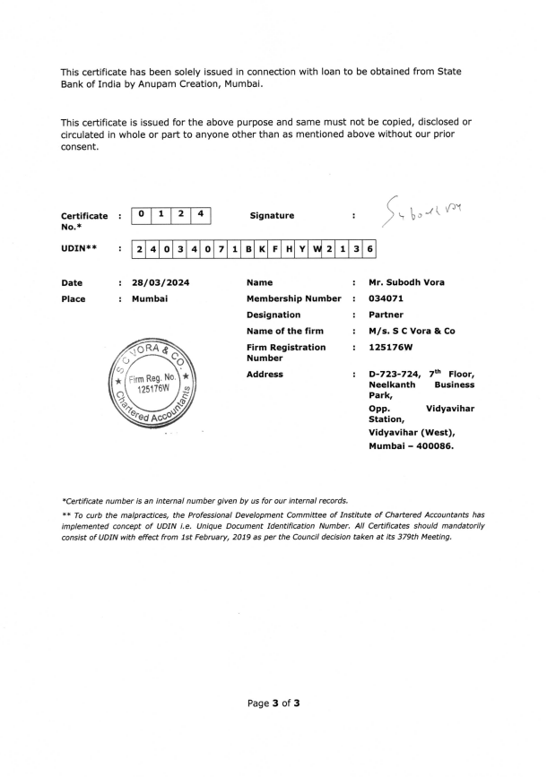**CA Certificate Dated 28.03.2024 till 29.02.2024**