Vastu/Nashik/06/32014/2301224
22/20-325-RYBS
Date: 29.03.2024

To,
The Branch Manager,
Maharashtra Eng. Research lnstitute Branch
Dindori Road, MERI, Nashik, Maharashtra,
Nashik - 422004, State - Maharashtra, Country - lndia.

Sub: Vetting of Extra Amenities

Sir,

With reference to above subject, we have evaluated the Extra Amenities for Residential Flat No. 01 & 02, First Floor, " Darpan Delight Apartment ", Survey No. 212/ 2, Plot No. 7/ 8/ 9/ 12, Near Omkar Park, Kala Nagar, Dindori Road, Village – Mhasrul, Taluka & District – Nashik- 422 004, State – Maharashtra, Country – India belongs to Name of Proposed Purchaser : Sau. Namrata Santosh Gupta. Name of Owner: M/s. Bhamre Builders.

We have verified the rates quoted as per current market rates. Details of Extra Amenities considered as per copy of Extra Amenities Agreement between Sau. Namrata Santosh Gupta (First Party). Shri. Sachin Sukdev Dhatrak (Second Party) received on dated 28.03.2024. The Extra Amenities amount is Rs. 8,45,000/- (Rupees Eight Lakh Forty Five Thousand Only)

The said Cost Vetting Certificate is valid upto next 6 months Only.

Thanking you

Sincerely yours

Manoj B. Chalikwar
Registered Valuer
Chartered Engineer (India)
Reg. No. CAT-I-F-1763
SBI Empanelment No.: SME/TCC/2021-22/86/3
Encl. Valuation Report

Agreement for Extra Amenities
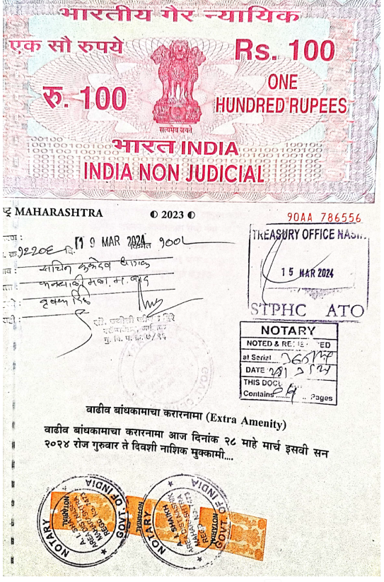
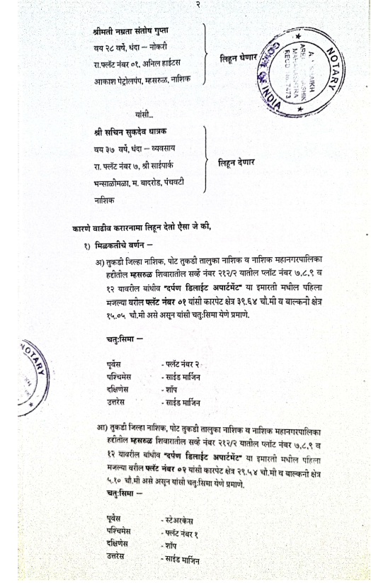

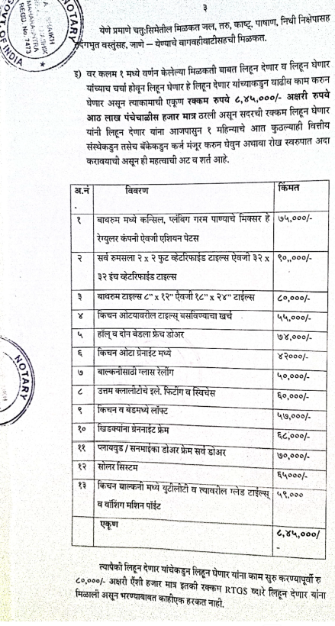
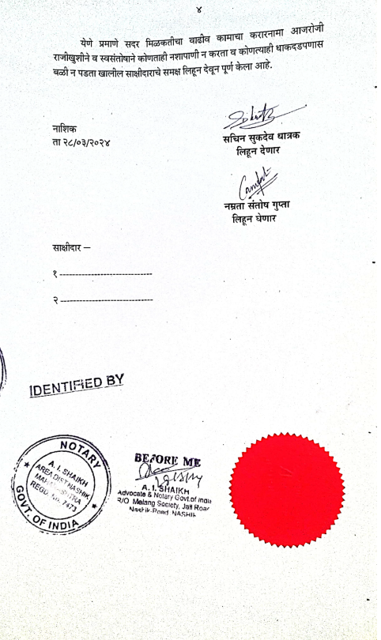

The Extra Amenities amount is Rs. 8,45,000/- (Rupees Eight Lakh Forty Five Thousand Only)

