Vastu/Nashik/03/2024/007945/2305722
23/22-470-RPBS
Date: 29.03.2024

To, `
The Branch Manager,
State Bank of India
RACPC Nashik Branch
1st Floor, Patel Plaza, N.D. Patel Road,
Opp. BSNL, Landmark Seawoods Navratna Hotel,
Nashik - 422001, State – Maharashtra, Country – India.

Sub: Vetting of Extra Amenities

Sir,

With reference to above subject, we have evaluated the Extra Amenities for Residential Flat No. 301, Third Floor, “Ashapuri Imperial”, Survey No. 866/ B/ 50, Plot No. 50A+50B, Behind Vinay Nagar Police Station, Deepali Nagar, Wadala - Pathardi Road,Village – Nashik, Taluka & District – Nashik, Nashik - 422 009, State – Maharashtra, Country – India belongs to Name of Proposed Purchaser : Mr. Sachin Ashok Sabale & Mrs. Rupali Sachin Sabale. Name of Owner: M/s. Rishi Builders & Developers.

We have verified the rates quoted as per current market rates. Details of work and Extra Amenities considered as per copy of Extra Amenities issued by Mr. Sachin Ashok Sabale (First Party) and Shri. Pramod Prabhakar Chaudhari (Second Party) received on dated 28.03.2024. The Extra Amenities amount is Rs.1,86,000/- (Rupees One Lakh Eighty Six Thousand Only).

The said Cost Vetting Certificate is valid upto next 6 months Only.

Thanking you

Sincerely yours

Manoj B. Chalikwar
Registered Valuer
Chartered Engineer (India)
Reg. No. CAT-I-F-1763
Reg. No. IBBI/RV/07/2018/10366
BOB Empanelment No.: ZO:MZ:ADV:46:941
Encl: Valuation report.

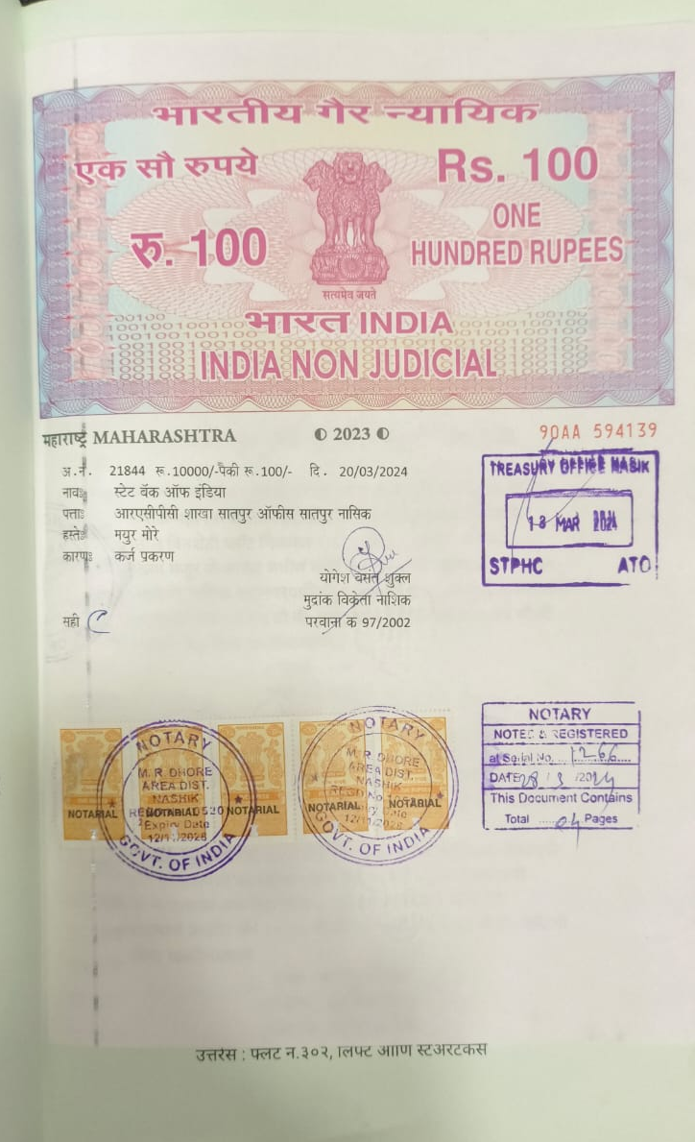
Agreement for Extra Amenities
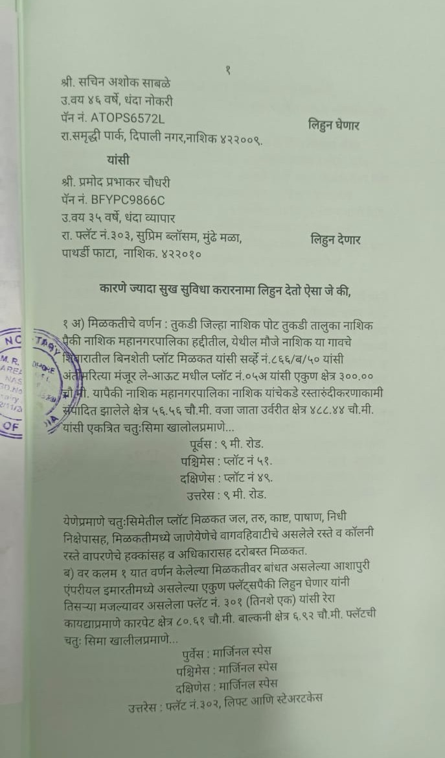

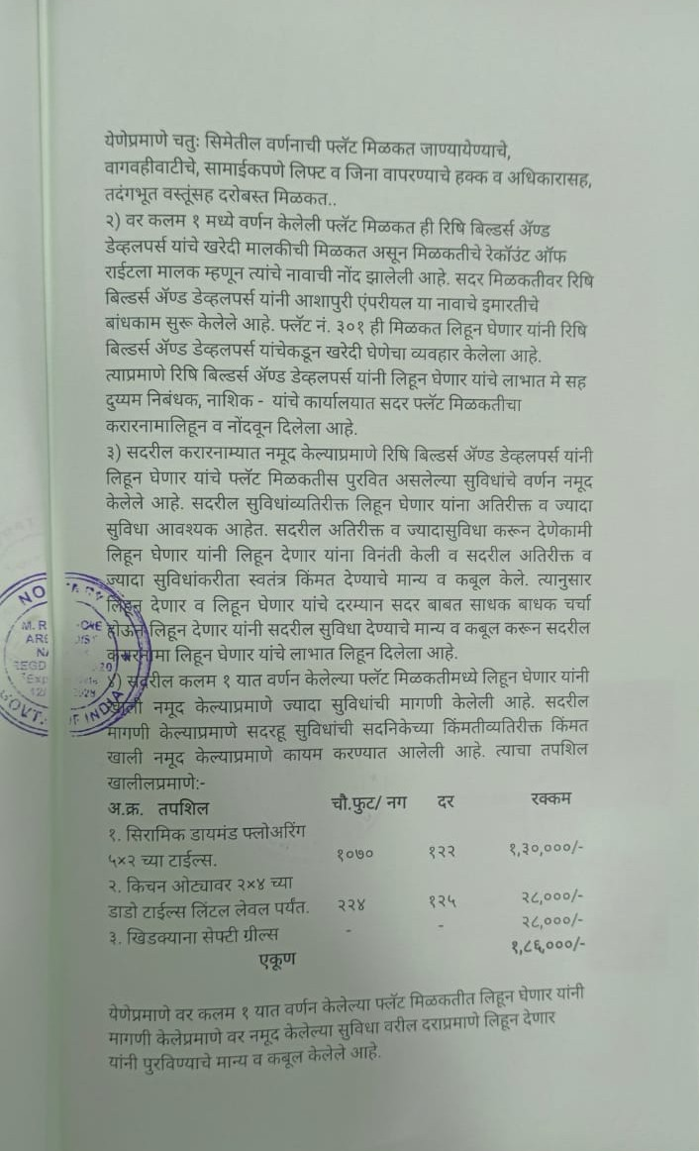
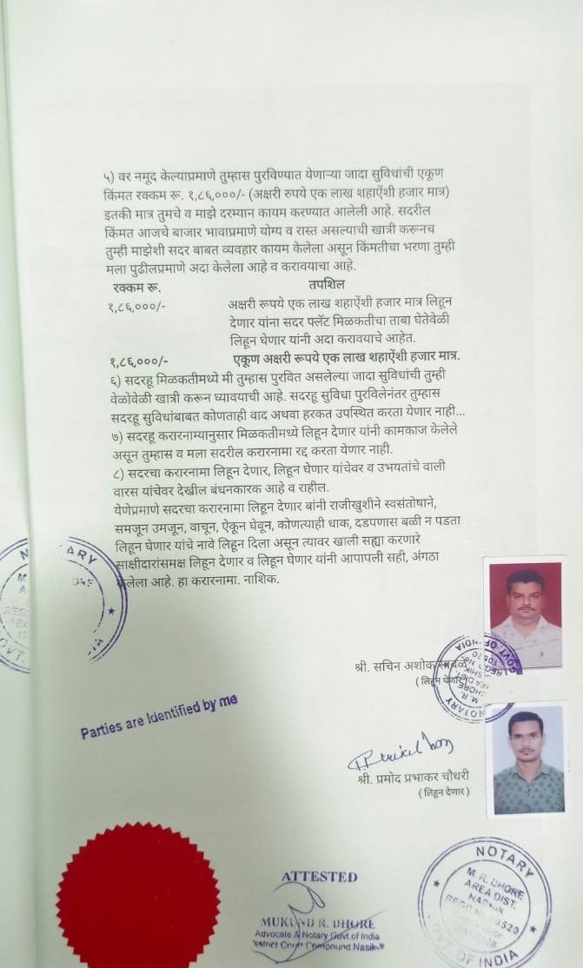

The Extra Amenities amount is Rs.1,86,000/- (Rupees One Lakh Eighty Six Thousand Only)

