COST VETTING REPORT
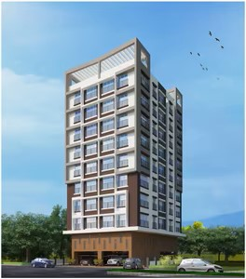

Details of the property under consideration:

Name of Project: "Srinathji Vishwashree"

"Srinathji Vishwashree", Proposed Redevelopment on plot bearing C.T.S No. 13/A/1, Tika No. 8,
Prabhakar Hedge Marg, Opposite Holly High School, Thane (West), Mumbai – 400 601,
State – Maharashtra, Country – India

Latitude Longitude: 19°12’13.5”N 72°58’42.7”E

Valuation Done for:
State Bank of India
SME Chembur Branch
Unit No. 11, Building No. 11, Ground Floor, Corporate Park, Sion Trombay Road,
Chembur, Mumbai, Pin Code – 400 071, State - Maharashtra, Country – India.

Vastu/SBI/Mumbai/05/2024/7964/2306221
08/02-81-PY
Date: 08.05.2024

To,
The Branch Manager,
State Bank of India
SME Chembur Branch
Unit No. 11, Building No. 11,
Ground Floor, Corporate Park,
Sion Trombay Road, Chembur,
Mumbai, Pin Code – 400 071,
State - Maharashtra, Country – India.

Sub: Cost Vetting Report for "Srinathji Vishwashree" at Thane (West), Pin Code – 400 601.

Dear Sir,
In accordance with your letter of engagement as stated above, we enclose our Report on Cost Vetting for "Srinathji Vishwashree", Proposed Redevelopment on plot bearing C.T.S No. 13/A/1, Tika No. 8, Prabhakar Hedge Marg, Opposite Holly High School, Thane (West), Mumbai – 400 601, State – Maharashtra, Country – India.
M/s. Srinathji Construction is proposing Redevelopment on plot bearing C.T.S No. 13/A/1, Tika No. 8, Prabhakar Hedge Marg, Opposite Holly High School, Thane (West), Mumbai – 400 601, State – Maharashtra, Country – India Project is comprising Sale Building.
Residential of Sale Building is proposed of Ground/Stilt + 1st to 8th Upper Floors with total RERA carpet area of 16,615.53.00 Sq. Ft. which consists 1 BHK & 2 BHK, with 28 nos. of Sell flats, 1 Tenant Flat & 1 Society Flat providing with Society Office, & Other Amenities.
In this regard, SBI, SME Chembur Branch, Unit No. 11, Building No. 11, Ground Floor, Corporate Park, Sion Trombay Road, Chembur, Mumbai, Pin Code – 400 071, has approached Vastukala Consultants (I) Pvt. Ltd. (VCIPL) to conduct a Cost Vetting of the said project.
Our analysis of the cost vetting is enclosed in this report. This Report forms an integral whole and cannot be split in parts. The outcome of the report/ study can only lead to proper conclusions if the Report as a whole is taken into account.

The information used by Vastukala Consultants (I) Pvt. Ltd. (VCIPL) in preparing this report has been obtained from a variety of sources and other relevant documents provided by the client & bank. As agreed, we have performed our cost vetting exercise with the data available related to the business, considering the market prospects and projections. Our results are dependent on documents provided by client & bank, the underlying assumptions, which has been analyzed at a broader level by VCIPL while assessing their reasonableness.
Total Project Cost for the completion of Project will be ` 13.42 Cr.

For Vastukala Consultants (I) Pvt. Ltd.

Manoj B. Chalikwar
Registered Valuer
Chartered Engineer (India)
Reg. No. IBBI / RV / 07/2018/10366
Reg. No. CAT-I-F-1763
SBI Empanelment No.: SME/TCC/2021-22/86/3
About the Project:
Proposed Redevelopment on plot bearing C.T.S No. 13/A/1, Tika No. 8, Prabhakar Hedge Marg, Opposite Holly High School, Thane (West), Mumbai – 400 601, State – Maharashtra, Country – India It is about 2.40 Km. travelling distance from Thane Railway station.

Area Statement as per Approved Plan
A | AREA STATEMENT
1 | Area of the plot (Minimum area of A, B, C to be Considered) | -
a. | As per Ownership document (7/12 CTS Extract) | 444.00
b. | As per Measurement Sheet | 444.23
c. | As per Site | 444.00
2 | Deduction For | -
a. | Any Reservation | -
b. | Proposed D.P/D.P. Road Widening Area / Service Road / Highway Widening | 25.91
c. | Total (a + b) | 25.91
3. | Balance Area of Plot (1 - 2) | 418.09
4. | Amenity Space (If Applicable) | -
a. | Required | -
b. | Adjustment of 2(b), If Any | -
c. | Balance Proposed | -
5 | Net Plot Area (3 – 4 (c)) | 418.09
6 | Recreational Open Space (If Applicable) | -
a. | Required | -
b. | Proposed | -
7 | Internal Road Area | -
8 | Plottable Area (If Applicable) | -
9 | Existing Built up Area | -
a. | Owners Area | 366.00
b. | Tenants Area | 1843.47

Construction Area as per Approved Plan

Sr. No. | Floor | Built Up Area in Sq. M. | Lift Area in Sq. M. | Other Area in Sq. M. | Total Construction Area in Sq. M. | Total Construction Area in Sq. Ft.
1 | Ground Floor | 54.55 | 3.22 | 208.80 | 266.57 | 2,869.36
2 | 1st Floor | 239.29 | 3.22 | 24.06 | 266.57 | 2,869.39
3 | 2nd Floor | 239.29 | 3.22 | 24.06 | 266.57 | 2,869.39
4 | 3rd Floor | 239.29 | 3.22 | 24.06 | 266.57 | 2,869.39
5 | 4th Floor | 239.29 | 3.22 | 24.06 | 266.57 | 2,869.39
6 | 5th Floor | 239.29 | 3.22 | 24.06 | 266.57 | 2,869.39
7 | 6th Floor | 239.29 | 3.22 | 24.06 | 266.57 | 2,869.39
8 | 7th Floor | 239.29 | 3.22 | 24.06 | 266.57 | 2,869.39
9 | 8th Floor | 113.89 | 3.22 | 10.92 | 128.03 | 1,378.14
10 | Terrace / OHT | - | 20.67 | - | 20.67 | 222.49
TOTAL |  | 1,843.47 | 49.65 | 388.16 | 2,281.28 | 24,555.70
No. of Stack Car Parking |  |  |  |  |  | 24 Nos.

Project Cost
Sr. No. | Particulars | Total Estimated Amount in ` | Total Estimated Amount  in ` Cr.
1 | Land Cost
 | Acquisition Cost of Land or Development Rights, and Legal Cost. | 78,66,670.00 | 0.79
 | Rent to Tenants, Lease premium, Lease Rent, interest cost incurred or payable on Land Cost | - | -
 | Amount of Premium payable to obtain development rights, FSI, additional FSI, fungible area, and any other incentive under DCR from Local Authority or State Government or any Statutory Authority. | 1,06,24,592.00 | 1.06
 | Acquisition cost of TDR (if any) | - | -
2 | Cost of Construction
 | Estimated construction cost of rehab cum sale building including site development and infrastructure for the same. | 8,76,31,549.00 | 8.76
 | On site expenditure for development of entire project excluding cost of construction as per(i) above,
a. | Architect Fees & Consultant fees | 43,81,577.00 | 0.44
b. | Admin Cost includes salaries, site overheads, development works, cost of services (including water, electricity, sewerage, drainage, layout roads etc.), cost of machineries and equipment including its hire and maintenance cost, consumables etc. All costs directly incurred to complete the construction of the entire phase of the project registered. | 52,57,893.00 | 0.53
c. | Marketing Cost | 47,99,690.00 | 0.48
3 | Interest during the Project | 1,10,00,000.00 | 1.10
4. | Contingency Charges | 26,28,946.00 | 0.26
 | GRAND TOTAL: | 13,41,90,917.00 | 13.42

Manoj B. Chalikwar
Registered Valuer
Chartered Engineer (India)
Reg. No. IBBI / RV / 07/2018/10366
Reg. No. CAT-I-F-1763
SBI Empanelment No.: SME/TCC/2021-22/86/3

Comments on each element of Cost of Project: -
- Land Cost:
As per Present Ready Reckoner rate the Project Land Value is ` 1.52 Cr. considering Land Rate @ ` 36,300.00 per Sq. M. & Net Plot Area of 418.09 Sq. M.
As per document purchase cost of land & stamp duty cost is ` 78,66,670.00 i.e., ` 0.79 Cr. which is 5.86% of Total Project Cost.
Sr. No. | Agreement Name | Date | Particulars | Estimate Amount in ` | Incurred Amount in `
1 | Sale Agreement | 31.05.2021 | Purchase Cost | 60,00,000.00 | 60,00,000.00
2 | Sale Agreement | 31.05.2021 | Stamp Duty | 3,60,000.00 | 3,60,000.00
3 | Sale Agreement | 31.05.2021 | Reg. Fees | 30,000.00 | 30,000.00
4 | Sale Agreement | 31.05.2021 | Reg. Fees | 760.00 | 760.00
5 | Conveyance Deed | 19.11.2019 | Stamp Duty | 14,10,300.00 | 14,10,300.00
6 | Conveyance Deed | 19.11.2019 | Reg. Fees | 30,000.00 | 30,000.00
7 | Conveyance Deed | 19.11.2019 | Reg. Fees | 600.00 | 600.00
8 | General Power of Attorney | 27-03-2021 | Stamp Duty | 500.00 | 500.00
9 | General Power of Attorney | 27-03-2021 | Reg. Fees | 420.00 | 420.00
10 | Development Agreement | 28.11.1997 | Stamp Duty | 31,900.00 | 31,900.00
11 | Development Agreement | 28.11.1997 | Reg. Fees | 2,190.00 | 2,190.00
 | TOTAL |  |  | 78,66,670.00 | 78,66,670.00

- Building Cost of Construction for Sale Building:
Construction Area of Sale Building = 2,281.28 Sq. M. i.e., 24,555.70 Sq. Ft.
No. of Stack Car Parking = 24 Nos.
Total estimated cost for construction of Building (includes cost of RCC work, manpower, lift, material, painting, finishing work, site development, etc.) is ` 6,87,55,954.00 i.e., ` 33.99 Cr. which comes ` 28,000.00 per Sq. Ft. on construction area for building, cost of construction for deep excavation & piling work is ` 68,75,595.00 i.e., ` 0.69 Cr. which is 10% of Cost of Construction and cost for stack parking is ` 1,20,00,000.00 i.e., ` 1.20 Cr. which comes ` 5,00,000.00 per stack parking.
Hence, total construction cost (Cost of construction of building + Cost of Construction of deep excavation & piling work + Cost of stack parking) (` 6,87,55,954.00 + ` 68,75,595.00 + ` 1,20,00,000.00) = ` 8,76,31,549.00 i.e., ` 8.76 Cr.
The total construction area is 2,281.28 Sq. M. i.e., 24,555.70 Sq. Ft., projected cost of ` 8.76 Cr is 65.30% of total project cost
VCIPL opinion the construction cost of 2,800/- Per Sq. Ft. which is in line with Market-Trend.
Particulars | Rate per Sq. Ft.
Excavation Work | 300.00
Total RCC Work | 1,200.00
Final Finishing Work | 700.00
Other Work | 600.00
Cost of Construction | 28000.00
Deep Excavation & Piling Work | 10% of Cost of Construction
Stack Car Parking Cost | 5,00,000.00 per parking

- Approval Charges:
The Total Approval Cost (Fungible Cost & Development Cess Premium & TDR Cost) as per challan provided by the developer will be ` 1,06,24,592.00 i.e., ` 1.06 Cr. which is 7.92% of Total Project Cost.
As per information provided by developer.
S. No. | Nature of Charges | Estimated Cost in ` | Incurred Cost in `
1 | Scrutiny Fees | 9,220.00 | 9,220.00
2 | Development Fund (50% of Premium) | 8,46,153.00 | 8,46,153.00
3 | Welfare Cess | 5,30,617.00 | 5,30,617.00
4 | Additional FSI Government Share | 8,46,153.00 | 8,46,153.00
5 | Development Charges | 14,18,946.00 | 14,18,946.00
6 | Development Charges for Metro Project | 14,18,946.00 | 14,18,946.00
7 | Ancillary FSI Premium | 37,40,715.00 | 37,40,715.00
8 | Fire NOC | 8,04,364.00 | 8,04,364.00
9 | Other Charges | 10,09,478.00 | 10,09,478.00
Total |  | 1,06,24,592.00 | 1,06,24,592.00

- Architect Cost, RCC & Other Professional Charges:
The total Architect charges of ` 43,81,577.00 i.e., ` 0.44 Cr. is 5.0% of total construction cost building & it is line up with Market trend.
The professional charge consists of Architect & Legal which in market is in the range of 2% - 5% of Total Construction cost of the project.

- Administrative Expenses:
Salaries, site overheads, development works, cost of services (including water, electricity, sewerage, drainage, layout roads etc.), cost of machineries and equipment including its hire and maintenance cost, consumables etc. All costs directly incurred to complete the construction of the entire phase of the project registered is estimated 6% of total construction cost Building which comes to ` 52,57,893.00 i.e., ` 0.53Cr.
The admin charges which in market is in the range of 4% - 6% of Total Construction cost of the project.

- Marketing Expenses:
Marketing costs directly incurred to complete the construction of the entire phase of the project registered is estimated at 2% of total Sale income from the project which comes to ` 47,99,690.00 i.e., ` 0.48 Cr.
The marketing charge consists of brokerage & commission which in market is in the range of 1% - 3% of Total Sale income of the property.

- Interest Costs:
The Interest cost for the term loan is ` 1,10,00,000.00 i.e., ` 1.10 Cr., which is 8.20% of total project cost.
As per information provided by the client.

- Contingency Costs:
The contingency charges estimated at 3% of total cost of construction which comes to ` 26,28,946.00 i.e., ` 0.26 Cr.
Observation and Construction: -
Total estimated cost of project i.e., ` 13,41,90,917.00 (Rupees Thirteen Crore Forty – One Lakh Ninety Thousand Nine Hundred Seventeen Only) i.e., ` 13.42 Cr. is fair & reasonable.
The project cost is including land premium payable to concern authorities, Fungible FSI Premium, Cost of Construction of Sale Building, on site expenses including admin & marketing expenses, premiums / charges to be paid to competent authority and Bank interest, etc. we have not independently verified interest cost hence not consider in cost vetting.
As per present sanctioned building plan, permissible built-up area on the said plot is 1,843.47 Sq. M. The sale building is presently approved for Ground (Pt) + Stilt (Pt) Floor + 1st to 7th Upper Floors + 8th (Pt) Upper Floors only. Estimated cost of entire project of 8th upper floors are considered.
Total estimated cost of construction of Sales building is ` 6,87,55,954.00 i.e., ` 33.99 Cr. which comes ` 28,000.00 per Sq. Ft. on construction area for building, cost of construction for deep excavation & piling work is ` 68,75,595.00 i.e., ` 0.69 Cr. which is 10% of Cost of Construction and cost for stack parking is ` 1,20,00,000.00 i.e., ` 1.20 Cr. which comes ` 5,00,000.00 per stack parking. Hence, total construction cost (Cost of construction of building + Cost of Construction of deep excavation & piling work + Cost of stack parking) (` 6,87,55,954.00 + ` 68,75,595.00 + ` 1,20,00,000.00) = ` 8,76,31,549.00 i.e., ` 8.76 Cr., which is fair & reasonable considering the present status of project, type & quality of construction & specification of the building materials to be used, height of the structure, amenities to be provided in proposed building.

Assumptions & Remarks-
- The adequacy of Engineering / Structural design is beyond the scope of our assignment.
- Estimated project completion date is 31/12/2025. The cost is certified based on the assumptions that the project will be completed within time frame. Few assumptions are made regarding inflation & cost rise etc. during construction period.

Photo copy of following document is provided to us & this report should be read along with it:
- Copy of Developer Agreement dated 31.05.2021 between Mr. Wilbur Joseph Almeida (The Occupant) and Mr. Ramesh Jagannath Jadhav (The Owner) through registered Doc. No. TNN1/7440/2021 dated 31.05.2021.
- Copy of Conveyance Deed agreement dated 19.11.2019 between Mr. Ivo Peter Almeida, Mr. Clyde John Almedia and Mr. May Patricia Menezes (The Owners) and Mr. Ramesh Jagannath Jadhav (Purchaser) through registered Doc. No. TNN5/19391/2019 dated 19.11.2019.
- Copy of General Power of Attorney for Development of Immovable Property dated 12.12.199
- Copy of Conveyance Deed Between Mr. Edmund Gregory Almeida (Vendor – One Part) AND Mr. Vincent Norbert Almeida (Purchaser – One Part) dated 26.08.1968, Doc. No. Thane/758/1/7/1968.
- Copy of Approved Plan No. VP S2C/0225/20TMC/TD-DP/TPS/4180/22 dated 18.08.2022 issued by Thane Municipal Corporation.
Approved upto: Ground (Pt) + Stilt (Pt) + 1st to 7th Floors + 8th (Pt) Floors
- Copy of Commencement Certificate No. V.P. No. S2C/0225/20TMC/TDD/4180/22 dated 18.08.2022 issued by Thane Municipal Corporation.
(This CC is endorsed for the work for up to Ground (Pt) + Stilt (Pt) + 1st to 7th Floors + 8th (Pt) Floors Only)
- Copy of Fire NOC Certificate No. TMC/CFO/M/LR/87/76 dated 11.08.2022 issued Thane Municipal Corporation, Thane Fire Brigade.
- Copy of General Power of Attorney dated 19.11.2019 registered agreement Doc. No. TNN5/19392/2019 dated 19.11.2019.
- Copy of CA Certificate (Form 3) dated 06.05.2024 issued by M/s. Abhishek Pradhan & Co.
- Copy of Engineer Certificate (Form 2) dated 31.03.2024 issued by Ajay Mahale Consulting Engineer.
- Copy of RERA Certificate No. P51700051822 dated 07.07.2023 issued by Maharashtra Real Estate Regulatory Authority (MAHRERA).
- Copy of Property Card

Actual Site Photographs
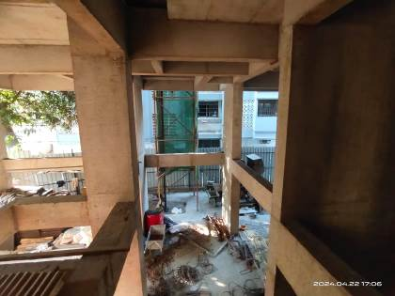
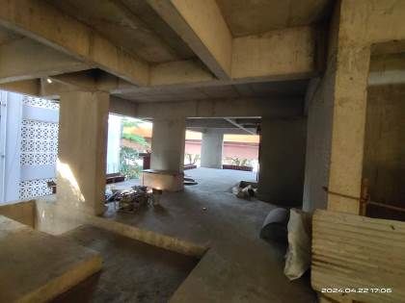
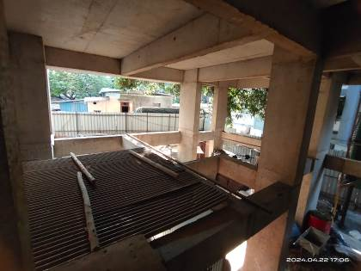
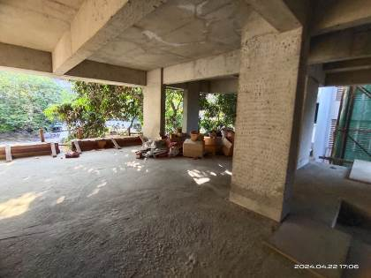
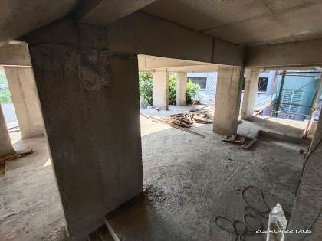

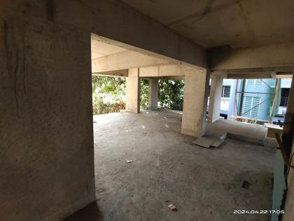

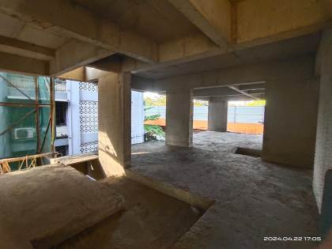

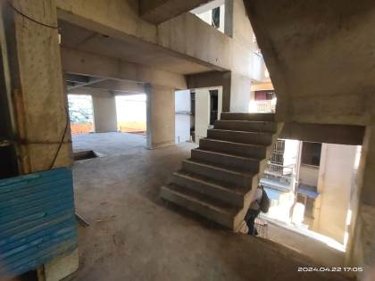

Actual Site Photographs
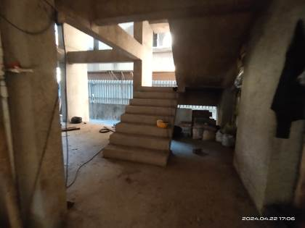
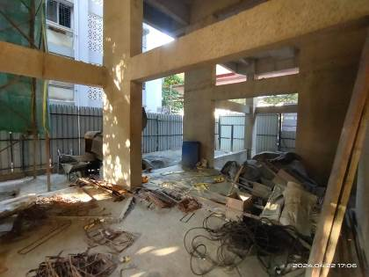

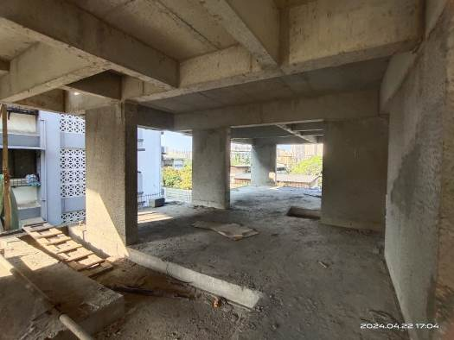
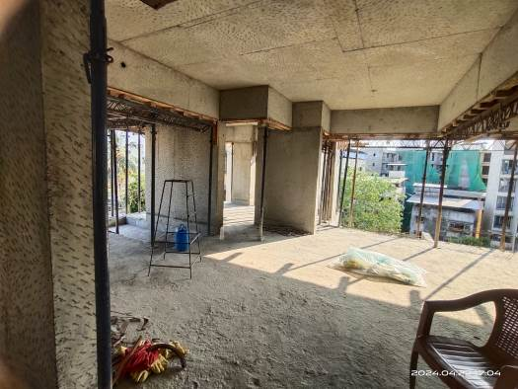

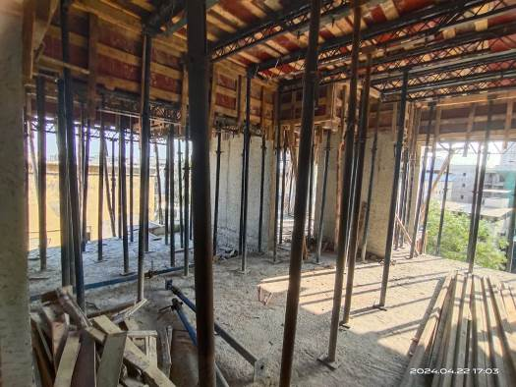
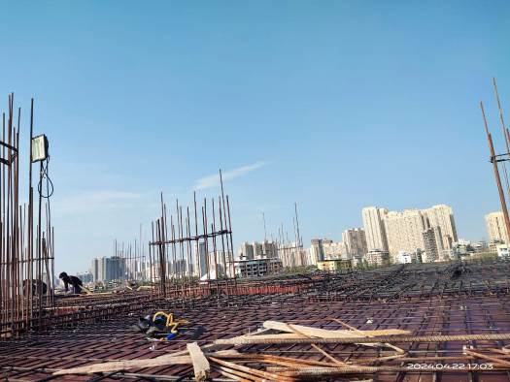

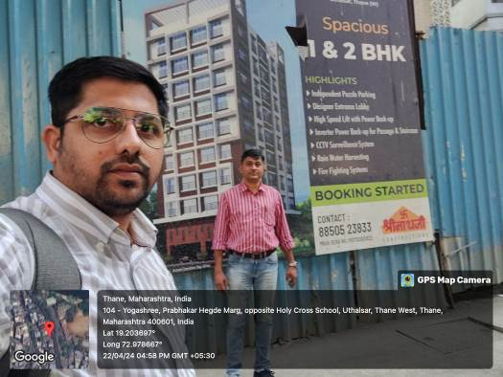
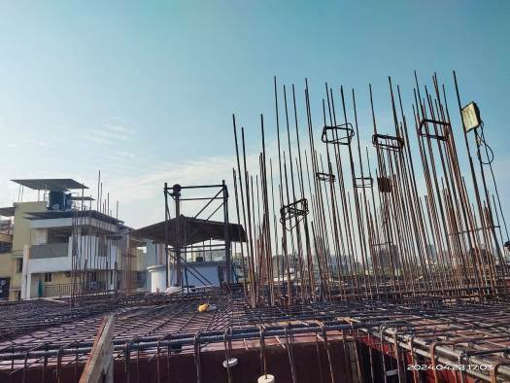

Actual Site Photographs
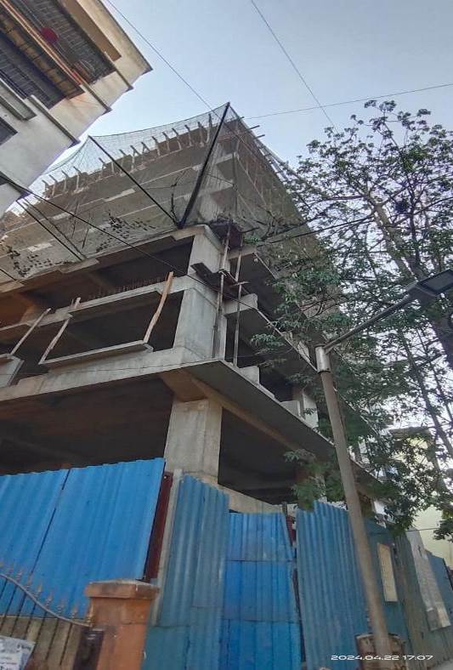
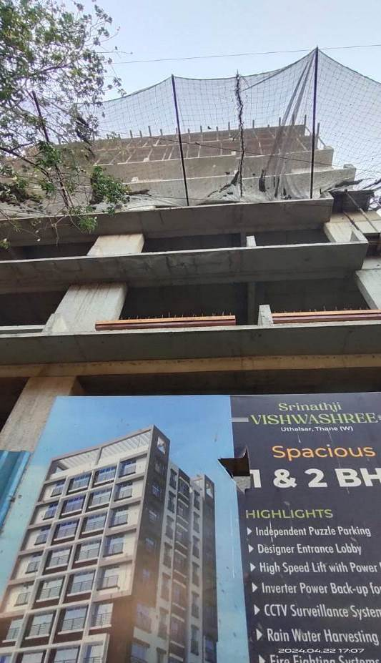
Route Map of the property
Site u/r

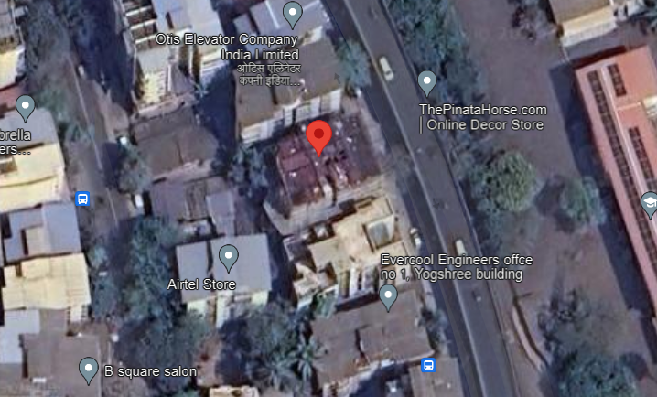

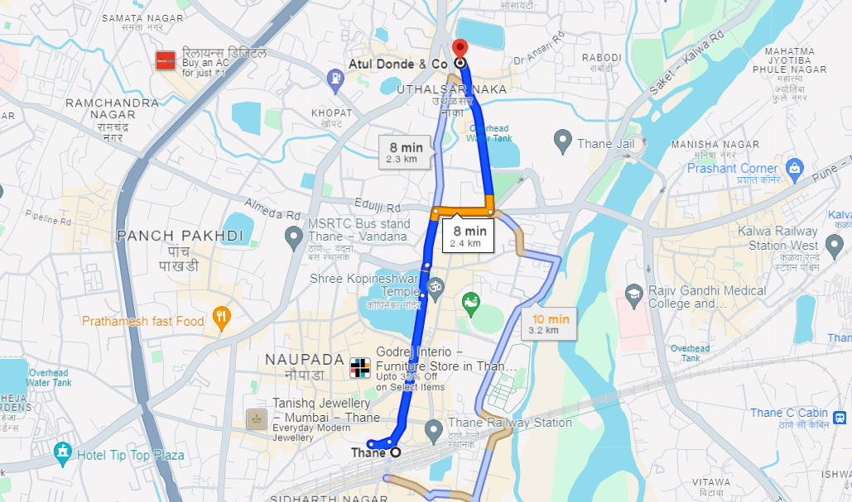

Latitude Longitude: 19°12’13.5”N 72°58’42.7”E
Note: The Blue line shows the route to site from nearest railway station (Thane – 2.4 Km.)

