PROJECT VALUATION REPORT
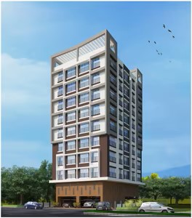

Details of the property under consideration:

Name of Project: "Srinathji Vishwashree"

"Srinathji Vishwashree", Proposed Redevelopment on plot bearing C.T.S No. 13/A/1, Tika No. 8,
Prabhakar Hedge Marg, Opposite Holly High School, Thane (West), Mumbai – 400 601,
State – Maharashtra, Country – India

Latitude Longitude: 19°12’13.5”N 72°58’42.7”E

Valuation Done for:
State Bank of India
SME Chembur Branch
Unit No. 11, Building No. 11, Ground Floor, Corporate Park, Sion Trombay Road,
Chembur, Mumbai, Pin Code – 400 071, State - Maharashtra, Country – India.

Vastu/SBI/Mumbai/05/2024/7963/2306220
08/01-80-SSPPY
Date: 08.05.2024

To,
The Branch Manager,
State Bank of India
SME Chembur Branch
Unit No. 11, Building No. 11,
Ground Floor, Corporate Park,
Sion Trombay Road, Chembur,
Mumbai, Pin Code – 400 071,
State - Maharashtra, Country – India.

Sub: Project Valuation for "Srinathji Vishwashree" at Thane (West), Pin Code – 400 601.

Dear Sir,
In accordance with your letter of engagement as stated above, we enclose our Report on Project Valuation for "Srinathji Vishwashree", Proposed Redevelopment on plot bearing C.T.S No. 13/A/1, Tika No. 8, Prabhakar Hedge Marg, Opposite Holly High School, Thane (West), Mumbai – 400 601, State – Maharashtra, Country – India.
M/s. Srinathji Construction is proposing Redevelopment on plot bearing C.T.S No. 13/A/1, Tika No. 8, Prabhakar Hedge Marg, Opposite Holly High School, Thane (West), Mumbai – 400 601, State – Maharashtra, Country – India Project is comprising Sale Building.
Residential of Sale Building is proposed of Ground/Stilt + 1st to 8th Upper Floors with total RERA carpet area of 16,615.53.00 Sq. Ft. which consists 1 BHK & 2 BHK, with 28 nos. of Sell flats, 1 Tenant Flat & 1 Society Flat providing with Society Office, & Other Amenities.
In this regard, SBI, SME Chembur Branch, Unit No. 11, Building No. 11, Ground Floor, Corporate Park, Sion Trombay Road, Chembur, Mumbai, Pin Code – 400 071, has approached Vastukala Consultants (I) Pvt. Ltd. (VCIPL) to conduct a Project Valuation of the said project.
Our analysis of the project valuation is enclosed in this report. This Report forms an integral whole and cannot be split in parts. The outcome of the report/ study can only lead to proper conclusions if the Report as a whole is taken into account.

The information used by Vastukala Consultants (I) Pvt. Ltd. (VCIPL) in preparing this report has been obtained from a variety of sources and other relevant documents provided by the client & bank. As agreed, we have performed our project valuation exercise with the data available related to the business, considering the market prospects and projections. Our results are dependent on documents provided by client & bank, the underlying assumptions, which has been analyzed at a broader level by VCIPL while assessing their reasonableness.
Sale Realisation from the Project is ` 24.00 Cr. and Net Present Value of the project as on date is ` 9.92 Cr.

For Vastukala Consultants (I) Pvt. Ltd.

Manoj B. Chalikwar
Registered Valuer
Chartered Engineer (India)
Reg. No. IBBI / RV / 07/2018/10366
Reg. No. CAT-I-F-1763
SBI Empanelment No.: SME/TCC/2021-22/86/3
PROJECT VALUATION REPORT
OF
" Shrinathji Vishwashree "

"Srinathji Vishwashree", Proposed Redevelopment on plot bearing C.T.S No. 13/A/1, Tika No. 8, Prabhakar Hedge Marg, Opposite Holly High School, Thane (West), Mumbai – 400 601, State – Maharashtra, Country – India.

Latitude Longitude: 19°12’13.5”N 72°58’42.7”E

NAME OF DEVELOPER: M/s. Srinathji Construction.
Pursuant to instructions from State Bank of India, SME Chembur Branch, we have duly visited, inspected, surveyed & assessed the above said property to determine the fair & reasonable market value of the said property as on 08th May 2024 for approval of project finance purpose.

- Location Details:
Proposed Redevelopment on plot bearing C.T.S No. 13/A/1, Tika No. 8, Prabhakar Hedge Marg, Opposite Holly High School, Thane (West), Mumbai – 400 601, State – Maharashtra, Country – India It is about 2.40 Km. travelling distance from Thane Railway station. Surface transport to the property is by buses, taxis & private vehicles. The property is in developed locality. All the amenities like shops, banks, hotels, markets, schools, hospitals, etc. are all available in the surrounding locality. The area is higher middle class & developed.

2. Developer Details:
Name of builder | M/s. Srinathji Construction.
Project Registration Number | P51700051822
Register office address | M/s. Srinathji Construction.  Ground Floor, Abhiwadan Building, Gokhale Road, Ambedkar Chowk, Naupada, Thane, Mumbai – 400 602, State - Maharashtra, Country – India
Contact Numbers | Contact Person:  Mr. Nishant Jadhav (Owner)  Mb. No. +91 - 9819847899
E – mail ID and Website

3. Boundaries of the Property:
Direction
On or towards North | Silver Line Building
On or towards South | Yogashree Building
On or towards East | Prabhakar Hegade Marg
On or towards West | Darshan Building

Vastukala Consultants (I) Pvt. Ltd.
B1-001, U/B Floor, Boomerang, Chandivali Farm Road, Powai, Andheri (East), Mumbai – 400 072

To,
The Branch Manager,
State Bank of India
SME Chembur Branch
Unit No. 11, Building No. 11, Ground Floor,
Corporate Park, Sion Trombay Road,
Chembur, Mumbai – 400 071,
State - Maharashtra, Country – India.

VALUATION REPORT (IN RESPECT OF PROJECT FINANCE)
I | General
1. | Purpose for which the valuation is made |  |  |  | : | As per request from State Bank of India, SME Chembur Branch, to assess Fair Market value of the Project for bank loan purpose.
2. | a) |  | Date of inspection |  | : | 22.04.2024
 | b) |  | Date on which the valuation is made |  | : | 08.05.2024
3. | List of documents produced for perusal
 | - Copy of Developer Agreement dated 31.05.2021 between Mr. Wilbur Joseph Almeida (The Occupant) and Mr. Ramesh Jagannath Jadhav (The Owner) through registered Doc. No. TNN1/7440/2021 dated 31.05.2021.
 | - Copy of Conveyance Deed agreement dated 19.11.2019 between Mr. Ivo Peter Almeida, Mr. Clyde John Almedia and Mr. May Patricia Menezes (The Owners) and Mr. Ramesh Jagannath Jadhav (Purchaser) through registered Doc. No. TNN5/19391/2019 dated 19.11.2019.
 | - Copy of General Power of Attorney for Development of Immovable Property dated 12.12.199
 | - Copy of Conveyance Deed Between Mr. Edmund Gregory Almeida (Vendor – One Part) AND Mr. Vincent Norbert Almeida (Purchaser – One Part) dated 26.08.1968, Doc. No. Thane/758/1/7/1968.
- Copy of Approved Plan No. VP S2C/0225/20TMC/TD-DP/TPS/4180/22 dated 18.08.2022 issued by Thane Municipal Corporation.
Approved upto: Ground (Pt) + Stilt (Pt) + 1st to 7th Floors + 8th (Pt) Floors
- Copy of Commencement Certificate No. V.P. No. S2C/0225/20TMC/TDD/4180/22 dated 18.08.2022 issued by Thane Municipal Corporation.
(This CC is endorsed for the work for up to Ground (Pt) + Stilt (Pt) + 1st to 7th Floors + 8th (Pt) Floors Only)
 | - Copy of Fire NOC Certificate No. TMC/CFO/M/LR/87/76 dated 11.08.2022 issued Thane Municipal Corporation, Thane Fire Brigade.
 | - Copy of General Power of Attorney dated 19.11.2019 registered agreement Doc. No. TNN5/19392/2019 dated 19.11.2019.
 | - Copy of CA Certificate (Form 3) dated 06.05.2024 issued by M/s. Abhishek Pradhan & Co.
 | - Copy of Engineer Certificate (Form 2) dated 31.03.2024 issued by Ajay Mahale Consulting Engineer.
 | - Copy of RERA Certificate No. P51700051822 dated 07.07.2023 issued by Maharashtra Real Estate Regulatory Authority (MAHRERA).
 | - Copy of Property Card
 | Project Name  (with address & phone nos.) |  |  |  | : | "Srinathji Vishwashree", Proposed Redevelopment on plot bearing C.T.S No. 13/A/1, Tika No. 8, Prabhakar Hedge Marg, Opposite Holly High School, Thane (West), Mumbai – 400 601, State – Maharashtra, Country – India
4. | Name of the owner(s) and his / their address (es) with Phone no. (details of share of each owner in case of joint ownership) |  |  |  | : | M/s. Srinathji Construction.  Ground Floor, Abhiwadan Building, Gokhale Road, Ambedkar Chowk, Naupada, Thane, Mumbai – 400 602, State - Maharashtra, Country – India  Contact Person:  Mr. Nishant Jadhav (Owner)  Mb. No. +91 - 9819847899
5. | Brief description of the property (Including Leasehold / freehold etc.): Freehold land
About Project:
Srinathji Vishwashree is a well-designed project by Srinathji Constructions. It is offering Under Construction units. Set in an expanse of 0.1 Acres, the property offers a remarkable lifestyle. Available configurations include 1 BHK, 2 BHK. As per the area plan, units are in the size range of 454.00 - 640.00 Sq. Ft. Srinathji Vishwashree was launched in July 2023. Project possession will be starting from Dec 2025. Total number of flats at Srinathji Vishwashree is 28. They are renowned name in the real estate space. Social infrastructure like banks, schools and parks surround Thane West area. It is also very well-connected to various parts of the city by public transport network.
TYPE OF THE BUILDING:
Building | Number of Floors
"Srinathji Vishwashree” | Proposed Residential Building of Ground (Pt) + Stilt (Pt) + 1st to 7th Upper Floors + 8th (Pt) Floors Only as per Approved Plan.

LEVEL OF COMPLETEION:
Building | Present stage of Construction | % of work completion | % of construction cost incurred till 31.03.2024
Srinathji Vishwashree | Till 6th Floor Slab work is completed & 7th floor slab work is in progress | 40.00% | 42.00%

PROPOSED DATE OF COMPLETION & FUTURE LIFE:
Expected completion date as informed by builder is 31.12.2025 (As per RERA Certificate)
Future estimated life of the Structure is 60 years (after completion) Subject to proper, preventive periodic maintenance & Structural repairs.

PROPOSED PROJECT AMENITIES:
Vitrified flooring tiles in all rooms
Granite Kitchen platform with Stainless Steel Sink
Powder coated aluminum sliding windows with M.S. Grills
Laminated wooden flush doors with Safety door
Concealed wiring
Concealed plumbing
Fire Fighting System
Car Parking
Gymnasium

6. | Location of property |  |  |  | :
 | a) | Plot No. / Survey No. |  |  | :
 | b) | Door No. |  |  | : | Not applicable
 | c) | C. T.S. No. / Village |  |  | : | C.T.S. No. 13/A/1, Village – Thane.
 | d) | Ward / Taluka |  |  | : | Taluka – Thane
 | e) | Mandal / District |  |  | : | District – Thane
7. | Postal address of the property |  |  |  | : | "Srinathji Vishwashree", Proposed Redevelopment on plot bearing C.T.S No. 13/A/1, Tika No. 8, Prabhakar Hedge Marg, Opposite Holly High School, Thane (West), Mumbai – 400 601, State – Maharashtra, Country – India.
8. | City / Town |  |  |  | : | Thane, Mumbai
 | Residential area |  |  |  | : | Yes
 | Commercial area |  |  |  | : | No
 | Industrial area |  |  |  | : | No
9. | Classification of the area |  |  |  | :
 | i) High / Middle / Poor |  |  |  | : | Higher Middle Class
 | ii) Urban / Semi Urban / Rural |  |  |  | : | Urban
10. | Coming under Corporation limit / Village Panchayat / Municipality |  |  |  | : | Thane, Mumbai  Thane Municipal Corporation.
11. | Whether covered under any State / Central Govt. enactments (e.g., Urban Land Ceiling Act) or notified under agency area/ scheduled area / cantonment area |  |  |  | : | No
12. | In Case it is Agricultural land, any conversion to house site plots is contemplated |  |  |  | : | N.A.
13. | Boundaries of the property |  |  | As per Agreement | As per RERA Certificate |  | As per Site
 | North |  |  | Property Bearing T. No. 8 CTS No. 10 | Tika No. 8, CTS No 10 |  | Silver Line Building
 | South |  |  | Property Bearing T. No. 8 CTS 13 B and the Gr. + 5 structure “Yogashree” | Tika No. 8, CTS No 10 and 12 |  | Yogashree Building
 | East |  |  | Old Bombay Agra Road | Tika No 8, CTS No 13-A-2 under DP Road. |  | Prabhakar Hegade Marg
 | West |  |  | Property Bearing T. No. 8 CTS No. 10 and 12 | Tika No 8, CTS No. 10 and 12 |  | Darshan Building
14.1 | Dimensions of the site |  |  |  |  | N. A. as the land is irregular in shape
 |  |  |  |  |  | A (As per the Deed) |  | B (Actuals)
 | North |  |  |  | : | - |  | -
 | South |  |  |  | : | - |  | -
 | East |  |  |  | : | - |  | -
 | West |  |  |  | : | - |  | -
14.2 | Latitude, Longitude & Co-ordinates of property |  |  |  | : | 19°12’13.5”N 72°58’42.7”E
14. | Extent of the site |  |  |  | : | Net Plot area = 418.09 Sq. M.  (As per Approved Plan)  Structure - As per table attached to the report
15. | Extent of the site considered for Valuation (least of 14A& 14B) |  |  |  | : | Net Plot area = 418.09 Sq. M.  (As per Approved Plan)
16 | Whether occupied by the owner / tenant? If occupied by tenant since how long? Rent received per month. |  |  |  | : | N.A. Building Construction work is in progress
II | CHARACTERSTICS OF THE SITE
 | Classification of locality |  |  |  | : | Higher Middle class
 | Development of surrounding areas |  |  |  | : | Good
 | Possibility of frequent flooding/ sub-merging |  |  |  | : | No
 | Feasibility to the Civic amenities like School, Hospital, Bus Stop, Market etc. |  |  |  | : | All available near by
 | Level of land with topographical conditions |  |  |  | : | Plain
 | Shape of land |  |  |  | : | Irregular
 | Type of use to which it can be put |  |  |  | : | For residential purpose
 | Any usage restriction |  |  |  | : | Residential
 | Is plot in town planning approved layout? |  |  |  | : | Copy of Approved Plan No. VP S2C/0225/20 TMC/TD-DP/TPS/4180/22 dated 18.08.2022 issued by Thane Municipal Corporation.  Approved upto: Ground (Pt) + Stilt (Pt) + 1st to 7th Floors + 8th (Pt) Floors
 | Corner plot or intermittent plot? |  |  |  | : | Corner Plot
 | Road facilities |  |  |  | : | Yes
 | Type of road available at present |  |  |  | : | Bituminous Road
 | Width of road – is it below 20 ft. or more than 20 ft. |  |  |  | : | 20 M wide road
 | Is it a Land – Locked land? |  |  |  | : | No
 | Water potentiality |  |  |  | : | Municipal Water supply
 | Underground sewerage system |  |  |  | : | Connected to Municipal sewer
 | Is Power supply is available in the site |  |  |  | : | Yes
 | Advantages of the site |  |  |  | : | Located in developed area
 | Special remarks, if any like threat of acquisition of land for publics service purposes, road widening or applicability of CRZ provisions etc. (Distance from sea-cost / tidal level must be incorporated) |  |  |  | : | No
Part – A (Valuation of land)
1 | Size of plot |  |  |  | : | Net Plot area = 418.09 Sq. M.  (As per Approved Plan)
 | North & South |  |  |  | : | -
 | East & West |  |  |  | : | -
2 | Total extent of the plot |  |  |  | : | As per table attached to the report
3 | Prevailing market rate (Along With details / reference of at least two latest deals / transactions with respect to adjacent properties in the areas) |  |  |  | : | As per table attached to the report  Details of recent transactions/online listings are attached with the report.
4 | Guideline rate obtained from the Register’s Office (evidence thereof to be enclosed) |  |  |  | : | ` 36,300.00 per Sq. M. for Land  ` 85,000.00 per Sq. M. for Residential Flat
5 | Assessed / adopted rate of valuation |  |  |  | : | As per table attached to the report
6 | Estimated value of land |  |  |  | : | As per table attached to the report
Part – B (Valuation of Building)
1 | Technical details of the building |  |  |  | :
 | - Type of Building (Residential / Commercial / Industrial) |  |  |  | : | Residential
 | - Type of construction (Load bearing / RCC / Steel Framed) |  |  |  | : | R.C.C. Framed structure
 | - Year of construction |  |  |  | : | Building Construction work is in progress
 | - Number of floors and height of each floor including basement, if any |  |  |  | :
Building | Number of Floors
"Shrinathji Vishwashree” | Proposed Residential Building of Ground (Pt) + Stilt (Pt) + 1st to 7th Upper Floors + 8th (Pt) Floors Only as per Approved Plan.

 | - Plinth area floor-wise |  |  |  | : | As per table attached to the report
 | - Condition of the building |  |  |  | :
 | - Exterior – Excellent, Good, Normal, Poor |  |  |  | : | N.A. Building Construction work is in progress
 | - Interior – Excellent, Good, Normal, Poor |  |  |  | : | N.A. Building Construction work is in progress
 | - Date of issue and validity of layout of approved map |  |  |  | : | - Copy of Approved Plan No. VP S2C/0225/20 TMC/TD-DP/TPS/4180/22 dated 18.08.2022 issued by Thane Municipal Corporation.  Approved upto: Ground (Pt) + Stilt (Pt) + 1st to 7th Floors + 8th (Pt) Floors  - Copy of Commencement Certificate No. V.P. No. S2C/0225/20, TMC/TDD/4180/22 dated 18.08.2022 issued by Thane Municipal Corporation.  (This CC is endorsed for the work for up to Ground (Pt) + Stilt (Pt) + 1st to 7th Floors + 8th (Pt) Floors Only)
 | - Approved map / plan issuing authority |  |  |  | : | Thane Municipal Corporation.
 | - Whether genuineness or authenticity of approved map / plan is verified |  |  |  | : | Verified
 | - Any other comments by our empanelled valuers on authentic of approved plan |  |  |  | : | N.A.

Specifications of construction (floor-wise) in respect of
Sr. No. | Description
 | Foundation | : | Proposed R.C.C. Footing
 | Basement | : | Yes, Building Construction work is in progress
 | Superstructure | : | Proposed as per IS Code requirements
 | Joinery / Doors & Windows (Please furnish details about size of frames, shutters, glazing, fitting etc. and specify the species of timber | : | Proposed
 | RCC Works | : | N.A. Building Construction work is in progress
 | Plastering | : | N.A. Building Construction work is in progress
 | Flooring, Skirting, dado | : | N.A. Building Construction work is in progress
 | Special finish as marble, granite, wooden paneling, grills etc. | : | N.A. Building Construction work is in progress
 | Roofing including weather proof course | : | N.A. Building Construction work is in progress
 | Drainage | : | Proposed
2. | Compound Wall | :
 | Height | : | N.A. Building Construction work is in progress
 | Length | : | N.A. Building Construction work is in progress
 | Type of construction | : | N.A. Building Construction work is in progress
3. | Electrical installation | : | N.A. Building Construction work is in progress
 | Type of wiring | : | N.A. Building Construction work is in progress
 | Class of fittings (superior / ordinary / poor) | : | N.A. Building Construction work is in progress
 | Number of light points | : | N.A. Building Construction work is in progress
 | Fan points | : | N.A. Building Construction work is in progress
 | Spare plug points | : | N.A. Building Construction work is in progress
 | Any other item | : | -
4. | Plumbing installation
 | - No. of water closets and their type | : | N.A. Building Construction work is in progress
 | - No. of wash basins | : | N.A. Building Construction work is in progress
 | - No. of urinals | : | N.A. Building Construction work is in progress
 | - No. of bath tubs | : | N.A. Building Construction work is in progress
 | - Water meters, taps etc. | : | N.A. Building Construction work is in progress
 | - Any other fixtures | : | N.A. Building Construction work is in progress
Remarks:

Part – C (Extra Items) |  | : | Amount in `
 | Portico | : | N.A. Building Construction work is in progress
 | Ornamental front door | : | N.A. Building Construction work is in progress
 | Sit out / Verandah with steel grills | : | N.A. Building Construction work is in progress
 | Overhead water tank | : | N.A. Building Construction work is in progress
 | Extra steel / collapsible gates | : | N.A. Building Construction work is in progress
 | Total |  | N.A. Building Construction work is in progress
Part – D (Amenities) |  | : | Amount in `
 | Wardrobes | : | N.A. Building Construction work is in progress
 | Glazed tiles | : | N.A. Building Construction work is in progress
 | Extra sinks and bath tub | : | N.A. Building Construction work is in progress
 | Marble / ceramic tiles flooring | : | N.A. Building Construction work is in progress
 | Interior decorations | : | N.A. Building Construction work is in progress
 | Architectural elevation works |  | N.A. Building Construction work is in progress
 | Paneling works |  | N.A. Building Construction work is in progress
 | Aluminum works |  | N.A. Building Construction work is in progress
 | Aluminum hand rails |  | N.A. Building Construction work is in progress
 | False ceiling |  | N.A. Building Construction work is in progress
 | Total |  | N.A. Building Construction work is in progress
Part – E (Miscellaneous) |  | : | Amount in `
 | Separate toilet room | : | N.A. Building Construction work is in progress
 | Separate lumber room | : | N.A. Building Construction work is in progress
 | Separate water tank / sump | : | N.A. Building Construction work is in progress
 | Trees, gardening | : | N.A. Building Construction work is in progress
 | Total |  | N.A. Building Construction work is in progress
Part – F (Services) |  | : | Amount in `
 | Water supply arrangements | : | N.A. Building Construction work is in progress
 | Drainage arrangements | : | N.A. Building Construction work is in progress
 | Compound wall | : | N.A. Building Construction work is in progress
 | C.B. deposits, fittings etc. | : | N.A. Building Construction work is in progress
 | Pavement |  | N.A. Building Construction work is in progress
 | Total |  | N.A. Building Construction work is in progress

Total abstract of the entire property
Part – A | Land | : | As per below table attached in the report
Part – B | Building | : | As per below table attached in the report
 | Land development |  | As per below table attached in the report
Part – C | Compound wall | : | As per below table attached in the report
Part - D | Amenities | : | As per below table attached in the report
Part – E | Pavement | : | As per below table attached in the report
Part – F | Services | : | As per below table attached in the report

Area Statement as per Approved Plan
A | AREA STATEMENT
1 | Area of the plot (Minimum area of A, B, C to be Considered) | -
a. | As per Ownership document (7/12 CTS Extract) | 444.00
b. | As per Measurement Sheet | 444.23
c. | As per Site | 444.00
2 | Deduction For | -
a. | Any Reservation | -
b. | Proposed D.P/D.P. Road Widening Area / Service Road / Highway Widening | 25.91
c. | Total (a + b) | 25.91
3. | Balance Area of Plot (1 - 2) | 418.09
4. | Amenity Space (If Applicable) | -
a. | Required | -
b. | Adjustment of 2(b), If Any | -
c. | Balance Proposed | -
5 | Net Plot Area (3 – 4 (c)) | 418.09
6 | Recreational Open Space (If Applicable) | -
a. | Required | -
b. | Proposed | -
7 | Internal Road Area | -
8 | Plottable Area (If Applicable) | -
9 | Existing Built up Area | -
a. | Owners Area | 366.00
b. | Tenants Area | 1843.47

CA Certificate dated 06.05.2024 issued by M/s. Abhishek Pradhan & Co. incurred cost till 31.03.2024
Sr. No. | Particulars | Amounts in `
Sr. No. | Particulars | Estimated | Incurred
1 | Land Cost
a | Value of Land as ascertained from the Annual Statement of Rates (ASR) | - | -
b | Amount of Premium payable to obtain development rights, FSI, additional FSI, fungible area, and any other incentive under DCR from Local Authority or State Government or any Statutory Authority | 2,00,000.00 | -
c | Acquisition cost of TDR (if any) | - | -
d | Amounts payable to State Government or competent authority or any other statutory authority of the State or Central Government, towards stamp duty, transfer charges, registration fees etc. (Stamp Duty Paid on account of Development agreement and Municipal Charges paid) | 20,70,300.00 | 18,30,300.00
e | Land Premium payable as per annual statement of rates (ASR) for redevelopment of land owned by public authorities. | - | -
f | Under Rehabilitation Scheme
g | Estimated construction cost of rehab building including site development and infrastructure lbr the same as certified by Engineer | - | -
h | Actual Cost of construction of rehab building incurred as per the books of accounts as verified by the CA Note: (for total cost of construction incurred, Minimum of (i) or (ii) is to be considered). | - | -
i | Cost towards clearance of land of all or any encumbrances including cost of removal of legal/illegal occupants, cost for providing temporary transit accommodation or rent in lieu of Transit Accommodation, overhead cost | 60,00,000.00 | 45,00,000.00
j | Cost of ASR linked premium, fees, charges and security deposits or maintenance deposit, or any amount whatsoever payable to any authorities towards and in project of rehabilitation | - | -
2 | Development Cost / Cost of Construction
a | Estimated Cost of Construction as certified by Engineer | 8,75,00,000.00 | 2,43,65,230.00
b | Actual Cost of construction incurred as per the books of accounts as verified by the CA Note: (for total cost of construction incurred, Minimum of (i) or (ii) is to be considered). | - | -
c | Onsite expenditure for development of entire project excluding cost (iii) of construction as per (i) or (ii) above, i.e., salaries, consultants’ fees, site overheads, development works, cost of services (including water, electricity, sewerage, drainage, layout roads etc.), cost of machineries and equipment including its hire and maintenance costs, consumables etc. All costs directly incurred to complete the construction of the entire phase of the project registered | 1,20,00,000.00 | 64,79,904.00
d | All costs directly incurred to complete the construction of the buildings / wings of the projects registered | - | -
i | Payment of Taxes, cess, fees, charges, premiums, interest etc. to any statutory Authority Including all Charges paid to Municipality | 1,10,00,000.00 | 1,08,07,074.00
ii | Principal sum and interest payable to financial institutions, scheduled banks, non-banking financial institution (NBFC) or money lenders on construction funding or money borrowed for construction | - | -
TOTAL |  | 11,87,70,300.00 | 4,79,82,508.00
Construction Area as per Approved Plan

Sr. No. | Floor | Built Up Area in Sq. M. | Lift Area in Sq. M. | Other Area in Sq. M. | Total Construction Area in Sq. M. | Total Construction Area in Sq. Ft.
1 | Ground Floor | 54.55 | 3.22 | 208.80 | 266.57 | 2,869.36
2 | 1st Floor | 239.29 | 3.22 | 24.06 | 266.57 | 2,869.39
3 | 2nd Floor | 239.29 | 3.22 | 24.06 | 266.57 | 2,869.39
4 | 3rd Floor | 239.29 | 3.22 | 24.06 | 266.57 | 2,869.39
5 | 4th Floor | 239.29 | 3.22 | 24.06 | 266.57 | 2,869.39
6 | 5th Floor | 239.29 | 3.22 | 24.06 | 266.57 | 2,869.39
7 | 6th Floor | 239.29 | 3.22 | 24.06 | 266.57 | 2,869.39
8 | 7th Floor | 239.29 | 3.22 | 24.06 | 266.57 | 2,869.39
9 | 8th Floor | 113.89 | 3.22 | 10.92 | 128.03 | 1,378.14
10 | Terrace / OHT | - | 20.67 | - | 20.67 | 222.49
TOTAL |  | 1,843.47 | 49.65 | 388.16 | 2,281.28 | 24,555.70
No. of Stack Car Parking |  |  |  |  |  | 24 Nos.

The floor wise Area Statement of the Project is as table below:

Sr. | Floor No. | Flat No. | Comp. | RERA Carpet Area in Sq. M. | RERA Carpet Area in Sq. Ft. | Built-Up Area in Sq. Ft. | Sold / Unsold / Tentant Inventory
1 | Ground Floor |  | Society Office | - | - | - | Society Office
2 | Ground Floor |  | Fitness Center | - | - | - | Fitness Center
3 | Ground Floor |  | Driver Room | - | - | - | Driver Room
4 | Ground Floor |  | Meter Room | - | - | - | Meter Room
5 | 1st Floor | 101 | 1 BHK | 47.84 | 514.95 | 566.44 | Unsold
6 | 1st Floor | 102 | 1 BHK | 42.17 | 453.92 | 499.31 | Unsold
7 | 1st Floor | 103 | 2 BHK | 59.43 | 639.70 | 703.67 | Unsold
8 | 1st Floor | 104 | 2 BHK | 58.86 | 633.57 | 696.93 | Unsold
9 | 2nd Floor | 201 | 1 BHK | 47.84 | 514.95 | 566.44 | Unsold
10 | 2nd Floor | 202 | 1 BHK | 42.17 | 453.92 | 499.31 | Unsold
11 | 2nd Floor | 203 | 2 BHK | 59.43 | 639.70 | 703.67 | Unsold
12 | 2nd Floor | 204 | 2 BHK | 58.86 | 633.57 | 696.93 | Unsold
13 | 3rd Floor | 301 | 1 BHK | 47.84 | 514.95 | 566.44 | Unsold
14 | 3rd Floor | 302 | 1 BHK | 42.17 | 453.92 | 499.31 | Sold
15 | 3rd Floor | 303 | 2 BHK | 59.43 | 639.70 | 703.67 | Unsold
16 | 3rd Floor | 304 | 2 BHK | 58.86 | 633.57 | 696.93 | Unsold
17 | 4th Floor | 401 | 1 BHK | 47.84 | 514.95 | 566.44 | Unsold
18 | 4th Floor | 402 | 1 BHK | 42.17 | 453.92 | 499.31 | Tenant
19 | 4th Floor | 403 | 2 BHK | 59.43 | 639.70 | 703.67 | Sold
20 | 4th Floor | 404 | 2 BHK | 58.86 | 633.57 | 696.93 | Unsold
21 | 5th Floor | 501 | 1 BHK | 47.84 | 514.95 | 566.44 | Unsold
22 | 5th Floor | 502 | 1 BHK | 42.17 | 453.92 | 499.31 | Sold
23 | 5th Floor | 503 | 2 BHK | 59.43 | 639.70 | 703.67 | Unsold
24 | 5th Floor | 504 | 2 BHK | 58.86 | 633.57 | 696.93 | Sold
25 | 6th Floor | 601 | 1 BHK | 47.84 | 514.95 | 566.44 | Unsold
26 | 6th Floor | 602 | 1 BHK | 42.17 | 453.92 | 499.31 | Unsold
27 | 6th Floor | 603 | 2 BHK | 59.43 | 639.70 | 703.67 | Unsold
28 | 6th Floor | 604 | 2 BHK | 58.86 | 633.57 | 696.93 | Unsold
29 | 7th Floor | 701 | 1 BHK | 47.84 | 514.95 | 566.44 | Unsold
30 | 7th Floor | 702 | 1 BHK | 42.17 | 453.92 | 499.31 | Unsold
31 | 7th Floor | 703 | 2 BHK | 59.43 | 639.70 | 703.67 | Unsold
32 | 7th Floor | 704 | 2 BHK | 58.86 | 633.57 | 696.93 | Unsold
33 | 8th Floor | 801 | Terrace | - | - | - | Terrace
34 | 8th Floor | 802 | Terrace | - | - | - | Terrace
35 | 8th Floor | 803 | 1 RK | 26.66 | 286.97 | 315.67 | Society
36 | 8th Floor | 804 | 2 BHK | 58.86 | 633.57 | 696.93 | Unsold
TOTAL |  |  |  | 1,543.62 | 16,615.53 | 18,277.08

Unsold Flats Inventory
Sr. | Floor No. | Flat No. | Comp. | RERA Carpet Area in Sq. Ft. | Built-Up Area in Sq. Ft. | Rate per Sq. Ft. on Carpet Area | Value in `
1 | 1st Floor | 101 | 1 BHK | 514.95 | 566.44 | 15,500.00 | 79,81,721.00
2 | 1st Floor | 102 | 1 BHK | 453.92 | 499.31 | 15,500.00 | 70,35,727.00
3 | 1st Floor | 103 | 2 BHK | 639.70 | 703.67 | 15,500.00 | 99,15,420.00
4 | 1st Floor | 104 | 2 BHK | 633.57 | 696.93 | 15,500.00 | 98,20,320.00
5 | 2nd Floor | 201 | 1 BHK | 514.95 | 566.44 | 15,500.00 | 79,81,721.00
6 | 2nd Floor | 202 | 1 BHK | 453.92 | 499.31 | 15,500.00 | 70,35,727.00
7 | 2nd Floor | 203 | 2 BHK | 639.70 | 703.67 | 15,500.00 | 99,15,420.00
8 | 2nd Floor | 204 | 2 BHK | 633.57 | 696.93 | 15,500.00 | 98,20,320.00
9 | 3rd Floor | 301 | 1 BHK | 514.95 | 566.44 | 15,500.00 | 79,81,721.00
10 | 3rd Floor | 303 | 2 BHK | 639.70 | 703.67 | 15,500.00 | 99,15,420.00
11 | 3rd Floor | 304 | 2 BHK | 633.57 | 696.93 | 15,500.00 | 98,20,320.00
12 | 4th Floor | 401 | 1 BHK | 514.95 | 566.44 | 15,500.00 | 79,81,721.00
13 | 4th Floor | 404 | 2 BHK | 633.57 | 696.93 | 15,500.00 | 98,20,320.00
14 | 5th Floor | 501 | 1 BHK | 514.95 | 566.44 | 15,500.00 | 79,81,721.00
15 | 5th Floor | 503 | 2 BHK | 639.70 | 703.67 | 15,500.00 | 99,15,420.00
16 | 6th Floor | 601 | 1 BHK | 514.95 | 566.44 | 15,500.00 | 79,81,721.00
17 | 6th Floor | 602 | 1 BHK | 453.92 | 499.31 | 15,500.00 | 70,35,727.00
18 | 6th Floor | 603 | 2 BHK | 639.70 | 703.67 | 15,500.00 | 99,15,420.00
19 | 6th Floor | 604 | 2 BHK | 633.57 | 696.93 | 15,500.00 | 98,20,320.00
20 | 7th Floor | 701 | 1 BHK | 514.95 | 566.44 | 15,500.00 | 79,81,721.00
21 | 7th Floor | 702 | 1 BHK | 453.92 | 499.31 | 15,500.00 | 70,35,727.00
22 | 7th Floor | 703 | 2 BHK | 639.70 | 703.67 | 15,500.00 | 99,15,420.00
23 | 7th Floor | 704 | 2 BHK | 633.57 | 696.93 | 15,500.00 | 98,20,320.00
24 | 8th Floor | 804 | 2 BHK | 633.57 | 696.93 | 15,500.00 | 98,20,320.00
TOTAL |  |  |  | 13,693.53 | 15,062.88 |  | 21,22,49,715.00

Sold Flats Inventory
Sr. | Floor No. | Unit No. | Comp. | RERA Carpet Area in Sq. Ft. | Built-Up Area in Sq. Ft. | Agreement Value in ` | Received Amount in ` | Receivable Value in `
1 | 3rd Floor | 302 | 1 BHK | 453.92 | 499.31 | 42,00,000.00 | 15,09,900.00 | 26,90,100.00
2 | 4th Floor | 403 | 2 BHK | 639.70 | 703.67 | 95,00,000.00 | 23,80,952.00 | 71,19,048.00
3 | 5th Floor | 502 | 1 BHK | 453.92 | 499.31 | 67,19,200.00 | 39,50,281.00 | 27,68,919.00
4 | 5th Floor | 504 | 2 BHK | 633.57 | 696.93 | 73,15,591.00 | 68,17,054.00 | 4,98,537.00
TOTAL |  |  |  | 2,181.11 | 2,399.22 | 2,77,34,791.00 | 1,46,58,187.00 | 1,30,76,604.00

Tenant Flat Inventory
Sr. | Floor No. | Flat No. | Comp. | RERA Carpet Area in Sq. M. | RERA Carpet Area in Sq. Ft. | Built-Up Area in Sq. Ft.
1 | 4th Floor | 402 | 1 BHK | 42.17 | 453.92 | 499.31

Society Flat Inventory
Sr. | Floor No. | Flat No. | Comp. | RERA Carpet Area in Sq. M. | RERA Carpet Area in Sq. Ft. | Built-Up Area in Sq. Ft.
1 | 8th Floor | 803 | 1 RK | 26.66 | 286.97 | 315.67

TOTAL SUMMARY
Particulars | Carpet Area in Sq. Ft. | No. of Units | Rate in ` | Mkt. Value in ` | Received Amount in ` | Balance Amount in `
Unsold Flat | 13,693.53 | 24.00 | 15,500.00 | 21,22,49,719.00 | - | -
Sold Flat | 2,181.11 | 4.00 |  | 2,77,34,791.00 | 1,46,58,187.00 | 1,30,76,604.00
Tenant Flat | 453.92 | 1.00 |  | - | - | -
Society Flat | 286.97 | 1.00 |  | - | - | -
Total | 16,615.53 | 30.00 |  | 23,99,84,510.00 | 1,46,58,187.00 | 1,30,76,604.00
Total Income from Sale in Cr. |  |  |  | 24.00 | 1.47 | 1.31

COST OF PROJECT
Project expenses | Incurred Cost in ` Cr. | To be Incurred Cost in ` Cr. | Total  (` in Cr.)
Land & Stamp Duty Cost | 0.63 | 0.15 | 0.79
Construction Cost of Sale Building | 2.44 | 6.33 | 8.76
Approval Cost of Fungible Cost & Development charges | 1.08 | - | 1.06
Architect Cost, RCC & other Professional fees | 0.65 | 0.81 | 0.44
Administrative Expenses | 0.65 | 0.81 | 0.53
Marketing Expenses | 0.65 | 0.81 | 0.48
Interest Cost | - | 1.10 | 1.10
Contingency Cost | - | 0.26 | 0.26
TOTAL COST | 4.80 | 8.64 | 13.42

- Land Cost:
As per Present Ready Reckoner rate the Project Land Value is ` 1.52 Cr. considering Land Rate @ ` 36,300.00 per Sq. M. & Net Plot Area of 418.09 Sq. M.
As per document purchase cost of land & stamp duty cost is ` 78,66,670.00 i.e., ` 0.79 Cr. which is 5.86% of Total Project Cost.
Sr. No. | Agreement Name | Date | Particulars | Estimate Amount in ` | Incurred Amount in `
1 | Sale Agreement | 31.05.2021 | Purchase Cost | 60,00,000.00 | 60,00,000.00
2 | Sale Agreement | 31.05.2021 | Stamp Duty | 3,60,000.00 | 3,60,000.00
3 | Sale Agreement | 31.05.2021 | Reg. Fees | 30,000.00 | 30,000.00
4 | Sale Agreement | 31.05.2021 | Reg. Fees | 760.00 | 760.00
5 | Conveyance Deed | 19.11.2019 | Stamp Duty | 14,10,300.00 | 14,10,300.00
6 | Conveyance Deed | 19.11.2019 | Reg. Fees | 30,000.00 | 30,000.00
7 | Conveyance Deed | 19.11.2019 | Reg. Fees | 600.00 | 600.00
8 | General Power of Attorney | 27-03-2021 | Stamp Duty | 500.00 | 500.00
9 | General Power of Attorney | 27-03-2021 | Reg. Fees | 420.00 | 420.00
10 | Development Agreement | 28.11.1997 | Stamp Duty | 31,900.00 | 31,900.00
11 | Development Agreement | 28.11.1997 | Reg. Fees | 2,190.00 | 2,190.00
 | TOTAL |  |  | 78,66,670.00 | 78,66,670.00

- Building Cost of Construction for Sale Building:
Construction Area of Sale Building = 2,281.28 Sq. M. i.e., 24,555.70 Sq. Ft.
No. of Stack Car Parking = 24 Nos.
Total estimated cost for construction of Building (includes cost of RCC work, manpower, lift, material, painting, finishing work, site development, etc.) is ` 6,87,55,954.00 i.e., ` 33.99 Cr. which comes ` 28,000.00 per Sq. Ft. on construction area for building, cost of construction for deep excavation & piling work is ` 68,75,595.00 i.e., ` 0.69 Cr. which is 10% of Cost of Construction and cost for stack parking is ` 1,20,00,000.00 i.e., ` 1.20 Cr. which comes ` 5,00,000.00 per stack parking.
Hence, total construction cost (Cost of construction of building + Cost of Construction of deep excavation & piling work + Cost of stack parking) (` 6,87,55,954.00 + ` 68,75,595.00 + ` 1,20,00,000.00) = ` 8,76,31,549.00 i.e., ` 8.76 Cr.
The total construction area is 2,281.28 Sq. M. i.e., 24,555.70 Sq. Ft., projected cost of ` 8.76 Cr is 65.30% of total project cost
VCIPL opinion the construction cost of 2,800/- Per Sq. Ft. which is in line with Market-Trend.
Particulars | Rate per Sq. Ft.
Excavation Work | 300.00
Total RCC Work | 1,200.00
Final Finishing Work | 700.00
Other Work | 600.00
Cost of Construction | 28000.00
Deep Excavation & Piling Work | 10% of Cost of Construction
Stack Car Parking Cost | 5,00,000.00 per parking

- Approval Charges:
The Total Approval Cost (Fungible Cost & Development Cess Premium Cost) as per challan provided by the developer will be ` 1,06,24,592.00 i.e., ` 1.06 Cr. which is 7.92% of Total Project Cost.
As per information provided by developer.
S. No. | Nature of Charges | Estimated Cost in ` | Incurred Cost in `
1 | Scrutiny Fees | 9,220.00 | 9,220.00
2 | Development Fund (50% of Premium) | 8,46,153.00 | 8,46,153.00
3 | Welfare Cess | 5,30,617.00 | 5,30,617.00
4 | Additional FSI Government Share | 8,46,153.00 | 8,46,153.00
5 | Development Charges | 14,18,946.00 | 14,18,946.00
6 | Development Charges for Metro Project | 14,18,946.00 | 14,18,946.00
7 | Ancillary FSI Premium | 37,40,715.00 | 37,40,715.00
8 | Fire NOC | 8,04,364.00 | 8,04,364.00
9 | Other Charges | 10,09,478.00 | 10,09,478.00
Total |  | 1,06,24,592.00 | 1,06,24,592.00

- Architect Cost, RCC & Other Professional Charges:
The total Architect charges of ` 43,81,577.00 i.e., ` 0.44 Cr. is 5.0% of total construction cost building & it is line up with Market trend.
The professional charge consists of Architect & Legal which in market is in the range of 2% - 5% of Total Construction cost of the project.

- Administrative Expenses:
Salaries, site overheads, development works, cost of services (including water, electricity, sewerage, drainage, layout roads etc.), cost of machineries and equipment including its hire and maintenance cost, consumables etc. All costs directly incurred to complete the construction of the entire phase of the project registered is estimated 6% of total construction cost Building which comes to ` 52,57,893.00 i.e., ` 0.53Cr.
The admin charges which in market is in the range of 4% - 6% of Total Construction cost of the project.

- Marketing Expenses:
Marketing costs directly incurred to complete the construction of the entire phase of the project registered is estimated at 2% of total Sale income from the project which comes to ` 47,99,690.00 i.e., ` 0.48 Cr.
The marketing charge consists of brokerage & commission which in market is in the range of 1% - 3% of Total Sale income of the property.

- Interest Costs:
The Interest cost for the term loan is ` 1,10,00,000.00 i.e., ` 1.10 Cr., which is 8.20% of total project cost.
As per information provided by the client.

- Contingency Costs:
The contingency charges estimated at 3% of total cost of construction which comes to ` 26,28,946.00 i.e., ` 0.26 Cr.

PROFIT FROM THE PROJECT:

Particulars | Amount (` in Cr.)
Gross Estimated Revenue | 24.00
Less: Total projected Expenses | 13.44
Estimated Surplus | 10.56
Project Cost and Developer Profit
Govt. Taxes @ 30% of estimated surplus | 3.17
Net Surplus (3-4) | 7.39
PV (discounted @ 8% for 1.5 years) | Rs. 6.58
Add:
Expenses already incurred as on date | 4.80
(As per the certified Trial Balance Sheet of the project)
Less: | 1.47
Present Value of the project potential/ Land Value as on Date | Rs. 9.92
The realizable value of the property | Rs. 8.92
Distress value of the property | Rs. 7.93

Actual Site Photographs
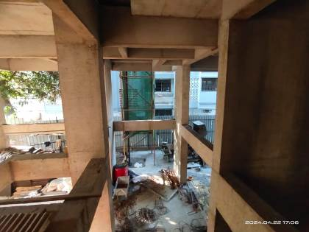
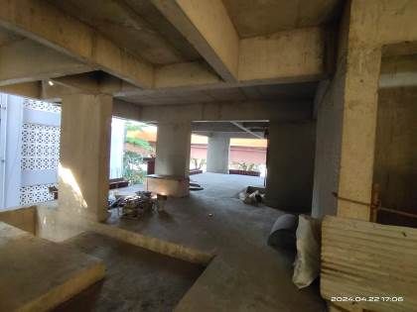
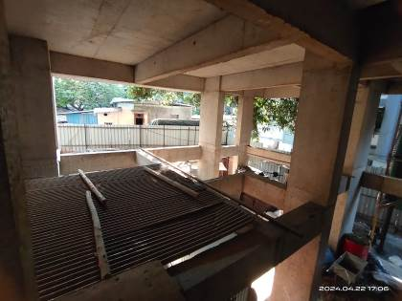
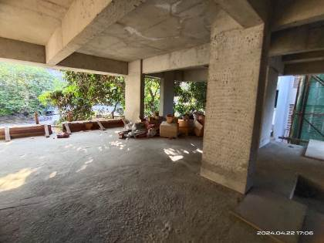
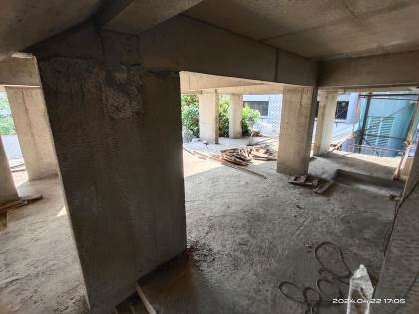

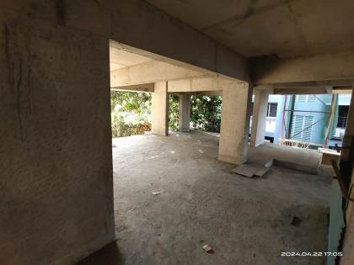

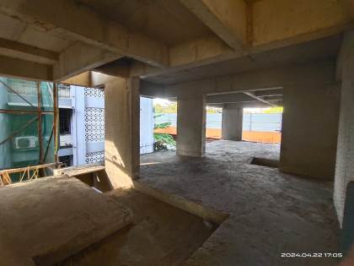

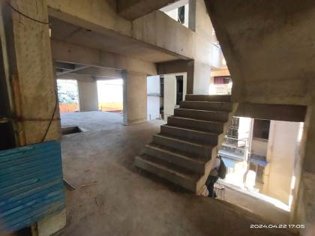

Actual Site Photographs
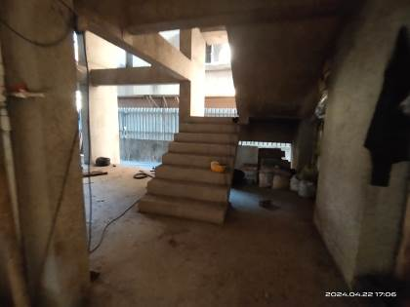
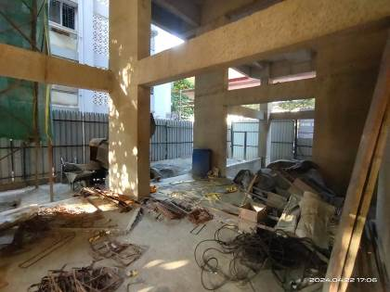

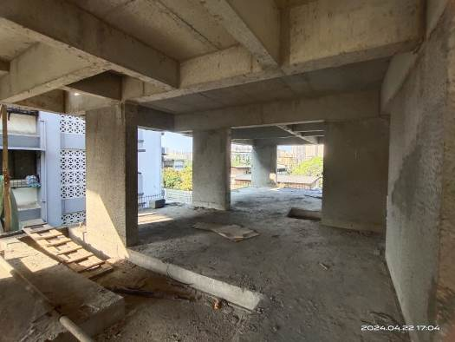
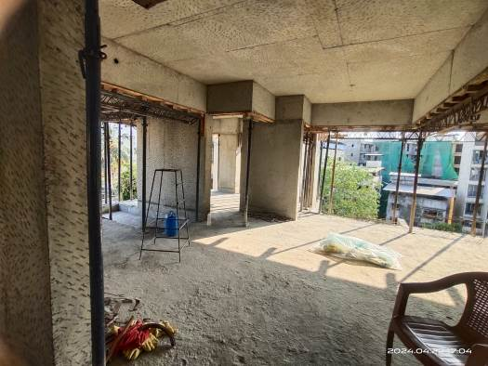

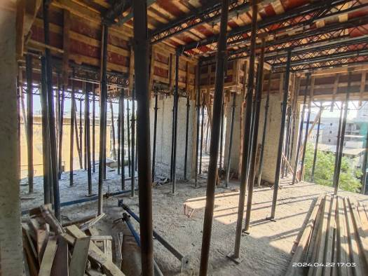
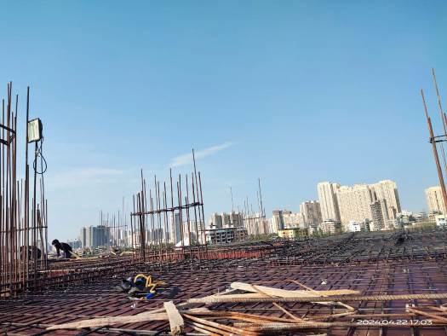

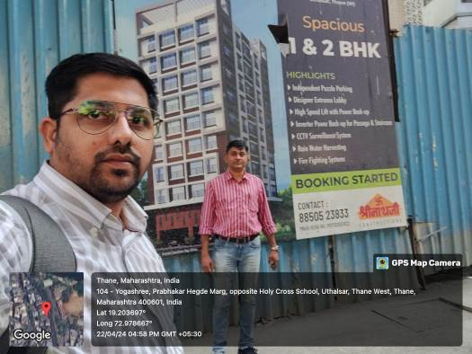
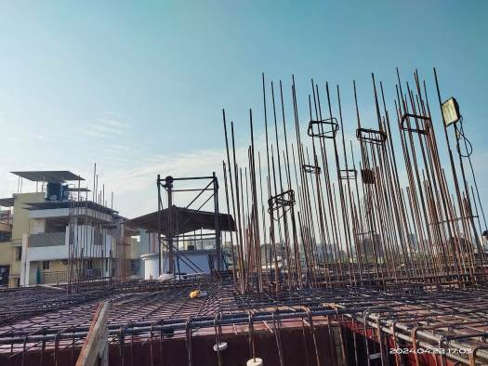

Actual Site Photographs
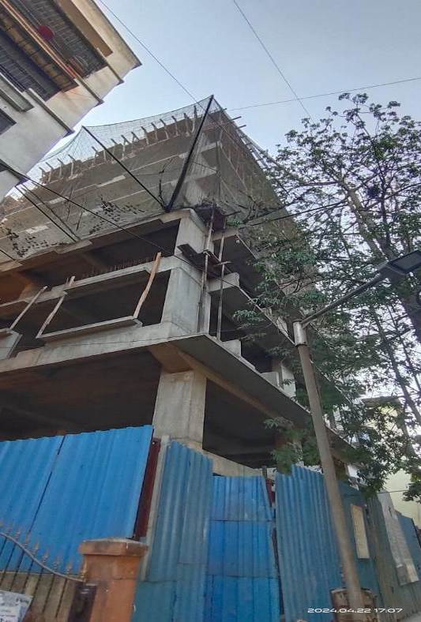
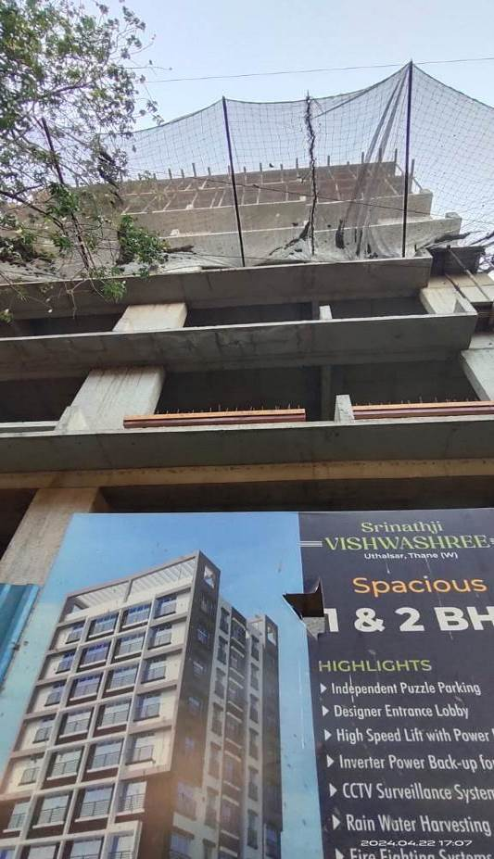
Route Map of the property
Site u/r

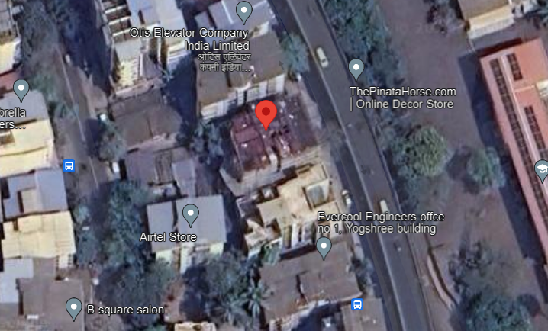

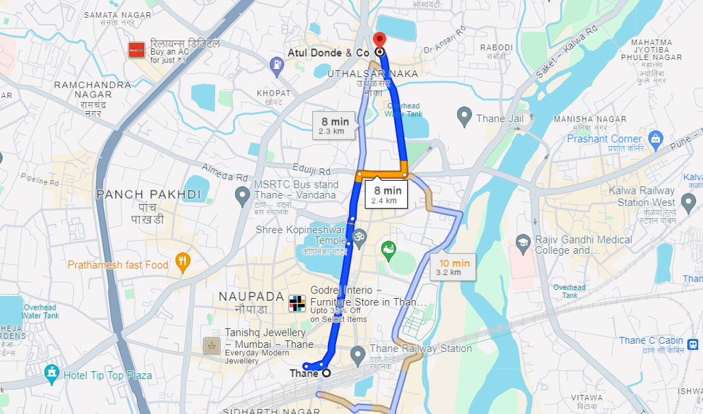

Latitude Longitude: 19°12’13.5”N 72°58’42.7”E
Note: The Blue line shows the route to site from nearest railway station (Thane – 2.4 Km.)

Ready Reckoner 2023 – 2024

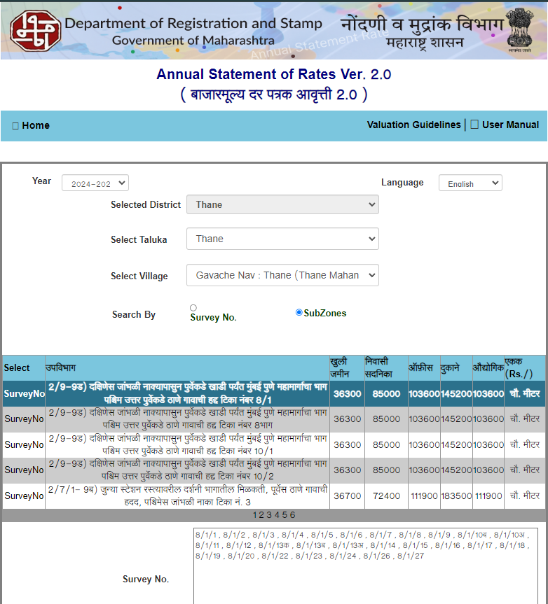

Registered Sales Instances
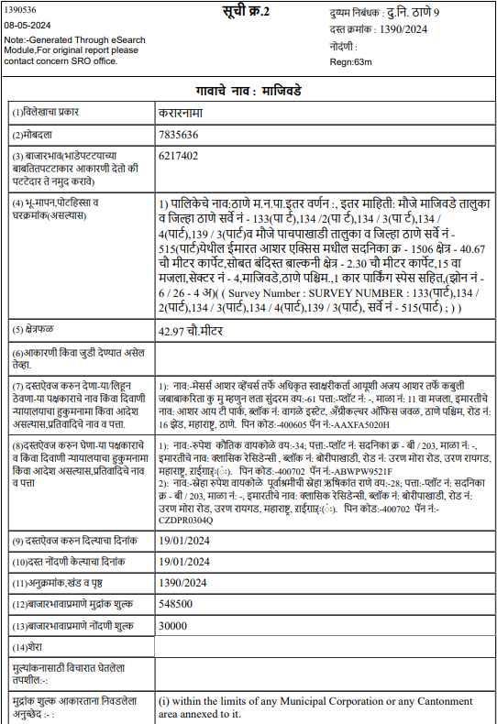
Registered Sales Instances
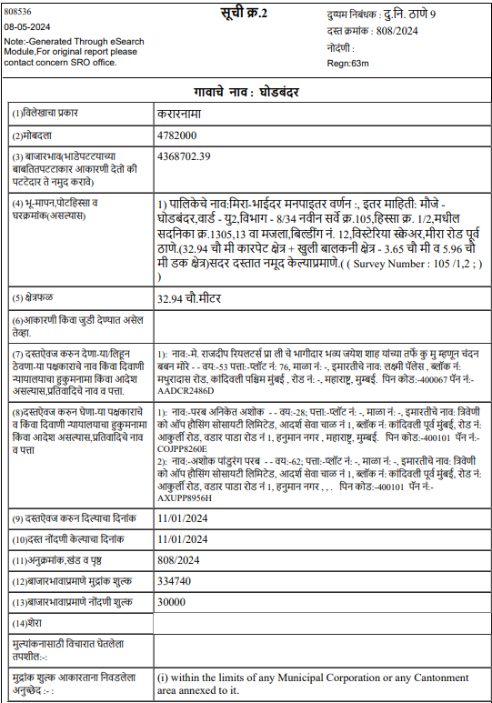

Price Indicators for Flats

Sr. No. | Project Name | Developer Name | RERA No. | Carpet Area in Sq. Ft. | Value in ` | Rate / Sq. Ft. on Carpet Area
1 | Roshan Residency | Abbas Constructions | P51700022344 | 469.00 | 93,80,000.00 | 20,000.00
2 | Sankalp Siddhi | Sankalp Developers | P51700008438 | 364.00 | 69,99,000.00 | 19,228.00
3 | Aurum | Shree GHP Housing | P51700022870 | 679.00 | 1,48,00,000.00 | 21,797.00
4 | Mount Casa | Nagraj Mutha | P51700034835 | 442.00 | 95,00,000.00 | 21,493.00
5 | Nakhuda | Holy Square Realty | P51700028817 | 650.00 | 1,07,00,000.00 | 16,462.00

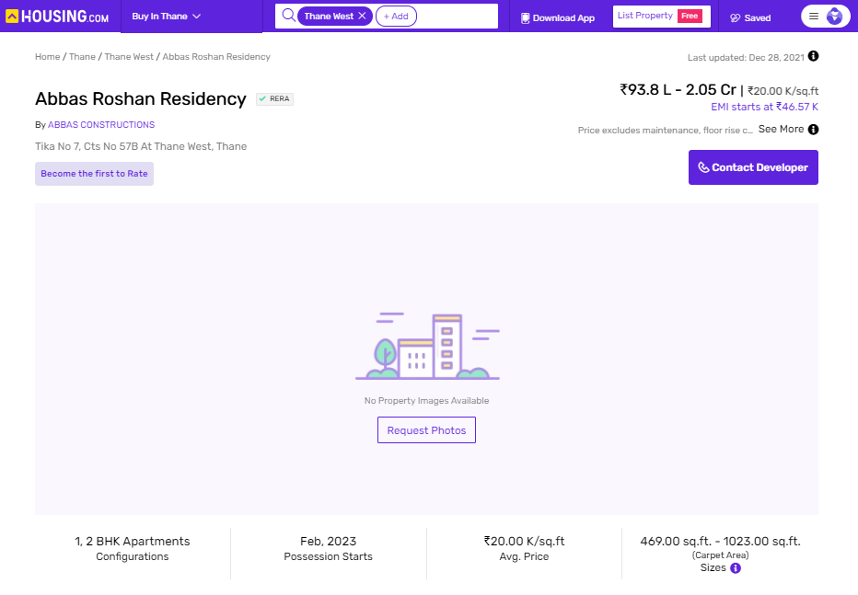

Price Indicators for Flats
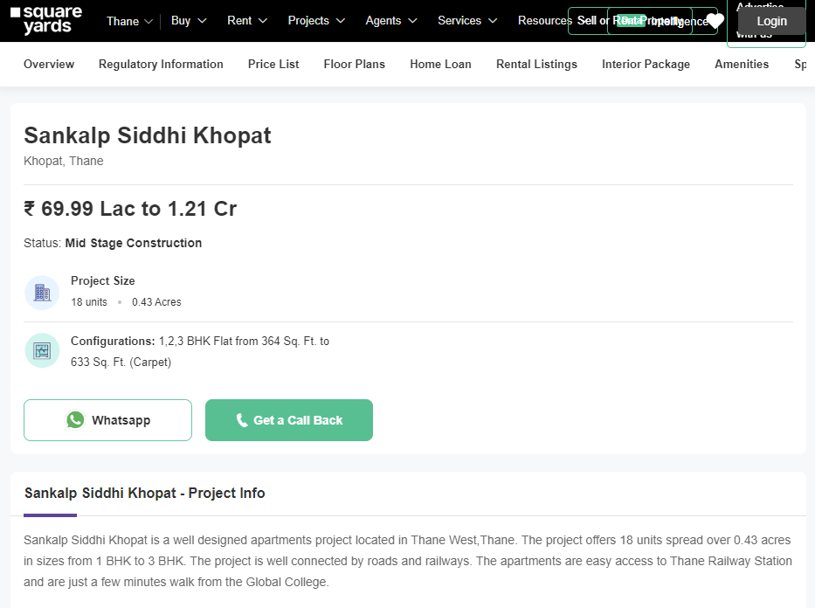
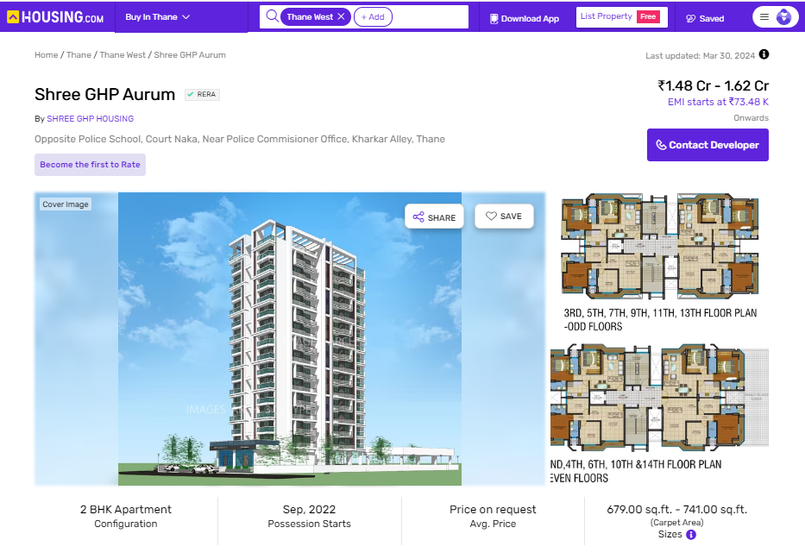
Price Indicators for Flats
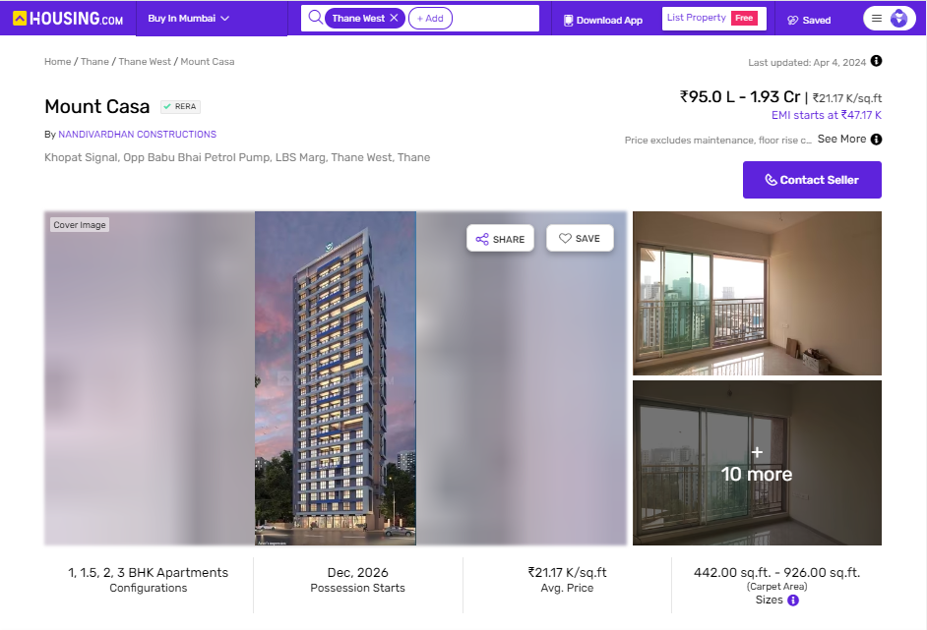
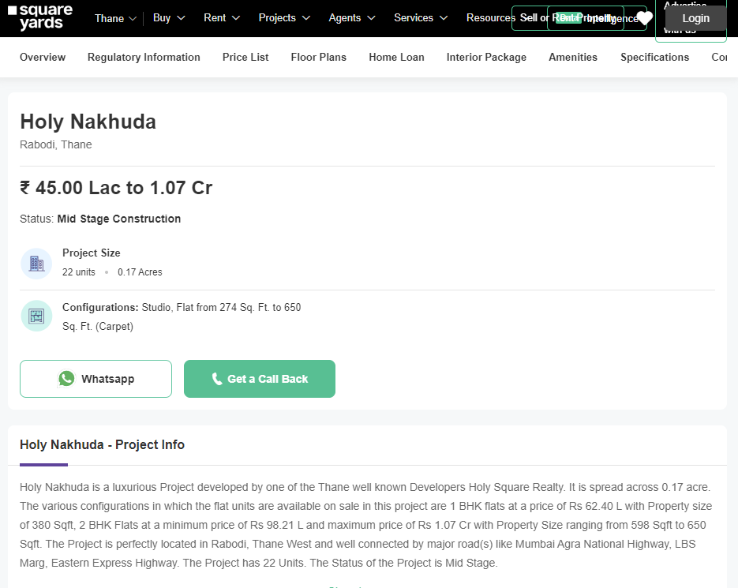
Justification for price /rate

The Market Value of the property is based on facts of markets discovered by us during our enquiries, however the government rate value in this case is less than the market value arrived by us. We are of the opinion that the value arrive by us will prove to be correct if an Auction of the subject property is carried out. As far as Market Value in Index II is concerned, it is not possible to comment on same, may be government rates are fixed by sampling during same point of time in part and whereas, Market values change every month.

In most of the cases the actual deal amount or Transaction value is not reflected in Index II because of various Market practices. As Valuer, we always try to give a value which is correct reflection of actual transaction value irrespective of any factors in market.

We hope this will satisfy your requirements.
As a result of my appraisal and analysis, it is my considered opinion that the realizable Value of the above property in the prevailing condition with aforesaid specification is (As per table attached to the report)

Place: Mumbai
Date: 08.05.2024

Manoj B. Chalikwar
Registered Valuer
Chartered Engineer (India)
Reg. No. IBBI / RV / 07/2018/10366
Reg. No. CAT-I-F-1763
SBI Empanelment No.: SME/TCC/2021-22/86/3

Enclosures
 | Declaration-cum-undertaking from the valuer (Annexure- I) | Attached
 | Model code of conduct for valuer - (Annexure - II) | Attached
(Annexure-I)

DECLARATION-CUM-UNDERTAKING

I, Manoj Chalikwar son of Shri. Baburao Chalikwar do hereby solemnly affirm and state that:

- I am a citizen of India.

- I will not undertake valuation of any assets in which I have a direct or indirect interest or become so interested at any time during a period of three years prior to my appointment as valuer or three years after the valuation of assets was conducted by me.

- The information furnished in my valuation report dated 08.05.2024 is true and correct to the best of my knowledge and belief and I have made an impartial and true valuation of the property.

- I/ my authorized representative have personally inspected the property on 22.04.2024. The work is not sub - contracted to any other valuer and carried out by myself.

- Valuation report is submitted in the format as prescribed by the bank.

- I have not been depanelled / delisted by any other bank and in case any such depanelment by other banks during my empanelment with you, I will inform you within 3 days of such depanelment.

- I have not been removed / dismissed from service / employment earlier.

- I have not been convicted of any offence and sentenced to a term of imprisonment

- I have not been found guilty of misconduct in my professional capacity.

- I have not been declared to be unsound mind

- I am not an undischarged bankrupt, or has not applied to be adjudicated as a bankrupt;

- I am not an undischarged insolvent.

- I have not been levied a penalty under section 271J of Income-tax Act, 1961 (43 of 1961) and time limit for filing appeal before Commissioner of Income-tax (Appeals) or Income-tax Appellate Tribunal, as the case may be has expired, or such penalty has been confirmed by Income-tax Appellate Tribunal, and five years have not elapsed after levy of such penalty

- I have not been convicted of an offence connected with any proceeding under the Income Tax Act 1961, Wealth Tax Act 1957 or Gift Tax Act 1958 and

- My PAN Card number as applicable is AERPC9086P

- I undertake to keep you informed of any events or happenings which would make me ineligible for empanelment as a valuer

- I have not concealed or suppressed any material information, facts and records and I have made a complete and full disclosure

- I have read the Handbook on Policy, Standards and procedure for Real Estate Valuation, 2011 of the IBA and this report is in conformity to the "Standards" enshrined for valuation in the Part - B of the above handbook to the best of my ability.

- I have read the International Valuation Standards (IVS) and the report submitted to the Bank for the respective asset class is in conformity to the "Standards" as enshrined for valuation in the IVS in "General Standards" and "Asset Standards" as applicable. The valuation report is submitted in the prescribed format of the bank.

- I abide by the Model Code of Conduct for empanelment of valuer in the Bank. (Annexure V - A signed copy of same to be taken and kept along with this declaration)

- I am valuer registered with Insolvency & Bankruptcy Board of India (IBBI)

- My CIBIL Score and credit worthiness is as per Bank's guidelines.

- I am Chairman & Managing Director of the company, who is competent to sign this valuation report.

- I will undertake the valuation work on receipt of Letter of Engagement generated from the system (i.e., LLMS / LOS) only.

- Further, I hereby provide the following information.

 | Particulars | Valuer comment
 | Background information of the asset being valued; | The property under consideration is developed by M/s. Srinathji Construction.
 | Purpose of valuation and appointing authority | As per request from State Bank of India, SME Chembur Branch to assess Fair Market value of the Project for bank loan purpose.
 | Identity of the Valuer and any other experts involved in the valuation; | Manoj B. Chalikwar – Regd. Valuer  Umang Ashwin Patel – Regd. Valuer  Prayush P. Parekh – Senior Valuation Engineer
 | Disclosure of Valuer interest or conflict, if any; | We have no interest, either direct or indirect, in the property valued. Further to state that we do not have relation or any connection with property owner / applicant directly or indirectly. Further to state that we are an independent Valuer and in no way related to property owner / applicant
 | Date of appointment, valuation date and date of report; | Date of Appointment – 20.04.2024  Valuation Date – 08.05.2024  Date of Report – 08.05.2024
 | Inspections and/or investigations undertaken; | Physical Inspection done on date 22.04.2024
 | Nature and sources of the information used or relied upon; | - Market Survey at the time of site visit  - Ready Reckoner rates / Circle rates  - Online search for Registered Transactions  - Online Price Indicators on real estate portals  - Enquiries with Real estate consultants  - Existing data of Valuation assignments carried out by us
 | Procedures adopted in carrying out the valuation and valuation standards followed; | Sales Comparative Method
 | Restrictions on use of the report, if any; | This valuation is for the use of the party to whom it is addressed and for no other purpose. No responsibility is accepted to any third party who may use or rely on the whole or any part of this valuation. The valuer has no pecuniary interest that would conflict with the proper valuation of the property.
- . | Major factors that were taken into account during the valuation; | Current market conditions, demand and supply position, residential land size, location, sustained demand for residential land, all round development of commercial and residential application in the locality etc.
 | Caveats, limitations and disclaimers to the extent they explain or elucidate the limitations faced by valuer, which shall not be for the purpose of limiting his responsibility for the valuation report. | Attached

Assumptions, Disclaimers, Limitations & Qualifications
Value Subject to Change
The subject appraisal exercise is based on prevailing market dynamics as on 08th May 2024 and does not take into account any unforeseeable developments which could impact the same in the future.
Our Investigations
We are not engaged to carry out all possible investigations in relation to the subject property. Where in our report we identify certain limitations to our investigations, this is to enable the reliant party to instruct further investigations where considered appropriate or where we recommend as necessary prior to reliance. Vastukala Consultants India Pvt. Ltd. (VCIPL) is not liable for any loss occasioned by a decision not to conduct further investigations
Assumptions
Assumptions are a necessary part of undertaking valuations. VCIPL adopts assumptions for the purpose of providing valuation advise because some matters are not capable of accurate calculations or fall outside the scope of our expertise, or out instructions. The reliant party accepts that the valuation contains certain specific assumptions and acknowledge and accept the risk of that if any of the assumptions adopted in the valuation are incorrect, then this may have an effect on the valuation.
Information Supplied by Others
The appraisal is based on the information provided by the client. The same has been assumed to be correct and has been used for appraisal exercise. Where it is stated in the report that another party has supplied information to VCIPL, this information is believed to be reliable but VCIPL can accept no responsibility if this should prove not to be so.
Future Matters
To the extent that the valuation includes any statement as to a future matter, that statement is provided as an estimate and/or opinion based on the information known to VCIPL at the date of this document. VCIPL does not warrant that such statements are accurate or correct.
Map and Plans
Any sketch, plan or map in this report is included to assist the reader while visualising the property and assume no responsibility in connection with such matters.
Site Details
Based on documents / information received from Client's representative and site visit conducted, we understand that the subject property is currently a Building Under Construction work is in progress contiguous and non-agricultural land parcel admeasuring as per table attached to the report and in the name of M/s. Srinathji Construction. Further, VCIPL has assumed that the subject property is free from any encroachment and is available as on the date of the appraisal.
Property Title
Based on our discussion with the Client, we understand that the subject property is owned by M/s. Srinathji Construction. For the purpose of this appraisal exercise, we have assumed that the subject property has a clear title and is free from any encumbrances, disputes and claims. VCIPL has made no further enquiries with the relevant local authorities in this regard and does not certify the property as having a clear and marketable title. Further, no legal advice regarding the title and ownership of the subject property has been obtained for the purpose of this appraisal exercise. It has been assumed that the title deeds are clear and marketable.
Environmental Conditions
We have assumed that the subject property is not contaminated and is not adversely affected by any existing or proposed environmental law and any processes which are carried out on the property are regulated by environmental legislation and are properly licensed by the appropriate authorities.

Town Planning
The permissible land use, zoning, achievable FSI, area statement adopted for purpose of this valuation is based on the documents / information provided by the Client's representative and the same has been adopted for this valuation purpose. VCIPL has assumed the same to be correct and permissible. VCIPL has not validated the same from any authority.
Area
Based on the document provided by the Client's representative, we understand that the subject property is a Building Under Construction work is in progress, contiguous and non-agricultural land parcel admeasuring as per table attached to the report.
Condition & Repair
In the absence of any information to the contrary, we have assumed that there are no abnormal ground conditions, nor archaeological remains present which might adversely affect the current or future occupation, development or value of the property. The property is free from rat, infestation, structural or latent defect. No currently known deleterious or hazardous materials or suspect techniques will be used in the construction of or subsequent alteration or additions to the property and comments made in the property details do not purport to express an opinion about, or advise upon, the condition of uninspected parts and should not be taken as making an implied representation or statement about such parts
Valuation Methodology
For the purpose of this valuation exercise, the valuation methodology used is Direct Comparison Approach Method and proposed Highest and Best Use model is used for analysing development potential.
The Direct Comparison Approach involves a comparison of the property being valued to similar properties that have actually been sold in arms - length transactions or are offered for sale. This approach demonstrates what buyers have historically been willing to pay (and sellers willing to accept) for similar properties in an open and competitive market and is particularly useful in estimating the value of the land and properties that are typically traded on a unit basis.
In case of inadequate recent transaction activity in the subject micro-market, the appraiser would collate details of older transactions. Subsequently, the appraiser would analyse rental / capital value trends in the subject micro-market in order to calculate the percentage increase / decrease in values since the date of the identified transactions. This percentage would then be adopted to project the current value of the same.
Where reliance has been placed upon external sources of information in applying the valuation methodologies, unless otherwise specifically instructed by Client and/or stated in the valuation, VCIPL has not independently verified that information and VCIPL does not advise nor accept it as reliable. The person or entity to whom the report is addressed acknowledges and accepts the risk that if any of the unverified information in the valuation is incorrect, then this may have an effect on the valuation.
Not a Structural Survey
We state that this is a valuation report and not a structural survey
Other
All measurements, areas and ages quoted in our report are approximate
Legal
We have not made any allowances with respect to any existing or proposed local legislation relating to taxation on realization of the sale value of the subject property. VCIPL is not required to give testimony or to appear in court by reason of this appraisal report, with reference to the property in question, unless arrangement has been made thereof. Further, no legal advice on any aspects has been obtained for the purpose of this appraisal exercise

Property specific assumptions
Based on inputs received from the client and site visit conducted, we understand that the subject property is currently Building Under Construction work is in progress, contiguous and non-agricultural land parcel admeasuring area as per table attached to the report.

ASSUMPTIONS, CAVEATS, LIMITATION AND DISCLAIMERS
- We assume no responsibility for matters of legal nature affecting the property appraised or the title thereto, nor do we render our opinion as to the title, which is assumed to be good and marketable.
- The property is valued as though under responsible ownership.
- It is assumed that the property is free of liens and encumbrances.
- It is assumed that there are no hidden or unapparent conditions of the subsoil or structure that would render it more or less valuable. No responsibility is assumed for such conditions or for engineering that might be required to discover such factors.
- There is no direct/ indirect interest in the property valued.
- The rates for valuation of the property are in accordance with the Govt. approved rates and prevailing market rates.
(Annexure - II)
MODEL CODE OF CONDUCT FOR VALUERS
Integrity and Fairness
- A valuer shall, in the conduct of his/its business, follow high standards of integrity and fairness in all his/its dealings with his/its clients and other valuers.
- A valuer shall maintain integrity by being honest, straightforward, and forthright in all professional relationships.
- A valuer shall endeavour to ensure that he/it provides true and adequate information and shall not misrepresent any facts or situations.
- A valuer shall refrain from being involved in any action that would bring disrepute to the profession.
- A valuer shall keep public interest foremost while delivering his services.
Professional Competence and Due Care
- A valuer shall render at all times high standards of service, exercise due diligence, ensure proper care and exercise independent professional judgment.
- A valuer shall carry out professional services in accordance with the relevant technical and professional standards that may be specified from time to time.
- A valuer shall continuously maintain professional knowledge and skill to provide competent professional service based on up-to-date developments in practice, prevailing regulations / guidelines and techniques.
- In the preparation of a valuation report, the valuer shall not disclaim liability for his/its expertise or deny his/its duty of care, except to the extent that the assumptions are based on statements of fact provided by the company or its auditors or consultants or information available in public domain and not generated by the valuer.
- A valuer shall not carry out any instruction of the client insofar as they are incompatible with the requirements of integrity, objectivity and independence.
- A valuer shall clearly state to his client the services that he would be competent to provide and the services for which he would be relying on other valuers or professionals or for which the client can have a separate arrangement with other valuers.
Independence and Disclosure of Interest
- A valuer shall act with objectivity in his/its professional dealings by ensuring that his/its decisions are made without the presence of any bias, conflict of interest, coercion, or undue influence of any party, whether directly connected to the valuation assignment or not.
- A valuer shall not take up an assignment if he/it or any of his/its relatives or associates is not independent in terms of association to the company.
- A valuer shall maintain complete independence in his/its professional relationships and shall conduct the valuation independent of external influences.
- A valuer shall wherever necessary disclose to the clients, possible sources of conflicts of duties and interests, while providing unbiased services.
- A valuer shall not deal in securities of any subject company after any time when he/it first becomes aware of the possibility of his / its association with the valuation, and in accordance with the Securities and Exchange Board of India (Prohibition of Insider Trading)Regulations,2015 or till the time the valuation report becomes public, whichever is earlier.
- A valuer shall not indulge in "mandate snatching" or offering "convenience valuations" in order to cater to a company or client's needs.
- As an independent valuer, the valuer shall not charge success fee.
- In any fairness opinion or independent expert opinion submitted by a valuer, if there has been a prior engagement in an unconnected transaction, the valuer shall declare the association with the company during the last five years.
Confidentiality
- A valuer shall not use or divulge to other clients or any other party any confidential information about the subject company, which has come to his / its knowledge without proper and specific authority or unless there is a legal or professional right or duty to disclose.
Information Management
- A valuer shall ensure that he/ it maintains written contemporaneous records for any decision taken, the reasons for taking the decision, and the information and evidence in support of such decision. This shall be maintained so as to sufficiently enable a reasonable person to take a view on the appropriateness of his /its decisions and actions.
- A valuer shall appear, co-operate and be available for inspections and investigations carried out by the authority, any person authorised by the authority, the registered valuers organisation with which he/it is registered or any other statutory regulatory body.
- A valuer shall provide all information and records as may be required by the authority, the Tribunal, Appellate Tribunal, the registered valuers organisation with which he/it is registered, or any other statutory regulatory body.
- A valuer while respecting the confidentiality of information acquired during the course of performing professional services, shall maintain proper working papers for a period of three years or such longer period as required in its contract for a specific valuation, for production before a regulatory authority or for a peer review. In the event of a pending case before the Tribunal or Appellate Tribunal, the record shall be maintained till the disposal of the case.
Gifts and hospitality:
- A valuer or his / its relative shall not accept gifts or hospitality which undermines or affects his independence as a valuer.
- Explanation: For the purposes of this code the term 'relative' shall have the same meaning as defined in clause (77) of Section 2 of the Companies Act, 2013 (18 of 2013).
- A valuer shall not offer gifts or hospitality or a financial or any other advantage to a public servant or any other person with a view to obtain or retain work for himself / itself, or to obtain or retain an advantage in the conduct of profession for himself / itself.
Remuneration and Costs.
- A valuer shall provide services for remuneration which is charged in a transparent manner, is a reasonable reflection of the work necessarily and properly undertaken, and is not inconsistent with the applicable rules.
- A valuer shall not accept any fees or charges other than those which are disclosed in a written contract with the person to whom he would be rendering service.
Occupation, employability and restrictions.
- A valuer shall refrain from accepting too many assignments, if he/it is unlikely to be able to devote adequate time to each of his/ its assignments.
- A valuer shall not conduct business which in the opinion of the authority or the registered valuer organisation discredits the profession.
Miscellaneous
- A valuer shall refrain from undertaking to review the work of another valuer of the same client except under written orders from the bank or housing finance institutions and with knowledge of the concerned valuer.
- A valuer shall follow this code as amended or revised from time to time.
DEFINITION OF VALUE FOR THIS SPECIFIC PURPOSE

This exercise is to assess Master Valuation of the property under reference as on 08th May 2024.

The term Fair Market Value is defined as

“The most probable price, as of a specified date, in cash, terms equivalent to cash, or in other precisely revealed terms for which the specified property rights would sell after reasonable exposure in a competitive market under all conditions requisite to a fair sale, with the buyer and seller each acting prudently knowledgeably and for self-interest assuming that neither is under undue duress”.

Fundamental assumptions and conditions presumed in this definition are:

1. Buyer and seller are motivated by self-interest.
2. Buyer and seller are well informed and are acting prudently.
3. The property is exposed for a reasonable time on the open market.
4. Payment is made in cash or equivalent or in specified financing terms.
DECLARATION OF PROFESSIONAL FEES CHARGED

We hereby declare that, our professional fees are not contingent upon the valuation findings. However, if the statute AND/OR clients demands that, the fees should be charged on the percentage of assessed value then, with the full knowledge of the AND/OR end user, it is being charged accordingly.

VALUATION OF THE PROPERTY PREMISES

Considering various parameters recorded herein above, existing economic scenario, and the information that is available with reference to the development of neighborhood and method selected for valuation, we are of the opinion that, the property premises can be assessed and valued for this particular purpose as per the details provided.

Manoj B. Chalikwar
Registered Valuer
Chartered Engineer (India)
Reg. No. IBBI / RV / 07/2018/10366
Reg. No. CAT-I-F-1763
SBI Empanelment No.: SME/TCC/2021-22/86/3

