Vastu/Nashik/03/2024/007945/2305722
23/22-470-RPBS
Date: 06.03.2024

To, `
The Branch Manager,
State Bank of India
RACC Nashik Branch
RBO.2, The Wave Building, 1st Floor,
Opposite Shell Petrol Pump, Pathardi Road,
Nashik – 422 010, State – Maharashtra, Country – India.

Sub: Vetting of Extra Amenities

Sir,

With reference to above subject, we have evaluated the Extra Amenities for Residential Row House No. 3, Ground + 2nd Floor, “Shree Hari Darshan Row Bungalow”, Survey No. 409/ 1P/ 409/ 3P, Plot No. 23, Near Dhanvantari Hospital, Behind Meghraj Bakery, Pingale Nagar, Peth Road, Village – Makhmalabad, Taluka & District – Nashik, PIN – 422 004, State – Maharashtra, Country – India belongs to Shri. Pintubhai Mansukhbhai Navapariya. & Shri. Vivek Mukeshbhai Kotadiya, Name of Proposed Purchaser: Suman Vithal Gave (Alias) Sau. Suman Pandit Valavi.

We have verified the rates quoted as per current market rates. Details of work and Extra Amenities considered as per copy of Extra Amenities issued by Suman Vithal Gave (First Party) and Vaishaliben Vivekbhai Kotadiya (Second Party) received on dated 26.02.2024. The Extra Amenities amount is Rs.8,00,000/- (Rupees Eight Lakh Only)

The said Cost Vetting Certificate is valid upto next 6 months Only.

Thanking you

Sincerely yours

Manoj B. Chalikwar
Registered Valuer
Chartered Engineer (India)
Reg. No. CAT-I-F-1763
Reg. No. IBBI/RV/07/2018/10366
BOB Empanelment No.: ZO:MZ:ADV:46:941
Encl: Valuation report.

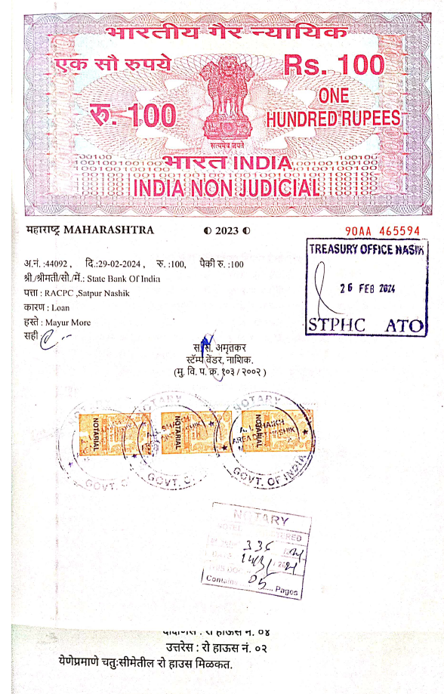
Agreement for Extra Amenities
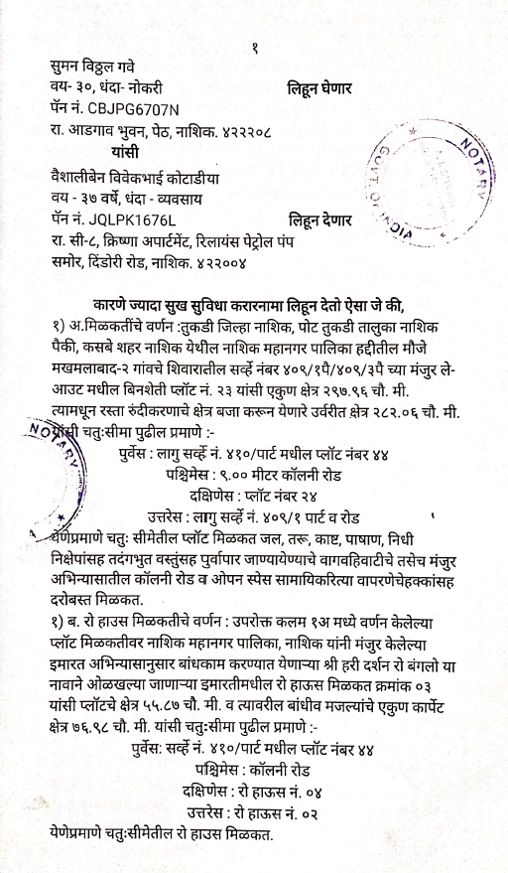

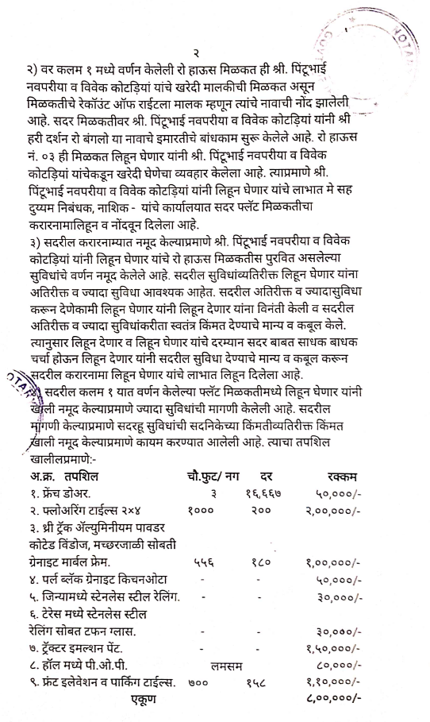
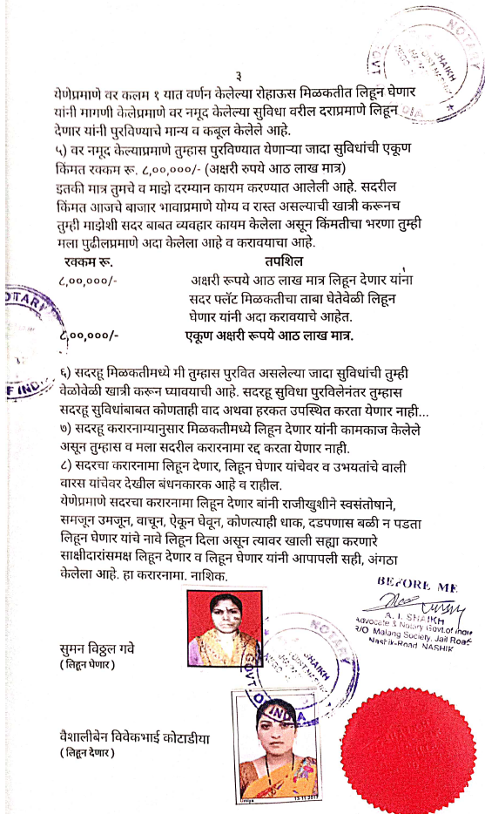

The Extra Amenities amount is Rs.8,00,000/- (Rupees Eight Lakh Only)

