Vastu/Nashik/09/3966/2302672
22/9-316-RYBS
Date: 22.03.2024

To,
State Bank of India
State Bank of India
RACPC Nashik Branch
1st Floor, Patel Plaza, N.D. Patel Road, Opp. BSNL, Landmark Seawoods Navratna Hotel,
Nashik - 422001, State – Maharashtra, Country – India.

Sub: Vetting of Estimate

Sir,

With reference to above subject, we have evaluated the Estimate for Residential Land and Proposed Bungalow On C.T.S. No. 215, Ground+ First Floor, Grampanchayat Milkat No. 332/ A & 332/ B, Near State Bank of India, Vateshwar Mandir, Maurti Gali, Dhodambe Road, Village – Dhodambe, Taluka - Chandwad, District - Nashik, PIN Code - 423 101,State - Maharashtra, Country - India. Belongs to Name of Owner: Shri. Kashinath Revanappa Tondkar.

We have verified the rates quoted as per current market rates. Details of Estimate considered as per copy of Estimate Provided by Aarkay Civil Work Consultants received on dated.22.03.2024. The Estimate amount is Rs.23,00,000/- (Rupees Twenty Three Lakh Only.)

Note:1) The said Cost Vetting Certificate is valid upto next 6 months Only.

Thanking you

Sincerely yours

Manoj B. Chalikwar
Registered Valuer
Chartered Engineer (India)
Reg. No. CAT-I-F-1763
Reg. No. IBBI/RV/07/2018/10366
BOB Empanelment No.: ZO:MZ:ADV:46:941
Encl: Valuation Report

Estimate
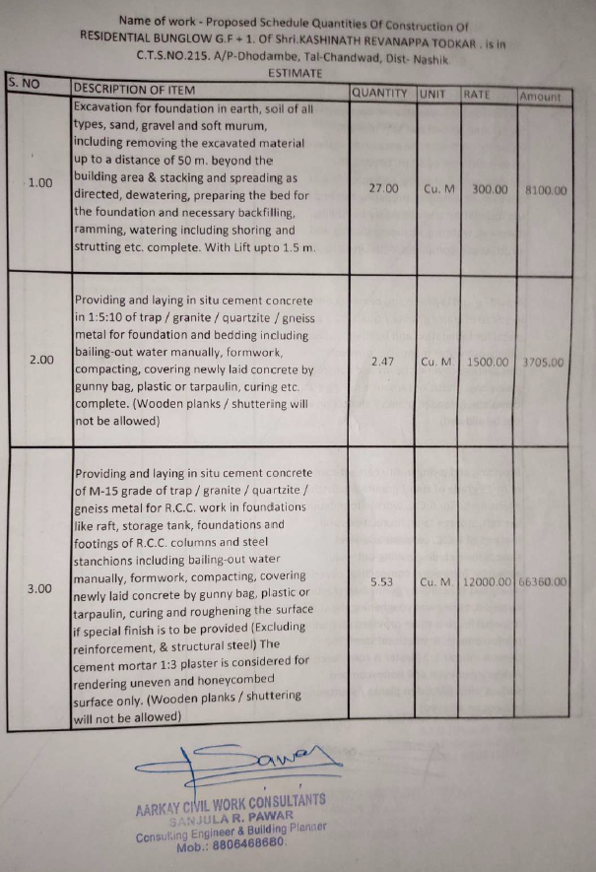
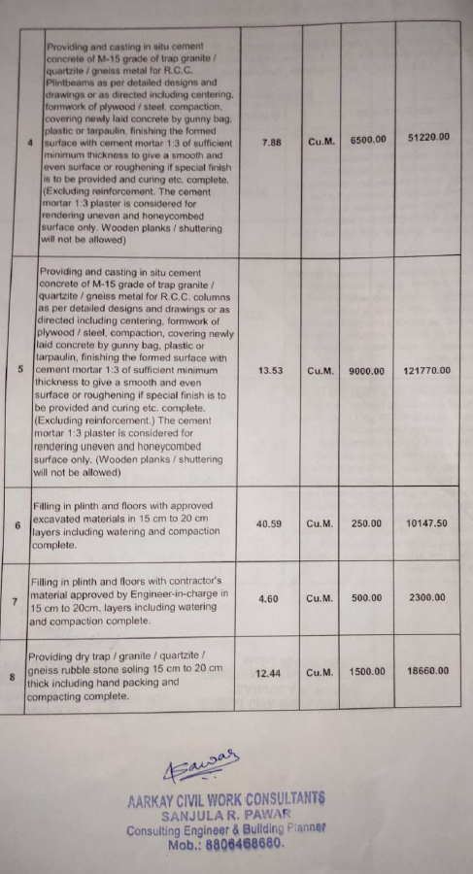

Estimate
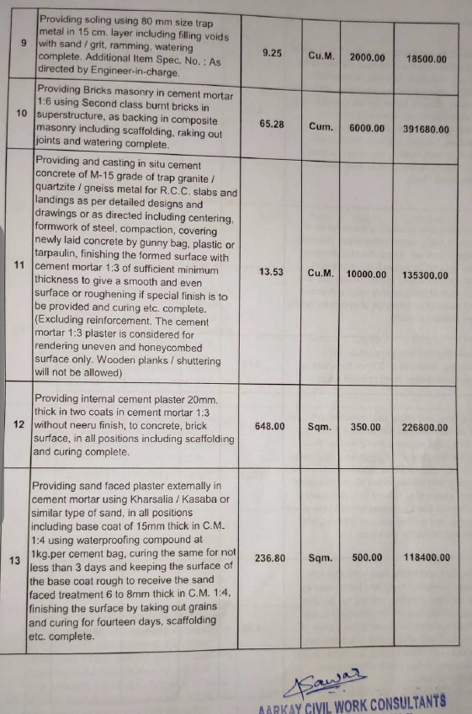
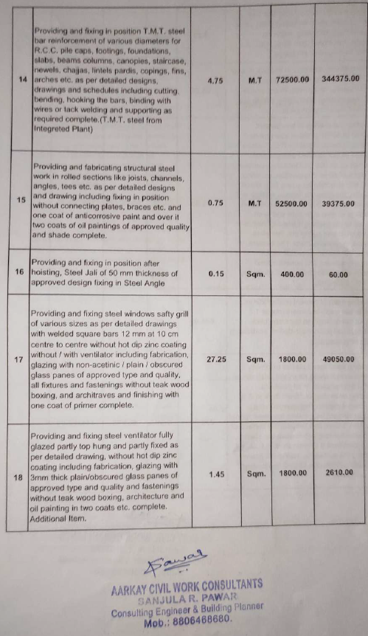

Estimate
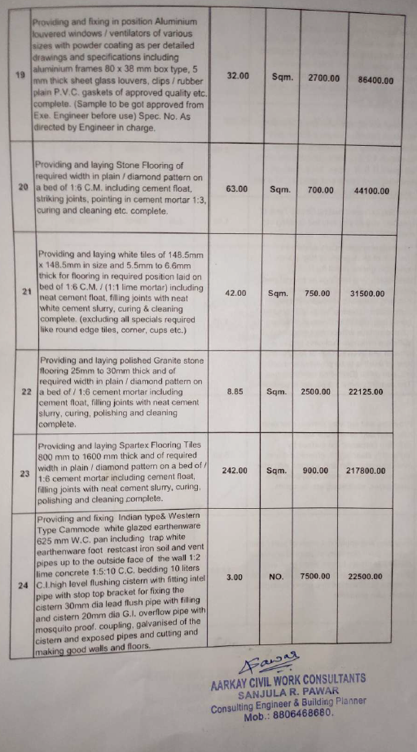
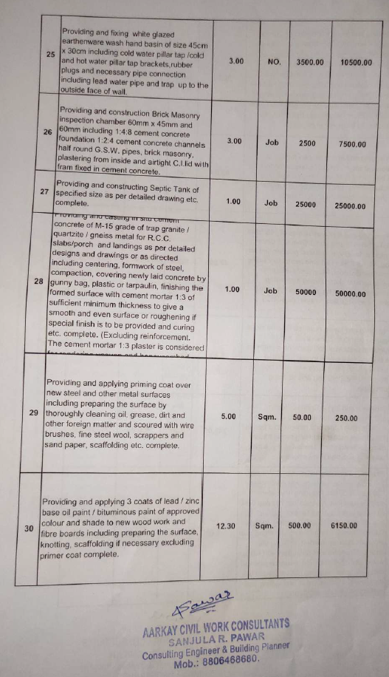

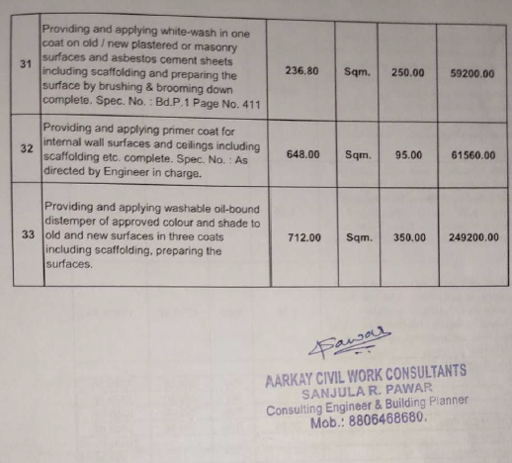
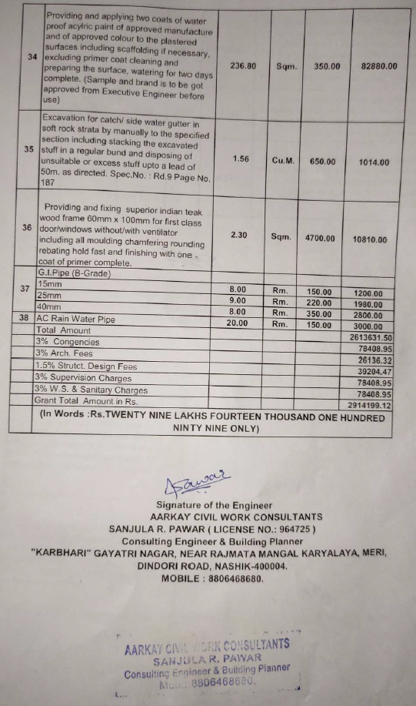

The Estimate amount is Rs.23,00,000/- (Rupees Twenty Three Lakh Only.)

