Valuation Report of the Immovable Property

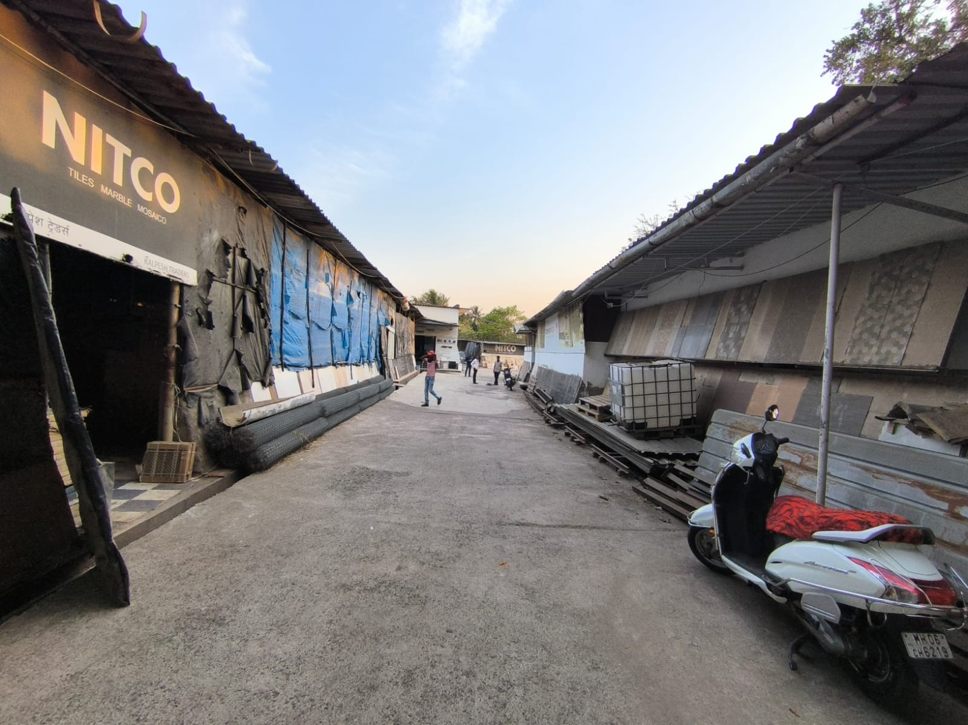

**Details of the property under consideration:**

Name of Owner: **Mr. Santosh Bhavarlal Jain**

**Residential NA Land** on Survey No. 66, Hissa No. 3 of Village – Ambepur, Nagothane Pezari Road,

Taluka – Alibaug, District – Raigad, PIN Code - 400 703, State – Maharashtra, Country – India.

# Latitude Longitude - 18°40’47.2”N 72°59’21.1”E

# 

**Valuation Prepared for:**

**Cosmos Bank**

**Pune Head Office Branch**

Cosmos Tower, Plot No. 6, ICS Colony, University Road, Ganeshkhind Road, Shivajinagar,

Pune - 411007, State - Maharashtra, Country – India.

Vastu/Mumbai/12/2023/5668/2304078

20/13-307-SKVSU Date: 22.03.2024

# VALUATION OPINION REPORT

The property bearing **Residential NA Land** on Survey No. 66, Hissa No. 3 of Village – Ambepur, Nagothane Pezari Road, Taluka – Alibaug, District – Raigad, PIN Code - 400 703, State – Maharashtra, Country – India belongs to **Mr. Santosh Bhavarlal Jain.**

|  |  |  |
| --- | --- | --- |
| **Boundaries of the property.** | | |
| North | : | Internal Road | |
| South | : | Property by Chikhalkar | |
| East | : | Mohan Rice Mill | |
| West | : | Property by Lilabai Ramdas | |

Considering various parameters recorded, existing economic scenario, and the information that is available with reference to the development of neighborhood and method selected for valuation, we are of the opinion that, the property premises can be assessed and valued for banking purpose as below –

|  |  |
| --- | --- |
| **Particulars** | **Value (`)** |
| **Fair Market Value** | **1,14,45,000.00** |
| **Realizable Value** | **1,03,00,500.00** |
| **Distress Sale Value** | **91,56,000.00** |

The valuation of the property is based on the documents produced by the concern. Legal aspects have not been taken into considerations while preparing this valuation report.

Hence certified

## Manoj B. Chalikwar

Registered Valuer

Chartered Engineer (India)

Reg. No. IBBI / RV / 07/2018/10366

Reg. No. CAT-I-F-1763

**Valuation Report of Residential NA Land** on Survey No. 66, Hissa No. 3 of Village – Ambepur, Nagothane Pezari Road, Taluka – Alibaug, District – Raigad, PIN Code - 400 703, State – Maharashtra, Country – India

*Form 0-1*

*(See Rule 8 D)*

REPORT OF VALUATION OF IMMOVABLE PROPERTY (OTHER THAN AGRICULTURAL LANDS, PLANTATIONS, FORESTS, MINES AND QUARRIES)

GENERAL:

|  |  |  |  |
| --- | --- | --- | --- |
| 1 | Purpose for which the valuation is made | | To assess the Fair Market Value as on 22.03.2024 for Bank loan Purpose |
| 2 | Date of inspection | | 20.03.2024 |
|  | Name of the owner/ owners | | **Mr. Santosh Bhavarlal Jain** |
| 4 | If the property is under joint ownership / co-ownership, share of each such owner. Are the shares undivided? | | Sole Ownership |
| 5 | Brief description of the property | | **Residential NA Land** on Survey No. 66, Hissa No. 3 of Village – Ambepur, Nagothane Pezari Road, Taluka – Alibaug, District – Raigad, PIN Code - 400 703, State – Maharashtra, Country – India. |
| 6 | Location, street, ward no | | Nagothane Pezari Road |
| 7 | Survey/ Plot no. of land | | Survey No. 66, Hissa No. 3 of Village – Ambepur |
| 8 | Is the property situated in residential/ commercial/ mixed area/ industrial area? | | Residential area |
| 9 | Classification of locality-high class/ middle class/poor class | | Middle Class |
| 10 | Proximity to civic amenities like schools, Hospitals, Offices, market, cinemas etc. | | All the amenities are available in the vicinity |
| 11 | Means and proximity to surface communication by which the locality is served | | Served by Buses and Private cars |
|  | *LAND* | |  |
| 12 | Area of land supported by documentary proof. Shape, dimension and physical features | | Plot Area – 2180 Sq. Mtr.  (Area as per Agreement for Sale) |
| 13 | Roads, Streets or lanes on which the land is abutting | | 20’0” Wide MIDC Road |
| 14 | If freehold or leasehold land | | Freehold |
| 15 | If leasehold, the name of Lessor/lessee, nature of lease, date of commencement and termination of lease and terms of renewal of lease. | | Freehold land |
| (i) Initial premium | | Not applicable |
| (ii) Ground rent payable per annum | | Not applicable |
| (iii) Unearned increase payable to the Lessor in the event of sale or transfer | | Not applicable |
| 16 | Is there any restriction covenant in regard to use of land? If so attach a copy of the covenant. | | Residential purpose |
| 17 | Are there any agreements of easements? If so, attach a copy of the covenant | | Information not available |
| 18 | Does the land fall in an area included in any Town Planning Scheme or any Development Plan of Government or any statutory body? If so, give Particulars. | | No |
| 19 | Has any contribution been made towards development or is any demand for such contribution still outstanding? | | Information not available |
| 20 | Has the whole or part of the land been notified for acquisition by government or any statutory body? Give date of the notification. | | No |
| 21 | Attach a dimensioned site plan | | Copy of Approved Plan not provided for our verification. |
|  | *IMPROVEMENT* | |  |
| 22 | Attach plans and elevations of all structures standing on the land and a lay-out plan. | | Attached |
| 23 | Furnish technical details of the building on a separate sheet (The Annexure to this form may be used) | | Attached |
| 24 | Is the building owner occupied/tenanted/both? | | Owner Occupied |
|  | If the property owner occupied, specify portion and extent of area under owner-occupation | | Owner Occupied |
| 25 | What is the Floor Space Index permissible and Percentage actually utilized? | | FSI – 0.2 |
| 26 | *RENTS* | |  |
|  | (i) | Names of tenants/ lessees/ licensees, etc. | N.A. |
|  | (ii) | Portions in their occupation | N.A. |
|  | (iii) | Monthly or annual rent/ compensation / license fee, etc. paid by each | N.A. |
|  | (iv) | Information not available | N.A. |
| 27 | Are any of the occupants related to, or close to business associates of the owner? | | N.A. |
| 28 | Is separate amount being recovered for the use of fixtures, like fans, geysers, refrigerators, cooking ranges, built-in wardrobes, etc. or for services charges? If so, give details | | N.A. |
| 29 | Give details of the water and electricity charges, if any, to be borne by the owner | | Information not available |
| 30 | Has the tenant to bear the whole or part of the cost repairs and maintenance? Give particulars | | N.A. |
| 31 | If a lift is installed, who is to bear the cost of maintenance and operation- owner or tenant? | | No lift |
| 32 | If a pump is installed, who is to bear the cost of maintenance and operation- owner or tenant? | | N.A. |
| 33 | Who has to bear the cost of electricity charges for lighting of common space like entrance hall, stairs, passage, compound, etc. owner or tenant? | | N.A. |
| 34 | What is the amount of property tax? Who is to bear it? Give details with documentary proof | | Information not available |
| 35 | Is the building insured? If so, give the policy no., amount for which it is insured and the annual premium | | Information not available |
| 36 | Is any dispute between landlord and tenant regarding rent pending in a court of rent? | | N.A. |
| 37 | Has any standard rent been fixed for the premises under any law relating to the control of rent? | | As per local norms |
|  | *SALES* | |  |
| 38 | Give instances of sales of immovable property in the locality on a separate sheet, indicating the Name and address of the property, registration No., sale price and area of land sold. | | As per sub registrar of assurance |
| 39 | Land rate adopted in this valuation | | ` 5,250.00 Per Sq. M. including Land Development such as plot levelling, plot filling, M.S. gate, Compound wall, partition wall, lean to shed and other miscellaneous items. |
| 40 | If sale instances are not available or not relied up on, the basis of arriving at the land rate | | Online Price Indicators, Location, development of surrounding area, type of land and construction, construction specifications, age of building, condition of the premises & building, facilities provided and its prevailing market rate. |
|  | *COST OF CONSTRUCTION* | |  |
| 41 | Year of commencement of construction and year of completion | | Not applicable being valuation of plot only |
| 42 | What was the method of construction, by contract / By employing Labour directly / both? | | Information not available |
| 43 | For items of work done on contract, produce copies of agreements | | Information not available |
| 44 | For items of work done by engaging Labour directly, give basic rates of materials and Labour supported by documentary proof. | | Information not available |
| 45 | Remarks | |  |

*PART II- VALUATION*

GENERAL:

Under the instruction of Cosmos Bank, Pune Head Office Branch, to assess fair market value as on **15th February 2024** for **Residential NA Land** on Survey No. 66, Hissa No. 3 of Village – Ambepur, Nagothane Pezari Road, Taluka – Alibaug, District – Raigad, PIN Code - 400 703, State – Maharashtra, Country – India belongs to **Mr. Santosh Bhavarlal Jain.**

We are in receipt of the following documents:

|  |  |
| --- | --- |
|  | Copy of Agreement for Sale dated 29.03.2004 between Mr. Madhukar Nagu Patil (the Seller) AND Mr. Santosh Bhavarlal Jain (the Purchaser). |
|  | Copy of 7/12 Extract in the name of Mr. Santosh Bhavarlal Jain |
|  | Copy of NA Order – Masha / LNA 1 / SR / 111 / 2006 dated 24.08.200 issued by Subdistrict Officer Raigad. |

**Land:**

The plot under valuation is Freehold residential plot for the with structure standing thereon. As per site inspection, layout approved plan were not provided, hence we have considered the plot area as per agreement for sale for valuation purpose.

**VALUATION OF THE PROPERTY :**

**Value of Land:**

|  |  |
| --- | --- |
| Plot area | 2,180.00 Sq. M. |
| Rate adopted for valuation | ` 5,250.00 per Sq. M. |
| **Fair Market Value** | **`** **1,14,45,000.00** |
| **Realizable Value** | **`** **1,03,00,500.00** |
| **Distress Sale Value** | **`** **91,56,000.00** |

**Government Value**

|  |  |
| --- | --- |
| Plot area | 2,180.00 Sq. M. |
| Rate adopted for valuation | ` 5,230.00 per Sq. M. |
| **Value** | **` 1,14,01,400.00** |

Taking into consideration above said facts, we can evaluate the value of **Residential NA Land** on Survey No. 66, Hissa No. 3 of Village – Ambepur, Nagothane Pezari Road, Taluka – Alibaug, District – Raigad, PIN Code - 400 703, State – Maharashtra, Country – India for this particular purpose at **`** **1,14,45,000.00 (Amount in words Rupees One Crore Fourteen Lakh Forty Five Thousand Only)** as on **22nd March 2024.**

**NOTES**

1. I, Manoj B. Chalikwar with my experience and ability to judgment I am of the considered opinion that the fair market value of the property as on 22nd March 2024 is ` 1,14,45,000.00 (Amount in words Rupees One Crore Fourteen Lakh Forty Five Thousand Only).
2. Value varies with time and purpose and hence this value should not be referred for any purpose other than mentioned in this report.
3. This valuation is done on the basis of information, which the valuer has obtained by information provided by the client about the premises and location of the surrounding area and also prevailing rates in the surrounding area, and further subject to document as mentioned in valuation report.
4. This valuer should not be held responsible for authentication of documents, clear title and other such related matters. For that purpose, Latest Legal Opinion should be sought.

*PART III- DECLARATION*

I hereby declare that

* + 1. The information furnished in part I is true and correct to the best of my knowledge and belief;
    2. I have no direct or indirect interest in the property valued:

ANNEXURE TO FORM 0-1

Technical details Main Building

|  |  |  |
| --- | --- | --- |
| 1. | No. of floors and height of each floor | Not applicable being valuation of plot only |
| 2. | Plinth area floor wise as per IS- 1225 | Plot Area – 2180 Sq. Mtr.  (Area as per Agreement for Sale) |
| 3 | Year of construction | Not applicable being valuation of plot only |
| 4 | Estimated future life | Not applicable being valuation of plot only |
| 5 | Type of construction- load bearing walls/RCC frame/ steel frame | Not applicable being valuation of plot only |
| 6 | Type of foundations | Not applicable being valuation of plot only |
| 7 | Walls | Not applicable being valuation of plot only |
| 8 | Partitions | Not applicable being valuation of plot only |
| 9 | Doors and Windows | **Not applicable being valuation of plot only** |
| 10 | Flooring | **Not applicable being valuation of plot only** |
| 11 | Finishing | Not applicable being valuation of plot only |
| 12 | Roofing and terracing | Not applicable being valuation of plot only |
| 13 | Special architectural or decorative features, if any | Not applicable being valuation of plot only |
| 14 | |  |  | | --- | --- | | (i) | Internal wiring – surface or conduit | | (ii) | Class of fittings: Superior/ Ordinary/ Poor. | | Not applicable being valuation of plot only |
| 15 | Sanitary installations   |  |  | | --- | --- | | (i) | No. of water closets | | (ii) | No. of lavatory basins | | (iii) | No. of urinals | | (iv) | No. of sinks |   Class of fittings: Superior colored / superior white/ordinary. | Not applicable being valuation of plot only |
| 16 | Compound wall  Height and length  Type of construction | Not applicable being valuation of plot only |
| 17 | No. of lifts and capacity | Not applicable being valuation of plot only |
| 18 | Underground sump – capacity and type of construction | Not applicable being valuation of plot only |
| 19 | Over-head tank Location, capacity Type of construction | Not applicable being valuation of plot only |
| 20 | Pumps- no. and their horse power | Not applicable being valuation of plot only |
| 21 | Roads and paving within the compound approximate area and type of paving | Not applicable being valuation of plot only |
| 22 | Sewage disposal – whereas connected to public sewers, if septic tanks provided, no. and capacity | Not applicable being valuation of plot only |

**Actual site photographs**

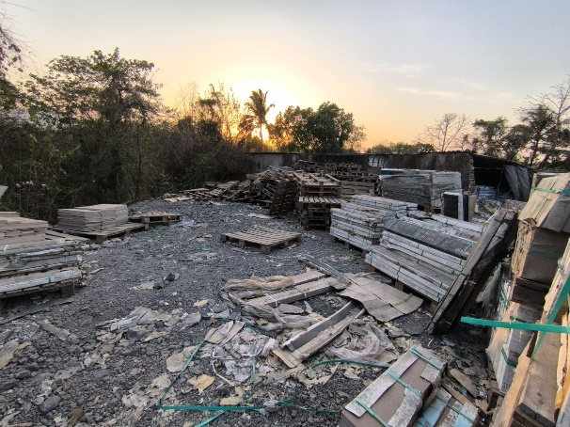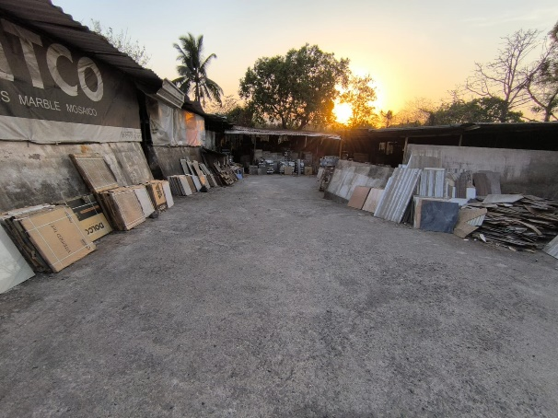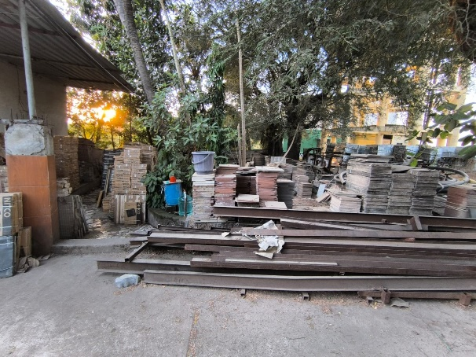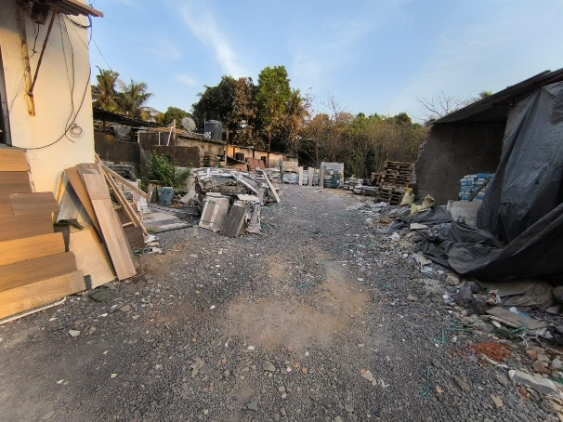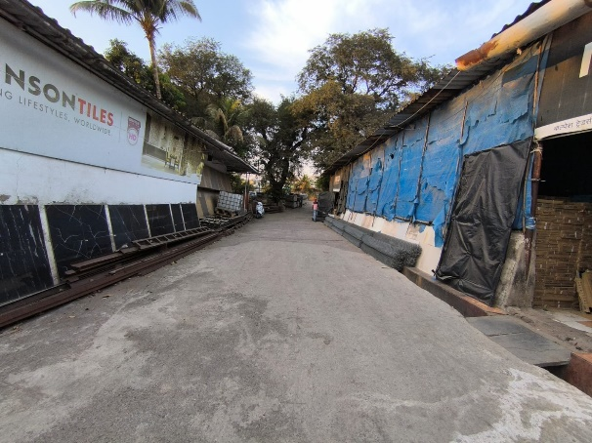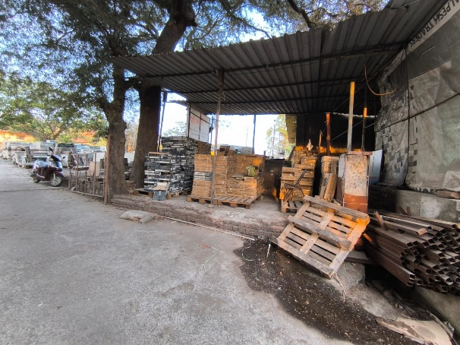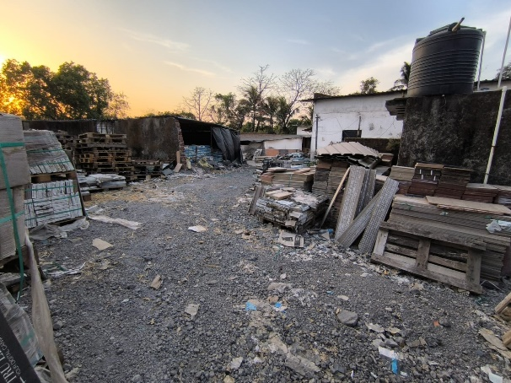

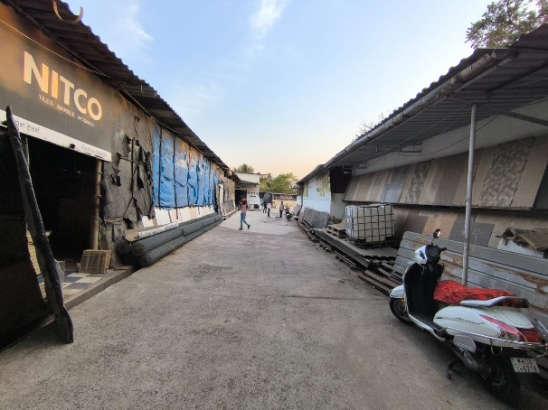

**Actual site photographs**

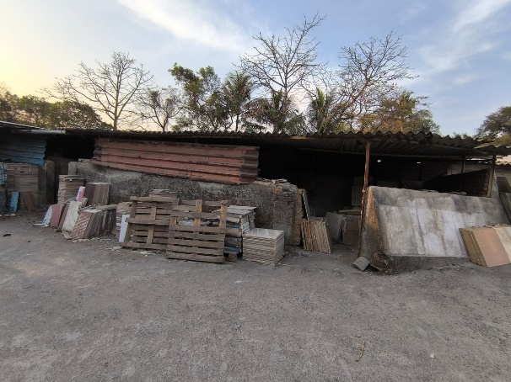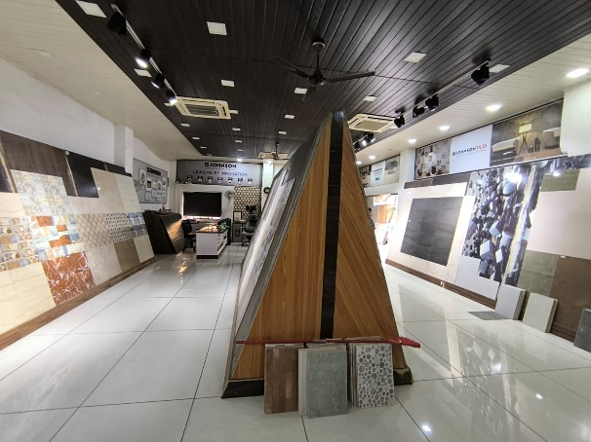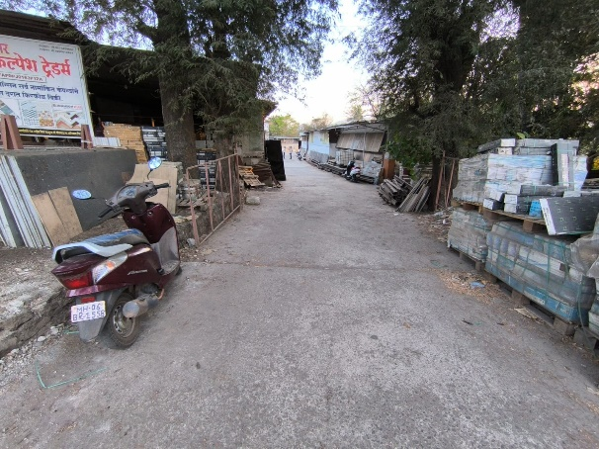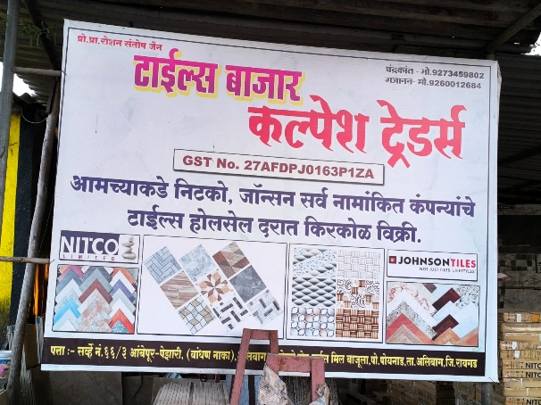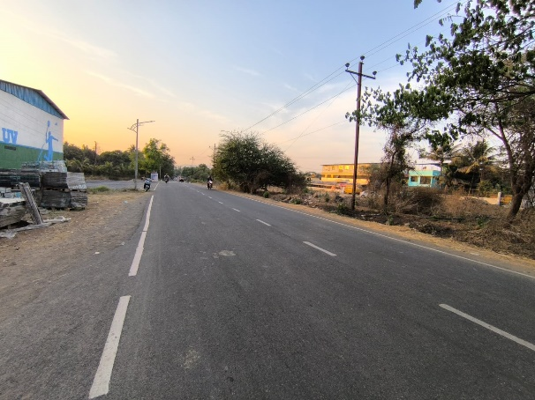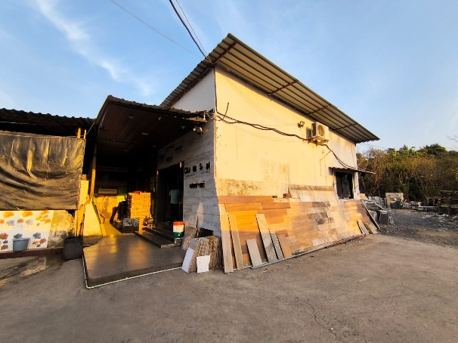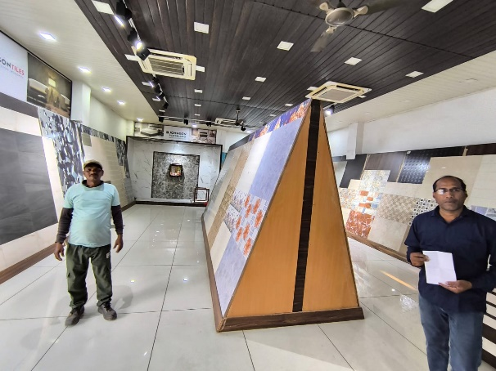

**Actual site photographs**

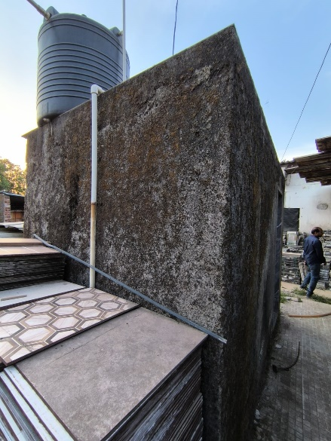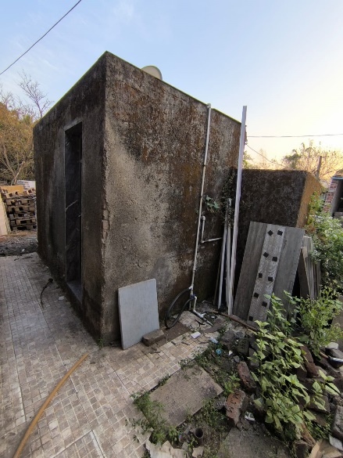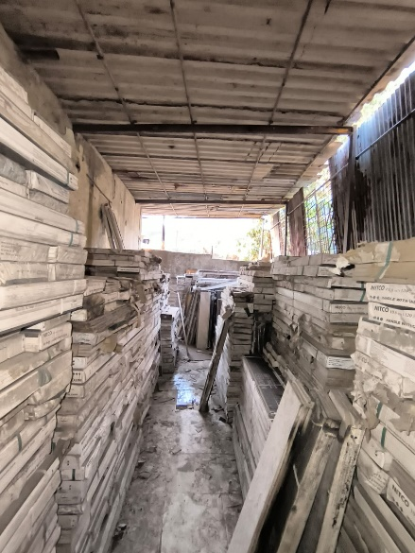

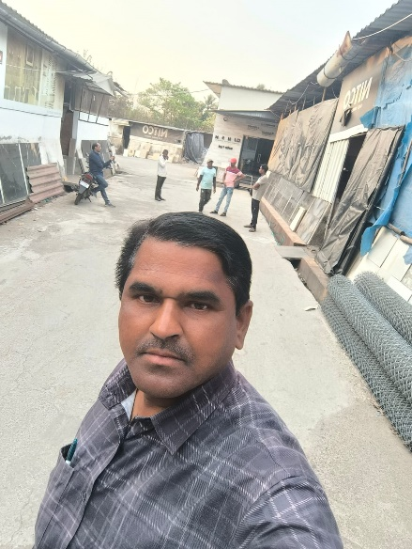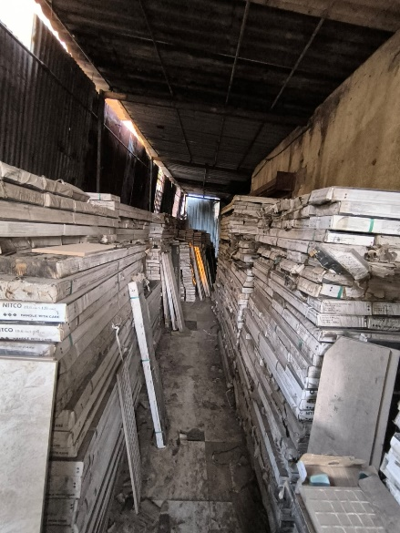

**Route Map of the property**

**Site u/r**

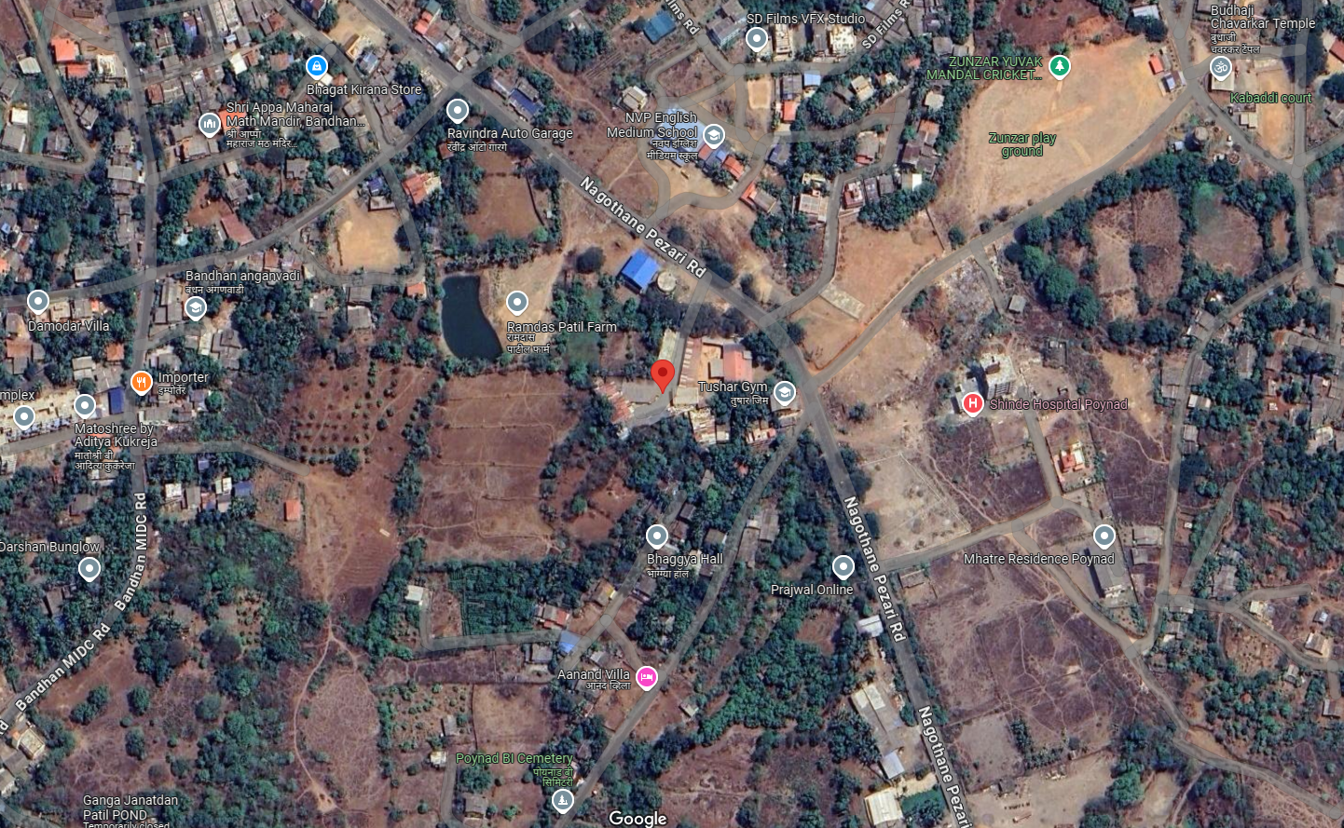

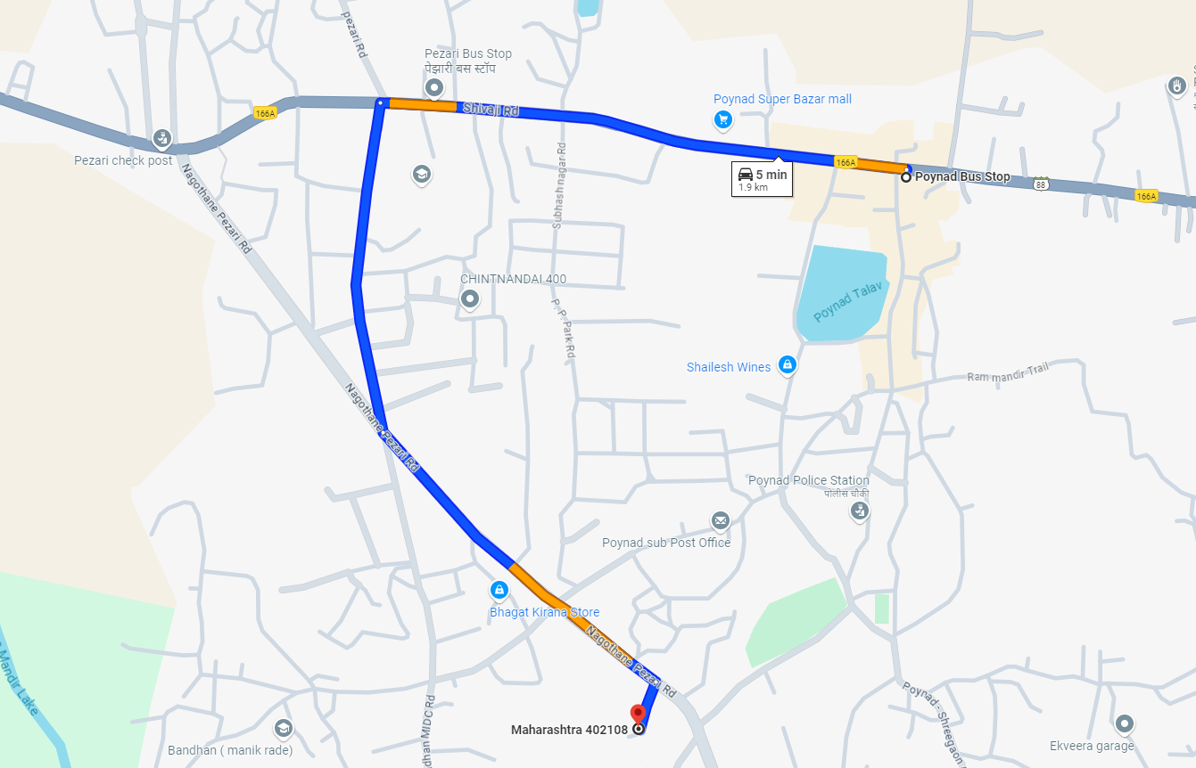

# Latitude Longitude - 18°40’47.2”N 72°59’21.1”E

# Note: The Blue line shows the route to site from nearest Bus Stop (Poinad – 1.9 KM.)

**Ready Reckoner Rate**

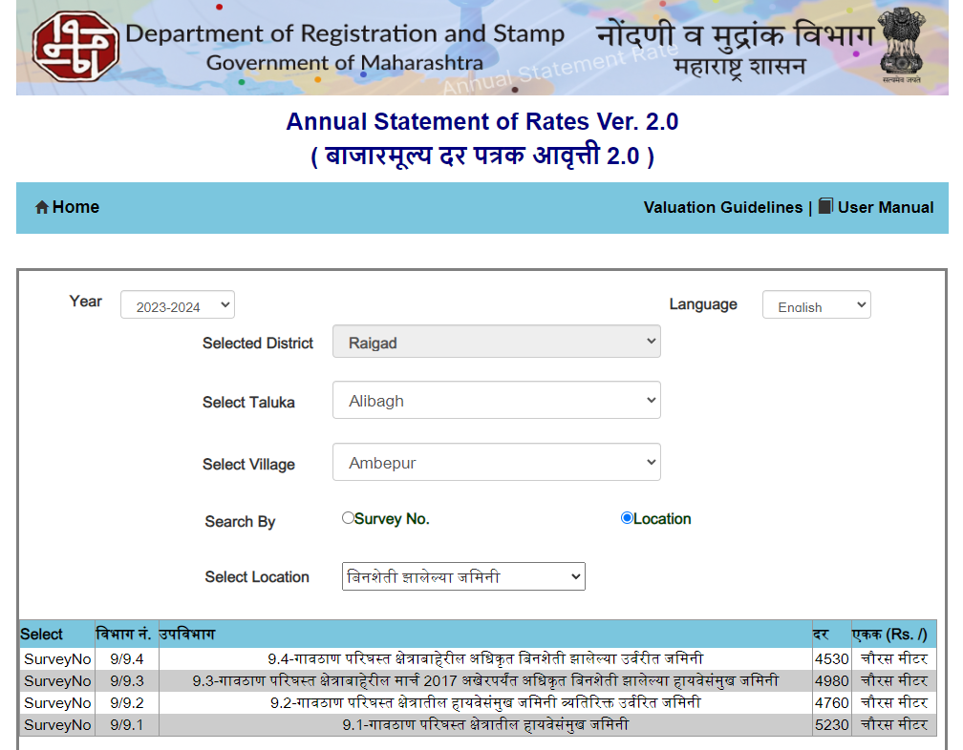

**Sale Instance**

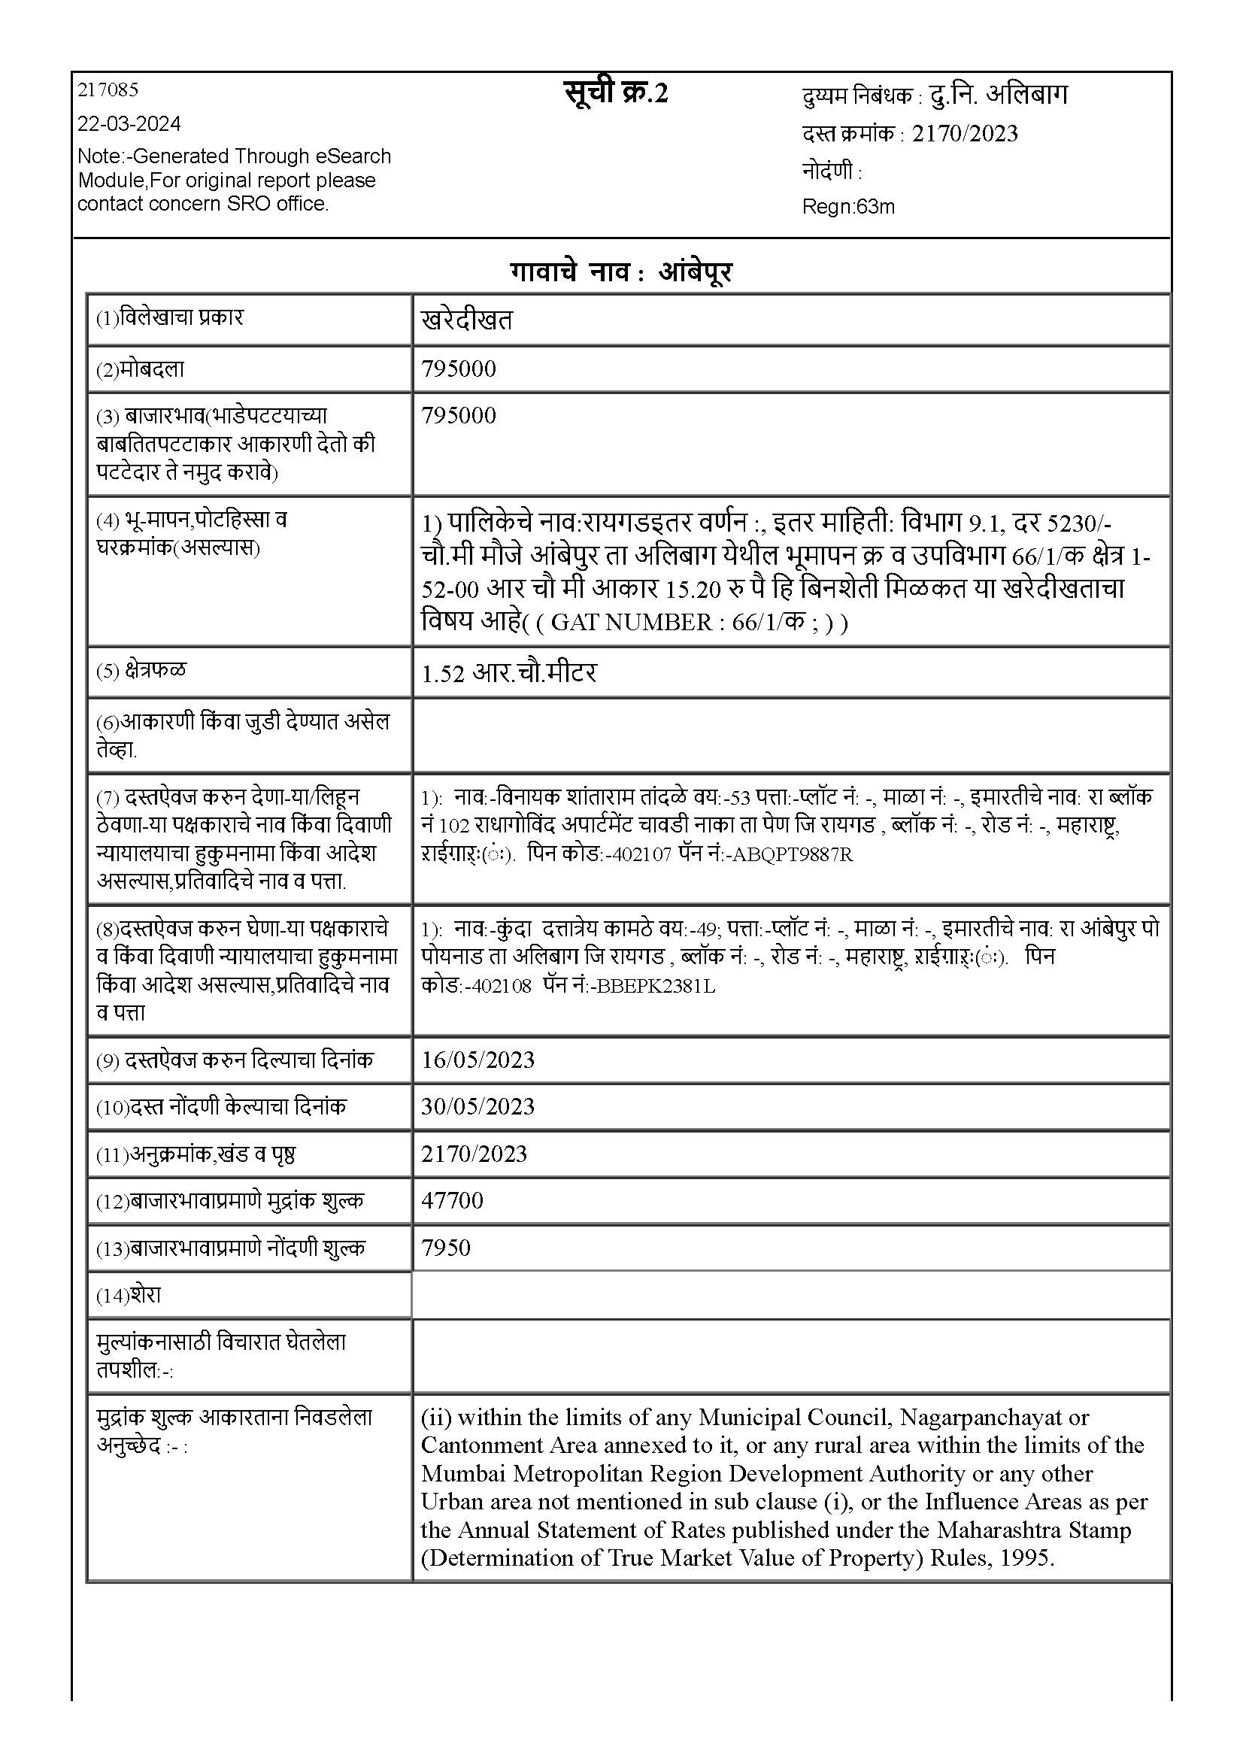

**Price Indicators**

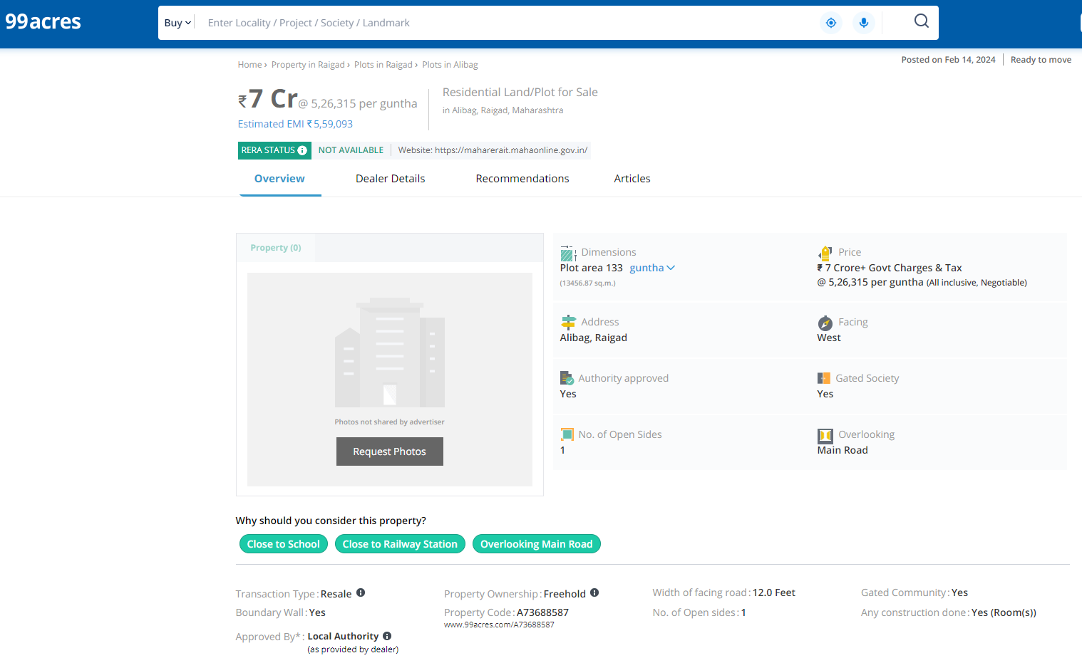

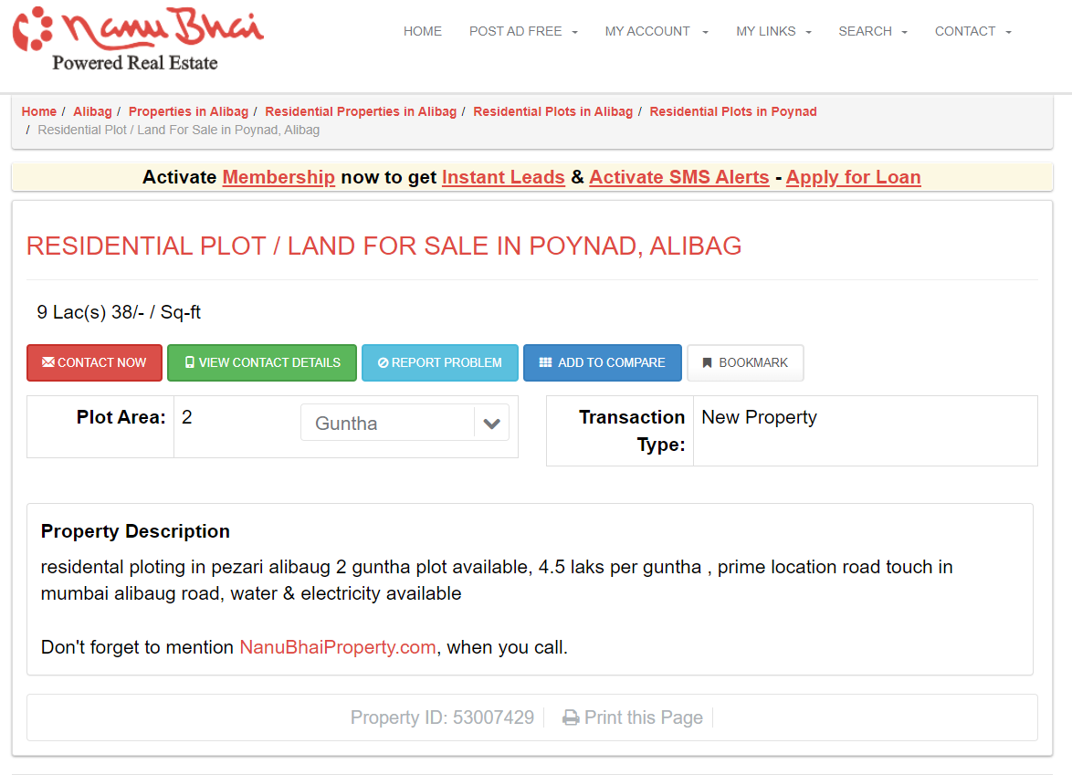

**DEFINITION OF VALUE FOR THIS SPECIFIC PURPOSE**

This exercise is to assess **Fair Market Value** of the property under reference as on **22nd March 2024.**

The term **Fair Market Value** is defined as

*“The most probable price, as of a specified date, in cash, terms equivalent to cash, or in other precisely revealed terms for which the specified property rights would sell after reasonable exposure in a competitive market under all conditions requisite to a fair sale, with the buyer and seller each acting prudently knowledgeably and for self-interest assuming that neither is under undue duress”.*

Fundamental assumptions and conditions presumed in this definition are:

1. Buyer and seller are motivated by self-interest.

2. Buyer and seller are well informed and are acting prudently.

3. The property is exposed for a reasonable time on the open market.

4. Payment is made in cash or equivalent or in specified financing terms.

#### UNDER LYING ASSUMPTIONS

1. We assume no responsibility for matters of legal nature affecting the property appraised or the title thereto, nor do we render our opinion as to the title, which is assumed to be good and marketable.

2. The property is valued as though under responsible ownership.

3. It is assumed that the property is free of liens and encumbrances.

4. It is assumed that there are no hidden or unapparent conditions of the subsoil or structure that would render it more or less valuable. No responsibility is assumed for such conditions or for engineering that might be required to discover such factors.

5. There is no direct/ indirect interest in the property valued

6. The rates for valuation of the property are in accordance with the Govt. approved rates and prevailing market rates.

## Sharadkumar B. Chalikwar

Govt. Reg. Valuer

Chartered Engineer (India)

Reg. No. (N) CCIT/1-14/52/2008-09