Vastu/SBI/SME/03/2021/10844
Date: 20-03-2024

DRAFT CHARTERED ENGINEER’S CERTIFICATE FOR THE USEFUL LIFE

OF ASSETS

To,

The Branch Manager,
Aditya Birla Renewables Subsidiary Ltd.
Birla Aurora, 11th Floor
Dr. Annie Besant Road
Worli, Mumbai 400 030.

Sub: Useful Life of Assets

Dear Sir,

M/s. Aditya Birla Renewables Subsidiary Ltd. (“Company” or “ABRSL”) is a Public Limited Company incorporated on 08th May 2018 and domiciled in India having its registered office at A-4, Aditya Birla Centre, S K Ahire Marg, Worli, Mumbai-400 030, Maharashtra, India. Its Holding Company is Aditya Birla Renewables Ltd. with 74% shareholding and Hindalco Industries Ltd. is an associated of the Company with 26% shareholding.

Definition of Useful Life of Assets:-
Useful Life is either the period over which a depreciable asset is expected to be used by the enterprise or the number of production or similar units expected to be obtained from the use of the asset by the enterprise. 'Depreciable amount' of a depreciable asset is its historical cost or other amount substituted for historical cost in the financial statements less the estimated residual value.

The Useful life of Wind Turbine Generator, Solar Module and Fulsar Substation for Grid Connectivity is as under: -

1) Wind Turbine Generator: -
A new paper titled “Benchmarking Anticipated Wind Project Lifetimes: Results from a Survey of U.S. Wind Industry Professionals” was published by Ryan Wiser and Mark Bolinger of the Lawrence Berkeley National Laboratory. The authors said the paper is based on a survey of wind industry experts to clarify trends in the expected useful life of land-based wind power plants in the United States. It follows from a related survey earlier this year on wind-project operational expenditures.
The expected useful life of a project is the period of time in which expected costs and revenues are assessed to determine a project’s economic viability. A longer assumed life may enhance the expected long-term profitability of a project, assuming any resulting increase in O&M costs is kept within reasonable bounds. Moreover, longer depreciation terms reduce annual book depreciation from an accounting perspective, thereby boosting net income in the near term. From a planning and modeling perspective, longer lifetimes may enable a lower levelized cost of wind energy by recovering capital costs over additional years of electricity production.
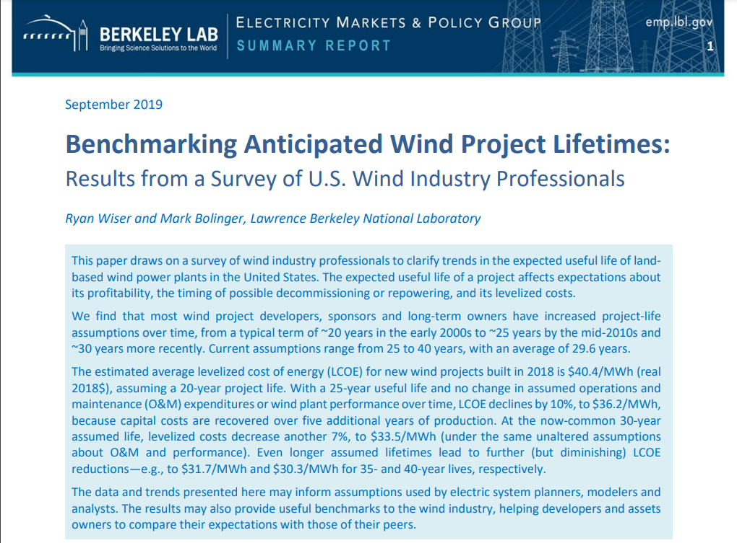Wiser and Bolinger said their interest was in better understanding how expectations for useful life have changed over time, as the wind industry has matured. They found that most wind project developers, sponsors and long-term owners have increased project-life assumptions, from a typical term of ~20 years in the early 2000s to ~25 years by the mid-2010s and ~30 years more recently. Current assumptions range from 25 to 40 years, with most respondents citing 30 years

2) Solar Module: -
As per Ryan Wiser, Mark Bolinger, and Joachim Seel, Lawrence Berkeley National Laboratory the Useful Life of Solar Module is as under:-
Solar project developers, sponsors, long-term owners, and consultants have increased project-life assumptions over time, from an average of ~21.5 years in 2007 to ~32.5 years in 2019. Current assumptions range from 25 years to more than 35 years depending on the organization; 17 out of 19 organizations surveyed or reviewed use 30 years or more.
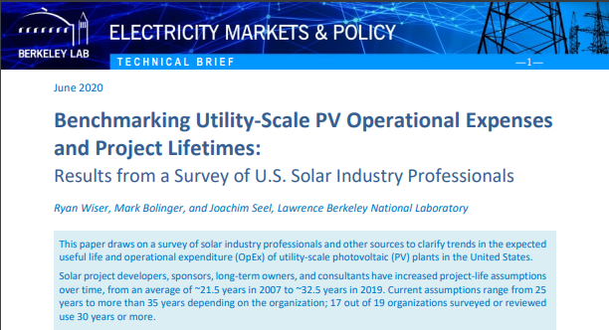

3) Fulsar Substation for Grid Connectivity: -
As Per notification from Central Electricity Regulatory Commission New Delhi vide Letter No. L-1/236/2018/CERC dated 07.03.2019, the useful life is as under:-
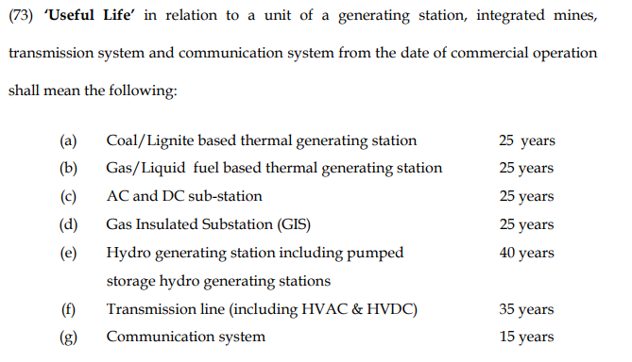

Based on CERC notification the useful life of Substation is 25 years.

SUMMARY: -
Based above mentioned research paper/Notification and our data base and experience we are at opinion that the useful Life as follows: -
S. No. | Description Of Asset | Total Useful Life (Yrs)
1 | Wind Turbine Generator | 30 Years
2 | Solar Module | 30 Years
3 | Fulsar Substation for Grid Connectivity | 25 Years

We have certified the Useful Life of Assets is fair and reasonable as per industrial trend and our database and knowledge.
We further declare that: --
1) In the preparation of the CE Certificate, we have relied on the information provided by the client.
2) The information furnished in this Certificate is true and correct to the best of our knowledge and belief.
3) We have no direct or indirect interest in the Unit.
Date:-20.03.2023
Place:- Mumbai

For Vastukala Consultants (I) Pvt. Ltd.

Umang Ashwin Patel
Regd. Valuer
Chartered Engineer (India)
Reg. No. IBBI/RV/04/2019/10803

