Vastu/SBI/SME/03/2021/10844
Date: 25-10-2023

CHARTERED ENGINEER’S CERTIFICATE

To,
The Manager,
Credit Saison India,
Revenue Village- Kondivita, 2nd Level,
33 CTS No. 195-A, Kalpatru Square, Andheri-Kurla Road,
Andheri East, Mumbai-400 059,
State - Maharashtra, Country - India.

Scope of work:
As per Request from Vaishak, Credit Saison India we have received the request through email for Verification of Components Received for High Precision Cold Rolling Machine with complete mechanical and electrical accessories, Model: TP-CRM-40.

Bases of Valuation:
As per request from client to ascertain Market Value & Transaction Cost.

Valuation Approaches:
As per IVS one or more valuation approach may be used in order to arrive at the value in accordance with the basis of value. Out of 3 approach i.e Market Approach, Income Approach & Cost Approach.
The Machine under Valuation is Specially design with higher accuracy and sophisticated PLC design which is not readily available in the Market, therefore the market Approach is not considered.
We have considered the Income Approach & Cost Approach for the Assignment.

Data Inputs:
We are in the receipt of following Documents:
- Copy of Invoice from Trades of Pacific.
- Copy of The Bronchus of High Precision Cold Rolling Machine
- Copy of Bills of Entry Summary.
- Copy of Packing List
- Quotation for Raw Material & Finished Pipe
- Copy of Detail of Cold Rolling Machine Model-TP-CRM-40
- Copy of Machinery Layout

Valuation Models:
- Income Approach:
ASSUMPTION:-
Particulars |  | FY25 | FY26 | FY27 | FY28 | FY29
Installed Capacity per shift |  | 2 | 2 | 2 | 2 | 2
No of Shift |  | 2 | 2 | 2 | 2 | 2
Total Production per day |  | 4 | 4 | 4 | 4 | 4
No of day in year |  | 300 | 300 | 300 | 300 | 300
Installed Capacity per Year |  | 1200 | 1200 | 1200 | 1200 | 1200
Capacity Utilisation |  | 65% | 65% | 65% | 65% | 65%
Utilised Capacity |  | 780 | 780 | 780 | 780 | 780
Product -1( 304)in % |  | 40% | 40% | 40% | 40% | 40%
Tube blank Price in Kg |  | 225 | 236 | 248 | 260 | 273
Finish Tube Price in Kg |  | 345 | 362 | 380 | 399 | 419
Expenses -
Material Cost % + |  | 225 | 236 | 248 | 260 | 273
Manufacturing Cost % | 5% | 11.25 | 11.8 | 12.4 | 13 | 13.65
Employee Cost % | 2% | 4.5 | 4.72 | 4.96 | 5.2 | 5.46
Other Cost % | 1% | 2.25 | 2.36 | 2.48 | 2.6 | 2.73
total Expenses |  | 243 | 254.88 | 267.84 | 280.8 | 294.84
Operating Profit |  | 102 | 107.12 | 112.16 | 118.2 | 124.16
OPM % |  | 30% | 30% | 30% | 30% | 30%
Product -2( 316)in % |  | 30% | 30% | 30% | 30% | 30%
Tube blank Price in Kg |  | 335 | 352 | 370 | 389 | 408
Finish Tube Price in Kg |  | 485 | 509 | 534 | 561 | 589
Sales +
Expenses -
Material Cost % + |  | 335 | 352 | 370 | 389 | 408
Manufacturing Cost % | 5% | 16.75 | 17.6 | 18.5 | 19.45 | 20.4
Employee Cost % | 2% | 6.7 | 7.04 | 7.4 | 7.78 | 8.16
Other Cost % | 1% | 3.35 | 3.52 | 3.7 | 3.89 | 4.08
total Expenses |  | 361.8 | 380.16 | 399.6 | 420.12 | 440.64
Operating Profit |  | 123.2 | 128.84 | 134.4 | 140.88 | 148.36
OPM % |  | 25% | 25% | 25% | 25% | 25%
Product -3( 310)in % |  | 30% | 30% | 30% | 30% | 30%
Tube blank Price in Kg |  | 700 | 735 | 772 | 811 | 852
Finish Tube Price in Kg |  | 950 | 998 | 1048 | 1100 | 1155
Sales +
Expenses -
Material Cost % + |  | 700 | 735 | 772 | 811 | 852
Manufacturing Cost % | 5% | 35 | 36.75 | 38.6 | 40.55 | 42.6
Employee Cost % | 2% | 14 | 14.7 | 15.44 | 16.22 | 17.04
Other Cost % | 1% | 7 | 7.35 | 7.72 | 8.11 | 8.52
total Expenses |  | 756 | 793.8 | 833.76 | 875.88 | 920.16
Operating Profit |  | 194 | 204.2 | 214.24 | 224.12 | 234.84
OPM % |  | 20% | 20% | 20% | 20% | 20%
Production
Product-1 |  | 312 | 312 | 312 | 312 | 312
Product-2 |  | 234 | 234 | 234 | 234 | 234
Product-3 |  | 234 | 234 | 234 | 234 | 234
Income +
Product-1 |  | 10,76,40,000 | 11,29,44,000 | 11,85,60,000 | 12,44,88,000 | 13,07,28,000
Product-2 |  | 11,34,90,000 | 11,91,06,000 | 12,49,56,000 | 13,12,74,000 | 13,78,26,000
Product-3 |  | 22,23,00,000 | 23,35,32,000 | 24,52,32,000 | 25,74,00,000 | 27,02,70,000
Total Income + |  | 44,34,30,000 | 46,55,82,000 | 48,87,48,000 | 51,31,62,000 | 53,88,24,000
Expenses
Product-1 |  | 7,58,16,000 | 7,95,22,560 | 8,35,66,080 | 8,76,09,600 | 9,19,90,080
Product-2 |  | 8,46,61,200 | 8,89,57,440 | 9,35,06,400 | 9,83,08,080 | 10,31,09,760
Product-3 |  | 17,69,04,000 | 18,57,49,200 | 19,50,99,840 | 20,49,55,920 | 21,53,17,440
Total Expenses |  | 33,73,81,200 | 35,42,29,200 | 37,21,72,320 | 39,08,73,600 | 41,04,17,280
Machine Cost |  | 35,27,50,000 | 35,27,50,000 | 35,27,50,000 | 35,27,50,000 | 35,27,50,000
Total Life |  | 20 | 20 | 20 | 20 | 20
Salvage |  | 5 | 5 | 5 | 5 | 5
Deprecation per year |  | 1,67,55,625 | 1,67,55,625 | 1,67,55,625 | 1,67,55,625 | 1,67,55,625
Loan As per Sheet
Interest Amount |  | 3,07,11,806 | 1,86,28,472 | 65,45,139
Loan Repayment (Principal + Interest) |  | 11,40,45,139 | 10,19,61,806 | 8,98,78,472

ASSUMPTION:-
Particulars |  | FY30 | FY31 | FY32 | FY33 | FY34
Installed Capacity per shift |  | 2 | 2 | 2 | 2 | 2
No of Shift |  | 2 | 2 | 2 | 2 | 2
Total Production per day |  | 4 | 4 | 4 | 4 | 4
No of day in year |  | 300 | 300 | 300 | 300 | 300
Installed Capacity per Year |  | 1200 | 1200 | 1200 | 1200 | 1200
Capacity Utilisation |  | 65% | 65% | 65% | 65% | 65%
Utilised Capacity |  | 780 | 780 | 780 | 780 | 780
Product -1( 304)in % |  | 40% | 40% | 40% | 40% | 40%
Tube blank Price in Kg |  | 287 | 301 | 316 | 332 | 349
Finish Tube Price in Kg |  | 440 | 462 | 485 | 509 | 534
Expenses -
Material Cost % + |  | 287 | 301 | 316 | 332 | 349
Manufacturing Cost % | 5% | 14.35 | 15.05 | 15.8 | 16.6 | 17.45
Employee Cost % | 2% | 5.74 | 6.02 | 6.32 | 6.64 | 6.98
Other Cost % | 1% | 2.87 | 3.01 | 3.16 | 3.32 | 3.49
total Expenses |  | 309.96 | 325.08 | 341.28 | 358.56 | 376.92
Operating Profit |  | 130.04 | 136.92 | 143.72 | 150.44 | 157.08
OPM % |  | 30% | 30% | 30% | 30% | 29%
Product -2( 316)in % |  | 30% | 30% | 30% | 30% | 30%
Tube blank Price in Kg |  | 428 | 449 | 471 | 495 | 520
Finish Tube Price in Kg |  | 618 | 649 | 681 | 715 | 751
Sales +
Expenses -
Material Cost % + |  | 428 | 449 | 471 | 495 | 520
Manufacturing Cost % | 5% | 21.4 | 22.45 | 23.55 | 24.75 | 26
Employee Cost % | 2% | 8.56 | 8.98 | 9.42 | 9.9 | 10.4
Other Cost % | 1% | 4.28 | 4.49 | 4.71 | 4.95 | 5.2
total Expenses |  | 462.24 | 484.92 | 508.68 | 534.6 | 561.6
Operating Profit |  | 155.76 | 164.08 | 172.32 | 180.4 | 189.4
OPM % |  | 25% | 25% | 25% | 25% | 25%
Product -3( 310)in % |  | 30% | 30% | 30% | 30% | 30%
Tube blank Price in Kg |  | 895 | 940 | 987 | 1036 | 1088
Finish Tube Price in Kg |  | 1213 | 1274 | 1338 | 1405 | 1475
Sales +
Expenses -
Material Cost % + |  | 895 | 940 | 987 | 1036 | 1088
Manufacturing Cost % | 5% | 44.75 | 47 | 49.35 | 51.8 | 54.4
Employee Cost % | 2% | 17.9 | 18.8 | 19.74 | 20.72 | 21.76
Other Cost % | 1% | 8.95 | 9.4 | 9.87 | 10.36 | 10.88
total Expenses |  | 966.6 | 1015.2 | 1065.96 | 1118.88 | 1175.04
Operating Profit |  | 246.4 | 258.8 | 272.04 | 286.12 | 299.96
OPM % |  | 20% | 20% | 20% | 20% | 20%
Production
Product-1 |  | 312 | 312 | 312 | 312 | 312
Product-2 |  | 234 | 234 | 234 | 234 | 234
Product-3 |  | 234 | 234 | 234 | 234 | 234
Income +
Product-1 |  | 13,72,80,000 | 14,41,44,000 | 15,13,20,000 | 15,88,08,000 | 16,66,08,000
Product-2 |  | 14,46,12,000 | 15,18,66,000 | 15,93,54,000 | 16,73,10,000 | 17,57,34,000
Product-3 |  | 28,38,42,000 | 29,81,16,000 | 31,30,92,000 | 32,87,70,000 | 34,51,50,000
Total Income + |  | 56,57,34,000 | 59,41,26,000 | 62,37,66,000 | 65,48,88,000 | 68,74,92,000
Expences
Product-1 |  | 9,67,07,520 | 10,14,24,960 | 10,64,79,360 | 11,18,70,720 | 11,75,99,040
Product-2 |  | 10,81,64,160 | 11,34,71,280 | 11,90,31,120 | 12,50,96,400 | 13,14,14,400
Product-3 |  | 22,61,84,400 | 23,75,56,800 | 24,94,34,640 | 26,18,17,920 | 27,49,59,360
Total Expenses |  | 43,10,56,080 | 45,24,53,040 | 47,49,45,120 | 49,87,85,040 | 52,39,72,800
Machine Cost |  | 35,27,50,000 | 35,27,50,000 | 35,27,50,000 | 35,27,50,000 | 35,27,50,000
Total Life |  | 20 | 20 | 20 | 20 | 20
Salvage |  | 5 | 5 | 5 | 5 | 5
Deprecation per year |  | 1,67,55,625 | 1,67,55,625 | 1,67,55,625 | 1,67,55,625 | 1,67,55,625

Cost of Debt | 14.5%
Cost of Equity | 10.5%
Tax | 30%
Machinery value | 35,27,50,000
Debt | 25,00,00,000
Equity | 10,27,50,000
WACC | 10.25%

VALUATION SUMMARY: -
 | FY25 | FY26 | FY27 | FY28 | FY29 | FY30 | FY31 | FY32 | FY33 | FY34
Sales + | 44.34 | 46.56 | 48.87 | 51.32 | 53.88 | 56.57 | 59.41 | 62.38 | 65.49 | 68.75
Expenses - | 33.74 | 35.42 | 37.22 | 39.09 | 41.04 | 43.11 | 45.25 | 47.49 | 49.88 | 52.4
Operating Profit | 10.6 | 11.14 | 11.65 | 12.23 | 12.84 | 13.46 | 14.16 | 14.89 | 15.61 | 16.35
OPM % | 24% | 24% | 24% | 24% | 24% | 24% | 24% | 24% | 24% | 24%
Interest | 3.07 | 1.86 | 0.65 | 0.00 | 0.00 | 0.00 | 0.00 | 0.00 | 0.00 | 0.00
Principle Repayment | 8.33 | 8.33 | 8.33 | 0.00 | 0.00 | 0.00 | 0.00 | 0.00 | 0.00 | 0.00
Depreciation | 1.68 | 1.68 | 1.68 | 1.68 | 1.68 | 1.68 | 1.68 | 1.68 | 1.68 | 1.68
Profit before tax | 5.85 | 7.60 | 9.32 | 10.55 | 11.16 | 11.78 | 12.48 | 13.21 | 13.93 | 14.67
Tax % | 30% | 30% | 30% | 30% | 30% | 30% | 30% | 30% | 30% | 30%
Tax | 1.75 | 2.28 | 2.79 | 3.17 | 3.35 | 3.53 | 3.74 | 3.96 | 4.18 | 4.40
Net Profit + | 4.09 | 5.32 | 6.52 | 7.39 | 7.81 | 8.25 | 8.74 | 9.25 | 9.75 | 10.27
Cash Inflow | 8.85 | 8.86 | 8.86 | 9.07 | 9.49 | 9.93 | 10.42 | 10.93 | 11.43 | 11.95
Cash Outflow | 11.40 | 10.19 | 8.98 | 0.00 | 0.00 | 0.00 | 0.00 | 0.00 | 0.00 | 0.00
Net Cash | -2.56 | -1.33 | -0.13 | 9.07 | 9.49 | 9.93 | 10.42 | 10.93 | 11.43 | 11.95
PV | -2.32 | -1.10 | -0.10 | 6.14 | 5.83 | 5.53 | 5.26 | 5.01 | 4.75 | 4.50
Net Present Value | 33.50

Based on Income Approach Net Present Value of High Precision Cold Rolling Machine with complete mechanical and electrical accessories, Model: TP-CRM-40 is Rs. 33.50 Crores.

- Cost Approach:
As per invoice provided the invoice cost is 42,50,000/- USD ( i.e. 32.28 Crores)

Documents & Reporting:

Dear Sir,
With reference to above subject, we have visited the Unit of M/s. Jay Jagdamba Limited located at Gut No. 92/3, 422, 423,424 Village Abitghar, Shirispada Shahapur Road Taluka-Wada, District- Palghar PIN Code- 421 303, State-Maharashtra, Country-India on 01.03.2024. During the time of our visit, we found that the machinery has arrived at site showing 31 nos. of Items and the numbered as 1/31 to 31/31 packed in 28 boxes as per packing List.
The machine will be installed in the existing shed and it will take about 45 to 60 working days for the complete installation & final trial run.
The Machine under Valuation is Specially design with higher accuracy and sophisticated PLC design which is not readily available in the Market, therefore the Valuation of the said machine is calculated by Income Approach & Cost Approach Only.
The Above value as per income is to be accompanied by the final installation certificate. We can issue final installation certificate after the verification of successful trail run by the Owner.
We have checked both approach cost Approach & Income Approach and based on the result the market value after the final installation of High Precision Cold Rolling Machine with complete mechanical and electrical accessories, Model: TP-CRM-40 is Rs. 33.50 Crores.
Market Value: 33.50 Crores.
Realised Value: 28.48 Crores
Distress Value: 25.12 Crores
Hence Certified.

This report is prepared for Credit Saison India, Mumbai.
We further declare that: --
In the preparation of the CE Certificate, we have relied on the information provided by the client.
The information furnished in this Certificate is true and correct to the best of our knowledge and belief.

We have no direct or indirect interest in the Unit.

For Vastukala Consultants (I) Pvt. Ltd.

Date: -19.03.2024
Place: - Mumbai

Umang Ashwin Patel
Regd. Valuer
Chartered Engineer (India)
Reg. No. IBBI/RV/04/2019/10803

Photographs: -
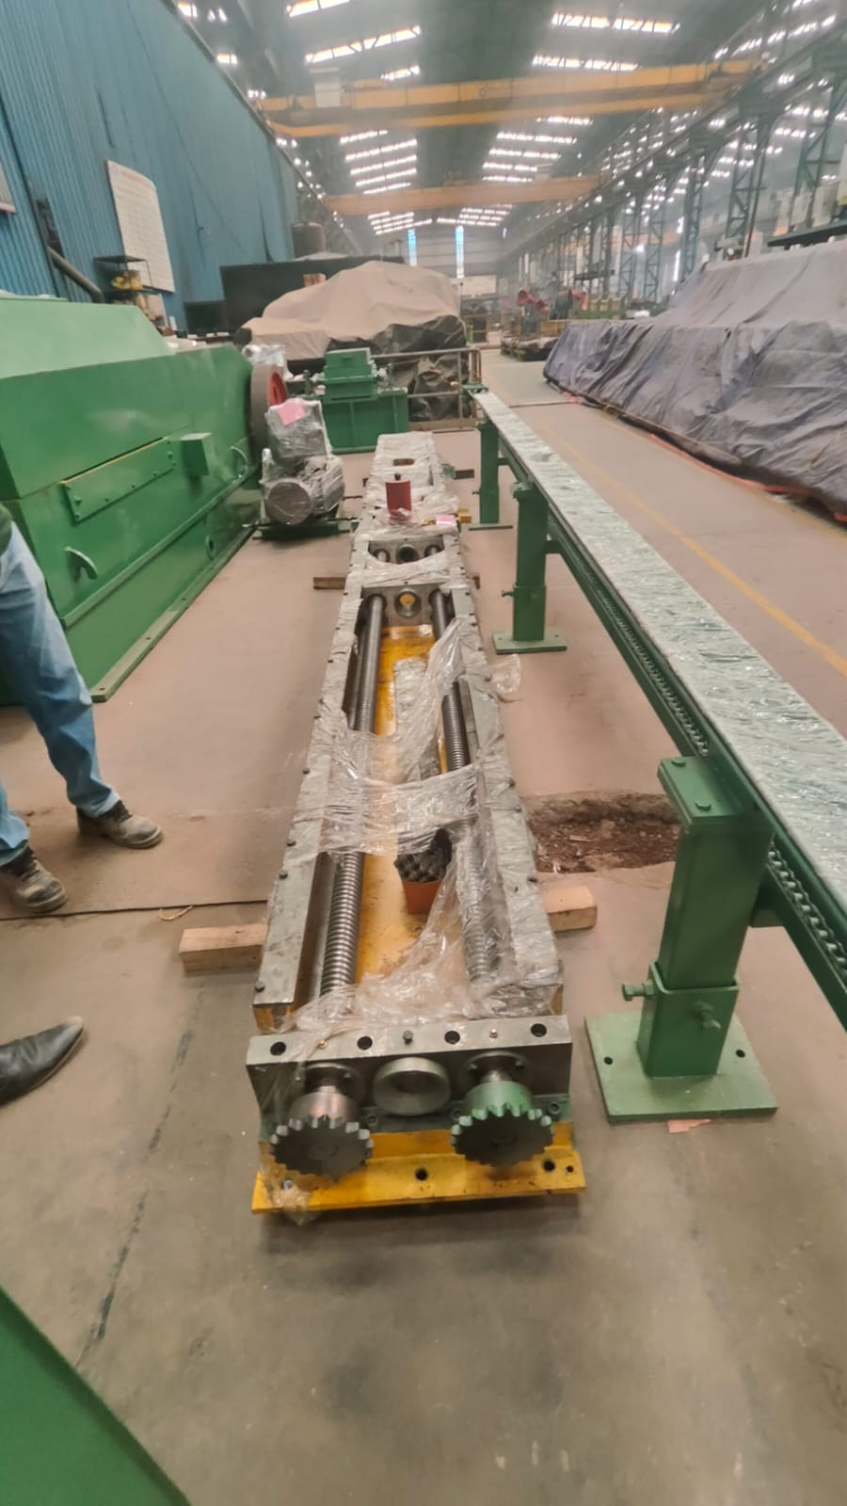 | 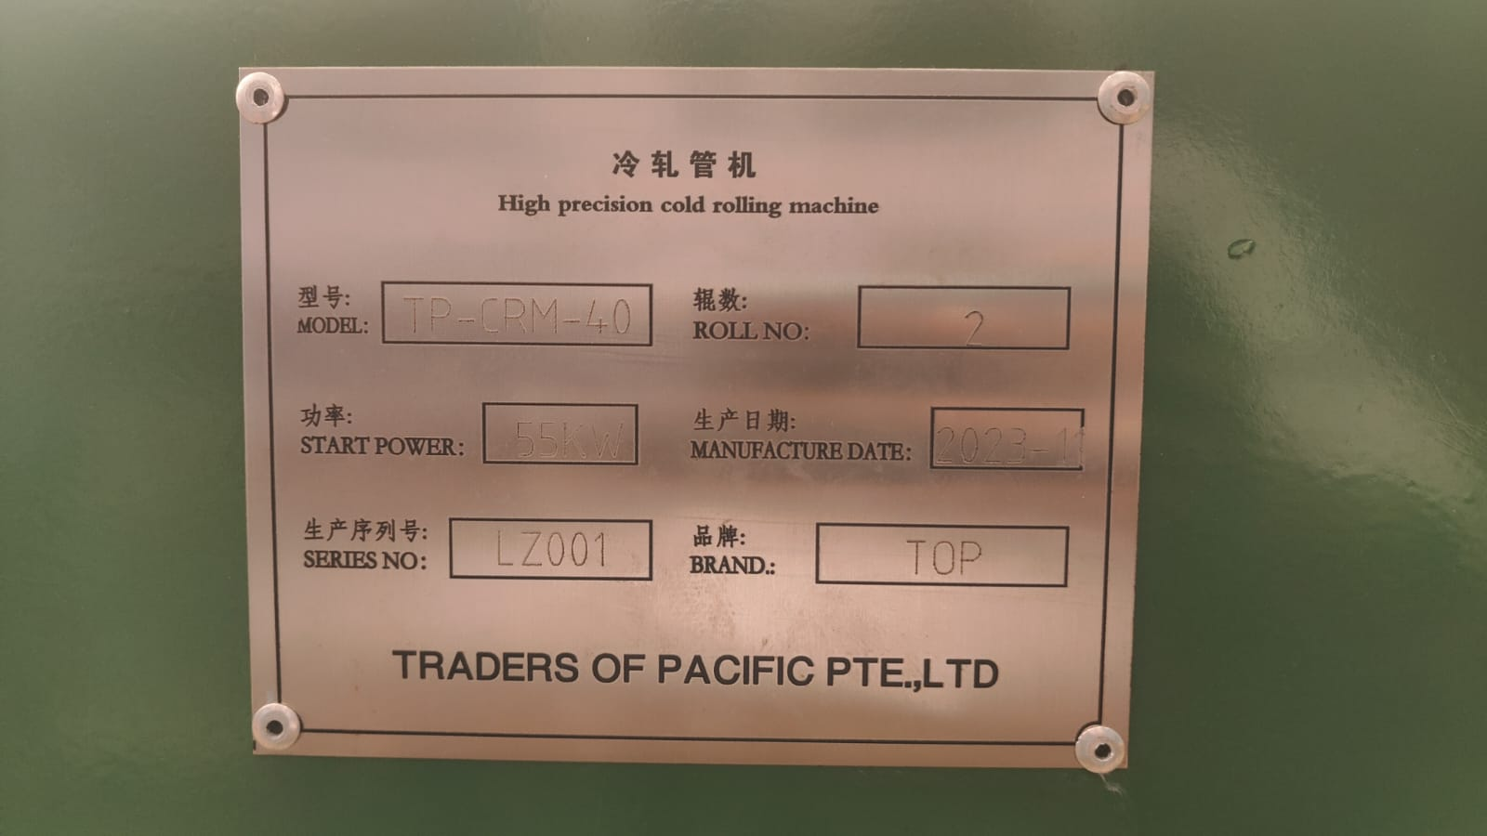 | 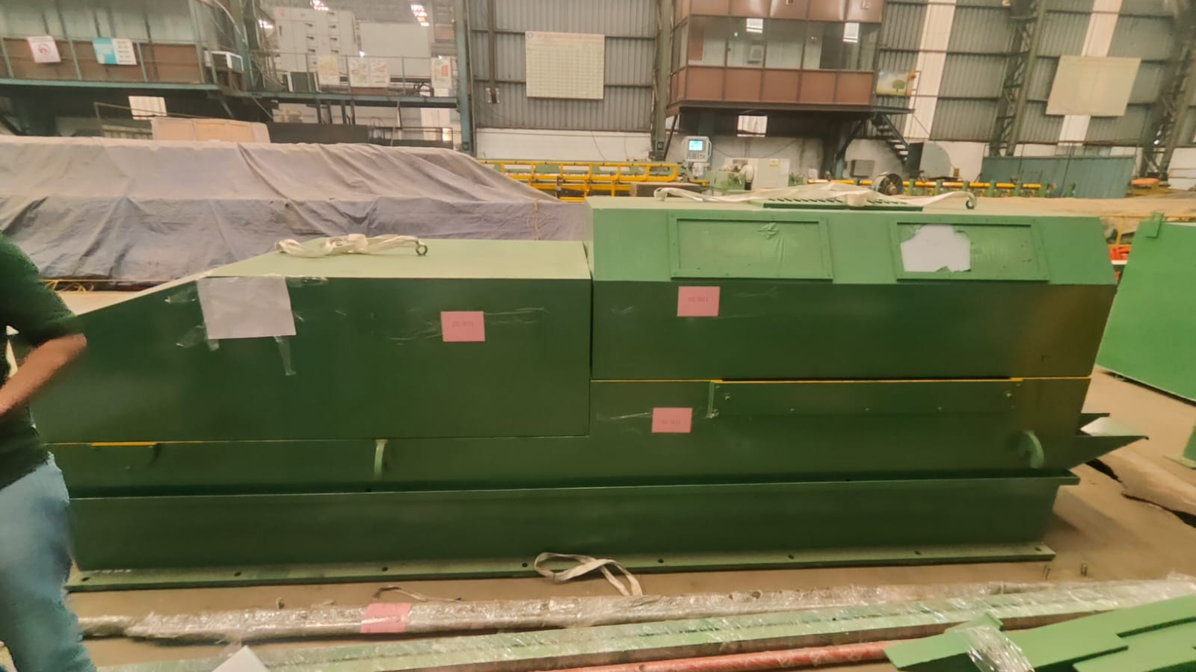
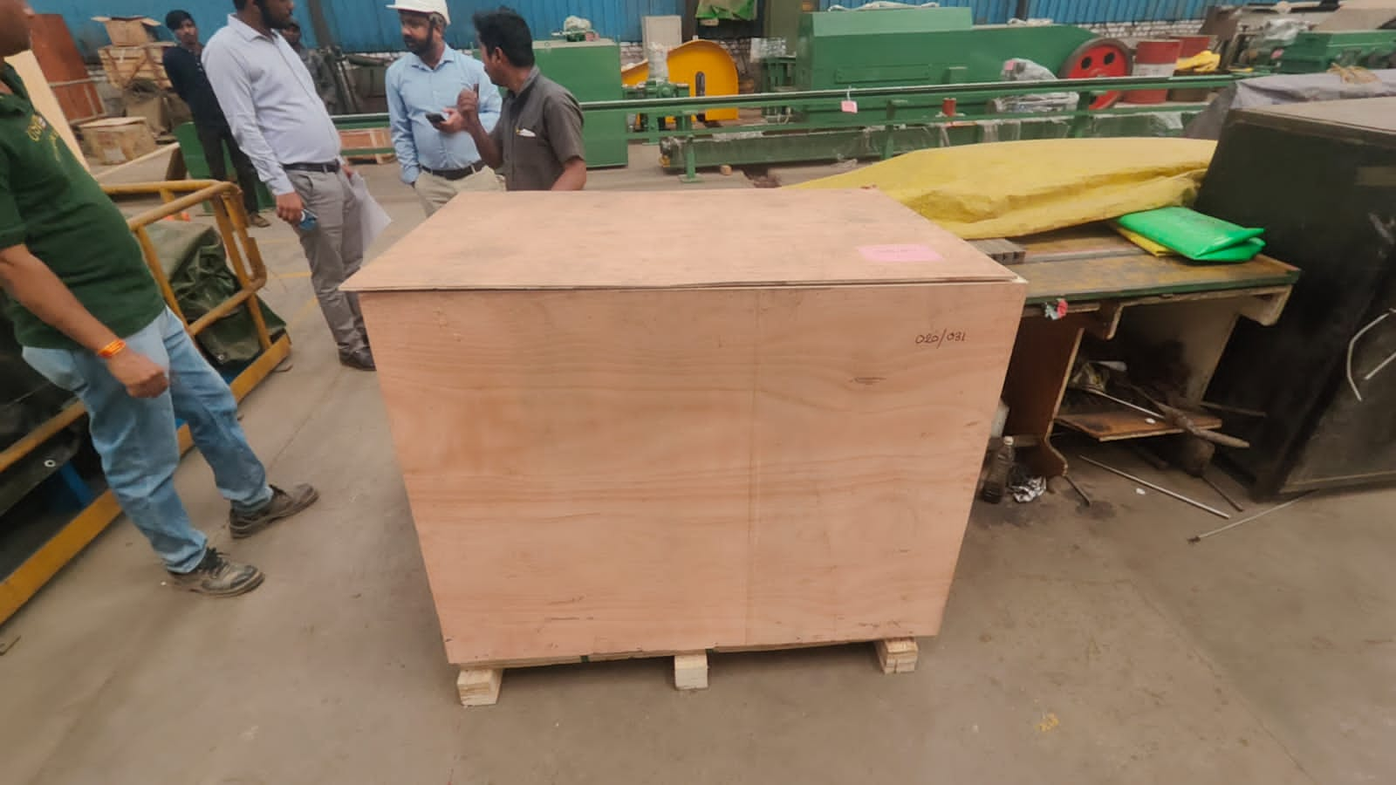 | 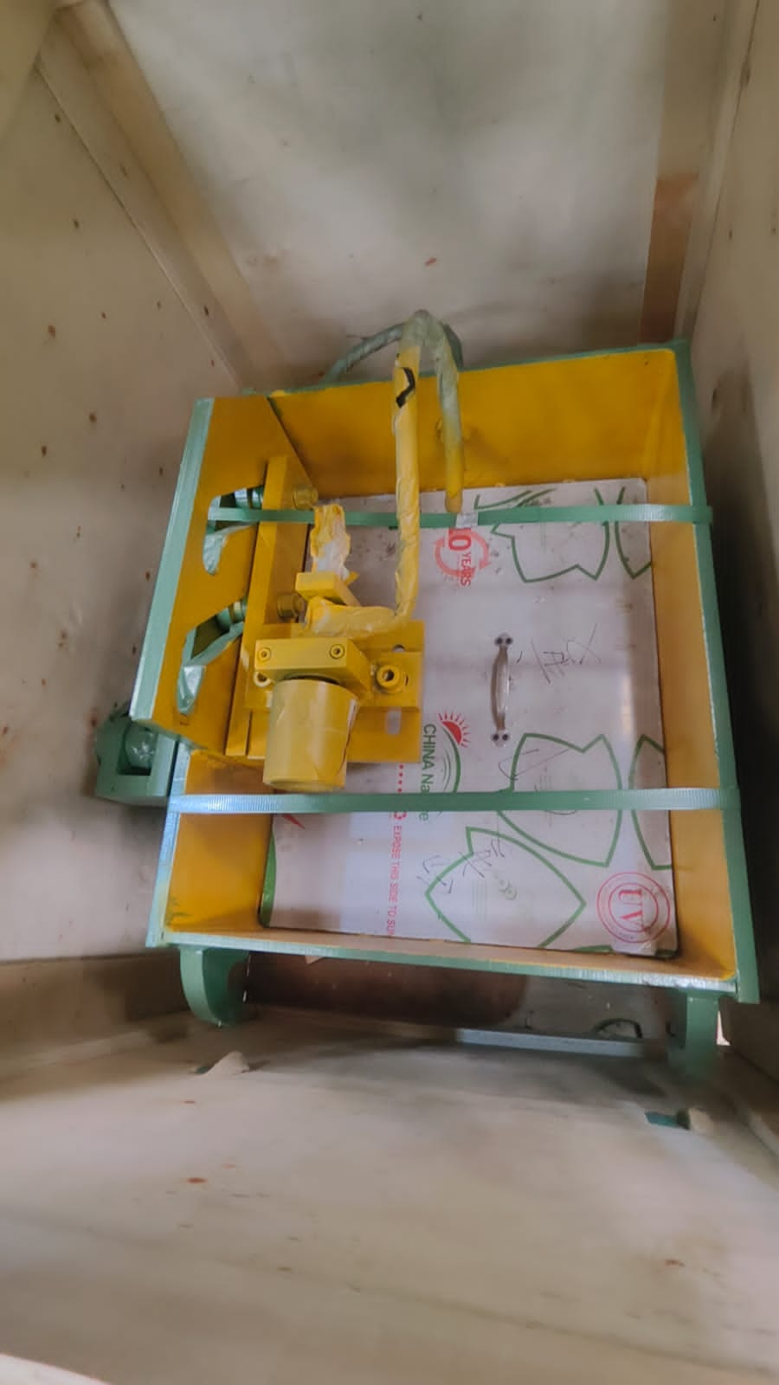 | 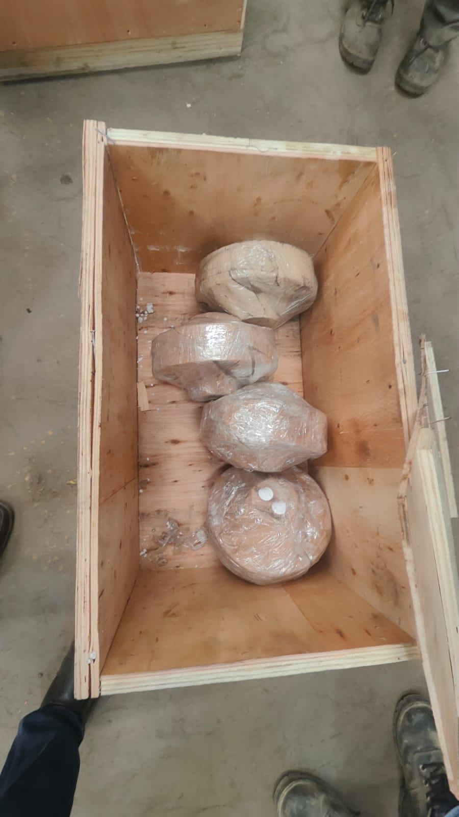
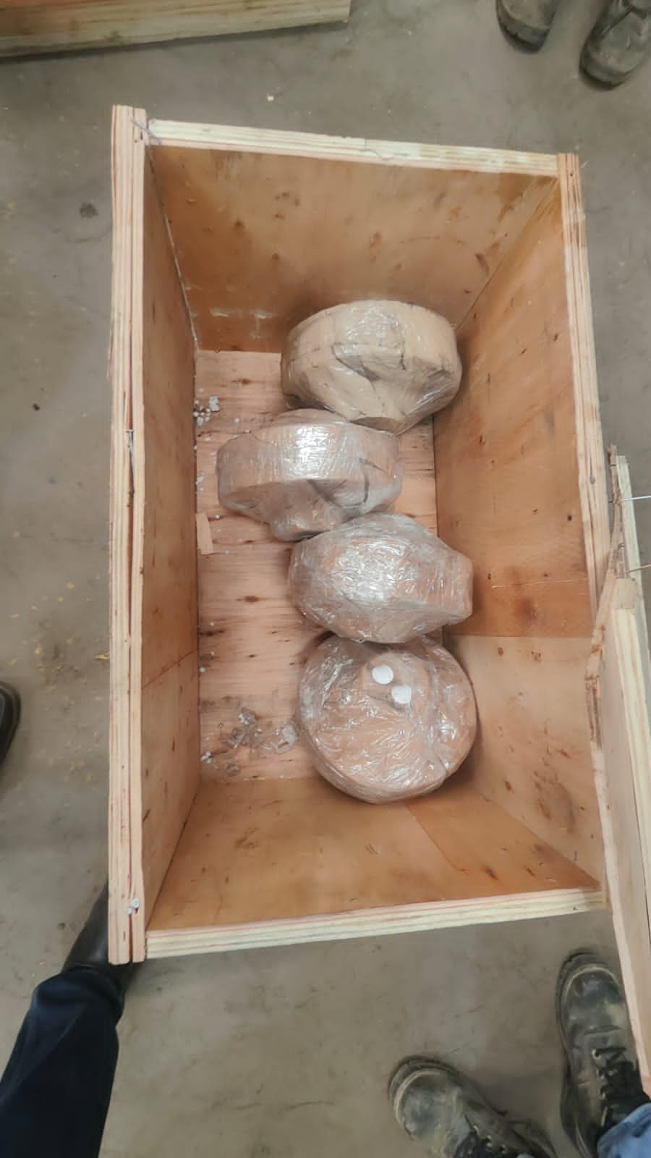 | 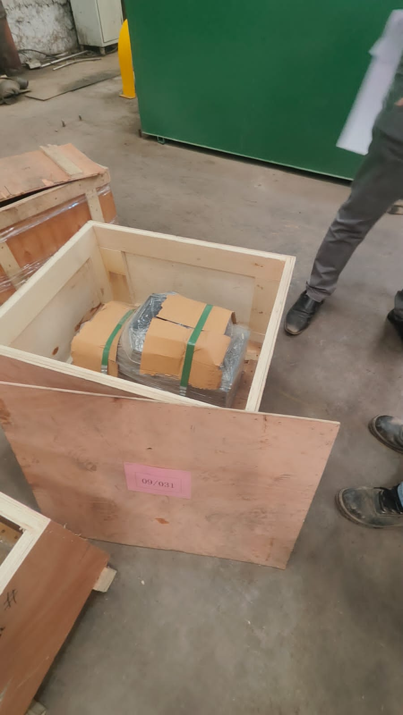 | 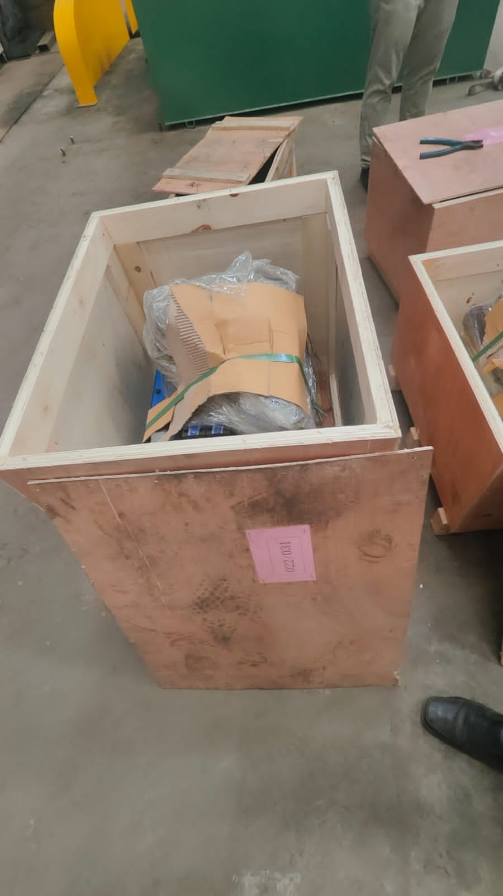

Photographs: -
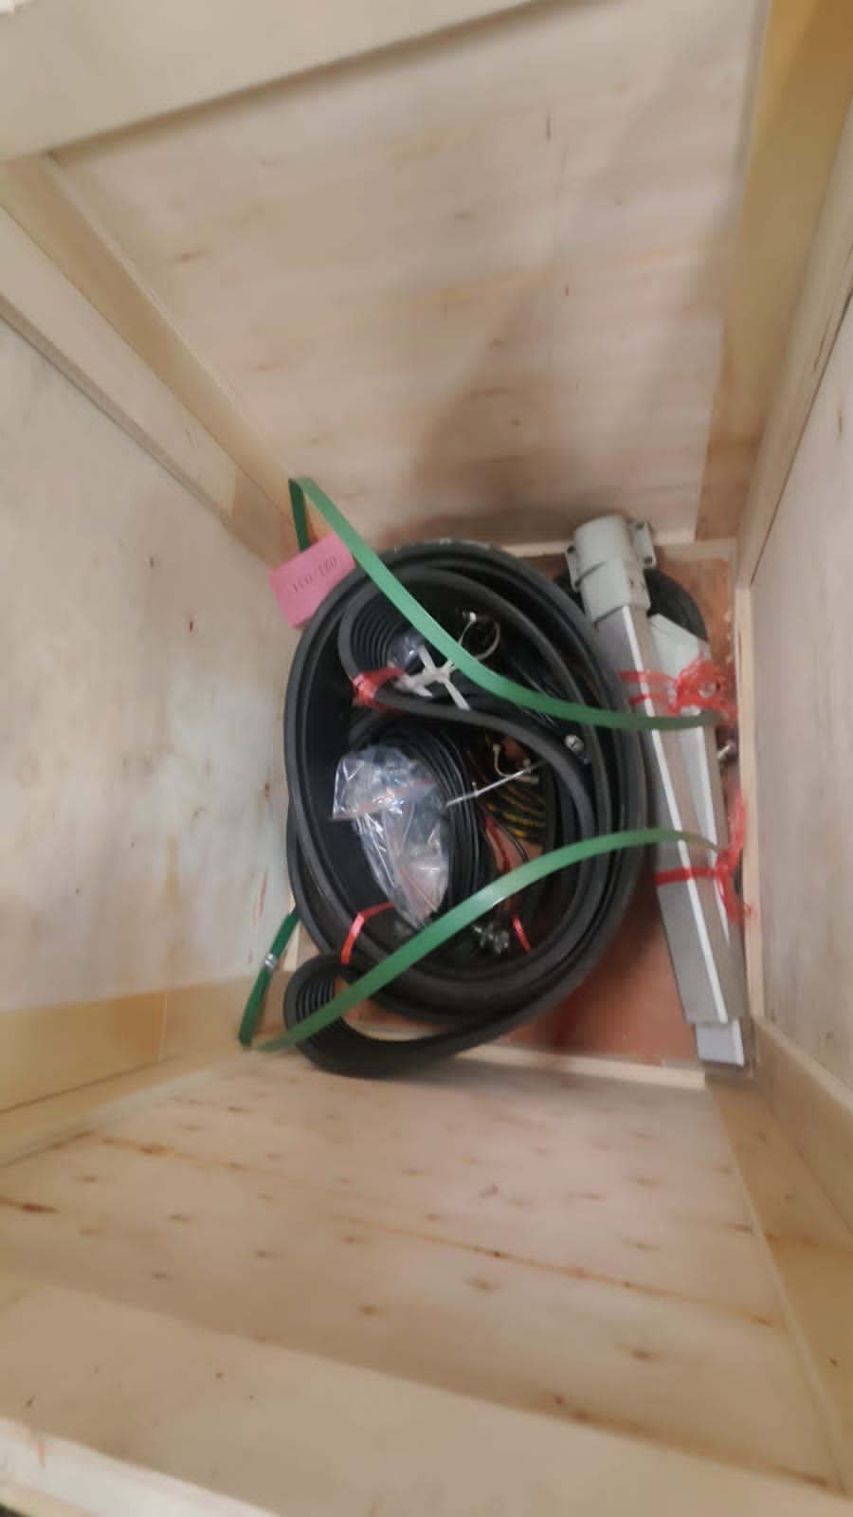 | 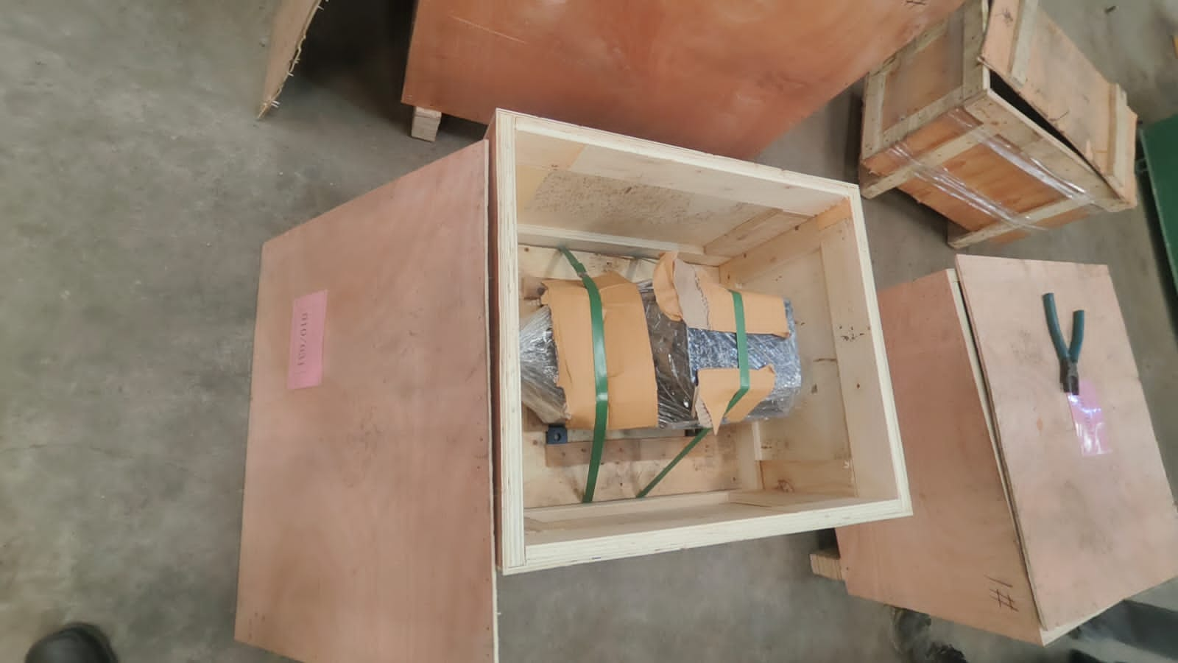 | 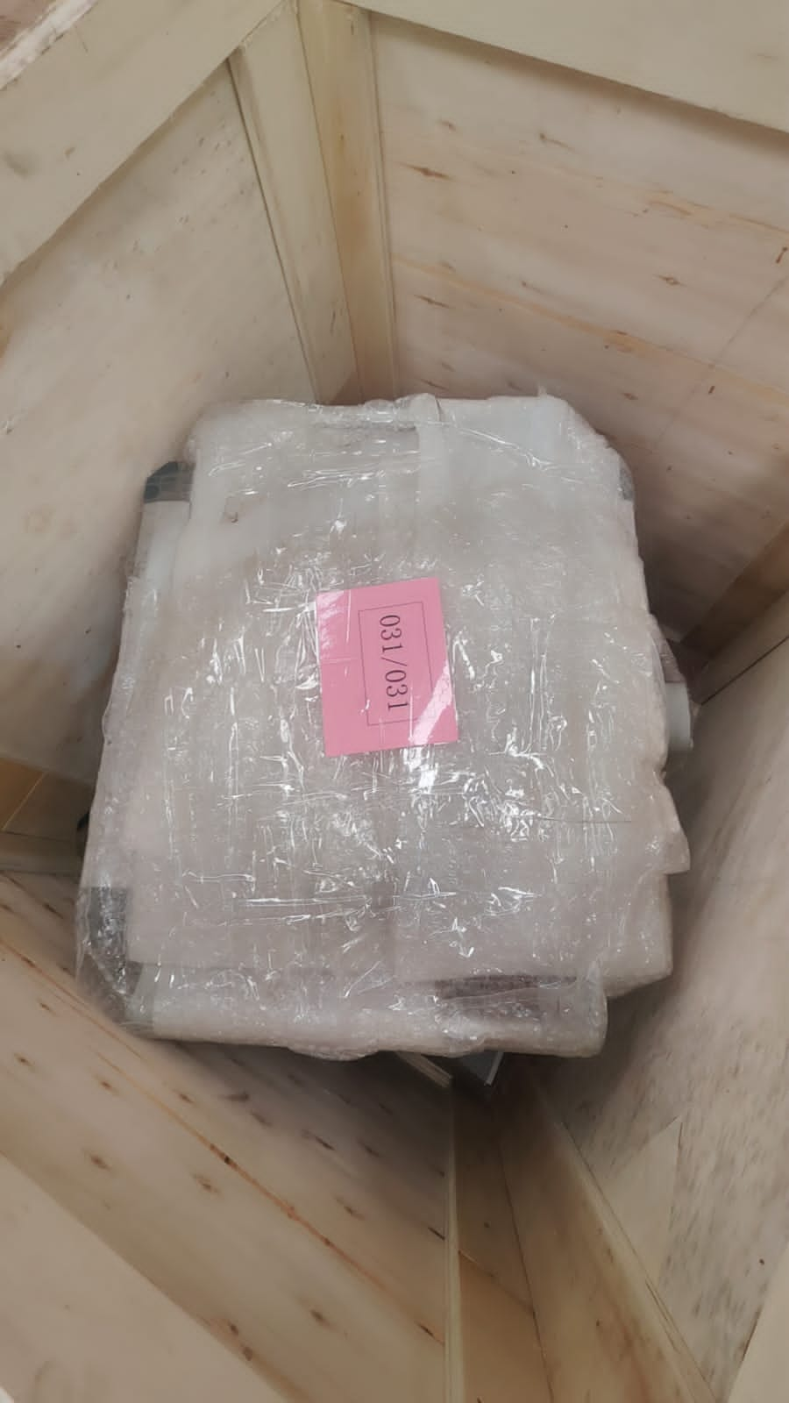
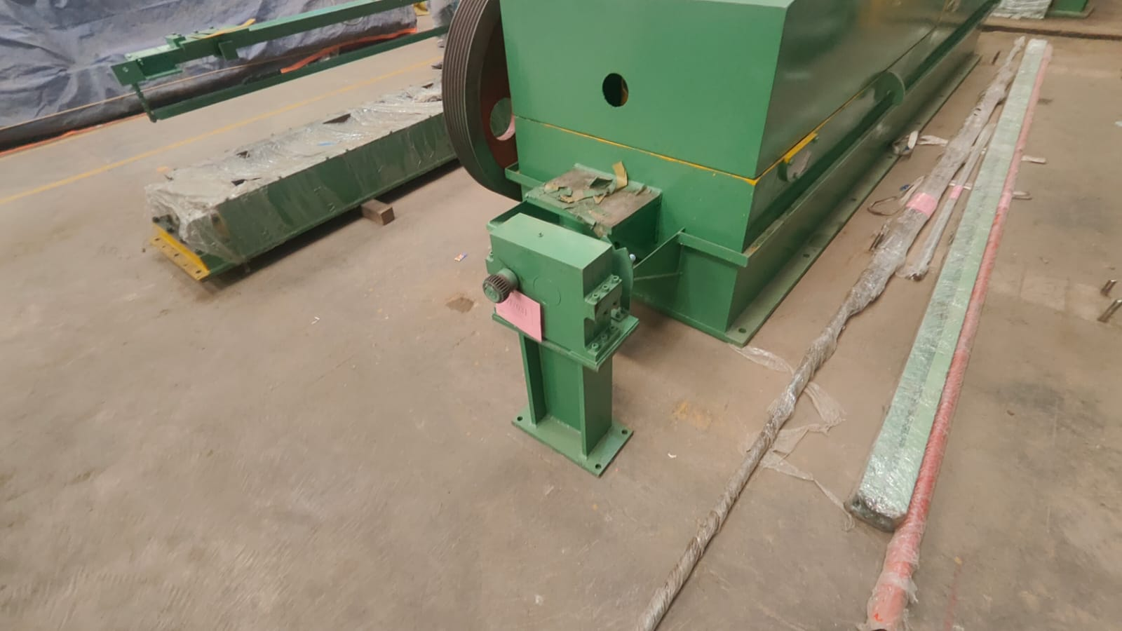 | 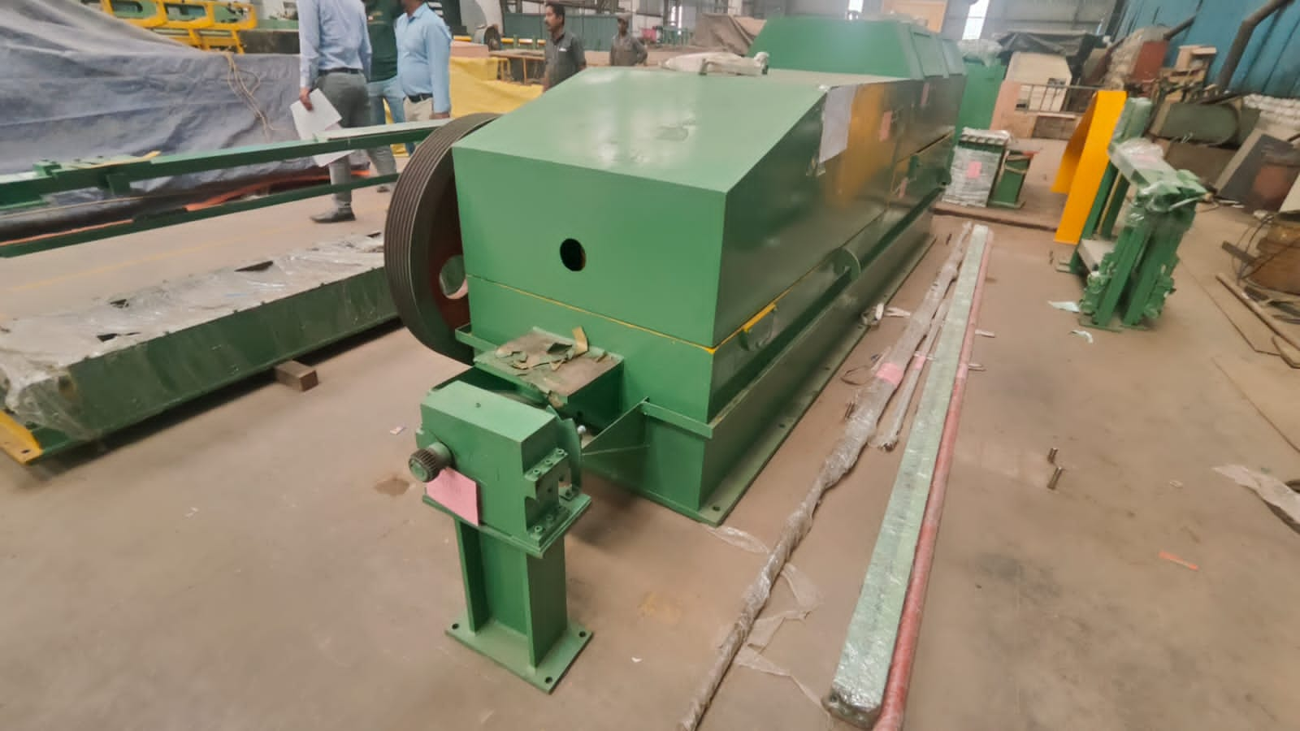 | 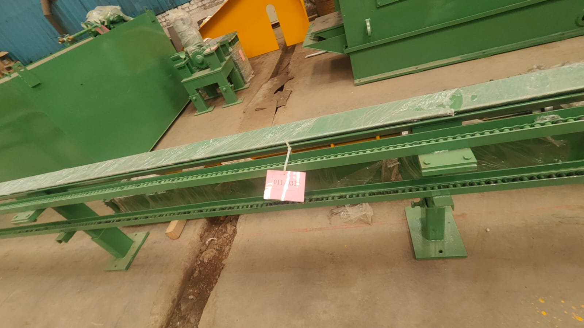
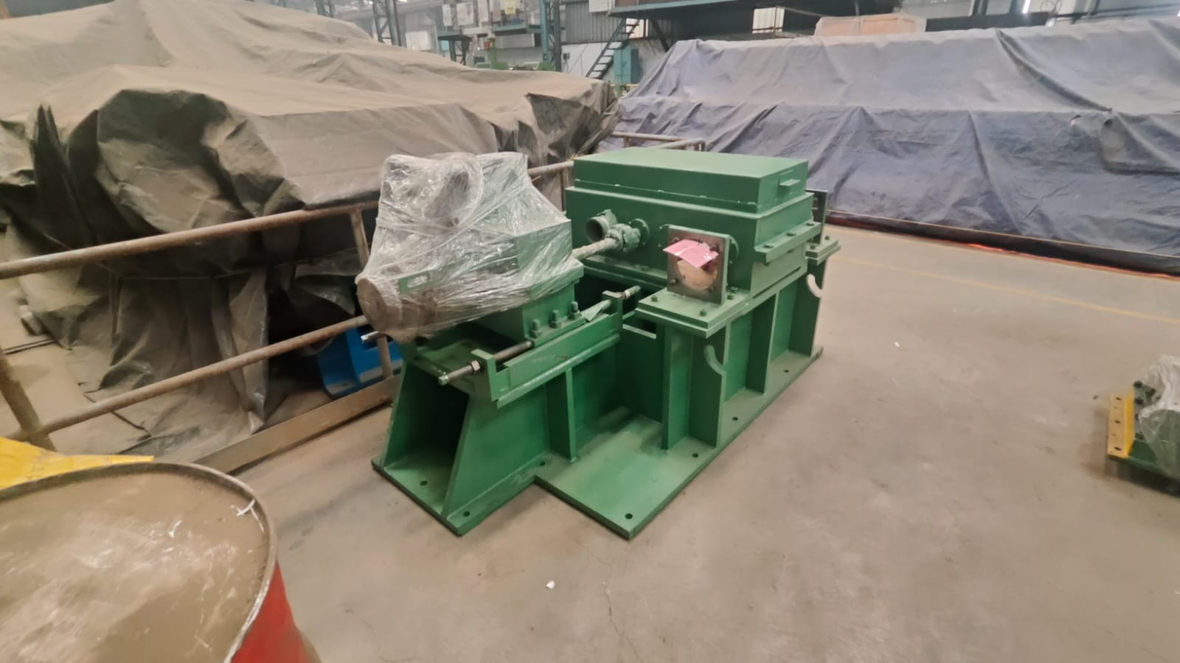 | 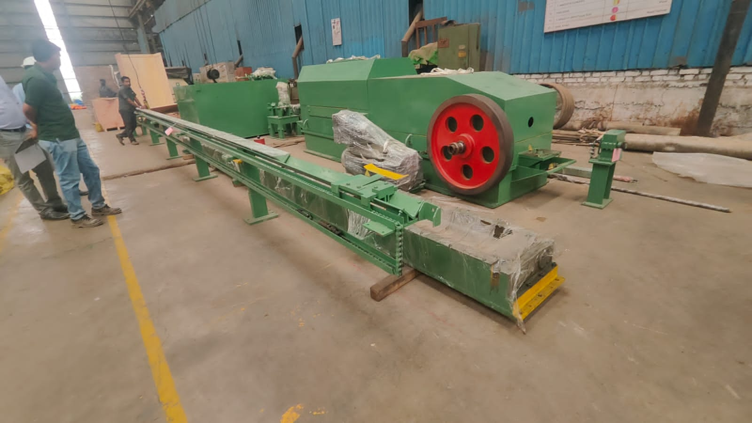 | 