Vastu/Nashik/03/2024/007835/2305643
20/9-391-RPBS
Date: 20.03.2024

To, `
The Branch Manager,
State Bank of India
Shinde Palse (Shinde Br 61457)
Nivrutti Complex, Gat No. 82, Nashik Pune Road,
At Post Shinde Taluka and Dist. Nashik'
Pin 422102, State - Maharashtra, Country - lndia.

Sub: Vetting of Extra Amenities

Sir,

With reference to above subject, we have evaluated the Extra Amenities for Residential Flat No. 27, 7th Floor, “Pushpak Paradise”, Survey No. 212/ 2, Plot No. 10+11, Near Sai Mandir, Kalananagar, Vaiduwadi, Village - Mhasrul, Taluka & District – Nashik, PIN – 422 004, State – Maharashtra, Country – India belongs to M/s. Krishna Developers Name of Proposed Purchaser: Mr. Anand Sambhaji Waghmare.

We have verified the rates quoted as per current market rates. Details of work and Extra Amenities considered as per copy of Extra Amenities issued by Mr. Anand Sambhaji Waghmare (First Party) and Ashish Vinod Purwar (Second Party) received on dated 19.03.2024. The Extra Amenities amount is Rs.9,00,000/- (Rupees Nine Lakh Only.)

The said Cost Vetting Certificate is valid upto next 6 months Only.

Thanking you

Sincerely yours

Manoj B. Chalikwar
Registered Valuer
Chartered Engineer (India)
Reg. No. CAT-I-F-1763
Reg. No. IBBI/RV/07/2018/10366
BOB Empanelment No.: ZO:MZ:ADV:46:941
Encl: Valuation report.

Agreement for Extra Amenities
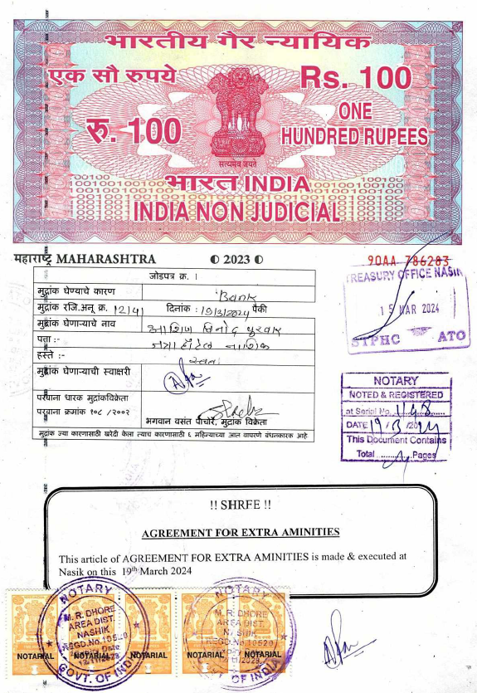
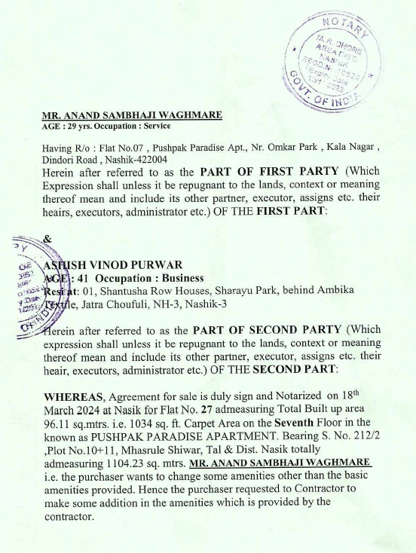

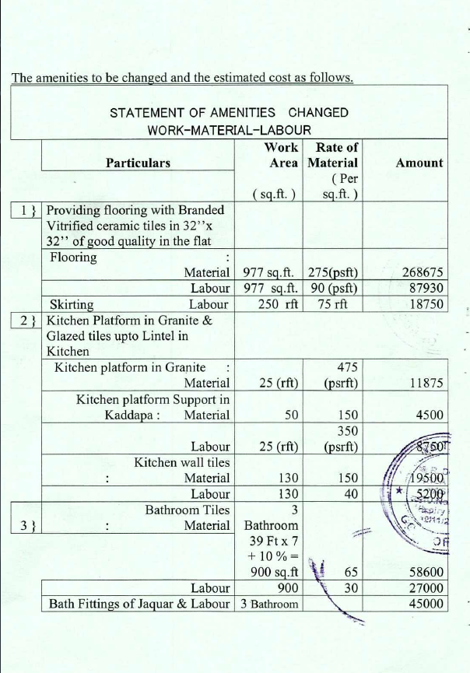
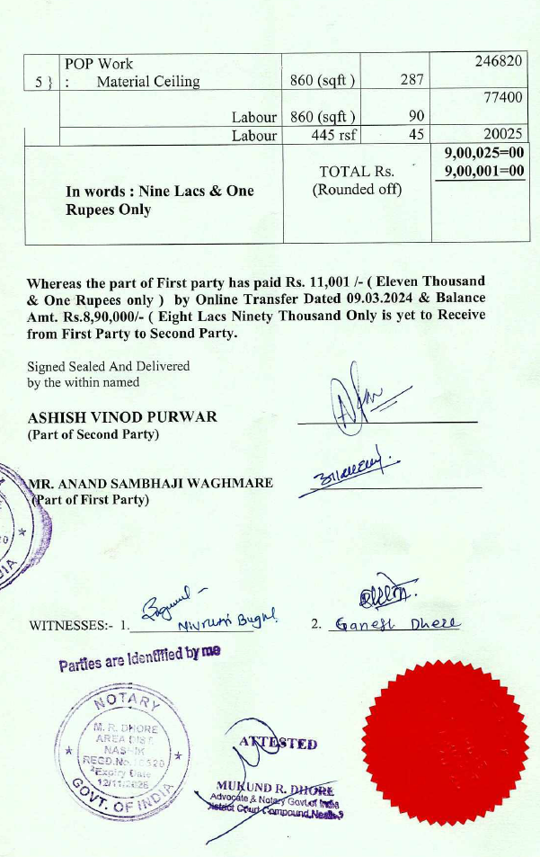

The Extra Amenities amount is Rs.9,00,000/- (Rupees Nine Lakh Only)

