Vastu/Nashik/06/32014/2301224
22/20-325-RYBS
Date: 18.03.2024

To,
The Branch Manager,
Bank of Baroda
Regional Office
BSNL Building, Datta Mandir Road, Nashik Road,
Nashik, PIN – 422 101, State - Maharashtra, Country - India.

Sub: Vetting of Extra Work

Sir,

With reference to above subject, we have evaluated the Extra Work For Residential Row House On Plot No. 37+38/ 3, Ground + First floor, Survey No. 45/ 2/ 3/ 4/ 1/ 1, Behind APMC Market Yard, Samarth Nagar, Vibgyor School Road, Village – Makhmalabad, Taluka – Nashik, District - Nashik, PIN Code – 422 004, State – Maharashtra, Country – India belongs to Name of Proposed : Sau. Sonali Kunal Kale & Shri. Kunal Ulhas Kale. Name of Owner: Shri. Dyaneshwar Pandurang Kakad.

We have verified the rates quoted as per current market rates. Details of Extra Work considered as per copy of Cost Sheet Agreement between Mr. Hemant Madhukar Narkhede & Mrs. Archana Hemant Narkhede. (First Party). M/s. Mauli Builders. (Second Party) received on dated.16.03.2024. The Extra Work amount is Rs. 7,00,000/- (Rupees Seven Lakh Only)

The said Cost Vetting Certificate is valid upto next 6 months Only.

Thanking you

Sincerely yours

Manoj B. Chalikwar
Registered Valuer
Chartered Engineer (India)
Reg. No. CAT-I-F-1763
Reg. No. IBBI/RV/07/2018/10366
BOB Empanelment No.: ZO:MZ:ADV:46:941
Encl: Valuation report.

Agreement for Extra Work
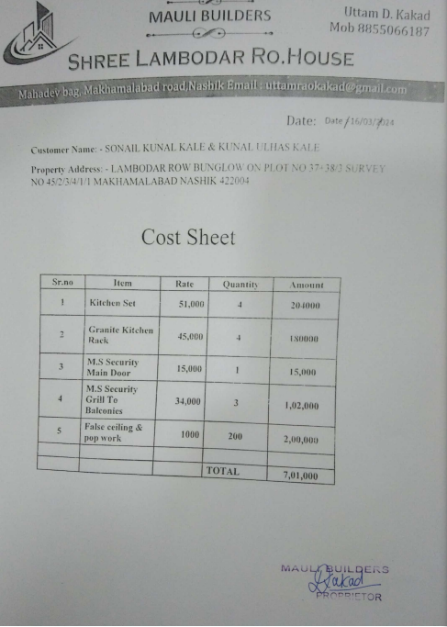

The Extra Work amount is Rs. 7,00,000/- (Rupees Seven Lakh Only)

