Vastu/Thane/03/2024/7747/2305647
20/13-395 APU
Date: 20.03.2024
Asset Verification Report

1. General Information
Agreement Number: | A10184904
Label Number: | L1724B
Customer: | M/s. Bharat Technoplast Pvt. Ltd.
Address of Asset Location: | Gate No.7/2/1. Gat No.347/1, Varale Ambethan Road, Bhamboli, Chakan, Taluka Khed, District Pune – 410501, Maharashtra, India.
Asset/s financed as per Agreement | Sl.no | Asset Description | Model | Supplier | Quantity
 | 1 | Injection Moulding Machine | C-Series 2300 | Milacron India Private Limited | 1 No.
Name Plate | ☑ Available ◻ Not Available |  | ☑ Visible ◻ Not Visible
Serial number (On Asset) | ☑ Available ◻ Not Available If Available – Refer Photos
Serial number (in Invoice): (If available) | M4701DA010013
Type of Foundation for Asset (wherever applicable) | ☑ Steel supporting structure |  | ◻ Concrete floor ◻ Other
Level of Bondage | ☑ Asset easy to remove |  | ◻ Asset fixed permanently
Description of the premises : | ☑ Manufacturing Facility ◻ Hospital ◻ Warehouse ◻ Office Premises  ◻Diagnostic ◻ Others (Please specify): _________________________________
Asset influencing circumstances ( i.e Chemical Zone, Corrosive atmosphere, Highly Polluted location etc.,) : | ◻Yes  If yes, please specify: |  | ☑ No

2. Asset Condition
Optical impression of physical condition of Asset: | ◻ Excellent ☑ Good ◻ Fair ◻ Poor ◻ Very Poor
Was the asset in operation at the time of Inspection | ☑ Yes ◻ No If No Please specify reasons
Age of the Asset at the time of inspection | ~ 7 Months
Asset condition at the time of purchase | ☑ New ◻ Used
Any Breakdown in the machine | ◻ Yes ◻ No ☑ Not Known
Photos: | ☑ Yes | ◻ No
3. Information About Onsite Visit
Date of Onsite Visit: | 14/03/2024
Latitude & Longitude | 18°47'46.2"N 73°46'33.8"E
Customer Personnel met at site: | Mr. Sanjay (Manager) - 9004993701
Report created at | Mumbai

For Vastukala Consultants (I) Pvt. Ltd.

Umang Ashwin Patel
Regd. Valuer
Chartered Engineer (India)
Reg. No. IBBI/RV/04/2019/10803

Photographs

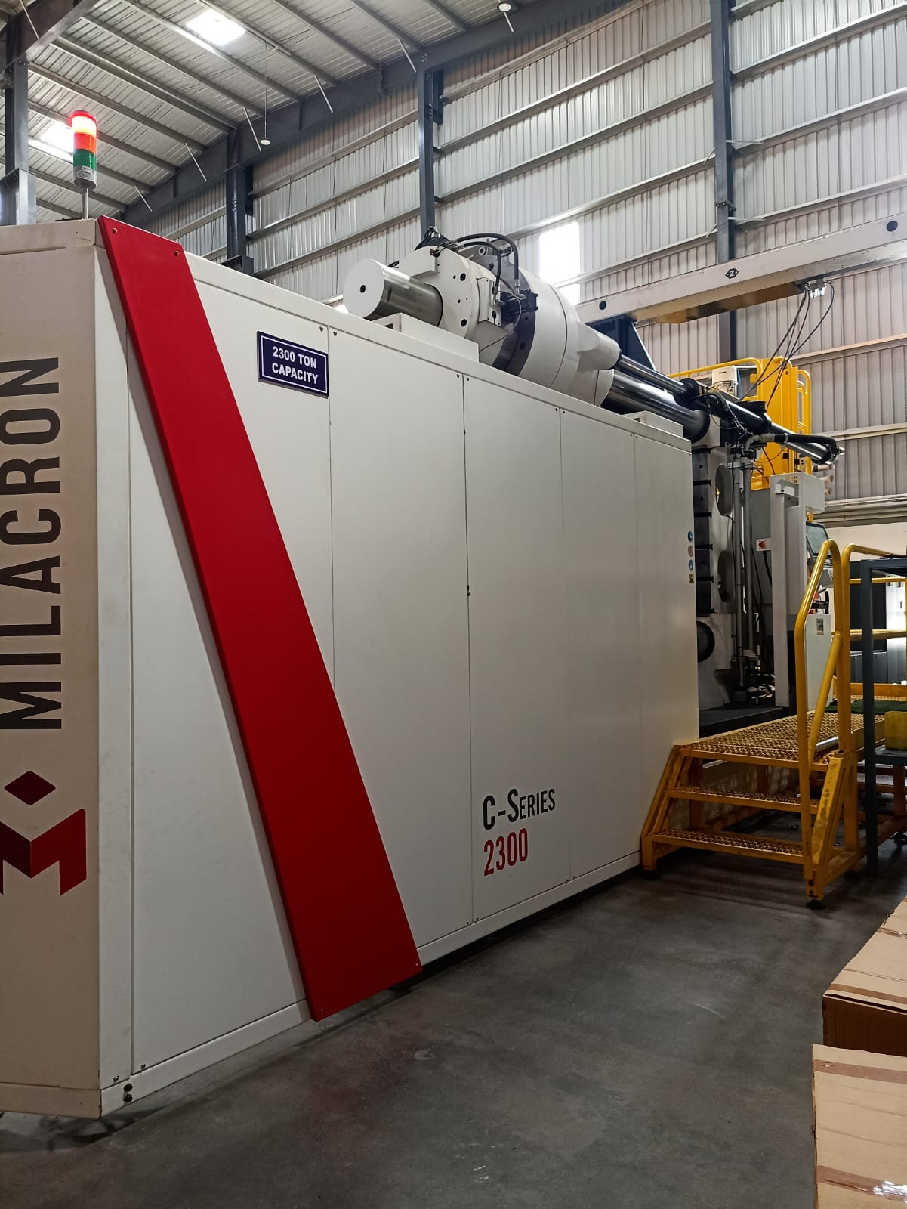 | 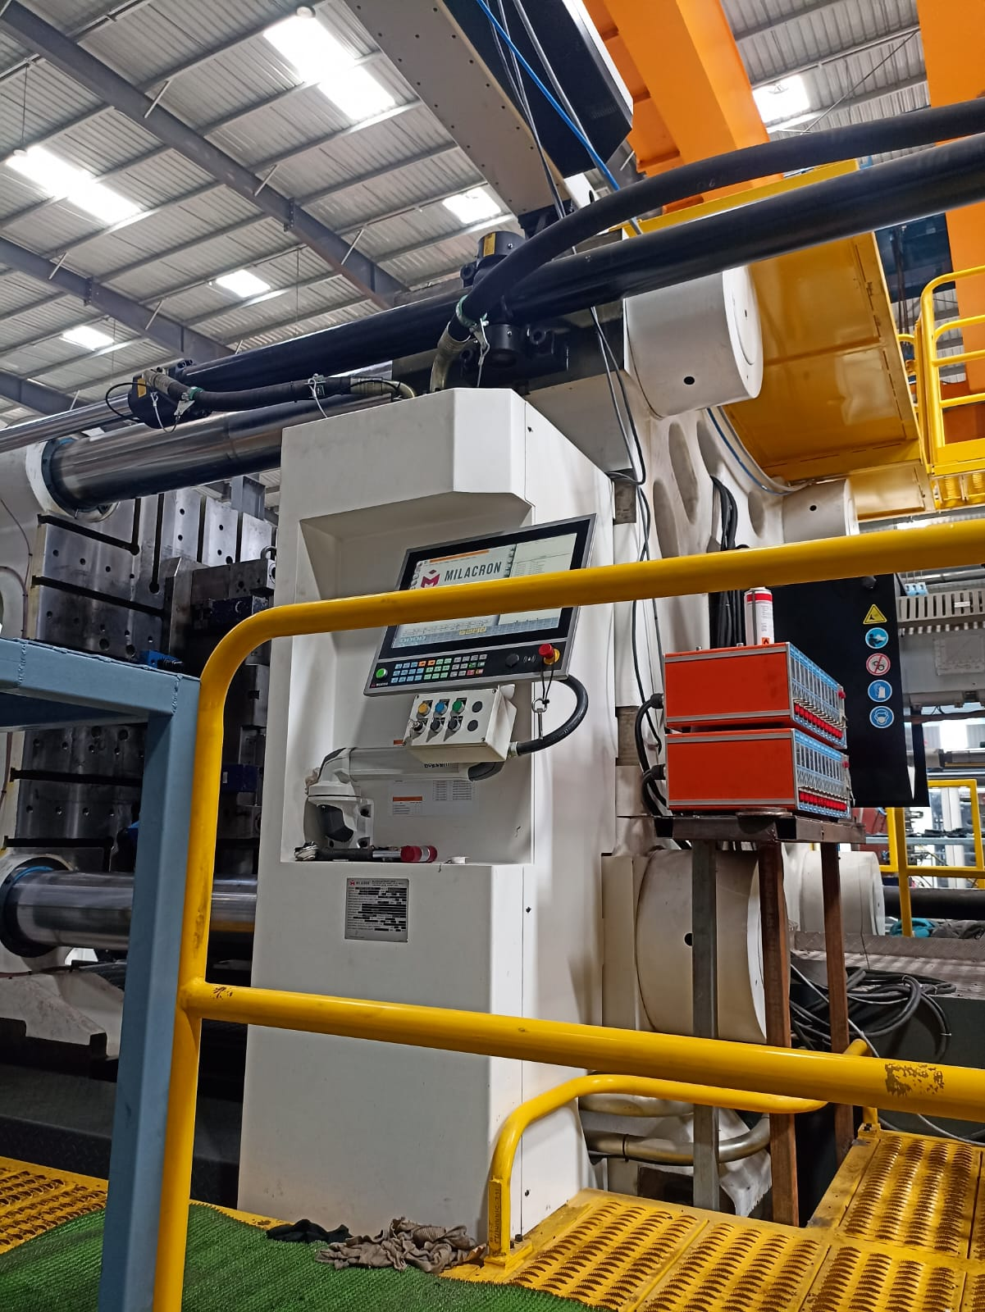
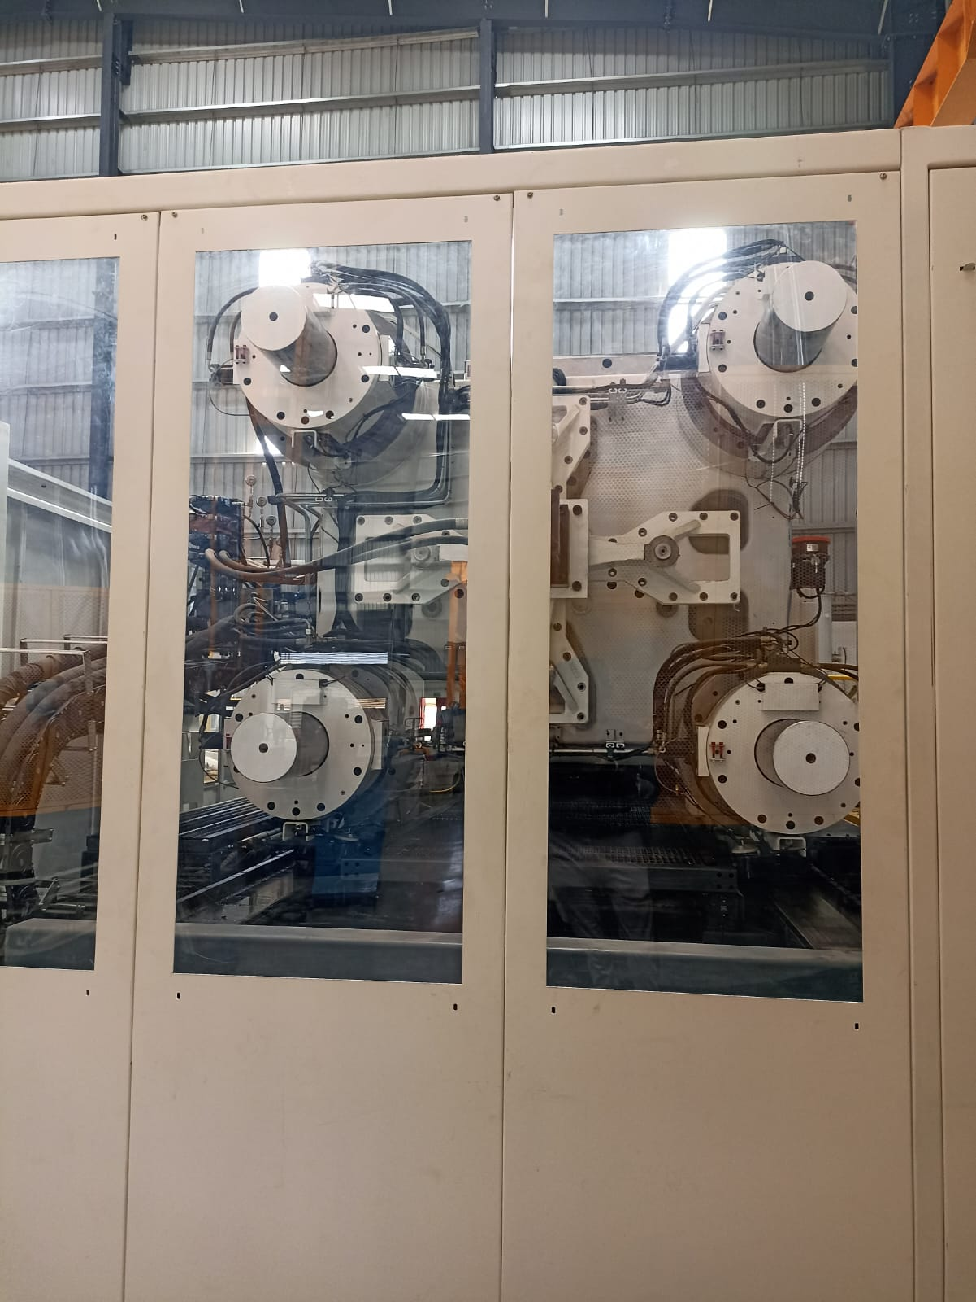 | 