Vastu/Thane/03/2024/7745/2305646
20/12-394 APU
Date: 20.03.2024

Asset Verification Report

1. General Information
Agreement Number: | A10173618
Label Number: | L1663B
Customer: | M/s. U S Hydraulics
Address of Asset Location: | S-Block, S 234/9, near Indrayani Corner, PCNTDA, MIDC, Bhosari, Pune, Pimpri-Chinchwad, District Pune – 411026, Maharashtra, India.
Asset/s financed as per Agreement | Sl.no | Asset Description | Model | Supplier | Quantity
 | 1 | CNC Vertical Machining Center | MCV - 450 | ACE Manufacturing Systems Limited | 1 No.
Name Plate | ☑ Available ◻ Not Available |  | ☑ Visible ◻ Not Visible
Serial number (On Asset) | ☑ Available ◻ Not Available If Available – Refer Photos
Serial number (in Invoice): (If available) | M30-4424
Type of Foundation for Asset (wherever applicable) | ☑ Steel supporting structure |  | ◻ Concrete floor ◻ Other
Level of Bondage | ☑ Asset easy to remove |  | ◻ Asset fixed permanently
Description of the premises : | ☑ Manufacturing Facility ◻ Hospital ◻ Warehouse ◻ Office Premises  ◻Diagnostic ◻ Others (Please specify) : _________________________________
Asset influencing circumstances ( i.e Chemical Zone, Corrosive atmosphere, Highly Polluted location etc.,) : | ◻Yes  If yes, please specify: |  | ☑ No

2. Asset Condition
Optical impression of physical condition of Asset : | ◻ Excellent ☑ Good ◻ Fair ◻ Poor ◻ Very Poor
Was the asset in operation at the time of Inspection | ☑ Yes ◻ No If No Please specify reasons
Age of the Asset at the time of inspection | ~ 8 Months
Asset condition at the time of purchase | ☑ New ◻ Used
Any Breakdown in the machine | ◻ Yes ◻ No ☑ Not Known
Photos: | ☑ Yes | ◻ No
3. Information About Onsite Visit
Date of Onsite Visit: | 14/03/2024
Latitude & Longitude | 18°37'44.7"N 73°50'27.0"E
Customer Personnel met at site: | Mr. Nasir Jahagirdar (Manager) - 8308818825
Report created at | Mumbai

For Vastukala Consultants (I) Pvt. Ltd.Umang Ashwin Patel

Regd. Valuer
Chartered Engineer (India)
Reg. No. IBBI/RV/04/2019/10803
Photographs

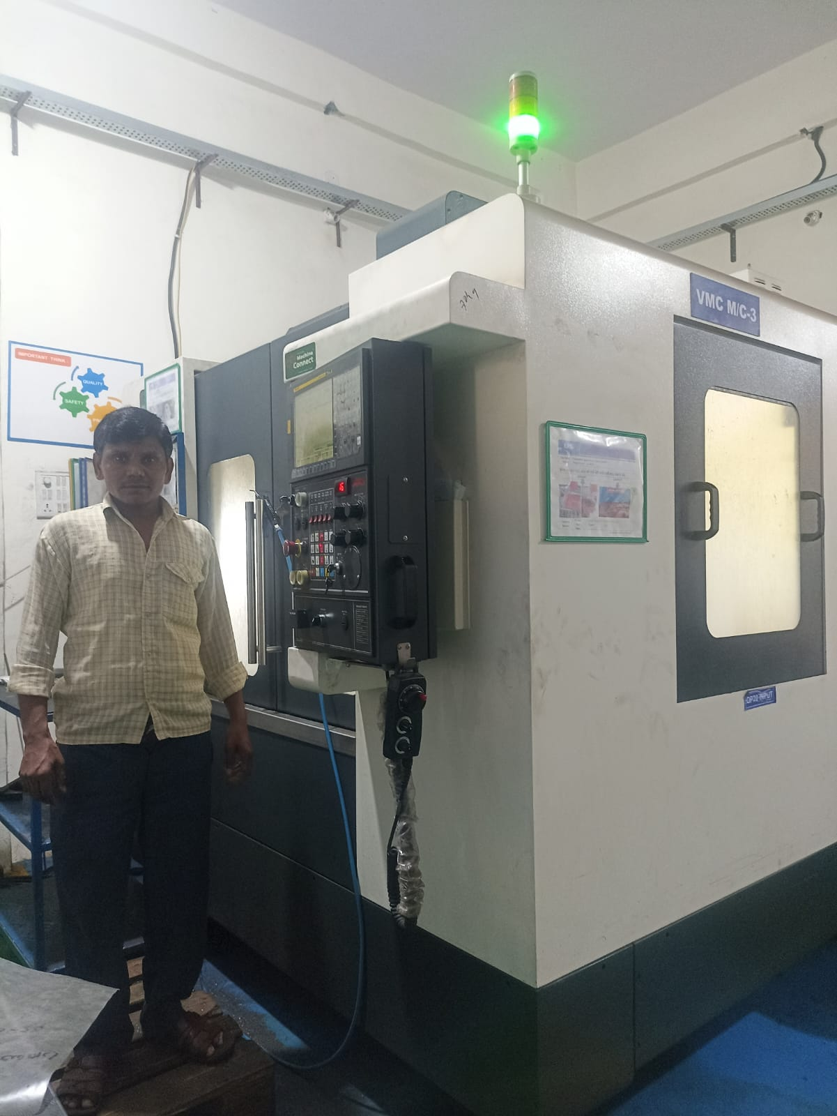 | 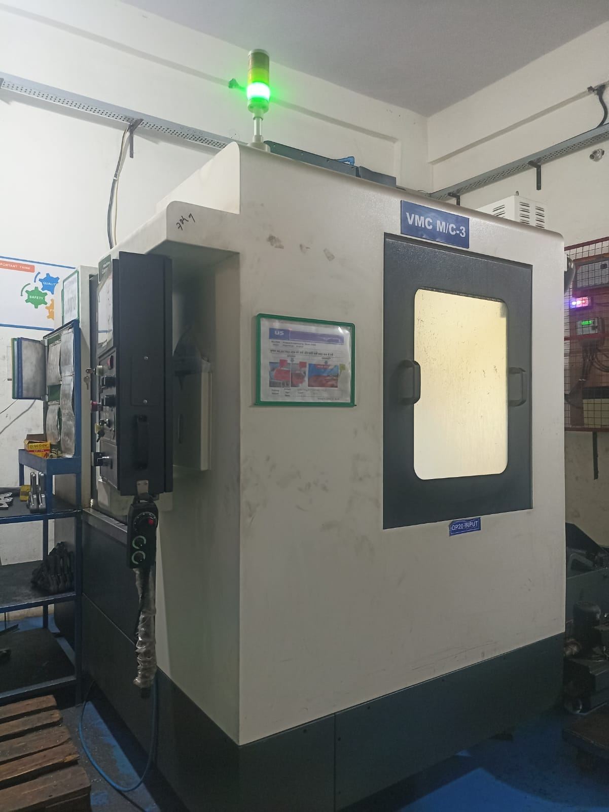
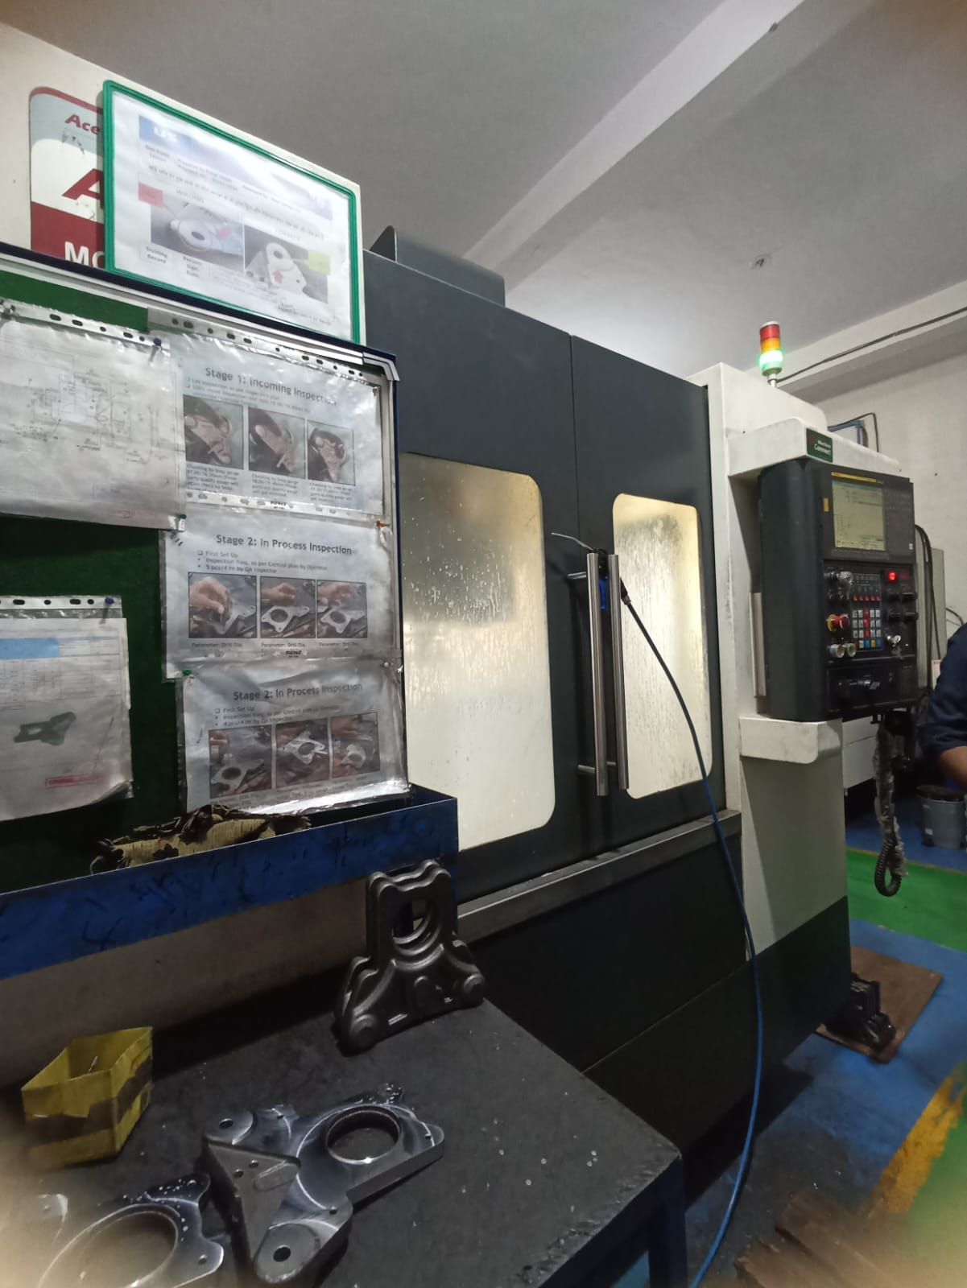 | 