Vastu/Nashik/02/2024/006731/2304808
03/4-30-RYBS
Date: 16.03.2024

To,
The Branch Manager,
Punjab National Bank

Canada Corner Branch
Shop No.2, 3, 4 Prestige Point, Opp. Vasant Market, Canada Corner
Nashik – 422 005, State – Maharashtra, Country – India.

Sub: Vetting of Extra Amenities Agreement

Sir,

With reference to above subject, we have evaluated the Extra Residential Flat No. 205, Second Floor, " Shraddha Heights ", Survey No. 201/ 1B/ 2B/ 3B, Plot No. 25+29+30, Near Trikoni Bangala, Ayodhya Nagari, Dr Nanasaheb Dharmadhikari Marg, Village – Nashik, Taluka & District - Nashik, PIN Code – 422 003, State – Maharashtra, Country – India. belongs to Name of Proposed Purchaser: Mr. Ramdas Mhata Thombare & Mr. Mohinesh Ramdas Thombare. Name of Owner: Mr. Sanjay Vishanu Damodare.

We have verified the rates quoted as per current market rates. Details of work and Extra Amenities considered as per copy of Agreement for Extra Amenities Agreement between Mr. Ramdas Mhata Thombare & Mr. Mohinesh Ramdas Thombare. (First Party) and Mr. Sanjay Vishanu Damodare. (Second Party) received on dated 15.03.2024. The Extra Amenities amount is Rs.8,25,000/- (Rupees Three Lakh Forty Five Thousand Only)

The said Cost Vetting Certificate is valid upto next 6 months Only.

Thanking you

Sincerely yours

Sharadkumar B. Chalikwar
Govt. Reg. Valuer
Chartered Engineer (India)
Reg. No. (N) CCIT/1-14/52/2008-09
PNB Empanelment No. ZO:SAMD:1138
Encl: Vetting Report.

Extra Amenities Agreement
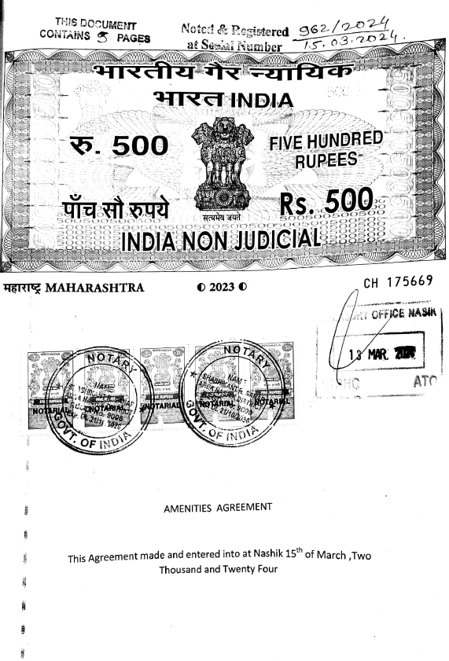
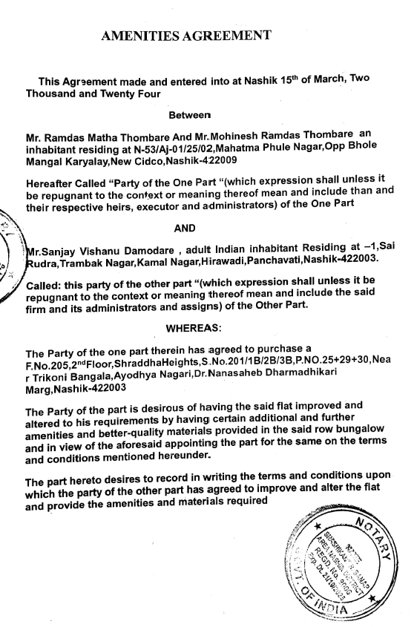

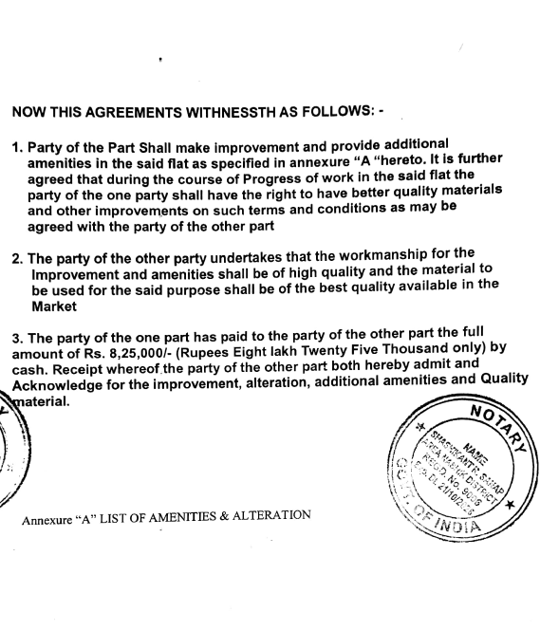
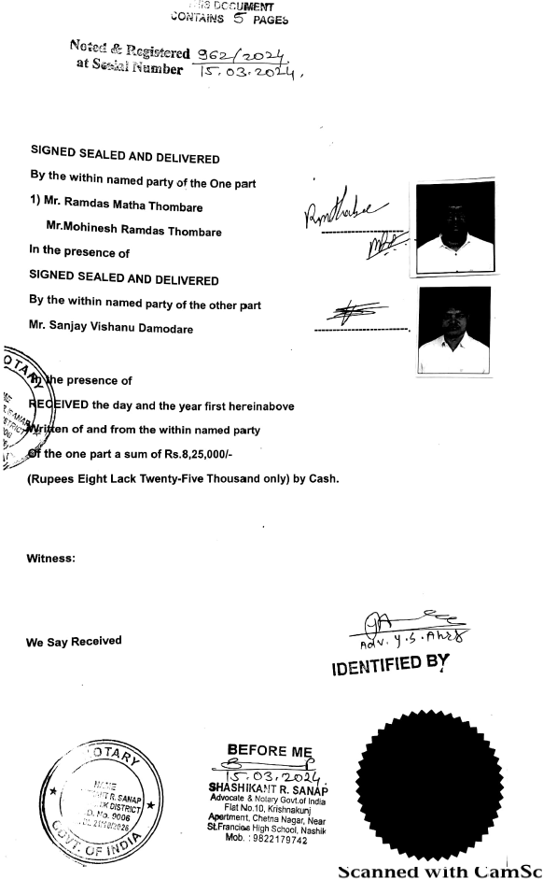

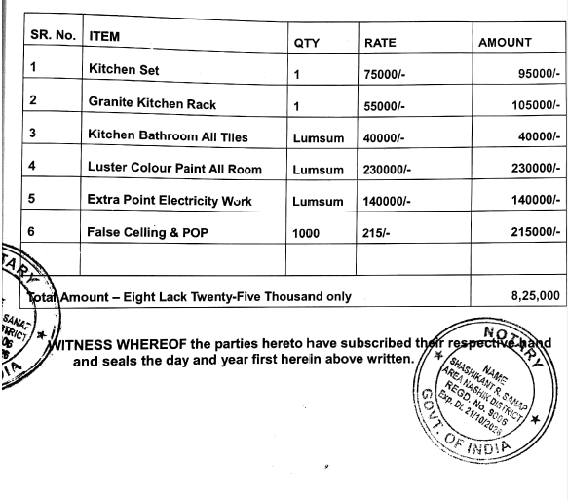

The Extra Amenities amount is Rs.8,25,000/- (Rupees Eight Lakh Twenty Five Thousand Only)

