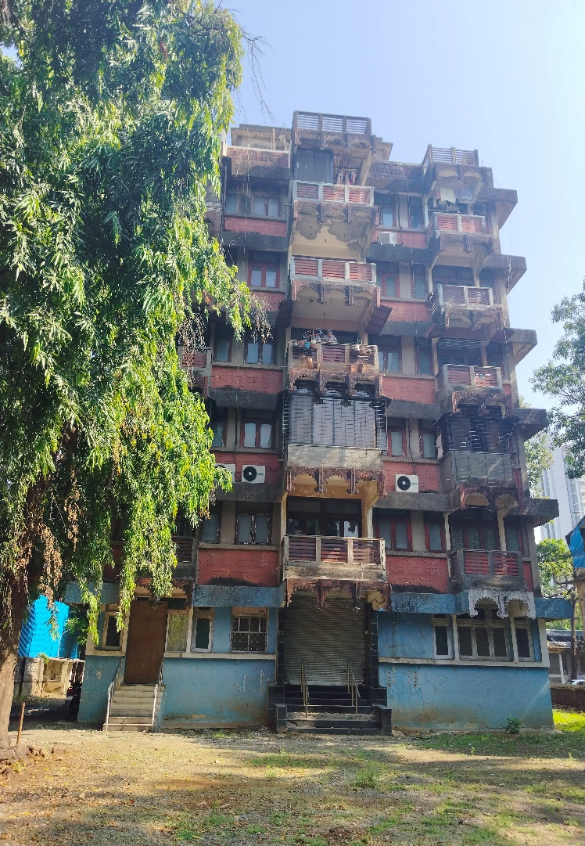

Intened User : **M/s. The India United Manufacturing Company**

Report Prepared By : **Mr. Manoj B. Chalikwar – Registered Valuer**

Report Prepared By Manoj Baburao Chalikwar Umang Ashwin Patel Prashant Jain

Report Prepared By Manoj Baburao Chalikwar Umang Ashwin Patel Prashant Jain

Valuation of Immovable Property

# Contents

Contents 2

1. Executive Summary of Valuation 3

1.1. Appointment of Valuer: 3

1.2. Details of property for valuation: 4

1.3. Summary of Valuation: 5

2. Scope of Work: 5

3. Valuation Date and Report Date 5

4. Methodology 5

4.1. Basis (Bases) of Value 6

4.1.1. Determination of fair market value of Asset owned by the firm 6

4.2. Premise of Value – Current Use / Existing Use 7

4.2.1. Current Use/Existing Use 7

5. Disclosure of Valuer’s Interest 7

6. About the Building: 7

6.1. The Building Shree Ram House Amenities & Features: 7

6.2. Location Advantages: 8

7. Conditions and Major Assumptions: 8

7.1. Conditions: 8

7.2. Assumptions 8

7.3. Nature and Source of Information Used or Relied Upon: 9

7.4. Date of Site inspection / site Visit: 9

8. VALUATION REPORT IN RESPECT OF IMMOVABLE PROPERTY 10

8.1. Valuation Report 10

8.2. Actual site photographs 13

8.3. Actual site photographs 14

8.4. Route Map of the property 15

8.5. Ready Reckoner 2023 -24 16

9. Valuation for F. Y. 2023 - 24: 17

10. Conclusion 18

# Executive Summary of Valuation

Determination of fair market value (under Rule-11UA) for Entire Ground & Basement Floor, **“Shree Ram House”**, Near Bal Bharati College, Bearing Corporation No. 94, C.T.S. No. 377 and 377 (1 to 21), S. V. Road, Kandivali (West), Mumbai – 400067, State – Maharashtra, Country – India.

## Appointment of Valuer:

Mr. Ashish Chandgothia of M/s. The India United Manufacturing Company has appointed Manoj B. Chalikwar, Director of M/s Vastukala Consultants (I) Pvt. Ltd. - Registered Valuer – Immovable Property to provide an opinion on Determination of fair market value (under Rule-11UA) for Entire Ground & Basement Floor, **“Shree Ram House”**, Near Bal Bharati College, Bearing Corporation No. 94, C.T.S. No. 377 and 377 (1 to 21), S. V. Road, Kandivali (West), Mumbai – 400067, State – Maharashtra, Country – India

|  |  |
| --- | --- |
| Asset Class | Land & building |
| Name of the Regd. Valuer | **Manoj B. Chalikwar** |
| Registration number | IBBI/RV/07/2018/10366 |
| E-mail Id | [manoj@vastukala.org](mailto:manoj@vastukala.org) |
| Address | **Vastukala Consultants (I) Pvt. Ltd.**, B1-001, U/B Floor, Boomerang, Chandivali Farm Road, Powai, Andheri (East), Mumbai – 400 072, State - Maharashtra, Country - India |

## Details of property for valuation:

**Entire Basement & Ground Floor**

The property under reference is at entire Ground and basement floor. At the time of inspection, we found that property on ground and basement floor was in poor condition. The property consists of Kota Stone Flooring, M.S. Rolling Shutter, Wooden flush door, Concealed plumbing & open, Casing Capping electrification.

**Area as per Description of Capital Value Calculation:**

|  |  |
| --- | --- |
| **Floor** | **Carpet area (Sq. M.)** |
| Basement | 94.00 |
| Ground | 153.60 |

**As per Stamp Duty Ready Reckoner Guidelines, we have considered 20% loading on Carpet area to arrive at Built up area and the same is considered for valuation purpose:**

|  |  |  |
| --- | --- | --- |
| **Floor** | **Carpet area (Sq. M.)** | **Built up area (Sq. M.)** |
| Basement | 94.00 | 112.80 |
| Ground | 153.60 | 184.32 |

## Summary of Valuation:

|  |  |  |
| --- | --- | --- |
| Floor | Built up area  (Sq. M.) | Value (` ) |
| Basement | 112.80 | 94,53,542.00 |
| Ground | 184.32 | 2,20,67,896.00 |
| Total | | **3,15,21,438.00** |



The value adopted or assessed or assessable by any authority of the Government for the purpose of payment of stamp duty in respect of the immovable property shall be **`** **3,15,21,438/- Say (Rupee Three Crore Fifteen Lakh Twenty One Thousand Four Hundred Thirty Eight Only).**

# Scope of Work:

To provide an opinion on Determination of fair market value (under Rule-11UA) for:

* Entire Ground & Basement Floor, **“Shree Ram House”,** Near Bal Bharati College, Bearing Corporation No. 94, C.T.S. No. 377 and 377 (1 to 21), S. V. Road, Kandivali (West), Mumbai – 400067, State – Maharashtra, Country – India

# Valuation Date and Report Date

|  |  |
| --- | --- |
| Appointment Date | 05.02.2024 |
| Date of Visit | 05.02.2024 |
| Date of Valuation | 19.03.2024 |
| Date (last set of Data received) | 13.03.2024 |
| Date of Report | 19.03.2024 |

# Methodology

**This Immovable Asset Valuation Report is carried out in the following sequence:**

* *Verification of the documents provided by Client*
* *Identification of missing information and requesting for the revised list of documents*
* *Overall Site inspection & site visit*
* *Assessment of the value adopted or assessed or assessable by any authority of the Government for the purpose of payment of stamp duty in respect of the immovable property (****Value for F. Y. 2023 – 24****):*

## Basis (Bases) of Value

*Bases of value (sometimes called standards of value) describe the fundamental premises on which the reported values will be based. It is critical that the basis (or bases) of value be appropriate to the terms and purpose of the valuation assignment, as a basis of value may influence or dictate a Valuer’s selection of methods, inputs and assumptions, and the ultimate opinion of value. As per the appointment by Client,* ***the basis of value for this assignment is: Stamp Duty Rates of Dept. Of Registration & Stamps, Maharashtra  using Ready Reckoner for the year 2023 – 2024*** *for calculation of Value as on date.*

### Determination of fair market value of Asset owned by the firm

***As Per Income Tax Rule11UA*** *defines* ***“fair market value of the inventory”*** *as*

*(i)  being an immovable property, being land or building or both, shall be the value adopted or assessed or assessable by any authority of the Central Government or a State Government for the purpose of stamp duty in respect of such immovable property on the date on which the inventory is converted into, or treated, as a capital asset;*

*(ii)  being jewellery, archaeological collections, drawings, paintings, sculptures, any work of art, shares or securities referred to in rule 11UA, shall be the value determined in the manner provided in sub-rule (1) of rule 11UA and for this purpose the reference to the valuation date in the rule 11U and rule 11UA shall be the date on which the inventory is converted into, or treated, as a capital asset;*

*(iii) being the property, other than those specified in clause (i) and clause (ii), the price that such property would ordinarily fetch on sale in the open market on the date on which the inventory is converted into, or treated, as a capital asset.]*

## Premise of Value – Current Use / Existing Use

*Premise of Value or Assumed Use describes the circumstances of how an asset or liability is used. Different bases of value may require a particular premise of value or allow the consideration of multiple Premises of Value. Some common Premises of Value are:*

* *Highest and best use (HABU)*
* *Current use/existing use*
* *Orderly liquidation*
* *Forced sale*

***We have used the Premise of ‘Current use / Existing use’ for this valuation assignment.***

### Current Use/Existing Use

*Current use/existing use is the current way an asset, liability, or group of assets and/or liabilities is used. The current use may be, but is not necessarily, also the highest and best use.*

# Disclosure of Valuer’s Interest

***I, Manoj B. Chalikwar*** *hereby declare that - I have no interest, either direct or indirect, in subject property. Further to state that I do not have relation or any connection with Promoters or Directors or any Shopr of the client company, directly or indirectly. Further o state that I am independent and in no way related to any officials of Company.*

# About the Building:

## The Building Shree Ram House Amenities & Features:

*The Structure is of Basement + Ground + 5 upper floors building. The building is known as* ***“Shree Ram House”****. It is used for residential & commercial purpose. The building is having 1 lift.*

*Out of above building structure, the client’s firm has owned Basement & ground floor structure which is considered for the purpose of valuation.*

## Location Advantages:

*The properyt is located in Kandivali (West), Mumbai and well connected by major road(s) like S. V. Road, Western Express Highway. The locality is well linked to several parts of Mumbai through the public transport network and important roads. Kandivali Suburban Railway Station is 700 M. distance from the property and Chhatrapati Shivaji Maharaj International Airport is at a distance of around 14.8 KM. from the said property.*

# Conditions and Major Assumptions:

## Conditions:

This report is prepared on the request of client and this report is only to be used in its entirety, and for the purpose stated in the report. No third parties should rely on the information or data contained in this report without written permission from the Valuer.

We have acknowledged that we have no present or contemplated financial interest in the Company. Our fees for this valuation are based upon our normal billing rates, and not contingent upon the results or the value or any other manner. We have no responsibility to modify this report for events and circumstances occurring subsequent to the date of this report.

We have used conceptually sound and generally accepted method, principle and procedures of International Valuation Standard determining the Stamp Duty Value estimate included in this report.

## Assumptions

The Opinion of valuer given in this report is based on information/ documents provided by client and we assumed the information to be accurate and complete.

We have not attempted to confirm whether or not the property has good title. We have assumed that the subject property has Good & Marketable Title which is free from any encumbrance.

## Nature and Source of Information Used or Relied Upon:

We have relied on following information, data and documents to form our opinion in report:

1. Copy of Article of agreement dated 29.01.1982 between Mr. Harishchandra Jaidayal Chandgothia (The Owner) and M/s. The India United Manufacturing Company (The Tenant)
2. Copy of Deed of Reconstitution of Partnership dated 19.04.2012
3. Copy of Previous valuation report dated 11.10.2013 issued by Yardi Prabhu Consultants & Valuer Pvt. Ltd.
4. Copy of Description of Capital Value Calculation issued by Assessment and Collection Dept., BMC

## Date of Site inspection / site Visit:

In view to have first-hand information regarding the assets to be valued following persons inspected the subject property as under:

|  |  |  |  |
| --- | --- | --- | --- |
| Valuers Representative | Client Representative | Type of Property | Date of Visit |
| Mr. Barkat Hodekar  (Civil Engineer) | Mr. Ashish Chandgothia  (Contact No. – 92232 59001) | Commercial property | 05.02.2024 |

# VALUATION REPORT IN RESPECT OF IMMOVABLE PROPERTY

## Valuation Report

|  |  |  |  |  |  |  |
| --- | --- | --- | --- | --- | --- | --- |
| I | **General** | | | | | |
| 1. | Purpose for which the valuation is made | | | | : | As per Client’s Request to Assess the Fair Market value under 11UA. |
| 2. | a) | Date of inspection | | | : | 05.02.2024 |
|  | b) | Date on which the valuation is made | | | : | 19.03.2024 |
|  | Address of the property | | | | : | Entire Ground & Basement Floor, “Shree Ram House”, Near Bal Bharati College, Bearing Corporation No. 94, C.T.S. No. 377 and 377 (1 to 21), S. V. Road, Kandivali (West), Mumbai – 400067, State – Maharashtra, Country – India |
| 4. | Name of the owner(s) and his / their address (es) with Phone no. (details of share of each owner in case of joint ownership) | | | | : | **M/s. The India United Manufacturing Company**  **Contact Person :**  Mr. Ashish Chandgothia Contact No. – 92232 59001 |
| 5. | Brief description of the property (Including Leasehold / freehold etc.) | | | | : |  |
|  | The property under reference is at entire Ground and basement floor. At the time of inspection, we found that property on ground floor was in poor condition. The property consists of Vitrified Flooring, M.S. Rolling Shutter, Wooden flush door, Concealed plumbing & open electrification. | | | | | |
| 6. | Location of property | | | | : |  |
|  | a) | | Plot No. / Survey No. | | : | - |
|  | b) | | Door No. | | : | Entire basement and ground floor |
|  | c) | | C. T.S. No. / Village | | : | Bearing Corporation No. 94, C.T.S. No. 377 and 377 (1 to 21), Village – Malad (North) |
|  | d) | | Ward / Taluka | | : | Taluka – Borivali |
|  | e) | | Mandal / District | | : | Mumbai Suburban District |
| 7. | Postal address of the property | | | | : | Entire Ground & Basement Floor, **“Shree Ram House”**, Near Bal Bharati College, Bearing Corporation No. 94, C.T.S. No. 377 and 377 (1 to 21), S. V. Road, Kandivali (West), Mumbai – 400067, State – Maharashtra, Country – India |
| 8. | City / Town | | | | : | Mumbai |
|  | Residential area | | | | : | Yes |
|  | Commercial area | | | | : | Yes |
|  | Industrial area | | | | : | No |
| 9. | Classification of the area | | | | : |  |
|  | i) High / Middle / Poor | | | | : | Middle Class |
|  | ii) Urban / Semi Urban / Rural | | | | : | Urban |
| 10. | Coming under Corporation limit / Village Panchayat / Municipality | | | | : | Municipal Corporation of Greater Mumbai |
| 11. | Whether covered under any State / Central Govt. enactments (e.g., Urban Land Ceiling Act) or notified under agency area/ scheduled area / cantonment area | | | | : | No |
| 12. | **Boundaries of the property** | | | **As per Site inspection** | | |
|  | North | | | Matru Ashish CHSL | | |
|  | South | | | 92 Basanti Bhavan | | |
|  | East | | | Shree Ram Building | | |
|  | West | | | S. V. Road | | |
| 13. | Latitude, Longitude & Co-ordinates of property | | | | : | 19°11'58.9"N 72°50'56.5"E |
| 14. | Extent of the site | | | | : | Basement Carpet Area = 94.00 Sq. M. Ground Floor Carpet Area = 153.60 Sq. M. (Area as per Property Tax Annexure Report)  **Basement Built up Area = 112.80 Sq. M. Ground Floor Built up Area = 184.32 Sq. M. (Carpet Area + 20%)** |
| 15. | Extent of the site considered for Valuation | | | | : | **Basement Built up Area = 112.80 Sq. M. Ground Floor Built up Area = 184.32 Sq. M. (Carpet Area + 20%)** |
| 16 | Whether occupied by the owner / tenant? If occupied by tenant since how long? Rent received per month. | | | | : | Vacant |
| **II** | **APARTMENT BUILDING** | | | |  |  |
|  | Nature of the Apartment | | | | : | Commercial |
|  | Location | | | | : |  |
|  | C.T.S. No. | | | | : | Bearing Corporation No. 94, C.T.S. No. 377 and 377 (1 to 21) |
|  | Block No. | | | | : | - |
|  | Ward No. | | | | : | - |
|  | Village / Municipality / Corporation | | | | : | Village – Malad (North)  Municipal Corporation of Greater Mumbai |
|  | Door No., Street or Road (Pin Code) | | | | : | Entire Ground & Basement Floor, **“Shree Ram House”**, Near Bal Bharati College, Bearing Corporation No. 94, C.T.S. No. 377 and 377 (1 to 21), S. V. Road, Kandivali (West), Mumbai – 400067, State – Maharashtra, Country – India |
|  | Description of the locality Residential / Commercial / Mixed | | | | : | Residential cum commercial |
|  | Year of Construction | | | | : | Year of Construction – 1982 (As per site information) |
|  | Number of Floors | | | | : | Basement + Ground + 5 upper floors |
|  | Type of Structure | | | | : | R.C.C. Framed Structure |
|  | Number of Dwelling units in the building | | | | : | 1 unit on entire basement and ground floor |
|  | Quality of Construction | | | | : | Normal |
|  | Appearance of the Building | | | | : | Normal |
|  | Maintenance of the Building | | | | : | Normal |
|  | Facilities Available | | | | : |  |
|  | Lift | | | | : | 1 lift |
|  | Protected Water Supply | | | | : | Municipal Water supply |
|  | Underground Sewerage | | | | : | Connected to Municipal Sewerage System |
|  | Car parking - Open / Covered | | | | : | Open |
|  | Is Compound wall existing? | | | | : | Yes |
|  | Is pavement laid around the building | | | | : | Yes |
| **III** | **Shop** | | | |  |  |
| 1 | The floor in which the Shop is situated | | | | : | Entire basement and ground floor |
| 2 | Door No. of the Shop | | | | : | Entire basement and ground floor |
| 3 | Specifications of the Shop | | | | : |  |
|  | Roof | | | | : | R.C.C. Slab |
|  | Flooring | | | | : | Kota Stone flooring |
|  | Doors | | | | : | M.S. Rolling shutter, Wooden flush doors |
|  | Windows | | | | : | Aluminum sliding windows |
|  | Fittings | | | | : | Concealed plumbing with C.P. fittings. Open casing capping Electrical wiring. |
|  | Finishing | | | | : | Cement Plastering |
| 4 | House Tax | | | | : |  |
|  | Assessment No. | | | | : | Details not available |
|  | Tax paid in the name of: | | | | : | Details not available |
|  | Tax amount: | | | | : | Details not available |
| 5 | Electricity Service connection No.: | | | | : | Details not available |
|  | Meter Card is in the name of: | | | | : | Details not available |
| 6 | How is the maintenance of the Shop? | | | | : | At the time of inspection, we found that property on ground floor was in poor condition |
| 7 | Sale Deed executed in the name of | | | | : | M/s. The India United Manufacturing Company |
| 8 | What is the undivided area of land as per Sale Deed? | | | | : | Details not available |
| 9 | What is the plinth area of the Shop? | | | | : | Basement Built up Area = 112.80 Sq. M. Ground Floor Built up Area = 184.32 Sq. M. (Carpet Area + 20%) |
| 10 | What is the floor space index (app.) | | | | : | As per MCGM norms |
| 11 | What is the Carpet Area of the Shop? | | | | : | Basement Carpet Area = 94.00 Sq. M. Ground Floor Carpet Area = 153.60 Sq. M. |
| 12 | Is it Posh / I Class / Medium / Ordinary? | | | | : | Middle Class |
| 13 | Is it being used for Residential or Commercial purpose? | | | | : | Commercial purpose |

## Actual site photographs

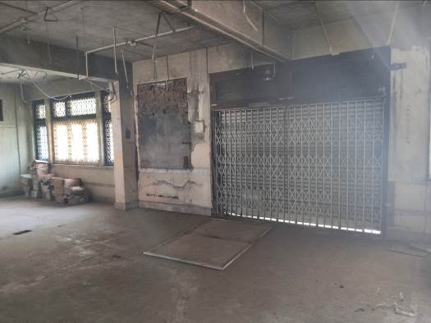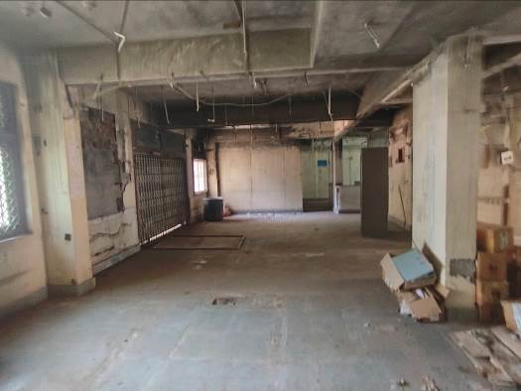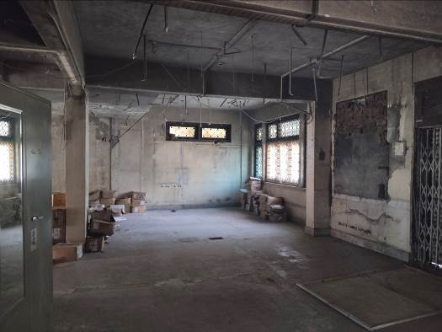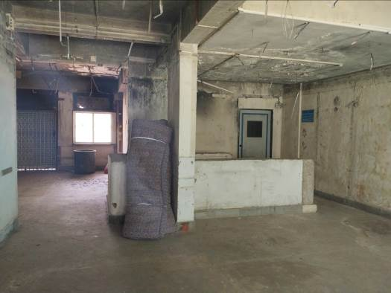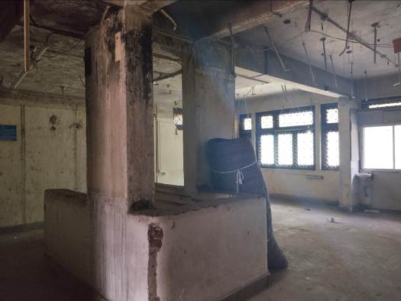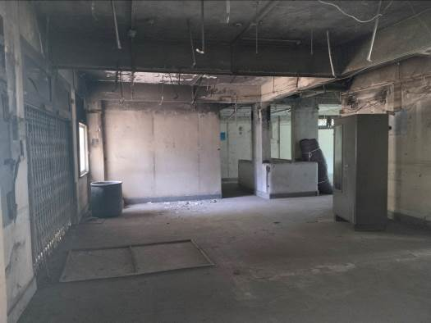

## Actual site photographs

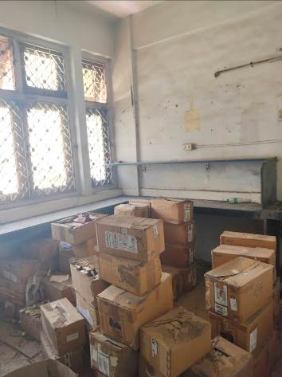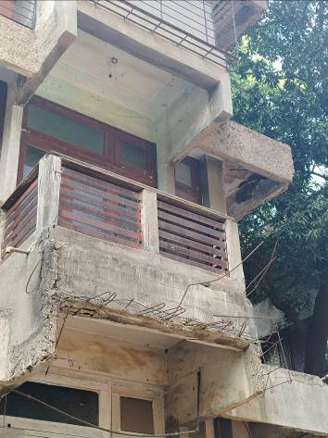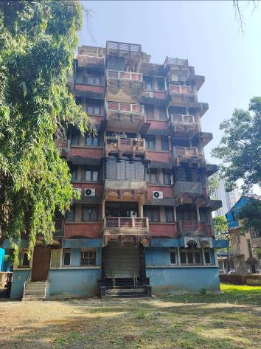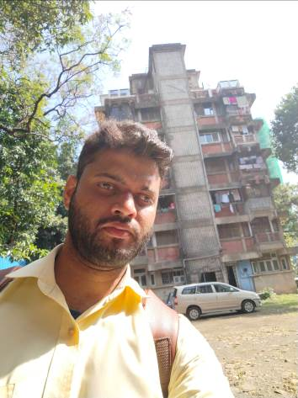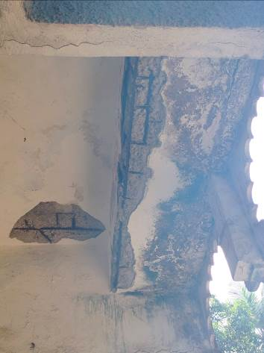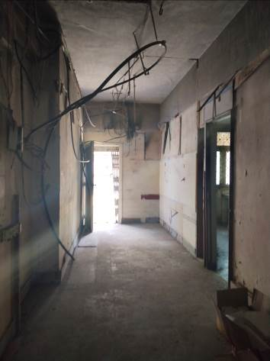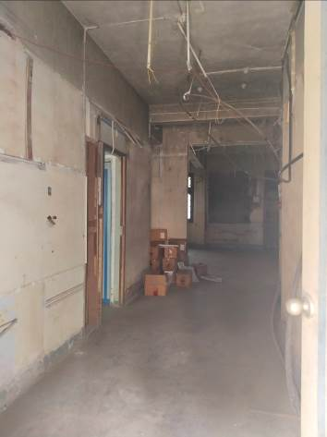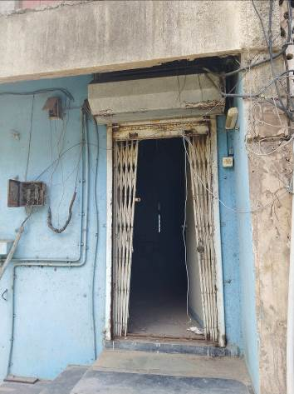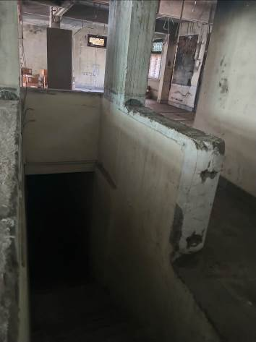

## Route Map of the property

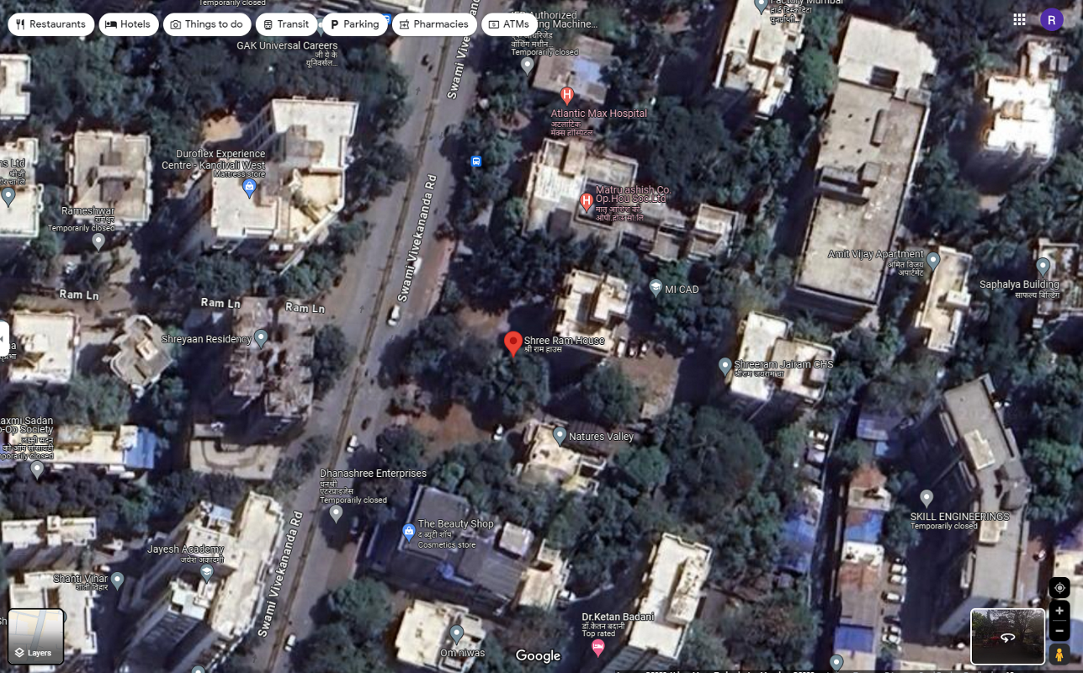**Site u/r**

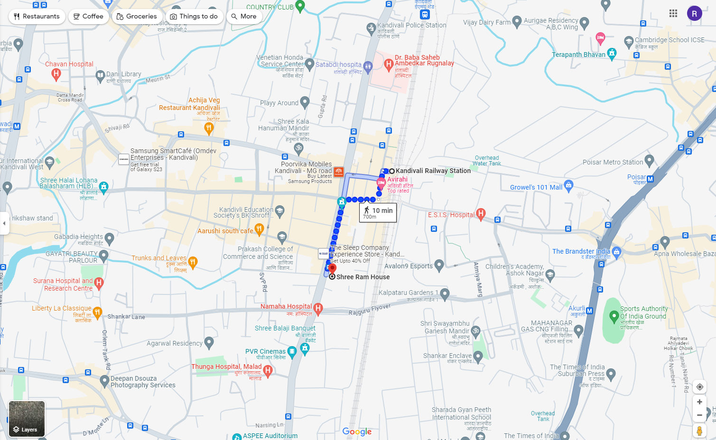

**Latitude Longitude: 19°11'58.9"N 72°50'56.5"E**

**Note:** The Blue line shows the route to site from nearest Railway station (Kandivali – 700 M.)

## Ready Reckoner 2023 -24

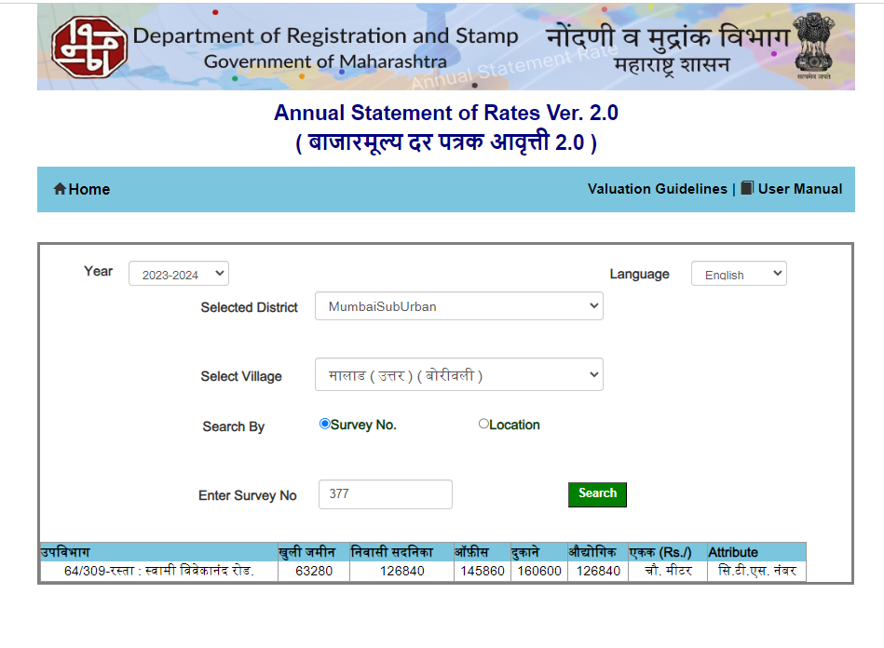

# Valuation for F. Y. 2023 - 24:

|  |  |  |  |  |
| --- | --- | --- | --- | --- |
| **Floor** | **Built up area**  **(Sq. M.)** | **Rate / Sq. M. for F.Y.2023 – 24**  **(` )** | **Depreciated Rate / Sq. M. (` )** | **Value**  **(` )** |
| Basement | 112.80 | - | 83,808.00 | 94,53,542.00 |
| Ground | 184.32 | 1,60,600.00 | 1,19,726.00 | 2,20,67,896.00 |
|  |  | **TOTAL** |  | **3,15,21,438.00** |

|  |  |
| --- | --- |
|  | **Sq. M.** |
| Stamp Duty Ready Reckoner Market Rate for Shop | 1,60,600.00 |
| No increase as Shop located on ground and basement floor | 0.00 |
| **Stamp Duty Ready Reckoner Rate for new construction (A)** | **1,60,600.00** |
| Stamp Duty Ready Reckoner Rate for Land (B) | 63,280.00 |
| The difference between land rate and building rate (A – B = C) | 97,320.00 |
| Depretiated cost of construction in Percentage (D) [100% - 42%]  (Age of the Building – 42 Years) | 58% |
| **Rate to be adopted after considering depreciation [B + (C x D)]** | **1,19,726.00** |
| **For Basement 70% of depreciated rate of ground floor is considered** | **83,808.00** |

# Conclusion

|  |  |
| --- | --- |
| Name of Client | **M/s. The India United Manufacturing Company** |
| Asset being Valued | Entire Ground & Basement Floor |
| Valuation Currency | Indian Rupees (INR) / ` |
| Purpose of Valuation | Value for F. Y. 2023 – 24 |
| Valuation Standards Referred | Income Tax – Rule 11UA |
| Basis of Value | Stamp Duty Value |
| Premises for value | Existing Use Current Use |
| Valuation Date | 19.03.2024 |
| Valuation Approach | Composite Rate as per Stamp Duty Ready Reckoner |
| Valuation Methodology | Analysis of Stamp duty valuation |
| Value of Assets | **` 3,15,21,438.00** |

|  |
| --- |
| Manoj B. Chalikwar |
| Registered Valuer  Chartered Engineer (India)  Reg. No. IBBI / RV / 07/2018/10366 |