Vastu/Nashik/03/2024/007723/2305538
15/26-286-RPBS
Date: 15.03.2024

To,
The Branch Manager,
Punjab National Bank

Canada Corner Branch
Shop No.2, 3, 4 Prestige Point, Opp. Vasant Market, Canada Corner
Nashik – 422 005, State – Maharashtra, Country – India.

Sub: Vetting of Extra Amenities Agreement

Sir,

With reference to above subject, we have evaluated the Extra Residential Land & Row House No.1, Ground Floor, "Deeplaxmi-C Row Houses" Survey No.63/2/A, Plot No.23, Opposite Anna Bhau Sathe Play Ground , Ambedkar Nagar, Trimurti Road, Village- Chunchale , Tal & Dist.- Nashik, PIN Code – 422 007, State - Maharashtra, Country - India belongs to Shri. Shiva Mukinda Borkar & Shri.Sani Mukinda Borkar. Name of Proposed Purchaser: Shri. Prafulla Bharatbhushan Prasad Kumar. & Sau. Sugandhi Kumari.

We have verified the rates quoted as per current market rates. Details of work and Extra Amenities considered as per copy of Agreement for Extra Amenities Agreement between Shr Shri. Prafulla Bharatbhushan Prasad Kumar. & Sau. Sugandhi Kumari. (First Party) and Mr. Shiva Mukinda Borkar & Mr. Sunny M. Borkar. (Second Party) received on dated 15.03.2024. The Extra Amenities amount is Rs.3,45,000/- (Rupees Three Lakh Forty-Five Thousand Only)

The said Cost Vetting Certificate is valid upto next 6 months Only.

Thanking you

Sincerely yours

Sharadkumar B. Chalikwar
Govt. Reg. Valuer
Chartered Engineer (India)
Reg. No. (N) CCIT/1-14/52/2008-09
PNB Empanelment No. ZO:SAMD:1138
Encl: Vetting Report.

Extra Amenities Agreement
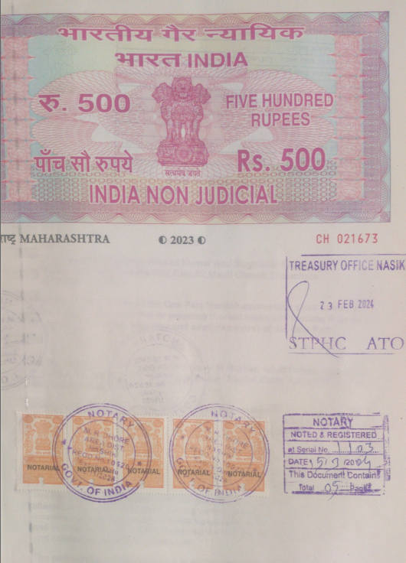
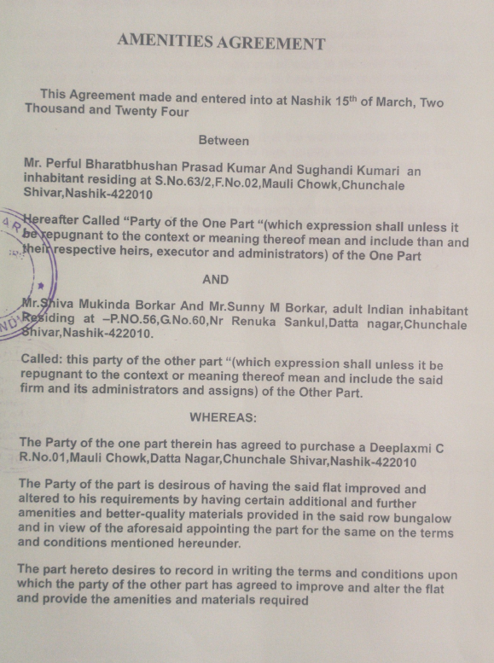

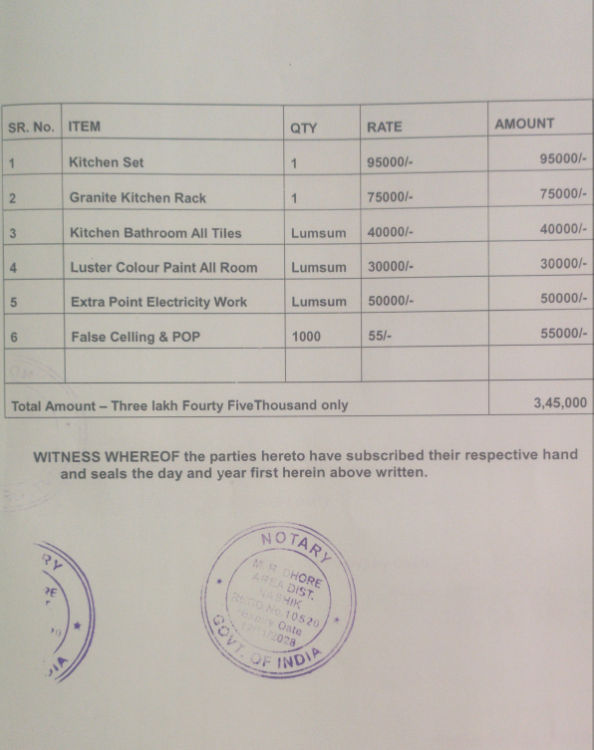
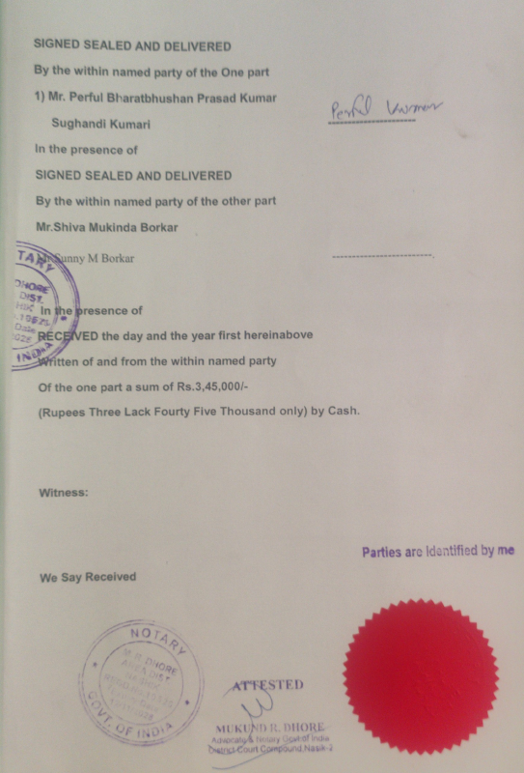

The Extra Amenities amount is Rs.3,45,000/- (Rupees Three Lakh Forty-Five Thousand Only)

